/////////////Program1//////////////

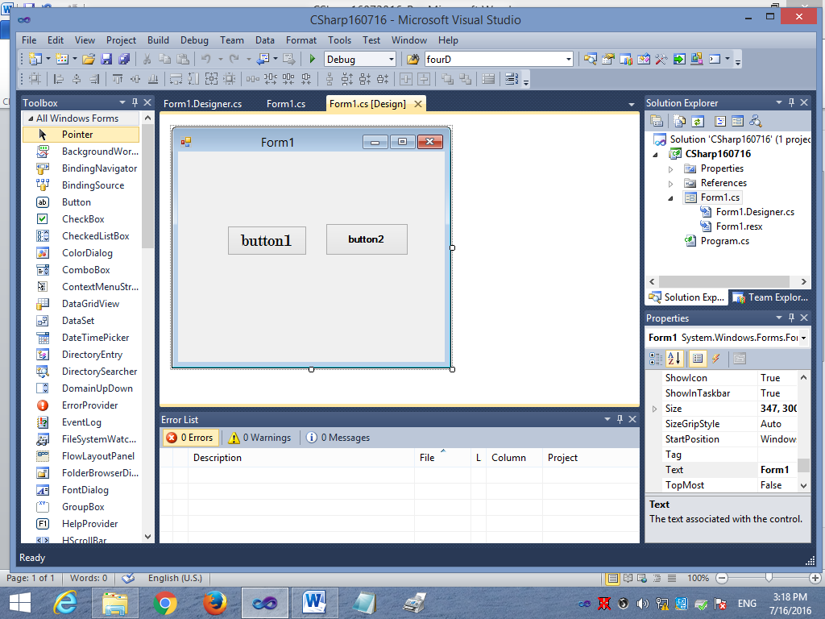

using System;

using System.Collections.Generic;

using System.ComponentModel;

using System.Data;

using System.Drawing;

using System.Linq;

using System.Text;

using System.Windows.Forms;

namespace CSharp160716

{

public partial class Form1 : Form

{

public Form1()

{

InitializeComponent();

}

private void Form1_Load(object sender, EventArgs e)

{

button1.Text = "&Click Me";

button2.Text = "Ca&ncel";

this.AcceptButton = button1;

this.CancelButton = button2;

this.button2.Font = new System.Drawing.Font("Modern No. 20", 15.75F, System.Drawing.FontStyle.Regular, System.Drawing.GraphicsUnit.Point, ((byte)(0)));

}

private void button1_Click(object sender, EventArgs e)

{

MessageBox.Show("Button control has been clicked");

}

private void button2_Click(object sender, EventArgs e)

{

this.Close();

}

}

}

/////////////Program2//////////////

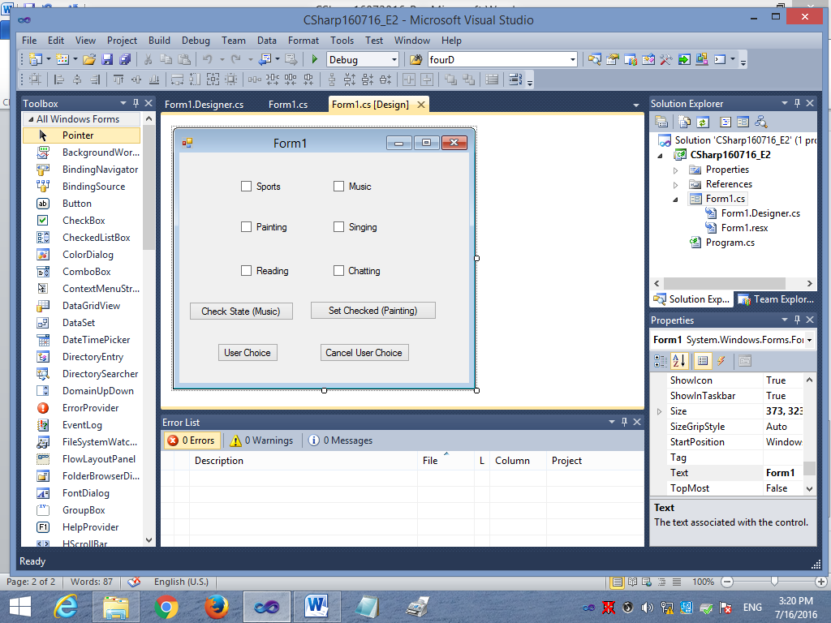

using System;

using System.Collections.Generic;

using System.ComponentModel;

using System.Data;

using System.Drawing;

using System.Linq;

using System.Text;

using System.Windows.Forms;

namespace CSharp160716_E2

{

public partial class Form1 : Form

{

public Form1()

{

InitializeComponent();

}

private void button1_Click(object sender, EventArgs e)

{

MessageBox.Show(chkMusic.CheckState.ToString());

}

private void button2_Click(object sender, EventArgs e)

{

chkPainting.Checked = true;

}

private void btnUserChoice_Click(object sender, EventArgs e)

{

String str="";

if (chkSports.Checked == true)

str = str + "Sports\n";

if (chkPainting.Checked == true)

str = str + "Painting\n";

if (chkReading.Checked == true)

str = str + "Reading\n";

if (chkMusic.Checked == true)

str = str + "Music\n";

if (chkSinging.Checked == true)

str = str + "Singing\n";

if (chkChatting.Checked == true)

str = str + "Chatting\n";

MessageBox.Show(str, "User Choice");

}

private void btnCancelUserChoice_Click(object sender, EventArgs e)

{

chkSports.Checked=false;

chkPainting.Checked = false;

chkReading.Checked = false;

chkMusic.Checked = false;

chkSinging.Checked = false;

chkChatting.Checked = false;

}

}

}

/////////////Program3//////////////

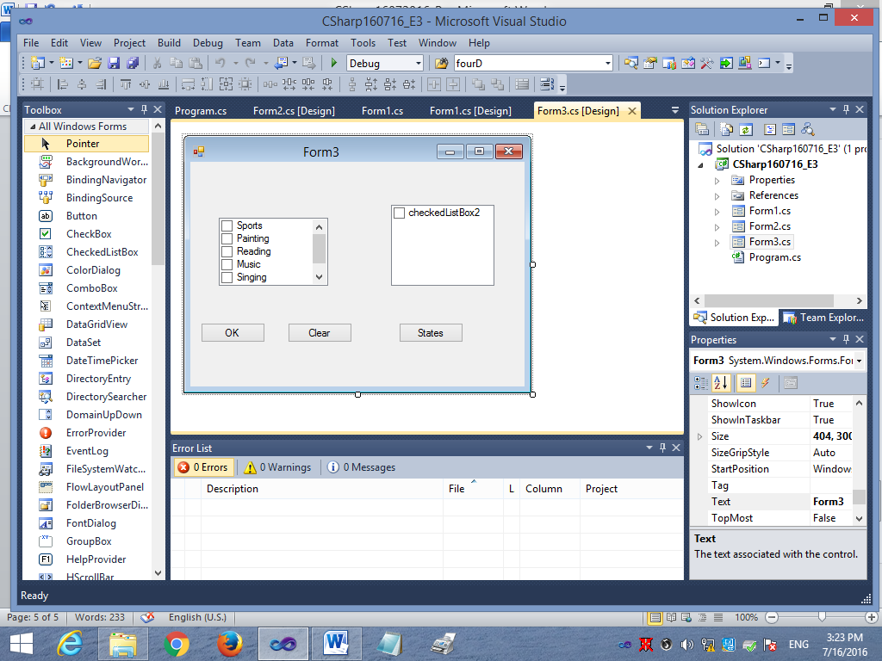

using System;

using System.Collections.Generic;

using System.ComponentModel;

using System.Data;

using System.Drawing;

using System.Linq;

using System.Text;

using System.Windows.Forms;

namespace CSharp160716_E3

{

public partial class Form3 : Form

{

public Form3()

{

InitializeComponent();

}

private void btnOK_Click(object sender, EventArgs e)

{

string str = "";

foreach (var SelectedValue in checkedListBox1.CheckedItems)

{

str += SelectedValue.ToString();

str += "\n";

}

MessageBox.Show(str, "Choice");

}

private void button1_Click(object sender, EventArgs e)

{

string str = "";

foreach (var SelectedValue in checkedListBox2.CheckedItems)

{

str += SelectedValue.ToString();

str += "\n";

}

MessageBox.Show(str, "States");

}

private void Form3_Load(object sender, EventArgs e)

{

checkedListBox2.Items.Add("Andhra Pradesh");

checkedListBox2.Items.Add("Madhya Pradesh");

checkedListBox2.Items.Add("Delhi");

checkedListBox2.Items.Add("Haryana");

checkedListBox2.Items.Add("Uttar Pradesh");

}

}

}

/////////////Program4//////////////

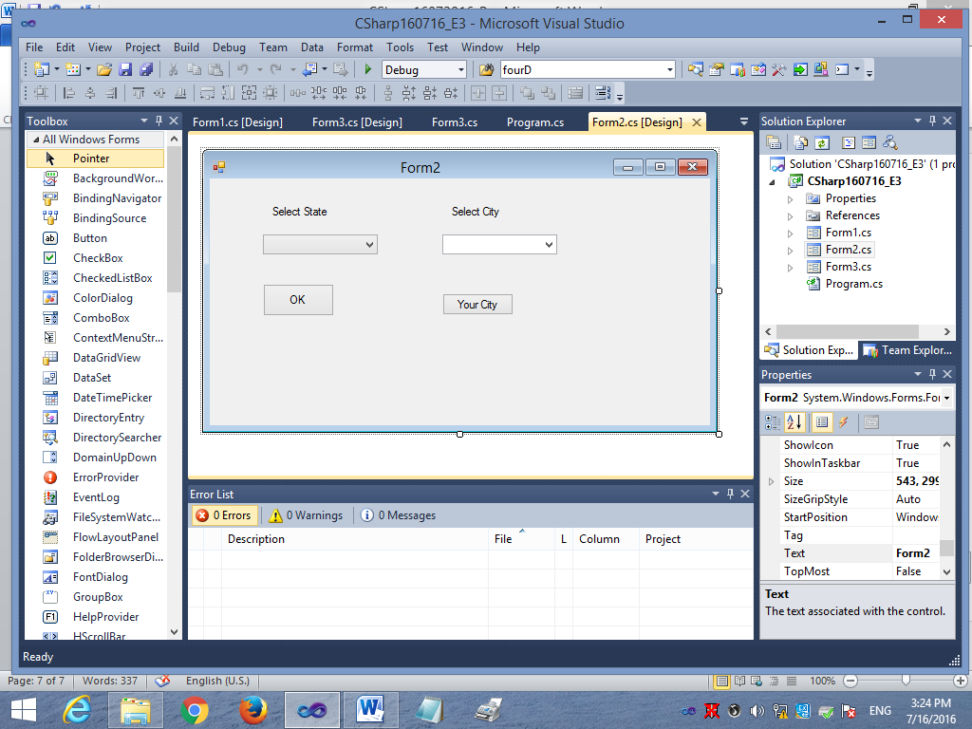

using System;

using System.Collections.Generic;

using System.ComponentModel;

using System.Data;

using System.Drawing;

using System.Linq;

using System.Text;

using System.Windows.Forms;

namespace CSharp160716_E3

{

public partial class Form2 : Form

{

public Form2()

{

InitializeComponent();

}

private void btnOK_Click(object sender, EventArgs e)

{

MessageBox.Show("State is " + cmbState.Text);

}

private void Form2_Load(object sender, EventArgs e)

{

cmbCity.Items.Add("Dehradun");

cmbCity.Items.Add("Rishikeh");

cmbCity.Items.Add("Haridwar");

cmbCity.Items.Add("Pauri");

cmbCity.Items.Add("Grahwal");

}

private void button1_Click(object sender, EventArgs e)

{

MessageBox.Show("City is " + cmbCity.Text);

}

}

}