///////////Program1/////////////

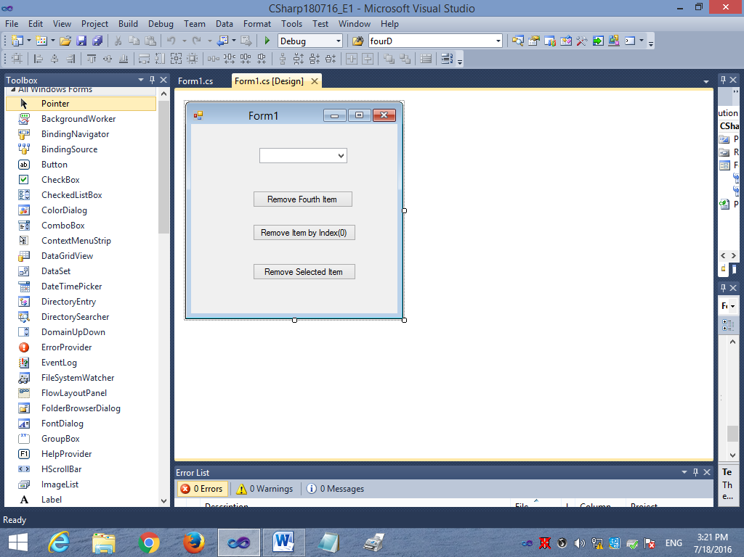

using System;

using System.Collections.Generic;

using System.ComponentModel;

using System.Data;

using System.Drawing;

using System.Linq;

using System.Text;

using System.Windows.Forms;

namespace CSharp180716_E1

{

public partial class Form1 : Form

{

public Form1()

{

InitializeComponent();

}

private void Form1_Load(object sender, EventArgs e)

{

comboBox1.Items.Add("First");

comboBox1.Items.Add("Second");

comboBox1.Items.Add("Third");

comboBox1.Items.Add("Fourth");

comboBox1.Items.Add("Fifth");

comboBox1.Items.Add("Sixth");

comboBox1.Items.Add("Seven");

comboBox1.Items.Add("Eight");

//comboBox1.Sorted = true;

}

private void button1_Click(object sender, EventArgs e)

{

comboBox1.Items.Remove("Fourth");

}

private void button2_Click(object sender, EventArgs e)

{

comboBox1.Items.RemoveAt(0);

}

private void button3_Click(object sender, EventArgs e)

{

comboBox1.Items.Remove(comboBox1.SelectedItem);

}

}

}

///////////Program2/////////////

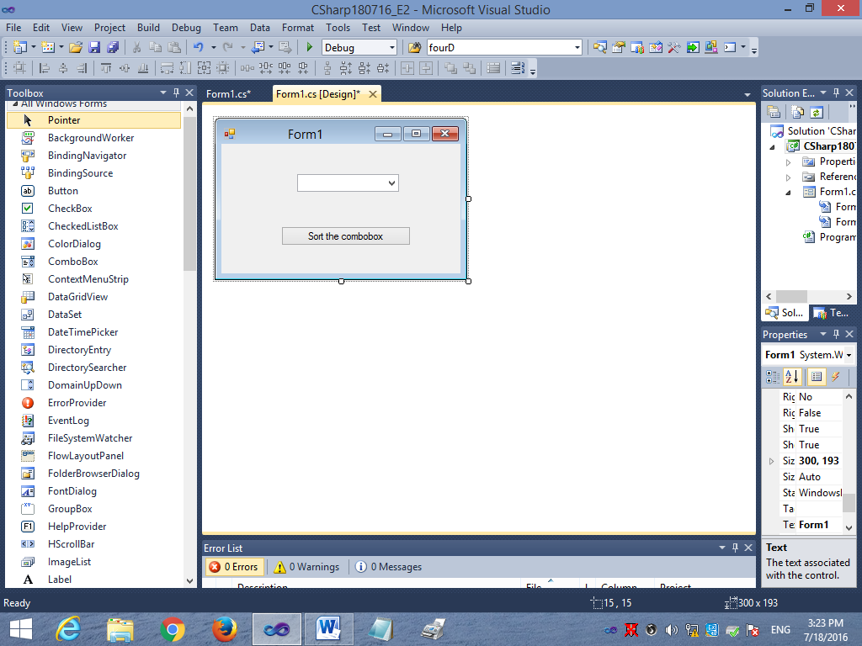

using System;

using System.Collections.Generic;

using System.ComponentModel;

using System.Data;

using System.Drawing;

using System.Linq;

using System.Text;

using System.Windows.Forms;

namespace CSharp180716_E2

{

public partial class Form1 : Form

{

public Form1()

{

InitializeComponent();

}

private void Form1_Load(object sender, EventArgs e)

{

/*comboBox1.Items.Add("Z");

comboBox1.Items.Add("C");

comboBox1.Items.Add("M");

comboBox1.Items.Add("N");

comboBox1.Items.Add("T");

comboBox1.Items.Add("A");

comboBox1.Items.Add("G");*/

comboBox1.Items.Add("9");

comboBox1.Items.Add("2");

comboBox1.Items.Add("5");

comboBox1.Items.Add("7");

comboBox1.Items.Add("1");

comboBox1.Items.Add("6");

comboBox1.Items.Add("4");

}

private void button1_Click(object sender, EventArgs e)

{

comboBox1.Sorted = true;

}

}

}

///////////Program3/////////////

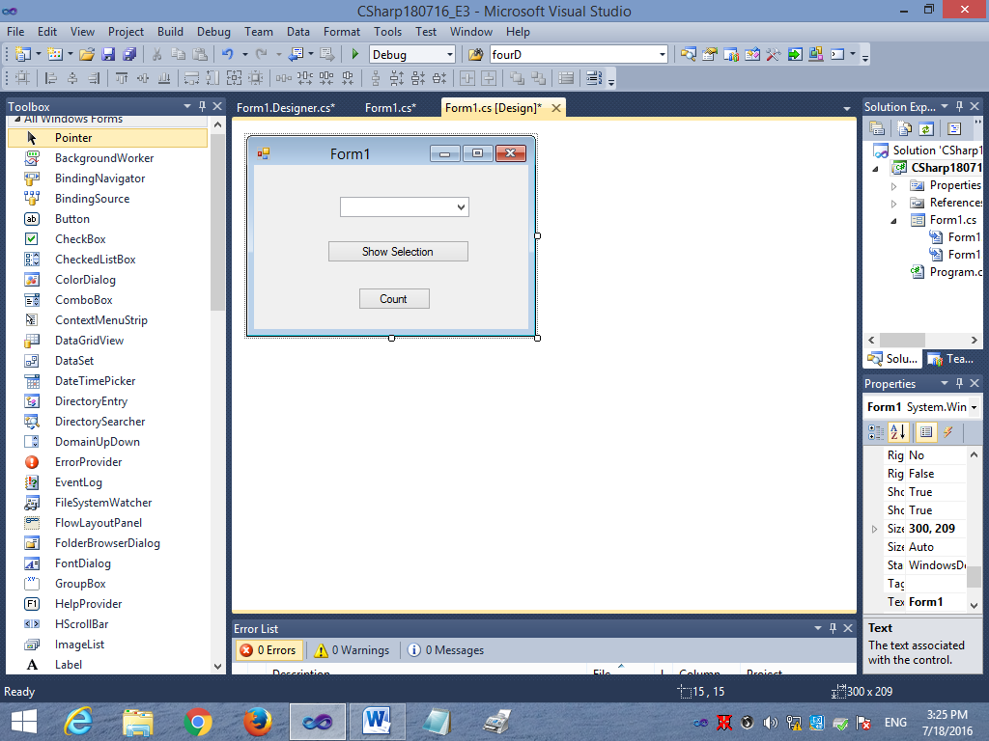

using System;

using System.Collections.Generic;

using System.ComponentModel;

using System.Data;

using System.Drawing;

using System.Linq;

using System.Text;

using System.Windows.Forms;

namespace CSharp180716_E3

{

public partial class Form1 : Form

{

public Form1()

{

InitializeComponent();

}

private void Form1_Load(object sender, EventArgs e)

{

comboBox1.Items.Add("C#");

comboBox1.Items.Add("Java");

comboBox1.Items.Add("SQL Server");

comboBox1.Items.Add("Adobe Photshop");

}

private void button1_Click(object sender, EventArgs e)

{

if (comboBox1.Text.Length == 0)

{

MessageBox.Show("Please select the item");

}

else

{

MessageBox.Show(comboBox1.SelectedItem.ToString());

}

}

private void button2_Click(object sender, EventArgs e)

{

MessageBox.Show(comboBox1.Items.Count.ToString());

}

}

}

///////////Program4/////////////

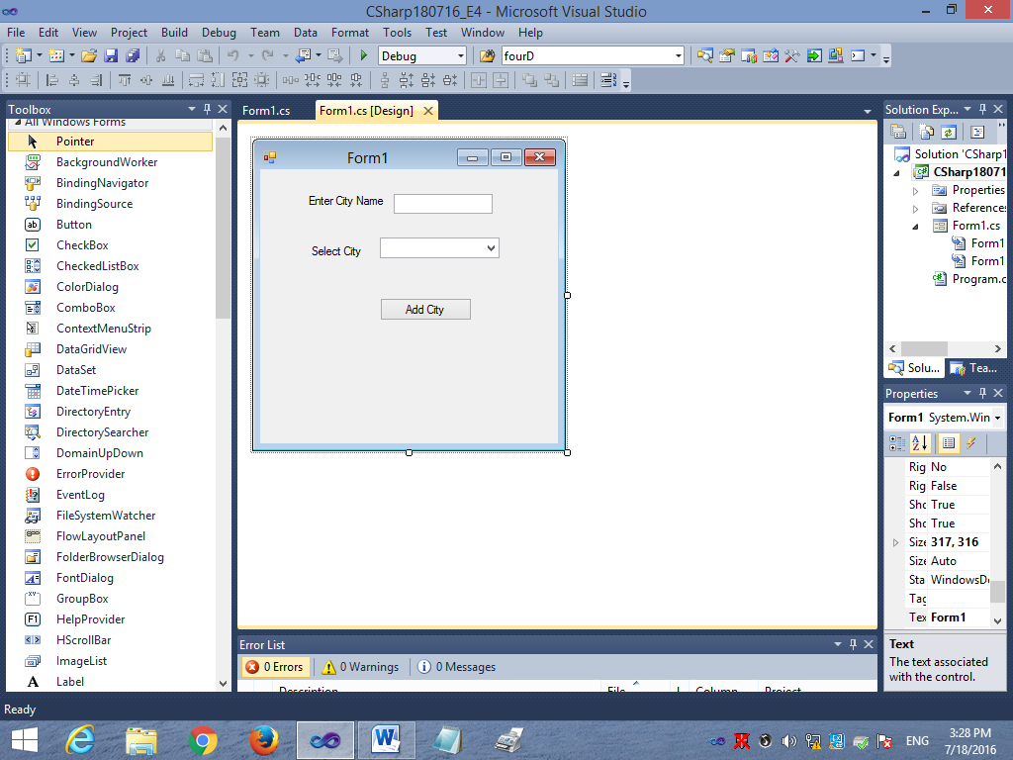

using System;

using System.Collections.Generic;

using System.ComponentModel;

using System.Data;

using System.Drawing;

using System.Linq;

using System.Text;

using System.Windows.Forms;

namespace CSharp180716_E4

{

public partial class Form1 : Form

{

public Form1()

{

InitializeComponent();

}

private void btnAddCity_Click(object sender, EventArgs e)

{

cmbCity.Items.Add(txtCity.Text);

cmbCity.Sorted = true;

}

private void Form1_Load(object sender, EventArgs e)

{

cmbCity.Items.Add("Anupshaahar");

cmbCity.Items.Add("Muraina");

cmbCity.Items.Add("Pauri");

cmbCity.Items.Add("Mussoorie");

}

}

}

///////////Program5/////////////

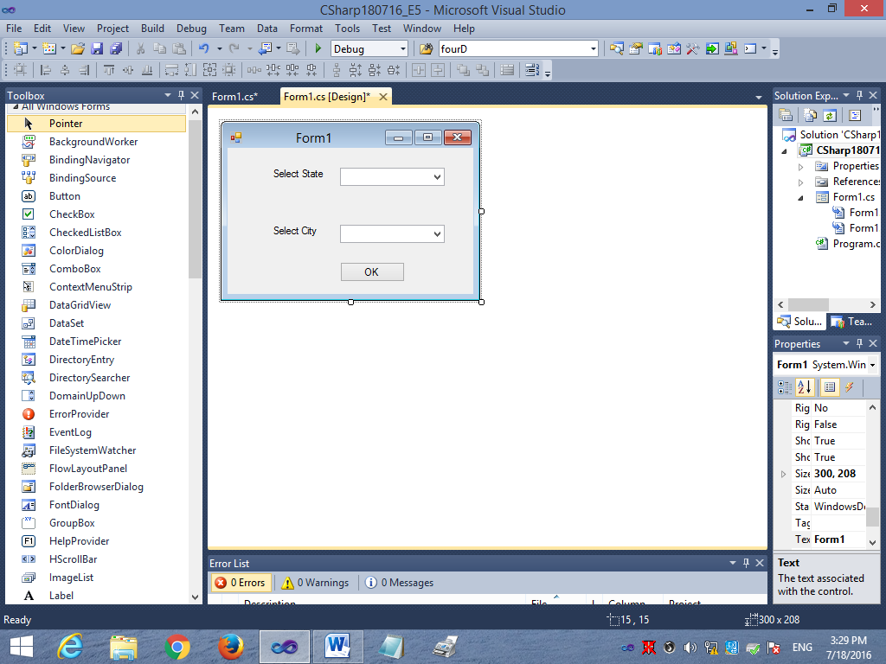

using System;

using System.Collections.Generic;

using System.ComponentModel;

using System.Data;

using System.Drawing;

using System.Linq;

using System.Text;

using System.Windows.Forms;

namespace CSharp180716_E5

{

public partial class Form1 : Form

{

public Form1()

{

InitializeComponent();

}

private void Form1_Load(object sender, EventArgs e)

{

cmbState.Items.Add("Uttar Pradesh");

cmbState.Items.Add("Uttarakhand");

cmbState.Items.Add("Maharashtra");

cmbState.Items.Add("Rajasthan");

cmbState.Sorted = true;

}

private void cmbState_SelectedIndexChanged(object sender, EventArgs e)

{

if (cmbState.Text.Length == 0)

{

MessageBox.Show("Plese Select The state");

}

else if (cmbState.Text =="Uttar Pradesh")

{

cmbCity.Items.Clear();

cmbCity.Items.Add("Meerut");

cmbCity.Items.Add("Kanpur");

cmbCity.Items.Add("Noida");

cmbCity.Items.Add("Hapur");

cmbCity.Sorted = true;

}

else if (cmbState.Text == "Uttarakhand")

{

cmbCity.Items.Clear();

cmbCity.Items.Add("Dehradun");

cmbCity.Items.Add("Haridwar");

cmbCity.Items.Add("Nainital");

cmbCity.Items.Add("Pauri");

cmbCity.Sorted = true;

}

else if (cmbState.Text == "Maharashtra")

{

cmbCity.Items.Clear();

cmbCity.Items.Add("Mumbai");

cmbCity.Items.Add("Pune");

cmbCity.Items.Add("Aurangabad");

cmbCity.Items.Add("Nagpur");

cmbCity.Sorted = true;

}

else if (cmbState.Text == "Rajasthan")

{

cmbCity.Items.Clear();

cmbCity.Items.Add("Jaipur");

cmbCity.Items.Add("Ajmer");

cmbCity.Items.Add("Pushkar");

cmbCity.Items.Add("Mountabu");

cmbCity.Sorted = true;

}

else

{

MessageBox.Show("Invalid state");

}

}

private void btnOK_Click(object sender, EventArgs e)

{

if (cmbState.Text.Length == 0)

{

MessageBox.Show("Please select the State");

}

else if (cmbCity.Text.Length == 0)

{

MessageBox.Show("Please select the City");

}

else

{

MessageBox.Show("State : " + cmbState.SelectedItem.ToString() +

"\nCity : " + cmbCity.SelectedItem.ToString());

}

}

}

}