// 09/06/2016

// UsingVaribles

using System;

using System.Collections.Generic;

using System.Linq;

using System.Text;

namespace UsingVaribles

{

class Program

{

static void Main(string[] args)

{

char grade = 'B';

String name = "Bill Gates";

int age = 26;

float fee = 5000.45F;

double total_fee = 85768.765;

bool selection = true;

Console.WriteLine("Displaying Variables values");

Console.WriteLine("----------------");

Console.WriteLine("Grade is {0}", grade);

Console.WriteLine("Name is {0}",name);

Console.WriteLine("Age is {0}",age);

Console.WriteLine("Fee is {0}",fee);

Console.WriteLine("Total Fee is {0}",total_fee);

Console.WriteLine("Selection is {0}",selection);

Console.WriteLine("----------------");

Console.WriteLine("Another Methaod");

Console.WriteLine("----------------");

Console.WriteLine("Age is");

Console.WriteLine(age);

Console.ReadLine();

}

}

}

//VariableInputOutput

using System;

using System.Collections.Generic;

using System.Linq;

using System.Text;

namespace VariableInputOutput

{

class Program

{

static void Main(string[] args)

{

char grade;

String name;

int age;

float fee;

double total_fee;

bool selection ;

Console.WriteLine("Enter Variables values");

Console.WriteLine("----------------");

Console.Write("Enter Grade : ");

grade=Convert.ToChar(Console.ReadLine());

Console.Write("Enter Name : ");

name = Console.ReadLine();

Console.Write("Enter Age : ");

age = Convert.ToInt32(Console.ReadLine());

Console.Write("Enter Fee : ");

fee = (float)Convert.ToDecimal(Console.ReadLine());

Console.Write("Enter Total Fee : ");

total_fee = Convert.ToDouble(Console.ReadLine());

Console.Write("Enter Selection : ");

selection = Convert.ToBoolean(Console.ReadLine());

Console.WriteLine("Displaying Variables values");

Console.WriteLine("----------------");

Console.WriteLine("Grade is {0}", grade);

Console.WriteLine("Name is {0}", name);

Console.WriteLine("Age is {0}", age);

Console.WriteLine("Fee is {0}", fee);

Console.WriteLine("Total Fee is {0}", total_fee);

Console.WriteLine("Selection is {0}", selection);

Console.WriteLine("----------------");

Console.WriteLine("Another Methaod");

Console.WriteLine("----------------");

Console.WriteLine("Age is");

Console.WriteLine(age);

Console.WriteLine("Name is {0} and Age is {1}",name,age);

Console.ReadLine();

}

}

}

//Automobile

using System;

class Car

{

//Member variables

string Engine;

int NoOfWheels;

//Member functions

public void AcceptDetails()

{

Console.WriteLine("Enter the Engine Model");

Engine = Console.ReadLine();

Console.WriteLine("Enter the number of Wheels");

NoOfWheels = Convert.ToInt32(Console.ReadLine());

}

public void DisplayDetails()

{

Console.WriteLine("The Engine Model is:{0}", Engine);

Console.WriteLine("The number of wheels are:{0}", NoOfWheels);

}

}

//Class used to instantiate the Car class

class ExecuteClass

{

public static void Main(string[] args)

{

Car MyCar1 = new Car();

Car MyCar2 = new Car();

Console.WriteLine("First Car Details");

Console.WriteLine("-----------------");

MyCar1.AcceptDetails();

MyCar1.DisplayDetails();

Console.WriteLine("-----------------");

Console.WriteLine("Second Car Details");

Console.WriteLine("-----------------");

MyCar2.AcceptDetails();

MyCar2.DisplayDetails();

Console.WriteLine("-----------------");

Console.ReadLine();

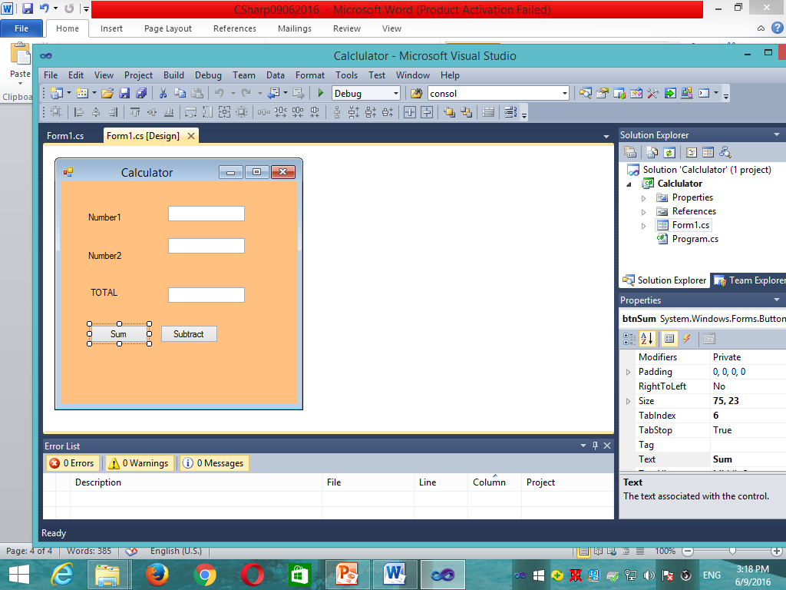 }

}

//

namespace Calclulator

{

public partial class Form1 : Form

{

public Form1()

{

InitializeComponent();

MessageBox.Show("Smart Calculator");

}

private void btnSum_Click(object sender, EventArgs e)

{

int num1, num2, num3;

num1 = Convert.ToInt32(txtNumber1.Text);

num2 = Convert.ToInt32(txtNumber2.Text);

num3 = num1 + num2;

txtTotal.Text = Convert.ToString(num3);

}

private void btnSubtraction_Click(object sender, EventArgs e)

{

int num1, num2, num3;

num1 = Convert.ToInt32(txtNumber1.Text);

num2 = Convert.ToInt32(txtNumber2.Text);

num3 = num1 - num2;

txtTotal.Text = Convert.ToString(num3);

}

}

}