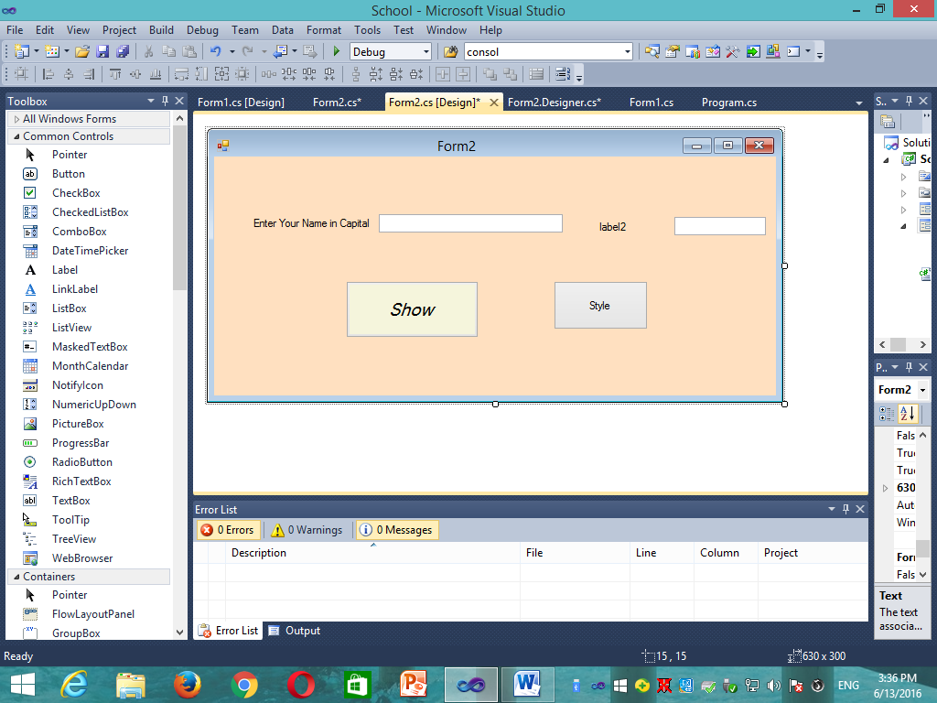

using System;

using System.Collections.Generic;

using System.ComponentModel;

using System.Data;

using System.Drawing;

using System.Linq;

using System.Text;

using System.Windows.Forms;

namespace School

{

public partial class Form2 : Form

{

public Form2()

{

InitializeComponent();

}

private void btnShow_Click(object sender, EventArgs e)

{

MessageBox.Show("Welcome " + txtName.Text);

}

private void btnStyle_Click(object sender, EventArgs e)

{

btnShow.BackColor = System.Drawing.Color.Blue;

label1.BackColor=System.Drawing.Color.DarkGreen;

txtName.BackColor=System.Drawing.Color.LightCoral;

btnStyle.BackColor=System.Drawing.Color.Plum;

label1.Location = new System.Drawing.Point(140, 366);

this.label1.Size = new System.Drawing.Size(234, 113);

}

private void label2_Click(object sender, EventArgs e)

{

MessageBox.Show("Label2 Hi");

}

private void textBox1_TextChanged(object sender, EventArgs e)

{

MessageBox.Show("TextBox Hi");

}

}

}