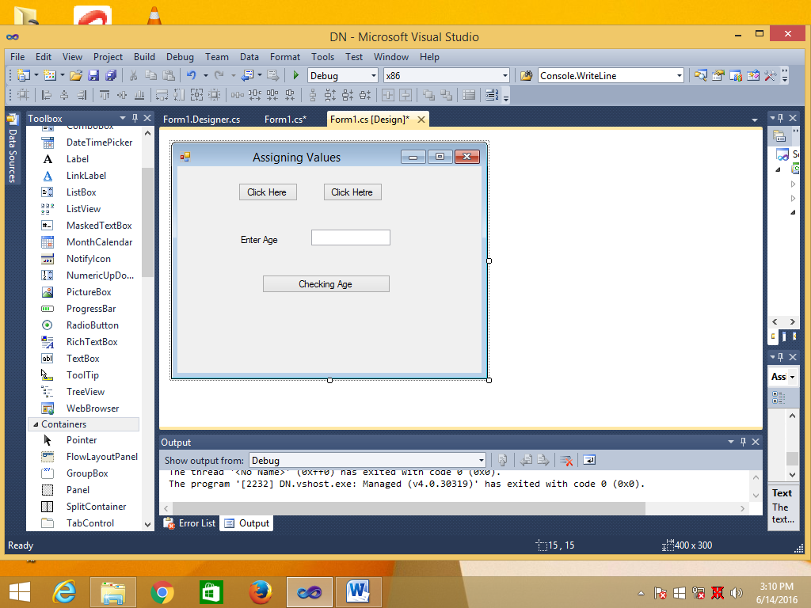

using System;

using System.Collections.Generic;

using System.ComponentModel;

using System.Data;

using System.Drawing;

using System.Linq;

using System.Text;

using System.Windows.Forms;

namespace DN

{

public partial class AssigningValues : Form

{

public AssigningValues()

{

InitializeComponent();

}

private void AssigningValues_Load(object sender, EventArgs e)

{

}

private void button1_Click(object sender, EventArgs e)

{

//This is a assignmint

String str = "Visual C#";

int i = 2005;

Boolean bol = true;

MessageBox.Show(str + " " + i + " " + bol);

}

private void button2_Click(object sender, EventArgs e)

{

/*Use Mltple variables

in C#

Example*/

String x;

x = "Ram";

String y;

y = "Sharma";

int z;

z = 76;

string str;

str = " The age of := " + x + " " + y + " " + "is " + z;

MessageBox.Show(str);

}

private void btnCheckingAge_Click(object sender, EventArgs e)

{

int result;

Boolean status;

result = Convert.ToInt32(txtAge.Text);

status = result < 30;

MessageBox.Show(status.ToString());

}

}

}

------------------Progaram2------------------------

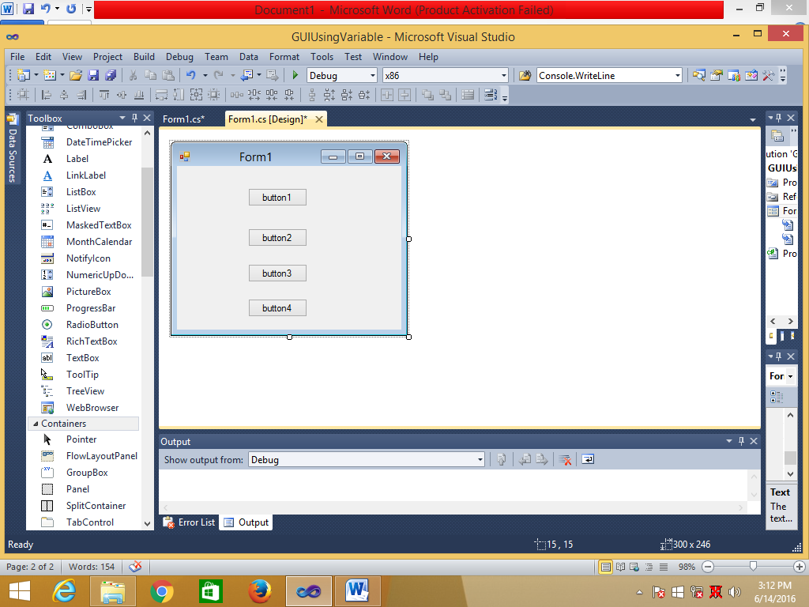

using System;

using System.Collections.Generic;

using System.ComponentModel;

using System.Data;

using System.Drawing;

using System.Linq;

using System.Text;

using System.Windows.Forms;

namespace GUIUsingVariable

{

public partial class Form1 : Form

{

public Form1()

{

InitializeComponent();

}

private void button1_Click(object sender, EventArgs e)

{

char grade = 'B';

String name = "Bill Gates";

int age = 26;

float fee = 5000.45F;

double total_fee = 85768.765;

bool selection = true;

MessageBox.Show("Displaying Variables values");

MessageBox.Show("----------------");

MessageBox.Show("Grade is "+ grade);

MessageBox.Show("Name is " + name);

MessageBox.Show("Age is " + age);

MessageBox.Show("Fee is " + fee);

MessageBox.Show("Total Fee is " + total_fee);

MessageBox.Show("Selection is " + selection);

MessageBox.Show("----------------");

MessageBox.Show("Another Methaod");

MessageBox.Show("----------------");

MessageBox.Show("Age is");

MessageBox.Show(age.ToString());

}

private void button2_Click(object sender, EventArgs e)

{

String name = "Bill Gates";

int age = 26;

MessageBox.Show("Name is " + name + "\nAge is " + age);

}

private void button3_Click(object sender, EventArgs e)

{

String address = "22/45 Patpad Ganj New Delhi";

MessageBox.Show(address);

}

private void button4_Click(object sender, EventArgs e)

{

bool xx;

xx = true;

MessageBox.Show(xx.ToString());

}

}

}

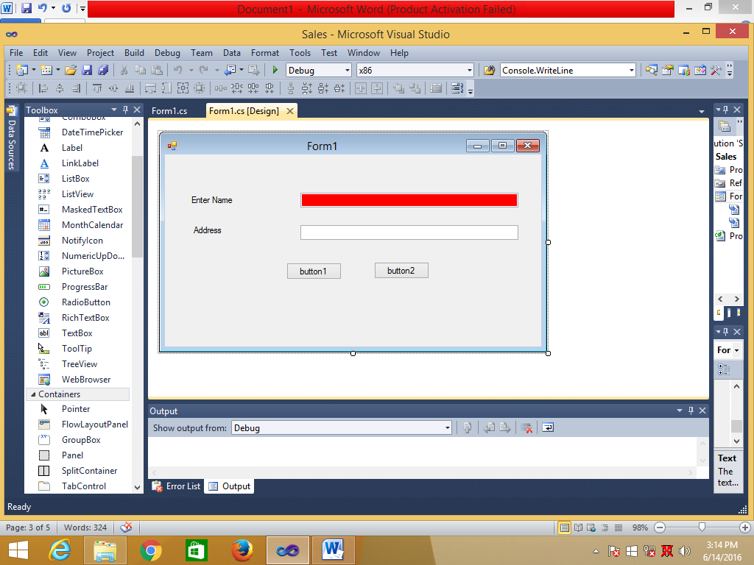

using System;

using System.Collections.Generic;

using System.ComponentModel;

using System.Data;

using System.Drawing;

using System.Linq;

using System.Text;

using System.Windows.Forms;

namespace Sales

{

public partial class Form1 : Form

{

Boolean flag=true;

public Form1()

{

InitializeComponent();

}

private void button1_Click(object sender, EventArgs e)

{

MessageBox.Show("Mr./Miss " + textBox1.Text);

}

private void textBox1_TextChanged(object sender, EventArgs e)

{

String str1;

str1 = textBox1.Text;

if (str1.Length == 0)

{

textBox1.BackColor = System.Drawing.Color.Red;

}

else

{

textBox1.BackColor = System.Drawing.Color.Azure;

}

}

private void textBox2_TextChanged(object sender, EventArgs e)

{

if (flag == true)

{

textBox2.BackColor = System.Drawing.Color.Azure;

button1.BackColor = System.Drawing.Color.Red;

flag = false;

}

else

{

textBox2.BackColor = System.Drawing.Color.Pink;

button1.BackColor = System.Drawing.Color.Green;

flag = true;

}

}

}

}