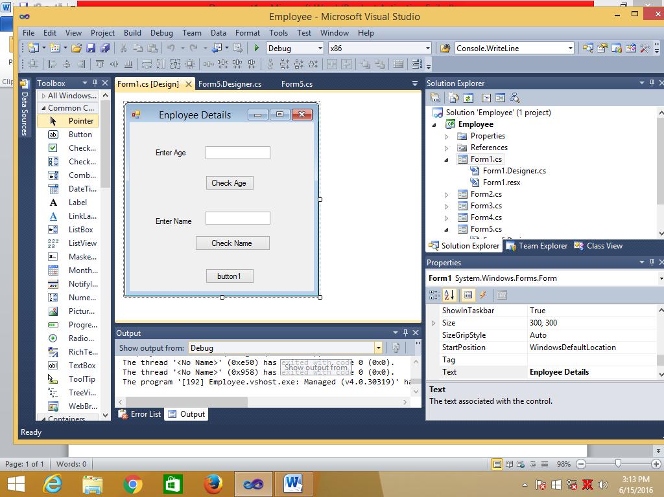

using System;

using System.Collections.Generic;

using System.ComponentModel;

using System.Data;

using System.Drawing;

using System.Linq;

using System.Text;

using System.Windows.Forms;

namespace Employee

{

public partial class Form1 : Form

{

public Form1()

{

InitializeComponent();

}

private void btnCheck_Click(object sender, EventArgs e)

{

int intAge;

intAge = Convert.ToInt32(txtAge.Text);

if(intAge<=30)

{

MessageBox.Show("Juniour");

}

else

{

MessageBox.Show("Seniour");

}

}

private void btnCheckName_Click(object sender, EventArgs e)

{

String strName;

strName = txtName.Text;

if (strName == "Raj")

{

MessageBox.Show("Welcome Raj");

}

else

{

MessageBox.Show("Invalid Name");

}

}

private void button1_Click(object sender, EventArgs e)

{

int x;

x = 2;

if (x > 3)

{

MessageBox.Show(" X > 3 ");

}

else

{

MessageBox.Show(" X < 3 ");

}

}

}

}

------------------------------Program2---------------

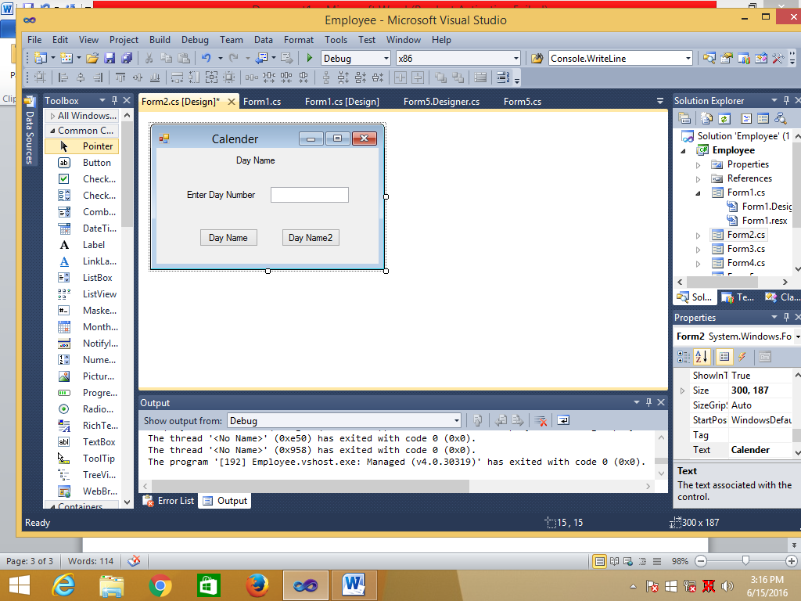

using System;

using System.Collections.Generic;

using System.ComponentModel;

using System.Data;

using System.Drawing;

using System.Linq;

using System.Text;

using System.Windows.Forms;

namespace Employee

{

public partial class Form2 : Form

{

public Form2()

{

InitializeComponent();

}

private void btnDayName_Click(object sender, EventArgs e)

{

int intDayNo;

intDayNo = Convert.ToInt32(txtDayNo.Text);

if (intDayNo == 1)

{

lblDayName.Text = "Sunday";

MessageBox.Show("Sunday");

}

else if (intDayNo == 2)

{

lblDayName.Text = "Monday";

MessageBox.Show("Monday");

}

else if (intDayNo == 3)

{

lblDayName.Text = "Tuesday";

MessageBox.Show("Tuesday");

}

else if (intDayNo == 4)

{

lblDayName.Text = "Wednesday";

MessageBox.Show("Wednesday");

}

else if (intDayNo == 5)

{

lblDayName.Text = "Thrusday";

MessageBox.Show("Thrusday");

}

else if (intDayNo == 6)

{

lblDayName.Text = "Friday";

MessageBox.Show("Friday");

}

else if (intDayNo == 7)

{

lblDayName.Text = "Saturday";

MessageBox.Show("Saturday");

}

else

{

lblDayName.Text = "Invalid day";

MessageBox.Show("Invalid day");

}

}

private void btnDayName2_Click(object sender, EventArgs e)

{

int intDayNo;

if (txtDayNo.Text.Length == 0)

{

lblDayName.Text = "Enter Day Number";

MessageBox.Show("Enter Day Number");

}

else

{

intDayNo = Convert.ToInt32(txtDayNo.Text);

if (intDayNo == 1)

{

lblDayName.Text = "Sunday";

MessageBox.Show("Sunday");

}

else if (intDayNo == 2)

{

lblDayName.Text = "Monday";

MessageBox.Show("Monday");

}

else if (intDayNo == 3)

{

lblDayName.Text = "Tuesday";

MessageBox.Show("Tuesday");

}

else if (intDayNo == 4)

{

lblDayName.Text = "Wednesday";

MessageBox.Show("Wednesday");

}

else if (intDayNo == 5)

{

lblDayName.Text = "Thrusday";

MessageBox.Show("Thrusday");

}

else if (intDayNo == 6)

{

lblDayName.Text = "Friday";

MessageBox.Show("Friday");

}

else if (intDayNo == 7)

{

lblDayName.Text = "Saturday";

MessageBox.Show("Saturday");

}

else

{

lblDayName.Text = "Invalid day";

MessageBox.Show("Invalid day");

}

}

}

}

}

------------Program3-----------------

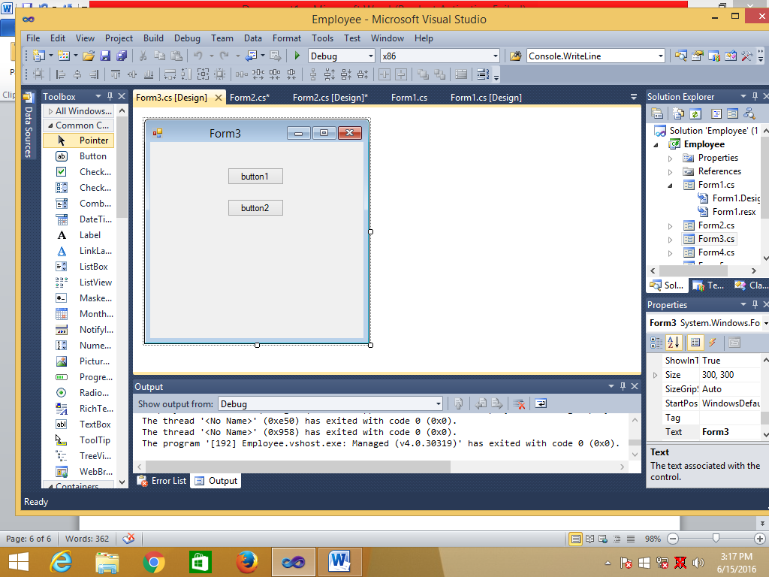

using System;

using System.Collections.Generic;

using System.ComponentModel;

using System.Data;

using System.Drawing;

using System.Linq;

using System.Text;

using System.Windows.Forms;

namespace Employee

{

public partial class Form3 : Form

{

public Form3()

{

InitializeComponent();

}

private void button1_Click(object sender, EventArgs e)

{

int x;

x = 5;

if (x > 3)

{

MessageBox.Show(" X > 3 ");

}

else if (x == 3)

{

MessageBox.Show(" X == 3 ");

}

else

{

MessageBox.Show(" X < 5 ");

}

}

private void button2_Click(object sender, EventArgs e)

{

for (int i = 1; i <= 5; )

{

MessageBox.Show("Hello");

}

}

}

}

-------------------Program4------------------

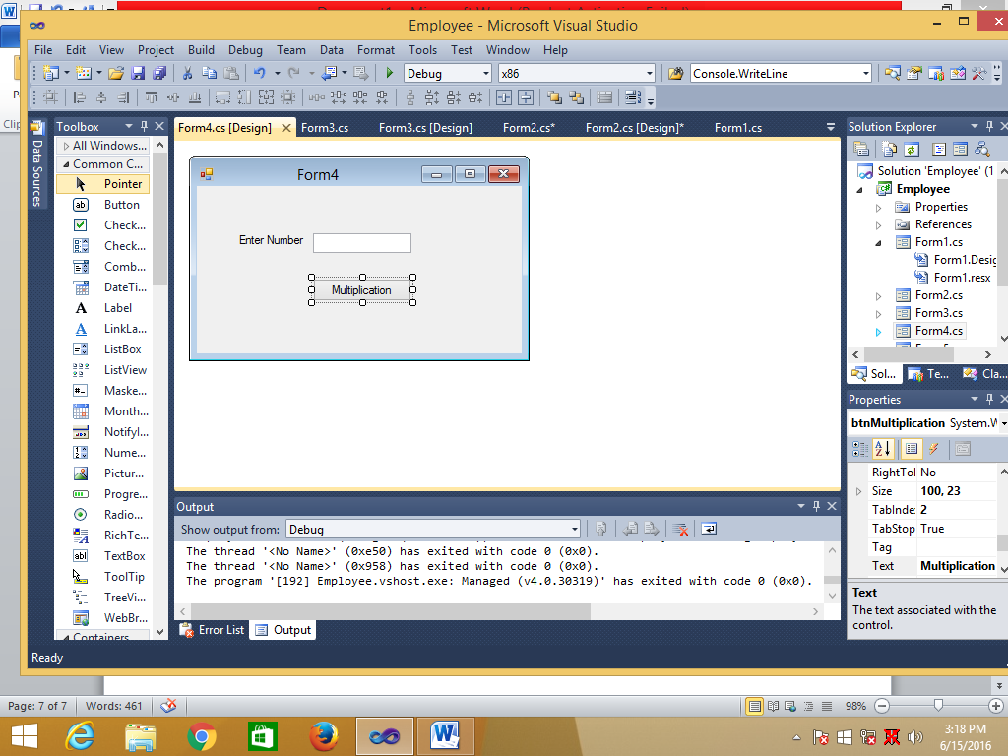

using System;

using System.Collections.Generic;

using System.ComponentModel;

using System.Data;

using System.Drawing;

using System.Linq;

using System.Text;

using System.Windows.Forms;

namespace Employee

{

public partial class Form4 : Form

{

public Form4()

{

InitializeComponent();

}

private void btnMultiplication_Click(object sender, EventArgs e)

{

try

{

int intNum;

intNum = Convert.ToInt32(txtNumber.Text);

intNum = intNum * 2;

MessageBox.Show("The Product is " + intNum);

}

catch (Exception exp)

{

MessageBox.Show(exp.Message);

}

}

}

}

-------------------Program5------------------

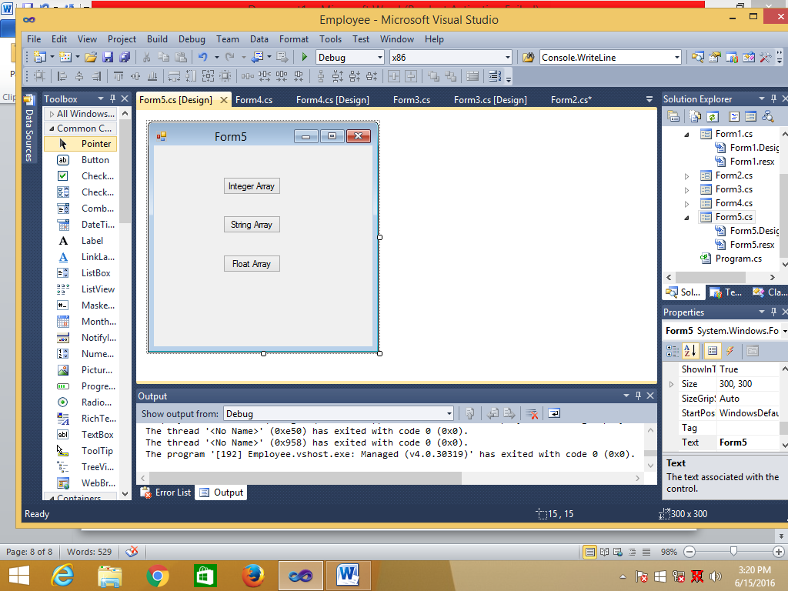

using System;

using System.Collections.Generic;

using System.ComponentModel;

using System.Data;

using System.Drawing;

using System.Linq;

using System.Text;

using System.Windows.Forms;

namespace Employee

{

public partial class Form5 : Form

{

public Form5()

{

InitializeComponent();

}

private void btnIntegerArray_Click(object sender, EventArgs e)

{

int []arrAccountNo = new int[4];

arrAccountNo[0] = 101;

arrAccountNo[1] = 102;

arrAccountNo[2] = 103;

arrAccountNo[3] = 104;

MessageBox.Show("Account Number1 : " + arrAccountNo[0]);

MessageBox.Show("Account Number2 : " + arrAccountNo[1]);

MessageBox.Show("Account Number3 : " + arrAccountNo[2]);

MessageBox.Show("Account Number4 : " + arrAccountNo[3]);

}

private void btnStringArray_Click(object sender, EventArgs e)

{

String[] strName = new String[4];

strName[0] = "Bill Gates";

strName[1] = "Mark Jukerberg";

strName[2] = "Shiv Nadar";

strName[3] = "Sameep Bhatia";

MessageBox.Show("Name1 : " + strName[0]);

MessageBox.Show("Name2 : " + strName[1]);

MessageBox.Show("Name3 : " + strName[2]);

MessageBox.Show("Name4 : " + strName[3]);

}

private void btnFloatArray_Click(object sender, EventArgs e)

{

float[] arrBalance = new float[4];

arrBalance[0] = 6754.22F;

arrBalance[1] = 533.7F;

arrBalance[2] = 455.78F;

arrBalance[3] = 7.4F;

MessageBox.Show("Balance1 : " + arrBalance[0]);

MessageBox.Show("Balance2 : " + arrBalance[1]);

MessageBox.Show("Balance3 : " + arrBalance[2]);

MessageBox.Show("Balance4 : " + arrBalance[3]);

}

}

}

-------------------Main Function-----------------

using System;

using System.Collections.Generic;

using System.Linq;

using System.Windows.Forms;

namespace Employee

{

static class Program

{

/// <summary>

/// The main entry point for the application.

/// </summary>

[STAThread]

static void Main()

{

Application.EnableVisualStyles();

Application.SetCompatibleTextRenderingDefault(false);

Application.Run(new Form5());

}

}

}