|  |  |  |
| --- | --- | --- |
|  | **SRI KRISHNA COLLEGE OF TECHNOLOGY**  **An Autonomous Institution | Accredited by NAAC with 'A' Grade Affiliated to Anna University | Approved by AICTE**  **KOVAIPUDUR, COIMBATORE 641042** |  |

# PET AND PET ESSENTIALS HUB

**A PROJECT REPORT**

***Submitted by***

# SACHIN VIPU M D 727822TUIT201

*in partial fulfilment for the award of the degree*

Of

# BACHELOR OF TECHNOLOGY

**IN**

# INFORMATION TECHNOLOGY

**JULY 2024**

**CHAPTER – 1**

**PET SALES PLATFORM**

**1.1 ABSTRACT**

The “Furry Finds” Platform is a comprehensive online solution designed to streamline the process of pet adoption and sales, connecting pet seekers with pet owners and breeders in a user-friendly and secure environment. This platform addresses the fragmented nature of existing pet sale solutions by offering a unified interface with enhanced features aimed at ensuring pets find loving homes efficiently and safely.

Key features of the platform include user registration, detailed pet listings, secure payment processing, and robust community support. The platform guarantees authenticity and security through verified profiles and secure transactions, fostering trust and reliability among users. The development of the Pet Sales Platform focuses on creating a robust and scalable web application using modern web technologies to provide a responsive and efficient user experience.

React.js will manage client-side interactions, ensuring a dynamic and intuitive interface. Spring Boot will handle server-side logic, providing a solid backend framework. MySQL will serve as the relational database management system, offering reliable data storage and retrieval. Additionally, SonarQube will be integrated to maintain high code quality and security standards throughout the development process. This document outlines the detailed specifications for the development and deployment of the Pet Sales Platform, emphasizing its role in revolutionizing the pet adoption and sales market by delivering a seamless and trustworthy digital experience.

**1.2 SYSTEM SPECIFICATION**

**1.2.1 HARDWARE SPECIFICATION**

* System : Pentium IV 2.4 GHz.

• Hard Disk : 500GB

• Monitor : 15 VGA Color

• Mouse : Logitech

• Ram : 4 GB

• Keyboard : 101 Keyboard

**1.2.2 SOFTWARE SPECIFICATION**

• Operating System : Windows 8, 10, 11, MAC OS, Linux

• Front End : React JS

• Back End : Spring Boot with MySQL

• Server : Sonar Cloud

**CHAPTER – 2**

**2.1 EXISTING SYSTEM**

The current system lacks integration and modularity, leading to difficulties in maintenance and scalability. Key issues include:

* **Inefficient User Interface:** The existing UI is not responsive and lacks modern design principles.
* **Monolithic Architecture:** The application is built using a monolithic architecture, causing performance bottlenecks.
* **Manual Code Quality Checks:** Code quality and security checks are performed manually, leading to potential oversight.

**2.2 PROPOSED SYSTEM**

The proposed Pet Sales Platform is designed to overcome the limitations of existing pet sale systems by providing a comprehensive, feature-rich, and user-friendly solution. This platform aims to ensure a seamless and secure experience for both pet seekers and pet owners, fostering a trustworthy environment for pet adoption and sales.

**Key Features and User Experience**

The platform offers a user-friendly interface with simplified browsing and listing of pets. Users can effortlessly navigate through the site using intuitive filters and search options to find pets based on specific criteria such as breed, age, and location. To maintain trust and reliability, the platform requires user verification through a thorough authentication process, ensuring that all profiles and pet listings are genuine and reducing the risk of fraud. Additionally, secure transactions are facilitated through an integrated payment gateway, providing users with a safe and efficient way to handle financial interactions.

Each pet listing includes detailed information such as health records, breed details, vaccination status, and high-quality images, helping potential adopters make informed decisions. The platform also provides a space for new pet owners to receive support and advice post-adoption through discussion forums, Q&A sections, and access to experienced pet owners and professionals. By integrating with popular social media channels, the platform allows users to share pet listings, success stories, and updates, increasing visibility and engagement.

**Advanced Functionalities and Services**

One of the standout features of the platform is live pet selling. This feature allows breeders and pet owners to showcase pets in real-time through live video streams, enabling potential adopters to interact directly, ask questions, and make decisions on the spot. To ensure the safest care in delivery, the platform collaborates with trusted pet transportation services to provide secure pet transportation. This includes proper handling, care during transit, and real-time tracking.

The platform also collaborates with local pet dealers and breeders to provide a more localized experience, ensuring a wider variety of pets and supporting the local pet community. By utilizing GPS technology, the platform can show pet listings based on the user's location, helping users find pets available nearby and reducing transportation costs and stress for the pets.

Access to veterinary services is another key feature of the platform, offering initial health checks, vaccinations, and ongoing medical care to ensure all pets are healthy and well-cared for before and after adoption. To help users find the perfect pet, the platform provides personalized recommendations through a guide and quiz based on the user's lifestyle, preferences, and needs, ensuring a good match and long-term satisfaction for both the pet and the owner.

**Community and Social Impact**

The platform promotes responsible pet ownership through pet donation and adoption services. Users have the option to donate pets or adopt pets in need, helping reduce the number of homeless pets and fostering a community of care and support.

**2.3 MODULES**

1. **User Management:**
   * User registration and login.
   * Profile management with verification.
   * Authentication and authorization mechanisms.
2. **Pet Listings:**
   * Add and manage pet listings.
   * Browse and search functionality for finding pets.
   * Detailed pet profiles with multimedia support.
3. **Transaction Management:**
   * Secure payment gateway integration.
   * Transaction history and records.
   * Refund and dispute management system.
4. **Community and Support:**
   * Discussion forums for pet owners.
   * Q&A section for pet care advice.
   * Customer support and frequently asked questions (FAQs).
5. **Products Listings:**
   * Add and manage pet products listings like pet foods and its essentials.
   * Browse and search functionality for finding pet products.
   * Detailed product profiles with multimedia support.

**CHAPTER-3**

**3.1 ENTITY RELATIONSHIP DIAGRAM**

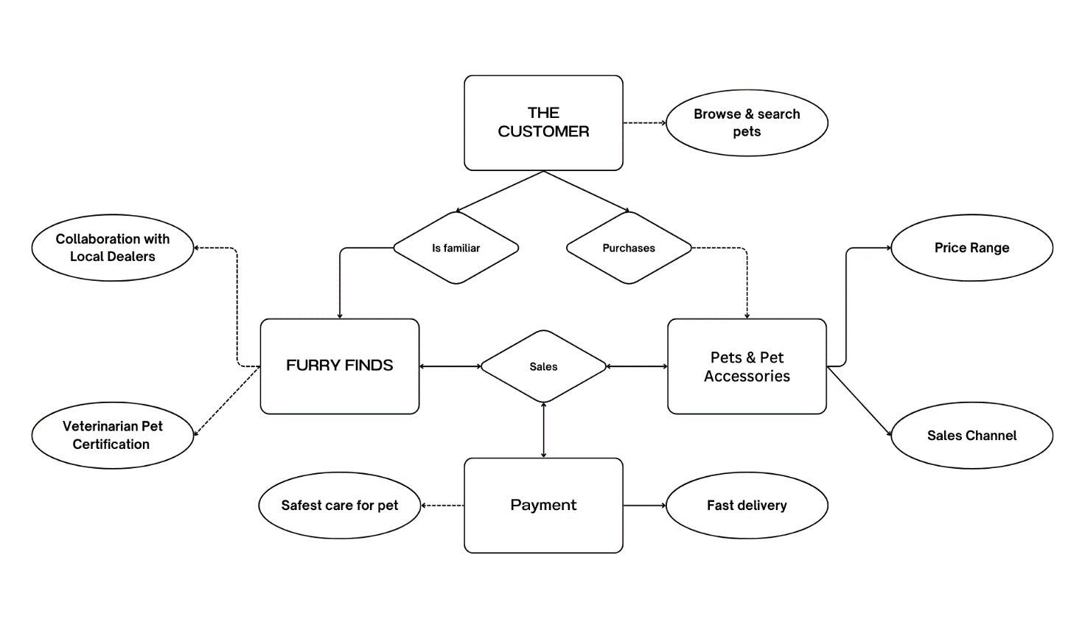

**3.2 Use Case Diagram**

