SHOT 01
START FRAME
CAMERA: Static, on DOLLY
ACTION: BOY plays with soil, he hears a distant call.

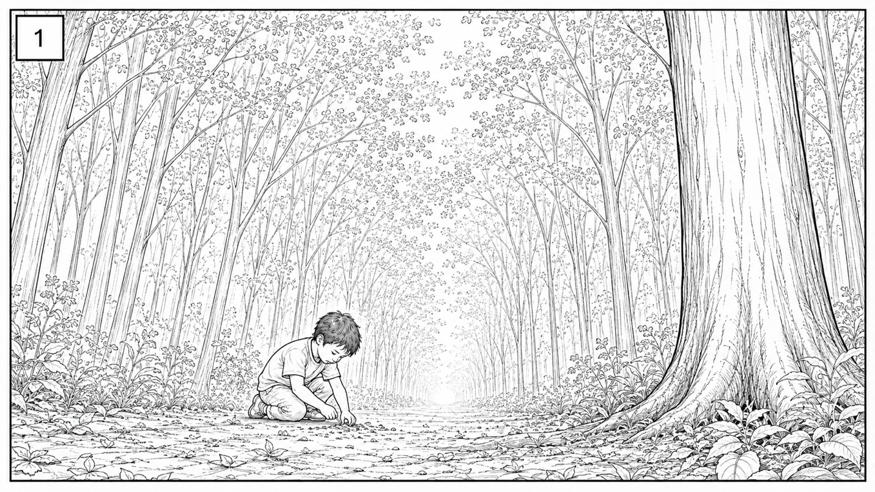

CONTINUES →

SHOT 01
MIDDLE FRAME
CAMERA: Static, on DOLLY
ACTION: BOY looks up.
fdf

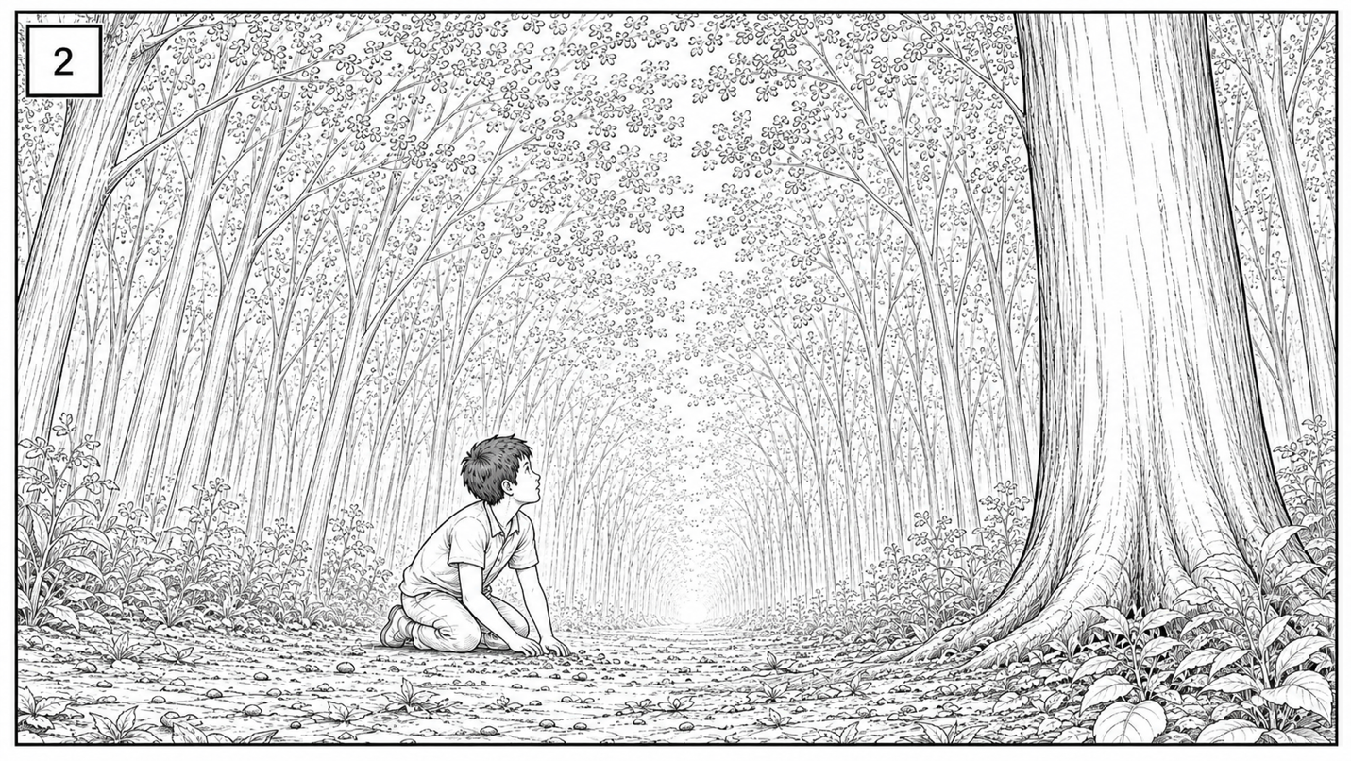

CONTINUES →

SHOT 01
END FRAME
CAMERA: DOLLY/FOLLOW
ACTION: BOY walks deeper into forest, following the sound.

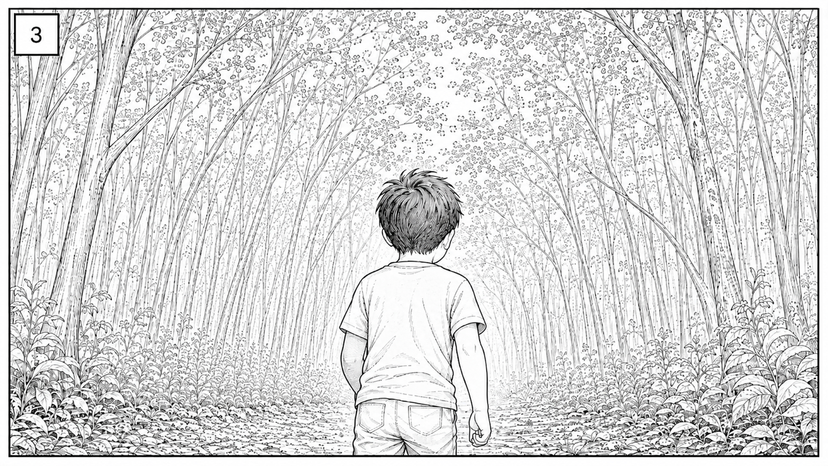
END SHOT

