SHOT 01
START FRAME
CAMERA: STATIC
ACTION: MAN WALKS UP TO FALLEN PAPER, CONTEMPLATES PICKING IT UP.

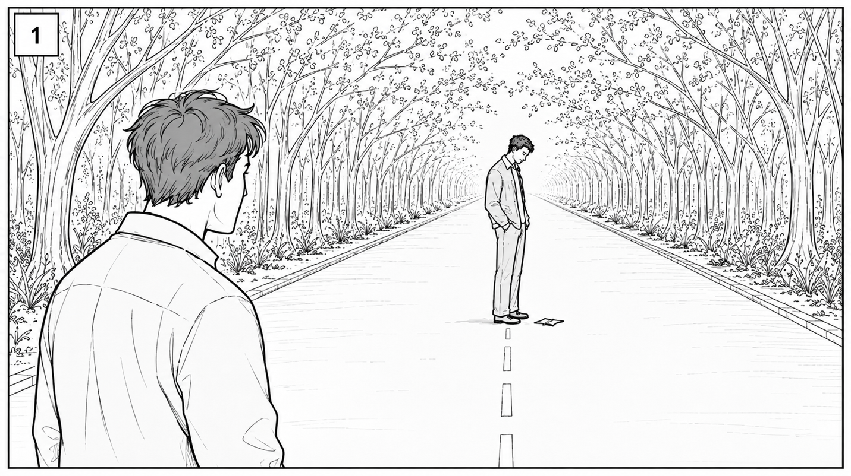

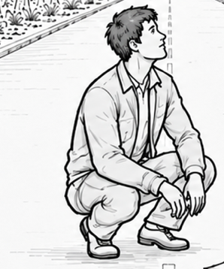

CONTINUES →

SHOT 01
MIDDLE FRAME
CAMERA: STATIC
ACTION: MAN KNEELS DOWN.

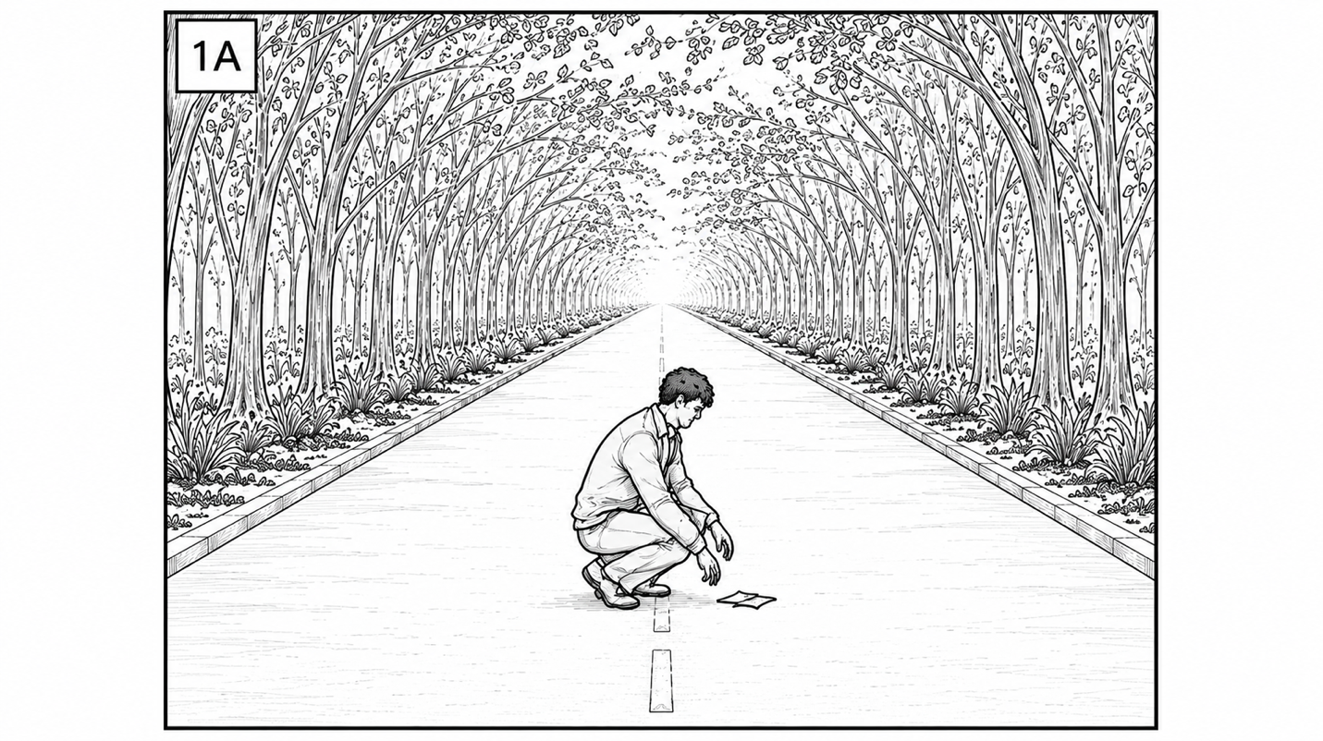

CONTINUES →

SHOT 01
MIDDLE FRAME
CAMERA: STATIC
ACTION: WOMAN WALKS INTO FRAME.

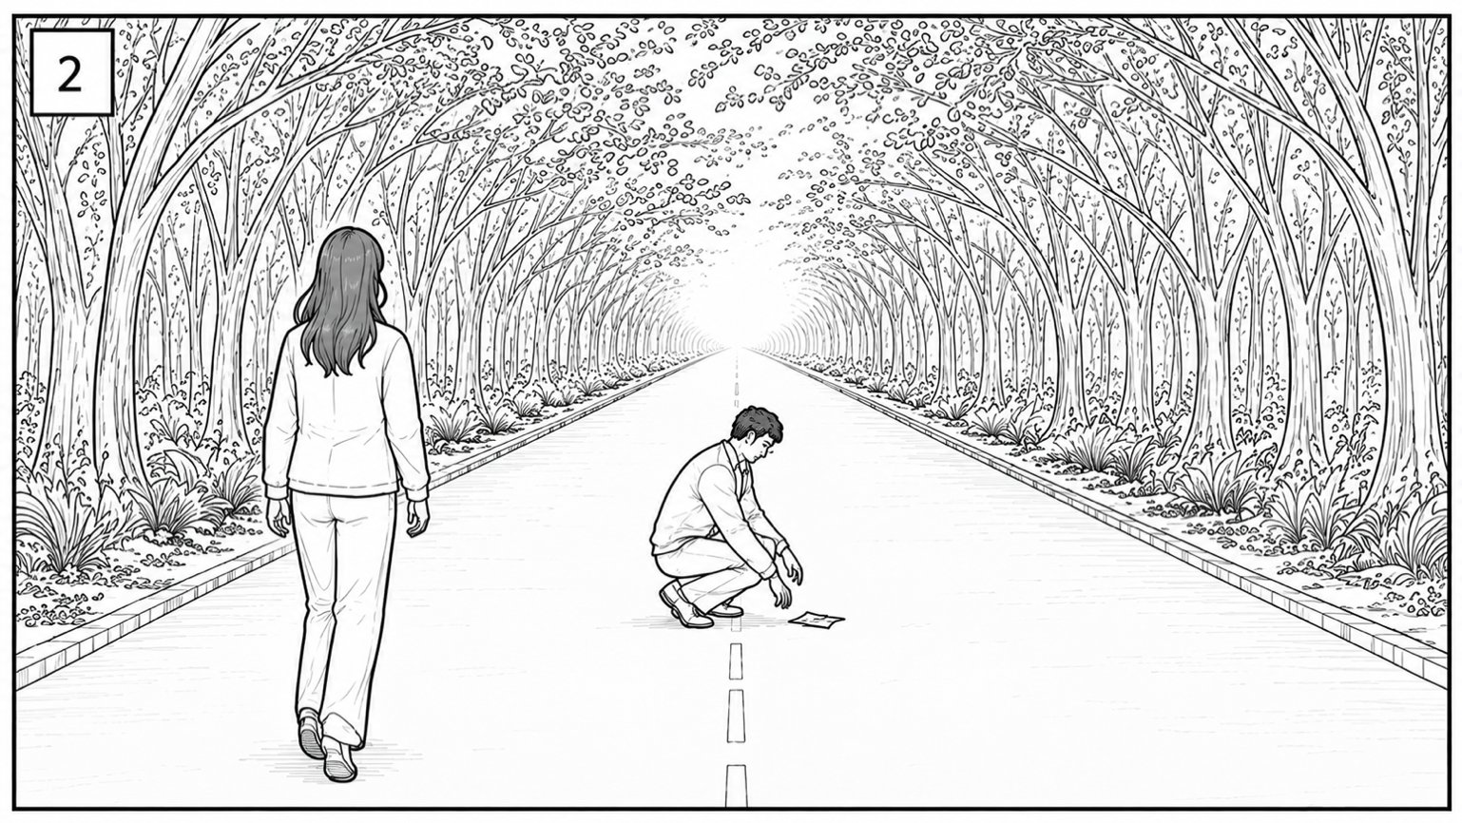

CONTINUES →

SHOT 01
MIDDLE FRAME
CAMERA: STATIC
ACTION: WOMAN STOPS. MAN LOOKS UP AT HER.

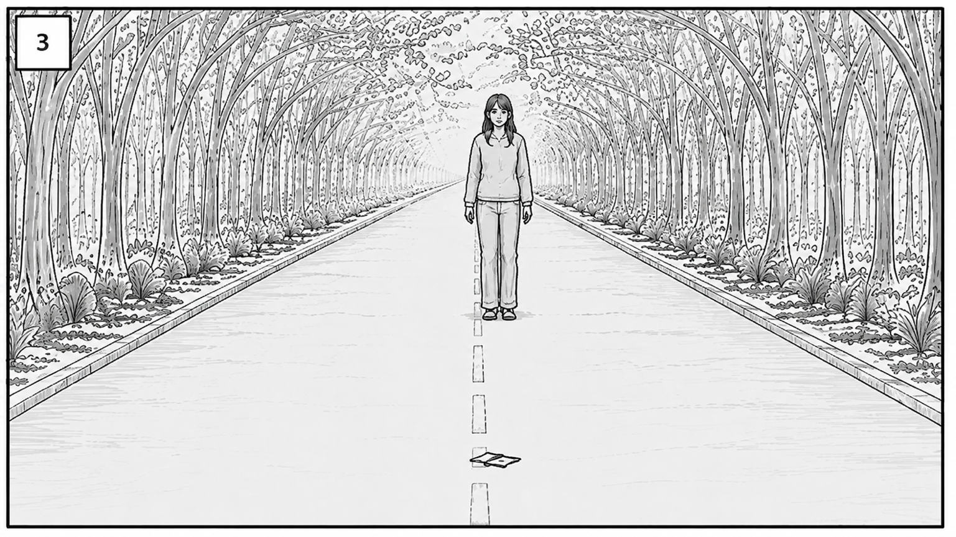

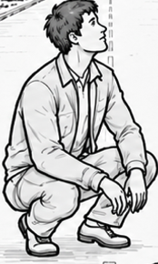

CONTINUES →

SHOT 01
END FRAME
CAMERA: STATIC
ACTION: WOMAN REPOSITIONS. MAN CONTINUES TO LOOK WHERE WOMAN WAS.

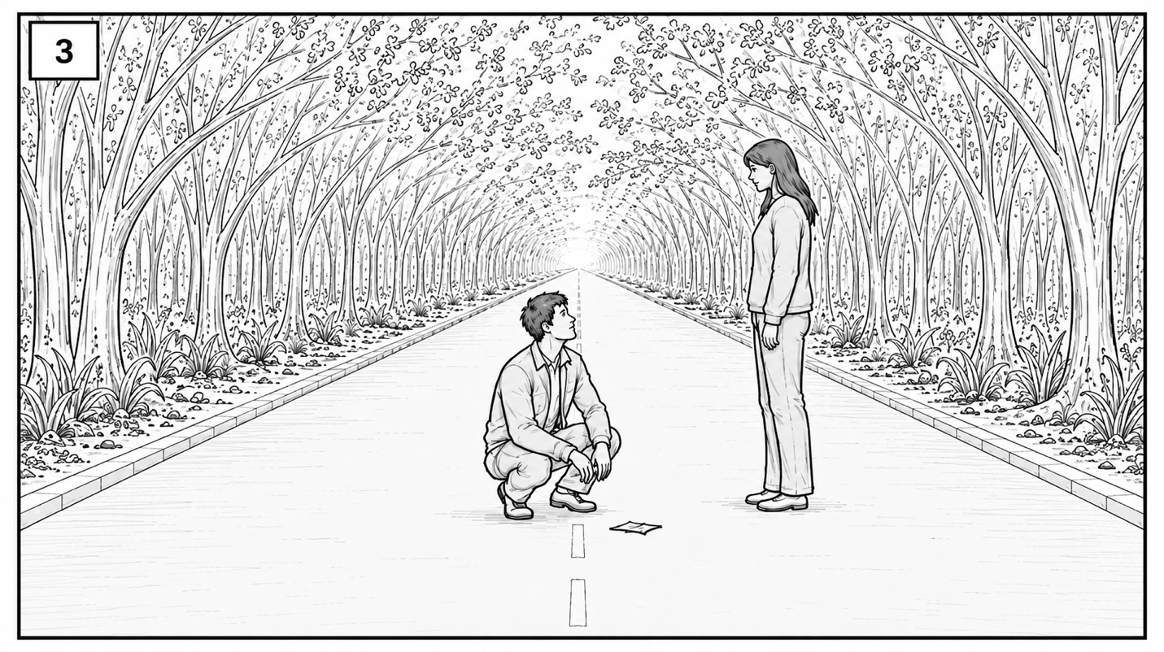

END SHOT

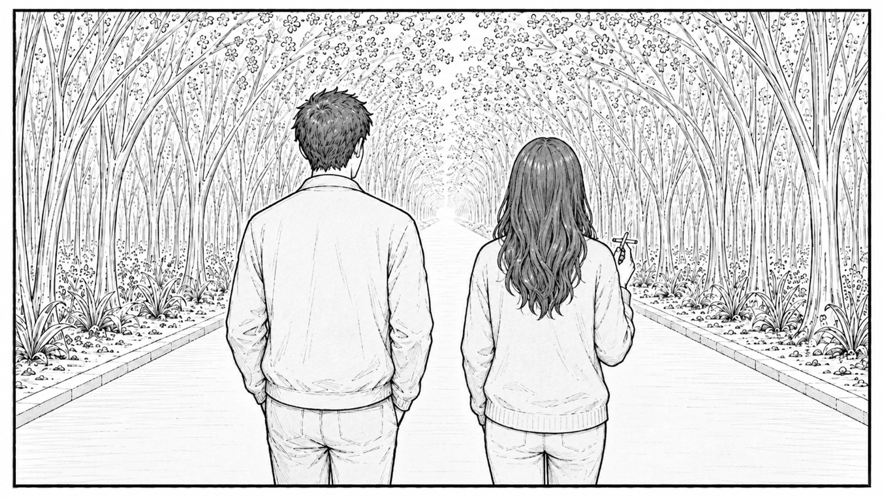
SHOT 02
START FRAME
CAMERA: DOLLY
ACTION: MAN AND WOMAN WALK DOWN THE STREET, CONVERSING.

CONTINUES →

SHOT 02
START FRAME
CAMERA: DOLLY STOPS
ACTION: MAN TURNS, WALKING DOWN THE STREET, CONVERSING.

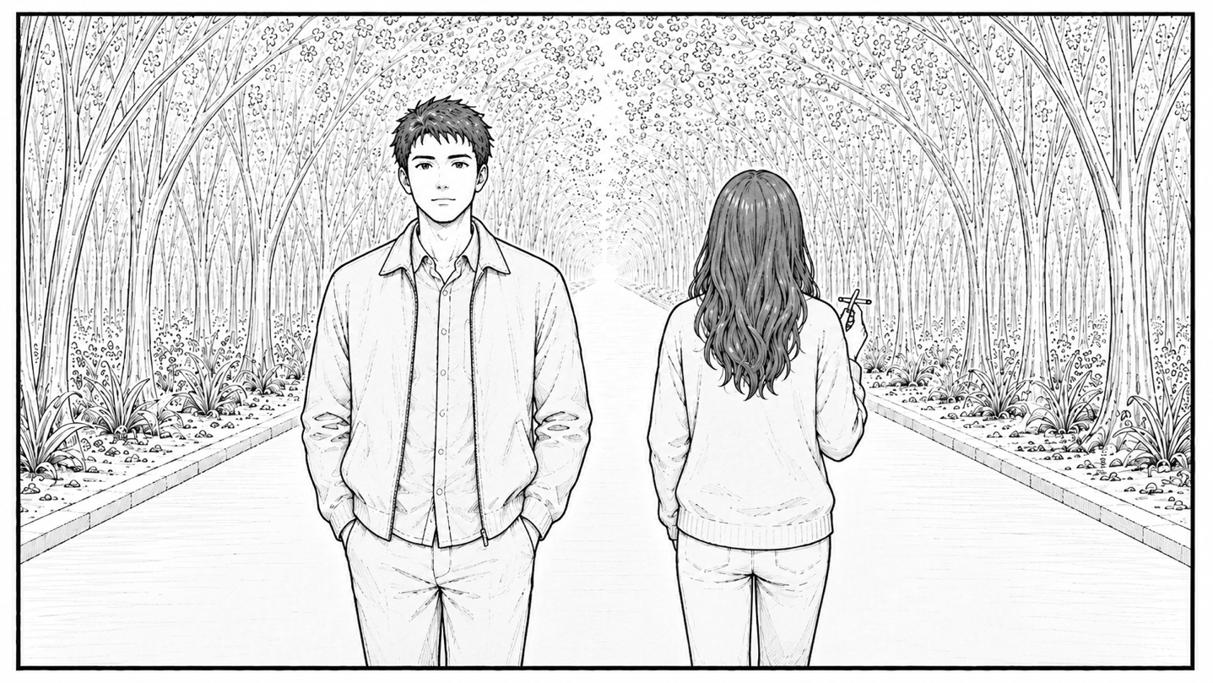
CONTINUES →
SHOT 02
START FRAME
CAMERA: DOLLY STOPS
ACTION: MAN AND WOMAN WALK DOWN THE STREET, CONVERSING.

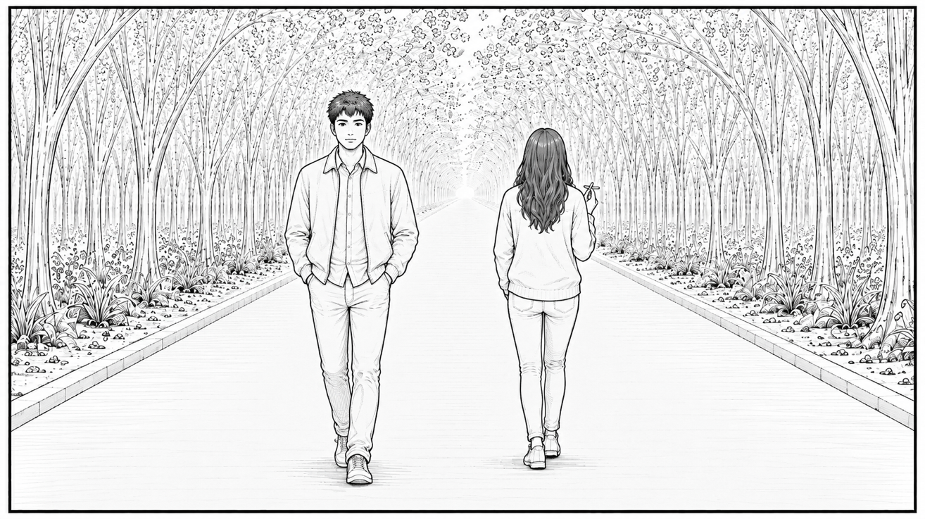

CONTINUES →

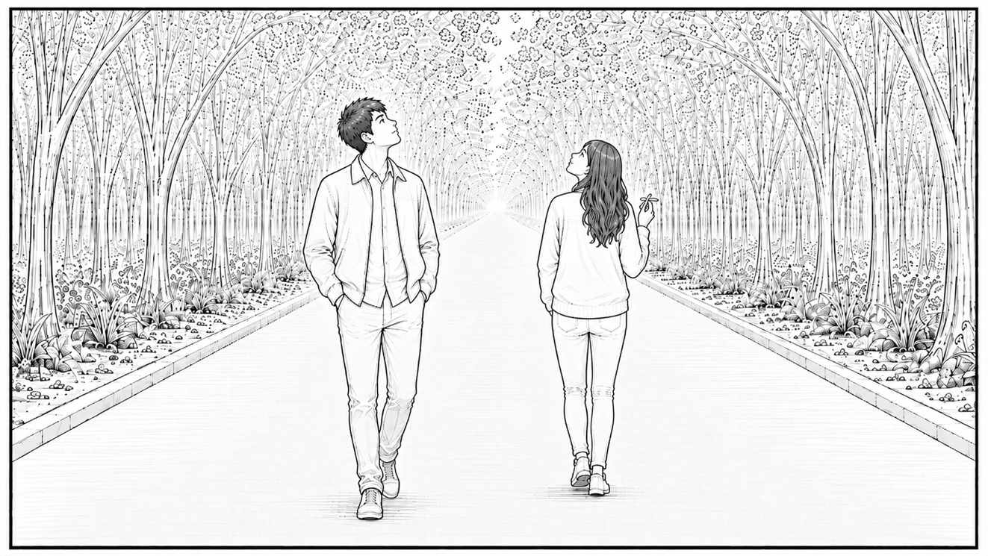
SHOT 02
START FRAME
CAMERA: STATIC
ACTION: MAN SEES SOMETHING, PAUSES. WOMAN FOLLOW SUIT.

CONTINUES →

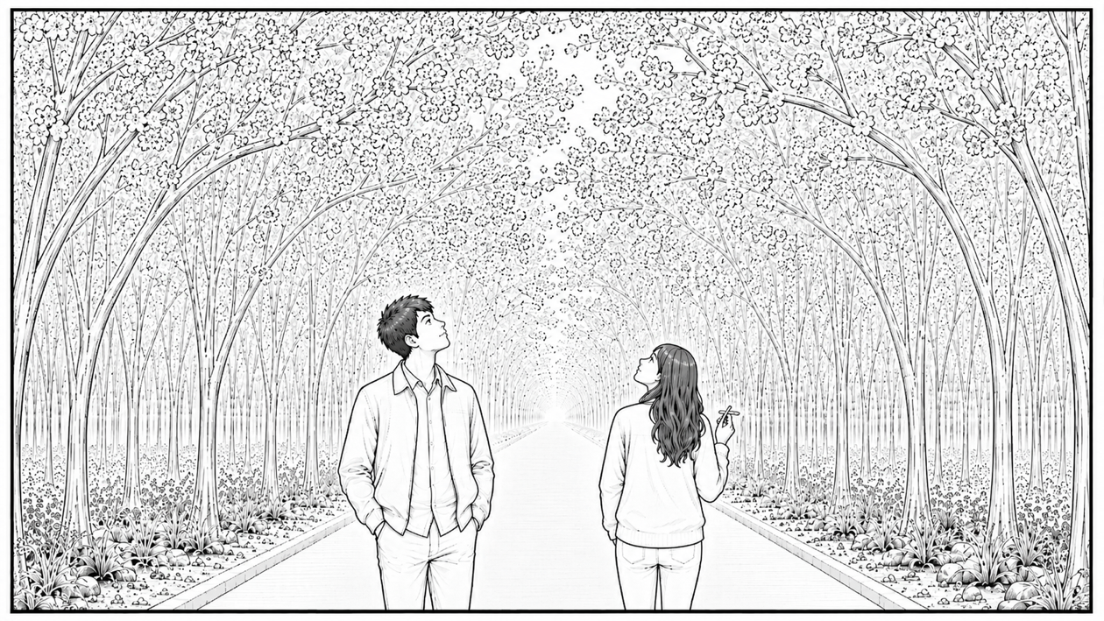
SHOT 02
START FRAME
CAMERA: TILT UP, CUT BEFORE REVEAL
ACTION: MAN WOMAN STAND, CONVEVRSING.

END SHOT

