SHOT 01
START FRAME
CAMERA: STATIC, HIGH ANGLE, SLOWLY TILTING UP. HOLD.
ACTION: -NONE-
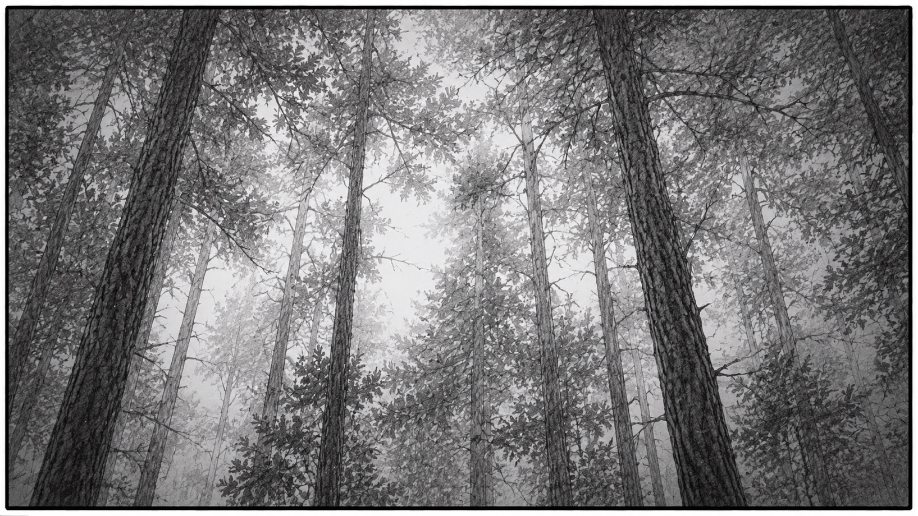
CONTINUES →
SHOT 01
MIDDLE FRAME
CAMERA: STATIC, HIGH ANGLE, SLOWLY TILTING DOWN.
ACTION: -NONE-
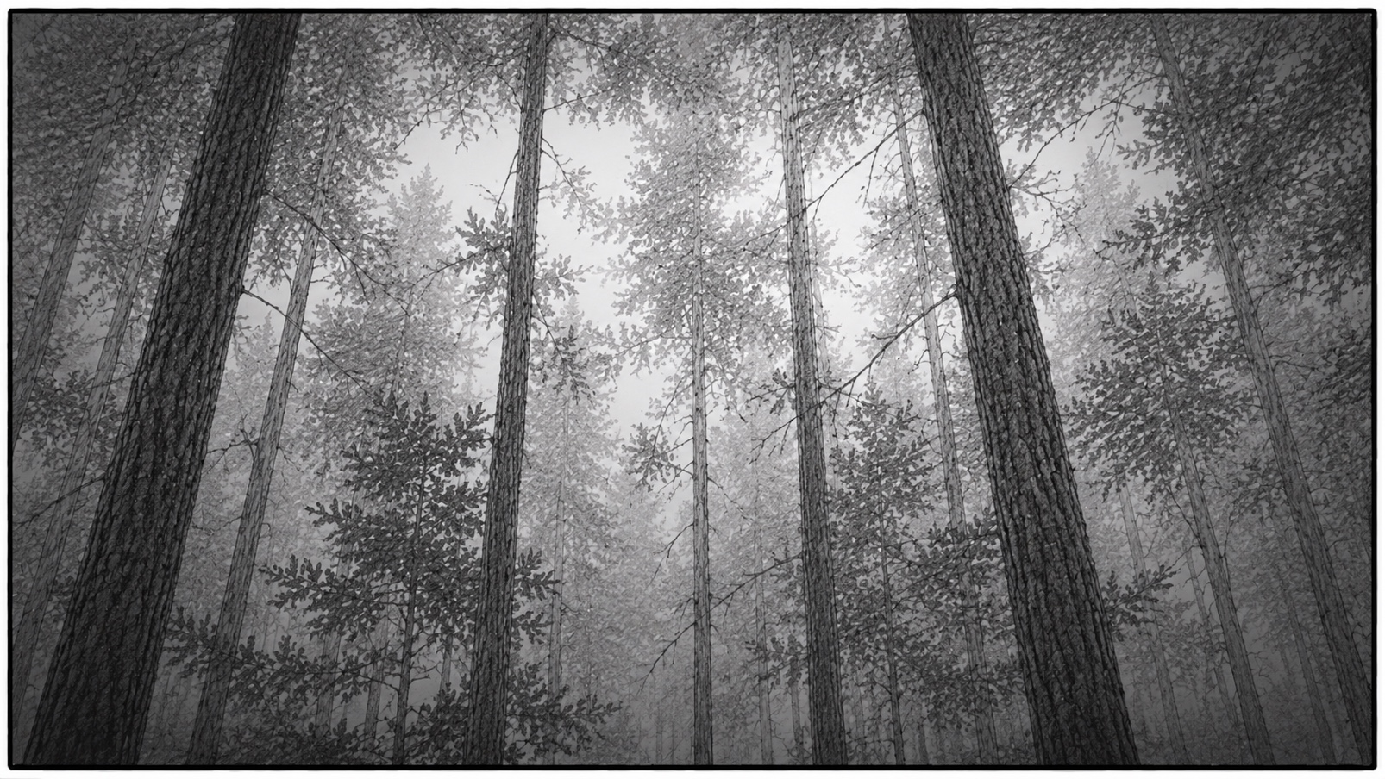
CONTINUES →
SHOT 01
MIDDLE FRAME
CAMERA: STATIC, HIGH ANGLE, TILTED DOWN
ACTION: BOY SEARCHES FOR SOURCE OF SOUND.
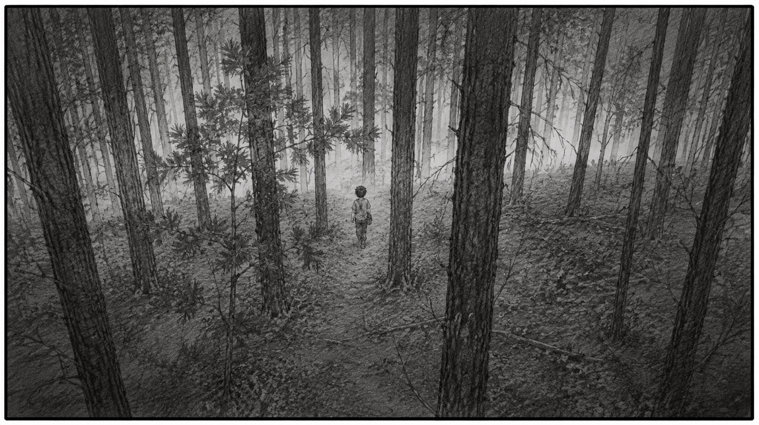
CONTINUES →
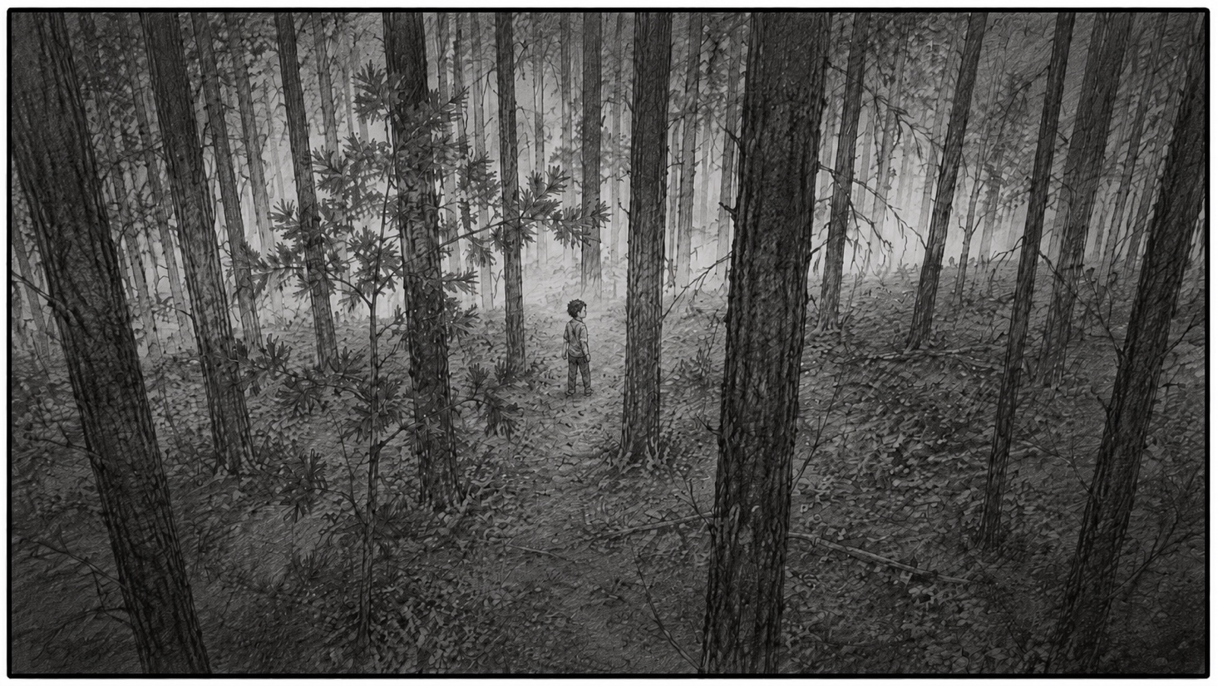
SHOT 01
END FRAME
CAMERA: STATIC, HIGH ANGLE, TILTED DOWN
ACTION: BOY SEARCHES FOR SOURCE OF SOUND.

END SHOT

