SHOT 01
START FRAME
CAMERA: SLOWLY TILT UP
ACTION: BOY SEES AN OPENING. WALKS TOWARDS IT.

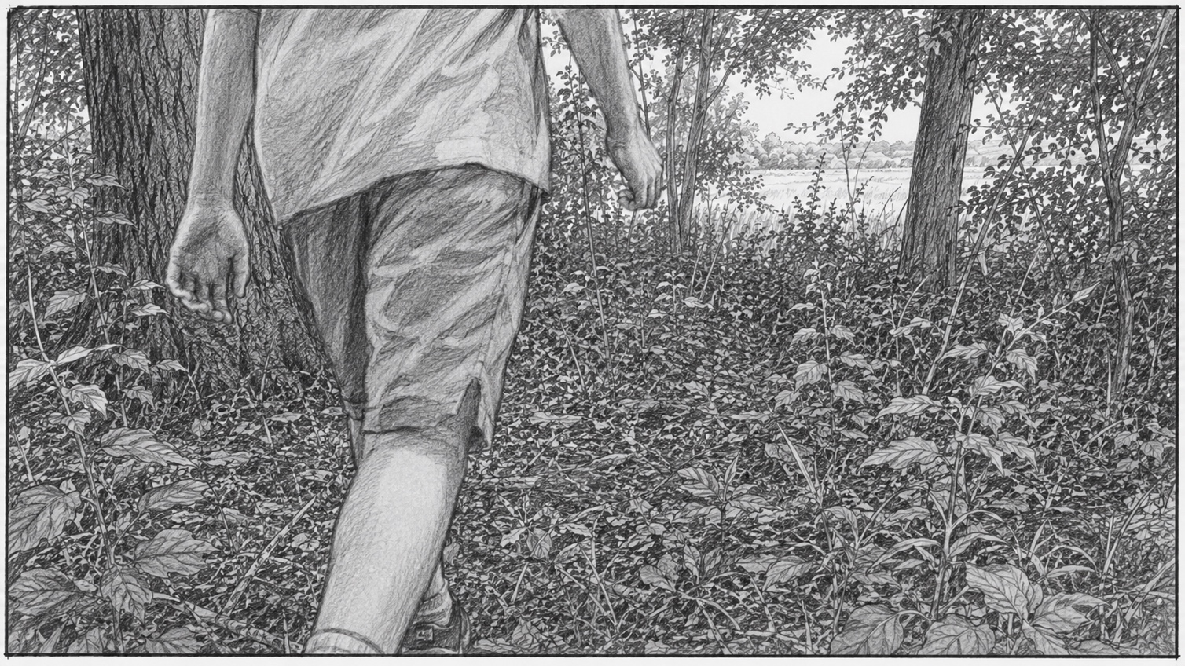
CONTINUES →

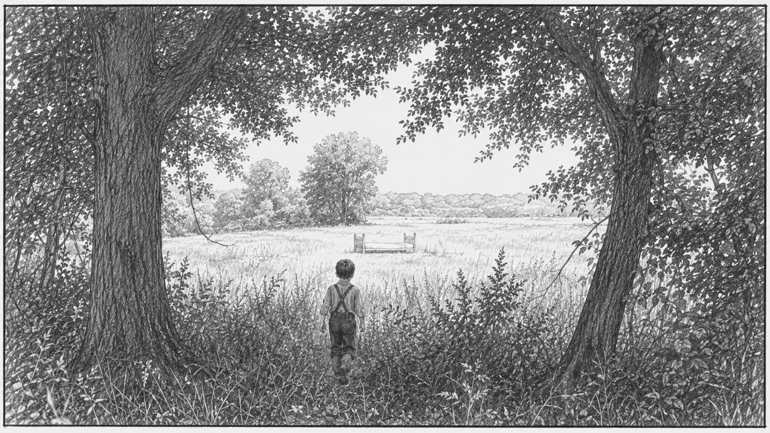
CONTINUES →
SHOT 01
START FRAME
CAMERA: TILT UP, HOLD
ACTION: BOY STOPS AT EDGE OF WOODS.

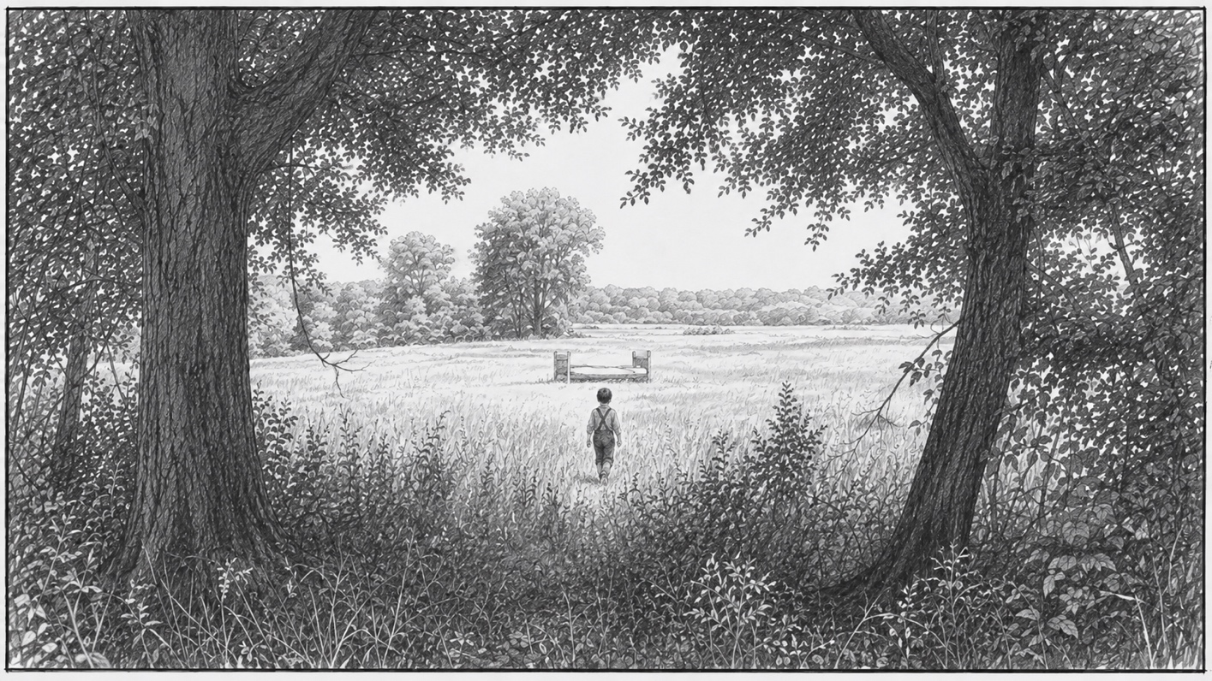
CONTINUES →
SHOT 01
MIDDLE FRAME
CAMERA: HOLD
ACTION: BOY WALKS INTO OPEN FIELD

SHOT 01
MIDDLE FRAME
CAMERA: HOLD
ACTION: BOY RUNS HAND AGAINST FABRIC.

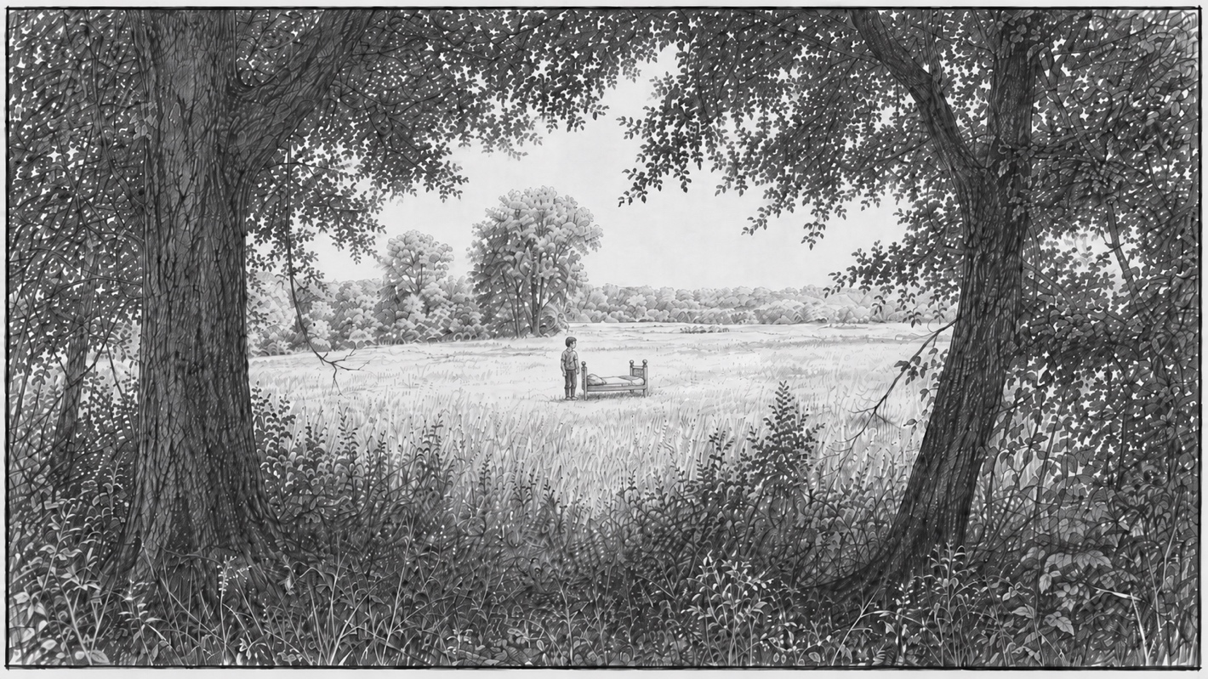
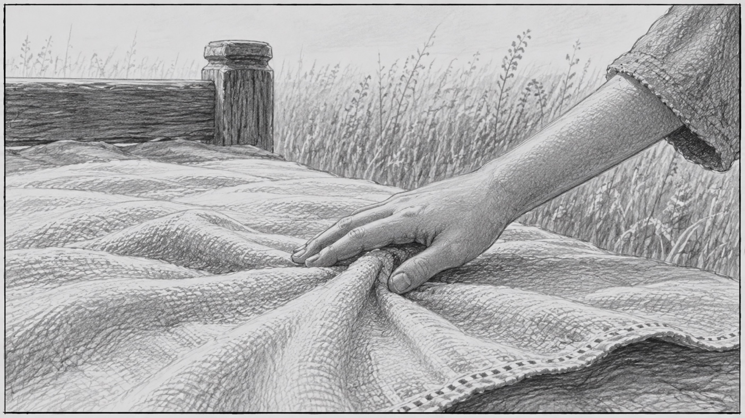
END SHOT
SHOT 02
START/END FRAME
CAMERA: STATIC
ACTION: BOY RUNS HAND AGAINST FABRIC

SHOT 03
START FRAME
CAMERA: ON DOLLY, HOLD
ACTION: BOY RUNS HAND AGAINST FABRIC.

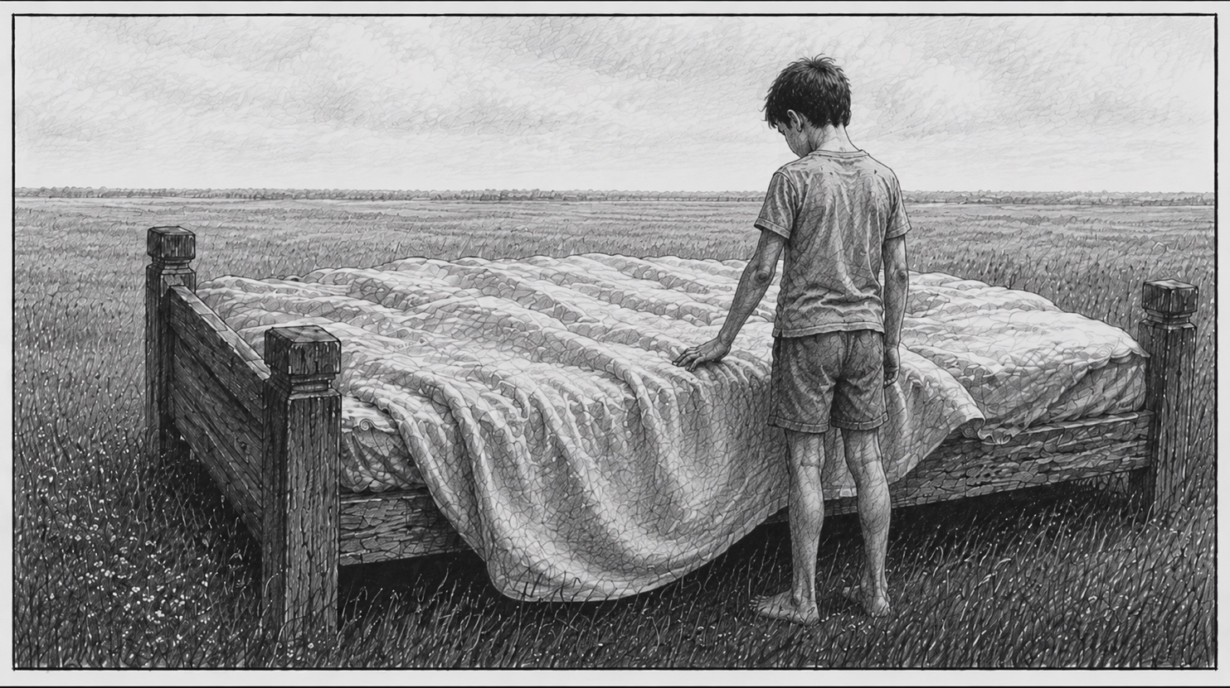
CONTINUES →

SHOT 03
START FRAME
CAMERA: STATIC TO START, ON DOLLY
ACTION: BOY CLIMBS ONTO BED.

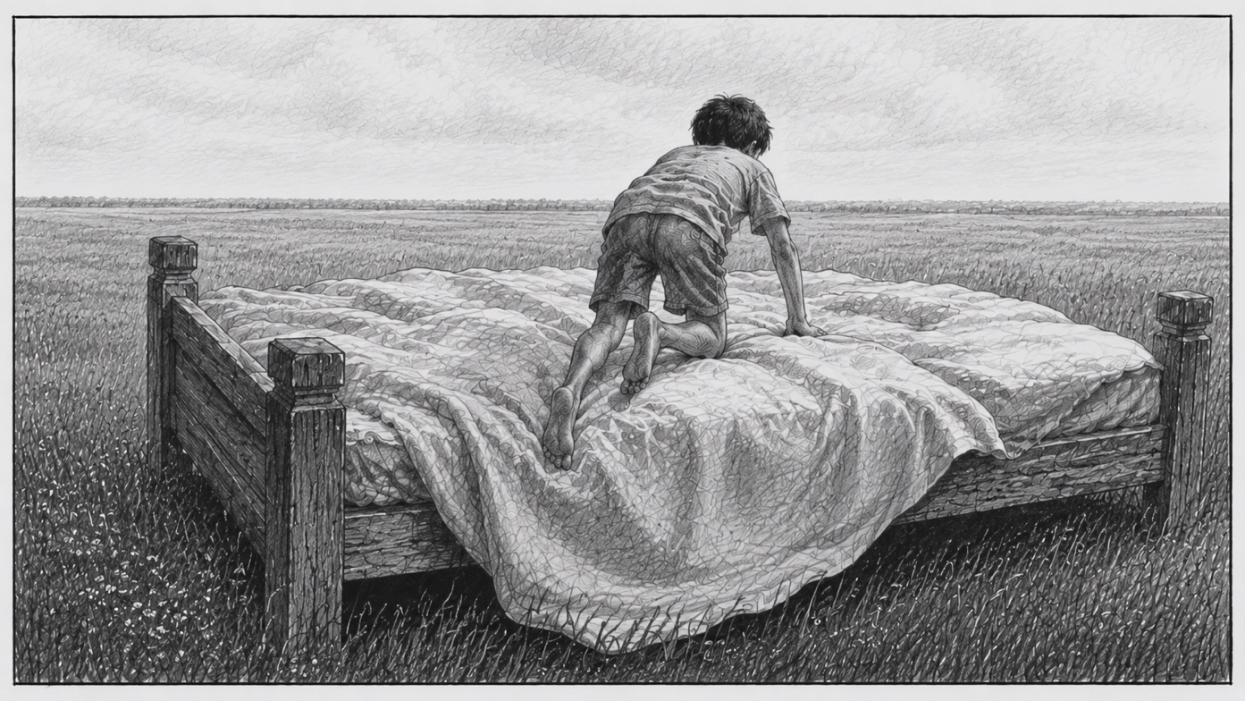

CONTINUES →

SHOT 03
MIDDLE FRAME
CAMERA: PAN UP AS BOY BEGINS JUMPING, HOLD
ACTION: BOY JUMPS ON BED.

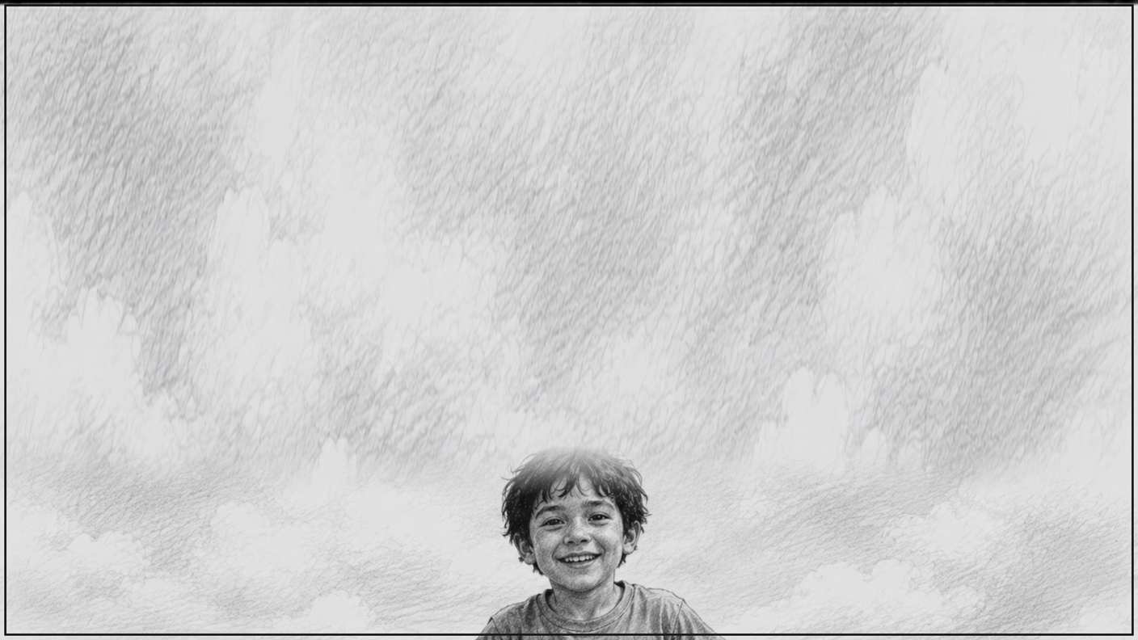
CONTINUES →
SHOT 03
MIDDLE FRAME
CAMERA: HOLD AT APEX OF JUMP
ACTION: BOY JUMPS ON BED.


CONTINUES →
SHOT 03
MIDDLE FRAME
CAMERA: HOLD AT APEX OF JUMP
ACTION: BOY TURNS WHILE JUMPING.

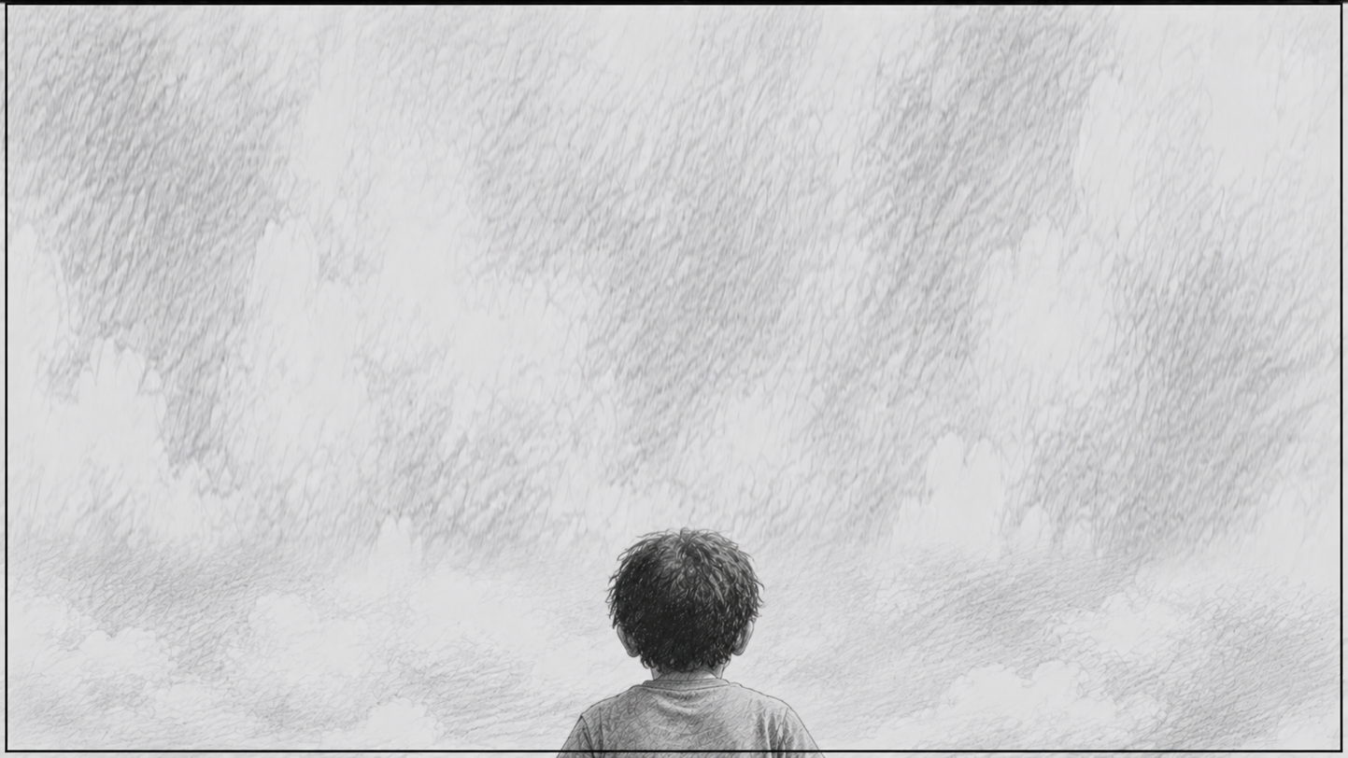

CONTINUES →

CONTINUES →
SHOT 03
MIDDLE FRAME
CAMERA: HOLD AT APEX OF JUMP
ACTION: BOY NEVER MAKE ITS BACK UP.

SHOT 03
MIDDLE FRAME
CAMERA: TILD DOWN, HOLD
ACTION: BOY IS ON KNEES, LOOKING DOWN.

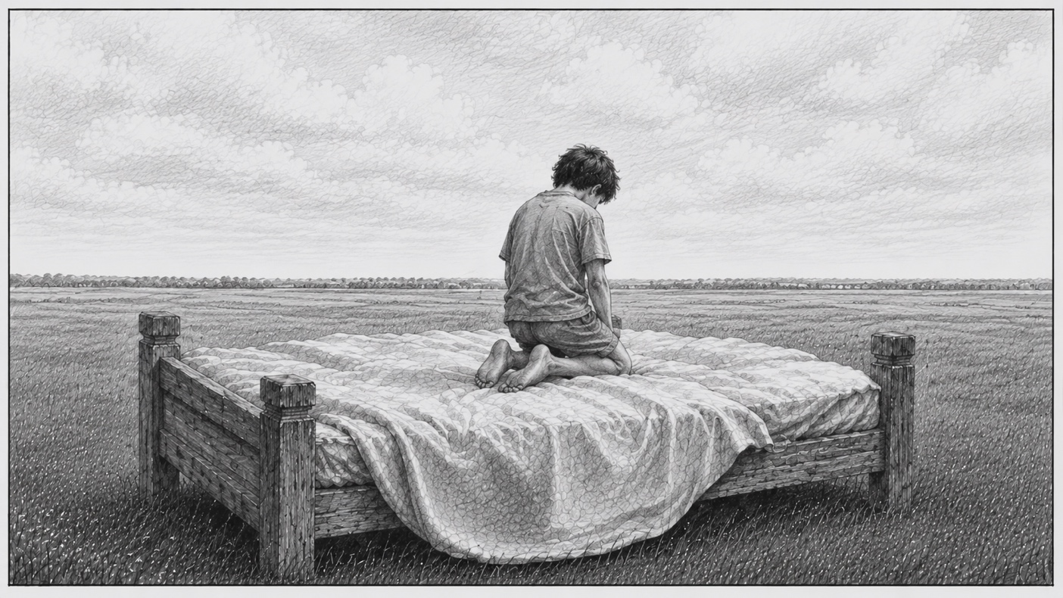
CONTINUES →
SHOT 03
MIDDLE FRAME
CAMERA: DOLLY IN
ACTION: BOY IS ON KNEES, LOOKS BACK.

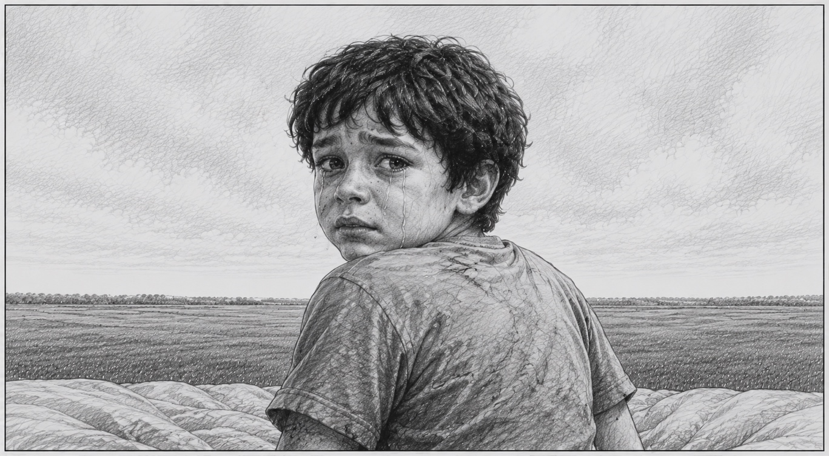
CONTINUES →

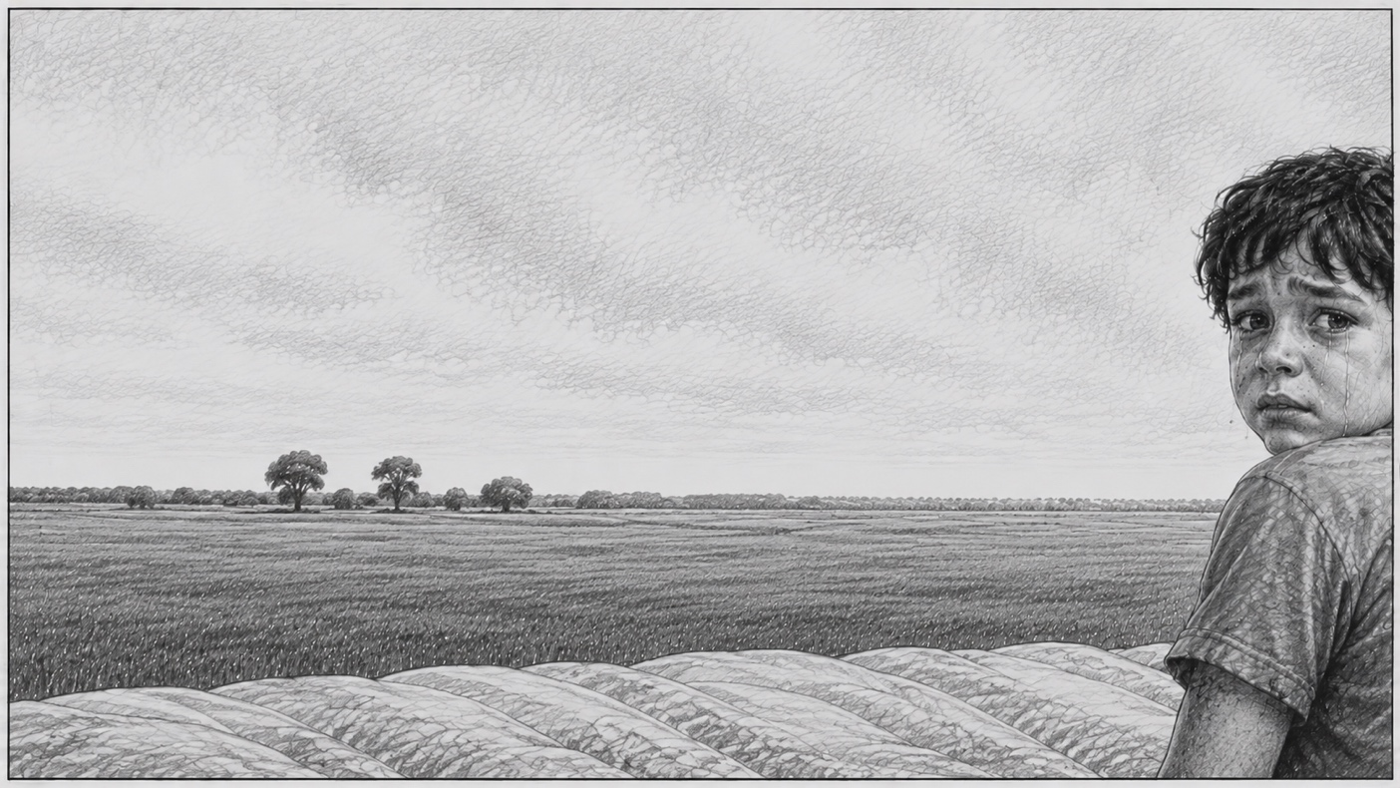
CONTINUES →
SHOT 03
MIDDLE FRAME
CAMERA: PAN LEFT
ACTION: BOY IS ON KNEES, LOOKS BACK.

SHOT 03
MIDDLE FRAME
CAMERA: PAN LEFT
ACTION: -NONE-

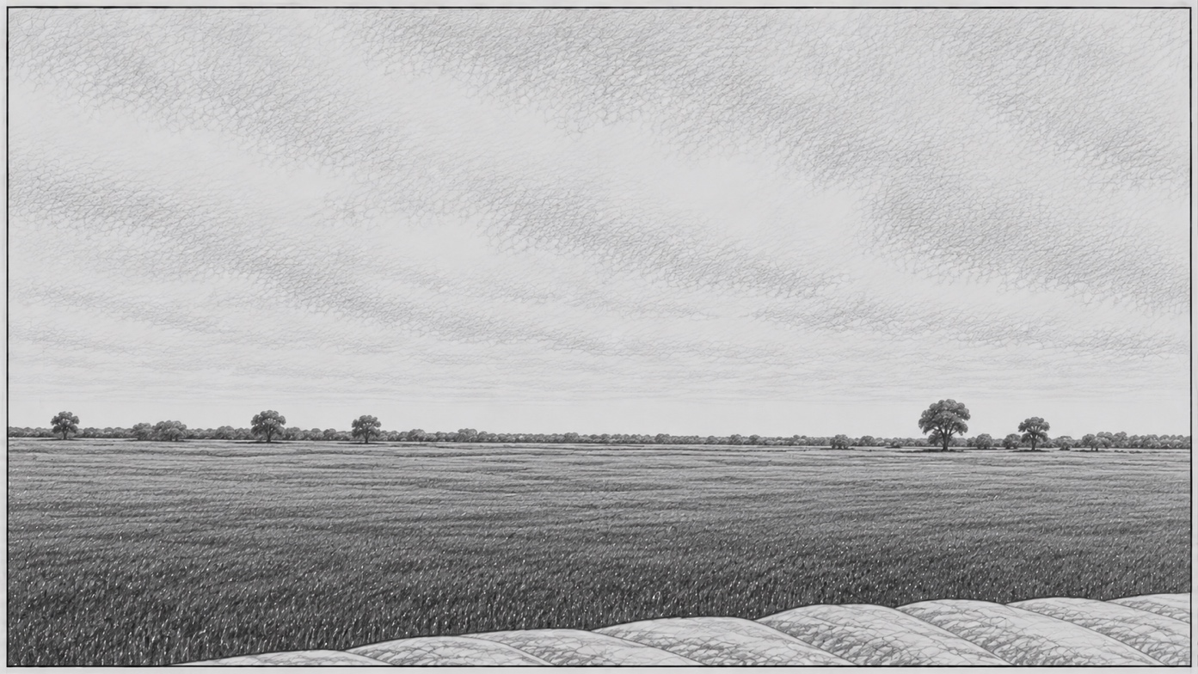

CONTINUES →
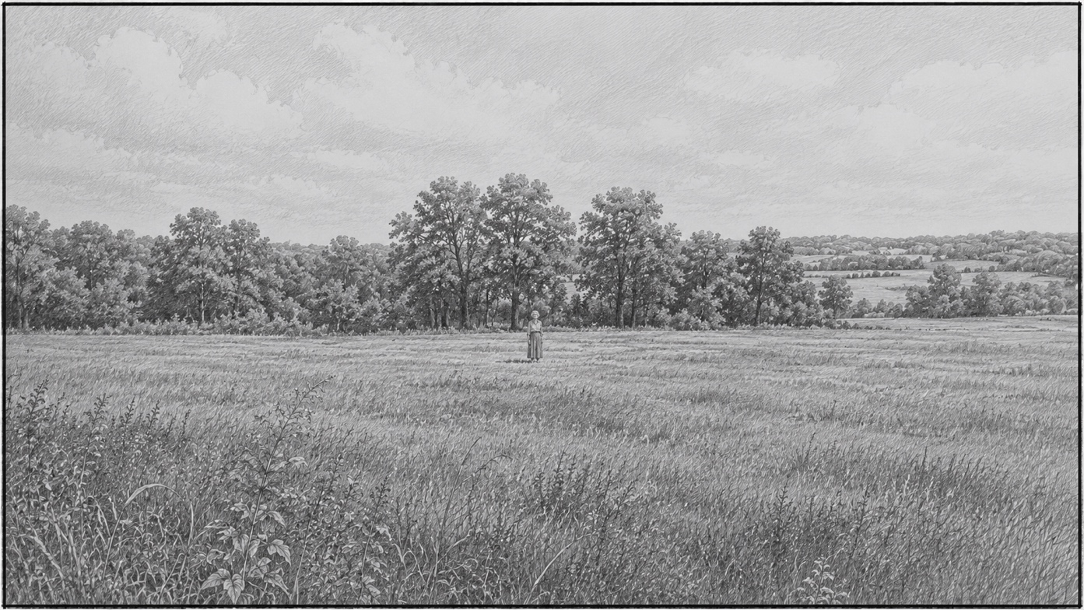
SHOT 03
END FRAME
CAMERA: PAN LEFT, HOLD
ACTION: WOMAN STANDS IN DISTANCE.

END SHOT

