SHOT 01
START FRAME
CAMERA: STATIC
ACTION: MAN AND WOMAN WALK.

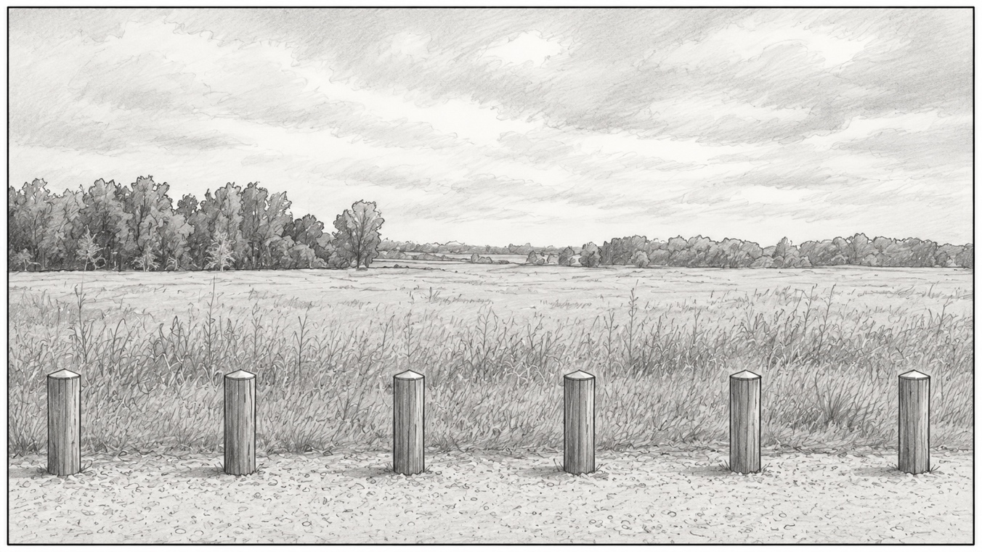
CONTINUES →
SHOT 01
START FRAME
CAMERA: STATIC
ACTION: MAN AND WOMAN WEAVE THROUGH BOLLARDS, TALKING.

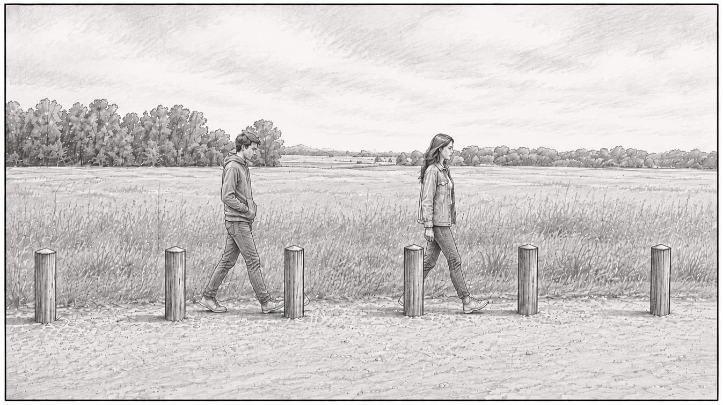
CONTINUES →
SHOT 01
MIDDLE FRAME
CAMERA: STATIC
ACTION: MAN AND WOMAN SIT ON FAR BOLLARDS, TALKING.

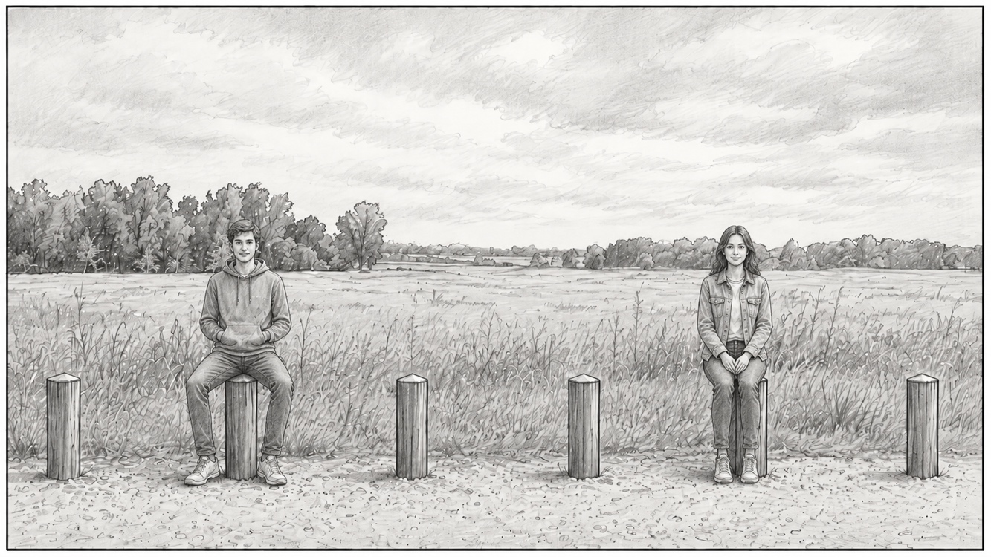
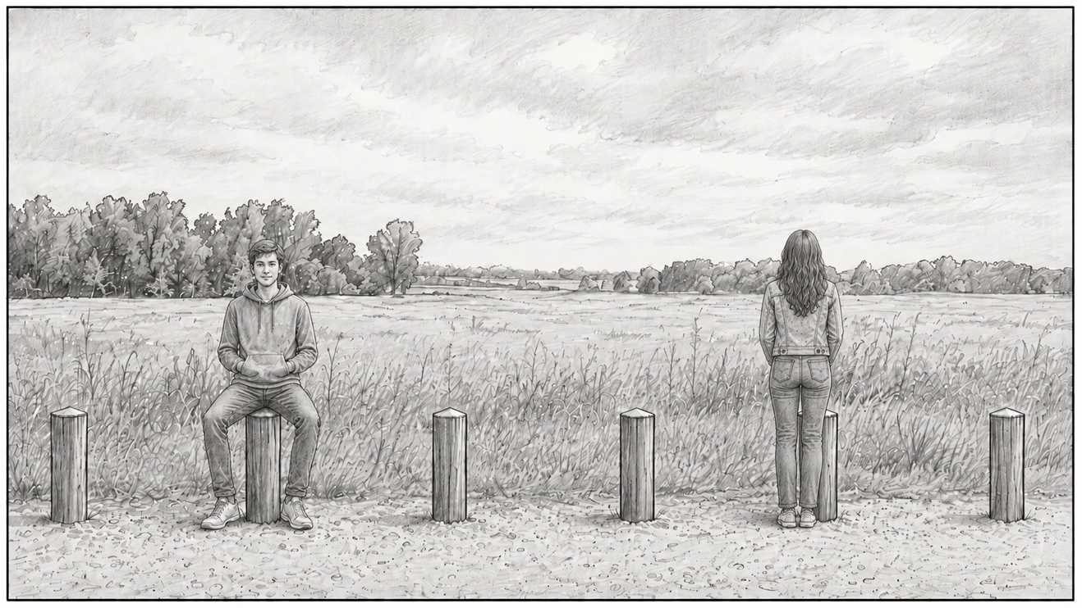
CONTINUES →
SHOT 01
MIDDLE FRAME
CAMERA: STATIC
ACTION: WOMAN STANDS UP AND TURNS. MAN TURNS THEREAFTER.

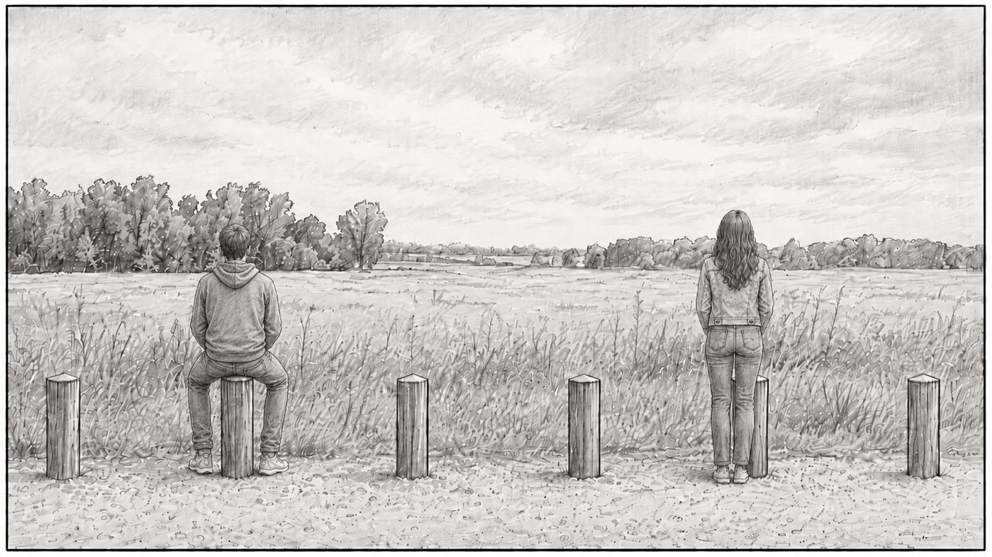
CONTINUES →
SHOT 01
MIDDLE FRAME
CAMERA: STATIC
ACTION: WOMAN SITS ON CLOSER BOLLARD.

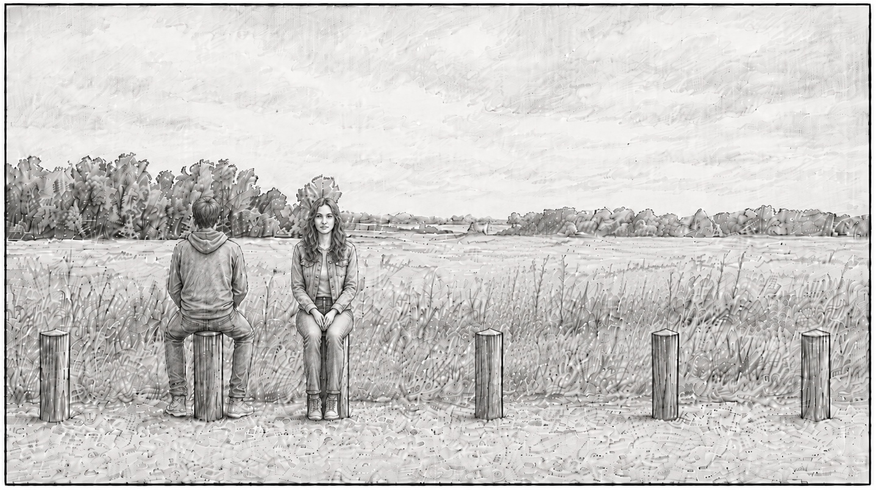
CONTINUES →
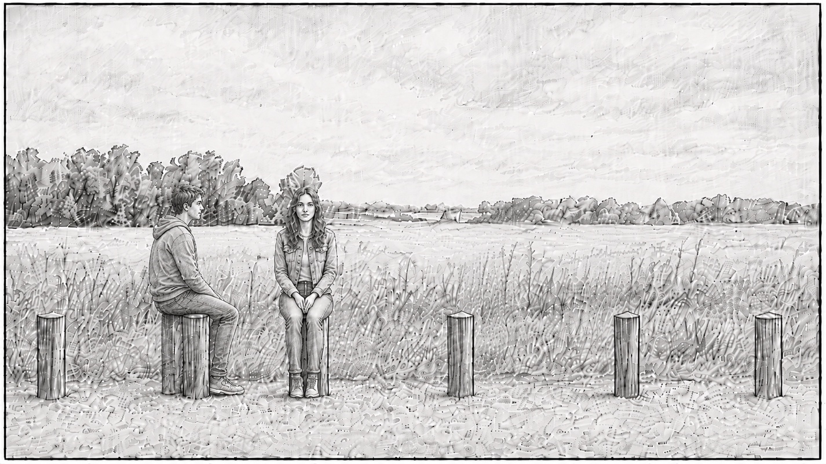
CONTINUES →
SHOT 01
MIDDLE FRAME
CAMERA: STATIC
ACTION: MAN TURNS TOWARDS WOMAN.

SHOT 01
MIDDLE FRAME
CAMERA: STATIC
ACTION: MAN WALKS INTO NATURE.

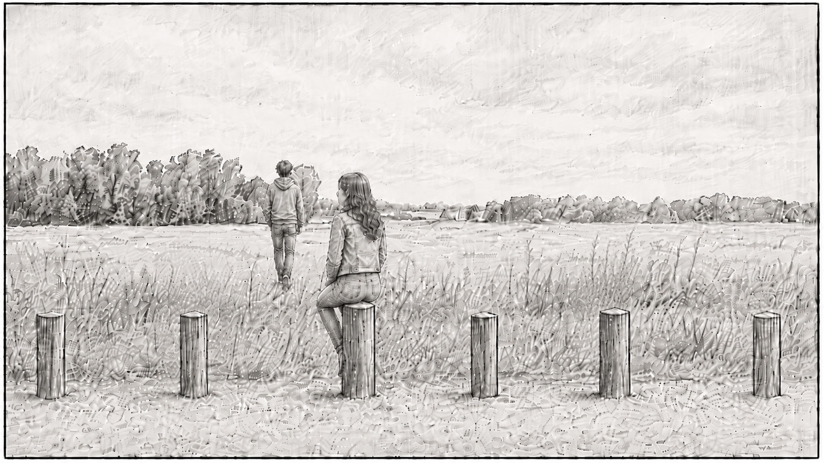
CONTINUES →
SHOT 01
END FRAME
CAMERA: STATIC
ACTION: WOMAN FOLLOWS MAN INTO NATURE.

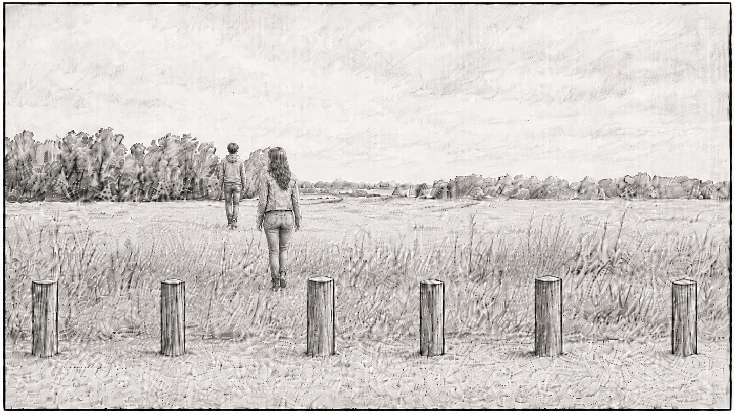
END SHOT
SHOT 02
START FRAME
CAMERA:
ACTION: SHOT OF BOY?

SHOT 03
START FRAME
CAMERA: LONG PAN OF NATURE
ACTION: -NONE-

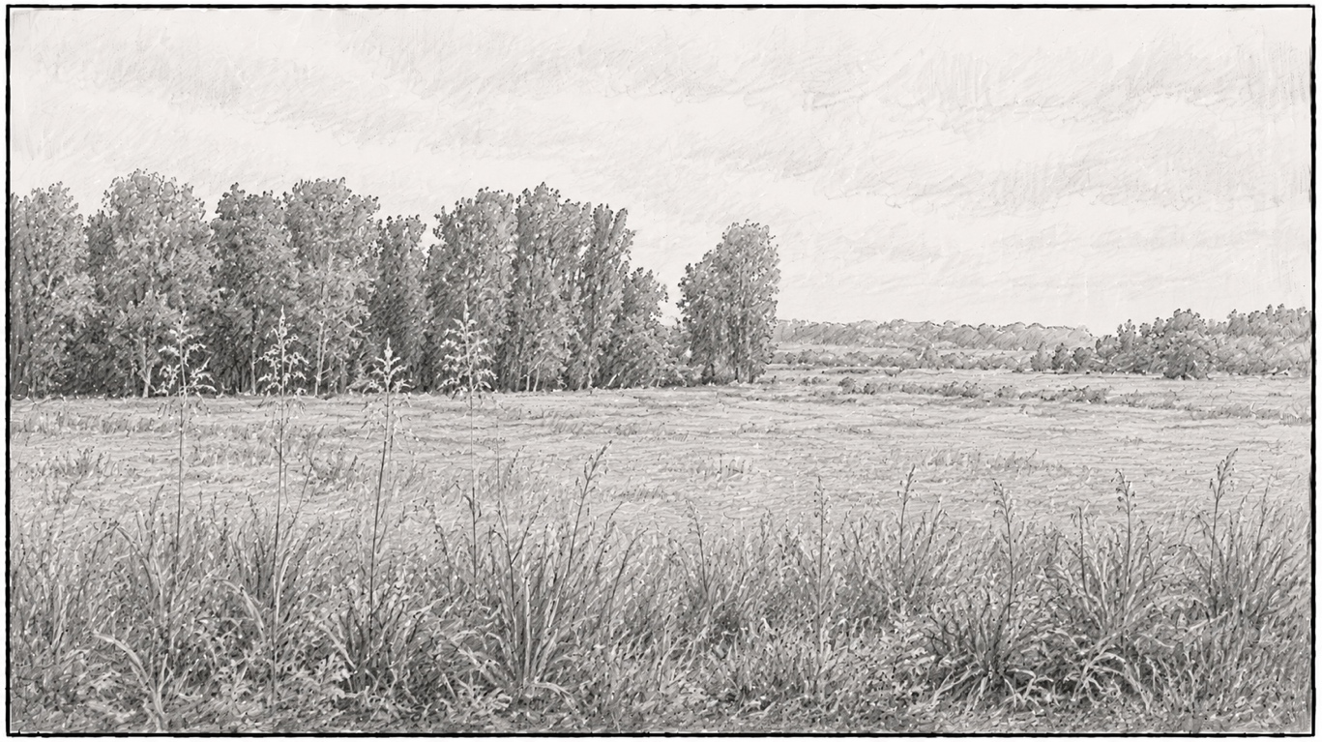
CONTINUES →
SHOT 03
MIDDLE FRAME
CAMERA: LONG PAN CONTINUED
ACTION: -NONE-

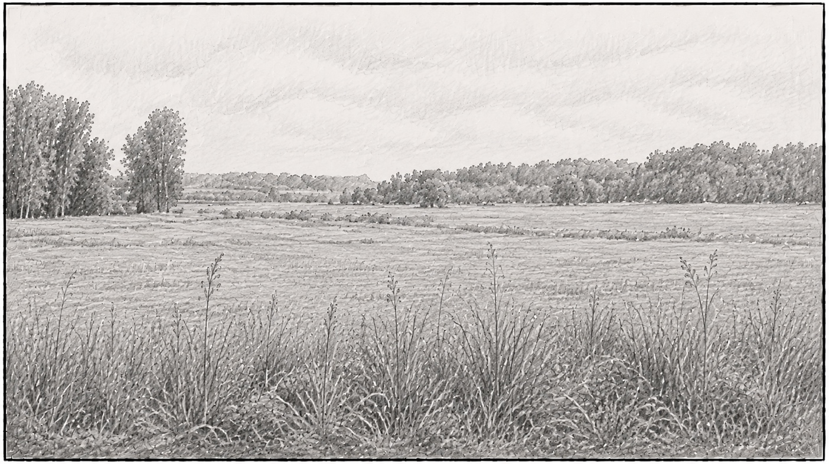
CONTINUES →
SHOT 03
START FRAME
CAMERA: STATIC
ACTION: MAN AND WOMAN SIT WITHIN NATURE.

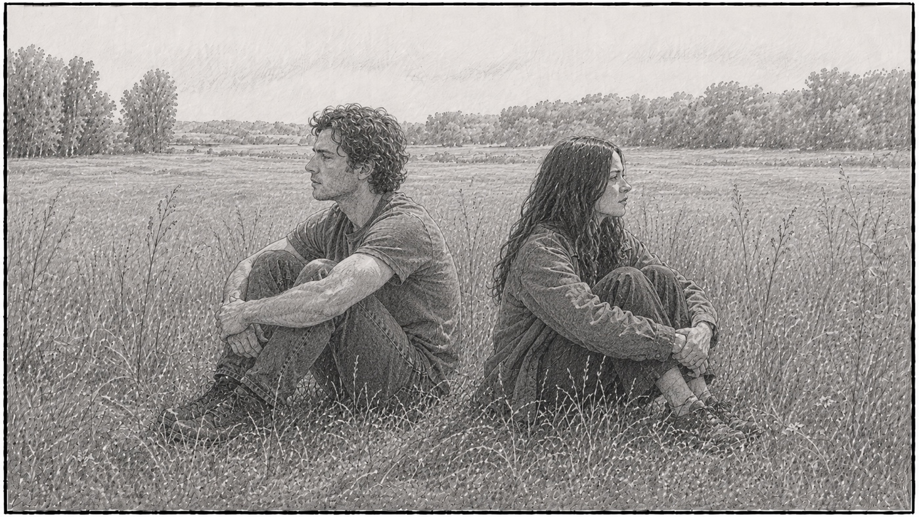
END SHOT

