SHOT 01
START/END FRAME
CAMERA: STATIC
ACTION: WOMAN LOOKS INTO DISTANCE, CONTEMPLATIVELY.

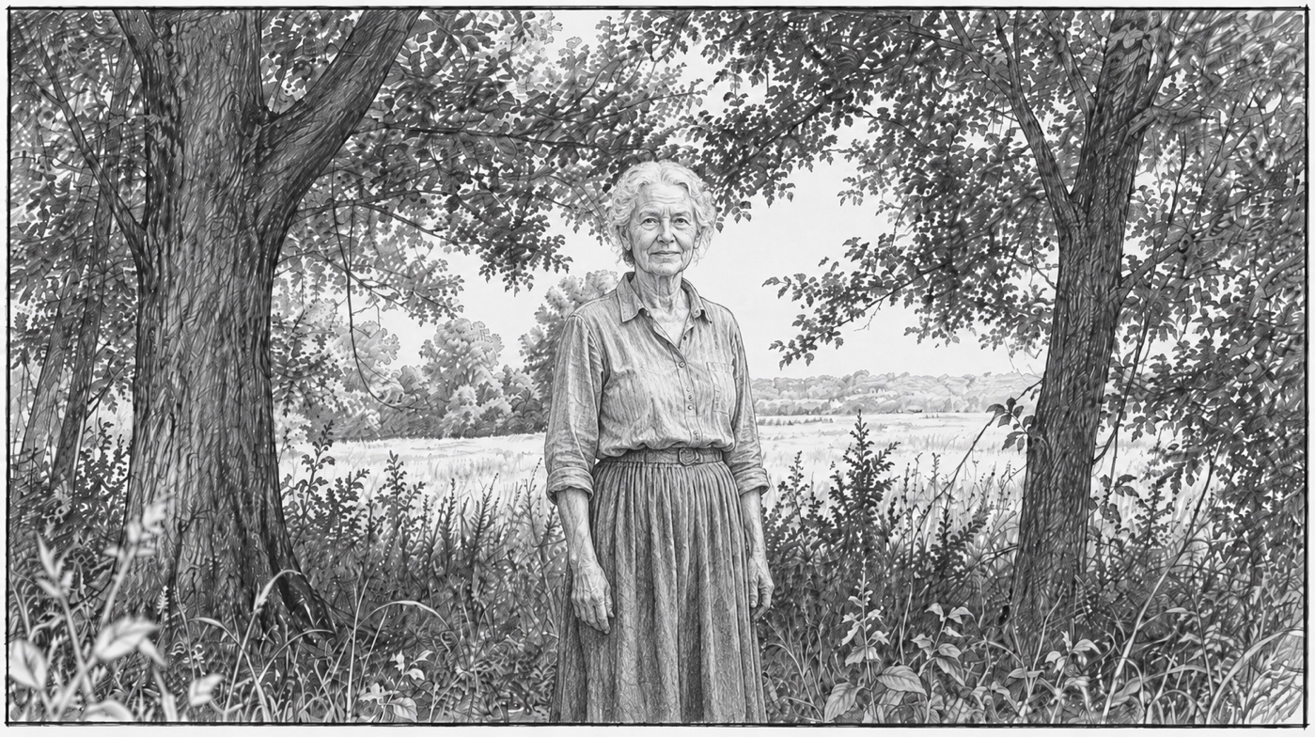
END SHOT

