LAB SHEET 02
Sadhana Nautiyal, CU240251605

Task 2.1: Interactive Theme-Switcher Landing Page
Aim: Build a responsive landing page that switches between two visual themes using CSS custom properties and a JavaScript event handler.
index.html
<!DOCTYPE html>
<html lang="en">
<head>
<meta charset="UTF-8">
<meta name="viewport" content="width=device-width, initial-scale=1.0">
<title>Orbital Landing Page</title>
<link rel="stylesheet" href="style.css">
</head>
<body>
<nav class="nav">
<div class="logo">ORBITAL</div>
<button class="toggle" id="theme">☀ Day view</button>
</nav>
<main class="hero">
<section class="hero-card">
<div class="eyebrow">CREATIVE • RESPONSIVE • FLUID</div>
<h1>One interface.<br>Two moods.</h1>
<p>A responsive landing page that changes its visual atmosphere.</p>
<button class="cta">Explore the idea →</button>
</section>
</main>
<script src="script.js"></script>
</body>
</html>

style.css
:root { --ink:#eaf2ff; --muted:#9fb0c7; --panel:#111c30; --glow:#7c5cff; --bg:#08111f; }
body.sunrise { --ink:#182235; --muted:#5f6b7b; --panel:#ffffff; --glow:#ff7a59; --bg:#edf3ff; }
* { box-sizing:border-box; }
body { margin:0; min-height:100vh; color:var(--ink); background:var(--bg); transition:.35s; }
.nav { display:flex; justify-content:space-between; padding:22px 7%; }
.hero { min-height:80vh; display:grid; place-items:center; padding:40px 7%; }
.hero-card { width:min(880px,100%); padding:60px; border-radius:28px; background:var(--panel); text-align:center; }
.toggle,.cta { border-radius:999px; padding:12px 20px; cursor:pointer; }
.cta { background:var(--glow); color:white; border:0; }
@media(max-width:600px) { .hero-card { padding:36px 20px; } }

script.js
const button = document.getElementById("theme");
button.addEventListener("click", () => {
document.body.classList.toggle("sunrise");
const light = document.body.classList.contains("sunrise");
button.textContent = light ? "☾ Night view" : "☀ Day view";
});

Output
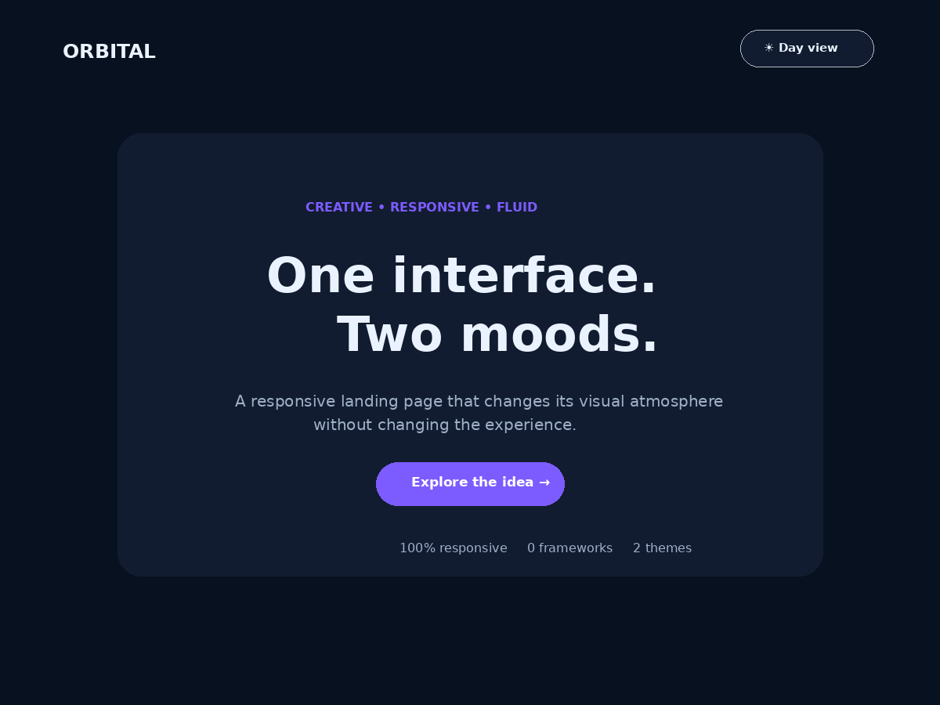
Dark theme — default state
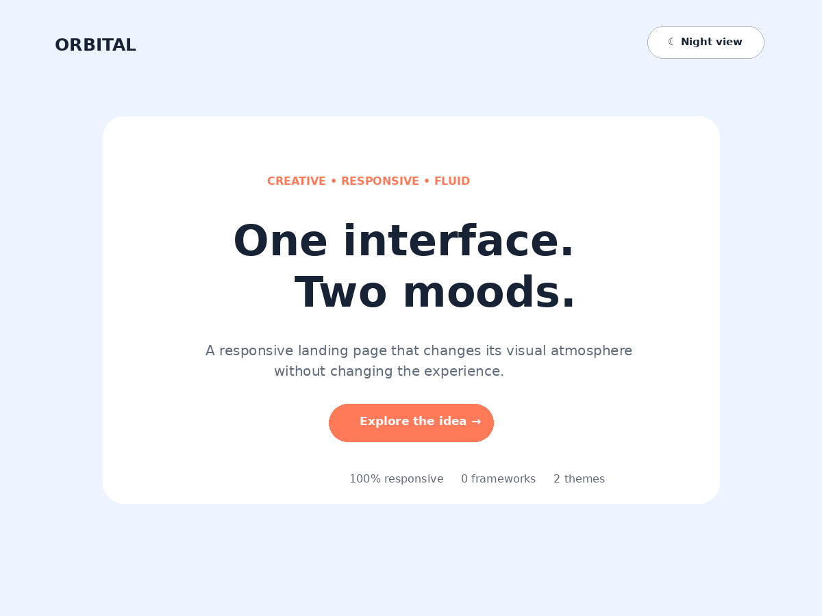
Light theme — after clicking the toggle button

Task 2.2: Responsive Scenic Gallery Using Flexbox
Aim: Build a responsive scenic gallery that wraps naturally on smaller screens and applies a scale, rotation, and colour enhancement effect when a photo is hovered.
index.html (gallery section)
<h1>Fragments of the Outdoors</h1>
<section class="wall">
<article class="shot"><img src="golden_valley.png" alt="Golden Valley"><span>Golden Valley</span></article>
<article class="shot"><img src="blue_lagoon.png" alt="Blue Lagoon"><span>Blue Lagoon</span></article>
<article class="shot"><img src="pine_trail.png" alt="Pine Trail"><span>Pine Trail</span></article>
<article class="shot"><img src="violet_peaks.png" alt="Violet Peaks"><span>Violet Peaks</span></article>
<article class="shot"><img src="amber_dunes.png" alt="Amber Dunes"><span>Amber Dunes</span></article>
<article class="shot"><img src="night_city.png" alt="Night Horizon"><span>Night Horizon</span></article>
</section>

style.css
body { margin:0; padding:44px 7%; font-family:Arial,sans-serif; background:#f6f2eb; }
.wall { display:flex; flex-wrap:wrap; gap:20px; justify-content:center; }
.shot { position:relative; flex:1 1 280px; max-width:430px; height:250px; overflow:hidden; border-radius:24px; }
.shot img { width:100%; height:100%; object-fit:cover; filter:saturate(.78); transition:.45s; }
.shot:hover img { transform:scale(1.1) rotate(-.6deg); filter:saturate(1.25) contrast(1.05); }
.shot span { position:absolute; left:16px; bottom:14px; padding:8px 12px; border-radius:999px; background:#18202ba8; color:white; }
@media(max-width:620px) { .shot { flex-basis:100%; max-width:none; height:220px; } }

Output
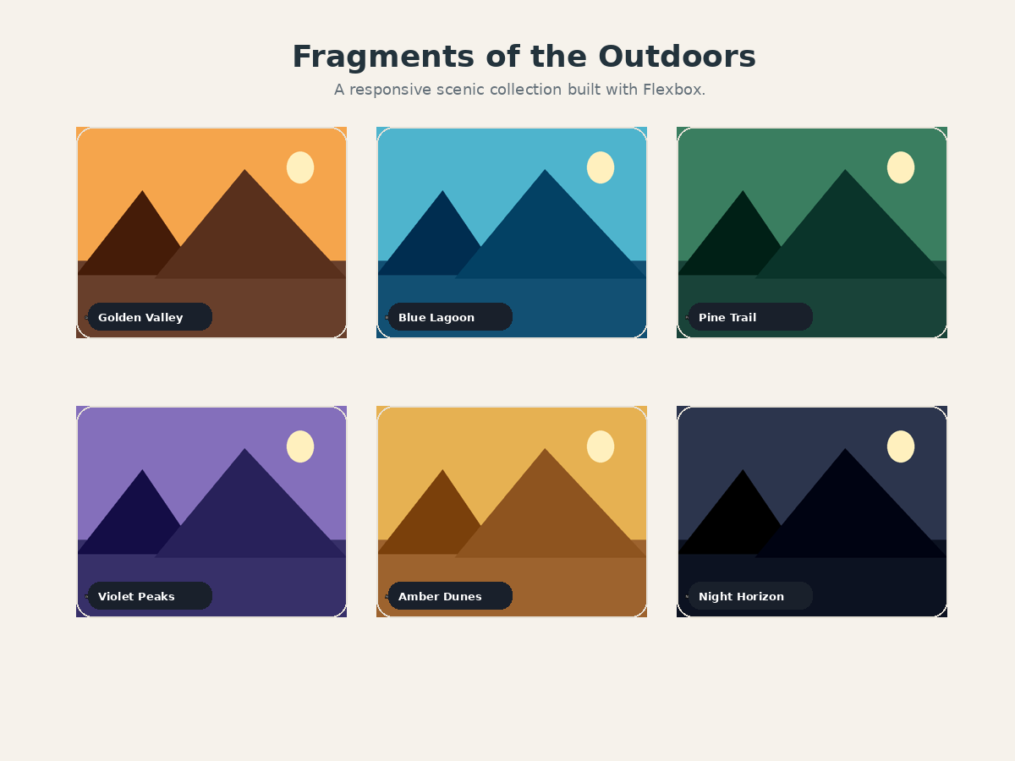
Rendered scenic gallery — six locally designed landscape images

Task 2.3: Client-Side Focus Board Application
Aim: Build a browser-based task manager that creates tasks with the DOM API, prevents empty entries, allows tasks to be completed or deleted, and keeps a live count of pending tasks.
JavaScript logic
const input = document.querySelector("#entry");
const add = document.querySelector("#add");
const list = document.querySelector("#list");
const message = document.querySelector("#message");
const count = document.querySelector("#count");
function refresh() {
const pending = [...list.children].filter(item => !item.classList.contains("done")).length;
count.textContent = `${pending} pending task${pending === 1 ? "" : "s"}`;
}
function addTask(text) {
const value = (text ?? input.value).trim();
if (!value) { message.textContent = "Please enter a task before adding it."; return; }
message.textContent = "";
const item = document.createElement("li");
item.className = "item";
const label = document.createElement("span");
label.textContent = value;
label.onclick = () => { item.classList.toggle("done"); refresh(); };
const remove = document.createElement("button");
remove.textContent = "Delete";
remove.onclick = () => { item.remove(); refresh(); };
item.append(label, remove); list.append(item); input.value = ""; refresh();
}
add.onclick = () => addTask();
input.onkeydown = e => { if (e.key === "Enter") addTask(); };

Core HTML structure
<main class="app">
<h1>Focus Board</h1>
<div class="composer">
<input id="entry" placeholder="Add a task for today">
<button id="add">Add</button>
</div>
<div id="message"></div>
<div class="status"><span id="count">0 pending</span></div>
<ul id="list"></ul>
</main>

Key CSS styling
.app { width:min(650px,92vw); background:#fff; padding:34px; border-radius:26px; box-shadow:0 20px 55px rgba(37,55,78,.14); }
.composer { display:flex; gap:10px; }
.item { list-style:none; display:flex; align-items:center; gap:12px; padding:13px 14px; background:#f7f8fb; border-radius:14px; }
.item.done span { text-decoration:line-through; color:#9aa5b1; }
.delete { border:0; background:#ffe5ea; color:#be3453; border-radius:9px; padding:7px 10px; }
@media(max-width:520px) { .composer { flex-direction:column; } }

Output
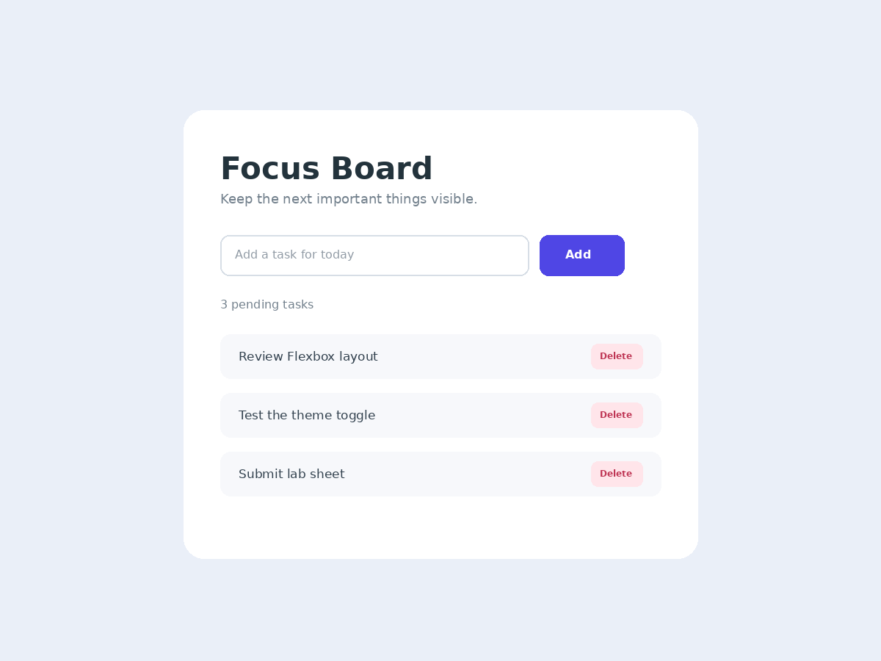
Focus Board after adding three sample tasks

