LAB SHEET 03
Sadhana Nautiyal | CUid: CU240251605 | Roll No.45

React Task Planner Using Vite
Aim: Create a component-based React task planner that can add, complete, remove, and persist tasks using browser local storage.

1. Create and Run the Project
Terminal commands
npm create vite@latest focus-board -- --template react
cd focus-board
npm install
npm run dev
The application is organised into small reusable components so that form handling, task rendering, and individual task actions remain separate.

2. Project Structure
Folder layout
focus-board/
├── src/
│ ├── components/
│ │ ├── TaskComposer.jsx
│ │ ├── TaskCollection.jsx
│ │ └── TaskRow.jsx
│ ├── App.jsx
│ ├── App.css
│ └── main.jsx
└── package.json

3. Component Flow
Component relationship
App
├── TaskComposer → creates a new task
└── TaskCollection
└── TaskRow → toggle or remove a task
4. App.jsx — Application State
import { useEffect, useMemo, useState } from "react";
import TaskComposer from "./components/TaskComposer";
import TaskCollection from "./components/TaskCollection";
import "./App.css";

const STORAGE_KEY = "focus-board-items";

export default function App() {
const [items, setItems] = useState(() => {
const raw = localStorage.getItem(STORAGE_KEY);
return raw ? JSON.parse(raw) : [];
});

useEffect(() => {
localStorage.setItem(STORAGE_KEY, JSON.stringify(items));
}, [items]);

const createItem = (title) => {
setItems((current) => [
...current,
{ id: crypto.randomUUID(), title, done: false }
]);
};

const flipStatus = (id) => {
setItems((current) => current.map((item) =>
item.id === id ? { ...item, done: !item.done } : item
));
};

const removeItem = (id) => {
setItems((current) => current.filter((item) => item.id !== id));
};

const summary = useMemo(() => {
const pending = items.filter((item) => !item.done).length;
return `${pending} remaining • ${items.length - pending} completed`;
}, [items]);

return (
<main className="shell">
<section className="board">
<p className="eyebrow">DAILY PRODUCTIVITY</p>
<h1>FocusBoard</h1>
<p className="intro">Plan less. Finish more.</p>
<TaskComposer onCreate={createItem} />
<p className="summary">{summary}</p>
<TaskCollection
items={items}
onToggle={flipStatus}
onRemove={removeItem}
/>
</section>
</main>
);
}
5. TaskComposer.jsx
import { useState } from "react";

export default function TaskComposer({ onCreate }) {
const [value, setValue] = useState("");
const [message, setMessage] = useState("");

function submitTask(event) {
event.preventDefault();
const cleanValue = value.trim();

if (cleanValue.length < 2) {
setMessage("Enter at least two characters.");
return;
}

onCreate(cleanValue);
setValue("");
setMessage("");
}

return (
<form className="composer" onSubmit={submitTask}>
<input
value={value}
onChange={(event) => setValue(event.target.value)}
placeholder="Add a task for today..."
aria-label="New task"
/>
<button type="submit">Add task</button>
{message && <small className="message">{message}</small>}
</form>
);
}
6. TaskCollection.jsx
import TaskRow from "./TaskRow";

export default function TaskCollection({ items, onToggle, onRemove }) {
if (items.length === 0) {
return <p className="empty-state">Your list is clear. Add something meaningful.</p>;
}

return (
<div className="task-stack">
{items.map((item) => (
<TaskRow
key={item.id}
item={item}
onToggle={onToggle}
onRemove={onRemove}
/>
))}
</div>
);
}
7. TaskRow.jsx
export default function TaskRow({ item, onToggle, onRemove }) {
return (
<article className={`task-row ${item.done ? "is-done" : ""}`}>
<button
className="check"
onClick={() => onToggle(item.id)}
aria-label="Toggle task status"
>
{item.done ? "✓" : ""}
</button>
<span>{item.title}</span>
<button className="remove" onClick={() => onRemove(item.id)}>
Remove
</button>
</article>
);
}
8. main.jsx
import { StrictMode } from "react";
import { createRoot } from "react-dom/client";
import App from "./App.jsx";

createRoot(document.getElementById("root")).render(
<StrictMode>
<App />
</StrictMode>
);
9. App.css
* { box-sizing: border-box; }

body {
margin: 0;
min-width: 320px;
font-family: Inter, system-ui, sans-serif;
background: linear-gradient(135deg, #eef2ff, #f8fafc);
color: #1f2937;
}

.shell { min-height: 100vh; display: grid; place-items: center; padding: 32px; }
.board {
width: min(720px, 100%); background: #fff; padding: 38px;
border-radius: 24px; box-shadow: 0 22px 55px rgba(79,70,229,.14);
}
.eyebrow { color: #7c3aed; font-size: .75rem; font-weight: 800; letter-spacing: .12em; }
h1 { margin: 8px 0 0; font-size: clamp(2.1rem, 7vw, 3.5rem); }
.intro, .summary, .empty-state { color: #64748b; }
.composer { display: flex; gap: 10px; flex-wrap: wrap; margin: 28px 0 8px; }
.composer input { flex: 1 1 320px; padding: 14px; border: 1px solid #cbd5e1; border-radius: 12px; }
button { border: 0; border-radius: 12px; padding: 12px 18px; background: #7c3aed; color: white; cursor: pointer; }
.message { width: 100%; color: #dc2626; }
.task-stack { display: grid; gap: 12px; margin-top: 18px; }
.task-row { display: flex; align-items: center; gap: 12px; padding: 13px; border-radius: 14px; background: #f8fafc; }
.task-row span { flex: 1; }
.check { width: 34px; height: 34px; padding: 0; background: white; color: #7c3aed; border: 2px solid #a78bfa; }
.remove { background: #fee2e2; color: #b91c1c; padding: 8px 12px; }
.is-done span { text-decoration: line-through; color: #94a3b8; }
@media (max-width: 520px) { .board { padding: 24px; } .composer button { width: 100%; } }

Output
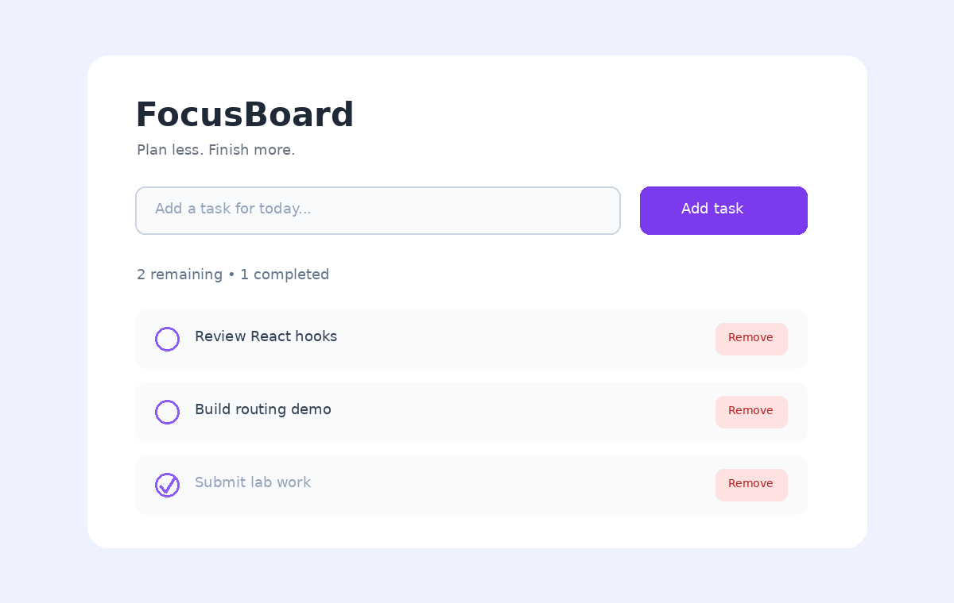
FocusBoard after adding and completing sample tasks.

LAB SHEET 04
Sadhana Nautiyal | CUid: CU240251605

React Product Explorer with Routing and Cart Context
Aim: Build a React single-page application that demonstrates navigation, route parameters, a reusable product card, and shared cart state through React Context.

1. Install the Router Package
Terminal command
npm install react-router-dom

2. Project Structure
Folder layout
campus-cart/
├── src/
│ ├── components/
│ │ ├── Header.jsx
│ │ └── ProductTile.jsx
│ ├── context/
│ │ └── CartContext.jsx
│ ├── data/
│ │ └── catalog.js
│ ├── pages/
│ │ ├── Landing.jsx
│ │ ├── Store.jsx
│ │ ├── ItemDetails.jsx
│ │ └── Missing.jsx
│ ├── App.jsx
│ ├── App.css
│ └── main.jsx
└── package.json
3. App.jsx — Route Configuration
import { BrowserRouter, Routes, Route } from "react-router-dom";
import Header from "./components/Header";
import Landing from "./pages/Landing";
import Store from "./pages/Store";
import ItemDetails from "./pages/ItemDetails";
import Missing from "./pages/Missing";

export default function App() {
return (
<BrowserRouter>
<Header />
<Routes>
<Route path="/" element={<Landing />} />
<Route path="/store" element={<Store />} />
<Route path="/store/:slug" element={<ItemDetails />} />
<Route path="*" element={<Missing />} />
</Routes>
</BrowserRouter>
);
}
4. data/catalog.js — Product Data
export const catalog = [
{
slug: "study-lamp",
name: "Study Lamp",
price: 899,
category: "Lighting",
description: "A compact LED lamp designed for a focused desk setup."
},
{
slug: "travel-bottle",
name: "Travel Bottle",
price: 549,
category: "Daily use",
description: "A lightweight reusable bottle for lectures and travel."
},
{
slug: "wireless-mouse",
name: "Wireless Mouse",
price: 1299,
category: "Tech",
description: "A comfortable wireless mouse with reliable everyday tracking."
}
];
5. Header.jsx — Navigation + Shared Cart Count
import { NavLink } from "react-router-dom";
import { useCart } from "../context/CartContext";

export default function Header() {
const { count } = useCart();

return (
<header className="header">
<NavLink className="brand" to="/">CampusCart</NavLink>
<nav>
<NavLink to="/">Home</NavLink>
<NavLink to="/store">Store</NavLink>
<span className="cart-badge">Cart ({count})</span>
</nav>
</header>
);
}
6. Landing.jsx
import { Link } from "react-router-dom";

export default function Landing() {
return (
<main className="page hero">
<p className="eyebrow">STUDENT ESSENTIALS</p>
<h1>Simple products for everyday campus life.</h1>
<p>Explore a small catalog built to demonstrate client-side routing.</p>
<Link className="primary-link" to="/store">Browse store</Link>
</main>
);
}
7. Store.jsx — Product Listing
import ProductTile from "../components/ProductTile";
import { catalog } from "../data/catalog";

export default function Store() {
return (
<main className="page">
<h1>Browse essentials for campus life</h1>
<p className="muted">Choose an item to view its dedicated route.</p>
<section className="grid">
{catalog.map((product) => (
<ProductTile key={product.slug} product={product} />
))}
</section>
</main>
);
}
8. ProductTile.jsx — Reusable Card
import { Link } from "react-router-dom";
import { useCart } from "../context/CartContext";

export default function ProductTile({ product }) {
const { add } = useCart();

return (
<article className="tile">
<div className="product-art" aria-hidden="true">●</div>
<p className="category">{product.category}</p>
<h2>{product.name}</h2>
<strong>₹{product.price}</strong>
<div className="actions">
<Link to={`/store/${product.slug}`}>Details</Link>
<button onClick={() => add(product)}>Add</button>
</div>
</article>
);
}
9. ItemDetails.jsx — Route Parameters
import { Link, useParams } from "react-router-dom";
import { catalog } from "../data/catalog";
import { useCart } from "../context/CartContext";

export default function ItemDetails() {
const { slug } = useParams();
const product = catalog.find((item) => item.slug === slug);
const { add } = useCart();

if (!product) {
return <main className="page"><h1>Product unavailable</h1></main>;
}

return (
<main className="page detail">
<p className="category">{product.category}</p>
<h1>{product.name}</h1>
<p>{product.description}</p>
<h2>₹{product.price}</h2>
<button onClick={() => add(product)}>Add to cart</button>
<Link to="/store">← Back to store</Link>
</main>
);
}
10. CartContext.jsx — Global Cart State
import { createContext, useContext, useMemo, useState } from "react";

const CartContext = createContext(null);

export function CartProvider({ children }) {
const [cart, setCart] = useState([]);

const add = (product) => setCart((items) => [...items, product]);
const removeOne = (slug) => {
setCart((items) => {
const index = items.findIndex((item) => item.slug === slug);
return index < 0 ? items : items.filter((_, i) => i !== index);
});
};

const value = useMemo(() => ({
cart, count: cart.length, add, removeOne
}), [cart]);

return <CartContext.Provider value={value}>{children}</CartContext.Provider>;
}

export function useCart() {
const context = useContext(CartContext);
if (!context) throw new Error("useCart must be used inside CartProvider");
return context;
}
11. Missing.jsx — Fallback Route
import { Link } from "react-router-dom";

export default function Missing() {
return (
<main className="page">
<h1>404</h1>
<p>This route is not part of CampusCart.</p>
<Link to="/">Return home</Link>
</main>
);
}
12. main.jsx — Context Provider
import { StrictMode } from "react";
import { createRoot } from "react-dom/client";
import { CartProvider } from "./context/CartContext";
import App from "./App.jsx";

createRoot(document.getElementById("root")).render(
<StrictMode>
<CartProvider>
<App />
</CartProvider>
</StrictMode>
);
13. App.css
* { box-sizing: border-box; }
body { margin: 0; font-family: Inter, system-ui, sans-serif; background: #f8fafc; color: #0f172a; }
.header {
display: flex; justify-content: space-between; align-items: center;
padding: 20px 8%; background: #0f172a; color: white;
}
.header a { color: #e2e8f0; text-decoration: none; margin-left: 20px; }
.header .brand { margin-left: 0; font-size: 1.35rem; font-weight: 800; color: white; }
.cart-badge { margin-left: 20px; padding: 8px 11px; background: #1e293b; border-radius: 999px; }
.page { width: min(1100px, 100%); margin: auto; padding: 60px 8%; }
.hero { padding-top: 110px; max-width: 900px; }
.hero h1 { font-size: clamp(2.5rem, 7vw, 5rem); max-width: 850px; }
.eyebrow, .category { color: #4f46e5; font-weight: 700; letter-spacing: .08em; text-transform: uppercase; }
.muted { color: #64748b; }
.primary-link, .actions a, .actions button, .detail button {
display: inline-block; border: 0; border-radius: 10px; padding: 11px 15px;
background: #4f46e5; color: white; text-decoration: none; cursor: pointer;
}
.grid { display: grid; grid-template-columns: repeat(auto-fit, minmax(240px, 1fr)); gap: 22px; margin-top: 32px; }
.tile { padding: 20px; border: 1px solid #e2e8f0; border-radius: 20px; background: white; }
.product-art { height: 130px; display: grid; place-items: center; font-size: 42px; background: #e0e7ff; border-radius: 14px; color: #6366f1; }
.tile h2 { margin: 8px 0; }
.actions { display: flex; gap: 10px; margin-top: 18px; }
.actions button { background: #0f172a; }
.detail { max-width: 760px; }
.detail a { display: block; margin-top: 24px; color: #4f46e5; }
@media (max-width: 650px) { .header { padding: 16px 6%; } .header nav a { margin-left: 10px; } .cart-badge { display: none; } }

14. Routing and State Flow
Application flow
Browser URL
├── / → Landing
├── /store → Store → ProductTile
├── /store/:slug → ItemDetails
└── unknown URL → Missing (404)

CartProvider → Header + ProductTile + ItemDetails
→ shared cart data and actions

Output
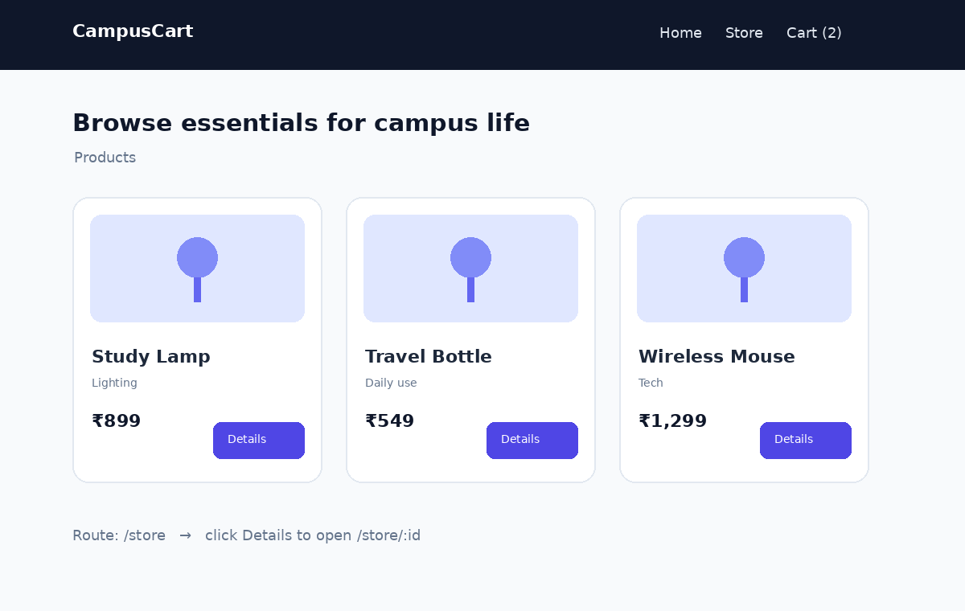
CampusCart product listing showing route navigation and cart state.

