FULL STACK DEVELOPMENT
LAB SHEET 05 · React Form Validation & Multi-Step Workflow

Submitted by | Sadhana Nautiyal
CU ID | CU240251605
Lab | Lab Sheet 05

1. Lab Overview
This lab focuses on controlled React forms, client-side validation, password-strength feedback, and a multi-step onboarding workflow. The source lab includes both a login-style validation exercise and a four-stage onboarding flow with review and completion states.

2. Objectives
- Validate email and password fields using reusable rule functions.
- Provide immediate, readable feedback about password quality.
- Build controlled components using React state.
- Move through a multi-step workflow while preserving form data.
- Prevent progression until the required data for a step is valid.

3. Design Approach
The implementation is intentionally organized as two self-contained exercises selected through a compact navigation switcher. Validation logic is expressed as small predicate functions, while the UI uses external CSS classes rather than a large inline-style object. The onboarding experience uses a progress strip and selectable cards, giving the application a substantially different interaction and visual structure.

4. Project Structure
src/
├── App.jsx # Application state and both exercises
├── App.css # Responsive visual design
└── main.jsx # React entry point

5. Functional Flow
Input | Validate | Feedback | Advance / Submit
The login form validates both fields on submission, while the wizard checks each stage before allowing the user to continue.

6. Main React Implementation (App.jsx)
import { useMemo, useState } from "react";
import "./App.css";
const emailIsValid = (value) => /^[^\s@]+@[^\s@]+\.[^\s@]+$/.test(value);
const rules = [
["At least 8 characters", (value) => value.length >= 8],
["One uppercase letter", (value) => /[A-Z]/.test(value)],
["One lowercase letter", (value) => /[a-z]/.test(value)],
["One number", (value) => /\d/.test(value)],
["One symbol", (value) => /[^A-Za-z0-9]/.test(value)],
];
function PasswordFeedback({ value }) {
const passed = rules.filter(([, test]) => test(value)).length;
if (!value) return null;
const names = ["Very weak", "Weak", "Fair", "Good", "Strong"];
const label = names[Math.max(0, passed - 1)] || "Very weak";
return (
<div className="password-feedback">
<div className="meter"><span style={{ width: `${passed * 20}%` }} /></div>
<small>{label} · {passed}/5 checks passed</small>
<div className="rule-list">
{rules.map(([label, test]) => (
<span className={test(value) ? "pass" : ""} key={label}>
{test(value) ? "✓" : "○"} {label}
</span>
))}
</div>
</div>
);
}
function LoginExercise() {
const [data, setData] = useState({ email: "", password: "" });
const [submitted, setSubmitted] = useState(false);
const [showPassword, setShowPassword] = useState(false);
const errors = useMemo(() => ({
email: emailIsValid(data.email) ? "" : "Enter a valid email address.",
password: rules.every(([, test]) => test(data.password))
? "" : "Use a password that satisfies all five checks."
}), [data]);
const valid = !errors.email && !errors.password;
function update(field, value) {
setData((current) => ({ ...current, [field]: value }));
setSubmitted(false);
}
function submit(event) {
event.preventDefault();
setSubmitted(true);
}
return (
<section className="exercise-grid">
<aside className="intro-panel">
<span className="eyebrow">EXERCISE 01</span>
<h2>Secure sign in</h2>
<p>Controlled inputs with immediate validation and password quality feedback.</p>
</aside>
<form className="form-panel" onSubmit={submit} noValidate>
<h3>Account access</h3>
<label>Email address</label>
<input
value={data.email}
onChange={(e) => update("email", e.target.value)}
placeholder="name@example.com"
/>
{submitted && errors.email && <p className="error">{errors.email}</p>}
<label>Password</label>
<div className="password-row">
<input
type={showPassword ? "text" : "password"}
value={data.password}
onChange={(e) => update("password", e.target.value)}
placeholder="Create a secure password"
/>
<button type="button" className="ghost" onClick={() => setShowPassword(!showPassword)}>
{showPassword ? "Hide" : "Show"}
</button>
</div>
<PasswordFeedback value={data.password} />
{submitted && errors.password && <p className="error">{errors.password}</p>}
<button className="primary">Validate form</button>
{submitted && valid && <p className="success">✓ Login form is ready to submit.</p>}
</form>
</section>
);
}
const focusOptions = [
"Frontend systems",
"Data & analytics",
"Cloud platforms",
"Product engineering",
];
function WizardExercise() {
const [step, setStep] = useState(0);
const [profile, setProfile] = useState({
name: "", email: "", username: "", password: "", focus: ""
});
const [complete, setComplete] = useState(false);
const canAdvance = () => {
if (step === 0) return profile.name.trim() && emailIsValid(profile.email);
if (step === 1) return profile.username.trim() &&
rules.every(([, test]) => test(profile.password));
if (step === 2) return Boolean(profile.focus);
return true;
};
const update = (field, value) =>
setProfile((current) => ({ ...current, [field]: value }));
if (complete) {
return (
<section className="completion">
<div className="check">✓</div>
<h2>Profile submitted</h2>
<p>All required information has been reviewed successfully.</p>
<button className="primary" onClick={() => { setStep(0); setComplete(false); }}>
Start again
</button>
</section>
);
}
return (
<section className="wizard">
<header className="wizard-head">
<span className="eyebrow">EXERCISE 02</span>
<h2>Create your learning profile</h2>
<p>Step {step + 1} of 4</p>
</header>
<div className="progress">
{[0, 1, 2, 3].map((item) => <span className={item <= step ? "active" : ""} key={item} />)}
</div>
{step === 0 && (
<div className="fields">
<label>Full name</label>
<input value={profile.name} onChange={(e) => update("name", e.target.value)} />
<label>Email address</label>
<input value={profile.email} onChange={(e) => update("email", e.target.value)} />
</div>
)}
{step === 1 && (
<div className="fields">
<label>Username</label>
<input value={profile.username} onChange={(e) => update("username", e.target.value)} />
<label>Choose password</label>
<input type="password" value={profile.password}
onChange={(e) => update("password", e.target.value)} />
<PasswordFeedback value={profile.password} />
</div>
)}
{step === 2 && (
<div className="choice-grid">
{focusOptions.map((option) => (
<button
type="button"
className={profile.focus === option ? "choice selected" : "choice"}
onClick={() => update("focus", option)}
key={option}
>
<strong>{option}</strong>
<small>Choose this learning direction</small>
</button>
))}
</div>
)}
{step === 3 && (
<div className="review">
<p><span>Name</span><strong>{profile.name}</strong></p>
<p><span>Email</span><strong>{profile.email}</strong></p>
<p><span>Username</span><strong>{profile.username}</strong></p>
<p><span>Focus</span><strong>{profile.focus}</strong></p>
</div>
)}
<footer className="wizard-actions">
<button type="button" className="secondary" disabled={step === 0}
onClick={() => setStep((current) => current - 1)}>Back</button>
{step === 3 ? (
<button type="button" className="primary" onClick={() => setComplete(true)}>Submit profile</button>
) : (
<button type="button" className="primary" disabled={!canAdvance()}
onClick={() => setStep((current) => current + 1)}>Continue</button>
)}
</footer>
</section>
);
}
export default function App() {
const [view, setView] = useState("login");
return (
<main className="app-shell">
<nav className="switcher">
<button className={view === "login" ? "tab current" : "tab"} onClick={() => setView("login")}>
Login validation
</button>
<button className={view === "wizard" ? "tab current" : "tab"} onClick={() => setView("wizard")}>
Profile wizard
</button>
</nav>
{view === "login" ? <LoginExercise /> : <WizardExercise />}
</main>
);
}

7. Styling (App.css)
* { box-sizing: border-box; }
body { margin: 0; font-family: Inter, Arial, sans-serif; background: #f5f7fb; color: #1e293b; }
button, input { font: inherit; }
.app-shell { width: min(980px, calc(100% - 32px)); margin: 42px auto; }
.switcher { display: flex; gap: 8px; margin-bottom: 18px; }
.tab { border: 1px solid #d9e1ec; background: white; padding: 10px 16px; border-radius: 999px; cursor: pointer; }
.tab.current { background: #172b4d; color: white; border-color: #172b4d; }
.exercise-grid { display: grid; grid-template-columns: 0.9fr 1.2fr; background: white; border-radius: 22px; overflow: hidden; box-shadow: 0 18px 50px rgba(32, 50, 80, .12); }
.intro-panel { background: #172b4d; color: white; padding: 56px 42px; min-height: 520px; }
.intro-panel p { color: #cbd7ea; line-height: 1.6; }
.eyebrow { font-size: 12px; font-weight: 800; letter-spacing: .12em; color: #7a4ce0; }
.intro-panel .eyebrow { color: #8ecbff; }
.form-panel, .wizard { padding: 42px; background: white; }
.form-panel h3 { margin-top: 0; font-size: 28px; }
label { display: block; margin: 18px 0 7px; font-weight: 700; font-size: 14px; }
input { width: 100%; border: 1px solid #cbd5e1; border-radius: 10px; padding: 12px 13px; outline: none; }
input:focus { border-color: #6d5bd0; box-shadow: 0 0 0 3px rgba(109,91,208,.12); }
.password-row { position: relative; }
.password-row input { padding-right: 72px; }
.ghost { position: absolute; right: 8px; top: 8px; border: 0; background: transparent; color: #53627a; cursor: pointer; }
.password-feedback { margin-top: 10px; }
.meter { height: 8px; border-radius: 8px; background: #e7ebf2; overflow: hidden; }
.meter span { display: block; height: 100%; background: #25a06b; transition: width .2s; }
.password-feedback small { display: block; margin-top: 6px; color: #667085; }
.rule-list { display: grid; grid-template-columns: 1fr 1fr; gap: 6px; margin-top: 10px; font-size: 12px; color: #8a94a6; }
.rule-list .pass { color: #16824f; }
.primary { border: 0; border-radius: 10px; background: #1669c9; color: white; padding: 12px 18px; font-weight: 800; cursor: pointer; }
.primary:disabled { opacity: .45; cursor: not-allowed; }
.form-panel .primary { width: 100%; margin-top: 20px; }
.secondary { border: 1px solid #cbd5e1; border-radius: 10px; background: white; padding: 11px 18px; font-weight: 700; cursor: pointer; }
.error { color: #c53636; font-size: 13px; margin: 6px 0 0; }
.success { color: #16824f; font-weight: 700; }
.wizard { border-radius: 22px; box-shadow: 0 18px 50px rgba(32, 50, 80, .10); }
.wizard-head h2 { margin: 8px 0 4px; font-size: 30px; }
.wizard-head p { color: #667085; }
.progress { display: grid; grid-template-columns: repeat(4, 1fr); gap: 8px; margin: 26px 0; }
.progress span { height: 7px; border-radius: 8px; background: #e5e7ef; }
.progress .active { background: #7a4ce0; }
.fields { max-width: 620px; }
.choice-grid { display: grid; grid-template-columns: 1fr 1fr; gap: 14px; }
.choice { text-align: left; padding: 20px; background: white; border: 1px solid #d9e1ec; border-radius: 14px; cursor: pointer; }
.choice strong, .choice small { display: block; }
.choice small { margin-top: 7px; color: #667085; }
.choice.selected { border: 2px solid #7a4ce0; background: #f6f2ff; }
.review p { display: flex; justify-content: space-between; gap: 20px; padding: 14px 0; border-bottom: 1px solid #edf0f5; }
.review span { color: #667085; }
.wizard-actions { display: flex; justify-content: space-between; margin-top: 30px; }
.completion { text-align: center; padding: 80px 30px; background: white; border-radius: 22px; box-shadow: 0 18px 50px rgba(32, 50, 80, .10); }
.check { width: 88px; height: 88px; margin: 0 auto 18px; display: grid; place-items: center; border-radius: 50%; background: #dff5e7; color: #16824f; font-size: 48px; font-weight: 900; }
@media (max-width: 720px) { .exercise-grid { grid-template-columns: 1fr; } .intro-panel { min-height: auto; padding: 34px; } .choice-grid { grid-template-columns: 1fr; } }

8. Output Demonstration
The following output illustrations show the redesigned interface and the main states of the application.

Exercise 01 — Login validation
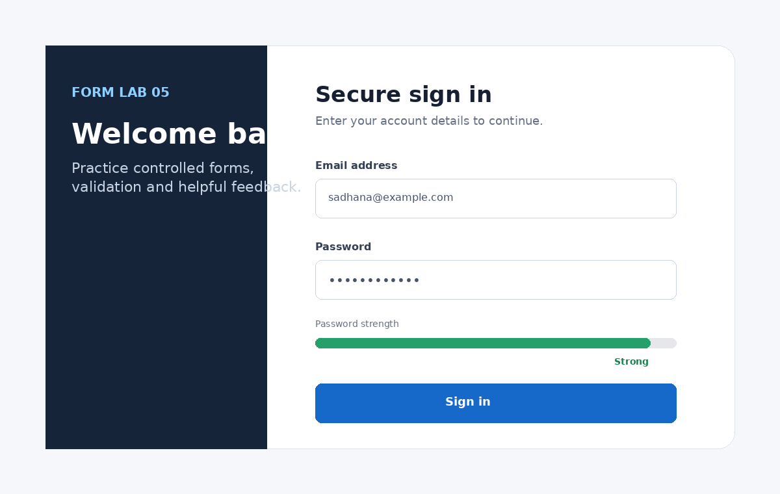
Password feedback and a split-panel sign-in layout.

Exercise 02 — Focus selection
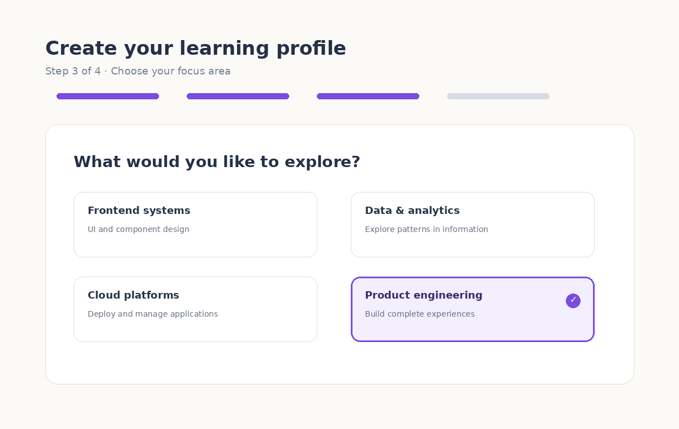
A card-based onboarding step with visible progress.

Completion state
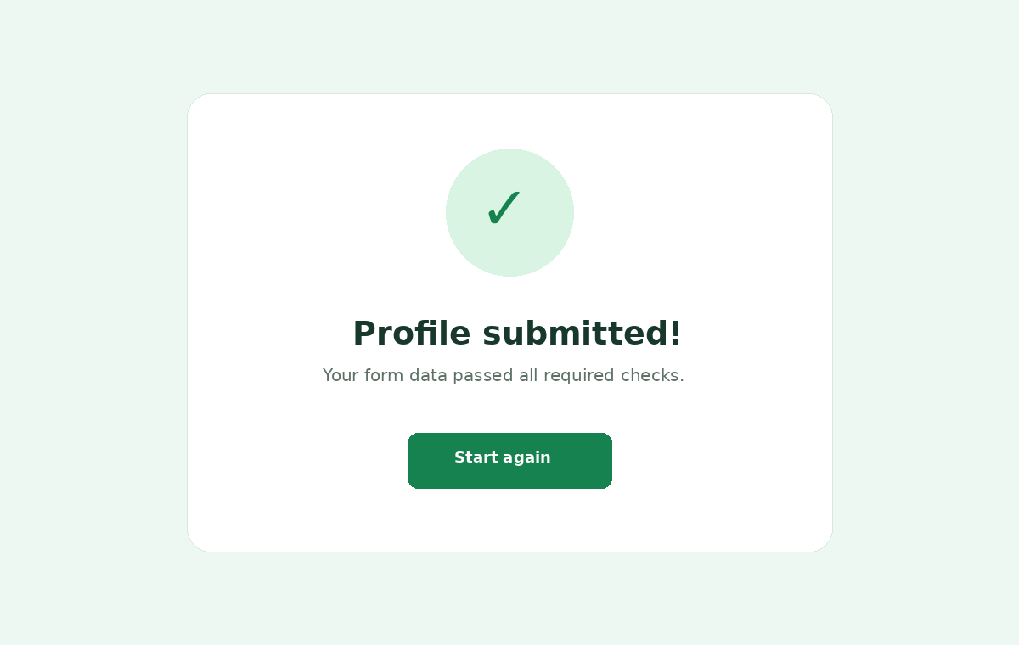
A separate confirmation screen after successful submission.

9. Key Observations
- Form values remain controlled by React state throughout the interaction.
- The password meter evaluates independent requirements instead of relying on a single regular expression.
- The onboarding workflow retains profile data when the user moves backward.
- Navigation is disabled when the current step does not satisfy its validation conditions.
- The layout adapts to smaller screens through a responsive media query.

10. Conclusion
The completed lab demonstrates practical React form handling with reusable validation rules and a multi-step user workflow. The final implementation emphasizes clarity, responsive layout, and understandable feedback while covering the core form-validation and onboarding concepts required by the lab.

