Features are listed below. High, Low, and Medium cast are used to indicate the importance of features.

|  |  |  |  |
| --- | --- | --- | --- |
| **Feature id** | **Description** | **Priority** | **Requester** |
| FE -01 | Internet based and can use from devices such as desktop,laptop,mobile and tablet. | High |  |
| FE-02 | Can be used by the buyer and seller. | High |  |
| FE-03 | Buyer can see how she/he looks after wearing the dress, shoes, glasses etc. | High |  |
| FE-04 | Buyer can also see the customer review while buying a product. | Medium |  |
| FE-05 | There will be a payment system where buyer can pay their payment. | High |  |

Use Cases

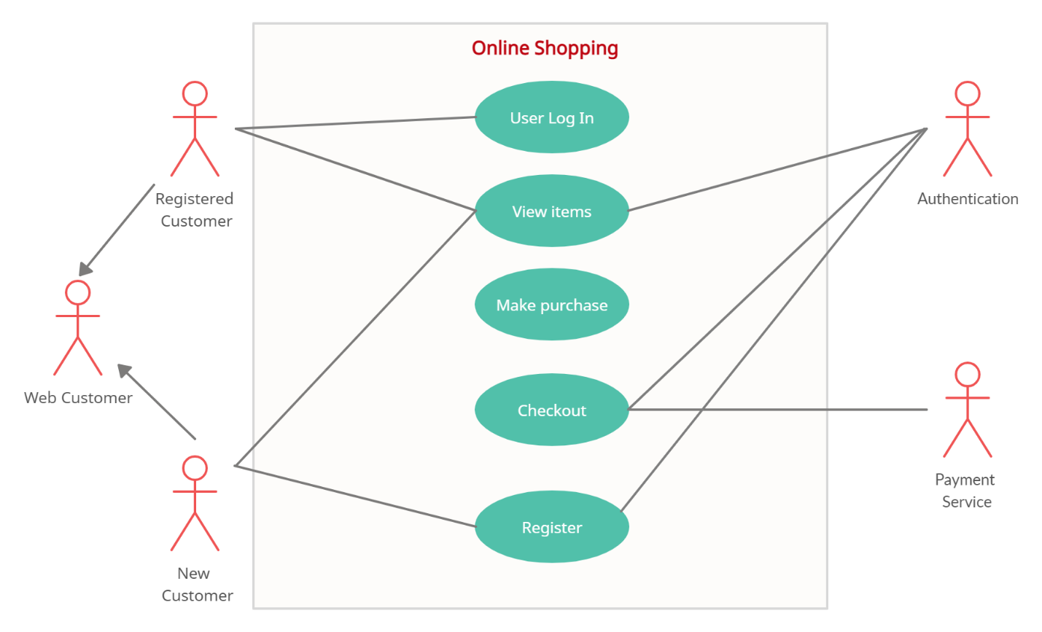

|  |  |
| --- | --- |
| **FE-01 –Customer Verification** | |
| **FE02_UC01** - User verification | |
| **Brief Description** | The customer opens up the portal and the portal shows the login form for access.He can update the price list. |
| **Pre-condition/s** | * User is not logged in already |
| **Priority** | High |
| **Actor/s** | Seller |
| **Main Success Scenario** | 1. Seller opens up the web portal 2. Seller update the price list. 3. System will update this. 4. The buyer can see all the details about the product. |
|  |  |

|  |  |
| --- | --- |
| FE-02-System and Management | |
| Brief Description | System will update the price list, discount price etc and buyer can see. |
| Pre-Condition | Products must be legal. |
| Priority | high |
| Actors | Buyer |
| Main Success | 1.System will book products with customer id.  2.Buyer can pre order products.  3.Buyer can make payment and take home delivery. |
| Notes | System will provide the options for buyer. |

|  |  |
| --- | --- |
| FE-03-Payment Method | |
| Brief Description | Here the payment system will be discussed. |
| Pre -Condition | System will follow up the buyer. |
| Priority | high |
| Actors | buyer |
| Main Success | 1.buyer will pay the money to the Seller  2.Here the buyer can pay the money by cash or online. |
| Notes | Here the purchase will done. |