ML Assignment # 1  
 Saniya Ashraf  
 September 2022

Student Name: SAEEDULLAH

CMS ID : 53493

Software Engineering

5th Semester

1.1 Task 1  
In your terminal, run  
>> conda info

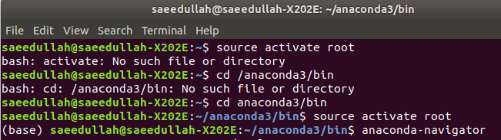

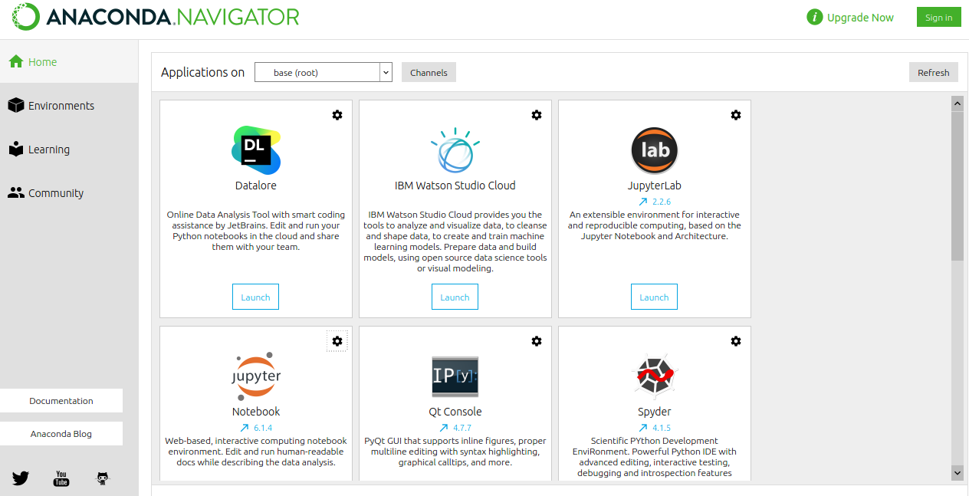

and paste the result into your report.

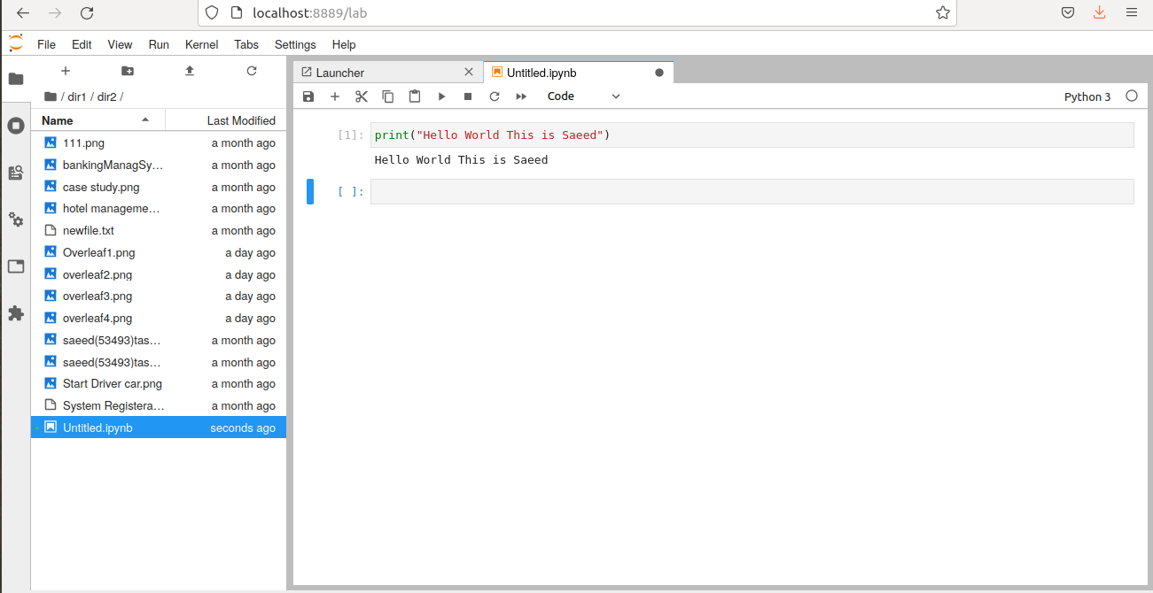

3.1 Task 2  
Run the following script in IPython and paste the figure created by the script  
into your report.  
import matplotlib.pyplot as plt  
plt.plot([1,2,3,4], [1,2,7,14])  
plt.axis([0, 6, 0, 20])  
plt.show()

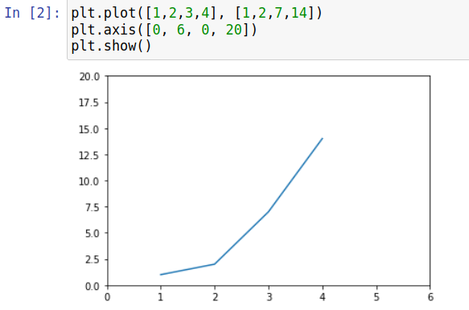

3.2 Task 3  
Use Matplotlib to create a figure of your choice in IPython. Paste your code  
and figure into your report.

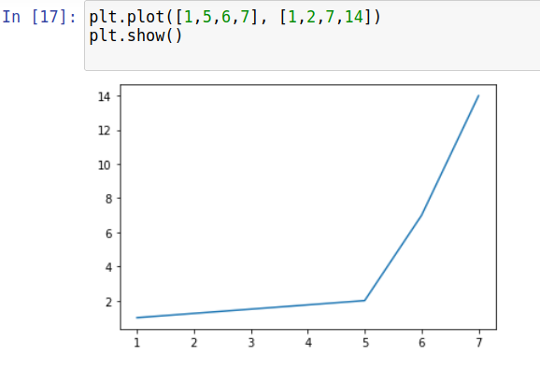

4.1 task 4  
register for a student account here for free private repository access for future  
projects and go through these tutorials. insert a screenshot of your user page  
in github in your report.

