Software Engineering Department



REPORT
PARKINSON DISEASE
Submitted By
DANYAL GHANI | 53440
FAISAL KAKAR | 53929
SAEEDULLAH | 53493
TO
Saniya Ashraf
Lecturer, Department of Software Engineering,
Faculty of ICT, BUITEMS, Quetta.
Session Fall – 2022
22/January/2023

BALOCHISTAN UNIVERSITY OF INFORMATION TECHNOLOGY, ENGINEERING AND MANAGEMENT SCIENCES, QUETTA.
1. Project Category:
This project is an application problem that attempts to Parkinson Disease of human, generally on the basis of symptoms. This project lies under the category of Supervised Learning and deals with Life Sciences specifically Nervous Disease (Mental Health).

2. Introduction:
Parkinson’s disease is a brain disorder that causes unintended or uncontrollable movements, such as shaking, stiffness, and difficulty with balance and coordination.
Symptoms usually begin gradually and worsen over time. As the disease progresses, people may have difficulty walking and talking. They may also have mental and behavioral changes, sleep problems, depression, memory difficulties, and fatigue. [1]
Parkinson’s disease is a brain disorder that causes unintended or uncontrollable movements, such as shaking, stiffness, and difficulty with balance and coordination. Symptoms usually begin gradually and worsen over time. As the disease progresses, people may have difficulty walking and talking. They may also have mental and behavioral changes[2]

3. Motivation Story:

The Computer Science and Software Engineering Students have types 350 words of text (two thirds of a page) on their own computer and KeySense records a myriad of timings about their finger movement which cause the Parkinson Disease. [6]
Most people with Parkinson’s first develop the disease after age 60, about 5% to 10% experience onset before the age of 50. Early-onset forms of Parkinson’s are often, but not always, inherited, and some forms have been linked to specific alterations in genes. [5]

4. Related Work:

These days, as someone types on a computer keyboard, the characteristics of their finger movement can be measured down to millisecond accuracy. Based on 4 years of peer-reviewed scientific research, with nearly 500 worldwide participants and 9,000 typing samples. The user types 350 words of text (two thirds of a page) on their own computer and KeySense records a myriad of timings about their finger movement. [3]
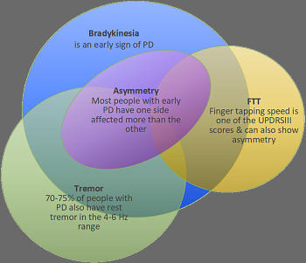
This data is then fed through a series of 11 machine learning models which identify the probabilities of specific movement features being within – or outside – normal expected ranges. Specifically, KeySense measures incon- sistency, drop-off and sidedness of movement and tremor, as well as combining these into an overall score. [4]

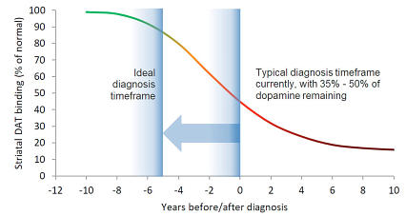

5. Our Dataset:
Our dataset have 43 features and have one Status Lable with 200 samples to find the Parkinson Disease.
The following steps can include in our dataset processing:
a). Dataset can be balance from unbalance dataset in Status lable.
b). Dataset can Split into train and test data.
c). Dataset can be scalled.
d). Apply model on the Dataset.

It can be available in kaggle* website. Which can require registration and download it to our local memory in CSV (comma-separated values) format.

6. Our Findings:
We apply the following Model to check its accuracy and its function:
1. Logistic Regression.
2. Decision Tree Classifier.
3. Support Vector Machine Classifier.
4. XGBoost Classifier.
We divide our problem into Balance Dataset Accuracy and Error and Imbalance Dataset Accuracy and Error. And comparing the Testing and Training Accuracy.

7. Results:

The summary of our results is given below, Where Decision Tree Classifier performed well.

Score:
MODEL (Algorithm) | Score (Accuracy)
Logistic Regression | 84%
Decision Tree | 98%
SVC by “RBF” Function | 91%
SVC by “poly” Function | 50%
XGBOOST | 100%

Error:

MODEL (Algorithm) | Error
Logistic Regression | 16%
Decision Tree | 2%
SVC by “RBF” Function | 9%
SVC by “poly” Function | 50%
XGBOOST | 0%

7. References:
[1] Information about Parkinson’s disease by National Institute of Neurological Disorders and Stroke (NINDS), National Institute on Aging https://www.nia.nih.gov/health/parkinsons-disease
800-352-9424
braininfo@ninds.nih.gov
www.ninds.nih.gov

[2] National Institute of Neurological Disorders and Stroke.
Parkinson’s Disease: Causes, Symptoms, and Treatments
https://www.nia.nih.gov/health/parkinsons-disease

[3] KeySense is a registered trademark of Parkinson’s Research (Australia) © Copyright 2022 Parkinson’s Research (Australia)
https://www.parkinsons-research.org/keysense.htm

[4] KeySense is a registered trademark of Parkinson’s Research (Australia). Parkinson's disease symptoms are different for different people. Some are hard for even doctors to detect. Others are obvious even to an untrained eye
https://www.parkinsons-research.org/keysense.htm

[5] Parkinsons Research (Austailia) by KeySense.
“https://www.parkinsons-research.org/diagnosis.htm“

[6] National Institute of Neurological Disorders and Stroke.
Parkinson’s Disease: Causes, Symptoms, and Treatments
https://www.nia.nih.gov/health/parkinsons-disease.

Dataset * Parkinson Disease Dataset in Kaggle.
https://www.kaggle.com/datasets/egintu/stress

