# Technical Summary

|  |  |
| --- | --- |
| Study Title | ADRIFT: Spatial and Temporal Distribution of Cetaceans in the California  Current Ecosystem Using Drifting Archival Passive Acoustic Monitoring |
| Report Title | Final Report for ADRIFT in the California Current Survey: Passive Acoustic Monitoring in the California Current using Drifting Recorders |
| Report Number(s) (OCS Study) | PC-20-04 |
| Completion Date of Report | September 2024 |
| Number of Pages | 98 |
| Award Number(s) | G14 M20PG00013 |
| Sponsoring OCS Region or Office | Pacific |
| Applicable Planning Area(s) | California, Oregon |
| Fiscal Year(s) of Study Funding | FY 2020: $2,715,410 |
| Costs by Fiscal Year | FY 2020: $1,365,410.00; FY 2021: $550,000.00; FY 2022: $800,000.00; FY 2023: $0; FY 2024: $0 |
| Cumulative Project Cost | $2,715,410 |
| Project Manager(s) | Shannon Rankin |
| Affiliation of Project Manager(s) | Marine Mammal & Turtle Division, Southwest Fisheries Science Center, NOAA Fisheries, National Oceanic and Atmospheric Administration |
| Address of Project Manager(s) | 8901 La Jolla Shore Dr., La Jolla, CA 92037 |
| Principal Investigator(s) | Shannon Rankin, Kourtney Burger, Cory Hom-Weaver, Kaitlin Palmer, Taiki Sakai, Anne Simonis |
| Keywords | Passive acoustic monitoring, marine mammals, cetaceans, renewable energy, Pacific Outer Continental Shelf |

**ABSTRACT:**

Renewable energy development in the Outer Continental Shelf (OCS) off California and Oregon requires research to understand the potential impacts of proposed activities on protected species in the Pacific; these data will inform environmental analyses and the decision-making process. BOEM and NOAA partnered to deploy drifting acoustic recording buoys to collect acoustic data from cetacean species and ocean noise in these offshore waters. In addition to successful deployment of 90 buoys in and near the proposed Wind Energy Areas (WEAs), NOAA analyzed archived drifting acoustic data from two previous surveys (CCES 2018, PASCAL 2016) for soundscape and the presence of marine mammal species.

**BACKGROUND**:

Passive acoustic monitoring (PAM) is an efficient approach to monitoring marine mammals as well as simultaneous characterization of the overall soundscape. Typical methods for offshore PAM studies can provide good temporal resolution (seafloor recorders) or good spatial resolution (towed hydrophone arrays); drifting recorders have been increasingly deployed during large scale surveys to augment visual line transect for cryptic and deep-diving species. As drifting recorders are not tethered to the seafloor or to a ship, they have shown potential as an alternative PAM platform for wind energy areas identified in the deep offshore waters of the U.S. West Coast. The ADRIFT in the California Current Project ('Adrift') used drifting acoustic recorders deployed offshore the U.S. West Coast, combined with more complete analysis of archived data from previous drifting acoustic recorder surveys, to assess the distribution of marine mammals and to characterize the marine soundscape.

**OBJECTIVES**:

The Adrift study uses passive acoustic drifting recorders to collect acoustic data on marine mammals and the ocean soundscape offshore California and Oregon to:

* Identify marine mammal species that frequent the WEAs,
* Describe the seasonal occurrence/distribution of marine mammal species in the California Current Ecosystem (CCE) and Wind Energy Areas (WEAs),
* Estimate densities for various marine mammal species when data are suitable, and
* Describe the ambient noise level(s) in the CCE and WEA(s) and identify the major contributors to the soundscape

**METHODS**:

Drifting acoustic buoys were deployed in and near the WEAs as opportunity (vessel availability, weather) allowed, with a focus on obtaining seasonal data. Data were analyzed to measure soundscape metrics and for the presence of odontocetes (sperm whales, beaked whales, dolphins, narrow-band high frequency species) and mysticetes (blue, fin, humpback, Bryde’s, sei, gray, and minke whales). Hourly detection and probability of detection are provided for each species, location, and season to allow for comparisons across these and other data. Methods to detect marine mammal species varied (detailed information provided in report and online methods). Soundscape metrics were measured using Triton’s Soundscape Remora (1 Hz, 1 s resolution). Raw data, metadata, and data products will be publicly available.

**RESULTS:**

A total of 90 drifting acoustic recorders were successfully deployed during the Adrift survey for a total of 493 days of effort (n = 21 in Oregon, n = 28 in Humboldt, n = 11 off San Francisco, and n = 30 off Morro Bay). In addition to new data collection, 529 days of data from 15 buoys were analyzed from the CCES 2018 survey and 421 days of data from 29 buoys were analyzed from the PASCAL 2016 survey. Summaries are provided for each species:

* Sperm whales: Detection of sperm whales were higher in Humboldt than our other study areas; there were no clear seasonal or annual trends.
* Beaked Whales: Beaked whales were most frequently detected in Morro Bay, with fewer detections off San Francisco and Humboldt, and no detections off Oregon. Goose-beaked whales were most commonly detected, followed by Baird’s beaked whale and few detections of other beaked whale species. There were fewer beaked whale detections during Adrift than the PASCAL and CCES surveys. Detection of large number of beaked whales concurrent with dolphin detections off Morro Bay were possible due to the vertical array on the drifting recorder that provided a means of identifying detection of deep diving beaked whales during massive acoustic encounters with more shallow diving dolphin schools.
* Dolphins: Previous surveys found a general decrease in detection of dolphins with increasing latitude off the U. S. West Coast and this trend was confirmed in our analysis of data from PASCAL and CCES. The highest probability of detecting Risso’s dolphins was off Humboldt during the upwelling season, and the highest probability of detecting Pacific white-sided dolphins was in Morro Bay during the upwelling season (and then San Francisco and Humboldt in the post-upwelling season).
* Narrow Band High Frequency (NBHF) species: Detection of NBHF species was similar across regions during the upwelling season, and increased in Oregon and San Francisco during the post-upwelling season. Probability of detecting NBHF species was relatively stable across seasons in Humboldt, and showed at least some level of annual variation in Morro Bay.
* Blue whales: Detection of blue whale song showed a consistently strong seasonal pulse during the post-upwelling season in all regions except Oregon, where there were few blue whale detections. Detection of blue whale D calls, considered to be social sounds, were detected during the late upwelling and post-upwelling seasons in all regions except Oregon, and at lower detection probability rates than song.
* Fin whales: Acoustic detection of fin whales was highly variable across region, season, and year. The probability of detection 40 Hz calls, associated with feeding, was lower than 20 Hz song.
* Humpback whales: Humpback whale social sounds were detected primarily in the post-upwelling season in Humboldt and San Francisco, with few detections in either Oregon or Morro Bay. The probability of detecting humpback song was higher in the post-upwelling for Humboldt and San Francisco, and few humpback whales were detected in Oregon. The probability of detecting humpback song was similar for the upwelling and post-upwelling seasons in Morro Bay.
* Bryde’s, sei whales: There were no detections of Bryde’s or sei whales during Adrift. Bryde’s whales occur in warmer waters and are not expected north of Point Conception, though this may change with increasing ocean temperatures due to climate change. There is little known of the vocal repertoire of Bryde’s and sei whales. More research on the vocal repertoire is needed, especially for sei whales, in order to use passive acoustics to study their populations in the Pacific Ocean.
* Gray whales: Gray whales migrate nearshore and there is little overlap with our Adrift deployments, and therefore our detection of this species is low. Most gray whale detections occurred off Oregon, and may be from the resident gray whales. There were some detections of gray whales during the post-upwelling season off San Francisco.
* Minke whales: There were no detections of minke whale song during the Adrift project, and very few during PASCAL and CCES. Little is known of the offshore distribution of this species, and of their vocal repertoire other than the ‘boing’ song. Additional research on the vocal repertoire of the minke whale is needed.
* Vessel Traffic in Humboldt shifted from night-time during the upwelling season to daytime during the post-upwelling season (summer). Morro Bay experienced the lowest amount of vessel traffic.
* Soundscape varied over time and space, with general ambient noise levels ranging from 50 dB re 1μPa to nearly 150 dB re 1 μPa (and the highest density of sound in the 75 – 100 dB range).

Adrift data collection efforts were constrained by the Covid pandemic but provide additional baseline data to inform management decisions related to offshore renewable energy development. Acoustic detection of baleen whales generally relies on detection of ‘song’, which is known to vary seasonally due to their migration patterns. Acoustic detection of toothed whales includes many deep diving species found in offshore waters, including those in and near the WEAs. Soundscape and vessel traffic showed strong variability in time and space. These data update and expand the available baseline data on presence of whale and dolphin species in the Pacific, and especially within and near the WEAs.

**CONCLUSIONS**:

Passive acoustics can serve as a means to remotely monitor offshore environments to understand the distribution of protected marine mammal species, and to understand geographic and temporal variation in their distributions. Data collection efforts were limited by the Covid pandemic but provide additional baseline data to improve our understanding of species presence in and near the WEAs. Some species showed strong seasonal presence (blue whales during upwelling season), while others showed significant variability (fin whales, humpback whales). We further expanded our understanding of beaked whales off Morro Bay, and provided additional information related to the presence of NBHF species in these regions. Ambient noise and vessel traffic varied in time and space and these data will contribute to an understanding of the baseline soundscape. Future research should consider deployment of clustered drifting acoustic recorders in conjunction with seafloor recorders to provide additional spatial context on marine mammals and the ocean soundscape.

**STUDY PRODUCTS:**

1. **BOEM study report:** Rankin, S., Burger, K., Hom-Weaver, C., Palmer, K., Sakai, T., Simonis, A. (Southwest Fisheries Science Center, NOAA Fisheries, La Jolla, CA). 2024. Final Report for Adrift in the California Current Survey: Passive Acoustic Monitoring in the California Current using Drifting Recorders. Camarillo (CA): U.S. Department of the Interior, Bureau of Ocean Energy Management. 98 p. Report No.: OCS Study BOEM 2024-047. Contract No.: G14 M20PG00013.
2. **Raw Acoustic Data, Metadata, Soundscape:** Raw acoustic data, metadata, and soundscape data are archived at the National Centers for Environmental Information and will be publicly available (<https://www.ncei.noaa.gov/products/passive-acoustic-data>). Detection data will be archived at Passive Acoustic Cetacean Map (<https://apps-nefsc.fisheries.noaa.gov/pacm/#/>). Copies of the data are archived Southwest Fisheries Science Center.
3. **Acoustic Data Products:** Acoustic data products (deployment data, detection data), including high resolution figures, code to reproduce data products, supplementary data, and associated reports and presentations are provided in the Adrift public repository (<https://github.com/SAEL-SWFSC/Adrift>). An html output of this repository is also available (<https://sael-swfsc.github.io/Adrift/).>
4. **Educational Resources:** “Eavesdropping on the Ocean” is a free classroom activity developed by Data Nuggets (<https://datanuggets.org/2024/04/eavesdropping-on-the-ocean>)
5. **Open Science Data Products:**
   * PAMpal- Processing passive acoustic data (<https://github.com/TaikiSan21/PAMpal>)
   * PAMscapes- Data integration and visualization of Soundscapes ([https://github.com/TaikiSan21/PAMscapes)](https://github.com/TaikiSan21/PAMscapes)-)
   * RoboJ- Methods for streamlining processing of beaked whale acoustic data for density estimation (<https://github.com/TaikiSan21/RoboJ>)

**MAP OF STUDY AREA**: Figure 3.2 of report OCS Study BOEM 2024-047.

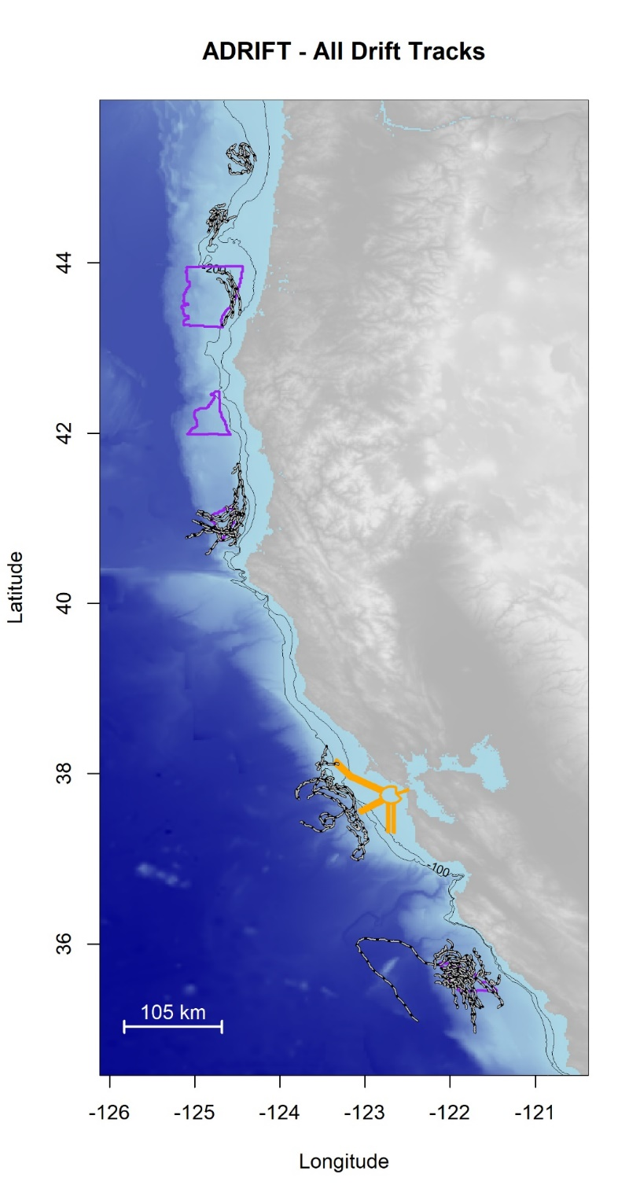

Figure 1. Plot of all successful drifts deployed during the Adrift in the California Current project. Drifts are shown as black/white lines; Wind Energy Areas are outlined in purple, and shipping lanes are outlined in yellow.