CSE145 – Introduction to Computing Assignment 2:
Turing Machines
— Design, Analysis & Simulation This assignment is individually personalized —
Name: ____Syed Abdullah Emad____ ERP No.: __36853___ Personalization block (fill in — see below): R = _53__ V = __1__ B = __110101__ n = __3__
Github repo link: https://github.com/SAEmeu/ITC/tree/36853-cse101-tm-Assignment-2
Q1) Task A) We want it to accept any binary value that is divisible by 4. While looking at multiples of 4 in binary I noticed that all of them had their last 2 digits to “00”. This makes sense as we want the value to not be odd so the last bit need to be off and we don’t want every even value so we will remove 2. Now I just need to make a tm that searches for and accepts only binary values that have 00 in the end. This also solves the problem of accepting 0 as a value.
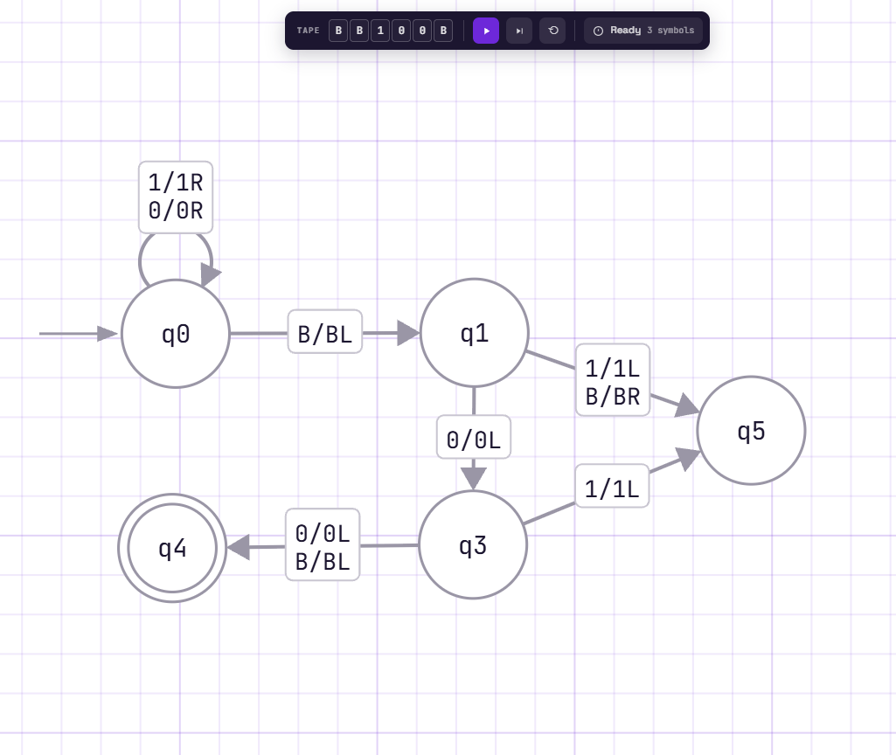
Line 3 README run 1) 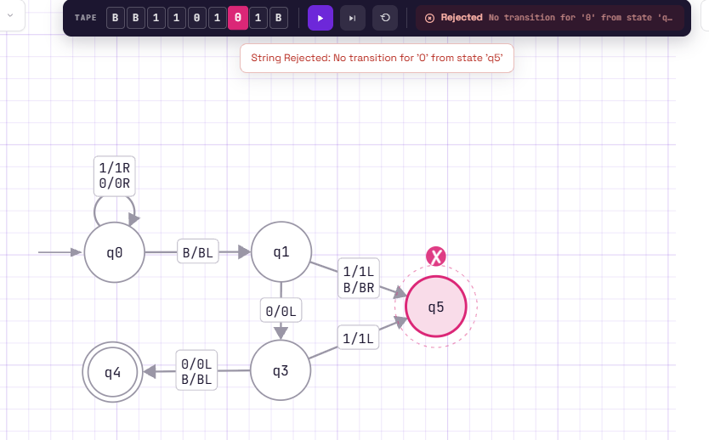
Line 4 README run 2)
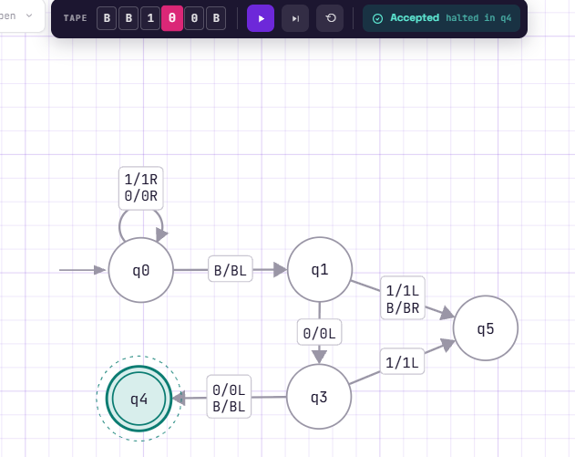
Line 5 README run 3)
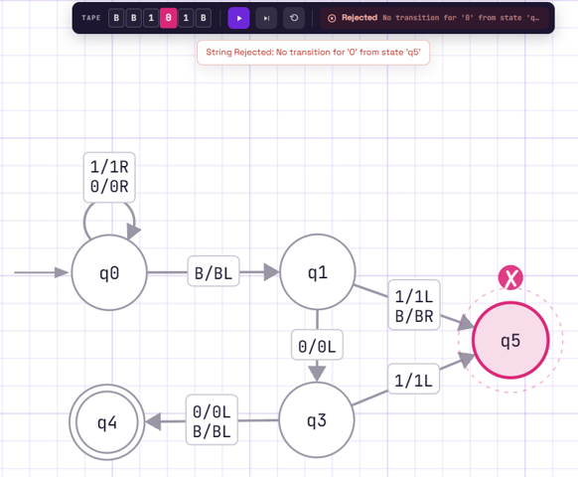

Q1 Task D) This TM would not work for any other value of M as it is only build for M=4 where the last 2 bits are always 0, which means the divisibility condition would be different for another M. I would need to change the transitions in the checking states, such as q1 and q3, and possibly add or remove states depending on the new divisibility rule.

Q2 Task A) The TM will scans the input from left to right, marking each processed a as Y so it is not used again. For every unmarked a, the machine searches for and marks two (b)s as X. It marks each a and its corresponding two (b)s so that they are not counted again during the next pass. The machine moves back and forth across the tape, repeating this process until all the as have been matched. If every a has exactly two corresponding bs and no unmatched bs remain, the machine accepts, otherwise it will reject.

Task B)
Current State | Read | Write | Move | Next State
q0 | a | a | S | q10
q10 | Y | Y | R | q10
q10 | a | Y | R | q1
q10 | b | b | R | q4
q10 | B | B | R | q4
q10 | X | X | R | q6
q1 | a | a | R | q1
q1 | X | X | R | q1
q1 | b | X | R | q2
q1 | B | B | R | q4
q2 | b | X | L | q3
q2 | B | B | R | q4
q2 | a | a | R | q4
q3 | Y | Y | L | q3
q3 | X | X | L | q3
q3 | a | a | L | q3
q3 | B | B | R | q10
q6 | X | X | R | q6
q6 | a | a | R | q4
q6 | b | b | R | q4
q6 | B | B | R | q8

Task C
README line 7 run 1)
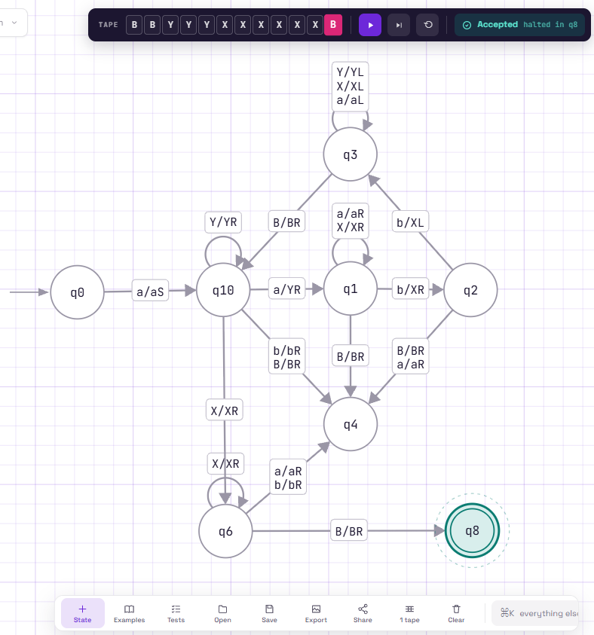
Line 8 README run 2)

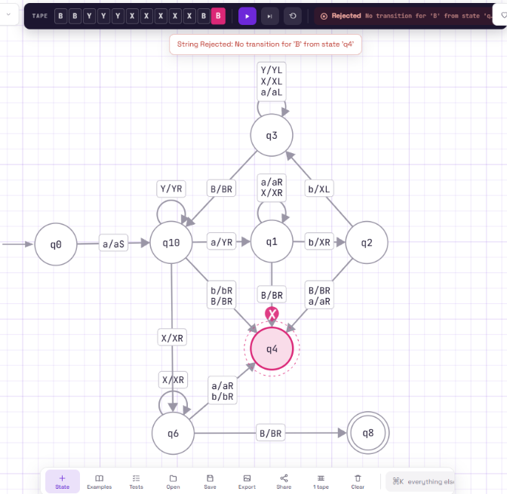
Line 9 README run 3)
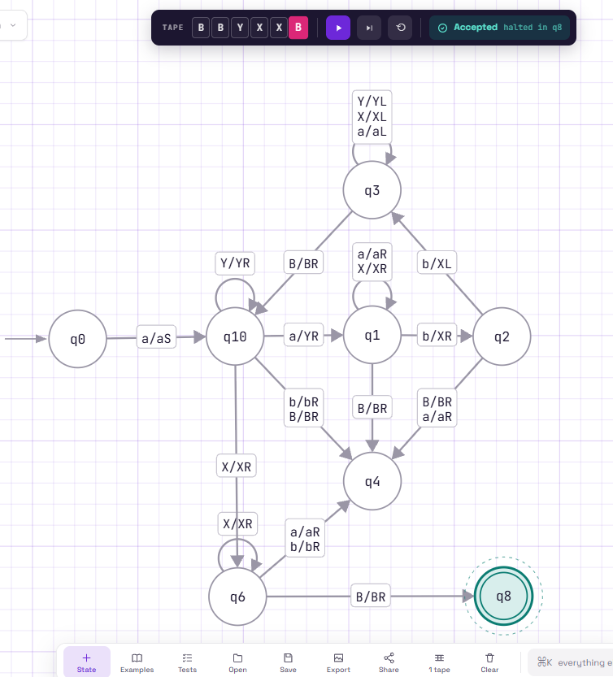
Task D) An off-by-one error could happen while matching the a's with the b's, in q1 and q2, where the machine finds the two b's for each a. I checked this by testing a correct string like aaabbbbbb and an incorrect string like aaabbbbb. The correct string was accepted and the one with a missing b was rejected, so the machine is matching the right number of b's for each a.

Q3 Task A) The machine first moves to the right end of the binary number so it can start the subtraction from the last bit. It then moves left to subtract 1. It changes 1 to 0 when it finds one, or changing a 0(s) to 1(s); continuing left when borrowing is needed. After the subtraction is complete, the machine moves back toward the left side of the tape to remove the unnecessary leading zeros. Finally, when it finds a 1 it stops in the accepting state once the result has been cleaned up.
Task B)
Current State | Read | Write | Move | Next State
q0 | 0 | 0 | R | q0
q0 | 1 | 1 | R | q1
q1 | 1 | 1 | R | q1
q1 | 0 | 0 | R | q1
q1 | B | B | L | q2
q2 | 1 | 0 | L | q4
q2 | 0 | 1 | L | q2
q4 | 0 | 0 | L | q4
q4 | 1 | 1 | L | q4
q4 | B | B | R | q3
q3 | 1 | 1 | R | q5
q3 | 0 | B | R | q6
q6 | 0 | B | R | q6
q6 | 1 | 1 | R | q5

Task C)
Initial) :
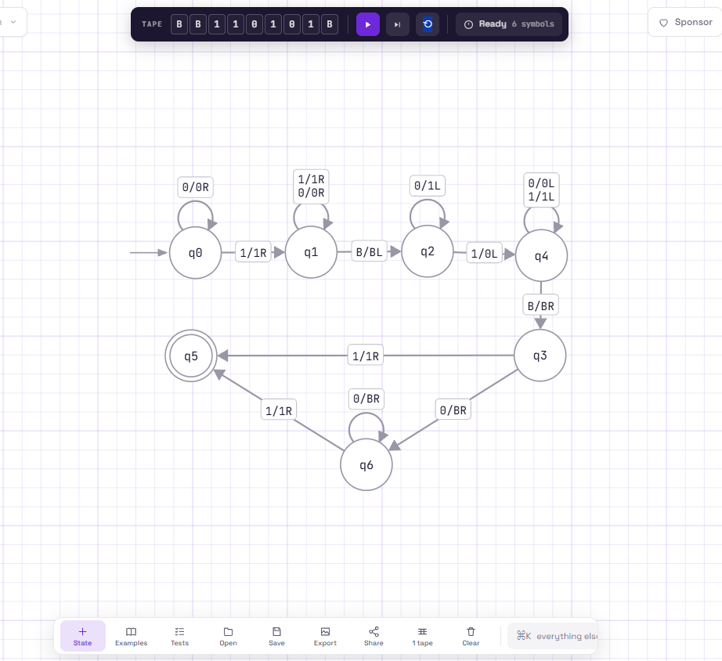
After):
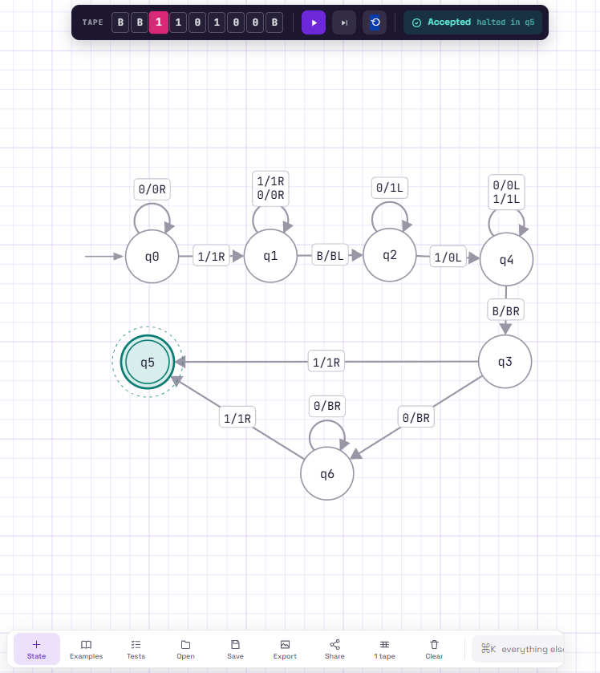
Task D) If the value entered was like this example (10010), changing the left most bit won’t be right because if we need to remove leading zeros and just start changing the last bit to blank we could end up changing a significant bit and loose that data. So we will need to make sure we read that value and change it only when it is a zero and not a 1.

Q4 Task A) I made the machine check whether the first and last symbols of the string are the same. It removes the first symbol, moves to the end of the string, and checks the last symbol against the one it removed. If they match, it removes it and then goes back to the left side and repeats the same process with the next pair of symbols. The machine accepts when all the matching pairs have been checked successfully, and rejects when two symbols do not match. It also checks if only one symbol is left and if it is the only one and in the middle it accepts it.

Task B)
Current State | Read | Write | Move | Next State
q0 | a | a | R | q24
q0 | b | b | R | q24
q0 | c | c | R | q24
q1 | a | B | R | q2
q1 | b | B | R | q16
q1 | c | B | R | q9
q2 | a | a | R | q4
q2 | b | b | R | q3
q2 | c | c | R | q5
q3 | a | a | R | q4
q3 | b | b | R | q3
q3 | c | c | R | q5
q4 | a | a | R | q4
q4 | b | b | R | q3
q4 | c | c | R | q5
q4 | B | B | L | q7
q5 | a | a | R | q4
q5 | b | b | R | q3
q5 | c | c | R | q5
q7 | a | B | L | q8
q8 | a | a | L | q22
q8 | b | b | L | q22
q8 | c | c | L | q22
q8 | B | B | R | q26
q9 | a | a | R | q12
q9 | b | b | R | q10
q9 | c | c | R | q11
q10 | a | a | R | q12
q10 | b | b | R | q10
q10 | c | c | R | q11
q11 | a | a | R | q12
q11 | b | b | R | q10
q11 | c | c | R | q11
q11 | B | B | L | q14
q12 | a | a | R | q12
q12 | b | b | R | q10
q12 | c | c | R | q11
q14 | c | c | L | q15
q15 | a | a | L | q22
q15 | b | b | L | q22
q15 | c | c | L | q22
q15 | B | B | R | q26
q16 | a | a | R | q18
q16 | b | b | R | q19
q16 | c | c | R | q17
q17 | a | a | R | q18
q17 | b | b | R | q19
q17 | c | c | R | q17
q18 | a | a | R | q18
q18 | b | b | R | q19
q18 | c | c | R | q17
q19 | a | a | R | q18
q19 | b | b | R | q19
q19 | c | c | R | q17
q19 | B | B | L | q20
q20 | b | b | L | q21
q21 | a | a | L | q22
q21 | b | b | L | q22
q21 | c | c | L | q22
q21 | B | B | R | q26
q22 | a | a | L | q22
q22 | b | b | L | q22
q22 | c | c | L | q22
q22 | B | B | R | q23
q23 | a | a | S | q0
q23 | b | b | S | q0
q23 | c | c | S | q0
q23 | B | B | R | q6
q24 | a | a | L | q1
q24 | b | b | L | q1
q24 | c | c | L | q1
q24 | B | B | R | q6
Task C)
Line 15 README run 1)
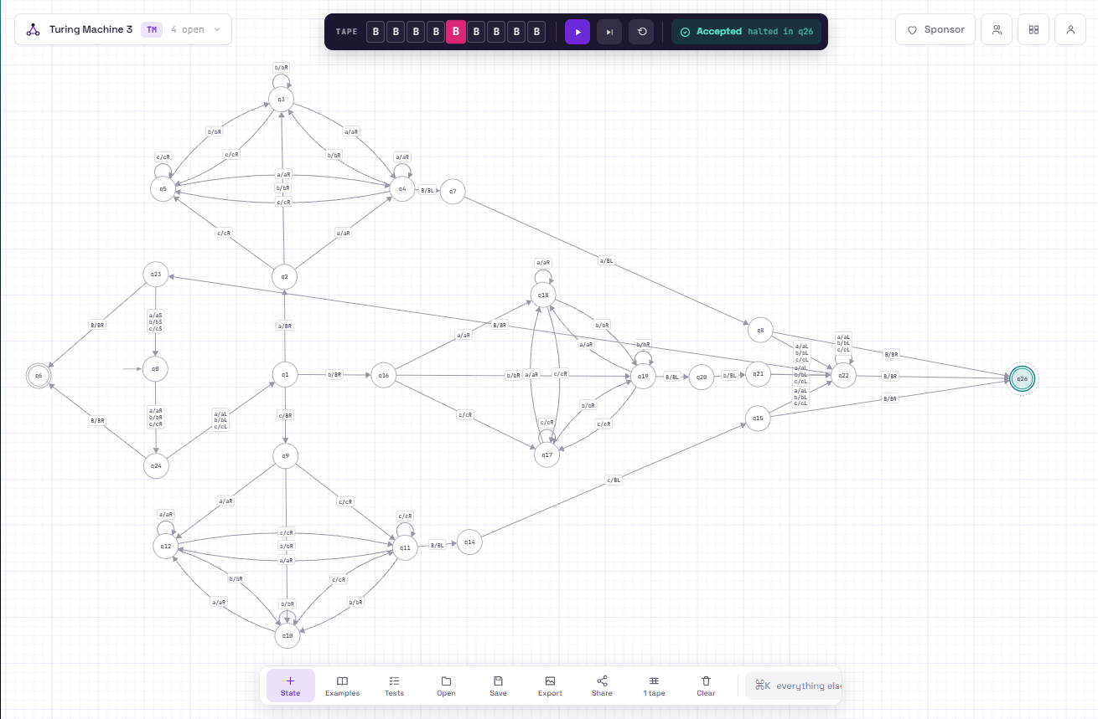
Line 16 README run 2)
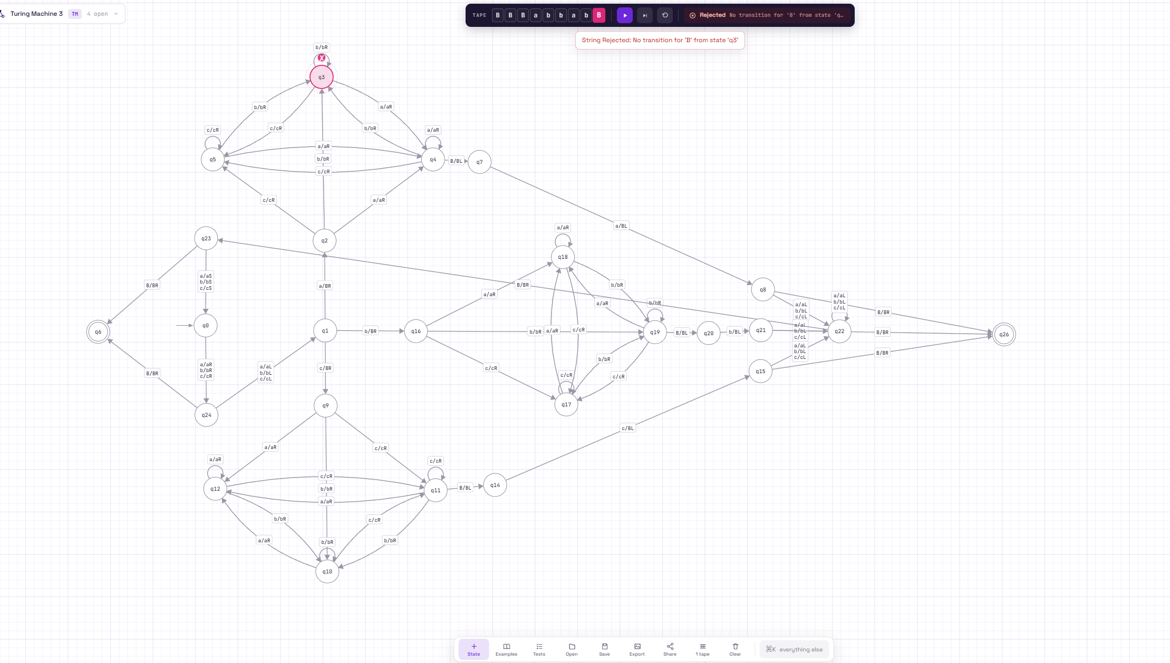
Line 17 README run 3)
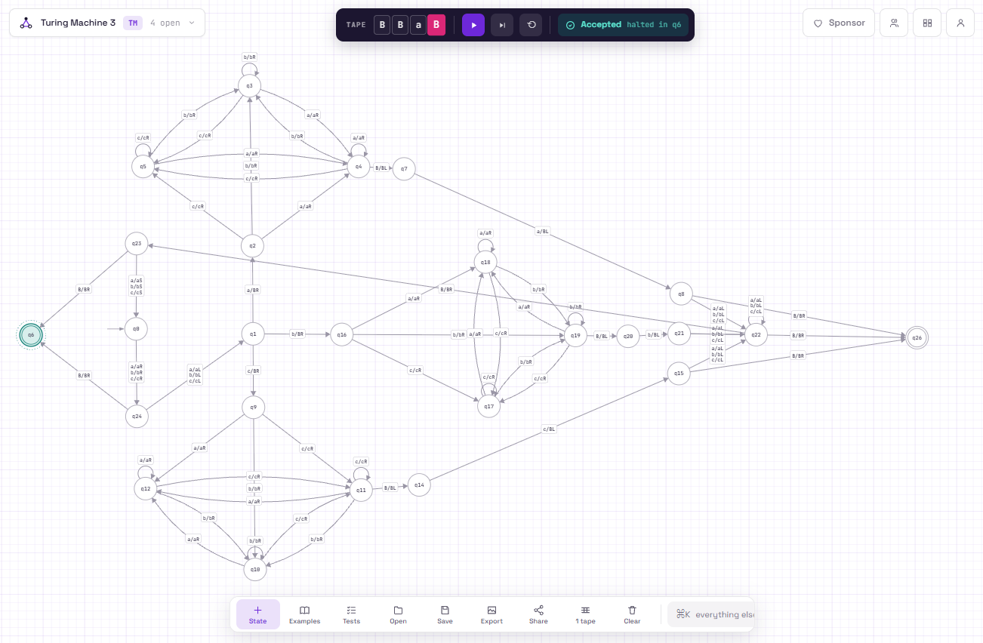
Task D) I need the tape head to make several left-to-right and right-to-left sweeps because the machine has to compare the first and last symbols, then come back and check the next pair. A single left-to-right pass would not let the machine easily compare a symbol with the one at the opposite end of the string without moving back and forth.
Q5 Task A) The Turing machine starts by taking the first symbol on the left side of the # and marks it. It then moves to the right side of the # and checks the symbol from the other end of the string. After finding the matching symbol, it marks it and moves back to the left side and repeats the process. It keeps doing this until all the symbols on both sides have been matched, and then it accepts if the right side is exactly the reverse of the left side. It also accepts if the only symbol is a # as string (w) can be entered empty.
Task B)
Current State | Read | Write | Move | Next State
q0 | 0 | 0 | S | q1
q0 | 1 | 1 | S | q1
q0 | # | # | R | q11
q1 | 0 | B | R | q2
q1 | 1 | B | R | q3
q1 | # | # | R | q7
q2 | 0 | 0 | R | q2
q2 | 1 | 1 | R | q2
q2 | # | # | R | q8
q3 | 0 | 0 | R | q3
q3 | 1 | 1 | R | q3
q3 | # | # | R | q4
q4 | 0 | 0 | R | q4
q4 | 1 | 1 | R | q4
q4 | B | B | L | q5
q5 | 1 | B | L | q6
q6 | 0 | 0 | L | q6
q6 | 1 | 1 | L | q6
q6 | # | # | L | q6
q6 | B | B | R | q1
q8 | 0 | 0 | R | q8
q8 | 1 | 1 | R | q8
q8 | B | B | L | q9
q9 | 0 | B | L | q10
q10 | 0 | 0 | L | q10
q10 | 1 | 1 | L | q10
q10 | # | # | L | q10
q10 | B | B | R | q1
q11 | B | B | R | q7

Task C)
Line 19 README run 1)
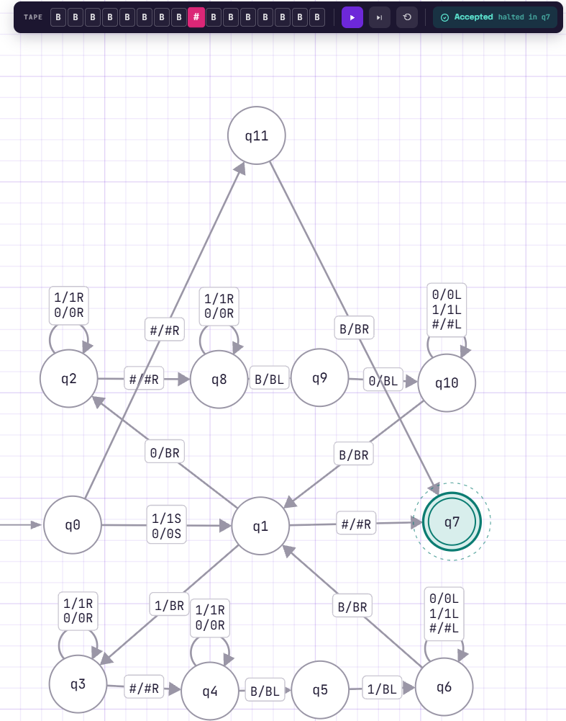
Line 20 README run 2)
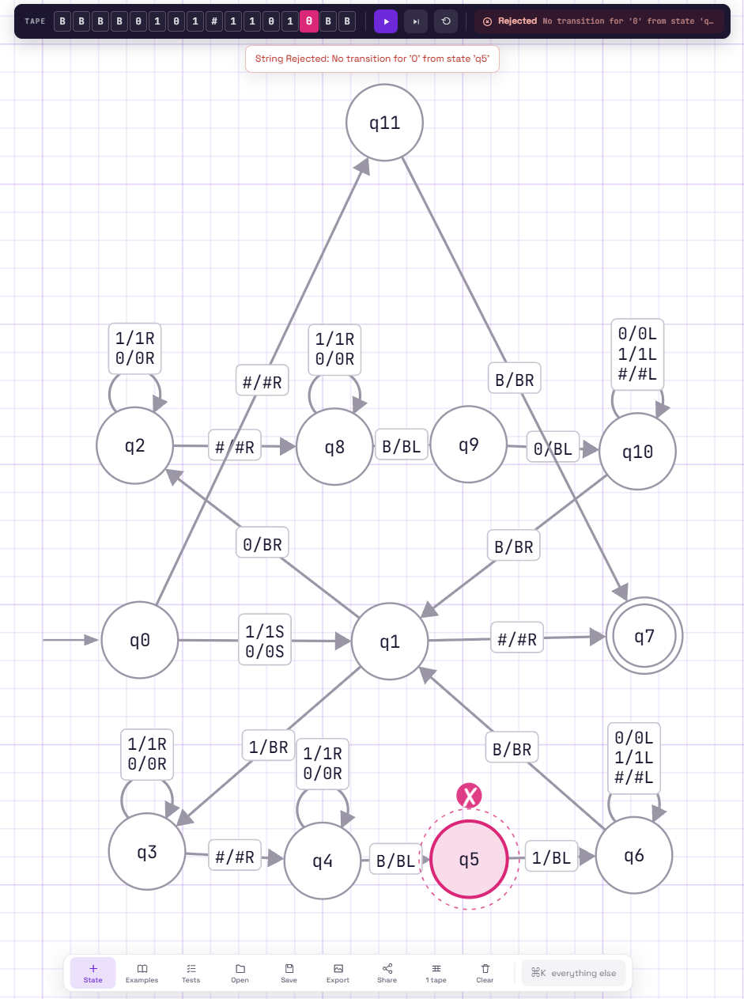
Task D) The machine cannot check the string in just one left-to-right pass because it has to compare each symbol on the left of the # with the matching symbol on the right. It needs to remember which symbol it picked on the left and then move across the # to find the correct symbol on the right. After checking a pair, it has to move back to the left side and repeat the process for the next symbol. Without moving back and forth, the machine would not be able to remember and compare all the required pairs

Q6 Task A) 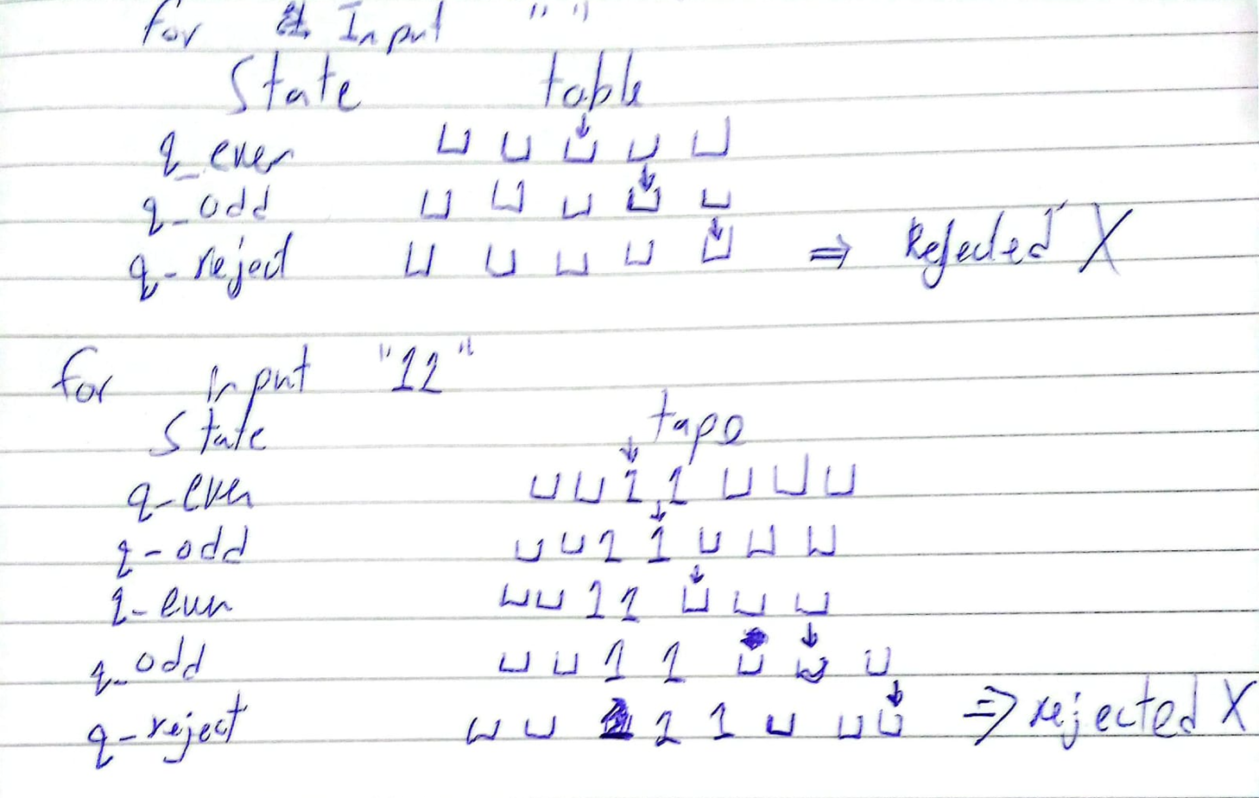
Task B) The incorrect row is the transition for q_even reading a blank. In the trace for the empty string, we see it reaches q_even at the end but goes to q_odd, even though zero/empty is an even number. The same problem happens with 11: after reading 11, the tm returns to q_even, but the blank transition sends it to q_odd and eventually causes the rejection. The correct transition should be q_even, ⊔ -> q_accept, because reaching the end of the tape while in q_even means the input contains an even number of 1s.

Task C)
(Broken)
Line 22 README run 1)
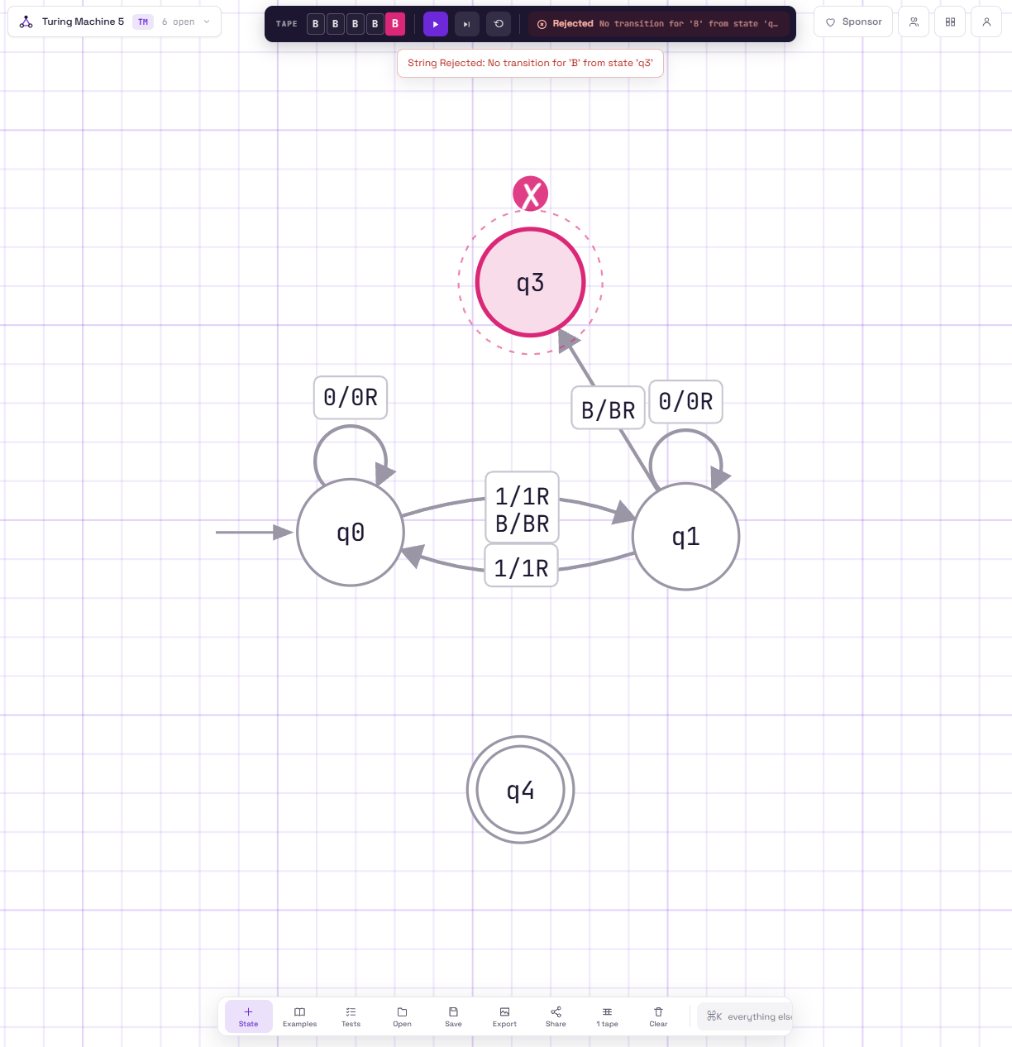
Line 23 README run 2)
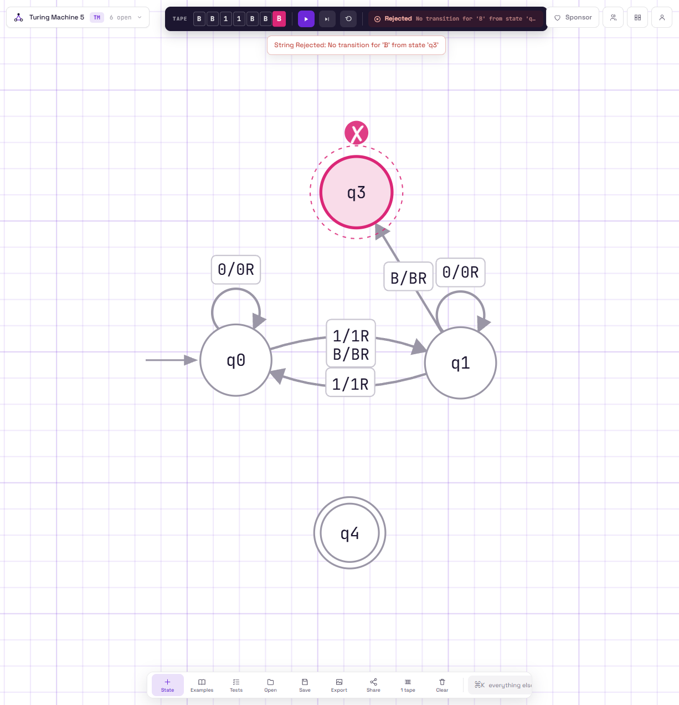
Line 24 README run 3)
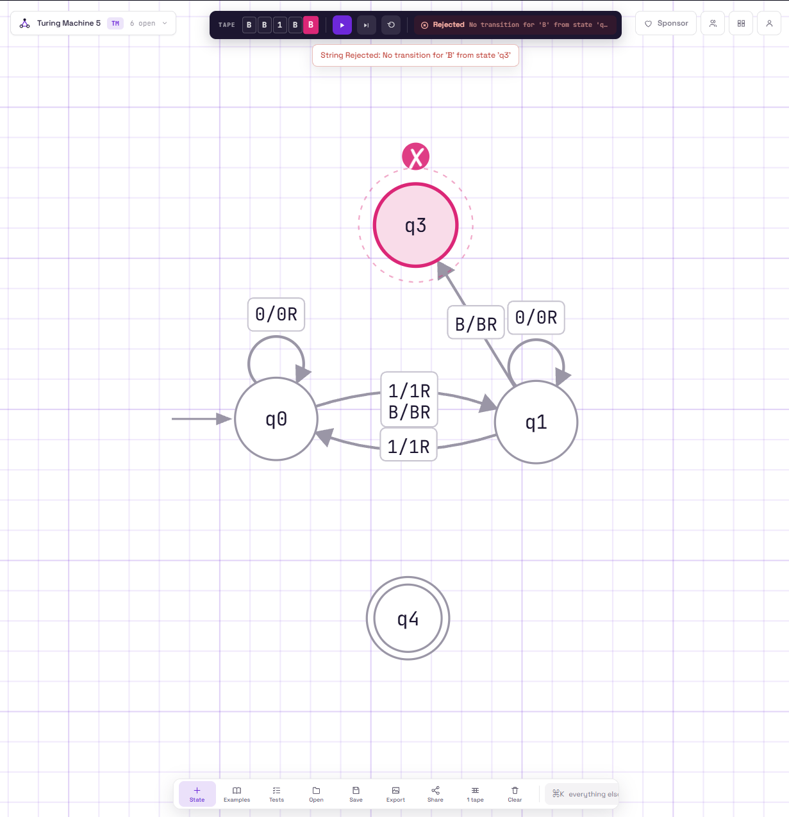
Line 225 README run 4)
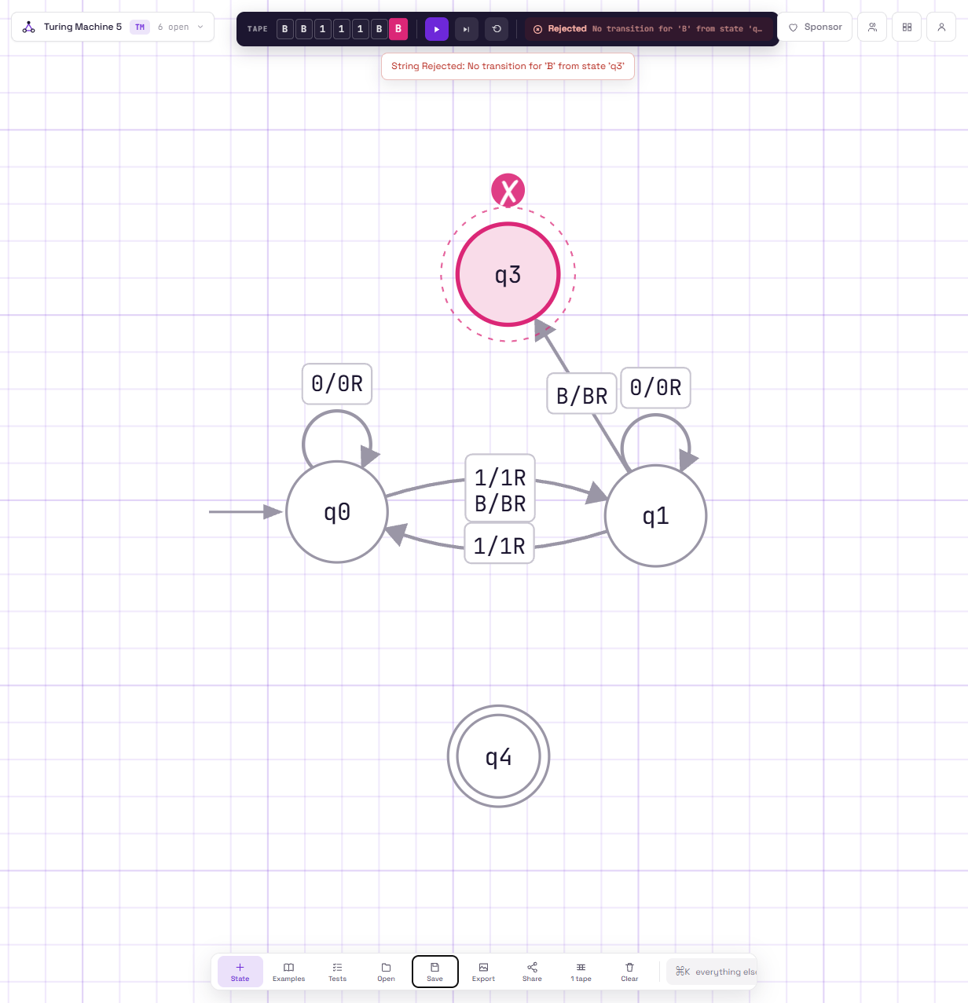
(Fixed)
Line 27 README run 1)
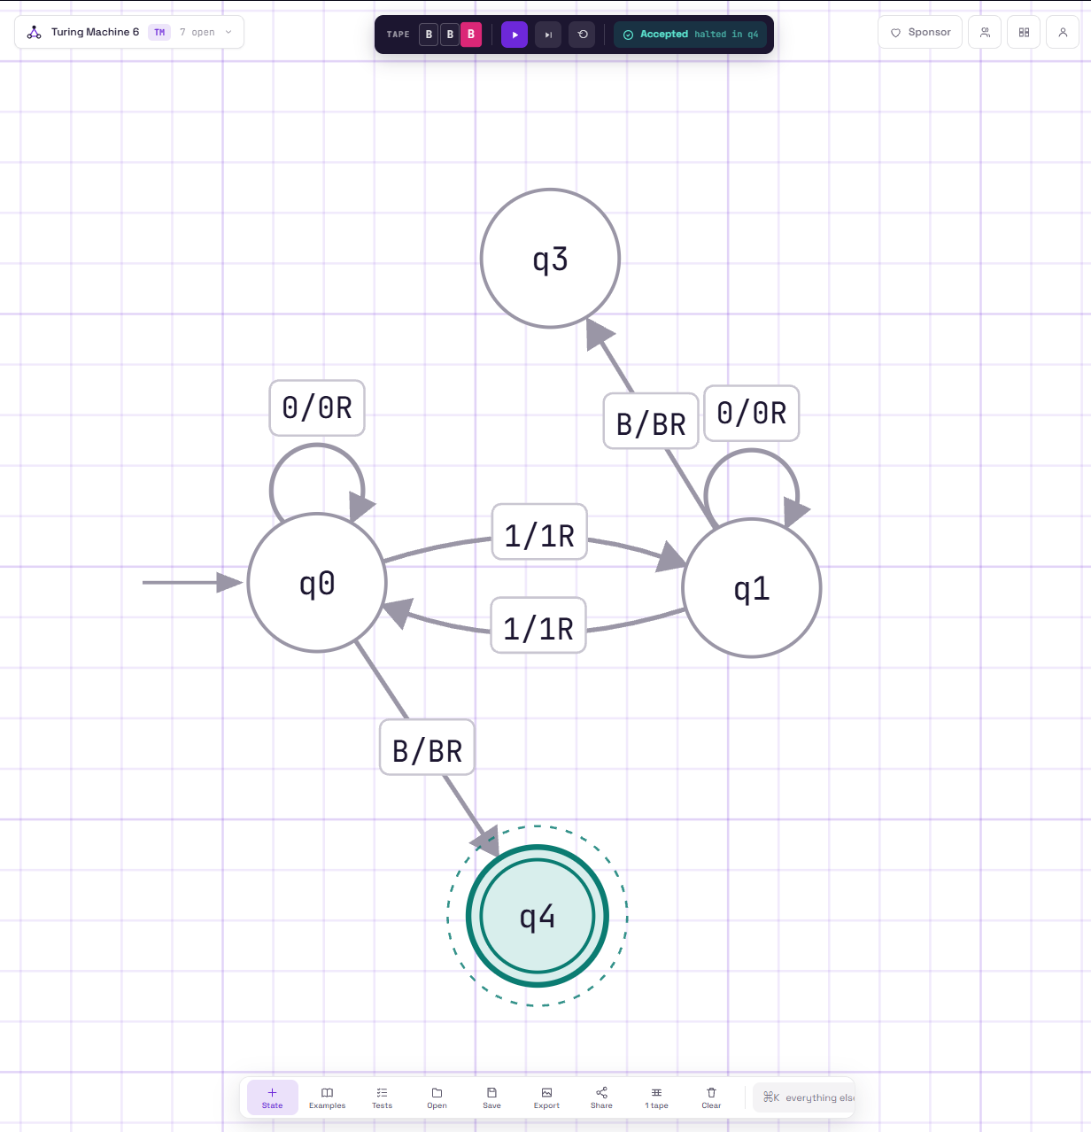
Line 28 README run 2)
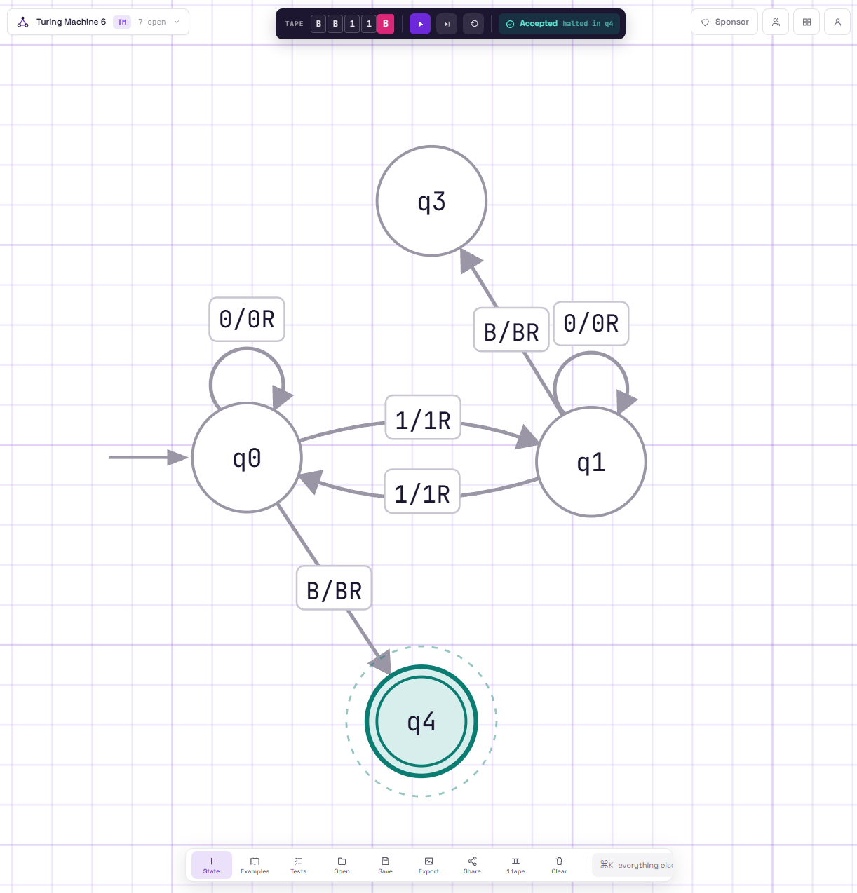

Line 29 README run 3)
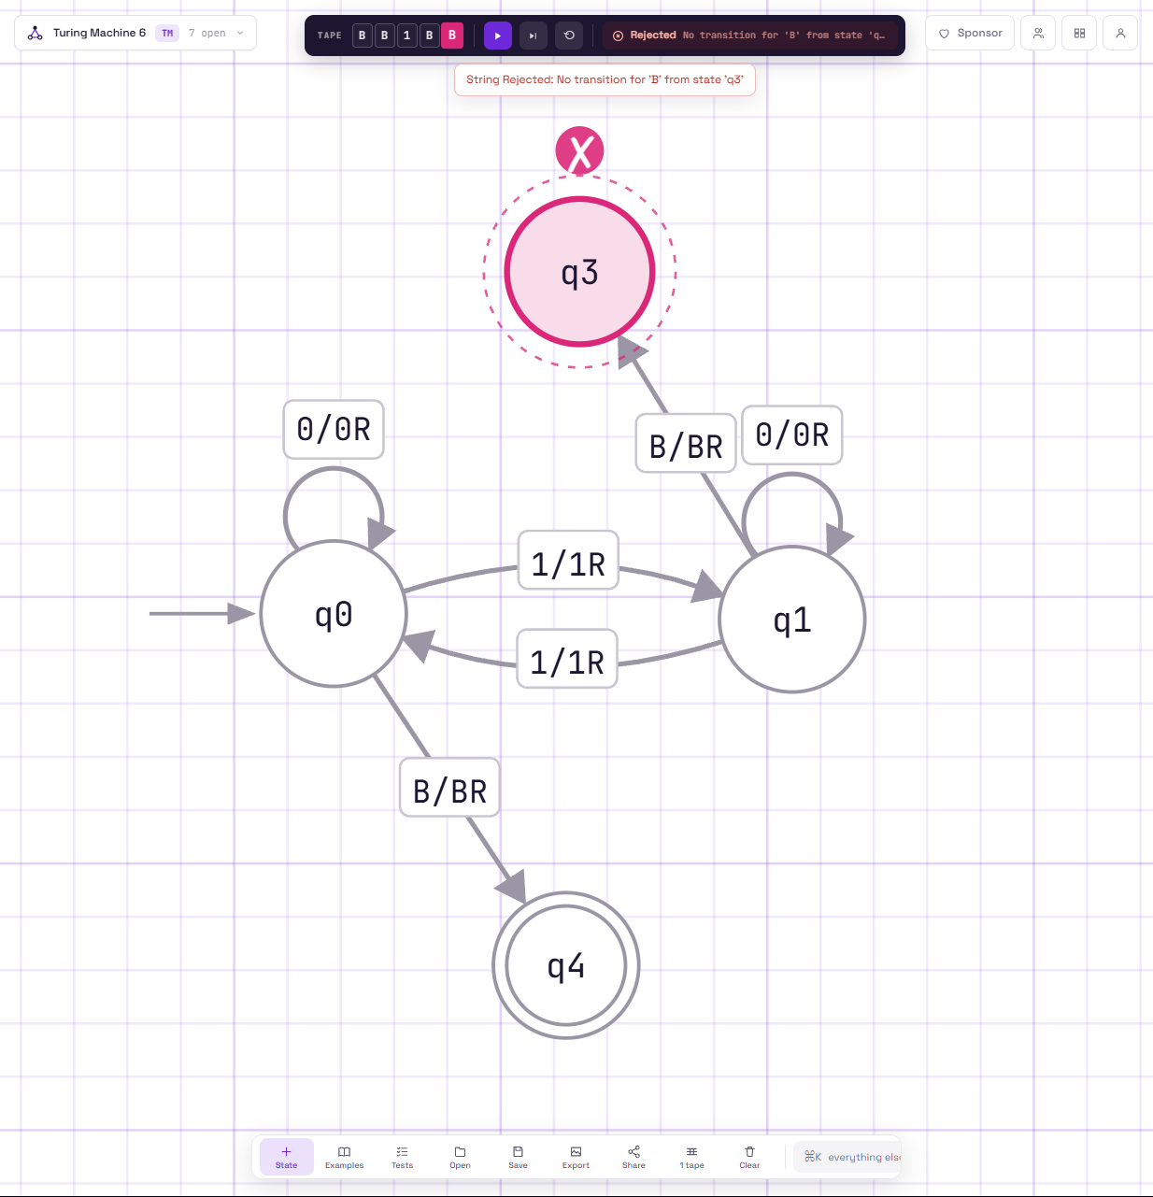
Line 30 README run 3)
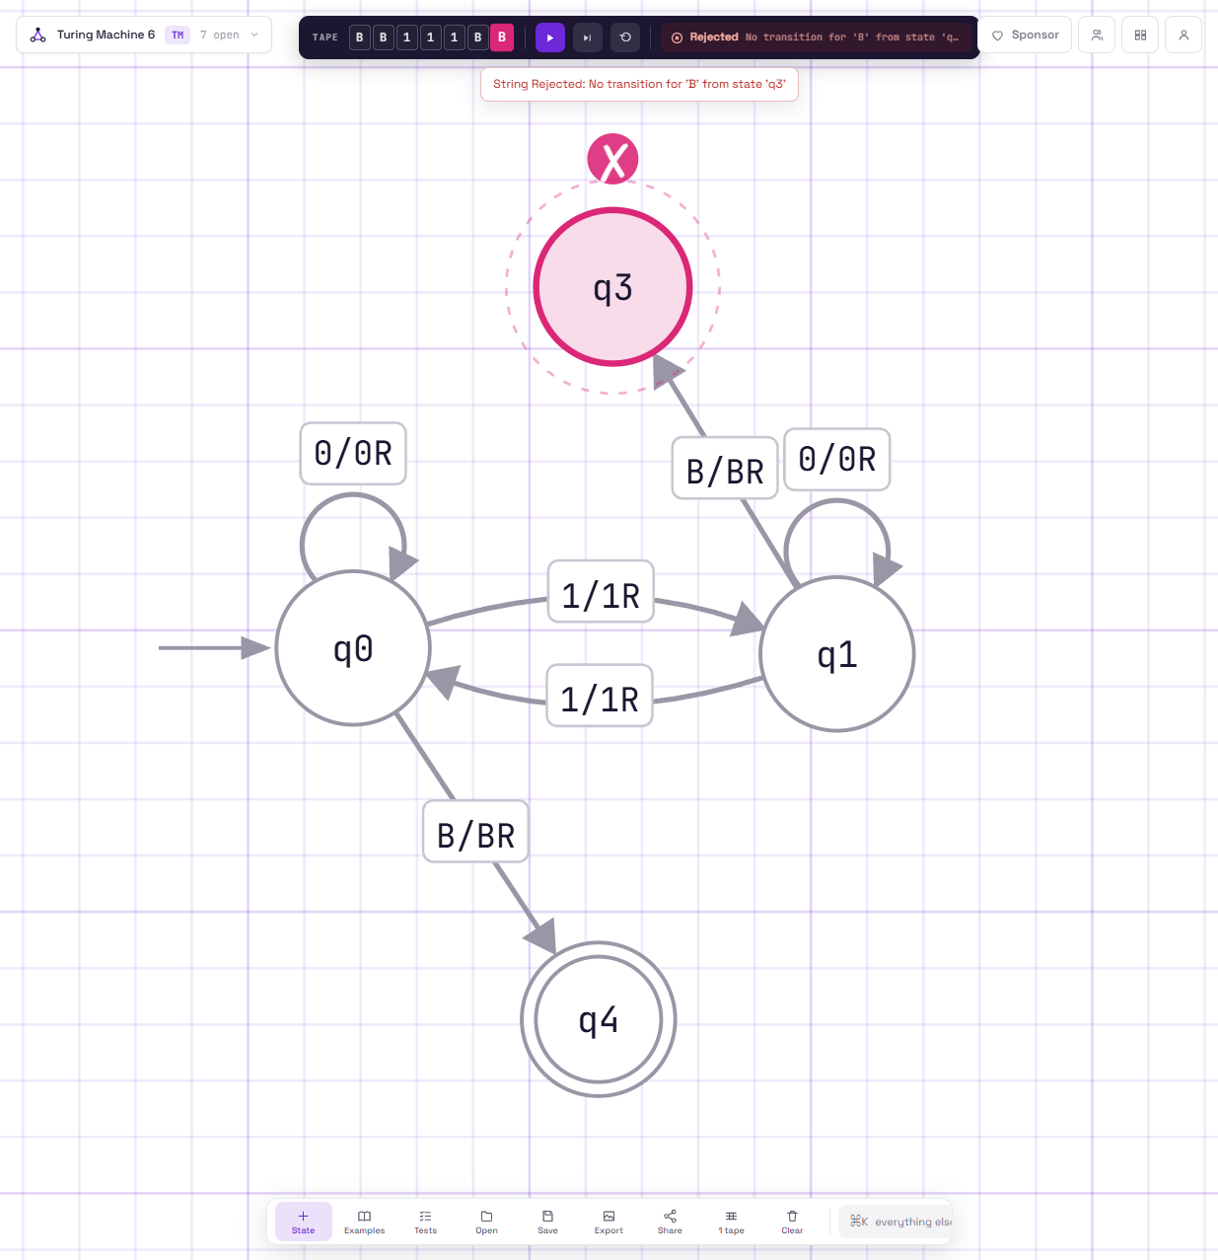

Task D) The inputs 1 and 111 alone would not have revealed the bug because both have an odd number of 1s, so the broken machine rejects them for the correct reason. The empty string and 11 are better test cases because they both have an even number of 1s and exposed the wrong transition. This shows that testing only a few normal cases is not enough when checking a machine. We should include boundary cases that cover both the accepting and rejecting conditions of the machine.

