results_summary

|  | **Database name** | | | |
| --- | --- | --- | --- | --- |
| Estimate | Barts | GOSH | IDRIL | UCLH |
| **General** | | | | |
| Snapshot date | 2025-05-19 | 2025-05-22 | 2025-05-19 | 2025-05-23 |
| Person count | 3,234,945 | 203,433 | 1,533,222 | 1,375,166 |
| Vocabulary version | v5.0 30-AUG-24 | v5.0 30-AUG-24 | v5.0 09-SEP-22 | v5.0 27-FEB-25 |
| **Observation period** | | | | |
| N | 3,235,843 | 204,159 | 2,580,013 | 1,213,754 |
| Start date | 1901-02-05 | 2019-04-19 | 2005-01-01 | 2019-04-01 |
| End date | 2025-05-09 | 2025-02-17 | 2025-01-02 | 2025-12-31 |
| **Cdm** | | | | |
| Source name | Barts Health Data Warehouse | GOSH DRE database | IDRIL | Data Catalogue - UCLH OMOP CDM |
| Version | 5.4 | v5.4 | 5.4 | 5.3 |
| Holder name | Barts Health NHS Trust | GOSH | Lancashire Teaching Hospitals NHS Foundation Trust | UCLH |
| Release date | 2024-08-30 | 2024-11-05 | 2025-01-02 | 2025-03-06 |
| Description | EDW OMOP Research | GOSH is a specialist tertiary care paediatrics hospital in the UK receiving children with complex and/or rare conditions. A large proportion of the children that we see typically require long-term care and follow up at GOSH. This results in data collected during routine healthcare that are very rich in number of variables and detail | Multi-source secondary care dataset | - |
| Documentation reference | - | - | http://omop-lsc.surge.sh/ | - |
| Source type | sql server | sql server | sql server | postgresql |

| High-cost medicine | Barts | Gosh | Idril | Uclh |
| --- | --- | --- | --- | --- |
| abatacept | No | No | No | Yes |
| adalimumab | No | Yes | No | Yes |
| alemtuzumab | No | Yes | No | Yes |
| amikacin | Yes | Yes | No | Yes |
| anakinra | No | No | No | Yes |
| anidulafungin | Yes | No | No | No |
| aprepitant | Yes | Yes | No | Yes |
| axicabtagene_ciloleucel | No | No | No | Yes |
| azacitidine | No | No | No | Yes |
| azathioprine | Yes | No | Yes | Yes |
| basiliximab | Yes | Yes | No | No |
| bendamustine | No | No | No | Yes |
| bevacizumab | No | No | No | Yes |
| bictegravir | No | No | No | Yes |
| biotin | No | No | No | Yes |
| bleomycin | No | Yes | No | Yes |
| bortezomib | No | No | No | Yes |
| botulinum_toxin_type_a | No | Yes | No | Yes |
| brentuximab_vedotin | No | No | No | Yes |
| cannabidiol | No | No | No | Yes |
| caplacizumab | No | No | No | Yes |
| carboplatin | No | Yes | No | Yes |
| carmustine | No | No | No | Yes |
| caspofungin | Yes | Yes | Yes | Yes |
| ceftazidime | Yes | Yes | No | Yes |
| cinacalcet | Yes | No | No | Yes |
| cisplatin | No | No | No | Yes |
| cladribine | No | No | No | Yes |
| cobicistat | No | No | No | Yes |
| colistin | Yes | Yes | No | No |
| cyclophosphamide | No | Yes | No | Yes |
| cyclosporine | Yes | Yes | No | Yes |
| cytarabine | No | Yes | No | Yes |
| dacarbazine | No | No | No | Yes |
| dalfampridine | No | No | No | Yes |
| daratumumab | No | No | No | Yes |
| darbepoetin_alfa | Yes | Yes | Yes | Yes |
| darunavir | Yes | No | No | Yes |
| daunorubicin | No | No | No | Yes |
| deferasirox | No | No | No | Yes |
| denosumab | Yes | No | No | Yes |
| dexamethasone | Yes | Yes | Yes | Yes |
| dexrazoxane | No | No | No | Yes |
| dimethyl_fumarate | No | No | No | Yes |
| docetaxel | No | No | No | Yes |
| dolutegravir | Yes | No | No | Yes |
| doravirine | No | No | No | Yes |
| dornase_alfa | Yes | No | No | No |
| doxorubicin | No | Yes | No | Yes |
| doxorubicin_pegylated_liposomal | No | No | No | Yes |
| eltrombopag | No | No | No | Yes |
| emtricitabine | No | No | No | Yes |
| entecavir | Yes | No | No | Yes |
| enzalutamide | No | No | No | Yes |
| epoetin_beta | Yes | No | No | Yes |
| epoprostenol | Yes | No | No | No |
| erenumab | No | No | No | Yes |
| etanercept | No | No | No | Yes |
| etoposide | No | Yes | No | Yes |
| factor_ix | No | No | No | Yes |
| factor_vii | No | No | No | Yes |
| factor_x | No | No | No | Yes |
| fibrinogen | No | No | No | Yes |
| fidaxomicin | Yes | No | Yes | Yes |
| filgrastim | Yes | No | Yes | Yes |
| floxacillin | Yes | Yes | Yes | Yes |
| fludarabine | No | Yes | No | Yes |
| fremanezumab | No | No | No | Yes |
| galcanezumab | No | No | No | Yes |
| ganciclovir | Yes | No | No | No |
| gemcitabine | No | No | No | Yes |
| heparin | Yes | Yes | No | Yes |
| hydroxyurea | Yes | No | No | Yes |
| idarubicin | No | No | No | Yes |
| ifosfamide | No | No | No | Yes |
| imatinib | No | No | No | Yes |
| immunoglobulin_g | Yes | Yes | No | Yes |
| infliximab | Yes | Yes | No | Yes |
| irinotecan | No | No | No | Yes |
| ivacaftor | Yes | No | No | No |
| lamivudine | Yes | No | No | Yes |
| lenalidomide | No | No | No | Yes |
| lenograstim | No | Yes | No | Yes |
| letermovir | Yes | No | No | Yes |
| levofloxacin | Yes | No | Yes | Yes |
| lomustine | No | No | No | Yes |
| mannitol | Yes | Yes | No | Yes |
| melphalan | No | No | No | Yes |
| mercaptopurine | No | Yes | No | Yes |
| mesna | Yes | Yes | No | Yes |
| methotrexate | Yes | Yes | Yes | Yes |
| micafungin | Yes | No | No | No |
| molnupiravir | No | No | No | Yes |
| mycophenolate_mofetil | Yes | Yes | Yes | Yes |
| nintedanib | No | No | No | Yes |
| nitric_oxide | Yes | No | No | No |
| nitrous_oxide | Yes | No | No | Yes |
| obinutuzumab | No | No | No | Yes |
| ocrelizumab | No | No | No | Yes |
| octreotide | Yes | No | No | Yes |
| ofatumumab | No | No | No | Yes |
| olaparib | No | No | No | Yes |
| ondansetron | Yes | Yes | Yes | Yes |
| paclitaxel | No | No | No | Yes |
| pegaspargase | No | Yes | No | No |
| pegfilgrastim | No | No | No | Yes |
| pembrolizumab | No | No | No | Yes |
| pemetrexed | No | No | No | Yes |
| plerixafor | No | No | No | Yes |
| polatuzumab_vedotin | No | No | No | Yes |
| pomalidomide | No | No | No | Yes |
| posaconazole | Yes | Yes | No | Yes |
| protein_c | No | No | No | Yes |
| raltegravir | Yes | No | No | Yes |
| rasburicase | Yes | No | No | Yes |
| regorafenib | No | No | No | Yes |
| remdesivir | Yes | No | Yes | Yes |
| rho_d_immune_globulin | Yes | No | Yes | Yes |
| ritonavir | Yes | No | No | Yes |
| rituximab | Yes | Yes | No | Yes |
| sapropterin | No | No | No | Yes |
| secukinumab | No | No | No | Yes |
| sevelamer | Yes | No | Yes | No |
| sildenafil | Yes | Yes | No | Yes |
| siponimod | No | No | No | Yes |
| sodium_chloride | Yes | Yes | Yes | Yes |
| somatropin | No | No | No | Yes |
| sotrovimab | No | No | No | Yes |
| tacrolimus | Yes | Yes | Yes | Yes |
| tadalafil | No | No | No | Yes |
| temozolomide | No | No | No | Yes |
| tenofovir | Yes | No | No | No |
| tenofovir_alafenamide | No | No | No | Yes |
| tenofovir_disoproxil | No | No | No | Yes |
| thalidomide | No | No | No | Yes |
| tigecycline | No | No | Yes | No |
| tobramycin | Yes | No | No | No |
| tocilizumab | Yes | Yes | No | Yes |
| tolvaptan | Yes | No | No | No |
| trastuzumab | No | No | No | Yes |
| upadacitinib | No | No | No | Yes |
| ustekinumab | No | No | No | Yes |
| valganciclovir | Yes | No | No | Yes |
| vancomycin | Yes | Yes | Yes | Yes |
| vedolizumab | No | No | No | Yes |
| venetoclax | Yes | No | No | Yes |
| vinblastine | No | No | No | Yes |
| vincristine | No | Yes | No | Yes |
| vinorelbine | No | No | No | Yes |
| voriconazole | Yes | Yes | No | No |

# A tibble: 1 × 1  
 n  
 <int>  
1 150

| Cdm name | N |
| --- | --- |
| Barts | 59 |
| GOSH | 40 |
| IDRIL | 18 |
| UCLH | 134 |

# top 5 meds

| Rank | Barts | Gosh | Idril | Uclh |
| --- | --- | --- | --- | --- |
| 1 | Ondansetron (69,872) | Ondansetron (16,032) | Ondansetron (16,653) | Sodium Chloride (114,666) |
| 2 | Sodium Chloride (36,677) | Dexamethasone (15,598) | Sodium Chloride (6,652) | Ondansetron (80,702) |
| 3 | Amikacin (23,303) | Sodium Chloride (9,737) | Floxacillin (5,278) | Dexamethasone (64,913) |
| 4 | Heparin (20,990) | Amikacin (5,017) | Dexamethasone (4,534) | Floxacillin (13,781) |
| 5 | Dexamethasone (20,840) | Heparin (2,200) | Levofloxacin (1,917) | Amikacin (6,533) |
| 6 | Floxacillin (17,275) | Floxacillin (1,596) | Vancomycin (1,249) | Filgrastim (4,311) |
| 7 | Vancomycin (4,636) | Vancomycin (1,316) | Darbepoetin Alfa (502) | Aprepitant (3,165) |
| 8 | Levofloxacin (4,454) | Mannitol (548) | Filgrastim (396) | Ritonavir (2,752) |
| 9 | Filgrastim (1,944) | Vincristine (491) | Mycophenolate Mofetil (240) | Tadalafil (2,651) |
| 10 | Rho D Immune Globulin (1,522) | Cyclophosphamide (430) | Tacrolimus (225) | Tacrolimus (2,410) |
| 11 | Darbepoetin Alfa (1,356) | Methotrexate (404) | Methotrexate (207) | Sildenafil (2,279) |
| 12 | Mycophenolate Mofetil (1,299) | Mycophenolate Mofetil (400) | Azathioprine (203) | Methotrexate (2,229) |
| 13 | Tacrolimus (1,291) | Rituximab (387) | Fidaxomicin (187) | Botulinum Toxin Type A (1,727) |
| 14 | Sevelamer (1,013) | Immunoglobulin G (359) | Rho D Immune Globulin (161) | Ceftazidime (1,698) |
| 15 | Remdesivir (759) | Lenograstim (355) | Sevelamer (150) | Rituximab (1,504) |

# ATC Group A: ALIMENTARY TRACT AND METABOLISM

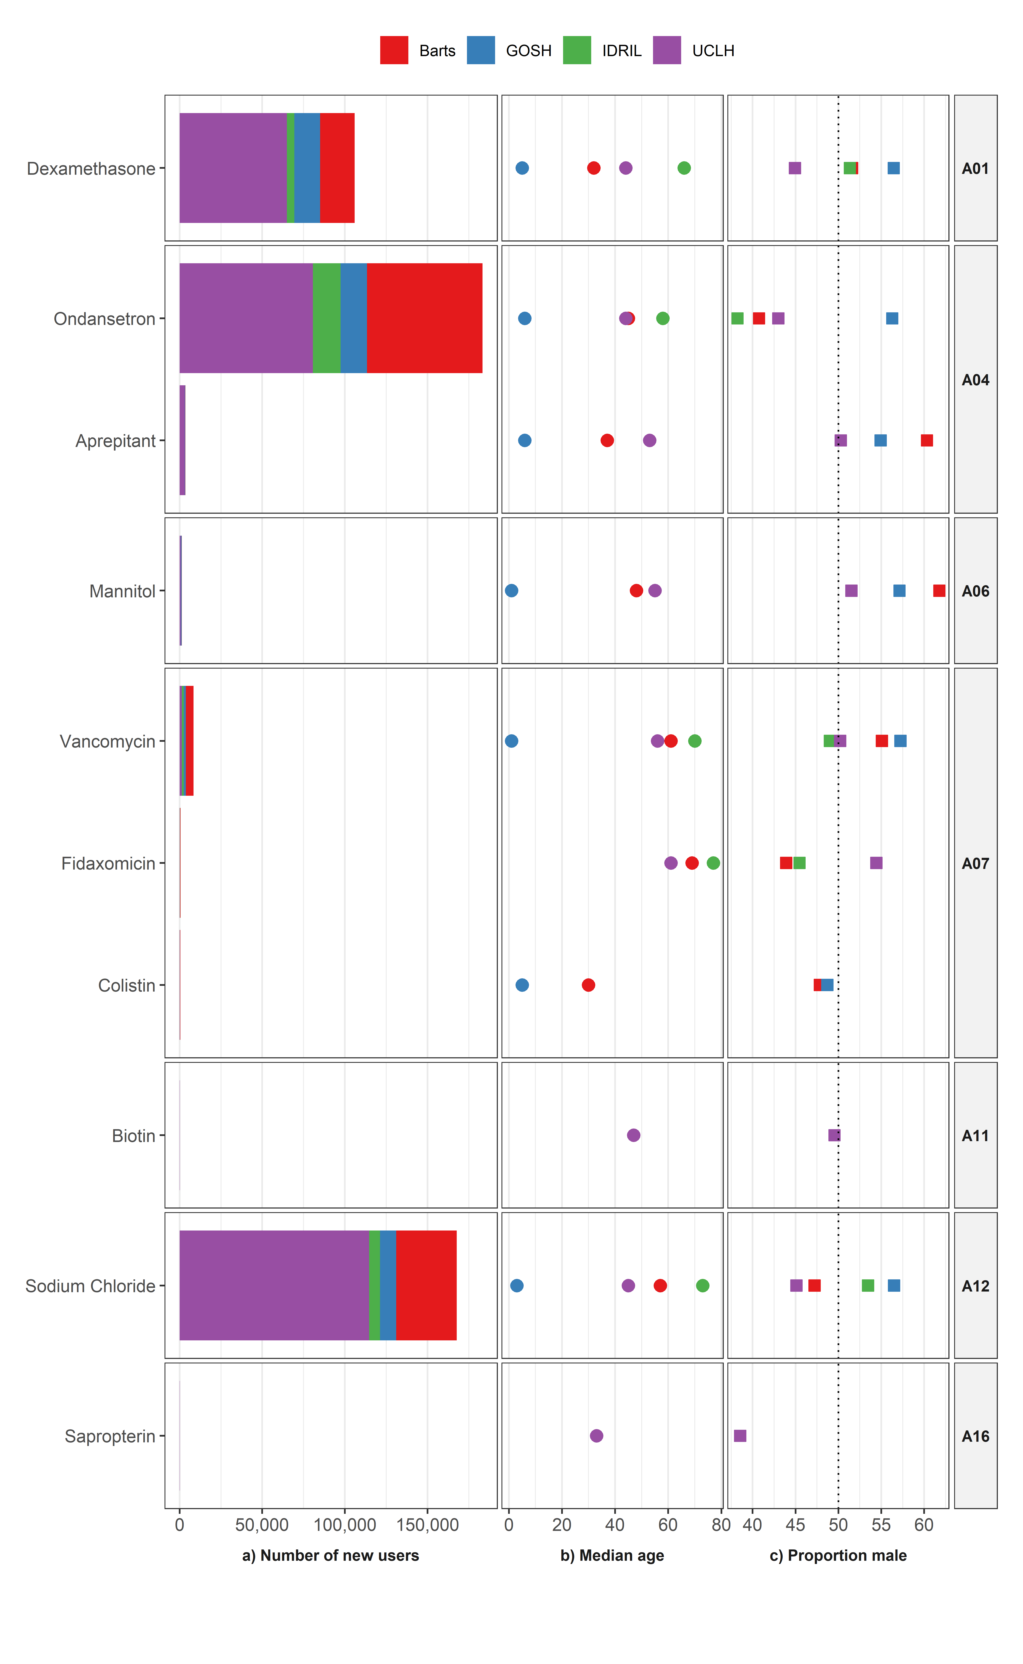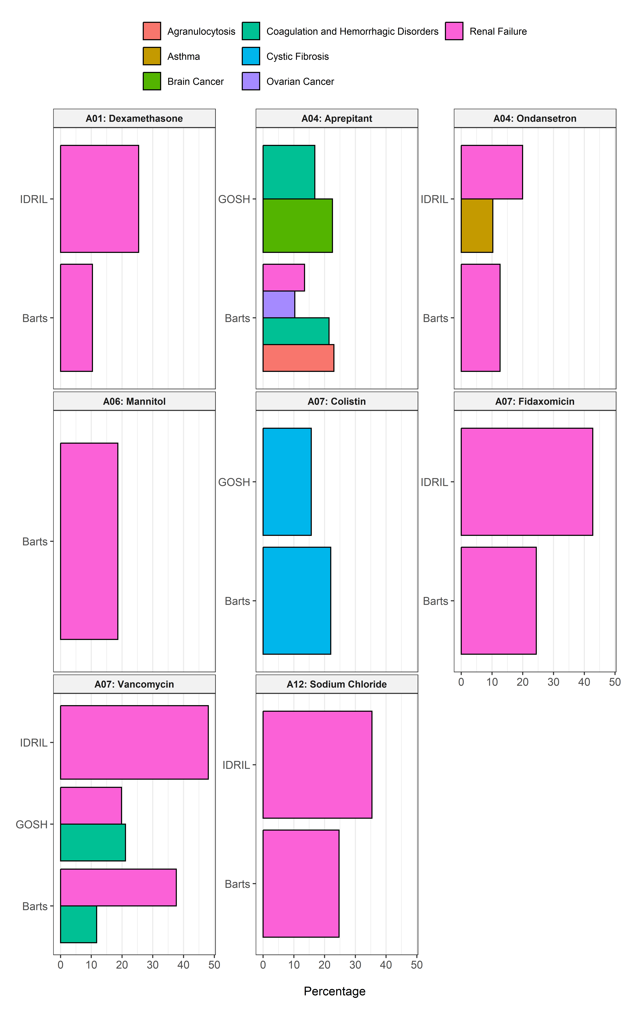

# ATC Group B: BLOOD AND BLOOD FORMING ORGANS

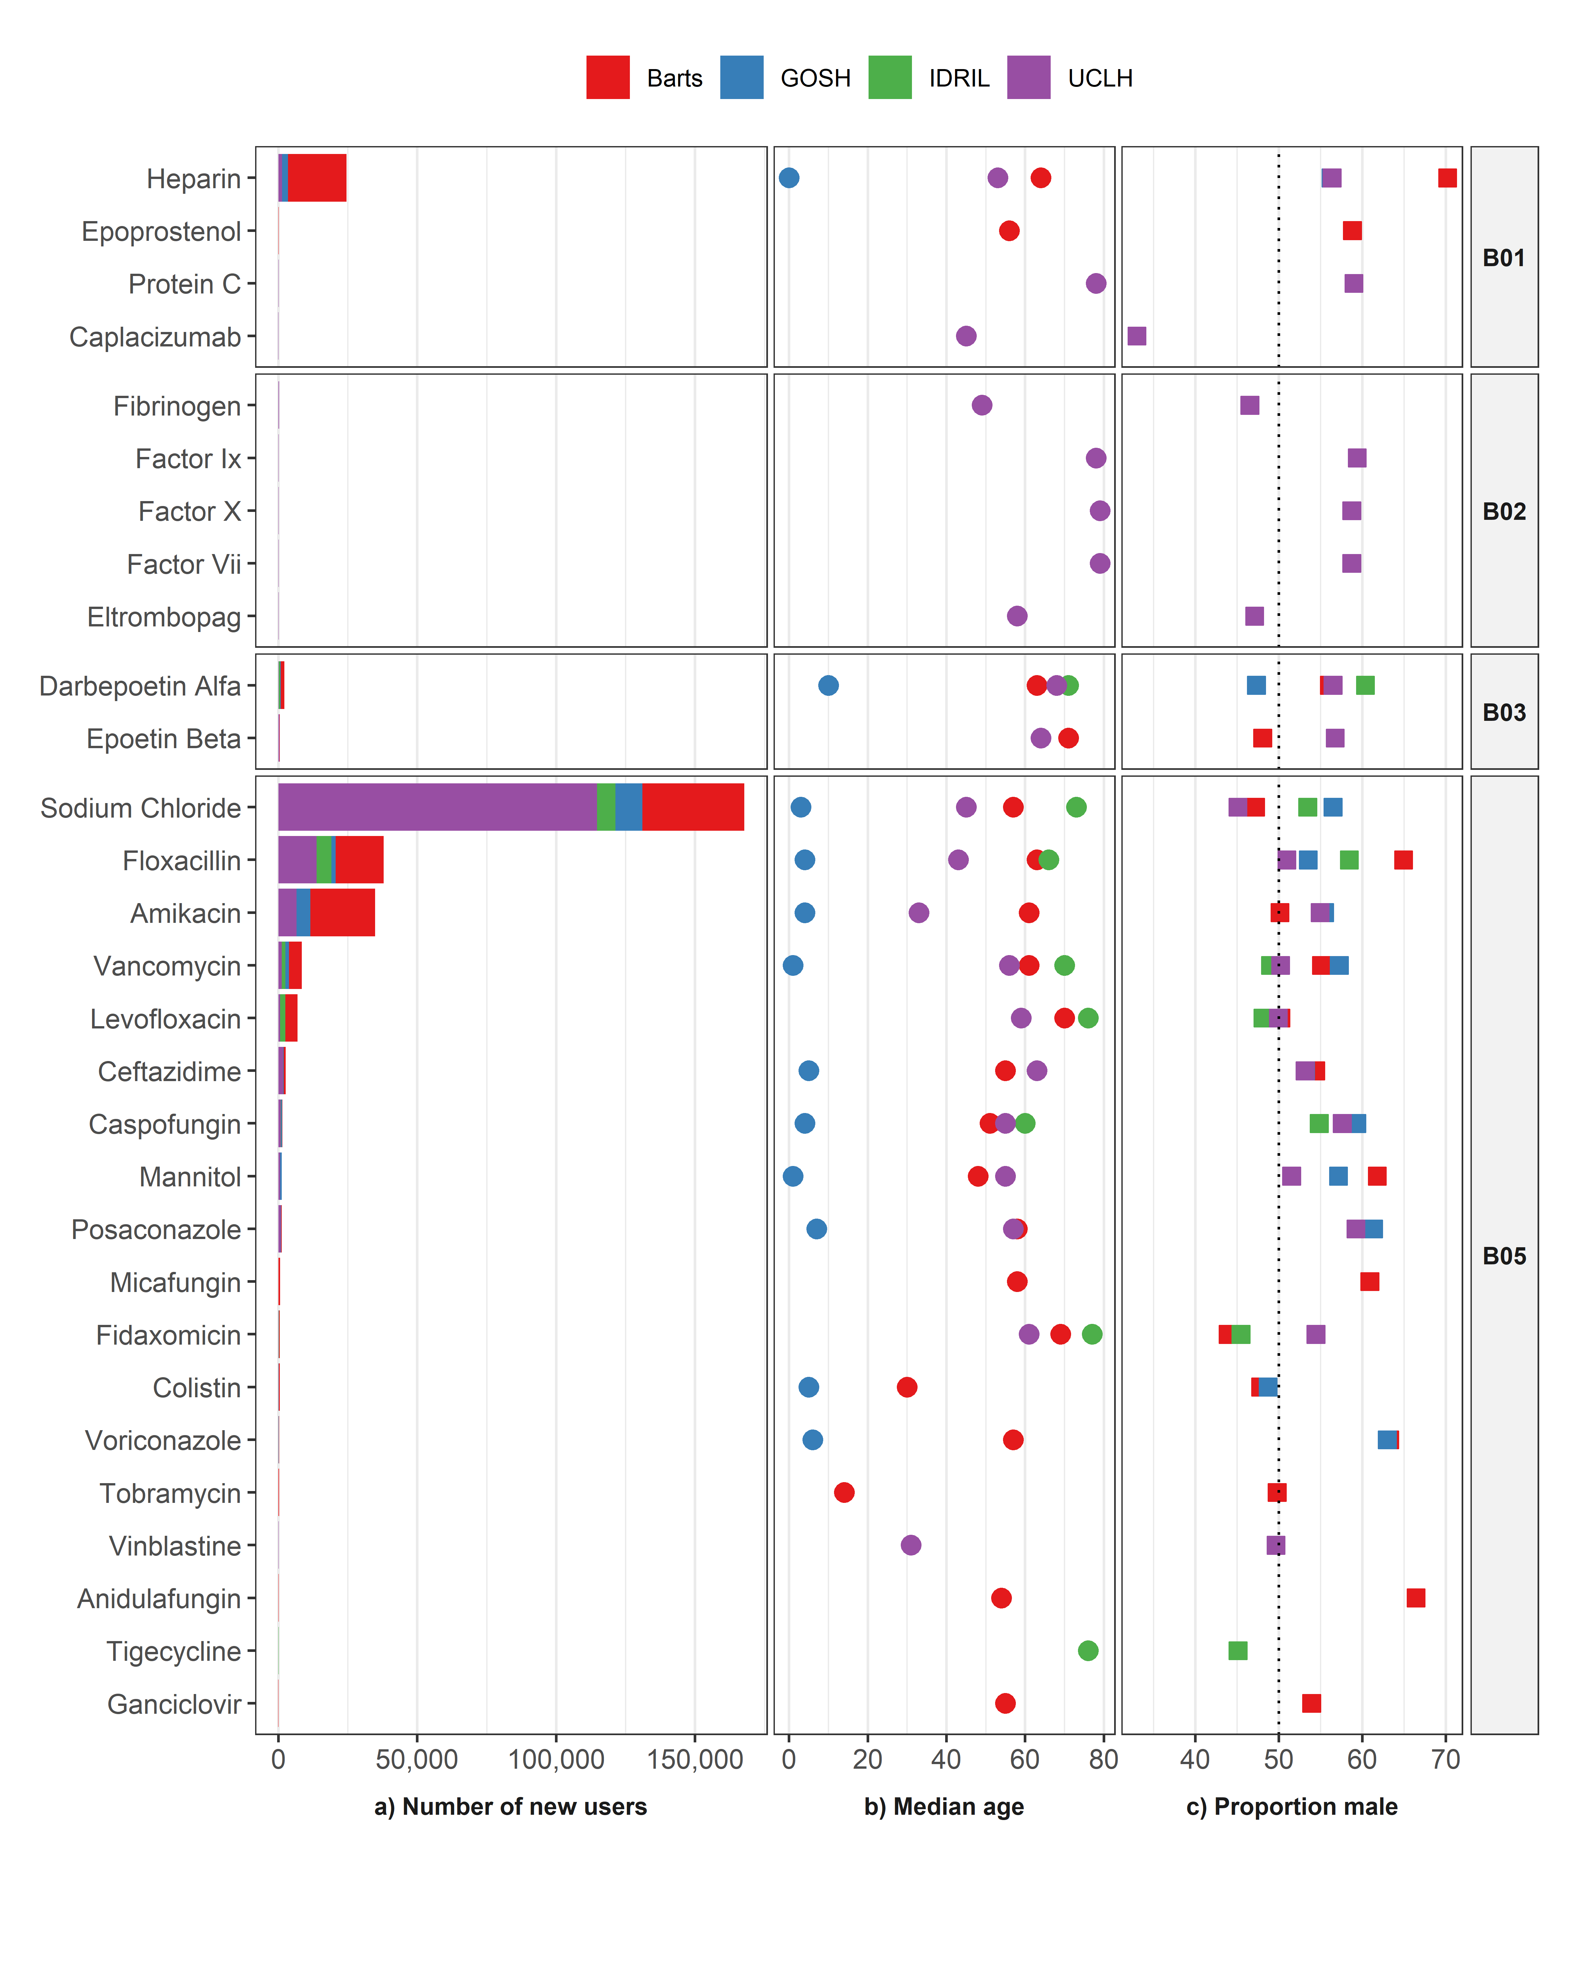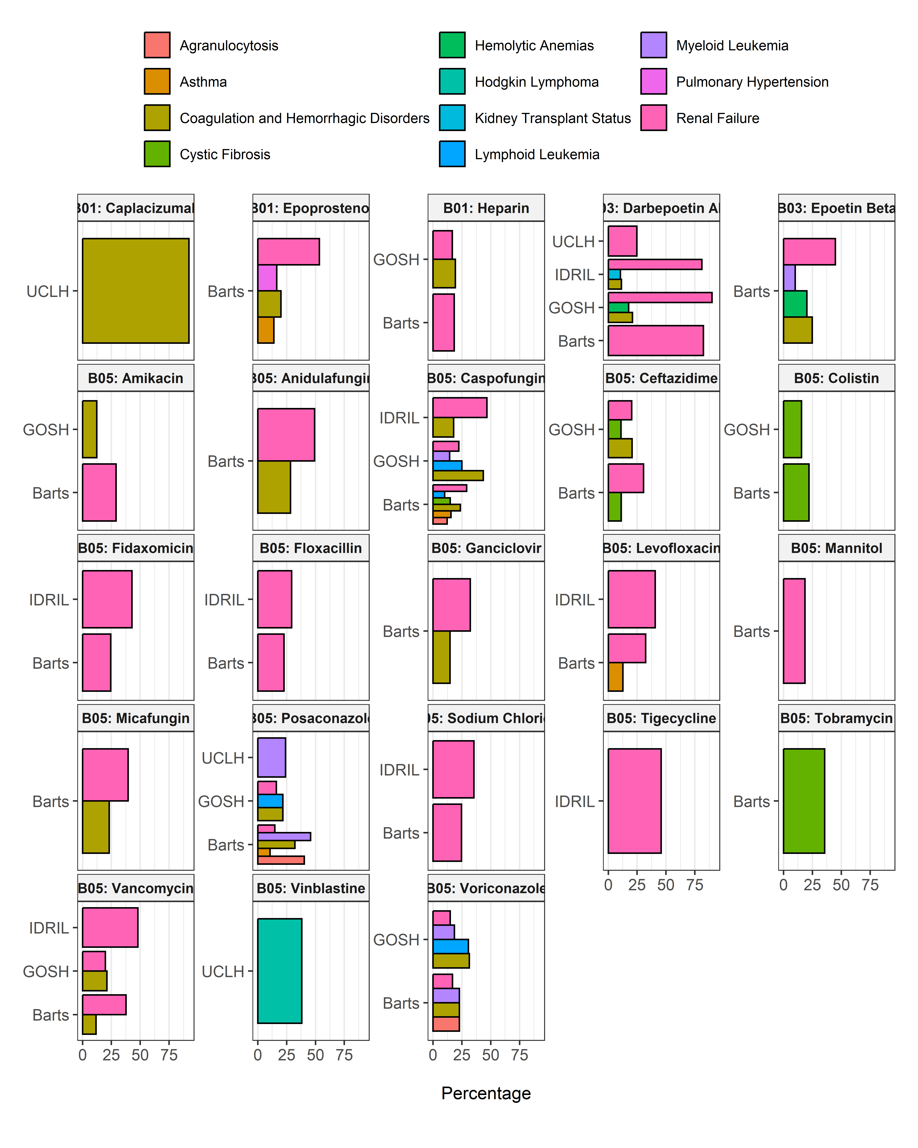

# ATC Group C: CARDIOVASCULAR SYSTEM

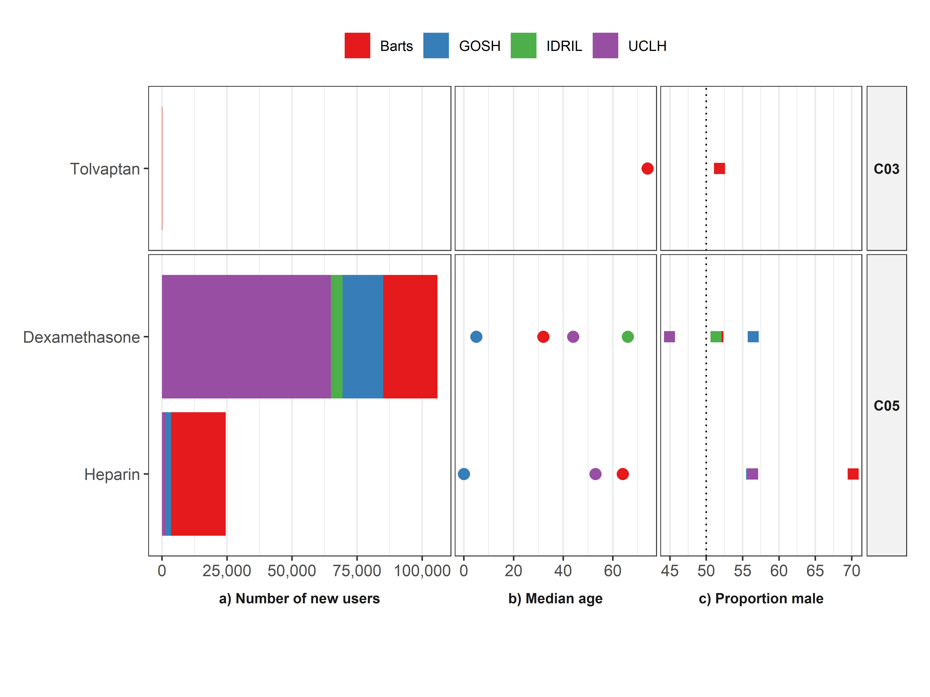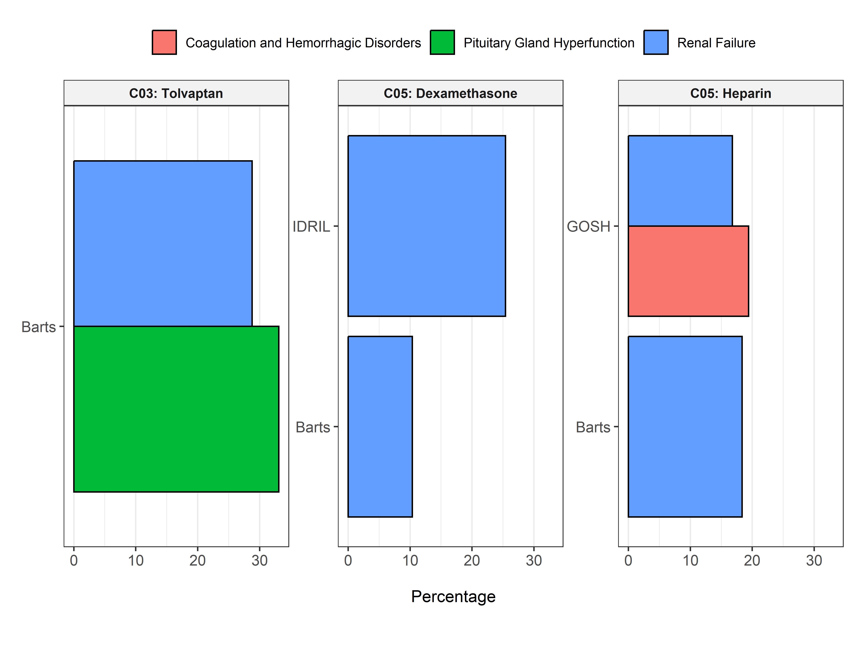

# ATC Group D: DERMATOLOGICALS

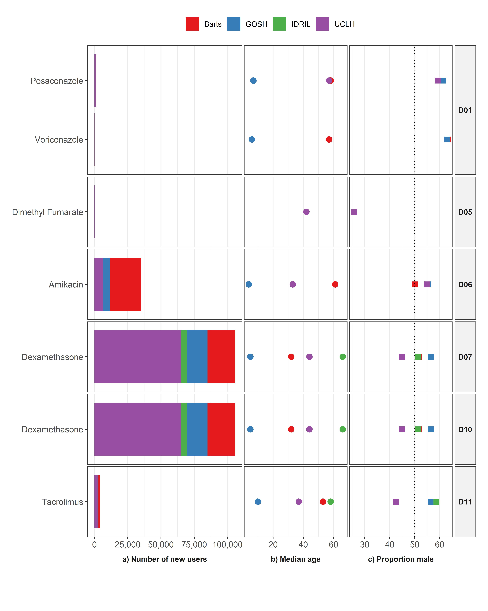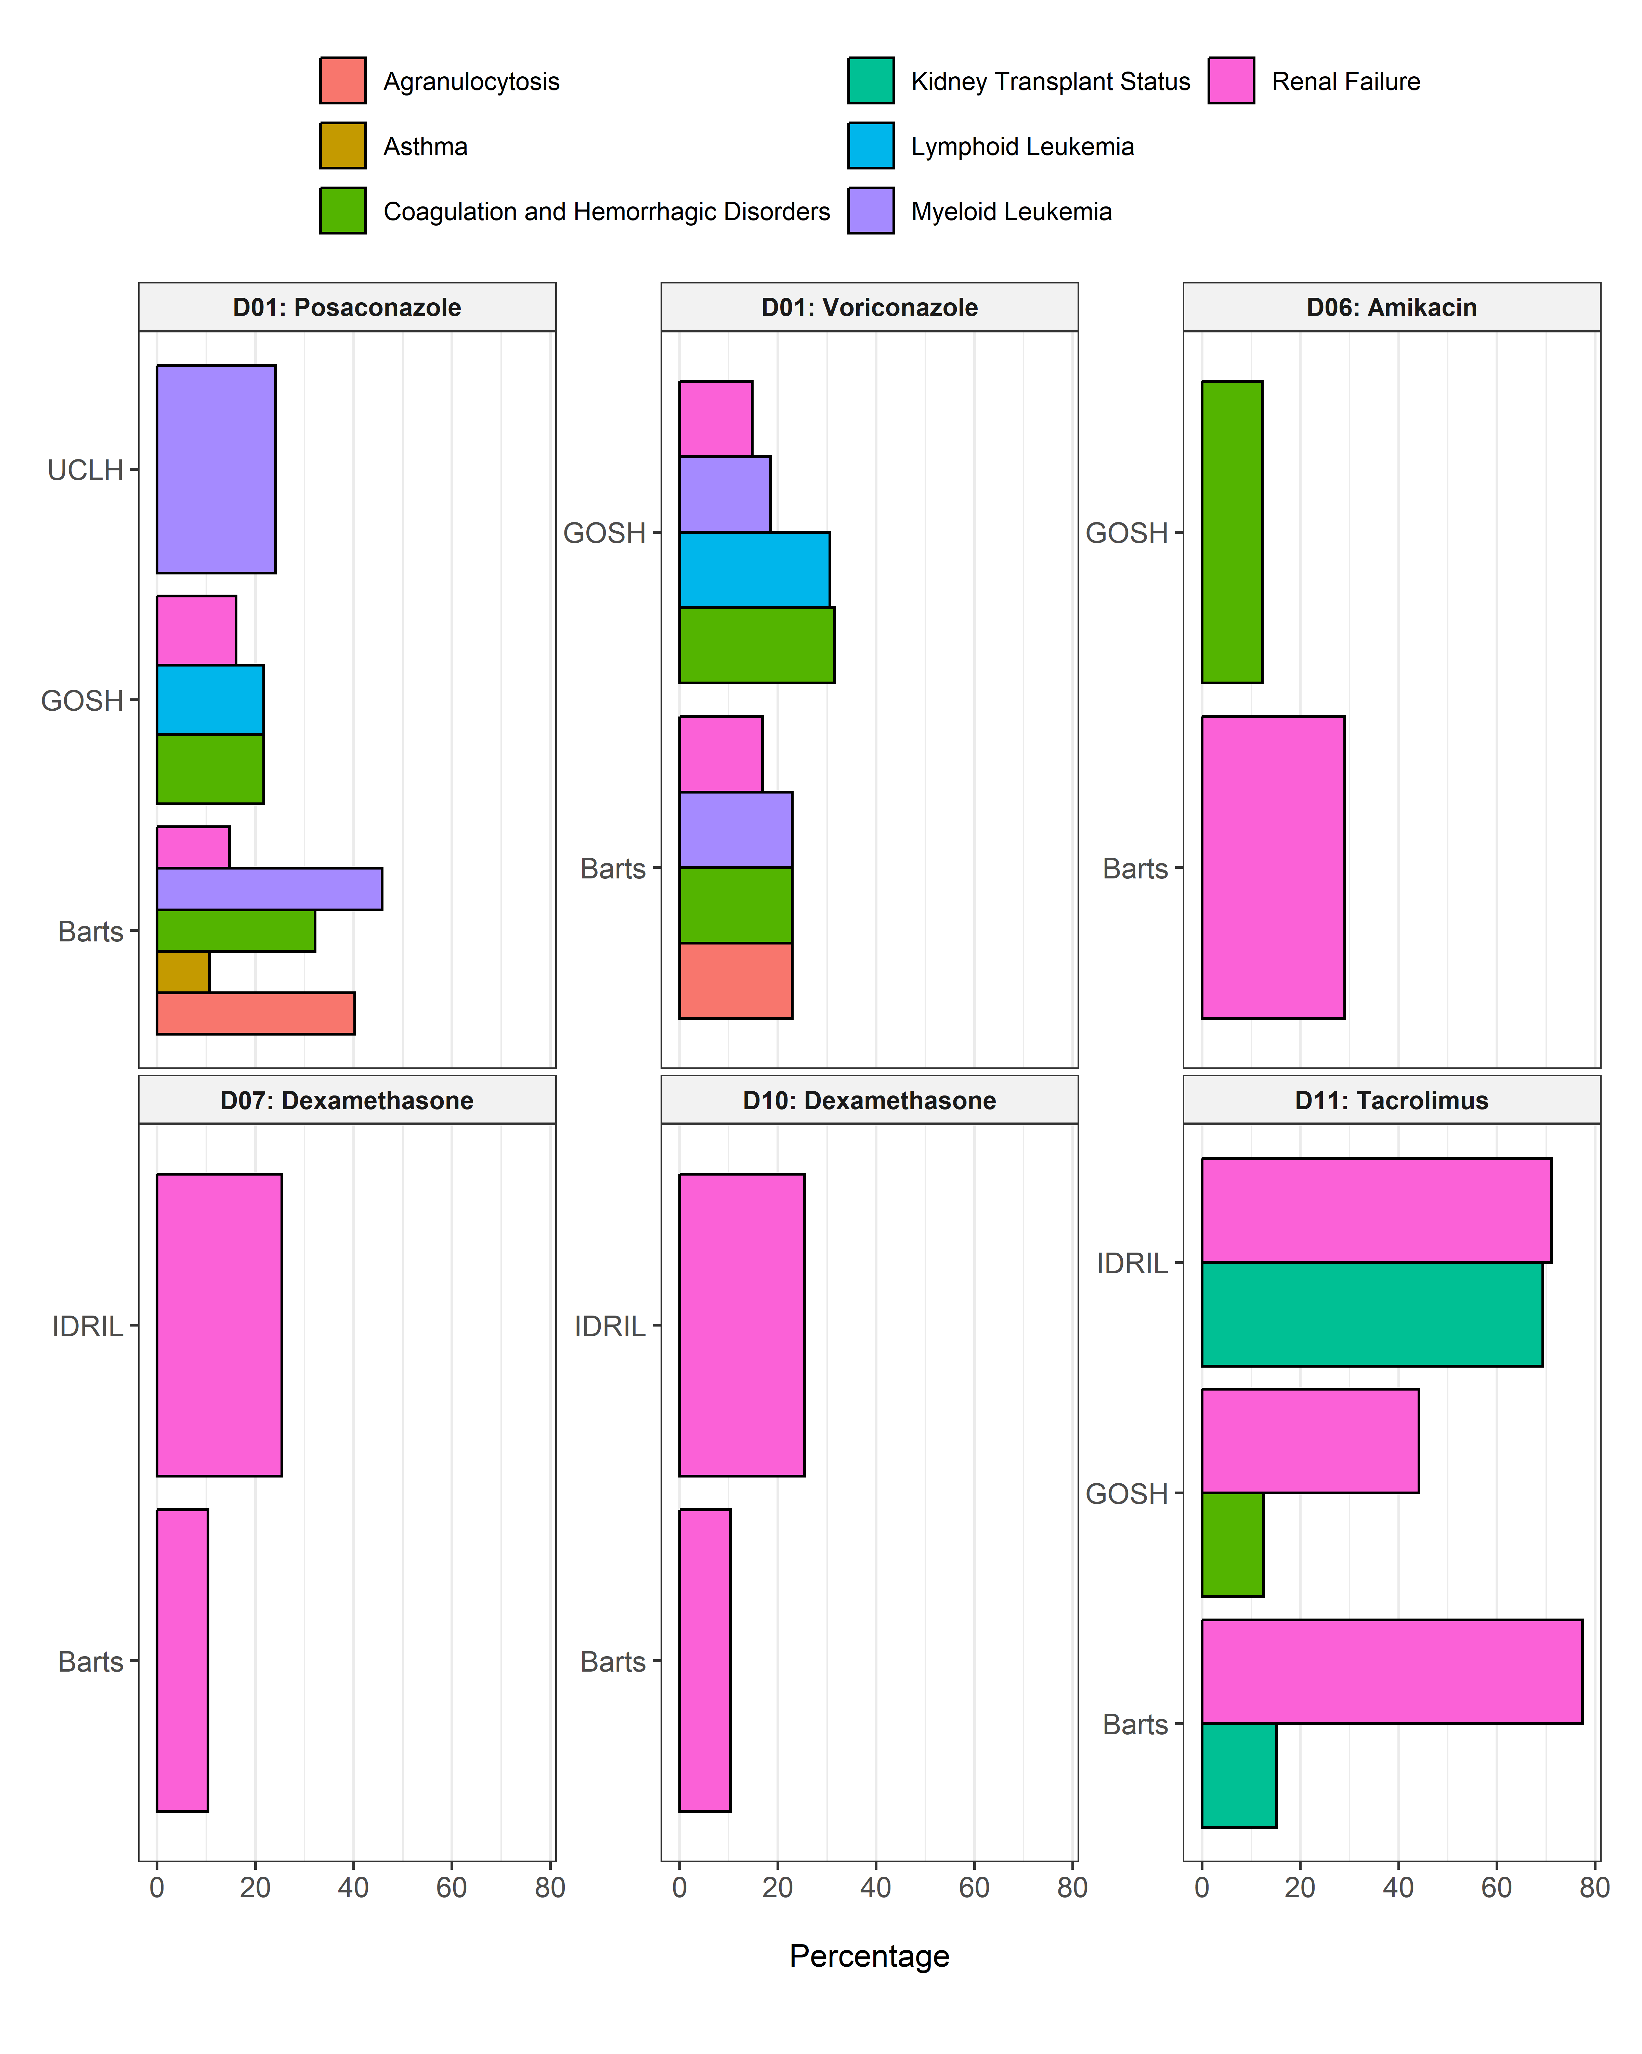

# ATC Group G: GENITO URINARY SYSTEM AND SEX HORMONES

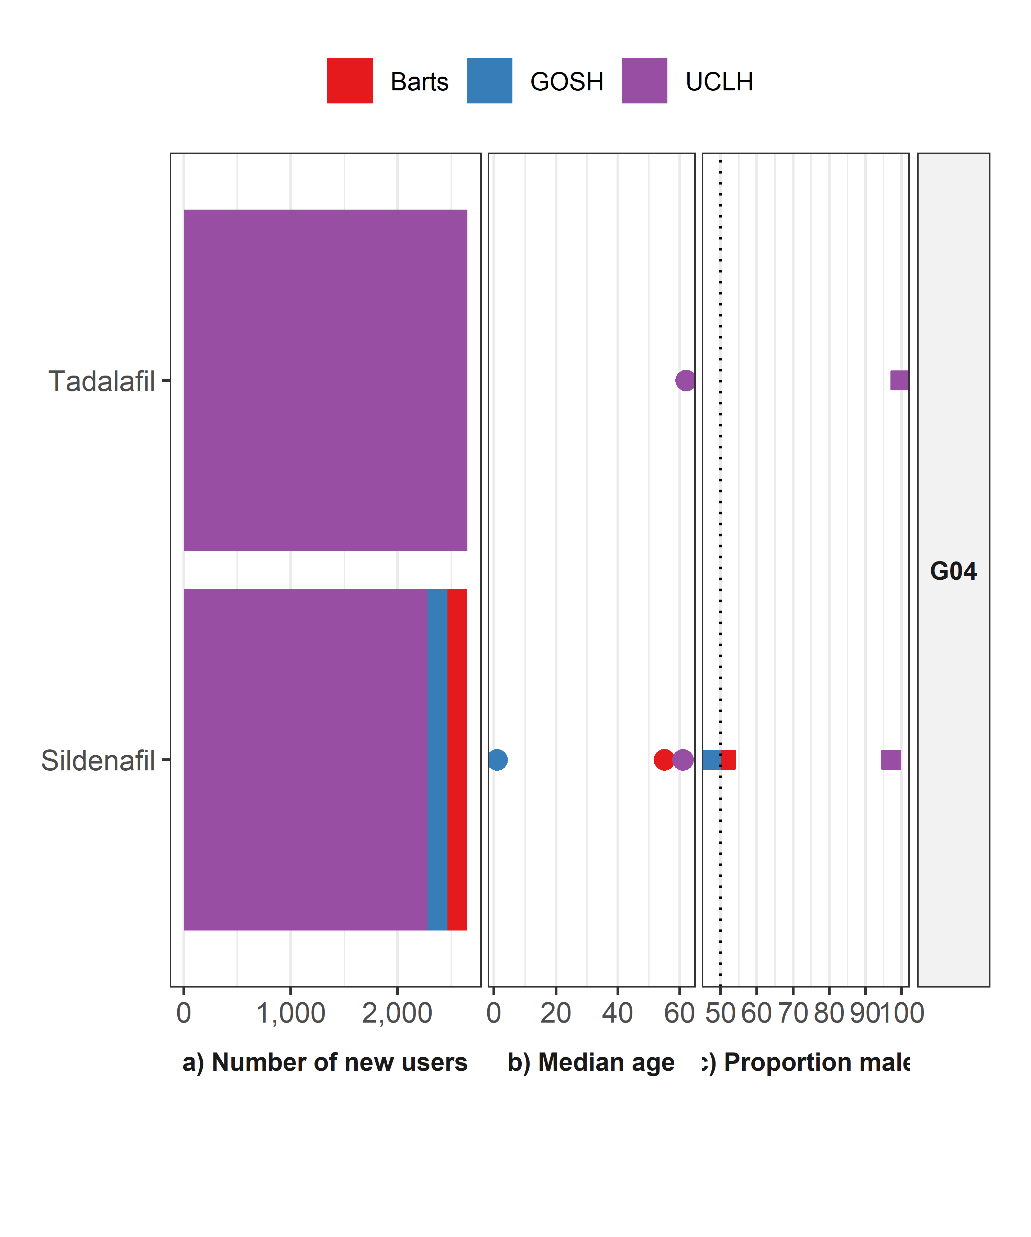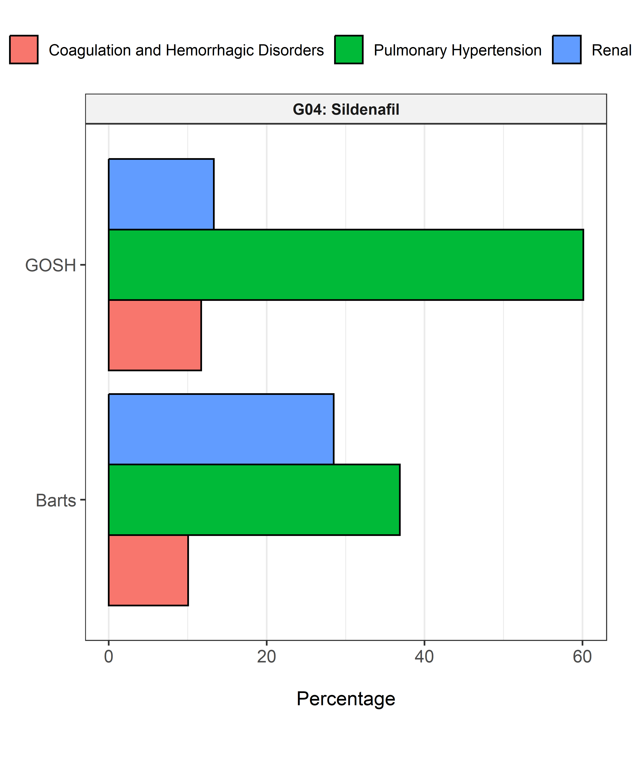

# ATC Group H: SYSTEMIC HORMONAL PREPARATIONS, EXCL. SEX HORMONES AND INSULINS

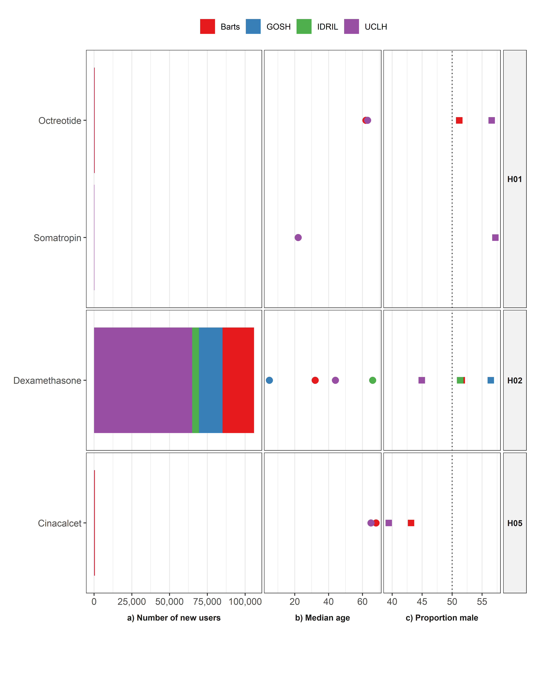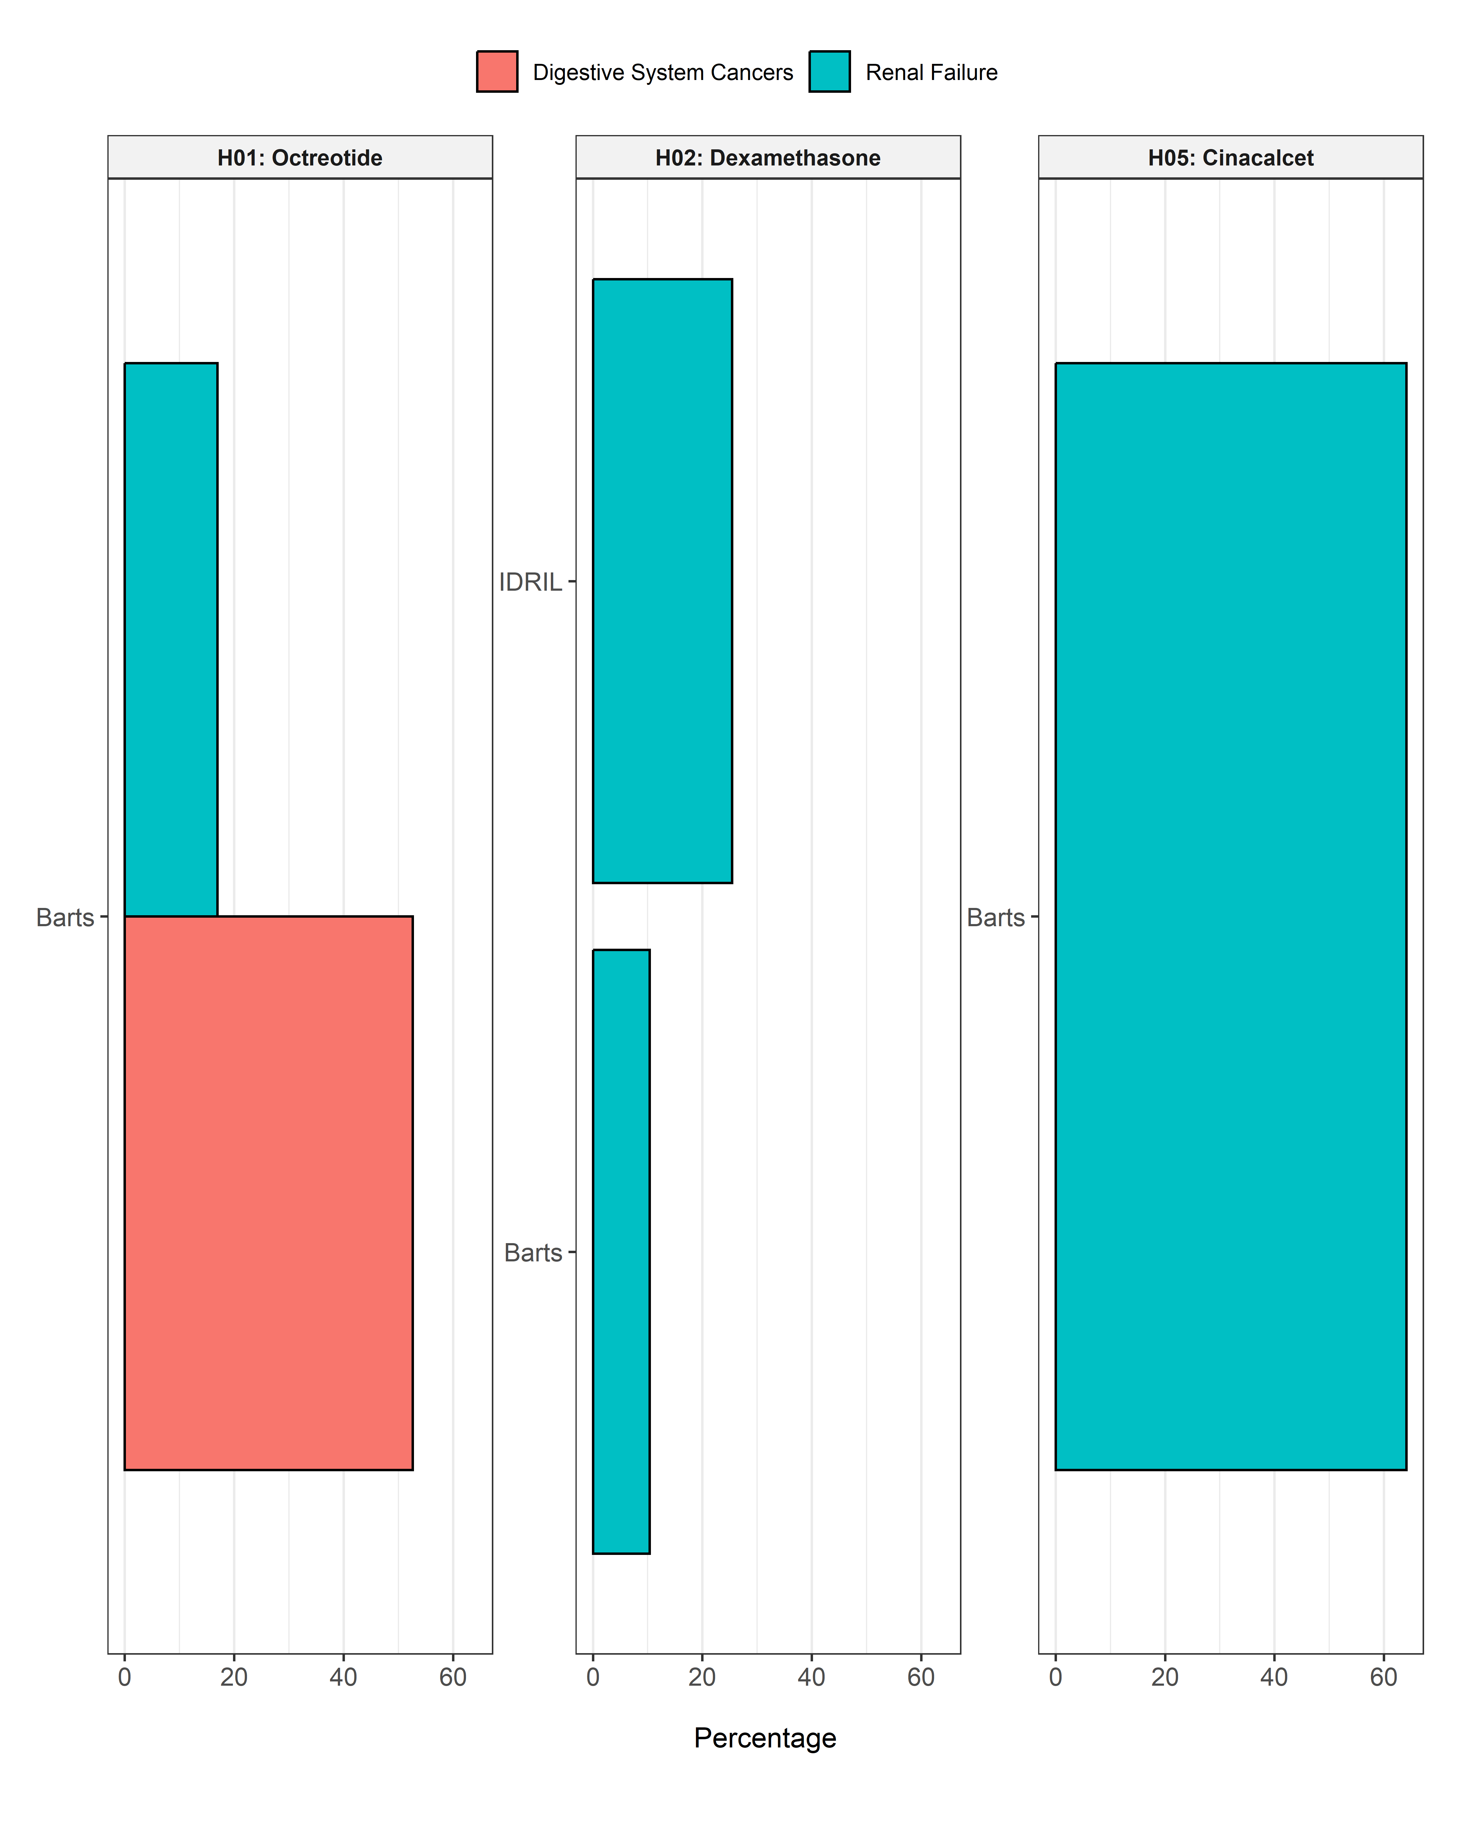

# ATC Group J: ANTIINFECTIVES FOR SYSTEMIC USE

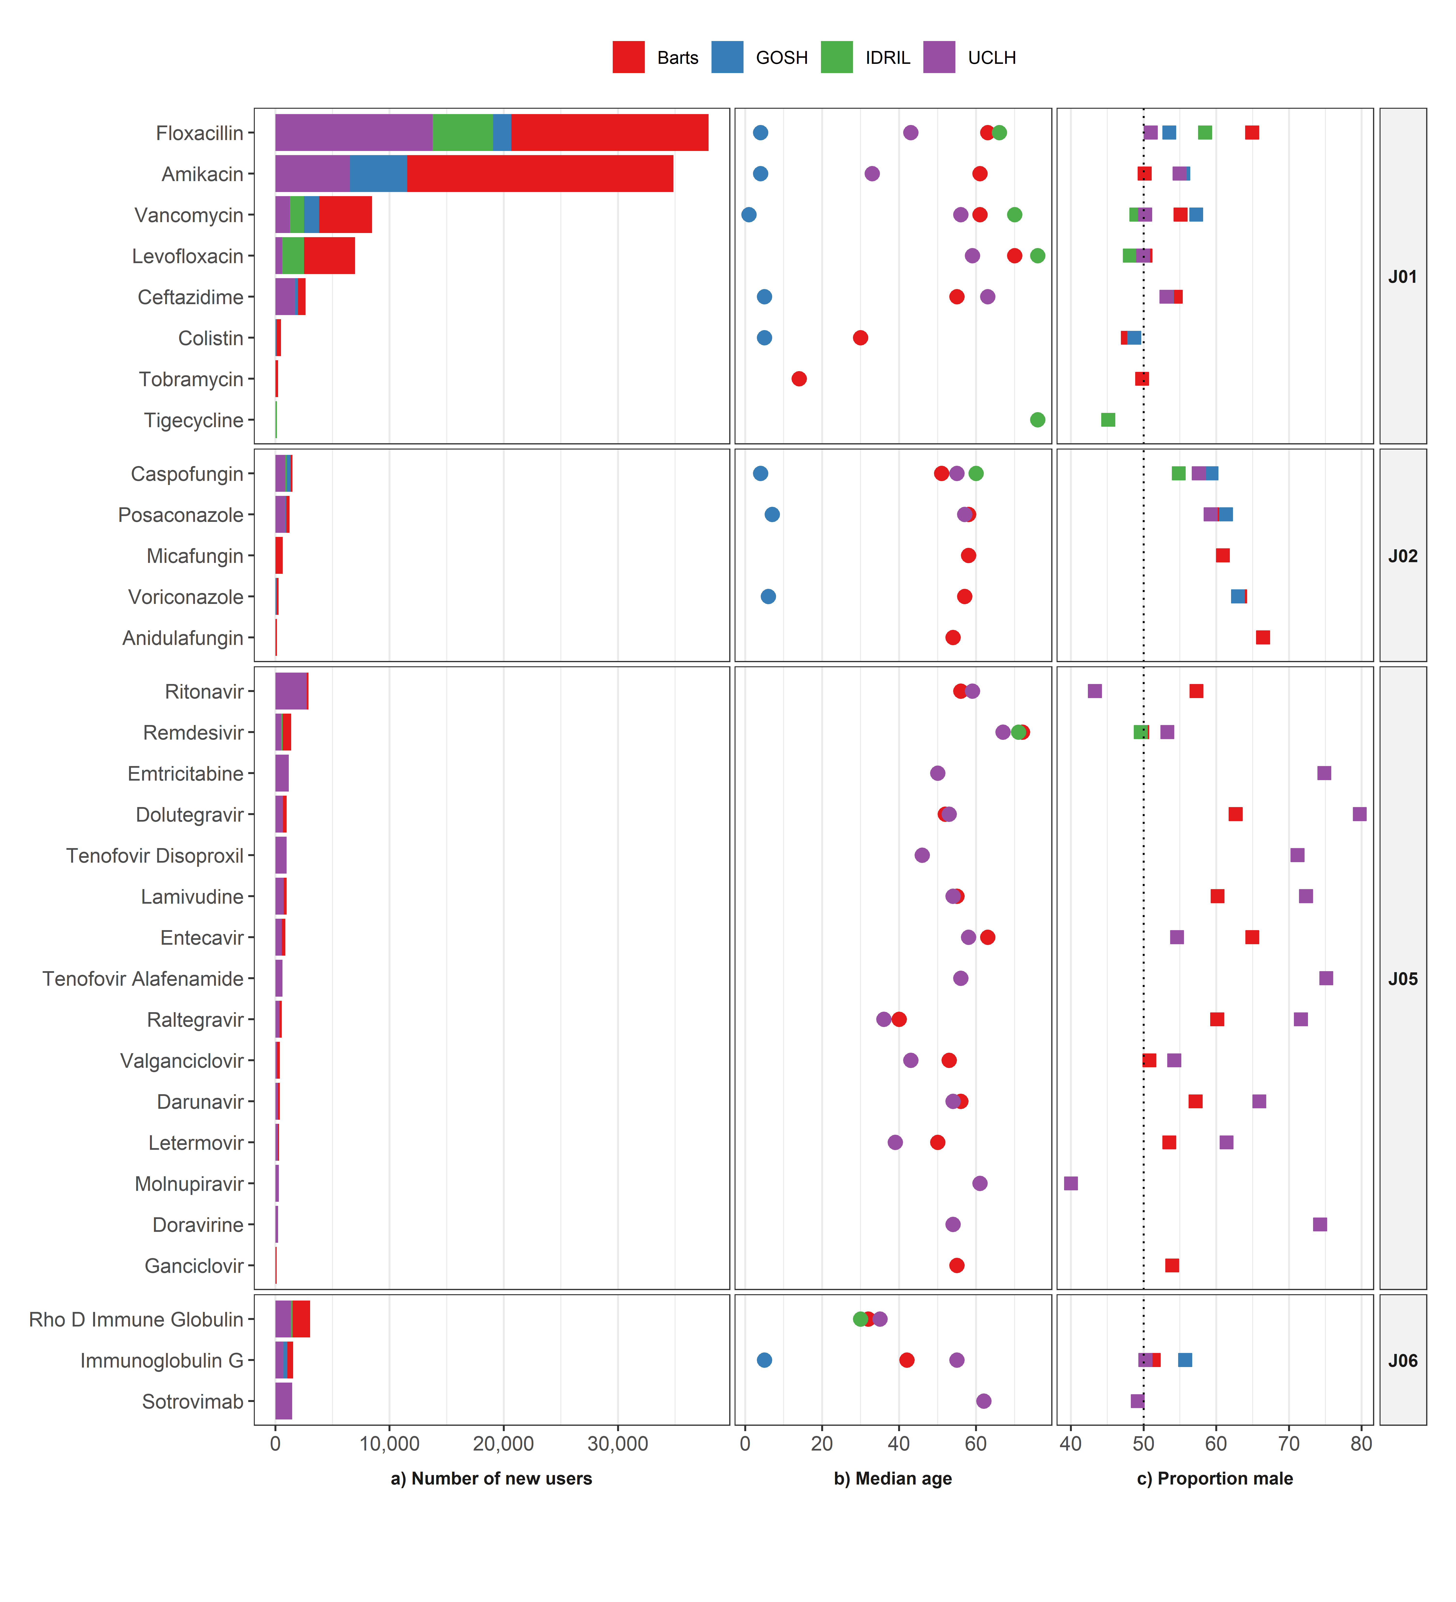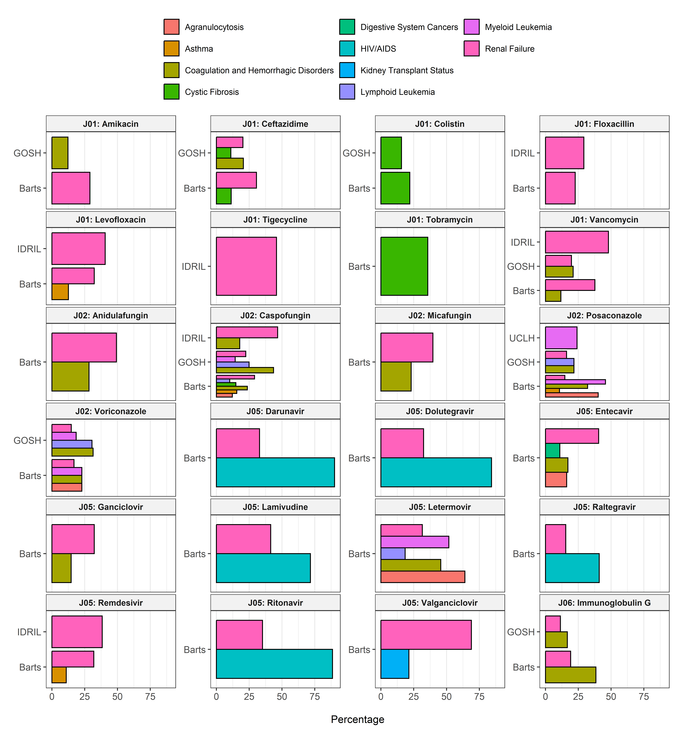

# ATC Group L01: Antineoplastic agents

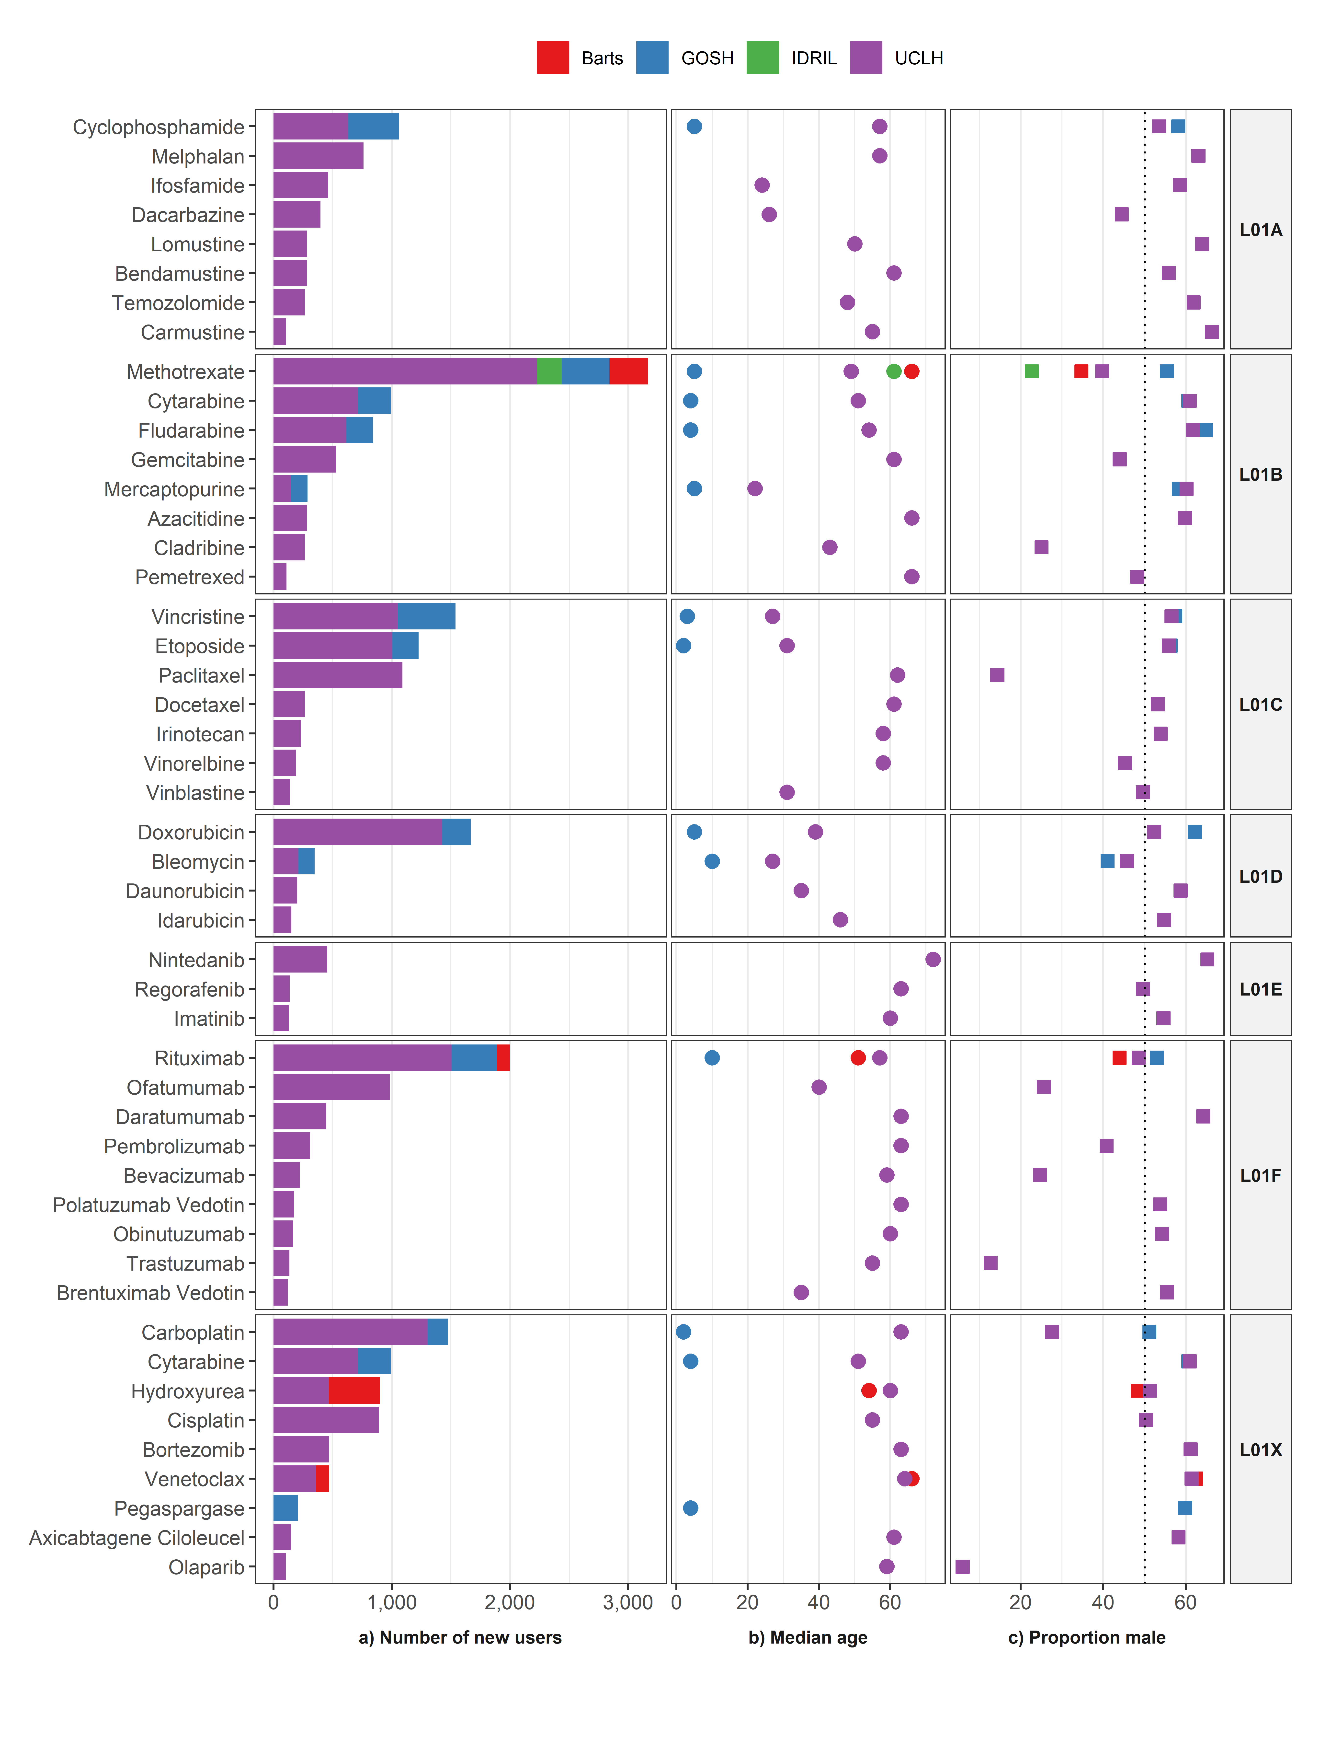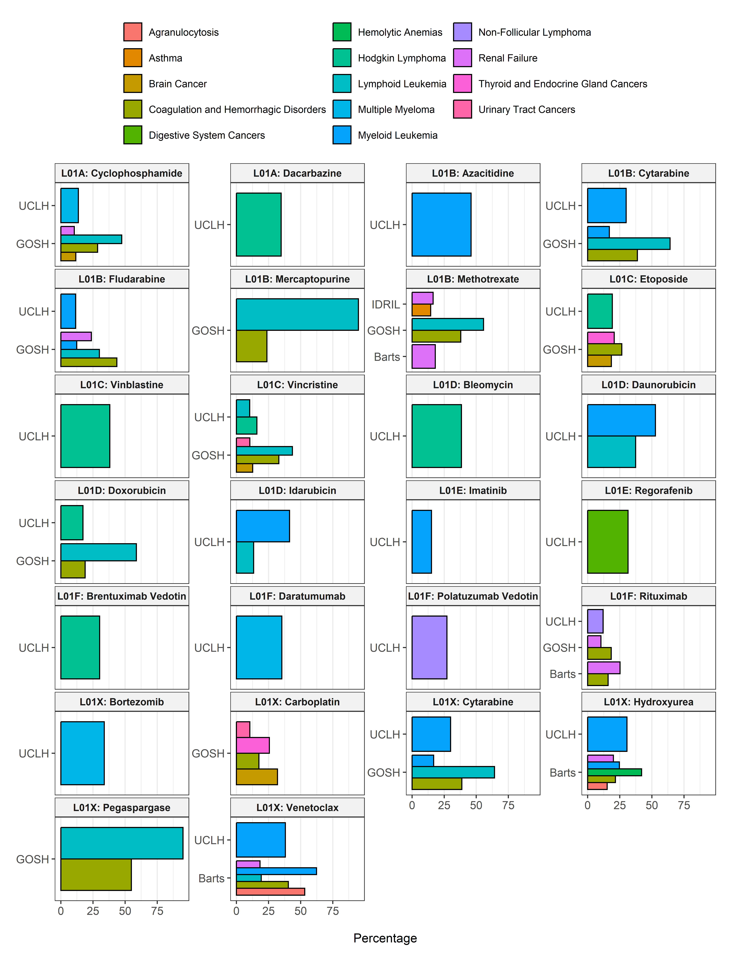

# ATC Group L02: Endocrine therapy

|  |
| --- |
|  |

# ATC Group L03: Immunostimulants

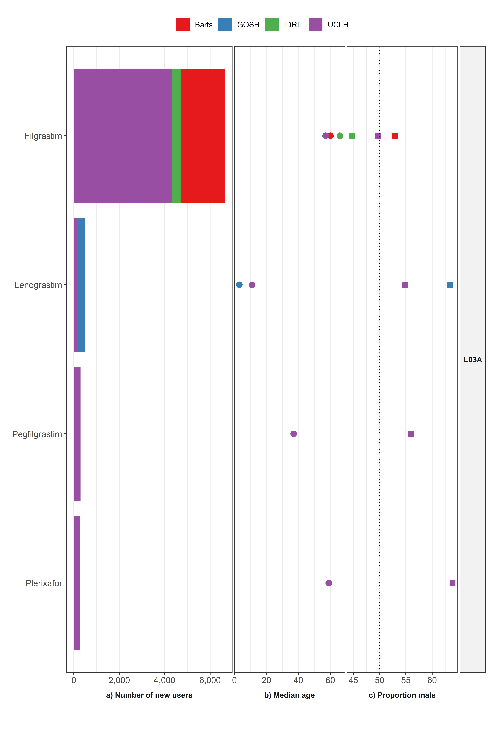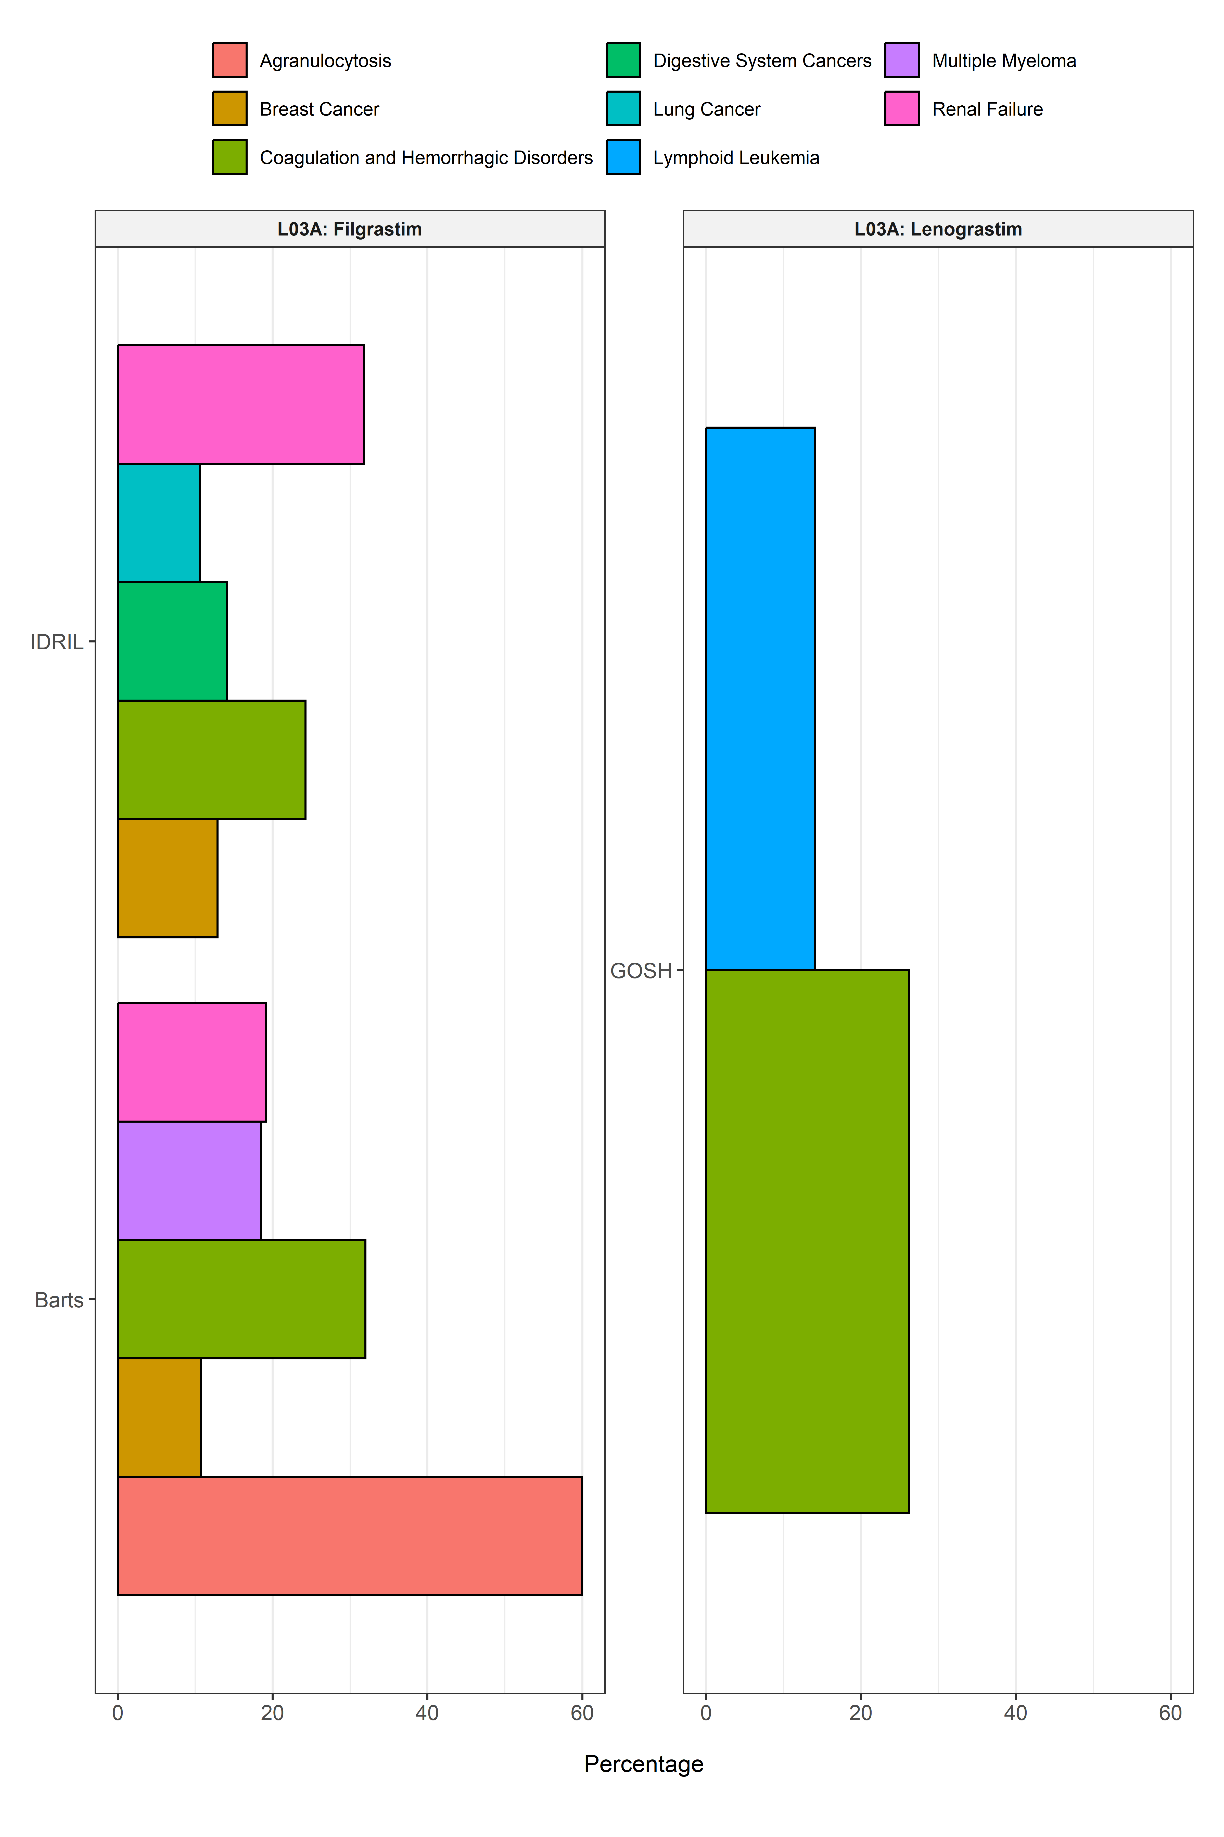

# ATC Group L04: Immunosuppressants

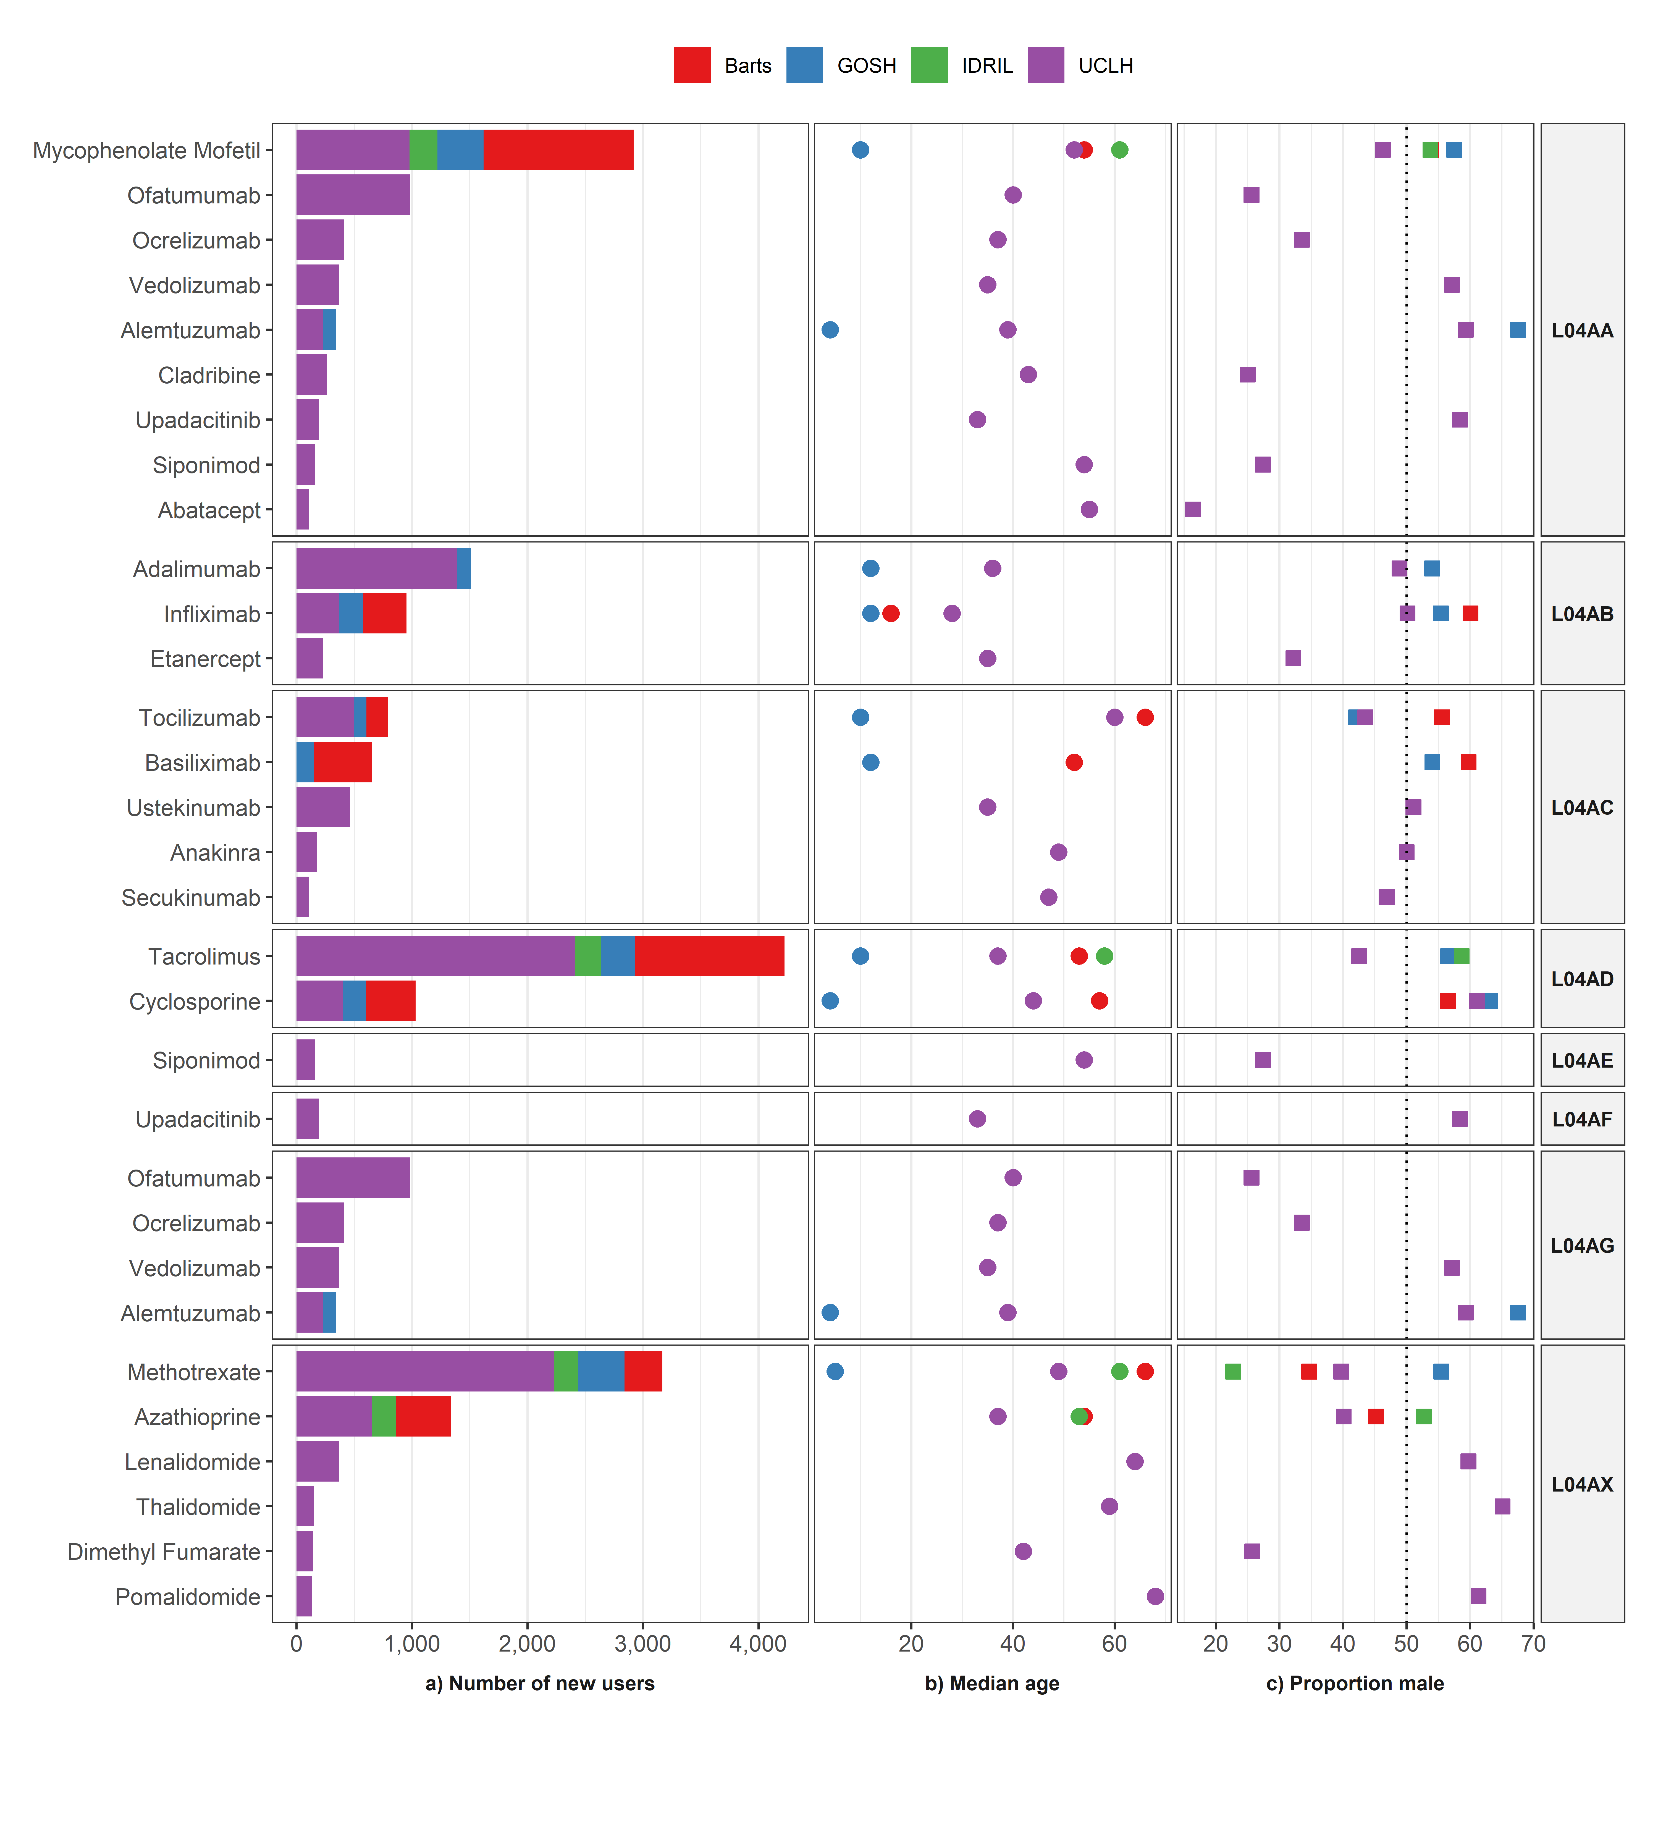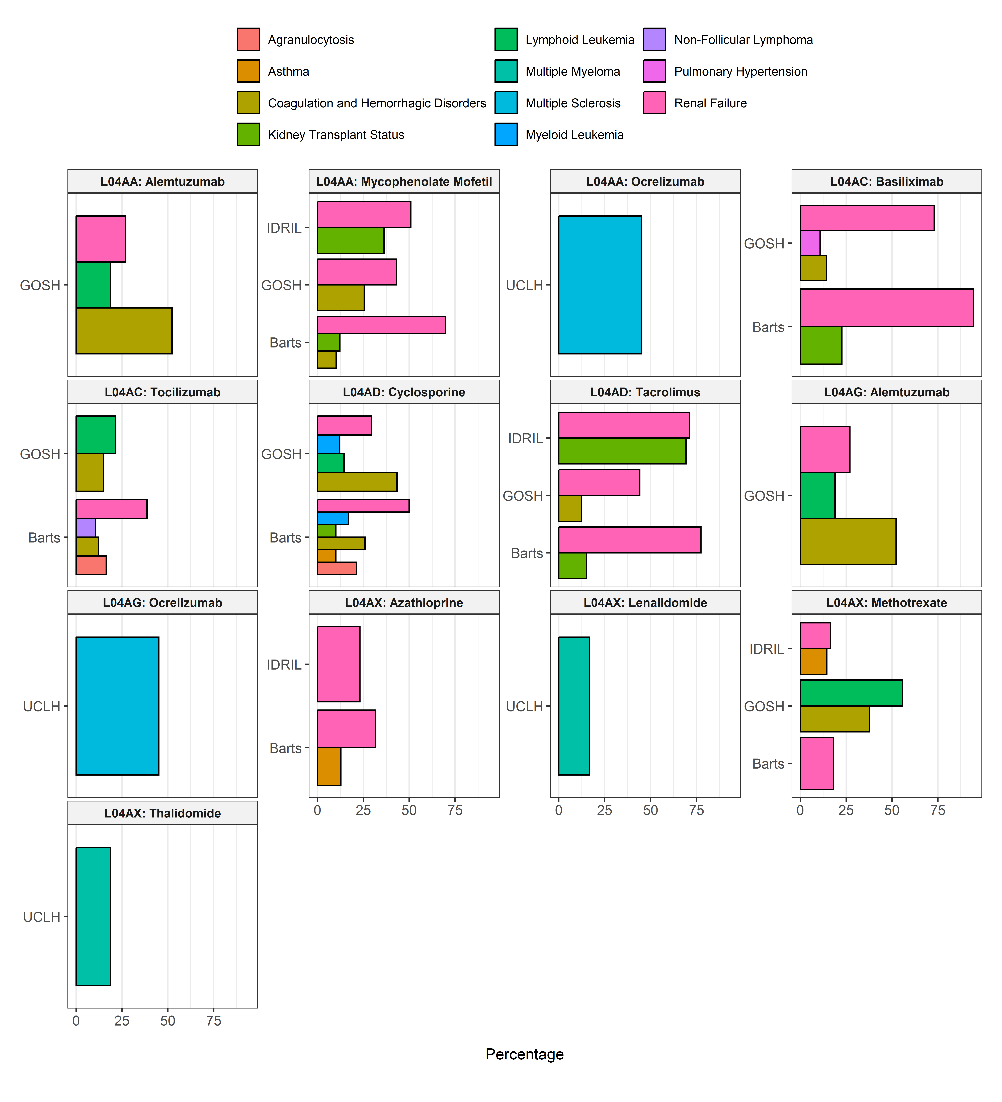

# ATC Group M: MUSCULO-SKELETAL SYSTEM

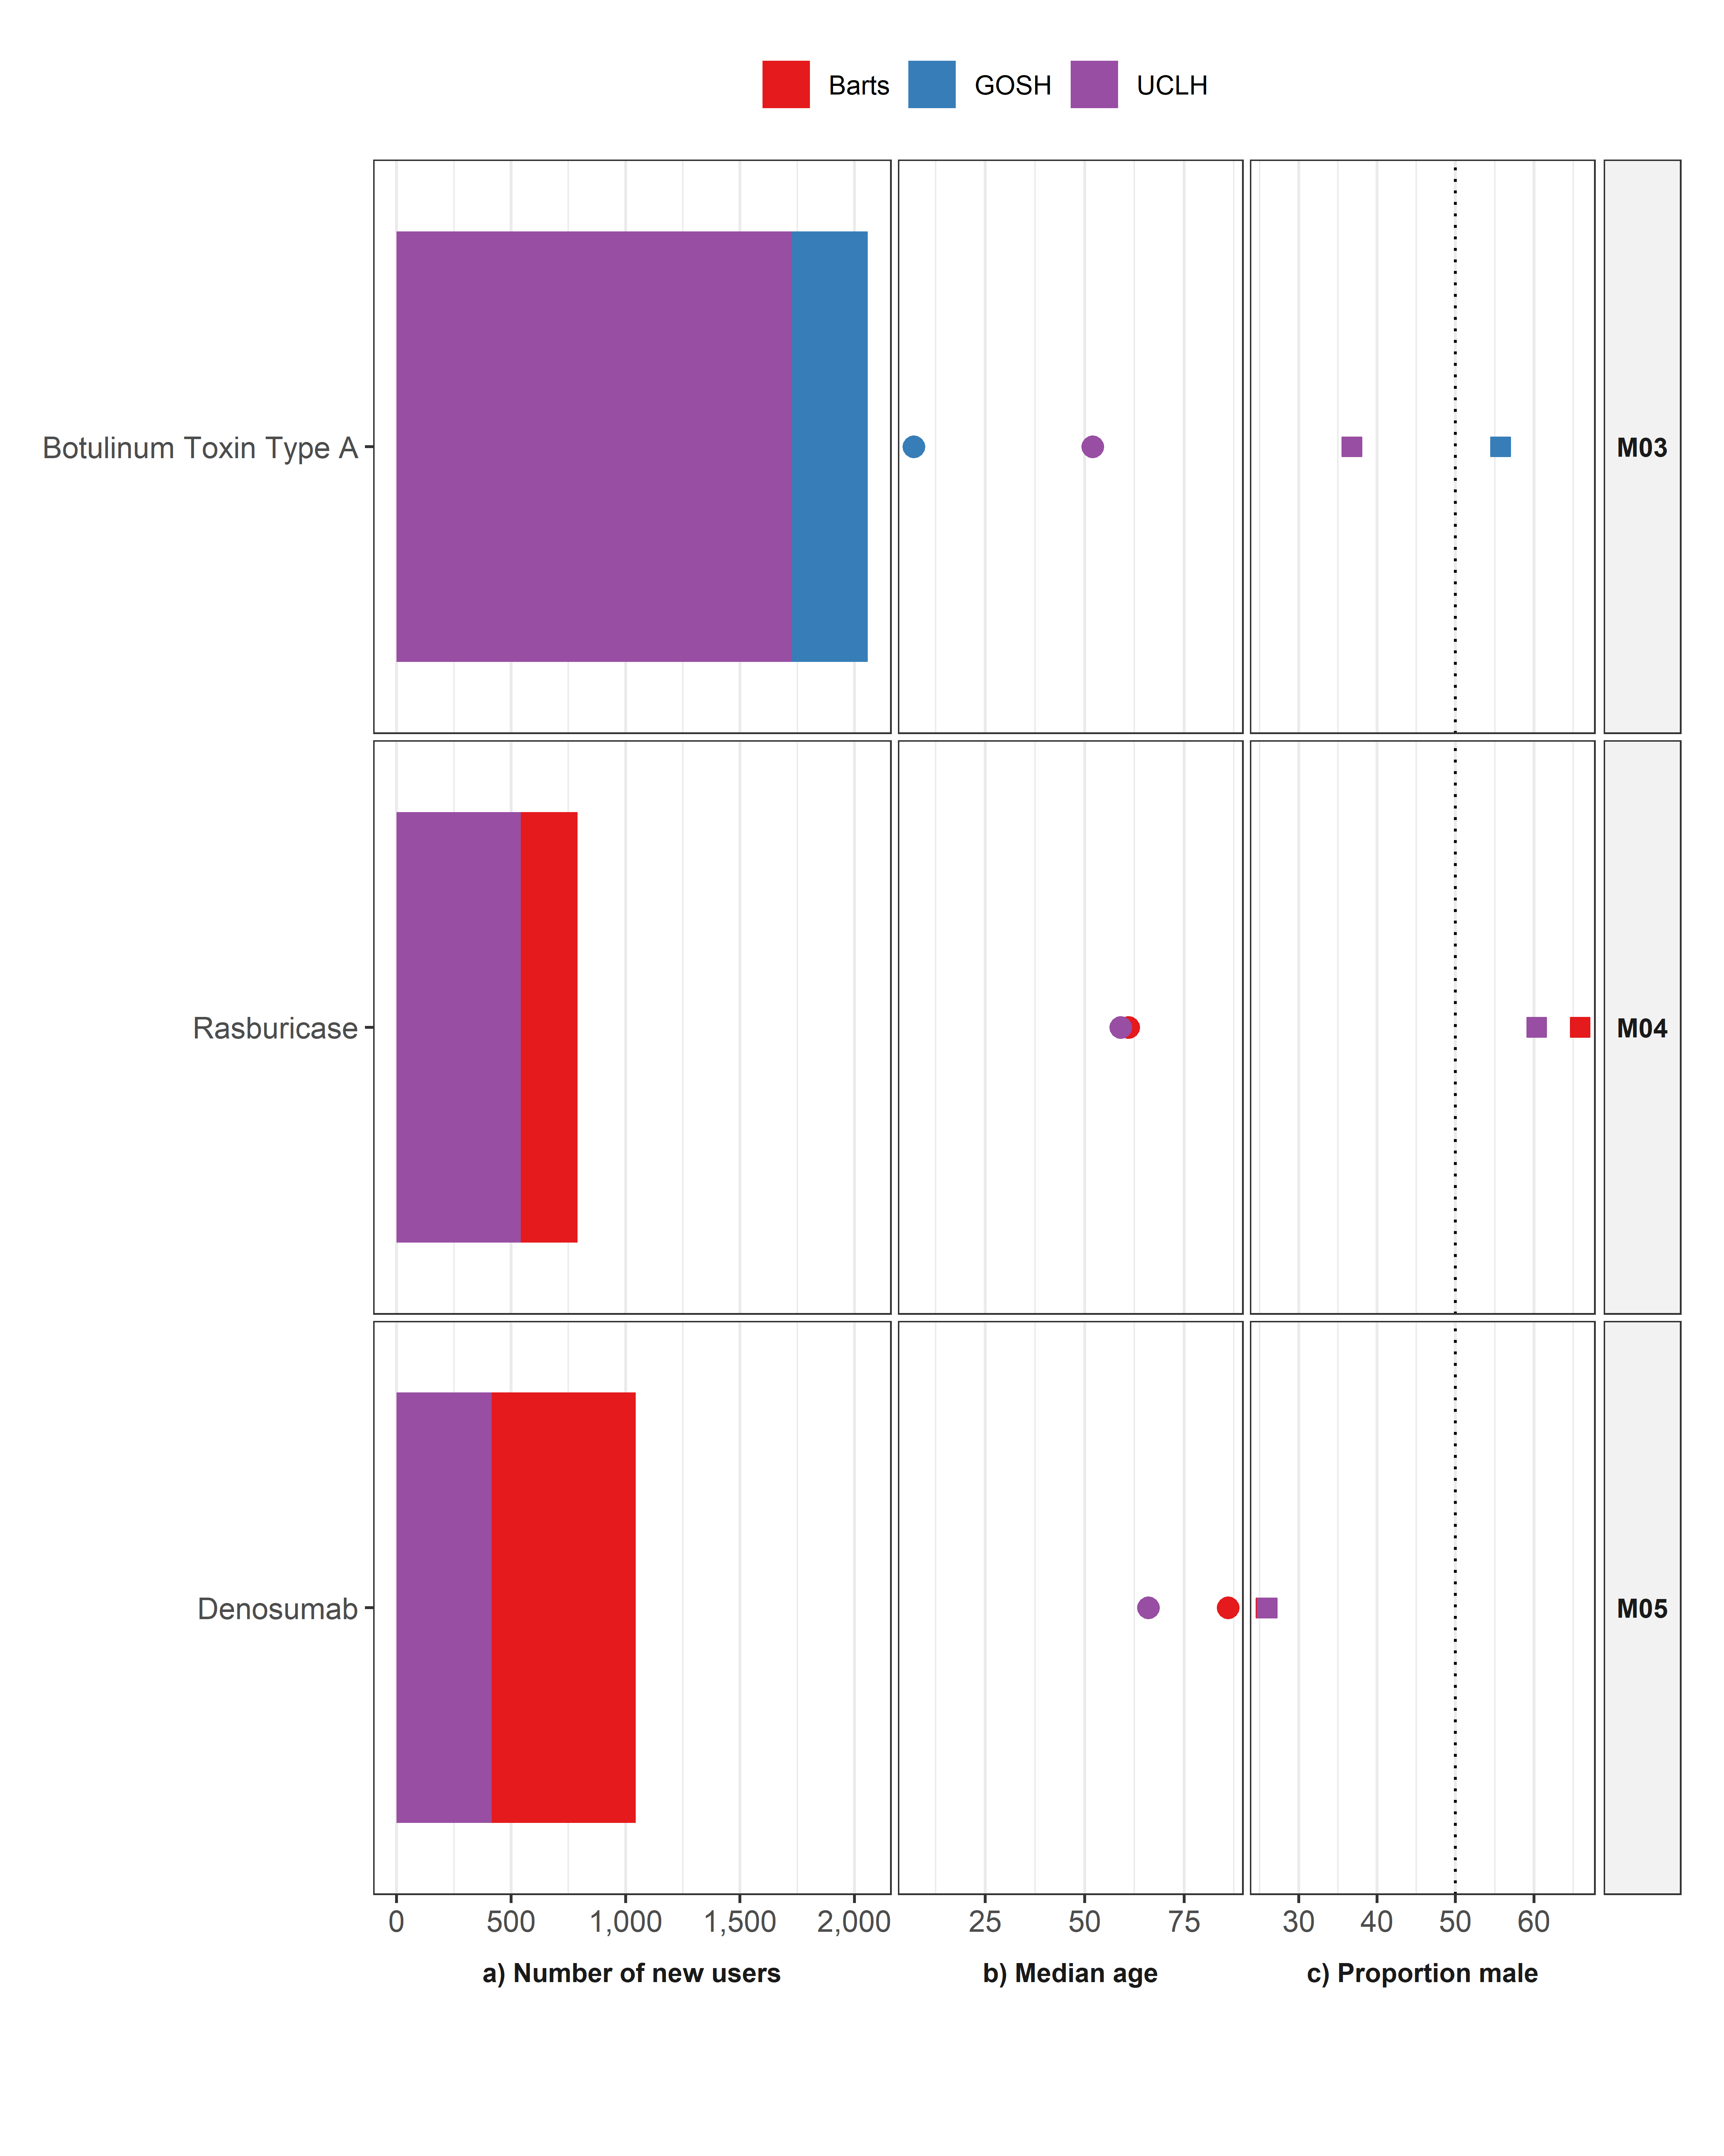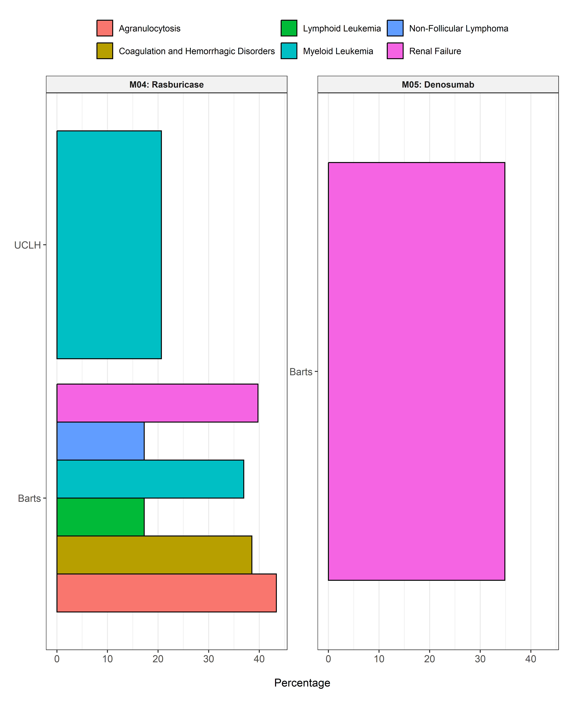

# ATC Group N: NERVOUS SYSTEM

|  |
| --- |
|  |

# ATC Group R: RESPIRATORY SYSTEM

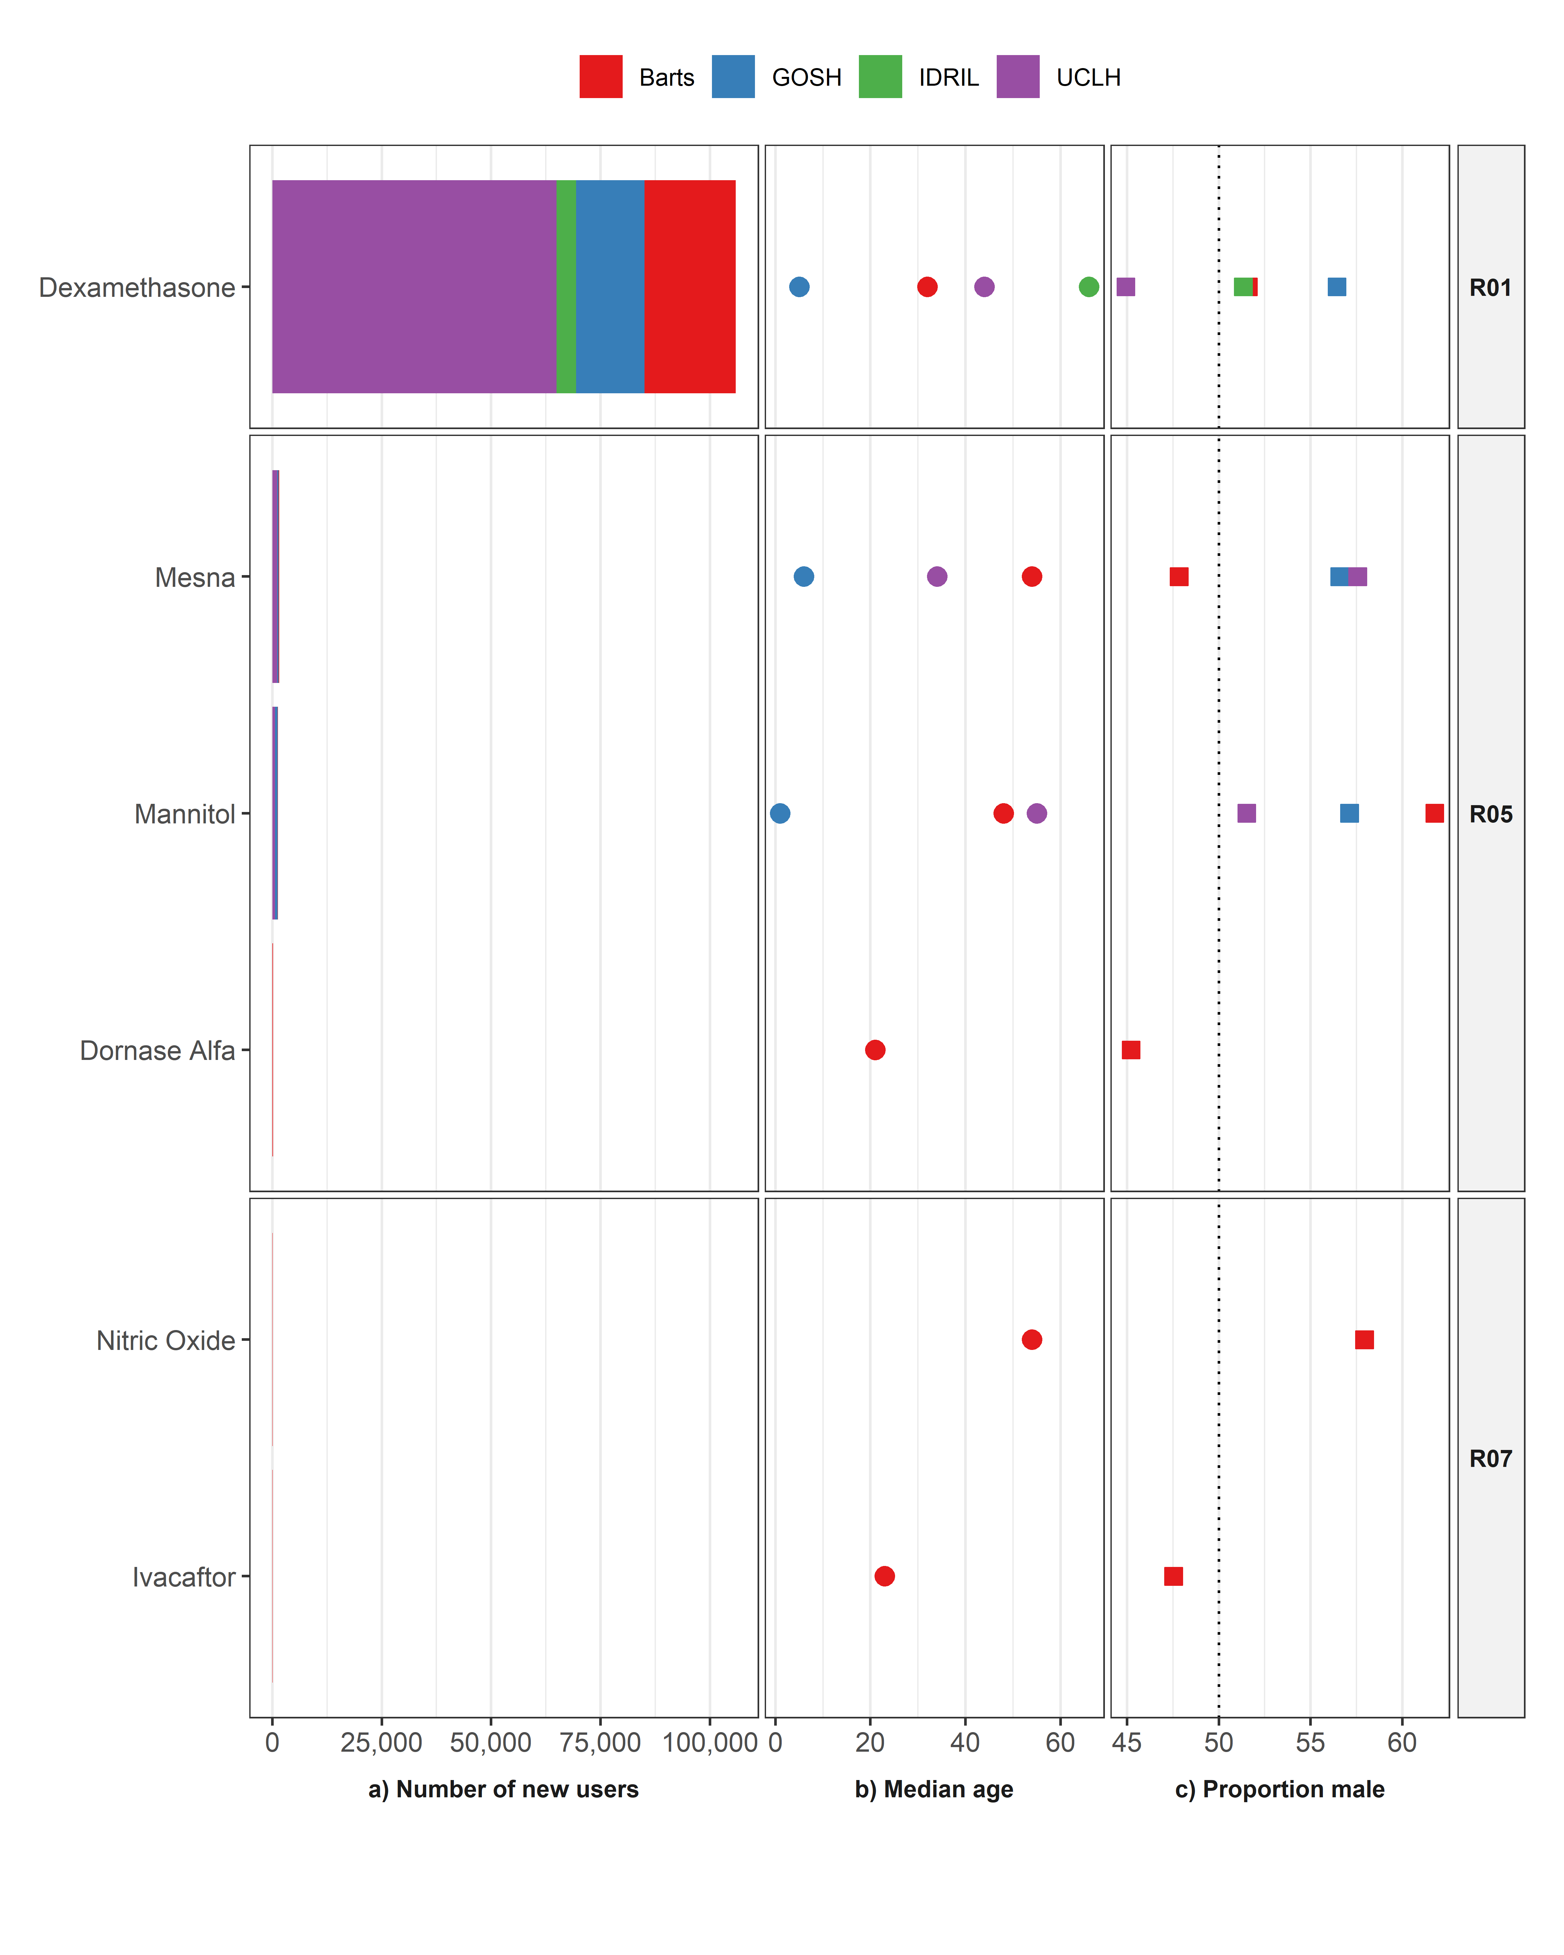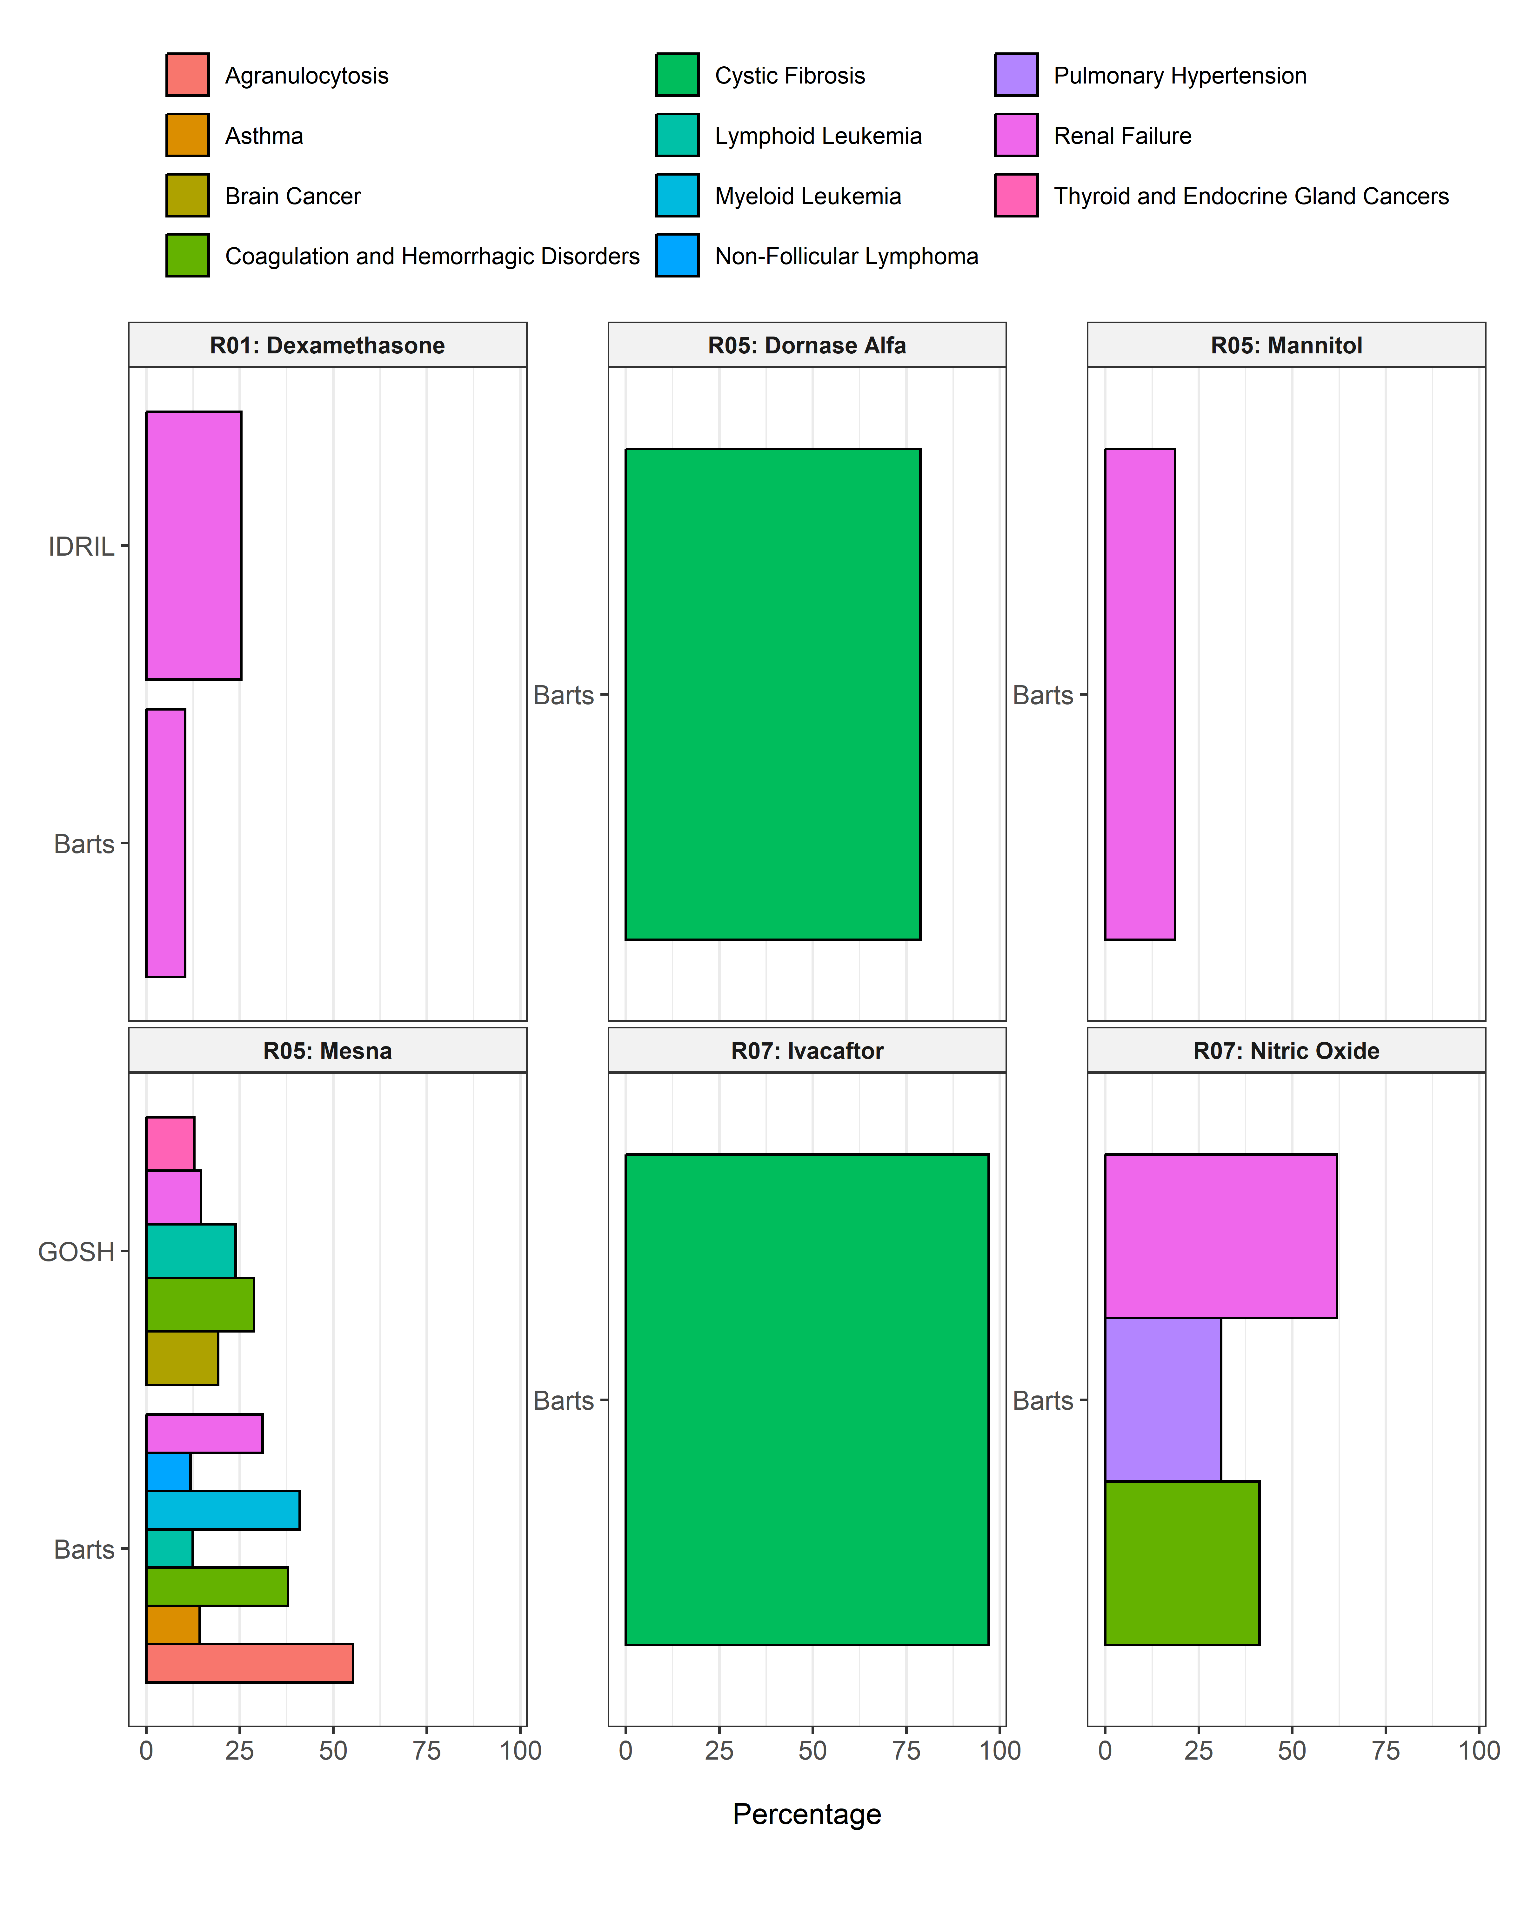

# ATC Group S: SENSORY ORGANS

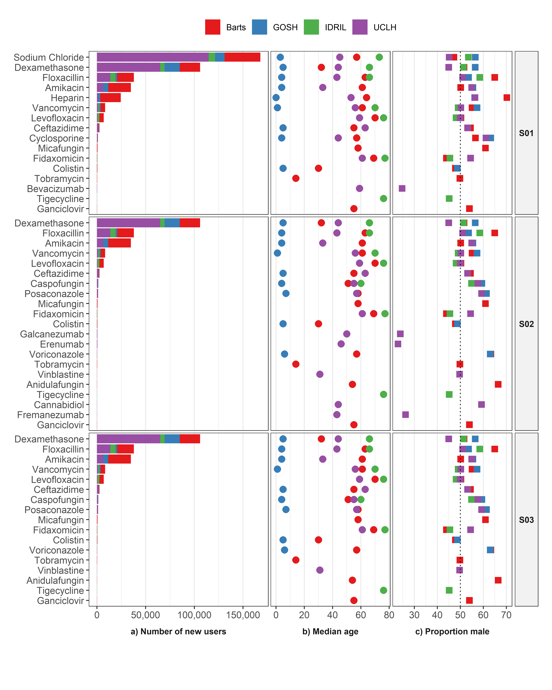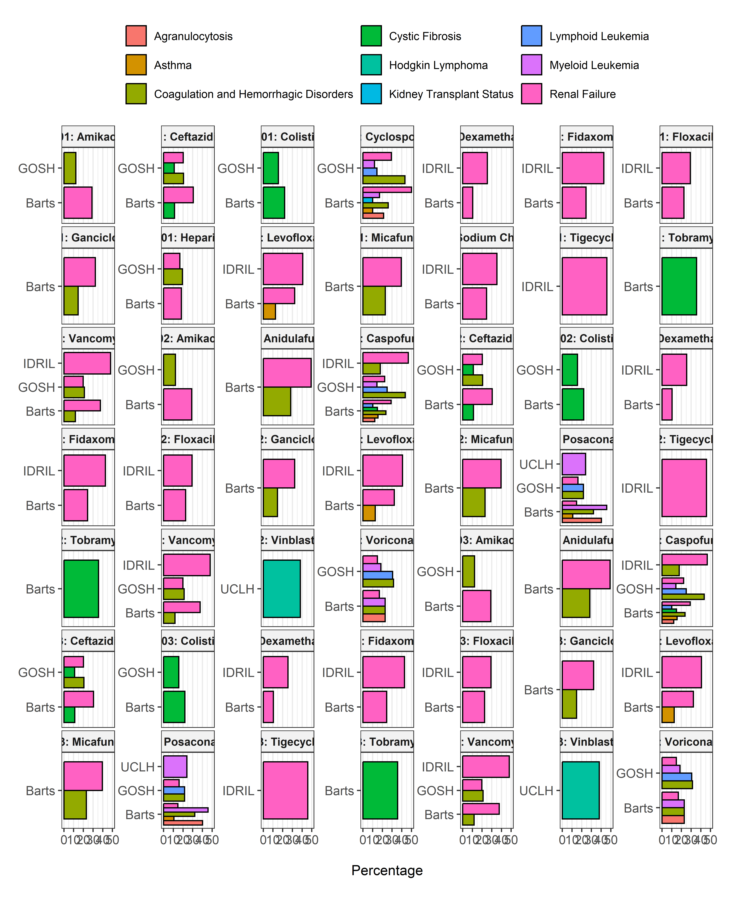

# ATC Group V: VARIOUS

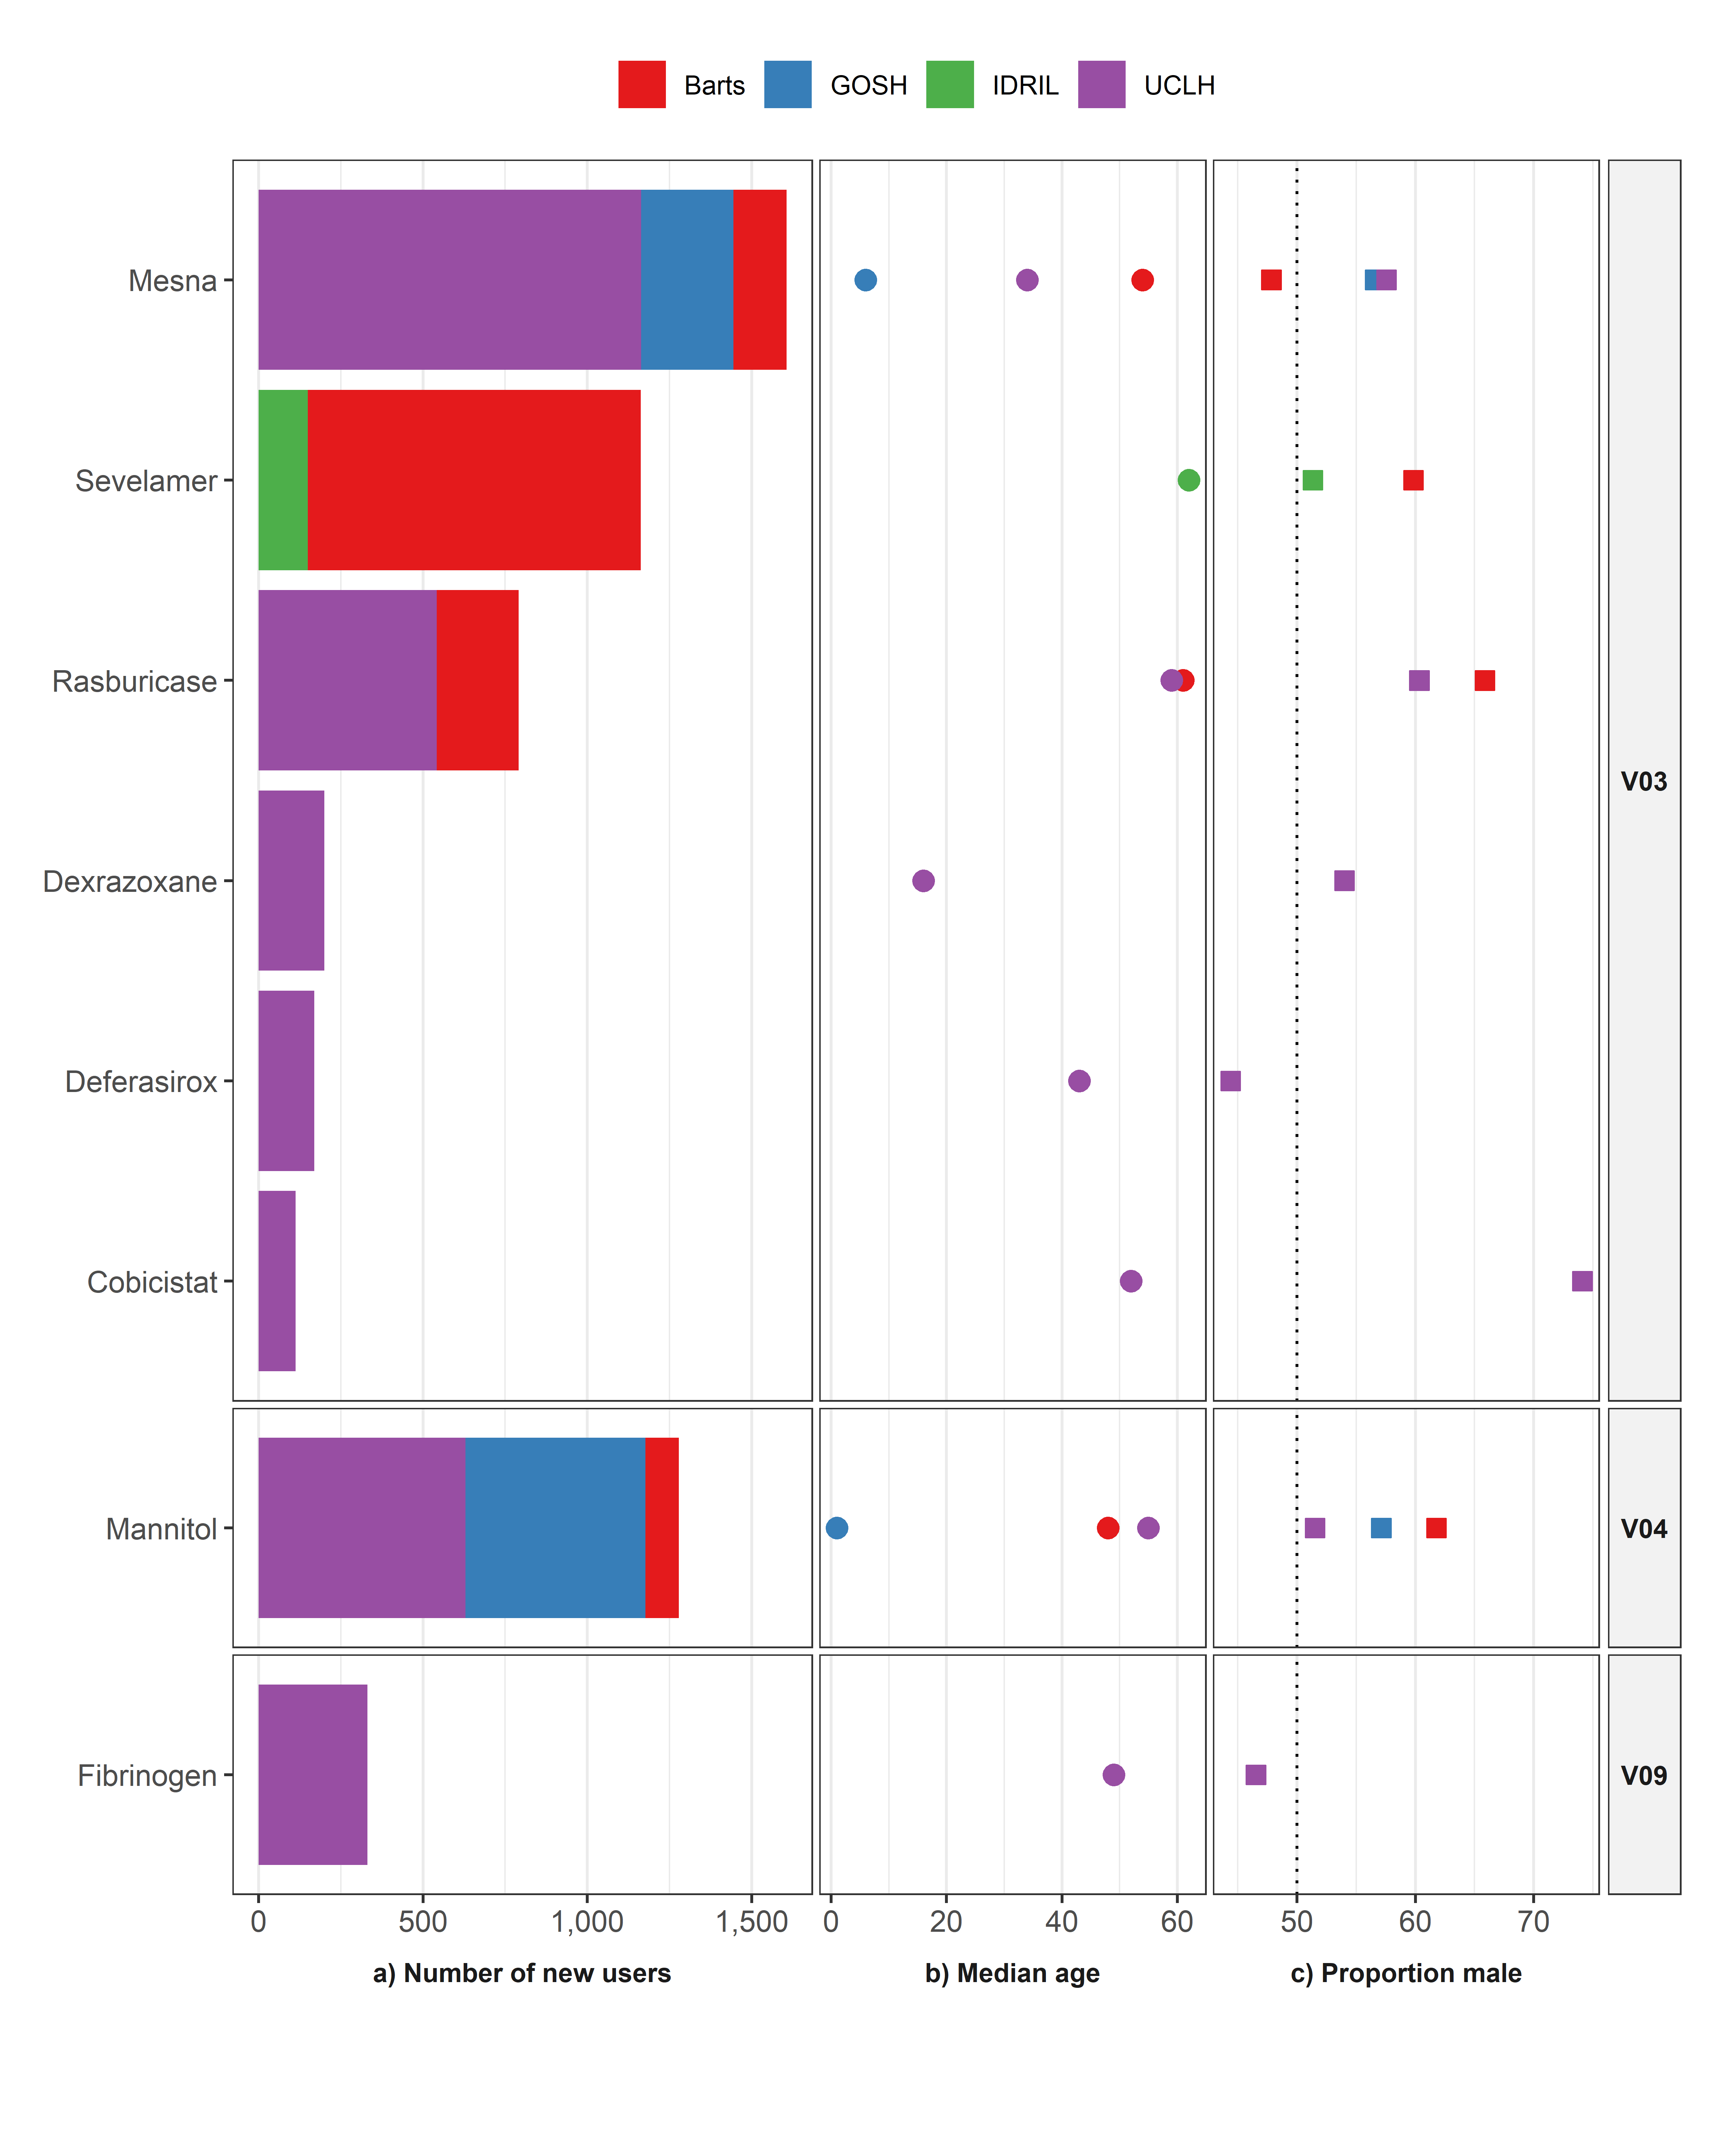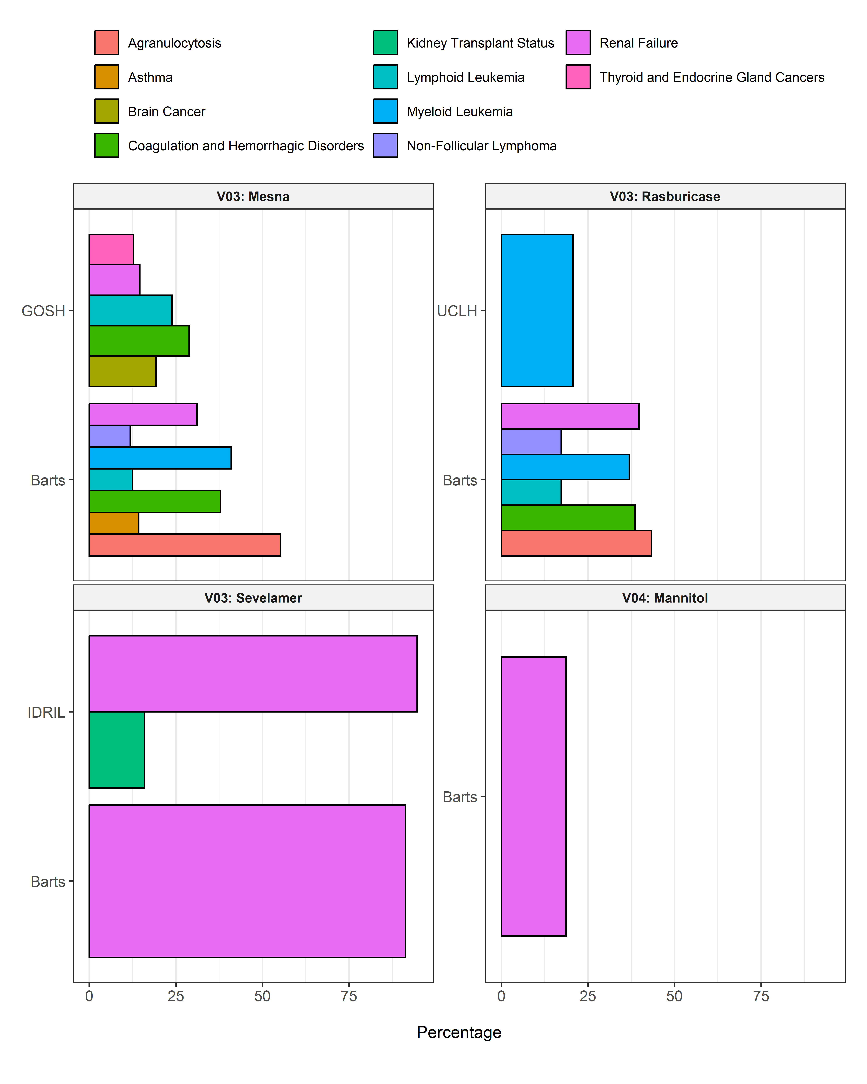

# Table characteristics

| Variable name | Variable level | Estimate name | Estimate value |
| --- | --- | --- | --- |
| **abacavir_all; UCLH** | | | |
| Number subjects |  | N | 117 |
| Age |  | Median [Q25 - Q75] | 52 [44 - 55] |
|  |  | Range | 18 to 80 |
| Age group | 18 to 65 | N (%) | 263 (95.29%) |
|  | 66 to 150 | N (%) | 13 (4.71%) |
| Sex | Female | N (%) | 114 (41.30%) |
|  | Male | N (%) | 162 (58.70%) |
| **abatacept_all; UCLH** | | | |
| Number subjects |  | N | 195 |
| Age |  | Median [Q25 - Q75] | 56 [28 - 70] |
|  |  | Range | 17 to 89 |
| Age group | 0 to 17 | N (%) | 5 (0.22%) |
|  | 18 to 65 | N (%) | 1,547 (66.94%) |
|  | 66 to 150 | N (%) | 759 (32.84%) |
| Sex | Female | N (%) | 1,977 (85.55%) |
|  | Male | N (%) | 334 (14.45%) |
| **abatacept_first; UCLH** | | | |
| Number subjects |  | N | 110 |
| Age |  | Median [Q25 - Q75] | 55 [28 - 69] |
|  |  | Range | 17 to 88 |
| Age group | 0 to 17 | N (%) | <5 |
|  | 18 to 65 | N (%) | 77 (70.00%) |
|  | 66 to 150 | N (%) | 31 (28.18%) |
| Sex | Female | N (%) | 92 (83.64%) |
|  | Male | N (%) | 18 (16.36%) |
| **abemaciclib_all; UCLH** | | | |
| Number subjects |  | N | 100 |
| Age |  | Median [Q25 - Q75] | 57 [47 - 68] |
|  |  | Range | 25 to 85 |
| Age group | 18 to 65 | N (%) | 240 (69.57%) |
|  | 66 to 150 | N (%) | 105 (30.43%) |
| Sex | Female | N (%) | 343 (99.42%) |
|  | Male | N (%) | <5 |
| **adalimumab_all; GOSH** | | | |
| Number subjects |  | N | 133 |
| Age |  | Median [Q25 - Q75] | 12 [9 - 14] |
|  |  | Range | 3 to 17 |
| Age group | 0 to 17 | N (%) | 540 (100.00%) |
| Sex | Female | N (%) | 205 (37.96%) |
|  | Male | N (%) | 335 (62.04%) |
| **adalimumab_all; UCLH** | | | |
| Number subjects |  | N | 1,594 |
| Age |  | Median [Q25 - Q75] | 37 [26 - 51] |
|  |  | Range | 9 to 88 |
| Age group | 0 to 17 | N (%) | 164 (5.39%) |
|  | 18 to 65 | N (%) | 2,650 (87.14%) |
|  | 66 to 150 | N (%) | 227 (7.46%) |
| Sex | Female | N (%) | 1,450 (47.68%) |
|  | Male | N (%) | 1,591 (52.32%) |
| **adalimumab_first; GOSH** | | | |
| Number subjects |  | N | 124 |
| Age |  | Median [Q25 - Q75] | 12 [8 - 15] |
|  |  | Range | 3 to 17 |
| Age group | 0 to 17 | N (%) | 124 (100.00%) |
| Sex | Female | N (%) | 57 (45.97%) |
|  | Male | N (%) | 67 (54.03%) |
| **adalimumab_first; UCLH** | | | |
| Number subjects |  | N | 1,387 |
| Age |  | Median [Q25 - Q75] | 36 [25 - 51] |
|  |  | Range | 9 to 87 |
| Age group | 0 to 17 | N (%) | 99 (7.14%) |
|  | 18 to 65 | N (%) | 1,183 (85.29%) |
|  | 66 to 150 | N (%) | 105 (7.57%) |
| Sex | Female | N (%) | 709 (51.12%) |
|  | Male | N (%) | 678 (48.88%) |
| **alemtuzumab_all; GOSH** | | | |
| Number subjects |  | N | 112 |
| Age |  | Median [Q25 - Q75] | 4 [1 - 7] |
|  |  | Range | 0 to 17 |
| Age group | 0 to 17 | N (%) | 536 (100.00%) |
| Sex | Female | N (%) | 172 (32.09%) |
|  | Male | N (%) | 364 (67.91%) |
| **alemtuzumab_all; UCLH** | | | |
| Number subjects |  | N | 233 |
| Age |  | Median [Q25 - Q75] | 48 [27 - 69] |
|  |  | Range | 13 to 75 |
| Age group | 0 to 17 | N (%) | 55 (7.98%) |
|  | 18 to 65 | N (%) | 430 (62.41%) |
|  | 66 to 150 | N (%) | 204 (29.61%) |
| Sex | Female | N (%) | 309 (44.85%) |
|  | Male | N (%) | 380 (55.15%) |
| **alemtuzumab_first; GOSH** | | | |
| Number subjects |  | N | 111 |
| Age |  | Median [Q25 - Q75] | 4 [1 - 7] |
|  |  | Range | 0 to 17 |
| Age group | 0 to 17 | N (%) | 111 (100.00%) |
| Sex | Female | N (%) | 36 (32.43%) |
|  | Male | N (%) | 75 (67.57%) |
| **alemtuzumab_first; UCLH** | | | |
| Number subjects |  | N | 231 |
| Age |  | Median [Q25 - Q75] | 39 [25 - 58] |
|  |  | Range | 13 to 74 |
| Age group | 0 to 17 | N (%) | 18 (7.79%) |
|  | 18 to 65 | N (%) | 192 (83.12%) |
|  | 66 to 150 | N (%) | 21 (9.09%) |
| Sex | Female | N (%) | 94 (40.69%) |
|  | Male | N (%) | 137 (59.31%) |
| **amikacin_all; Barts** | | | |
| Number subjects |  | N | 23,603 |
| Age |  | Median [Q25 - Q75] | 58 [32 - 74] |
|  |  | Range | 0 to 113 |
| Age group | 0 to 17 | N (%) | 7,661 (16.75%) |
|  | 18 to 65 | N (%) | 20,533 (44.88%) |
|  | 66 to 150 | N (%) | 17,555 (38.37%) |
| Sex | Female | N (%) | 21,704 (47.44%) |
|  | Male | N (%) | 24,045 (52.56%) |
| **amikacin_all; GOSH** | | | |
| Number subjects |  | N | 5,596 |
| Age |  | Median [Q25 - Q75] | 3 [0 - 10] |
|  |  | Range | 0 to 20 |
| Age group | 0 to 17 | N (%) | 34,340 (99.68%) |
|  | 18 to 65 | N (%) | 109 (0.32%) |
| Sex | Female | N (%) | 14,869 (43.16%) |
|  | Male | N (%) | 19,580 (56.84%) |
| **amikacin_all; UCLH** | | | |
| Number subjects |  | N | 6,652 |
| Age |  | Median [Q25 - Q75] | 14 [0 - 55] |
|  |  | Range | 0 to 102 |
| Age group | 0 to 17 | N (%) | 8,535 (51.76%) |
|  | 18 to 65 | N (%) | 5,719 (34.68%) |
|  | 66 to 150 | N (%) | 2,235 (13.55%) |
| Sex | Female | N (%) | 7,235 (43.88%) |
|  | Male | N (%) | 9,254 (56.12%) |
| **amikacin_first; Barts** | | | |
| Number subjects |  | N | 23,303 |
| Age |  | Median [Q25 - Q75] | 61 [37 - 76] |
|  |  | Range | 0 to 113 |
| Age group | 0 to 17 | N (%) | 2,645 (11.35%) |
|  | 18 to 65 | N (%) | 10,728 (46.04%) |
|  | 66 to 150 | N (%) | 9,930 (42.61%) |
| Sex | Female | N (%) | 11,623 (49.88%) |
|  | Male | N (%) | 11,680 (50.12%) |
| **amikacin_first; GOSH** | | | |
| Number subjects |  | N | 5,017 |
| Age |  | Median [Q25 - Q75] | 4 [0 - 11] |
|  |  | Range | 0 to 20 |
| Age group | 0 to 17 | N (%) | 5,001 (99.68%) |
|  | 18 to 65 | N (%) | 16 (0.32%) |
| Sex | Female | N (%) | 2,235 (44.55%) |
|  | Male | N (%) | 2,782 (55.45%) |
| **amikacin_first; UCLH** | | | |
| Number subjects |  | N | 6,533 |
| Age |  | Median [Q25 - Q75] | 33 [0 - 61] |
|  |  | Range | 0 to 102 |
| Age group | 0 to 17 | N (%) | 2,745 (42.02%) |
|  | 18 to 65 | N (%) | 2,521 (38.59%) |
|  | 66 to 150 | N (%) | 1,267 (19.39%) |
| Sex | Female | N (%) | 2,945 (45.08%) |
|  | Male | N (%) | 3,588 (54.92%) |
| **anakinra_all; UCLH** | | | |
| Number subjects |  | N | 198 |
| Age |  | Median [Q25 - Q75] | 45 [27 - 61] |
|  |  | Range | 14 to 88 |
| Age group | 0 to 17 | N (%) | 25 (0.98%) |
|  | 18 to 65 | N (%) | 2,107 (82.89%) |
|  | 66 to 150 | N (%) | 410 (16.13%) |
| Sex | Female | N (%) | 1,159 (45.59%) |
|  | Male | N (%) | 1,383 (54.41%) |
| **anakinra_first; UCLH** | | | |
| Number subjects |  | N | 174 |
| Age |  | Median [Q25 - Q75] | 49 [32 - 63] |
|  |  | Range | 14 to 88 |
| Age group | 0 to 17 | N (%) | <5 |
|  | 18 to 65 | N (%) | 135 (77.59%) |
|  | 66 to 150 | N (%) | 35 (20.11%) |
| Sex | Female | N (%) | 87 (50.00%) |
|  | Male | N (%) | 87 (50.00%) |
| **anidulafungin_all; Barts** | | | |
| Number subjects |  | N | 134 |
| Age |  | Median [Q25 - Q75] | 55 [46 - 64] |
|  |  | Range | 18 to 81 |
| Age group | 18 to 65 | N (%) | 721 (77.11%) |
|  | 66 to 150 | N (%) | 214 (22.89%) |
| Sex | Female | N (%) | 325 (34.76%) |
|  | Male | N (%) | 610 (65.24%) |
| **anidulafungin_first; Barts** | | | |
| Number subjects |  | N | 134 |
| Age |  | Median [Q25 - Q75] | 54 [42 - 63] |
|  |  | Range | 18 to 81 |
| Age group | 18 to 65 | N (%) | 105 (78.36%) |
|  | 66 to 150 | N (%) | 29 (21.64%) |
| Sex | Female | N (%) | 45 (33.58%) |
|  | Male | N (%) | 89 (66.42%) |
| **aprepitant_all; Barts** | | | |
| Number subjects |  | N | 127 |
| Age |  | Median [Q25 - Q75] | 28 [23 - 37] |
|  |  | Range | 2 to 82 |
| Age group | 0 to 17 | N (%) | 84 (9.52%) |
|  | 18 to 65 | N (%) | 764 (86.62%) |
|  | 66 to 150 | N (%) | 34 (3.85%) |
| Sex | Female | N (%) | 299 (33.90%) |
|  | Male | N (%) | 583 (66.10%) |
| **aprepitant_all; GOSH** | | | |
| Number subjects |  | N | 290 |
| Age |  | Median [Q25 - Q75] | 7 [2 - 11] |
|  |  | Range | 0 to 17 |
| Age group | 0 to 17 | N (%) | 4,884 (100.00%) |
| Sex | Female | N (%) | 1,784 (36.53%) |
|  | Male | N (%) | 3,100 (63.47%) |
| **aprepitant_all; UCLH** | | | |
| Number subjects |  | N | 3,414 |
| Age |  | Median [Q25 - Q75] | 50 [32 - 62] |
|  |  | Range | 1 to 91 |
| Age group | 0 to 17 | N (%) | 1,841 (8.24%) |
|  | 18 to 65 | N (%) | 16,653 (74.53%) |
|  | 66 to 150 | N (%) | 3,849 (17.23%) |
| Sex | Female | N (%) | 10,946 (48.99%) |
|  | Male | N (%) | 11,397 (51.01%) |
| **aprepitant_first; Barts** | | | |
| Number subjects |  | N | 126 |
| Age |  | Median [Q25 - Q75] | 37 [27 - 54] |
|  |  | Range | 2 to 82 |
| Age group | 0 to 17 | N (%) | 9 (7.14%) |
|  | 18 to 65 | N (%) | 106 (84.13%) |
|  | 66 to 150 | N (%) | 11 (8.73%) |
| Sex | Female | N (%) | 50 (39.68%) |
|  | Male | N (%) | 76 (60.32%) |
| **aprepitant_first; GOSH** | | | |
| Number subjects |  | N | 244 |
| Age |  | Median [Q25 - Q75] | 6 [2 - 10] |
|  |  | Range | 0 to 17 |
| Age group | 0 to 17 | N (%) | 244 (100.00%) |
| Sex | Female | N (%) | 110 (45.08%) |
|  | Male | N (%) | 134 (54.92%) |
| **aprepitant_first; UCLH** | | | |
| Number subjects |  | N | 3,165 |
| Age |  | Median [Q25 - Q75] | 53 [35 - 63] |
|  |  | Range | 1 to 91 |
| Age group | 0 to 17 | N (%) | 251 (7.93%) |
|  | 18 to 65 | N (%) | 2,285 (72.20%) |
|  | 66 to 150 | N (%) | 629 (19.87%) |
| Sex | Female | N (%) | 1,574 (49.73%) |
|  | Male | N (%) | 1,591 (50.27%) |
| **axicabtagene_ciloleucel_all; UCLH** | | | |
| Number subjects |  | N | 146 |
| Age |  | Median [Q25 - Q75] | 61 [51 - 69] |
|  |  | Range | 23 to 78 |
| Age group | 18 to 65 | N (%) | 97 (66.44%) |
|  | 66 to 150 | N (%) | 49 (33.56%) |
| Sex | Female | N (%) | 61 (41.78%) |
|  | Male | N (%) | 85 (58.22%) |
| **axicabtagene_ciloleucel_first; UCLH** | | | |
| Number subjects |  | N | 146 |
| Age |  | Median [Q25 - Q75] | 61 [51 - 69] |
|  |  | Range | 23 to 78 |
| Age group | 18 to 65 | N (%) | 97 (66.44%) |
|  | 66 to 150 | N (%) | 49 (33.56%) |
| Sex | Female | N (%) | 61 (41.78%) |
|  | Male | N (%) | 85 (58.22%) |
| **azacitidine_all; UCLH** | | | |
| Number subjects |  | N | 339 |
| Age |  | Median [Q25 - Q75] | 70 [62 - 76] |
|  |  | Range | 14 to 92 |
| Age group | 0 to 17 | N (%) | 14 (0.16%) |
|  | 18 to 65 | N (%) | 3,088 (34.84%) |
|  | 66 to 150 | N (%) | 5,762 (65.00%) |
| Sex | Female | N (%) | 3,634 (41.00%) |
|  | Male | N (%) | 5,230 (59.00%) |
| **azacitidine_first; UCLH** | | | |
| Number subjects |  | N | 283 |
| Age |  | Median [Q25 - Q75] | 66 [58 - 75] |
|  |  | Range | 14 to 92 |
| Age group | 0 to 17 | N (%) | <5 |
|  | 18 to 65 | N (%) | 133 (47.00%) |
|  | 66 to 150 | N (%) | 149 (52.65%) |
| Sex | Female | N (%) | 114 (40.28%) |
|  | Male | N (%) | 169 (59.72%) |
| **azathioprine_all; Barts** | | | |
| Number subjects |  | N | 499 |
| Age |  | Median [Q25 - Q75] | 60 [42 - 73] |
|  |  | Range | 2 to 99 |
| Age group | 0 to 17 | N (%) | 87 (1.89%) |
|  | 18 to 65 | N (%) | 2,809 (60.88%) |
|  | 66 to 150 | N (%) | 1,718 (37.23%) |
| Sex | Female | N (%) | 2,601 (56.37%) |
|  | Male | N (%) | 2,013 (43.63%) |
| **azathioprine_all; GOSH** | | | |
| Number subjects |  | N | 104 |
| Age |  | Median [Q25 - Q75] | 11 [6 - 14] |
|  |  | Range | 0 to 18 |
| Age group | 0 to 17 | N (%) | 850 (99.88%) |
|  | 18 to 65 | N (%) | <5 |
| Sex | Female | N (%) | 434 (51.00%) |
|  | Male | N (%) | 417 (49.00%) |
| **azathioprine_all; IDRIL** | | | |
| Number subjects |  | N | 232 |
| Age |  | Median [Q25 - Q75] | 61 [45 - 75] |
|  |  | Range | 17 to 93 |
| Age group | 0 to 17 | N (%) | <5 |
|  | 18 to 65 | N (%) | 1,414 (55.56%) |
|  | 66 to 150 | N (%) | 1,128 (44.32%) |
| Sex | Female | N (%) | 1,165 (45.78%) |
|  | Male | N (%) | 1,380 (54.22%) |
| **azathioprine_all; UCLH** | | | |
| Number subjects |  | N | 829 |
| Age |  | Median [Q25 - Q75] | 40 [28 - 60] |
|  |  | Range | 5 to 89 |
| Age group | 0 to 17 | N (%) | 102 (4.79%) |
|  | 18 to 65 | N (%) | 1,670 (78.48%) |
|  | 66 to 150 | N (%) | 356 (16.73%) |
| Sex | Female | N (%) | 1,292 (60.71%) |
|  | Male | N (%) | 836 (39.29%) |
| **azathioprine_first; Barts** | | | |
| Number subjects |  | N | 478 |
| Age |  | Median [Q25 - Q75] | 54 [36 - 68] |
|  |  | Range | 2 to 97 |
| Age group | 0 to 17 | N (%) | 26 (5.44%) |
|  | 18 to 65 | N (%) | 313 (65.48%) |
|  | 66 to 150 | N (%) | 139 (29.08%) |
| Sex | Female | N (%) | 262 (54.81%) |
|  | Male | N (%) | 216 (45.19%) |
| **azathioprine_first; IDRIL** | | | |
| Number subjects |  | N | 203 |
| Age |  | Median [Q25 - Q75] | 53 [36 - 68] |
|  |  | Range | 17 to 91 |
| Age group | 0 to 17 | N (%) | <5 |
|  | 18 to 65 | N (%) | 142 (69.95%) |
|  | 66 to 150 | N (%) | 60 (29.56%) |
| Sex | Female | N (%) | 96 (47.29%) |
|  | Male | N (%) | 107 (52.71%) |
| **azathioprine_first; UCLH** | | | |
| Number subjects |  | N | 656 |
| Age |  | Median [Q25 - Q75] | 37 [25 - 57] |
|  |  | Range | 5 to 89 |
| Age group | 0 to 17 | N (%) | 48 (7.32%) |
|  | 18 to 65 | N (%) | 518 (78.96%) |
|  | 66 to 150 | N (%) | 90 (13.72%) |
| Sex | Female | N (%) | 393 (59.91%) |
|  | Male | N (%) | 263 (40.09%) |
| **basiliximab_all; Barts** | | | |
| Number subjects |  | N | 503 |
| Age |  | Median [Q25 - Q75] | 52 [42 - 61] |
|  |  | Range | 17 to 81 |
| Age group | 0 to 17 | N (%) | <5 |
|  | 18 to 65 | N (%) | 810 (87.95%) |
|  | 66 to 150 | N (%) | 108 (11.73%) |
| Sex | Female | N (%) | 374 (40.61%) |
|  | Male | N (%) | 547 (59.39%) |
| **basiliximab_all; GOSH** | | | |
| Number subjects |  | N | 150 |
| Age |  | Median [Q25 - Q75] | 12 [6 - 14] |
|  |  | Range | 0 to 17 |
| Age group | 0 to 17 | N (%) | 295 (100.00%) |
| Sex | Female | N (%) | 136 (46.10%) |
|  | Male | N (%) | 159 (53.90%) |
| **basiliximab_first; Barts** | | | |
| Number subjects |  | N | 502 |
| Age |  | Median [Q25 - Q75] | 52 [42 - 61] |
|  |  | Range | 17 to 81 |
| Age group | 0 to 17 | N (%) | <5 |
|  | 18 to 65 | N (%) | 442 (88.05%) |
|  | 66 to 150 | N (%) | 58 (11.55%) |
| Sex | Female | N (%) | 202 (40.24%) |
|  | Male | N (%) | 300 (59.76%) |
| **basiliximab_first; GOSH** | | | |
| Number subjects |  | N | 148 |
| Age |  | Median [Q25 - Q75] | 12 [7 - 14] |
|  |  | Range | 0 to 17 |
| Age group | 0 to 17 | N (%) | 148 (100.00%) |
| Sex | Female | N (%) | 68 (45.95%) |
|  | Male | N (%) | 80 (54.05%) |
| **bendamustine_all; UCLH** | | | |
| Number subjects |  | N | 295 |
| Age |  | Median [Q25 - Q75] | 61 [50 - 72] |
|  |  | Range | 10 to 92 |
| Age group | 0 to 17 | N (%) | 28 (1.44%) |
|  | 18 to 65 | N (%) | 1,121 (57.49%) |
|  | 66 to 150 | N (%) | 801 (41.08%) |
| Sex | Female | N (%) | 845 (43.33%) |
|  | Male | N (%) | 1,105 (56.67%) |
| **bendamustine_first; UCLH** | | | |
| Number subjects |  | N | 283 |
| Age |  | Median [Q25 - Q75] | 61 [50 - 72] |
|  |  | Range | 10 to 91 |
| Age group | 0 to 17 | N (%) | 5 (1.77%) |
|  | 18 to 65 | N (%) | 162 (57.24%) |
|  | 66 to 150 | N (%) | 116 (40.99%) |
| Sex | Female | N (%) | 125 (44.17%) |
|  | Male | N (%) | 158 (55.83%) |
| **bevacizumab_all; UCLH** | | | |
| Number subjects |  | N | 247 |
| Age |  | Median [Q25 - Q75] | 60 [51 - 70] |
|  |  | Range | 5 to 91 |
| Age group | 0 to 17 | N (%) | <5 |
|  | 18 to 65 | N (%) | 1,510 (63.39%) |
|  | 66 to 150 | N (%) | 871 (36.57%) |
| Sex | Female | N (%) | 1,830 (76.83%) |
|  | Male | N (%) | 552 (23.17%) |
| **bevacizumab_first; UCLH** | | | |
| Number subjects |  | N | 223 |
| Age |  | Median [Q25 - Q75] | 59 [48 - 67] |
|  |  | Range | 5 to 89 |
| Age group | 0 to 17 | N (%) | <5 |
|  | 18 to 65 | N (%) | 153 (68.61%) |
|  | 66 to 150 | N (%) | 69 (30.94%) |
| Sex | Female | N (%) | 168 (75.34%) |
|  | Male | N (%) | 55 (24.66%) |
| **bictegravir_all; UCLH** | | | |
| Number subjects |  | N | 473 |
| Age |  | Median [Q25 - Q75] | 55 [47 - 61] |
|  |  | Range | 19 to 87 |
| Age group | 18 to 65 | N (%) | 1,491 (90.25%) |
|  | 66 to 150 | N (%) | 161 (9.75%) |
| Sex | Female | N (%) | 472 (28.57%) |
|  | Male | N (%) | 1,180 (71.43%) |
| **bictegravir_first; UCLH** | | | |
| Number subjects |  | N | 431 |
| Age |  | Median [Q25 - Q75] | 55 [44 - 62] |
|  |  | Range | 19 to 87 |
| Age group | 18 to 65 | N (%) | 376 (87.24%) |
|  | 66 to 150 | N (%) | 55 (12.76%) |
| Sex | Female | N (%) | 112 (25.99%) |
|  | Male | N (%) | 319 (74.01%) |
| **biotin_all; UCLH** | | | |
| Number subjects |  | N | 124 |
| Age |  | Median [Q25 - Q75] | 39 [18 - 50] |
|  |  | Range | 0 to 87 |
| Age group | 0 to 17 | N (%) | 110 (18.80%) |
|  | 18 to 65 | N (%) | 406 (69.40%) |
|  | 66 to 150 | N (%) | 69 (11.79%) |
| Sex | Female | N (%) | 333 (56.92%) |
|  | Male | N (%) | 252 (43.08%) |
| **biotin_first; UCLH** | | | |
| Number subjects |  | N | 107 |
| Age |  | Median [Q25 - Q75] | 47 [28 - 60] |
|  |  | Range | 0 to 84 |
| Age group | 0 to 17 | N (%) | 14 (13.08%) |
|  | 18 to 65 | N (%) | 72 (67.29%) |
|  | 66 to 150 | N (%) | 21 (19.63%) |
| Sex | Female | N (%) | 54 (50.47%) |
|  | Male | N (%) | 53 (49.53%) |
| **bleomycin_all; GOSH** | | | |
| Number subjects |  | N | 164 |
| Age |  | Median [Q25 - Q75] | 9 [3 - 13] |
|  |  | Range | 0 to 18 |
| Age group | 0 to 17 | N (%) | 321 (97.27%) |
|  | 18 to 65 | N (%) | 9 (2.73%) |
| Sex | Female | N (%) | 198 (60.00%) |
|  | Male | N (%) | 132 (40.00%) |
| **bleomycin_all; UCLH** | | | |
| Number subjects |  | N | 218 |
| Age |  | Median [Q25 - Q75] | 25 [21 - 34] |
|  |  | Range | 14 to 78 |
| Age group | 0 to 17 | N (%) | 95 (10.06%) |
|  | 18 to 65 | N (%) | 836 (88.56%) |
|  | 66 to 150 | N (%) | 13 (1.38%) |
| Sex | Female | N (%) | 506 (53.60%) |
|  | Male | N (%) | 438 (46.40%) |
| **bleomycin_first; GOSH** | | | |
| Number subjects |  | N | 139 |
| Age |  | Median [Q25 - Q75] | 10 [4 - 14] |
|  |  | Range | 0 to 18 |
| Age group | 0 to 17 | N (%) | 136 (97.84%) |
|  | 18 to 65 | N (%) | <5 |
| Sex | Female | N (%) | 82 (58.99%) |
|  | Male | N (%) | 57 (41.01%) |
| **bleomycin_first; UCLH** | | | |
| Number subjects |  | N | 208 |
| Age |  | Median [Q25 - Q75] | 27 [22 - 36] |
|  |  | Range | 14 to 78 |
| Age group | 0 to 17 | N (%) | 13 (6.25%) |
|  | 18 to 65 | N (%) | 190 (91.35%) |
|  | 66 to 150 | N (%) | 5 (2.40%) |
| Sex | Female | N (%) | 113 (54.33%) |
|  | Male | N (%) | 95 (45.67%) |
| **bortezomib_all; UCLH** | | | |
| Number subjects |  | N | 576 |
| Age |  | Median [Q25 - Q75] | 65 [56 - 73] |
|  |  | Range | 15 to 94 |
| Age group | 0 to 17 | N (%) | 7 (0.07%) |
|  | 18 to 65 | N (%) | 4,753 (50.17%) |
|  | 66 to 150 | N (%) | 4,713 (49.75%) |
| Sex | Female | N (%) | 3,421 (36.11%) |
|  | Male | N (%) | 6,052 (63.89%) |
| **bortezomib_first; UCLH** | | | |
| Number subjects |  | N | 471 |
| Age |  | Median [Q25 - Q75] | 63 [55 - 71] |
|  |  | Range | 15 to 94 |
| Age group | 0 to 17 | N (%) | <5 |
|  | 18 to 65 | N (%) | 267 (56.69%) |
|  | 66 to 150 | N (%) | 202 (42.89%) |
| Sex | Female | N (%) | 183 (38.85%) |
|  | Male | N (%) | 288 (61.15%) |
| **botulinum_toxin_type_a_all; GOSH** | | | |
| Number subjects |  | N | 537 |
| Age |  | Median [Q25 - Q75] | 9 [6 - 13] |
|  |  | Range | 0 to 18 |
| Age group | 0 to 17 | N (%) | 880 (98.99%) |
|  | 18 to 65 | N (%) | 9 (1.01%) |
| Sex | Female | N (%) | 390 (43.87%) |
|  | Male | N (%) | 499 (56.13%) |
| **botulinum_toxin_type_a_all; UCLH** | | | |
| Number subjects |  | N | 2,691 |
| Age |  | Median [Q25 - Q75] | 51 [39 - 62] |
|  |  | Range | 15 to 96 |
| Age group | 0 to 17 | N (%) | 5 (0.05%) |
|  | 18 to 65 | N (%) | 7,835 (82.53%) |
|  | 66 to 150 | N (%) | 1,653 (17.41%) |
| Sex | Female | N (%) | 7,119 (74.99%) |
|  | Male | N (%) | 2,374 (25.01%) |
| **botulinum_toxin_type_a_first; GOSH** | | | |
| Number subjects |  | N | 332 |
| Age |  | Median [Q25 - Q75] | 7 [4 - 11] |
|  |  | Range | 0 to 18 |
| Age group | 0 to 17 | N (%) | 330 (99.40%) |
|  | 18 to 65 | N (%) | <5 |
| Sex | Female | N (%) | 147 (44.28%) |
|  | Male | N (%) | 185 (55.72%) |
| **botulinum_toxin_type_a_first; UCLH** | | | |
| Number subjects |  | N | 1,727 |
| Age |  | Median [Q25 - Q75] | 52 [37 - 64] |
|  |  | Range | 15 to 96 |
| Age group | 0 to 17 | N (%) | 5 (0.29%) |
|  | 18 to 65 | N (%) | 1,350 (78.17%) |
|  | 66 to 150 | N (%) | 372 (21.54%) |
| Sex | Female | N (%) | 1,092 (63.23%) |
|  | Male | N (%) | 635 (36.77%) |
| **brentuximab_vedotin_all; UCLH** | | | |
| Number subjects |  | N | 135 |
| Age |  | Median [Q25 - Q75] | 35 [23 - 61] |
|  |  | Range | 6 to 88 |
| Age group | 0 to 17 | N (%) | 49 (7.64%) |
|  | 18 to 65 | N (%) | 478 (74.57%) |
|  | 66 to 150 | N (%) | 114 (17.78%) |
| Sex | Female | N (%) | 267 (41.65%) |
|  | Male | N (%) | 374 (58.35%) |
| **brentuximab_vedotin_first; UCLH** | | | |
| Number subjects |  | N | 119 |
| Age |  | Median [Q25 - Q75] | 35 [25 - 56] |
|  |  | Range | 7 to 87 |
| Age group | 0 to 17 | N (%) | 8 (6.72%) |
|  | 18 to 65 | N (%) | 95 (79.83%) |
|  | 66 to 150 | N (%) | 16 (13.45%) |
| Sex | Female | N (%) | 53 (44.54%) |
|  | Male | N (%) | 66 (55.46%) |
| **cannabidiol_all; UCLH** | | | |
| Number subjects |  | N | 169 |
| Age |  | Median [Q25 - Q75] | 29 [21 - 50] |
|  |  | Range | 5 to 80 |
| Age group | 0 to 17 | N (%) | 28 (5.86%) |
|  | 18 to 65 | N (%) | 431 (90.17%) |
|  | 66 to 150 | N (%) | 19 (3.97%) |
| Sex | Female | N (%) | 157 (32.85%) |
|  | Male | N (%) | 321 (67.15%) |
| **cannabidiol_first; UCLH** | | | |
| Number subjects |  | N | 120 |
| Age |  | Median [Q25 - Q75] | 44 [25 - 55] |
|  |  | Range | 5 to 80 |
| Age group | 0 to 17 | N (%) | 7 (5.83%) |
|  | 18 to 65 | N (%) | 104 (86.67%) |
|  | 66 to 150 | N (%) | 9 (7.50%) |
| Sex | Female | N (%) | 49 (40.83%) |
|  | Male | N (%) | 71 (59.17%) |
| **caplacizumab_all; UCLH** | | | |
| Number subjects |  | N | 108 |
| Age |  | Median [Q25 - Q75] | 49 [33 - 60] |
|  |  | Range | 13 to 82 |
| Age group | 0 to 17 | N (%) | 55 (5.18%) |
|  | 18 to 65 | N (%) | 837 (78.81%) |
|  | 66 to 150 | N (%) | 170 (16.01%) |
| Sex | Female | N (%) | 712 (67.04%) |
|  | Male | N (%) | 350 (32.96%) |
| **caplacizumab_first; UCLH** | | | |
| Number subjects |  | N | 103 |
| Age |  | Median [Q25 - Q75] | 45 [30 - 58] |
|  |  | Range | 13 to 78 |
| Age group | 0 to 17 | N (%) | 6 (5.83%) |
|  | 18 to 65 | N (%) | 85 (82.52%) |
|  | 66 to 150 | N (%) | 12 (11.65%) |
| Sex | Female | N (%) | 69 (66.99%) |
|  | Male | N (%) | 34 (33.01%) |
| **carboplatin_all; GOSH** | | | |
| Number subjects |  | N | 193 |
| Age |  | Median [Q25 - Q75] | 2 [1 - 6] |
|  |  | Range | 0 to 12 |
| Age group | 0 to 17 | N (%) | 1,330 (100.00%) |
| Sex | Female | N (%) | 648 (48.72%) |
|  | Male | N (%) | 682 (51.28%) |
| **carboplatin_all; UCLH** | | | |
| Number subjects |  | N | 1,477 |
| Age |  | Median [Q25 - Q75] | 64 [54 - 73] |
|  |  | Range | 1 to 93 |
| Age group | 0 to 17 | N (%) | 280 (4.14%) |
|  | 18 to 65 | N (%) | 3,440 (50.87%) |
|  | 66 to 150 | N (%) | 3,042 (44.99%) |
| Sex | Female | N (%) | 5,399 (79.84%) |
|  | Male | N (%) | 1,363 (20.16%) |
| **carboplatin_first; GOSH** | | | |
| Number subjects |  | N | 172 |
| Age |  | Median [Q25 - Q75] | 2 [0 - 4] |
|  |  | Range | 0 to 12 |
| Age group | 0 to 17 | N (%) | 172 (100.00%) |
| Sex | Female | N (%) | 84 (48.84%) |
|  | Male | N (%) | 88 (51.16%) |
| **carboplatin_first; UCLH** | | | |
| Number subjects |  | N | 1,302 |
| Age |  | Median [Q25 - Q75] | 63 [54 - 72] |
|  |  | Range | 1 to 93 |
| Age group | 0 to 17 | N (%) | 49 (3.76%) |
|  | 18 to 65 | N (%) | 696 (53.46%) |
|  | 66 to 150 | N (%) | 557 (42.78%) |
| Sex | Female | N (%) | 943 (72.43%) |
|  | Male | N (%) | 359 (27.57%) |
| **carfilzomib_all; UCLH** | | | |
| Number subjects |  | N | 112 |
| Age |  | Median [Q25 - Q75] | 65 [60 - 71] |
|  |  | Range | 36 to 87 |
| Age group | 18 to 65 | N (%) | 1,202 (52.01%) |
|  | 66 to 150 | N (%) | 1,109 (47.99%) |
| Sex | Female | N (%) | 880 (38.08%) |
|  | Male | N (%) | 1,431 (61.92%) |
| **carmustine_all; UCLH** | | | |
| Number subjects |  | N | 107 |
| Age |  | Median [Q25 - Q75] | 55 [42 - 62] |
|  |  | Range | 22 to 77 |
| Age group | 18 to 65 | N (%) | 88 (82.24%) |
|  | 66 to 150 | N (%) | 19 (17.76%) |
| Sex | Female | N (%) | 36 (33.64%) |
|  | Male | N (%) | 71 (66.36%) |
| **carmustine_first; UCLH** | | | |
| Number subjects |  | N | 107 |
| Age |  | Median [Q25 - Q75] | 55 [42 - 62] |
|  |  | Range | 22 to 77 |
| Age group | 18 to 65 | N (%) | 88 (82.24%) |
|  | 66 to 150 | N (%) | 19 (17.76%) |
| Sex | Female | N (%) | 36 (33.64%) |
|  | Male | N (%) | 71 (66.36%) |
| **caspofungin_all; Barts** | | | |
| Number subjects |  | N | 149 |
| Age |  | Median [Q25 - Q75] | 47 [31 - 60] |
|  |  | Range | 2 to 86 |
| Age group | 0 to 17 | N (%) | 148 (10.62%) |
|  | 18 to 65 | N (%) | 999 (71.66%) |
|  | 66 to 150 | N (%) | 247 (17.72%) |
| Sex | Female | N (%) | 566 (40.60%) |
|  | Male | N (%) | 828 (59.40%) |
| **caspofungin_all; GOSH** | | | |
| Number subjects |  | N | 381 |
| Age |  | Median [Q25 - Q75] | 4 [1 - 11] |
|  |  | Range | 0 to 17 |
| Age group | 0 to 17 | N (%) | 12,357 (100.00%) |
| Sex | Female | N (%) | 5,733 (46.39%) |
|  | Male | N (%) | 6,624 (53.61%) |
| **caspofungin_all; IDRIL** | | | |
| Number subjects |  | N | 139 |
| Age |  | Median [Q25 - Q75] | 63 [49 - 75] |
|  |  | Range | 16 to 97 |
| Age group | 0 to 17 | N (%) | 27 (1.91%) |
|  | 18 to 65 | N (%) | 728 (51.59%) |
|  | 66 to 150 | N (%) | 656 (46.49%) |
| Sex | Female | N (%) | 611 (43.30%) |
|  | Male | N (%) | 800 (56.70%) |
| **caspofungin_all; UCLH** | | | |
| Number subjects |  | N | 918 |
| Age |  | Median [Q25 - Q75] | 50 [25 - 62] |
|  |  | Range | 3 to 90 |
| Age group | 0 to 17 | N (%) | 1,747 (12.10%) |
|  | 18 to 65 | N (%) | 9,879 (68.41%) |
|  | 66 to 150 | N (%) | 2,814 (19.49%) |
| Sex | Female | N (%) | 6,337 (43.89%) |
|  | Male | N (%) | 8,103 (56.11%) |
| **caspofungin_first; Barts** | | | |
| Number subjects |  | N | 148 |
| Age |  | Median [Q25 - Q75] | 51 [28 - 63] |
|  |  | Range | 2 to 86 |
| Age group | 0 to 17 | N (%) | 20 (13.51%) |
|  | 18 to 65 | N (%) | 95 (64.19%) |
|  | 66 to 150 | N (%) | 33 (22.30%) |
| Sex | Female | N (%) | 61 (41.22%) |
|  | Male | N (%) | 87 (58.78%) |
| **caspofungin_first; GOSH** | | | |
| Number subjects |  | N | 349 |
| Age |  | Median [Q25 - Q75] | 4 [1 - 10] |
|  |  | Range | 0 to 17 |
| Age group | 0 to 17 | N (%) | 349 (100.00%) |
| Sex | Female | N (%) | 142 (40.69%) |
|  | Male | N (%) | 207 (59.31%) |
| **caspofungin_first; IDRIL** | | | |
| Number subjects |  | N | 135 |
| Age |  | Median [Q25 - Q75] | 60 [48 - 73] |
|  |  | Range | 16 to 97 |
| Age group | 0 to 17 | N (%) | <5 |
|  | 18 to 65 | N (%) | 77 (57.04%) |
|  | 66 to 150 | N (%) | 56 (41.48%) |
| Sex | Female | N (%) | 61 (45.19%) |
|  | Male | N (%) | 74 (54.81%) |
| **caspofungin_first; UCLH** | | | |
| Number subjects |  | N | 865 |
| Age |  | Median [Q25 - Q75] | 55 [35 - 66] |
|  |  | Range | 3 to 90 |
| Age group | 0 to 17 | N (%) | 69 (7.98%) |
|  | 18 to 65 | N (%) | 567 (65.55%) |
|  | 66 to 150 | N (%) | 229 (26.47%) |
| Sex | Female | N (%) | 367 (42.43%) |
|  | Male | N (%) | 498 (57.57%) |
| **ceftazidime_all; Barts** | | | |
| Number subjects |  | N | 663 |
| Age |  | Median [Q25 - Q75] | 41 [15 - 65] |
|  |  | Range | 0 to 98 |
| Age group | 0 to 17 | N (%) | 2,218 (29.55%) |
|  | 18 to 65 | N (%) | 3,510 (46.76%) |
|  | 66 to 150 | N (%) | 1,778 (23.69%) |
| Sex | Female | N (%) | 3,620 (48.23%) |
|  | Male | N (%) | 3,886 (51.77%) |
| **ceftazidime_all; GOSH** | | | |
| Number subjects |  | N | 340 |
| Age |  | Median [Q25 - Q75] | 8 [3 - 13] |
|  |  | Range | 0 to 18 |
| Age group | 0 to 17 | N (%) | 5,824 (99.67%) |
|  | 18 to 65 | N (%) | 19 (0.33%) |
| Sex | Female | N (%) | 2,743 (46.95%) |
|  | Male | N (%) | 3,100 (53.05%) |
| **ceftazidime_all; UCLH** | | | |
| Number subjects |  | N | 1,778 |
| Age |  | Median [Q25 - Q75] | 61 [46 - 73] |
|  |  | Range | 0 to 104 |
| Age group | 0 to 17 | N (%) | 666 (4.99%) |
|  | 18 to 65 | N (%) | 7,364 (55.12%) |
|  | 66 to 150 | N (%) | 5,330 (39.90%) |
| Sex | Female | N (%) | 6,399 (47.90%) |
|  | Male | N (%) | 6,961 (52.10%) |
| **ceftazidime_first; Barts** | | | |
| Number subjects |  | N | 649 |
| Age |  | Median [Q25 - Q75] | 55 [25 - 71] |
|  |  | Range | 0 to 98 |
| Age group | 0 to 17 | N (%) | 140 (21.57%) |
|  | 18 to 65 | N (%) | 284 (43.76%) |
|  | 66 to 150 | N (%) | 225 (34.67%) |
| Sex | Female | N (%) | 296 (45.61%) |
|  | Male | N (%) | 353 (54.39%) |
| **ceftazidime_first; GOSH** | | | |
| Number subjects |  | N | 282 |
| Age |  | Median [Q25 - Q75] | 5 [1 - 11] |
|  |  | Range | 0 to 18 |
| Age group | 0 to 17 | N (%) | 280 (99.29%) |
|  | 18 to 65 | N (%) | <5 |
| Sex | Female | N (%) | 132 (46.81%) |
|  | Male | N (%) | 150 (53.19%) |
| **ceftazidime_first; UCLH** | | | |
| Number subjects |  | N | 1,698 |
| Age |  | Median [Q25 - Q75] | 63 [50 - 75] |
|  |  | Range | 0 to 104 |
| Age group | 0 to 17 | N (%) | 65 (3.83%) |
|  | 18 to 65 | N (%) | 868 (51.12%) |
|  | 66 to 150 | N (%) | 765 (45.05%) |
| Sex | Female | N (%) | 796 (46.88%) |
|  | Male | N (%) | 902 (53.12%) |
| **cinacalcet_all; Barts** | | | |
| Number subjects |  | N | 447 |
| Age |  | Median [Q25 - Q75] | 71 [61 - 82] |
|  |  | Range | 17 to 104 |
| Age group | 0 to 17 | N (%) | <5 |
|  | 18 to 65 | N (%) | 3,393 (37.09%) |
|  | 66 to 150 | N (%) | 5,752 (62.88%) |
| Sex | Female | N (%) | 5,671 (61.99%) |
|  | Male | N (%) | 3,477 (38.01%) |
| **cinacalcet_all; IDRIL** | | | |
| Number subjects |  | N | 107 |
| Age |  | Median [Q25 - Q75] | 72 [62 - 82] |
|  |  | Range | 23 to 92 |
| Age group | 18 to 65 | N (%) | 510 (28.51%) |
|  | 66 to 150 | N (%) | 1,279 (71.49%) |
| Sex | Female | N (%) | 1,129 (63.11%) |
|  | Male | N (%) | 660 (36.89%) |
| **cinacalcet_all; UCLH** | | | |
| Number subjects |  | N | 116 |
| Age |  | Median [Q25 - Q75] | 75 [59 - 80] |
|  |  | Range | 19 to 97 |
| Age group | 18 to 65 | N (%) | 260 (39.16%) |
|  | 66 to 150 | N (%) | 404 (60.84%) |
| Sex | Female | N (%) | 434 (65.36%) |
|  | Male | N (%) | 230 (34.64%) |
| **cinacalcet_first; Barts** | | | |
| Number subjects |  | N | 415 |
| Age |  | Median [Q25 - Q75] | 68 [57 - 80] |
|  |  | Range | 17 to 104 |
| Age group | 0 to 17 | N (%) | <5 |
|  | 18 to 65 | N (%) | 184 (44.34%) |
|  | 66 to 150 | N (%) | 230 (55.42%) |
| Sex | Female | N (%) | 236 (56.87%) |
|  | Male | N (%) | 179 (43.13%) |
| **cinacalcet_first; UCLH** | | | |
| Number subjects |  | N | 104 |
| Age |  | Median [Q25 - Q75] | 65 [56 - 77] |
|  |  | Range | 19 to 97 |
| Age group | 18 to 65 | N (%) | 53 (50.96%) |
|  | 66 to 150 | N (%) | 51 (49.04%) |
| Sex | Female | N (%) | 63 (60.58%) |
|  | Male | N (%) | 41 (39.42%) |
| **cisplatin_all; UCLH** | | | |
| Number subjects |  | N | 948 |
| Age |  | Median [Q25 - Q75] | 55 [39 - 65] |
|  |  | Range | 5 to 87 |
| Age group | 0 to 17 | N (%) | 360 (8.32%) |
|  | 18 to 65 | N (%) | 2,900 (66.99%) |
|  | 66 to 150 | N (%) | 1,069 (24.69%) |
| Sex | Female | N (%) | 2,202 (50.87%) |
|  | Male | N (%) | 2,127 (49.13%) |
| **cisplatin_first; UCLH** | | | |
| Number subjects |  | N | 892 |
| Age |  | Median [Q25 - Q75] | 55 [36 - 64] |
|  |  | Range | 5 to 87 |
| Age group | 0 to 17 | N (%) | 87 (9.75%) |
|  | 18 to 65 | N (%) | 616 (69.06%) |
|  | 66 to 150 | N (%) | 189 (21.19%) |
| Sex | Female | N (%) | 443 (49.66%) |
|  | Male | N (%) | 449 (50.34%) |
| **cladribine_all; UCLH** | | | |
| Number subjects |  | N | 290 |
| Age |  | Median [Q25 - Q75] | 44 [35 - 56] |
|  |  | Range | 21 to 86 |
| Age group | 18 to 65 | N (%) | 595 (91.68%) |
|  | 66 to 150 | N (%) | 54 (8.32%) |
| Sex | Female | N (%) | 436 (67.18%) |
|  | Male | N (%) | 213 (32.82%) |
| **cladribine_first; UCLH** | | | |
| Number subjects |  | N | 264 |
| Age |  | Median [Q25 - Q75] | 43 [34 - 55] |
|  |  | Range | 21 to 86 |
| Age group | 18 to 65 | N (%) | 246 (93.18%) |
|  | 66 to 150 | N (%) | 18 (6.82%) |
| Sex | Female | N (%) | 198 (75.00%) |
|  | Male | N (%) | 66 (25.00%) |
| **cobicistat_all; UCLH** | | | |
| Number subjects |  | N | 163 |
| Age |  | Median [Q25 - Q75] | 55 [49 - 62] |
|  |  | Range | 20 to 83 |
| Age group | 18 to 65 | N (%) | 322 (87.26%) |
|  | 66 to 150 | N (%) | 47 (12.74%) |
| Sex | Female | N (%) | 107 (29.00%) |
|  | Male | N (%) | 262 (71.00%) |
| **cobicistat_first; UCLH** | | | |
| Number subjects |  | N | 112 |
| Age |  | Median [Q25 - Q75] | 52 [46 - 59] |
|  |  | Range | 24 to 82 |
| Age group | 18 to 65 | N (%) | 106 (94.64%) |
|  | 66 to 150 | N (%) | 6 (5.36%) |
| Sex | Female | N (%) | 29 (25.89%) |
|  | Male | N (%) | 83 (74.11%) |
| **colistin_all; Barts** | | | |
| Number subjects |  | N | 384 |
| Age |  | Median [Q25 - Q75] | 21 [10 - 56] |
|  |  | Range | 0 to 90 |
| Age group | 0 to 17 | N (%) | 3,809 (42.95%) |
|  | 18 to 65 | N (%) | 3,301 (37.22%) |
|  | 66 to 150 | N (%) | 1,758 (19.82%) |
| Sex | Female | N (%) | 4,813 (54.27%) |
|  | Male | N (%) | 4,055 (45.73%) |
| **colistin_all; GOSH** | | | |
| Number subjects |  | N | 148 |
| Age |  | Median [Q25 - Q75] | 4 [1 - 10] |
|  |  | Range | 0 to 19 |
| Age group | 0 to 17 | N (%) | 3,895 (96.99%) |
|  | 18 to 65 | N (%) | 121 (3.01%) |
| Sex | Female | N (%) | 2,084 (51.89%) |
|  | Male | N (%) | 1,932 (48.11%) |
| **colistin_all; UCLH** | | | |
| Number subjects |  | N | 101 |
| Age |  | Median [Q25 - Q75] | 47 [22 - 70] |
|  |  | Range | 1 to 87 |
| Age group | 0 to 17 | N (%) | 177 (19.05%) |
|  | 18 to 65 | N (%) | 491 (52.85%) |
|  | 66 to 150 | N (%) | 261 (28.09%) |
| Sex | Female | N (%) | 545 (58.67%) |
|  | Male | N (%) | 384 (41.33%) |
| **colistin_first; Barts** | | | |
| Number subjects |  | N | 368 |
| Age |  | Median [Q25 - Q75] | 30 [12 - 62] |
|  |  | Range | 0 to 90 |
| Age group | 0 to 17 | N (%) | 132 (35.87%) |
|  | 18 to 65 | N (%) | 155 (42.12%) |
|  | 66 to 150 | N (%) | 81 (22.01%) |
| Sex | Female | N (%) | 192 (52.17%) |
|  | Male | N (%) | 176 (47.83%) |
| **colistin_first; GOSH** | | | |
| Number subjects |  | N | 115 |
| Age |  | Median [Q25 - Q75] | 5 [1 - 12] |
|  |  | Range | 0 to 18 |
| Age group | 0 to 17 | N (%) | 114 (99.13%) |
|  | 18 to 65 | N (%) | <5 |
| Sex | Female | N (%) | 59 (51.30%) |
|  | Male | N (%) | 56 (48.70%) |
| **cyclophosphamide_all; GOSH** | | | |
| Number subjects |  | N | 469 |
| Age |  | Median [Q25 - Q75] | 6 [3 - 9] |
|  |  | Range | 0 to 17 |
| Age group | 0 to 17 | N (%) | 1,898 (100.00%) |
| Sex | Female | N (%) | 745 (39.25%) |
|  | Male | N (%) | 1,153 (60.75%) |
| **cyclophosphamide_all; UCLH** | | | |
| Number subjects |  | N | 717 |
| Age |  | Median [Q25 - Q75] | 61 [47 - 70] |
|  |  | Range | 3 to 95 |
| Age group | 0 to 17 | N (%) | 118 (5.56%) |
|  | 18 to 65 | N (%) | 1,215 (57.20%) |
|  | 66 to 150 | N (%) | 791 (37.24%) |
| Sex | Female | N (%) | 938 (44.16%) |
|  | Male | N (%) | 1,186 (55.84%) |
| **cyclophosphamide_first; GOSH** | | | |
| Number subjects |  | N | 430 |
| Age |  | Median [Q25 - Q75] | 5 [2 - 9] |
|  |  | Range | 0 to 17 |
| Age group | 0 to 17 | N (%) | 430 (100.00%) |
| Sex | Female | N (%) | 180 (41.86%) |
|  | Male | N (%) | 250 (58.14%) |
| **cyclophosphamide_first; UCLH** | | | |
| Number subjects |  | N | 632 |
| Age |  | Median [Q25 - Q75] | 57 [42 - 69] |
|  |  | Range | 3 to 88 |
| Age group | 0 to 17 | N (%) | 62 (9.81%) |
|  | 18 to 65 | N (%) | 369 (58.39%) |
|  | 66 to 150 | N (%) | 201 (31.80%) |
| Sex | Female | N (%) | 294 (46.52%) |
|  | Male | N (%) | 338 (53.48%) |
| **cyclosporine_all; Barts** | | | |
| Number subjects |  | N | 459 |
| Age |  | Median [Q25 - Q75] | 59 [48 - 67] |
|  |  | Range | 2 to 97 |
| Age group | 0 to 17 | N (%) | 70 (0.68%) |
|  | 18 to 65 | N (%) | 7,136 (69.52%) |
|  | 66 to 150 | N (%) | 3,058 (29.79%) |
| Sex | Female | N (%) | 4,769 (46.46%) |
|  | Male | N (%) | 5,495 (53.54%) |
| **cyclosporine_all; GOSH** | | | |
| Number subjects |  | N | 229 |
| Age |  | Median [Q25 - Q75] | 4 [1 - 8] |
|  |  | Range | 0 to 16 |
| Age group | 0 to 17 | N (%) | 13,669 (100.00%) |
| Sex | Female | N (%) | 5,166 (37.79%) |
|  | Male | N (%) | 8,503 (62.21%) |
| **cyclosporine_all; UCLH** | | | |
| Number subjects |  | N | 461 |
| Age |  | Median [Q25 - Q75] | 45 [25 - 59] |
|  |  | Range | 5 to 85 |
| Age group | 0 to 17 | N (%) | 666 (8.26%) |
|  | 18 to 65 | N (%) | 6,642 (82.38%) |
|  | 66 to 150 | N (%) | 755 (9.36%) |
| Sex | Female | N (%) | 3,073 (38.11%) |
|  | Male | N (%) | 4,990 (61.89%) |
| **cyclosporine_first; Barts** | | | |
| Number subjects |  | N | 428 |
| Age |  | Median [Q25 - Q75] | 57 [44 - 65] |
|  |  | Range | 2 to 97 |
| Age group | 0 to 17 | N (%) | 11 (2.57%) |
|  | 18 to 65 | N (%) | 314 (73.36%) |
|  | 66 to 150 | N (%) | 103 (24.07%) |
| Sex | Female | N (%) | 186 (43.46%) |
|  | Male | N (%) | 242 (56.54%) |
| **cyclosporine_first; GOSH** | | | |
| Number subjects |  | N | 201 |
| Age |  | Median [Q25 - Q75] | 4 [1 - 8] |
|  |  | Range | 0 to 15 |
| Age group | 0 to 17 | N (%) | 201 (100.00%) |
| Sex | Female | N (%) | 74 (36.82%) |
|  | Male | N (%) | 127 (63.18%) |
| **cyclosporine_first; UCLH** | | | |
| Number subjects |  | N | 401 |
| Age |  | Median [Q25 - Q75] | 44 [25 - 59] |
|  |  | Range | 5 to 85 |
| Age group | 0 to 17 | N (%) | 36 (8.98%) |
|  | 18 to 65 | N (%) | 324 (80.80%) |
|  | 66 to 150 | N (%) | 41 (10.22%) |
| Sex | Female | N (%) | 156 (38.90%) |
|  | Male | N (%) | 245 (61.10%) |
| **cytarabine_all; GOSH** | | | |
| Number subjects |  | N | 305 |
| Age |  | Median [Q25 - Q75] | 3 [1 - 8] |
|  |  | Range | 0 to 17 |
| Age group | 0 to 17 | N (%) | 2,649 (100.00%) |
| Sex | Female | N (%) | 1,078 (40.69%) |
|  | Male | N (%) | 1,571 (59.31%) |
| **cytarabine_all; UCLH** | | | |
| Number subjects |  | N | 784 |
| Age |  | Median [Q25 - Q75] | 46 [26 - 60] |
|  |  | Range | 13 to 90 |
| Age group | 0 to 17 | N (%) | 494 (8.12%) |
|  | 18 to 65 | N (%) | 4,717 (77.52%) |
|  | 66 to 150 | N (%) | 874 (14.36%) |
| Sex | Female | N (%) | 2,758 (45.32%) |
|  | Male | N (%) | 3,327 (54.68%) |
| **cytarabine_first; GOSH** | | | |
| Number subjects |  | N | 279 |
| Age |  | Median [Q25 - Q75] | 4 [2 - 8] |
|  |  | Range | 0 to 17 |
| Age group | 0 to 17 | N (%) | 279 (100.00%) |
| Sex | Female | N (%) | 110 (39.43%) |
|  | Male | N (%) | 169 (60.57%) |
| **cytarabine_first; UCLH** | | | |
| Number subjects |  | N | 714 |
| Age |  | Median [Q25 - Q75] | 51 [29 - 62] |
|  |  | Range | 13 to 90 |
| Age group | 0 to 17 | N (%) | 69 (9.66%) |
|  | 18 to 65 | N (%) | 515 (72.13%) |
|  | 66 to 150 | N (%) | 130 (18.21%) |
| Sex | Female | N (%) | 279 (39.08%) |
|  | Male | N (%) | 435 (60.92%) |
| **dacarbazine_all; UCLH** | | | |
| Number subjects |  | N | 417 |
| Age |  | Median [Q25 - Q75] | 25 [18 - 45] |
|  |  | Range | 5 to 83 |
| Age group | 0 to 17 | N (%) | 688 (19.83%) |
|  | 18 to 65 | N (%) | 2,495 (71.92%) |
|  | 66 to 150 | N (%) | 286 (8.24%) |
| Sex | Female | N (%) | 1,951 (56.24%) |
|  | Male | N (%) | 1,518 (43.76%) |
| **dacarbazine_first; UCLH** | | | |
| Number subjects |  | N | 396 |
| Age |  | Median [Q25 - Q75] | 26 [19 - 45] |
|  |  | Range | 5 to 82 |
| Age group | 0 to 17 | N (%) | 74 (18.69%) |
|  | 18 to 65 | N (%) | 294 (74.24%) |
|  | 66 to 150 | N (%) | 28 (7.07%) |
| Sex | Female | N (%) | 220 (55.56%) |
|  | Male | N (%) | 176 (44.44%) |
| **dactinomycin_all; GOSH** | | | |
| Number subjects |  | N | 100 |
| Age |  | Median [Q25 - Q75] | 3 [1 - 5] |
|  |  | Range | 0 to 13 |
| Age group | 0 to 17 | N (%) | 558 (100.00%) |
| Sex | Female | N (%) | 248 (44.44%) |
|  | Male | N (%) | 310 (55.56%) |
| **dalfampridine_all; UCLH** | | | |
| Number subjects |  | N | 638 |
| Age |  | Median [Q25 - Q75] | 58 [51 - 65] |
|  |  | Range | 18 to 93 |
| Age group | 18 to 65 | N (%) | 1,835 (76.91%) |
|  | 66 to 150 | N (%) | 551 (23.09%) |
| Sex | Female | N (%) | 1,585 (66.43%) |
|  | Male | N (%) | 801 (33.57%) |
| **dalfampridine_first; UCLH** | | | |
| Number subjects |  | N | 318 |
| Age |  | Median [Q25 - Q75] | 55 [47 - 63] |
|  |  | Range | 18 to 85 |
| Age group | 18 to 65 | N (%) | 252 (79.25%) |
|  | 66 to 150 | N (%) | 66 (20.75%) |
| Sex | Female | N (%) | 193 (60.69%) |
|  | Male | N (%) | 125 (39.31%) |
| **daratumumab_all; UCLH** | | | |
| Number subjects |  | N | 566 |
| Age |  | Median [Q25 - Q75] | 65 [57 - 75] |
|  |  | Range | 15 to 94 |
| Age group | 0 to 17 | N (%) | <5 |
|  | 18 to 65 | N (%) | 4,815 (51.20%) |
|  | 66 to 150 | N (%) | 4,588 (48.78%) |
| Sex | Female | N (%) | 3,402 (36.17%) |
|  | Male | N (%) | 6,003 (63.83%) |
| **daratumumab_first; UCLH** | | | |
| Number subjects |  | N | 447 |
| Age |  | Median [Q25 - Q75] | 63 [55 - 73] |
|  |  | Range | 15 to 93 |
| Age group | 0 to 17 | N (%) | <5 |
|  | 18 to 65 | N (%) | 251 (56.15%) |
|  | 66 to 150 | N (%) | 195 (43.62%) |
| Sex | Female | N (%) | 160 (35.79%) |
|  | Male | N (%) | 287 (64.21%) |
| **darbepoetin_alfa_all; Barts** | | | |
| Number subjects |  | N | 1,424 |
| Age |  | Median [Q25 - Q75] | 63 [51 - 72] |
|  |  | Range | 15 to 99 |
| Age group | 0 to 17 | N (%) | 9 (0.22%) |
|  | 18 to 65 | N (%) | 2,375 (56.74%) |
|  | 66 to 150 | N (%) | 1,802 (43.05%) |
| Sex | Female | N (%) | 1,823 (43.55%) |
|  | Male | N (%) | 2,363 (56.45%) |
| **darbepoetin_alfa_all; GOSH** | | | |
| Number subjects |  | N | 194 |
| Age |  | Median [Q25 - Q75] | 12 [7 - 15] |
|  |  | Range | 0 to 18 |
| Age group | 0 to 17 | N (%) | 2,708 (99.63%) |
|  | 18 to 65 | N (%) | 10 (0.37%) |
| Sex | Female | N (%) | 1,859 (68.40%) |
|  | Male | N (%) | 859 (31.60%) |
| **darbepoetin_alfa_all; IDRIL** | | | |
| Number subjects |  | N | 547 |
| Age |  | Median [Q25 - Q75] | 72 [58 - 80] |
|  |  | Range | 18 to 95 |
| Age group | 18 to 65 | N (%) | 495 (42.20%) |
|  | 66 to 150 | N (%) | 678 (57.80%) |
| Sex | Female | N (%) | 450 (38.36%) |
|  | Male | N (%) | 723 (61.64%) |
| **darbepoetin_alfa_all; UCLH** | | | |
| Number subjects |  | N | 182 |
| Age |  | Median [Q25 - Q75] | 64 [54 - 75] |
|  |  | Range | 5 to 96 |
| Age group | 0 to 17 | N (%) | <5 |
|  | 18 to 65 | N (%) | 238 (52.77%) |
|  | 66 to 150 | N (%) | 210 (46.56%) |
| Sex | Female | N (%) | 176 (39.02%) |
|  | Male | N (%) | 275 (60.98%) |
| **darbepoetin_alfa_first; Barts** | | | |
| Number subjects |  | N | 1,356 |
| Age |  | Median [Q25 - Q75] | 63 [51 - 73] |
|  |  | Range | 15 to 99 |
| Age group | 0 to 17 | N (%) | 6 (0.44%) |
|  | 18 to 65 | N (%) | 795 (58.63%) |
|  | 66 to 150 | N (%) | 555 (40.93%) |
| Sex | Female | N (%) | 596 (43.95%) |
|  | Male | N (%) | 760 (56.05%) |
| **darbepoetin_alfa_first; GOSH** | | | |
| Number subjects |  | N | 148 |
| Age |  | Median [Q25 - Q75] | 10 [5 - 14] |
|  |  | Range | 0 to 17 |
| Age group | 0 to 17 | N (%) | 148 (100.00%) |
| Sex | Female | N (%) | 78 (52.70%) |
|  | Male | N (%) | 70 (47.30%) |
| **darbepoetin_alfa_first; IDRIL** | | | |
| Number subjects |  | N | 502 |
| Age |  | Median [Q25 - Q75] | 71 [57 - 80] |
|  |  | Range | 18 to 95 |
| Age group | 18 to 65 | N (%) | 208 (41.43%) |
|  | 66 to 150 | N (%) | 294 (58.57%) |
| Sex | Female | N (%) | 199 (39.64%) |
|  | Male | N (%) | 303 (60.36%) |
| **darbepoetin_alfa_first; UCLH** | | | |
| Number subjects |  | N | 170 |
| Age |  | Median [Q25 - Q75] | 68 [57 - 78] |
|  |  | Range | 5 to 96 |
| Age group | 0 to 17 | N (%) | <5 |
|  | 18 to 65 | N (%) | 74 (43.53%) |
|  | 66 to 150 | N (%) | 93 (54.71%) |
| Sex | Female | N (%) | 74 (43.53%) |
|  | Male | N (%) | 96 (56.47%) |
| **darunavir_all; Barts** | | | |
| Number subjects |  | N | 164 |
| Age |  | Median [Q25 - Q75] | 59 [50 - 65] |
|  |  | Range | 23 to 84 |
| Age group | 18 to 65 | N (%) | 1,772 (75.63%) |
|  | 66 to 150 | N (%) | 571 (24.37%) |
| Sex | Female | N (%) | 1,080 (46.09%) |
|  | Male | N (%) | 1,263 (53.91%) |
| **darunavir_all; UCLH** | | | |
| Number subjects |  | N | 333 |
| Age |  | Median [Q25 - Q75] | 56 [48 - 62] |
|  |  | Range | 21 to 83 |
| Age group | 18 to 65 | N (%) | 927 (85.28%) |
|  | 66 to 150 | N (%) | 160 (14.72%) |
| Sex | Female | N (%) | 522 (48.02%) |
|  | Male | N (%) | 565 (51.98%) |
| **darunavir_first; Barts** | | | |
| Number subjects |  | N | 161 |
| Age |  | Median [Q25 - Q75] | 56 [45 - 61] |
|  |  | Range | 23 to 84 |
| Age group | 18 to 65 | N (%) | 137 (85.09%) |
|  | 66 to 150 | N (%) | 24 (14.91%) |
| Sex | Female | N (%) | 69 (42.86%) |
|  | Male | N (%) | 92 (57.14%) |
| **darunavir_first; UCLH** | | | |
| Number subjects |  | N | 220 |
| Age |  | Median [Q25 - Q75] | 54 [47 - 60] |
|  |  | Range | 21 to 82 |
| Age group | 18 to 65 | N (%) | 197 (89.55%) |
|  | 66 to 150 | N (%) | 23 (10.45%) |
| Sex | Female | N (%) | 75 (34.09%) |
|  | Male | N (%) | 145 (65.91%) |
| **daunorubicin_all; UCLH** | | | |
| Number subjects |  | N | 208 |
| Age |  | Median [Q25 - Q75] | 40 [21 - 55] |
|  |  | Range | 13 to 74 |
| Age group | 0 to 17 | N (%) | 134 (14.58%) |
|  | 18 to 65 | N (%) | 702 (76.39%) |
|  | 66 to 150 | N (%) | 83 (9.03%) |
| Sex | Female | N (%) | 413 (44.94%) |
|  | Male | N (%) | 506 (55.06%) |
| **daunorubicin_first; UCLH** | | | |
| Number subjects |  | N | 201 |
| Age |  | Median [Q25 - Q75] | 35 [19 - 56] |
|  |  | Range | 13 to 74 |
| Age group | 0 to 17 | N (%) | 38 (18.91%) |
|  | 18 to 65 | N (%) | 142 (70.65%) |
|  | 66 to 150 | N (%) | 21 (10.45%) |
| Sex | Female | N (%) | 83 (41.29%) |
|  | Male | N (%) | 118 (58.71%) |
| **deferasirox_all; UCLH** | | | |
| Number subjects |  | N | 240 |
| Age |  | Median [Q25 - Q75] | 37 [30 - 54] |
|  |  | Range | 1 to 85 |
| Age group | 0 to 17 | N (%) | 65 (5.40%) |
|  | 18 to 65 | N (%) | 1,000 (83.06%) |
|  | 66 to 150 | N (%) | 139 (11.54%) |
| Sex | Female | N (%) | 722 (59.97%) |
|  | Male | N (%) | 482 (40.03%) |
| **deferasirox_first; UCLH** | | | |
| Number subjects |  | N | 169 |
| Age |  | Median [Q25 - Q75] | 43 [29 - 56] |
|  |  | Range | 1 to 85 |
| Age group | 0 to 17 | N (%) | 16 (9.47%) |
|  | 18 to 65 | N (%) | 125 (73.96%) |
|  | 66 to 150 | N (%) | 28 (16.57%) |
| Sex | Female | N (%) | 94 (55.62%) |
|  | Male | N (%) | 75 (44.38%) |
| **deferoxamine_all; UCLH** | | | |
| Number subjects |  | N | 135 |
| Age |  | Median [Q25 - Q75] | 44 [28 - 56] |
|  |  | Range | 1 to 94 |
| Age group | 0 to 17 | N (%) | 17 (2.87%) |
|  | 18 to 65 | N (%) | 525 (88.68%) |
|  | 66 to 150 | N (%) | 50 (8.45%) |
| Sex | Female | N (%) | 357 (60.30%) |
|  | Male | N (%) | 235 (39.70%) |
| **denosumab_all; Barts** | | | |
| Number subjects |  | N | 629 |
| Age |  | Median [Q25 - Q75] | 85 [72 - 91] |
|  |  | Range | 22 to 105 |
| Age group | 18 to 65 | N (%) | 144 (21.02%) |
|  | 66 to 150 | N (%) | 541 (78.98%) |
| Sex | Female | N (%) | 505 (73.72%) |
|  | Male | N (%) | 180 (26.28%) |
| **denosumab_all; UCLH** | | | |
| Number subjects |  | N | 621 |
| Age |  | Median [Q25 - Q75] | 65 [53 - 77] |
|  |  | Range | 11 to 97 |
| Age group | 0 to 17 | N (%) | 8 (0.24%) |
|  | 18 to 65 | N (%) | 1,682 (51.12%) |
|  | 66 to 150 | N (%) | 1,600 (48.63%) |
| Sex | Female | N (%) | 2,808 (85.35%) |
|  | Male | N (%) | 482 (14.65%) |
| **denosumab_first; Barts** | | | |
| Number subjects |  | N | 628 |
| Age |  | Median [Q25 - Q75] | 86 [75 - 91] |
|  |  | Range | 22 to 105 |
| Age group | 18 to 65 | N (%) | 118 (18.79%) |
|  | 66 to 150 | N (%) | 510 (81.21%) |
| Sex | Female | N (%) | 466 (74.20%) |
|  | Male | N (%) | 162 (25.80%) |
| **denosumab_first; UCLH** | | | |
| Number subjects |  | N | 416 |
| Age |  | Median [Q25 - Q75] | 66 [54 - 76] |
|  |  | Range | 15 to 97 |
| Age group | 0 to 17 | N (%) | <5 |
|  | 18 to 65 | N (%) | 200 (48.08%) |
|  | 66 to 150 | N (%) | 214 (51.44%) |
| Sex | Female | N (%) | 308 (74.04%) |
|  | Male | N (%) | 108 (25.96%) |
| **dexamethasone_all; Barts** | | | |
| Number subjects |  | N | 21,077 |
| Age |  | Median [Q25 - Q75] | 59 [38 - 72] |
|  |  | Range | 0 to 114 |
| Age group | 0 to 17 | N (%) | 11,109 (11.32%) |
|  | 18 to 65 | N (%) | 51,145 (52.10%) |
|  | 66 to 150 | N (%) | 35,914 (36.58%) |
| Sex | Female | N (%) | 45,474 (46.32%) |
|  | Male | N (%) | 52,694 (53.68%) |
| **dexamethasone_all; GOSH** | | | |
| Number subjects |  | N | 17,685 |
| Age |  | Median [Q25 - Q75] | 5 [1 - 10] |
|  |  | Range | 0 to 22 |
| Age group | 0 to 17 | N (%) | 43,299 (99.13%) |
|  | 18 to 65 | N (%) | 378 (0.87%) |
| Sex | Female | N (%) | 19,197 (43.95%) |
|  | Male | N (%) | 24,480 (56.05%) |
| **dexamethasone_all; IDRIL** | | | |
| Number subjects |  | N | 4,700 |
| Age |  | Median [Q25 - Q75] | 70 [59 - 79] |
|  |  | Range | 0 to 101 |
| Age group | 0 to 17 | N (%) | 387 (1.16%) |
|  | 18 to 65 | N (%) | 12,877 (38.71%) |
|  | 66 to 150 | N (%) | 20,000 (60.13%) |
| Sex | Female | N (%) | 15,949 (47.95%) |
|  | Male | N (%) | 17,315 (52.05%) |
| **dexamethasone_all; UCLH** | | | |
| Number subjects |  | N | 71,984 |
| Age |  | Median [Q25 - Q75] | 54 [34 - 66] |
|  |  | Range | 0 to 104 |
| Age group | 0 to 17 | N (%) | 15,576 (8.59%) |
|  | 18 to 65 | N (%) | 117,381 (64.71%) |
|  | 66 to 150 | N (%) | 48,451 (26.71%) |
| Sex | Female | N (%) | 95,751 (52.78%) |
|  | Male | N (%) | 85,657 (47.22%) |
| **dexamethasone_first; Barts** | | | |
| Number subjects |  | N | 20,840 |
| Age |  | Median [Q25 - Q75] | 32 [9 - 59] |
|  |  | Range | 0 to 114 |
| Age group | 0 to 17 | N (%) | 6,523 (31.30%) |
|  | 18 to 65 | N (%) | 10,430 (50.05%) |
|  | 66 to 150 | N (%) | 3,887 (18.65%) |
| Sex | Female | N (%) | 10,088 (48.41%) |
|  | Male | N (%) | 10,752 (51.59%) |
| **dexamethasone_first; GOSH** | | | |
| Number subjects |  | N | 15,598 |
| Age |  | Median [Q25 - Q75] | 5 [1 - 11] |
|  |  | Range | 0 to 22 |
| Age group | 0 to 17 | N (%) | 15,454 (99.08%) |
|  | 18 to 65 | N (%) | 144 (0.92%) |
| Sex | Female | N (%) | 6,795 (43.56%) |
|  | Male | N (%) | 8,803 (56.44%) |
| **dexamethasone_first; IDRIL** | | | |
| Number subjects |  | N | 4,534 |
| Age |  | Median [Q25 - Q75] | 66 [47 - 78] |
|  |  | Range | 0 to 101 |
| Age group | 0 to 17 | N (%) | 306 (6.75%) |
|  | 18 to 65 | N (%) | 1,918 (42.30%) |
|  | 66 to 150 | N (%) | 2,310 (50.95%) |
| Sex | Female | N (%) | 2,207 (48.68%) |
|  | Male | N (%) | 2,327 (51.32%) |
| **dexamethasone_first; UCLH** | | | |
| Number subjects |  | N | 64,913 |
| Age |  | Median [Q25 - Q75] | 44 [30 - 62] |
|  |  | Range | 0 to 104 |
| Age group | 0 to 17 | N (%) | 7,195 (11.08%) |
|  | 18 to 65 | N (%) | 44,809 (69.03%) |
|  | 66 to 150 | N (%) | 12,909 (19.89%) |
| Sex | Female | N (%) | 35,750 (55.07%) |
|  | Male | N (%) | 29,163 (44.93%) |
| **dexrazoxane_all; UCLH** | | | |
| Number subjects |  | N | 219 |
| Age |  | Median [Q25 - Q75] | 15 [12 - 20] |
|  |  | Range | 2 to 72 |
| Age group | 0 to 17 | N (%) | 694 (64.92%) |
|  | 18 to 65 | N (%) | 369 (34.52%) |
|  | 66 to 150 | N (%) | 6 (0.56%) |
| Sex | Female | N (%) | 475 (44.43%) |
|  | Male | N (%) | 594 (55.57%) |
| **dexrazoxane_first; UCLH** | | | |
| Number subjects |  | N | 200 |
| Age |  | Median [Q25 - Q75] | 16 [13 - 20] |
|  |  | Range | 2 to 71 |
| Age group | 0 to 17 | N (%) | 115 (57.50%) |
|  | 18 to 65 | N (%) | 84 (42.00%) |
|  | 66 to 150 | N (%) | <5 |
| Sex | Female | N (%) | 92 (46.00%) |
|  | Male | N (%) | 108 (54.00%) |
| **dimethyl_fumarate_all; UCLH** | | | |
| Number subjects |  | N | 568 |
| Age |  | Median [Q25 - Q75] | 47 [39 - 54] |
|  |  | Range | 19 to 79 |
| Age group | 18 to 65 | N (%) | 2,467 (96.48%) |
|  | 66 to 150 | N (%) | 90 (3.52%) |
| Sex | Female | N (%) | 1,836 (71.80%) |
|  | Male | N (%) | 721 (28.20%) |
| **dimethyl_fumarate_first; UCLH** | | | |
| Number subjects |  | N | 144 |
| Age |  | Median [Q25 - Q75] | 42 [33 - 52] |
|  |  | Range | 20 to 77 |
| Age group | 18 to 65 | N (%) | 135 (93.75%) |
|  | 66 to 150 | N (%) | 9 (6.25%) |
| Sex | Female | N (%) | 107 (74.31%) |
|  | Male | N (%) | 37 (25.69%) |
| **docetaxel_all; UCLH** | | | |
| Number subjects |  | N | 294 |
| Age |  | Median [Q25 - Q75] | 61 [50 - 70] |
|  |  | Range | 13 to 87 |
| Age group | 0 to 17 | N (%) | 31 (2.43%) |
|  | 18 to 65 | N (%) | 721 (56.50%) |
|  | 66 to 150 | N (%) | 524 (41.07%) |
| Sex | Female | N (%) | 533 (41.77%) |
|  | Male | N (%) | 743 (58.23%) |
| **docetaxel_first; UCLH** | | | |
| Number subjects |  | N | 265 |
| Age |  | Median [Q25 - Q75] | 61 [50 - 70] |
|  |  | Range | 13 to 87 |
| Age group | 0 to 17 | N (%) | 6 (2.26%) |
|  | 18 to 65 | N (%) | 153 (57.74%) |
|  | 66 to 150 | N (%) | 106 (40.00%) |
| Sex | Female | N (%) | 124 (46.79%) |
|  | Male | N (%) | 141 (53.21%) |
| **dolutegravir_all; Barts** | | | |
| Number subjects |  | N | 355 |
| Age |  | Median [Q25 - Q75] | 56 [46 - 63] |
|  |  | Range | 15 to 89 |
| Age group | 0 to 17 | N (%) | <5 |
|  | 18 to 65 | N (%) | 5,514 (82.38%) |
|  | 66 to 150 | N (%) | 1,178 (17.60%) |
| Sex | Female | N (%) | 2,420 (36.16%) |
|  | Male | N (%) | 4,273 (63.84%) |
| **dolutegravir_all; UCLH** | | | |
| Number subjects |  | N | 776 |
| Age |  | Median [Q25 - Q75] | 55 [46 - 62] |
|  |  | Range | 20 to 91 |
| Age group | 18 to 65 | N (%) | 2,248 (85.02%) |
|  | 66 to 150 | N (%) | 396 (14.98%) |
| Sex | Female | N (%) | 629 (23.79%) |
|  | Male | N (%) | 2,015 (76.21%) |
| **dolutegravir_first; Barts** | | | |
| Number subjects |  | N | 332 |
| Age |  | Median [Q25 - Q75] | 52 [44 - 60] |
|  |  | Range | 15 to 89 |
| Age group | 0 to 17 | N (%) | <5 |
|  | 18 to 65 | N (%) | 289 (87.05%) |
|  | 66 to 150 | N (%) | 42 (12.65%) |
| Sex | Female | N (%) | 124 (37.35%) |
|  | Male | N (%) | 208 (62.65%) |
| **dolutegravir_first; UCLH** | | | |
| Number subjects |  | N | 651 |
| Age |  | Median [Q25 - Q75] | 53 [44 - 60] |
|  |  | Range | 20 to 91 |
| Age group | 18 to 65 | N (%) | 589 (90.48%) |
|  | 66 to 150 | N (%) | 62 (9.52%) |
| Sex | Female | N (%) | 132 (20.28%) |
|  | Male | N (%) | 519 (79.72%) |
| **doravirine_all; UCLH** | | | |
| Number subjects |  | N | 271 |
| Age |  | Median [Q25 - Q75] | 54 [46 - 60] |
|  |  | Range | 24 to 76 |
| Age group | 18 to 65 | N (%) | 517 (90.86%) |
|  | 66 to 150 | N (%) | 52 (9.14%) |
| Sex | Female | N (%) | 145 (25.48%) |
|  | Male | N (%) | 424 (74.52%) |
| **doravirine_first; UCLH** | | | |
| Number subjects |  | N | 237 |
| Age |  | Median [Q25 - Q75] | 54 [46 - 60] |
|  |  | Range | 24 to 76 |
| Age group | 18 to 65 | N (%) | 220 (92.83%) |
|  | 66 to 150 | N (%) | 17 (7.17%) |
| Sex | Female | N (%) | 61 (25.74%) |
|  | Male | N (%) | 176 (74.26%) |
| **dornase_alfa_all; Barts** | | | |
| Number subjects |  | N | 152 |
| Age |  | Median [Q25 - Q75] | 25 [17 - 34] |
|  |  | Range | 0 to 87 |
| Age group | 0 to 17 | N (%) | 1,173 (25.67%) |
|  | 18 to 65 | N (%) | 3,389 (74.16%) |
|  | 66 to 150 | N (%) | 8 (0.18%) |
| Sex | Female | N (%) | 2,547 (55.73%) |
|  | Male | N (%) | 2,023 (44.27%) |
| **dornase_alfa_all; GOSH** | | | |
| Number subjects |  | N | 152 |
| Age |  | Median [Q25 - Q75] | 9 [4 - 13] |
|  |  | Range | 0 to 19 |
| Age group | 0 to 17 | N (%) | 5,030 (98.38%) |
|  | 18 to 65 | N (%) | 83 (1.62%) |
| Sex | Female | N (%) | 2,318 (45.34%) |
|  | Male | N (%) | 2,795 (54.66%) |
| **dornase_alfa_first; Barts** | | | |
| Number subjects |  | N | 146 |
| Age |  | Median [Q25 - Q75] | 21 [13 - 31] |
|  |  | Range | 0 to 87 |
| Age group | 0 to 17 | N (%) | 60 (41.10%) |
|  | 18 to 65 | N (%) | 83 (56.85%) |
|  | 66 to 150 | N (%) | <5 |
| Sex | Female | N (%) | 80 (54.79%) |
|  | Male | N (%) | 66 (45.21%) |
| **doxorubicin_all; GOSH** | | | |
| Number subjects |  | N | 246 |
| Age |  | Median [Q25 - Q75] | 5 [3 - 8] |
|  |  | Range | 0 to 15 |
| Age group | 0 to 17 | N (%) | 855 (100.00%) |
| Sex | Female | N (%) | 313 (36.61%) |
|  | Male | N (%) | 542 (63.39%) |
| **doxorubicin_all; UCLH** | | | |
| Number subjects |  | N | 1,524 |
| Age |  | Median [Q25 - Q75] | 37 [20 - 59] |
|  |  | Range | 2 to 91 |
| Age group | 0 to 17 | N (%) | 1,288 (17.78%) |
|  | 18 to 65 | N (%) | 4,898 (67.60%) |
|  | 66 to 150 | N (%) | 1,060 (14.63%) |
| Sex | Female | N (%) | 3,449 (47.60%) |
|  | Male | N (%) | 3,797 (52.40%) |
| **doxorubicin_first; GOSH** | | | |
| Number subjects |  | N | 243 |
| Age |  | Median [Q25 - Q75] | 5 [3 - 8] |
|  |  | Range | 0 to 15 |
| Age group | 0 to 17 | N (%) | 243 (100.00%) |
| Sex | Female | N (%) | 92 (37.86%) |
|  | Male | N (%) | 151 (62.14%) |
| **doxorubicin_first; UCLH** | | | |
| Number subjects |  | N | 1,426 |
| Age |  | Median [Q25 - Q75] | 39 [21 - 60] |
|  |  | Range | 2 to 91 |
| Age group | 0 to 17 | N (%) | 236 (16.55%) |
|  | 18 to 65 | N (%) | 962 (67.46%) |
|  | 66 to 150 | N (%) | 228 (15.99%) |
| Sex | Female | N (%) | 680 (47.69%) |
|  | Male | N (%) | 746 (52.31%) |
| **doxorubicin_pegylated_liposomal_all; UCLH** | | | |
| Number subjects |  | N | 137 |
| Age |  | Median [Q25 - Q75] | 67 [57 - 75] |
|  |  | Range | 24 to 95 |
| Age group | 18 to 65 | N (%) | 268 (46.29%) |
|  | 66 to 150 | N (%) | 311 (53.71%) |
| Sex | Female | N (%) | 533 (92.06%) |
|  | Male | N (%) | 46 (7.94%) |
| **doxorubicin_pegylated_liposomal_first; UCLH** | | | |
| Number subjects |  | N | 125 |
| Age |  | Median [Q25 - Q75] | 67 [57 - 74] |
|  |  | Range | 30 to 95 |
| Age group | 18 to 65 | N (%) | 60 (48.00%) |
|  | 66 to 150 | N (%) | 65 (52.00%) |
| Sex | Female | N (%) | 117 (93.60%) |
|  | Male | N (%) | 8 (6.40%) |
| **dupilumab_all; GOSH** | | | |
| Number subjects |  | N | 101 |
| Age |  | Median [Q25 - Q75] | 12 [8 - 16] |
|  |  | Range | 1 to 17 |
| Age group | 0 to 17 | N (%) | 209 (100.00%) |
| Sex | Female | N (%) | 103 (49.28%) |
|  | Male | N (%) | 106 (50.72%) |
| **durvalumab_all; UCLH** | | | |
| Number subjects |  | N | 105 |
| Age |  | Median [Q25 - Q75] | 64 [52 - 72] |
|  |  | Range | 30 to 81 |
| Age group | 18 to 65 | N (%) | 381 (55.06%) |
|  | 66 to 150 | N (%) | 311 (44.94%) |
| Sex | Female | N (%) | 394 (56.94%) |
|  | Male | N (%) | 298 (43.06%) |
| **efavirenz_all; UCLH** | | | |
| Number subjects |  | N | 119 |
| Age |  | Median [Q25 - Q75] | 55 [51 - 61] |
|  |  | Range | 19 to 80 |
| Age group | 18 to 65 | N (%) | 265 (87.75%) |
|  | 66 to 150 | N (%) | 37 (12.25%) |
| Sex | Female | N (%) | 60 (19.87%) |
|  | Male | N (%) | 242 (80.13%) |
| **eltrombopag_all; UCLH** | | | |
| Number subjects |  | N | 240 |
| Age |  | Median [Q25 - Q75] | 60 [47 - 65] |
|  |  | Range | 13 to 96 |
| Age group | 0 to 17 | N (%) | 19 (1.25%) |
|  | 18 to 65 | N (%) | 1,125 (74.11%) |
|  | 66 to 150 | N (%) | 374 (24.64%) |
| Sex | Female | N (%) | 781 (51.45%) |
|  | Male | N (%) | 737 (48.55%) |
| **eltrombopag_first; UCLH** | | | |
| Number subjects |  | N | 155 |
| Age |  | Median [Q25 - Q75] | 58 [42 - 68] |
|  |  | Range | 13 to 88 |
| Age group | 0 to 17 | N (%) | <5 |
|  | 18 to 65 | N (%) | 108 (69.68%) |
|  | 66 to 150 | N (%) | 45 (29.03%) |
| Sex | Female | N (%) | 82 (52.90%) |
|  | Male | N (%) | 73 (47.10%) |
| **emtricitabine_all; UCLH** | | | |
| Number subjects |  | N | 1,528 |
| Age |  | Median [Q25 - Q75] | 54 [44 - 61] |
|  |  | Range | 15 to 91 |
| Age group | 0 to 17 | N (%) | 8 (0.16%) |
|  | 18 to 65 | N (%) | 4,463 (86.58%) |
|  | 66 to 150 | N (%) | 684 (13.27%) |
| Sex | Female | N (%) | 1,427 (27.68%) |
|  | Male | N (%) | 3,728 (72.32%) |
| **emtricitabine_first; UCLH** | | | |
| Number subjects |  | N | 1,165 |
| Age |  | Median [Q25 - Q75] | 50 [35 - 58] |
|  |  | Range | 15 to 91 |
| Age group | 0 to 17 | N (%) | <5 |
|  | 18 to 65 | N (%) | 1,063 (91.24%) |
|  | 66 to 150 | N (%) | 99 (8.50%) |
| Sex | Female | N (%) | 293 (25.15%) |
|  | Male | N (%) | 872 (74.85%) |
| **entecavir_all; Barts** | | | |
| Number subjects |  | N | 344 |
| Age |  | Median [Q25 - Q75] | 63 [50 - 70] |
|  |  | Range | 2 to 94 |
| Age group | 0 to 17 | N (%) | 26 (0.37%) |
|  | 18 to 65 | N (%) | 4,085 (58.23%) |
|  | 66 to 150 | N (%) | 2,904 (41.40%) |
| Sex | Female | N (%) | 2,980 (42.48%) |
|  | Male | N (%) | 4,035 (57.52%) |
| **entecavir_all; UCLH** | | | |
| Number subjects |  | N | 619 |
| Age |  | Median [Q25 - Q75] | 57 [47 - 65] |
|  |  | Range | 13 to 96 |
| Age group | 0 to 17 | N (%) | 66 (2.06%) |
|  | 18 to 65 | N (%) | 2,376 (74.04%) |
|  | 66 to 150 | N (%) | 767 (23.90%) |
| Sex | Female | N (%) | 1,129 (35.18%) |
|  | Male | N (%) | 2,080 (64.82%) |
| **entecavir_first; Barts** | | | |
| Number subjects |  | N | 328 |
| Age |  | Median [Q25 - Q75] | 63 [52 - 71] |
|  |  | Range | 2 to 94 |
| Age group | 0 to 17 | N (%) | <5 |
|  | 18 to 65 | N (%) | 192 (58.54%) |
|  | 66 to 150 | N (%) | 135 (41.16%) |
| Sex | Female | N (%) | 115 (35.06%) |
|  | Male | N (%) | 213 (64.94%) |
| **entecavir_first; UCLH** | | | |
| Number subjects |  | N | 546 |
| Age |  | Median [Q25 - Q75] | 58 [49 - 69] |
|  |  | Range | 13 to 92 |
| Age group | 0 to 17 | N (%) | <5 |
|  | 18 to 65 | N (%) | 369 (67.58%) |
|  | 66 to 150 | N (%) | 174 (31.87%) |
| Sex | Female | N (%) | 248 (45.42%) |
|  | Male | N (%) | 298 (54.58%) |
| **enzalutamide_all; UCLH** | | | |
| Number subjects |  | N | 281 |
| Age |  | Median [Q25 - Q75] | 73 [65 - 79] |
|  |  | Range | 38 to 95 |
| Age group | 18 to 65 | N (%) | 289 (26.08%) |
|  | 66 to 150 | N (%) | 819 (73.92%) |
| Sex | Male | N (%) | 1,108 (100.00%) |
| **enzalutamide_first; UCLH** | | | |
| Number subjects |  | N | 220 |
| Age |  | Median [Q25 - Q75] | 72 [65 - 77] |
|  |  | Range | 38 to 94 |
| Age group | 18 to 65 | N (%) | 62 (28.18%) |
|  | 66 to 150 | N (%) | 158 (71.82%) |
| Sex | Male | N (%) | 220 (100.00%) |
| **epoetin_beta_all; Barts** | | | |
| Number subjects |  | N | 130 |
| Age |  | Median [Q25 - Q75] | 71 [38 - 82] |
|  |  | Range | 1 to 96 |
| Age group | 0 to 17 | N (%) | <5 |
|  | 18 to 65 | N (%) | 171 (41.01%) |
|  | 66 to 150 | N (%) | 244 (58.51%) |
| Sex | Female | N (%) | 217 (52.04%) |
|  | Male | N (%) | 200 (47.96%) |
| **epoetin_beta_all; UCLH** | | | |
| Number subjects |  | N | 504 |
| Age |  | Median [Q25 - Q75] | 65 [52 - 78] |
|  |  | Range | 2 to 97 |
| Age group | 0 to 17 | N (%) | <5 |
|  | 18 to 65 | N (%) | 1,136 (50.15%) |
|  | 66 to 150 | N (%) | 1,126 (49.71%) |
| Sex | Female | N (%) | 1,130 (49.89%) |
|  | Male | N (%) | 1,135 (50.11%) |
| **epoetin_beta_first; Barts** | | | |
| Number subjects |  | N | 129 |
| Age |  | Median [Q25 - Q75] | 71 [46 - 81] |
|  |  | Range | 1 to 96 |
| Age group | 0 to 17 | N (%) | <5 |
|  | 18 to 65 | N (%) | 49 (37.98%) |
|  | 66 to 150 | N (%) | 78 (60.47%) |
| Sex | Female | N (%) | 67 (51.94%) |
|  | Male | N (%) | 62 (48.06%) |
| **epoetin_beta_first; UCLH** | | | |
| Number subjects |  | N | 379 |
| Age |  | Median [Q25 - Q75] | 64 [54 - 76] |
|  |  | Range | 2 to 94 |
| Age group | 0 to 17 | N (%) | <5 |
|  | 18 to 65 | N (%) | 196 (51.72%) |
|  | 66 to 150 | N (%) | 181 (47.76%) |
| Sex | Female | N (%) | 164 (43.27%) |
|  | Male | N (%) | 215 (56.73%) |
| **epoprostenol_all; Barts** | | | |
| Number subjects |  | N | 168 |
| Age |  | Median [Q25 - Q75] | 60 [48 - 68] |
|  |  | Range | 19 to 89 |
| Age group | 18 to 65 | N (%) | 460 (65.62%) |
|  | 66 to 150 | N (%) | 241 (34.38%) |
| Sex | Female | N (%) | 294 (41.94%) |
|  | Male | N (%) | 407 (58.06%) |
| **epoprostenol_first; Barts** | | | |
| Number subjects |  | N | 165 |
| Age |  | Median [Q25 - Q75] | 56 [46 - 68] |
|  |  | Range | 19 to 87 |
| Age group | 18 to 65 | N (%) | 116 (70.30%) |
|  | 66 to 150 | N (%) | 49 (29.70%) |
| Sex | Female | N (%) | 68 (41.21%) |
|  | Male | N (%) | 97 (58.79%) |
| **erenumab_all; UCLH** | | | |
| Number subjects |  | N | 457 |
| Age |  | Median [Q25 - Q75] | 49 [37 - 59] |
|  |  | Range | 19 to 80 |
| Age group | 18 to 65 | N (%) | 1,149 (91.77%) |
|  | 66 to 150 | N (%) | 103 (8.23%) |
| Sex | Female | N (%) | 965 (77.08%) |
|  | Male | N (%) | 287 (22.92%) |
| **erenumab_first; UCLH** | | | |
| Number subjects |  | N | 455 |
| Age |  | Median [Q25 - Q75] | 46 [36 - 57] |
|  |  | Range | 19 to 79 |
| Age group | 18 to 65 | N (%) | 419 (92.09%) |
|  | 66 to 150 | N (%) | 36 (7.91%) |
| Sex | Female | N (%) | 351 (77.14%) |
|  | Male | N (%) | 104 (22.86%) |
| **etanercept_all; UCLH** | | | |
| Number subjects |  | N | 561 |
| Age |  | Median [Q25 - Q75] | 41 [26 - 58] |
|  |  | Range | 10 to 90 |
| Age group | 0 to 17 | N (%) | 52 (3.01%) |
|  | 18 to 65 | N (%) | 1,445 (83.62%) |
|  | 66 to 150 | N (%) | 231 (13.37%) |
| Sex | Female | N (%) | 1,043 (60.36%) |
|  | Male | N (%) | 685 (39.64%) |
| **etanercept_first; UCLH** | | | |
| Number subjects |  | N | 230 |
| Age |  | Median [Q25 - Q75] | 35 [18 - 57] |
|  |  | Range | 10 to 86 |
| Age group | 0 to 17 | N (%) | 35 (15.22%) |
|  | 18 to 65 | N (%) | 164 (71.30%) |
|  | 66 to 150 | N (%) | 31 (13.48%) |
| Sex | Female | N (%) | 156 (67.83%) |
|  | Male | N (%) | 74 (32.17%) |
| **etoposide_all; GOSH** | | | |
| Number subjects |  | N | 237 |
| Age |  | Median [Q25 - Q75] | 3 [1 - 8] |
|  |  | Range | 0 to 14 |
| Age group | 0 to 17 | N (%) | 2,083 (100.00%) |
| Sex | Female | N (%) | 898 (43.11%) |
|  | Male | N (%) | 1,185 (56.89%) |
| **etoposide_all; UCLH** | | | |
| Number subjects |  | N | 1,065 |
| Age |  | Median [Q25 - Q75] | 21 [16 - 37] |
|  |  | Range | 1 to 87 |
| Age group | 0 to 17 | N (%) | 3,438 (34.37%) |
|  | 18 to 65 | N (%) | 6,043 (60.42%) |
|  | 66 to 150 | N (%) | 521 (5.21%) |
| Sex | Female | N (%) | 4,360 (43.59%) |
|  | Male | N (%) | 5,642 (56.41%) |
| **etoposide_first; GOSH** | | | |
| Number subjects |  | N | 222 |
| Age |  | Median [Q25 - Q75] | 2 [1 - 6] |
|  |  | Range | 0 to 14 |
| Age group | 0 to 17 | N (%) | 222 (100.00%) |
| Sex | Female | N (%) | 97 (43.69%) |
|  | Male | N (%) | 125 (56.31%) |
| **etoposide_first; UCLH** | | | |
| Number subjects |  | N | 1,005 |
| Age |  | Median [Q25 - Q75] | 31 [18 - 56] |
|  |  | Range | 1 to 87 |
| Age group | 0 to 17 | N (%) | 226 (22.49%) |
|  | 18 to 65 | N (%) | 665 (66.17%) |
|  | 66 to 150 | N (%) | 114 (11.34%) |
| Sex | Female | N (%) | 443 (44.08%) |
|  | Male | N (%) | 562 (55.92%) |
| **factor_ix_all; UCLH** | | | |
| Number subjects |  | N | 161 |
| Age |  | Median [Q25 - Q75] | 77 [67 - 85] |
|  |  | Range | 26 to 99 |
| Age group | 18 to 65 | N (%) | 44 (24.44%) |
|  | 66 to 150 | N (%) | 136 (75.56%) |
| Sex | Female | N (%) | 67 (37.22%) |
|  | Male | N (%) | 113 (62.78%) |
| **factor_ix_first; UCLH** | | | |
| Number subjects |  | N | 160 |
| Age |  | Median [Q25 - Q75] | 78 [69 - 85] |
|  |  | Range | 26 to 99 |
| Age group | 18 to 65 | N (%) | 30 (18.75%) |
|  | 66 to 150 | N (%) | 130 (81.25%) |
| Sex | Female | N (%) | 65 (40.62%) |
|  | Male | N (%) | 95 (59.38%) |
| **factor_vii_all; UCLH** | | | |
| Number subjects |  | N | 156 |
| Age |  | Median [Q25 - Q75] | 79 [71 - 86] |
|  |  | Range | 26 to 99 |
| Age group | 18 to 65 | N (%) | 26 (16.05%) |
|  | 66 to 150 | N (%) | 136 (83.95%) |
| Sex | Female | N (%) | 66 (40.74%) |
|  | Male | N (%) | 96 (59.26%) |
| **factor_vii_first; UCLH** | | | |
| Number subjects |  | N | 155 |
| Age |  | Median [Q25 - Q75] | 79 [71 - 86] |
|  |  | Range | 26 to 99 |
| Age group | 18 to 65 | N (%) | 25 (16.13%) |
|  | 66 to 150 | N (%) | 130 (83.87%) |
| Sex | Female | N (%) | 64 (41.29%) |
|  | Male | N (%) | 91 (58.71%) |
| **factor_x_all; UCLH** | | | |
| Number subjects |  | N | 156 |
| Age |  | Median [Q25 - Q75] | 79 [71 - 86] |
|  |  | Range | 26 to 99 |
| Age group | 18 to 65 | N (%) | 26 (16.05%) |
|  | 66 to 150 | N (%) | 136 (83.95%) |
| Sex | Female | N (%) | 66 (40.74%) |
|  | Male | N (%) | 96 (59.26%) |
| **factor_x_first; UCLH** | | | |
| Number subjects |  | N | 155 |
| Age |  | Median [Q25 - Q75] | 79 [71 - 86] |
|  |  | Range | 26 to 99 |
| Age group | 18 to 65 | N (%) | 25 (16.13%) |
|  | 66 to 150 | N (%) | 130 (83.87%) |
| Sex | Female | N (%) | 64 (41.29%) |
|  | Male | N (%) | 91 (58.71%) |
| **fibrinogen_all; UCLH** | | | |
| Number subjects |  | N | 332 |
| Age |  | Median [Q25 - Q75] | 49 [33 - 64] |
|  |  | Range | 0 to 94 |
| Age group | 0 to 17 | N (%) | 18 (2.43%) |
|  | 18 to 65 | N (%) | 565 (76.15%) |
|  | 66 to 150 | N (%) | 159 (21.43%) |
| Sex | Female | N (%) | 334 (45.01%) |
|  | Male | N (%) | 408 (54.99%) |
| **fibrinogen_first; UCLH** | | | |
| Number subjects |  | N | 331 |
| Age |  | Median [Q25 - Q75] | 49 [35 - 64] |
|  |  | Range | 0 to 94 |
| Age group | 0 to 17 | N (%) | 12 (3.63%) |
|  | 18 to 65 | N (%) | 242 (73.11%) |
|  | 66 to 150 | N (%) | 77 (23.26%) |
| Sex | Female | N (%) | 177 (53.47%) |
|  | Male | N (%) | 154 (46.53%) |
| **fidaxomicin_all; Barts** | | | |
| Number subjects |  | N | 165 |
| Age |  | Median [Q25 - Q75] | 71 [58 - 80] |
|  |  | Range | 18 to 98 |
| Age group | 18 to 65 | N (%) | 606 (36.62%) |
|  | 66 to 150 | N (%) | 1,049 (63.38%) |
| Sex | Female | N (%) | 878 (53.05%) |
|  | Male | N (%) | 777 (46.95%) |
| **fidaxomicin_all; IDRIL** | | | |
| Number subjects |  | N | 187 |
| Age |  | Median [Q25 - Q75] | 76 [64 - 83] |
|  |  | Range | 4 to 98 |
| Age group | 0 to 17 | N (%) | <5 |
|  | 18 to 65 | N (%) | 464 (25.40%) |
|  | 66 to 150 | N (%) | 1,359 (74.38%) |
| Sex | Female | N (%) | 987 (54.02%) |
|  | Male | N (%) | 840 (45.98%) |
| **fidaxomicin_all; UCLH** | | | |
| Number subjects |  | N | 150 |
| Age |  | Median [Q25 - Q75] | 66 [46 - 78] |
|  |  | Range | 9 to 95 |
| Age group | 0 to 17 | N (%) | 88 (8.48%) |
|  | 18 to 65 | N (%) | 422 (40.66%) |
|  | 66 to 150 | N (%) | 528 (50.87%) |
| Sex | Female | N (%) | 432 (41.62%) |
|  | Male | N (%) | 606 (58.38%) |
| **fidaxomicin_first; Barts** | | | |
| Number subjects |  | N | 164 |
| Age |  | Median [Q25 - Q75] | 69 [54 - 79] |
|  |  | Range | 18 to 98 |
| Age group | 18 to 65 | N (%) | 71 (43.29%) |
|  | 66 to 150 | N (%) | 93 (56.71%) |
| Sex | Female | N (%) | 92 (56.10%) |
|  | Male | N (%) | 72 (43.90%) |
| **fidaxomicin_first; IDRIL** | | | |
| Number subjects |  | N | 187 |
| Age |  | Median [Q25 - Q75] | 77 [66 - 84] |
|  |  | Range | 4 to 98 |
| Age group | 0 to 17 | N (%) | <5 |
|  | 18 to 65 | N (%) | 46 (24.60%) |
|  | 66 to 150 | N (%) | 140 (74.87%) |
| Sex | Female | N (%) | 102 (54.55%) |
|  | Male | N (%) | 85 (45.45%) |
| **fidaxomicin_first; UCLH** | | | |
| Number subjects |  | N | 147 |
| Age |  | Median [Q25 - Q75] | 61 [36 - 76] |
|  |  | Range | 9 to 95 |
| Age group | 0 to 17 | N (%) | 11 (7.48%) |
|  | 18 to 65 | N (%) | 75 (51.02%) |
|  | 66 to 150 | N (%) | 61 (41.50%) |
| Sex | Female | N (%) | 67 (45.58%) |
|  | Male | N (%) | 80 (54.42%) |
| **filgrastim_all; Barts** | | | |
| Number subjects |  | N | 1,976 |
| Age |  | Median [Q25 - Q75] | 57 [44 - 65] |
|  |  | Range | 3 to 94 |
| Age group | 0 to 17 | N (%) | 23 (0.12%) |
|  | 18 to 65 | N (%) | 14,513 (75.55%) |
|  | 66 to 150 | N (%) | 4,673 (24.33%) |
| Sex | Female | N (%) | 8,338 (43.41%) |
|  | Male | N (%) | 10,871 (56.59%) |
| **filgrastim_all; IDRIL** | | | |
| Number subjects |  | N | 409 |
| Age |  | Median [Q25 - Q75] | 67 [57 - 74] |
|  |  | Range | 17 to 96 |
| Age group | 0 to 17 | N (%) | 5 (0.28%) |
|  | 18 to 65 | N (%) | 771 (43.61%) |
|  | 66 to 150 | N (%) | 992 (56.11%) |
| Sex | Female | N (%) | 883 (49.94%) |
|  | Male | N (%) | 885 (50.06%) |
| **filgrastim_all; UCLH** | | | |
| Number subjects |  | N | 4,984 |
| Age |  | Median [Q25 - Q75] | 56 [39 - 65] |
|  |  | Range | 3 to 92 |
| Age group | 0 to 17 | N (%) | 1,496 (4.59%) |
|  | 18 to 65 | N (%) | 23,466 (72.02%) |
|  | 66 to 150 | N (%) | 7,620 (23.39%) |
| Sex | Female | N (%) | 15,694 (48.17%) |
|  | Male | N (%) | 16,888 (51.83%) |
| **filgrastim_first; Barts** | | | |
| Number subjects |  | N | 1,944 |
| Age |  | Median [Q25 - Q75] | 60 [48 - 68] |
|  |  | Range | 3 to 94 |
| Age group | 0 to 17 | N (%) | 10 (0.51%) |
|  | 18 to 65 | N (%) | 1,310 (67.39%) |
|  | 66 to 150 | N (%) | 624 (32.10%) |
| Sex | Female | N (%) | 917 (47.17%) |
|  | Male | N (%) | 1,027 (52.83%) |
| **filgrastim_first; IDRIL** | | | |
| Number subjects |  | N | 396 |
| Age |  | Median [Q25 - Q75] | 66 [56 - 75] |
|  |  | Range | 17 to 96 |
| Age group | 0 to 17 | N (%) | <5 |
|  | 18 to 65 | N (%) | 191 (48.23%) |
|  | 66 to 150 | N (%) | 204 (51.52%) |
| Sex | Female | N (%) | 219 (55.30%) |
|  | Male | N (%) | 177 (44.70%) |
| **filgrastim_first; UCLH** | | | |
| Number subjects |  | N | 4,311 |
| Age |  | Median [Q25 - Q75] | 57 [41 - 66] |
|  |  | Range | 3 to 92 |
| Age group | 0 to 17 | N (%) | 202 (4.69%) |
|  | 18 to 65 | N (%) | 2,925 (67.85%) |
|  | 66 to 150 | N (%) | 1,184 (27.46%) |
| Sex | Female | N (%) | 2,169 (50.31%) |
|  | Male | N (%) | 2,142 (49.69%) |
| **fingolimod_all; UCLH** | | | |
| Number subjects |  | N | 169 |
| Age |  | Median [Q25 - Q75] | 49 [42 - 54] |
|  |  | Range | 6 to 72 |
| Age group | 0 to 17 | N (%) | <5 |
|  | 18 to 65 | N (%) | 550 (97.69%) |
|  | 66 to 150 | N (%) | 11 (1.95%) |
| Sex | Female | N (%) | 379 (67.32%) |
|  | Male | N (%) | 184 (32.68%) |
| **floxacillin_all; Barts** | | | |
| Number subjects |  | N | 17,390 |
| Age |  | Median [Q25 - Q75] | 63 [48 - 76] |
|  |  | Range | 0 to 114 |
| Age group | 0 to 17 | N (%) | 1,986 (3.41%) |
|  | 18 to 65 | N (%) | 30,656 (52.58%) |
|  | 66 to 150 | N (%) | 25,662 (44.01%) |
| Sex | Female | N (%) | 21,591 (37.03%) |
|  | Male | N (%) | 36,713 (62.97%) |
| **floxacillin_all; GOSH** | | | |
| Number subjects |  | N | 1,698 |
| Age |  | Median [Q25 - Q75] | 5 [0 - 12] |
|  |  | Range | 0 to 19 |
| Age group | 0 to 17 | N (%) | 7,086 (99.30%) |
|  | 18 to 65 | N (%) | 50 (0.70%) |
| Sex | Female | N (%) | 3,363 (47.13%) |
|  | Male | N (%) | 3,773 (52.87%) |
| **floxacillin_all; IDRIL** | | | |
| Number subjects |  | N | 5,646 |
| Age |  | Median [Q25 - Q75] | 70 [56 - 80] |
|  |  | Range | 0 to 104 |
| Age group | 0 to 17 | N (%) | 228 (0.55%) |
|  | 18 to 65 | N (%) | 17,392 (41.62%) |
|  | 66 to 150 | N (%) | 24,172 (57.84%) |
| Sex | Female | N (%) | 16,265 (38.92%) |
|  | Male | N (%) | 25,527 (61.08%) |
| **floxacillin_all; UCLH** | | | |
| Number subjects |  | N | 14,422 |
| Age |  | Median [Q25 - Q75] | 50 [31 - 67] |
|  |  | Range | 0 to 104 |
| Age group | 0 to 17 | N (%) | 2,009 (7.95%) |
|  | 18 to 65 | N (%) | 16,450 (65.08%) |
|  | 66 to 150 | N (%) | 6,816 (26.97%) |
| Sex | Female | N (%) | 11,432 (45.23%) |
|  | Male | N (%) | 13,843 (54.77%) |
| **floxacillin_first; Barts** | | | |
| Number subjects |  | N | 17,275 |
| Age |  | Median [Q25 - Q75] | 63 [48 - 75] |
|  |  | Range | 0 to 114 |
| Age group | 0 to 17 | N (%) | 499 (2.89%) |
|  | 18 to 65 | N (%) | 9,023 (52.23%) |
|  | 66 to 150 | N (%) | 7,753 (44.88%) |
| Sex | Female | N (%) | 6,062 (35.09%) |
|  | Male | N (%) | 11,213 (64.91%) |
| **floxacillin_first; GOSH** | | | |
| Number subjects |  | N | 1,596 |
| Age |  | Median [Q25 - Q75] | 4 [0 - 12] |
|  |  | Range | 0 to 19 |
| Age group | 0 to 17 | N (%) | 1,591 (99.69%) |
|  | 18 to 65 | N (%) | 5 (0.31%) |
| Sex | Female | N (%) | 742 (46.49%) |
|  | Male | N (%) | 854 (53.51%) |
| **floxacillin_first; IDRIL** | | | |
| Number subjects |  | N | 5,278 |
| Age |  | Median [Q25 - Q75] | 66 [50 - 79] |
|  |  | Range | 0 to 104 |
| Age group | 0 to 17 | N (%) | 85 (1.61%) |
|  | 18 to 65 | N (%) | 2,494 (47.25%) |
|  | 66 to 150 | N (%) | 2,699 (51.14%) |
| Sex | Female | N (%) | 2,194 (41.57%) |
|  | Male | N (%) | 3,084 (58.43%) |
| **floxacillin_first; UCLH** | | | |
| Number subjects |  | N | 13,781 |
| Age |  | Median [Q25 - Q75] | 43 [28 - 62] |
|  |  | Range | 0 to 104 |
| Age group | 0 to 17 | N (%) | 1,094 (7.94%) |
|  | 18 to 65 | N (%) | 9,765 (70.86%) |
|  | 66 to 150 | N (%) | 2,922 (21.20%) |
| Sex | Female | N (%) | 6,759 (49.05%) |
|  | Male | N (%) | 7,022 (50.95%) |
| **fludarabine_all; GOSH** | | | |
| Number subjects |  | N | 235 |
| Age |  | Median [Q25 - Q75] | 4 [1 - 10] |
|  |  | Range | 0 to 17 |
| Age group | 0 to 17 | N (%) | 1,213 (100.00%) |
| Sex | Female | N (%) | 431 (35.53%) |
|  | Male | N (%) | 782 (64.47%) |
| **fludarabine_all; UCLH** | | | |
| Number subjects |  | N | 636 |
| Age |  | Median [Q25 - Q75] | 51 [32 - 61] |
|  |  | Range | 13 to 82 |
| Age group | 0 to 17 | N (%) | 214 (6.55%) |
|  | 18 to 65 | N (%) | 2,609 (79.91%) |
|  | 66 to 150 | N (%) | 442 (13.54%) |
| Sex | Female | N (%) | 1,253 (38.38%) |
|  | Male | N (%) | 2,012 (61.62%) |
| **fludarabine_first; GOSH** | | | |
| Number subjects |  | N | 227 |
| Age |  | Median [Q25 - Q75] | 4 [1 - 10] |
|  |  | Range | 0 to 17 |
| Age group | 0 to 17 | N (%) | 227 (100.00%) |
| Sex | Female | N (%) | 80 (35.24%) |
|  | Male | N (%) | 147 (64.76%) |
| **fludarabine_first; UCLH** | | | |
| Number subjects |  | N | 614 |
| Age |  | Median [Q25 - Q75] | 54 [36 - 63] |
|  |  | Range | 13 to 82 |
| Age group | 0 to 17 | N (%) | 43 (7.00%) |
|  | 18 to 65 | N (%) | 454 (73.94%) |
|  | 66 to 150 | N (%) | 117 (19.06%) |
| Sex | Female | N (%) | 235 (38.27%) |
|  | Male | N (%) | 379 (61.73%) |
| **fosaprepitant_all; GOSH** | | | |
| Number subjects |  | N | 101 |
| Age |  | Median [Q25 - Q75] | 4 [3 - 8] |
|  |  | Range | 0 to 18 |
| Age group | 0 to 17 | N (%) | 2,761 (99.96%) |
|  | 18 to 65 | N (%) | <5 |
| Sex | Female | N (%) | 1,059 (38.34%) |
|  | Male | N (%) | 1,703 (61.66%) |
| **fremanezumab_all; UCLH** | | | |
| Number subjects |  | N | 108 |
| Age |  | Median [Q25 - Q75] | 44 [35 - 55] |
|  |  | Range | 18 to 72 |
| Age group | 18 to 65 | N (%) | 270 (91.22%) |
|  | 66 to 150 | N (%) | 26 (8.78%) |
| Sex | Female | N (%) | 238 (80.41%) |
|  | Male | N (%) | 58 (19.59%) |
| **fremanezumab_first; UCLH** | | | |
| Number subjects |  | N | 107 |
| Age |  | Median [Q25 - Q75] | 43 [34 - 54] |
|  |  | Range | 18 to 72 |
| Age group | 18 to 65 | N (%) | 99 (92.52%) |
|  | 66 to 150 | N (%) | 8 (7.48%) |
| Sex | Female | N (%) | 79 (73.83%) |
|  | Male | N (%) | 28 (26.17%) |
| **galcanezumab_all; UCLH** | | | |
| Number subjects |  | N | 469 |
| Age |  | Median [Q25 - Q75] | 52 [43 - 60] |
|  |  | Range | 19 to 88 |
| Age group | 18 to 65 | N (%) | 1,034 (86.31%) |
|  | 66 to 150 | N (%) | 164 (13.69%) |
| Sex | Female | N (%) | 929 (77.55%) |
|  | Male | N (%) | 269 (22.45%) |
| **galcanezumab_first; UCLH** | | | |
| Number subjects |  | N | 469 |
| Age |  | Median [Q25 - Q75] | 50 [41 - 59] |
|  |  | Range | 19 to 88 |
| Age group | 18 to 65 | N (%) | 411 (87.63%) |
|  | 66 to 150 | N (%) | 58 (12.37%) |
| Sex | Female | N (%) | 357 (76.12%) |
|  | Male | N (%) | 112 (23.88%) |
| **ganciclovir_all; Barts** | | | |
| Number subjects |  | N | 103 |
| Age |  | Median [Q25 - Q75] | 55 [44 - 66] |
|  |  | Range | 0 to 93 |
| Age group | 0 to 17 | N (%) | 27 (3.04%) |
|  | 18 to 65 | N (%) | 621 (69.85%) |
|  | 66 to 150 | N (%) | 241 (27.11%) |
| Sex | Female | N (%) | 466 (52.42%) |
|  | Male | N (%) | 423 (47.58%) |
| **ganciclovir_first; Barts** | | | |
| Number subjects |  | N | 102 |
| Age |  | Median [Q25 - Q75] | 55 [41 - 67] |
|  |  | Range | 0 to 93 |
| Age group | 0 to 17 | N (%) | 7 (6.86%) |
|  | 18 to 65 | N (%) | 66 (64.71%) |
|  | 66 to 150 | N (%) | 29 (28.43%) |
| Sex | Female | N (%) | 47 (46.08%) |
|  | Male | N (%) | 55 (53.92%) |
| **gemcitabine_all; UCLH** | | | |
| Number subjects |  | N | 585 |
| Age |  | Median [Q25 - Q75] | 62 [50 - 70] |
|  |  | Range | 10 to 88 |
| Age group | 0 to 17 | N (%) | 80 (2.17%) |
|  | 18 to 65 | N (%) | 2,264 (61.42%) |
|  | 66 to 150 | N (%) | 1,342 (36.41%) |
| Sex | Female | N (%) | 2,159 (58.57%) |
|  | Male | N (%) | 1,527 (41.43%) |
| **gemcitabine_first; UCLH** | | | |
| Number subjects |  | N | 528 |
| Age |  | Median [Q25 - Q75] | 61 [49 - 71] |
|  |  | Range | 10 to 88 |
| Age group | 0 to 17 | N (%) | 13 (2.46%) |
|  | 18 to 65 | N (%) | 323 (61.17%) |
|  | 66 to 150 | N (%) | 192 (36.36%) |
| Sex | Female | N (%) | 296 (56.06%) |
|  | Male | N (%) | 232 (43.94%) |
| **glatiramer_all; UCLH** | | | |
| Number subjects |  | N | 293 |
| Age |  | Median [Q25 - Q75] | 46 [38 - 54] |
|  |  | Range | 20 to 75 |
| Age group | 18 to 65 | N (%) | 863 (95.89%) |
|  | 66 to 150 | N (%) | 37 (4.11%) |
| Sex | Female | N (%) | 676 (75.11%) |
|  | Male | N (%) | 224 (24.89%) |
| **heparin_all; Barts** | | | |
| Number subjects |  | N | 21,115 |
| Age |  | Median [Q25 - Q75] | 63 [54 - 73] |
|  |  | Range | 0 to 103 |
| Age group | 0 to 17 | N (%) | 611 (2.18%) |
|  | 18 to 65 | N (%) | 15,166 (54.21%) |
|  | 66 to 150 | N (%) | 12,197 (43.60%) |
| Sex | Female | N (%) | 8,096 (28.94%) |
|  | Male | N (%) | 19,878 (71.06%) |
| **heparin_all; GOSH** | | | |
| Number subjects |  | N | 2,436 |
| Age |  | Median [Q25 - Q75] | 1 [0 - 11] |
|  |  | Range | 0 to 19 |
| Age group | 0 to 17 | N (%) | 23,414 (99.68%) |
|  | 18 to 65 | N (%) | 76 (0.32%) |
| Sex | Female | N (%) | 11,933 (50.80%) |
|  | Male | N (%) | 11,557 (49.20%) |
| **heparin_all; UCLH** | | | |
| Number subjects |  | N | 1,333 |
| Age |  | Median [Q25 - Q75] | 37 [0 - 59] |
|  |  | Range | 0 to 100 |
| Age group | 0 to 17 | N (%) | 1,563 (42.42%) |
|  | 18 to 65 | N (%) | 1,533 (41.60%) |
|  | 66 to 150 | N (%) | 589 (15.98%) |
| Sex | Female | N (%) | 1,768 (47.98%) |
|  | Male | N (%) | 1,917 (52.02%) |
| **heparin_first; Barts** | | | |
| Number subjects |  | N | 20,990 |
| Age |  | Median [Q25 - Q75] | 64 [54 - 73] |
|  |  | Range | 0 to 103 |
| Age group | 0 to 17 | N (%) | 116 (0.55%) |
|  | 18 to 65 | N (%) | 11,452 (54.56%) |
|  | 66 to 150 | N (%) | 9,422 (44.89%) |
| Sex | Female | N (%) | 6,256 (29.80%) |
|  | Male | N (%) | 14,734 (70.20%) |
| **heparin_first; GOSH** | | | |
| Number subjects |  | N | 2,200 |
| Age |  | Median [Q25 - Q75] | 0 [0 - 5] |
|  |  | Range | 0 to 18 |
| Age group | 0 to 17 | N (%) | 2,199 (99.95%) |
|  | 18 to 65 | N (%) | <5 |
| Sex | Female | N (%) | 963 (43.77%) |
|  | Male | N (%) | 1,237 (56.23%) |
| **heparin_first; UCLH** | | | |
| Number subjects |  | N | 1,292 |
| Age |  | Median [Q25 - Q75] | 53 [0 - 67] |
|  |  | Range | 0 to 100 |
| Age group | 0 to 17 | N (%) | 369 (28.56%) |
|  | 18 to 65 | N (%) | 563 (43.58%) |
|  | 66 to 150 | N (%) | 360 (27.86%) |
| Sex | Female | N (%) | 564 (43.65%) |
|  | Male | N (%) | 728 (56.35%) |
| **hydroxyurea_all; Barts** | | | |
| Number subjects |  | N | 459 |
| Age |  | Median [Q25 - Q75] | 51 [26 - 74] |
|  |  | Range | 1 to 99 |
| Age group | 0 to 17 | N (%) | 355 (5.89%) |
|  | 18 to 65 | N (%) | 3,553 (58.90%) |
|  | 66 to 150 | N (%) | 2,124 (35.21%) |
| Sex | Female | N (%) | 3,569 (59.17%) |
|  | Male | N (%) | 2,463 (40.83%) |
| **hydroxyurea_all; UCLH** | | | |
| Number subjects |  | N | 765 |
| Age |  | Median [Q25 - Q75] | 57 [35 - 71] |
|  |  | Range | 5 to 98 |
| Age group | 0 to 17 | N (%) | 167 (4.54%) |
|  | 18 to 65 | N (%) | 2,242 (60.99%) |
|  | 66 to 150 | N (%) | 1,267 (34.47%) |
| Sex | Female | N (%) | 1,885 (51.28%) |
|  | Male | N (%) | 1,791 (48.72%) |
| **hydroxyurea_first; Barts** | | | |
| Number subjects |  | N | 434 |
| Age |  | Median [Q25 - Q75] | 54 [24 - 75] |
|  |  | Range | 1 to 98 |
| Age group | 0 to 17 | N (%) | 69 (15.90%) |
|  | 18 to 65 | N (%) | 196 (45.16%) |
|  | 66 to 150 | N (%) | 169 (38.94%) |
| Sex | Female | N (%) | 224 (51.61%) |
|  | Male | N (%) | 210 (48.39%) |
| **hydroxyurea_first; UCLH** | | | |
| Number subjects |  | N | 468 |
| Age |  | Median [Q25 - Q75] | 60 [38 - 72] |
|  |  | Range | 5 to 96 |
| Age group | 0 to 17 | N (%) | 13 (2.78%) |
|  | 18 to 65 | N (%) | 275 (58.76%) |
|  | 66 to 150 | N (%) | 180 (38.46%) |
| Sex | Female | N (%) | 228 (48.72%) |
|  | Male | N (%) | 240 (51.28%) |
| **ibrutinib_all; UCLH** | | | |
| Number subjects |  | N | 126 |
| Age |  | Median [Q25 - Q75] | 72 [61 - 84] |
|  |  | Range | 42 to 98 |
| Age group | 18 to 65 | N (%) | 192 (32.38%) |
|  | 66 to 150 | N (%) | 401 (67.62%) |
| Sex | Female | N (%) | 249 (41.99%) |
|  | Male | N (%) | 344 (58.01%) |
| **idarubicin_all; UCLH** | | | |
| Number subjects |  | N | 156 |
| Age |  | Median [Q25 - Q75] | 44 [30 - 58] |
|  |  | Range | 13 to 80 |
| Age group | 0 to 17 | N (%) | 31 (5.00%) |
|  | 18 to 65 | N (%) | 523 (84.35%) |
|  | 66 to 150 | N (%) | 66 (10.65%) |
| Sex | Female | N (%) | 271 (43.71%) |
|  | Male | N (%) | 349 (56.29%) |
| **idarubicin_first; UCLH** | | | |
| Number subjects |  | N | 150 |
| Age |  | Median [Q25 - Q75] | 46 [29 - 60] |
|  |  | Range | 13 to 80 |
| Age group | 0 to 17 | N (%) | 10 (6.67%) |
|  | 18 to 65 | N (%) | 116 (77.33%) |
|  | 66 to 150 | N (%) | 24 (16.00%) |
| Sex | Female | N (%) | 68 (45.33%) |
|  | Male | N (%) | 82 (54.67%) |
| **ifosfamide_all; UCLH** | | | |
| Number subjects |  | N | 506 |
| Age |  | Median [Q25 - Q75] | 22 [15 - 36] |
|  |  | Range | 1 to 76 |
| Age group | 0 to 17 | N (%) | 2,203 (35.79%) |
|  | 18 to 65 | N (%) | 3,859 (62.70%) |
|  | 66 to 150 | N (%) | 93 (1.51%) |
| Sex | Female | N (%) | 2,552 (41.46%) |
|  | Male | N (%) | 3,603 (58.54%) |
| **ifosfamide_first; UCLH** | | | |
| Number subjects |  | N | 461 |
| Age |  | Median [Q25 - Q75] | 24 [15 - 45] |
|  |  | Range | 1 to 76 |
| Age group | 0 to 17 | N (%) | 159 (34.49%) |
|  | 18 to 65 | N (%) | 287 (62.26%) |
|  | 66 to 150 | N (%) | 15 (3.25%) |
| Sex | Female | N (%) | 191 (41.43%) |
|  | Male | N (%) | 270 (58.57%) |
| **imatinib_all; UCLH** | | | |
| Number subjects |  | N | 263 |
| Age |  | Median [Q25 - Q75] | 63 [52 - 72] |
|  |  | Range | 14 to 100 |
| Age group | 0 to 17 | N (%) | 32 (2.97%) |
|  | 18 to 65 | N (%) | 557 (51.62%) |
|  | 66 to 150 | N (%) | 490 (45.41%) |
| Sex | Female | N (%) | 507 (46.99%) |
|  | Male | N (%) | 572 (53.01%) |
| **imatinib_first; UCLH** | | | |
| Number subjects |  | N | 132 |
| Age |  | Median [Q25 - Q75] | 60 [48 - 70] |
|  |  | Range | 14 to 95 |
| Age group | 0 to 17 | N (%) | 12 (9.09%) |
|  | 18 to 65 | N (%) | 69 (52.27%) |
|  | 66 to 150 | N (%) | 51 (38.64%) |
| Sex | Female | N (%) | 60 (45.45%) |
|  | Male | N (%) | 72 (54.55%) |
| **immunoglobulin_g_all; Barts** | | | |
| Number subjects |  | N | 520 |
| Age |  | Median [Q25 - Q75] | 45 [26 - 67] |
|  |  | Range | 0 to 96 |
| Age group | 0 to 17 | N (%) | 208 (15.49%) |
|  | 18 to 65 | N (%) | 765 (56.96%) |
|  | 66 to 150 | N (%) | 370 (27.55%) |
| Sex | Female | N (%) | 672 (50.04%) |
|  | Male | N (%) | 671 (49.96%) |
| **immunoglobulin_g_all; GOSH** | | | |
| Number subjects |  | N | 455 |
| Age |  | Median [Q25 - Q75] | 7 [3 - 12] |
|  |  | Range | 0 to 22 |
| Age group | 0 to 17 | N (%) | 2,722 (99.71%) |
|  | 18 to 65 | N (%) | 8 (0.29%) |
| Sex | Female | N (%) | 1,358 (49.74%) |
|  | Male | N (%) | 1,372 (50.26%) |
| **immunoglobulin_g_all; UCLH** | | | |
| Number subjects |  | N | 976 |
| Age |  | Median [Q25 - Q75] | 59 [47 - 69] |
|  |  | Range | 0 to 95 |
| Age group | 0 to 17 | N (%) | 155 (0.88%) |
|  | 18 to 65 | N (%) | 11,435 (65.24%) |
|  | 66 to 150 | N (%) | 5,938 (33.88%) |
| Sex | Female | N (%) | 7,990 (45.58%) |
|  | Male | N (%) | 9,538 (54.42%) |
| **immunoglobulin_g_first; Barts** | | | |
| Number subjects |  | N | 510 |
| Age |  | Median [Q25 - Q75] | 42 [23 - 63] |
|  |  | Range | 0 to 96 |
| Age group | 0 to 17 | N (%) | 107 (20.98%) |
|  | 18 to 65 | N (%) | 294 (57.65%) |
|  | 66 to 150 | N (%) | 109 (21.37%) |
| Sex | Female | N (%) | 248 (48.63%) |
|  | Male | N (%) | 262 (51.37%) |
| **immunoglobulin_g_first; GOSH** | | | |
| Number subjects |  | N | 359 |
| Age |  | Median [Q25 - Q75] | 5 [1 - 10] |
|  |  | Range | 0 to 22 |
| Age group | 0 to 17 | N (%) | 356 (99.16%) |
|  | 18 to 65 | N (%) | <5 |
| Sex | Female | N (%) | 159 (44.29%) |
|  | Male | N (%) | 200 (55.71%) |
| **immunoglobulin_g_first; UCLH** | | | |
| Number subjects |  | N | 683 |
| Age |  | Median [Q25 - Q75] | 55 [35 - 66] |
|  |  | Range | 0 to 95 |
| Age group | 0 to 17 | N (%) | 55 (8.05%) |
|  | 18 to 65 | N (%) | 457 (66.91%) |
|  | 66 to 150 | N (%) | 171 (25.04%) |
| Sex | Female | N (%) | 340 (49.78%) |
|  | Male | N (%) | 343 (50.22%) |
| **infliximab_all; Barts** | | | |
| Number subjects |  | N | 378 |
| Age |  | Median [Q25 - Q75] | 15 [12 - 16] |
|  |  | Range | 0 to 86 |
| Age group | 0 to 17 | N (%) | 1,784 (86.85%) |
|  | 18 to 65 | N (%) | 244 (11.88%) |
|  | 66 to 150 | N (%) | 26 (1.27%) |
| Sex | Female | N (%) | 835 (40.65%) |
|  | Male | N (%) | 1,219 (59.35%) |
| **infliximab_all; GOSH** | | | |
| Number subjects |  | N | 270 |
| Age |  | Median [Q25 - Q75] | 13 [10 - 15] |
|  |  | Range | 0 to 18 |
| Age group | 0 to 17 | N (%) | 3,035 (98.89%) |
|  | 18 to 65 | N (%) | 34 (1.11%) |
| Sex | Female | N (%) | 1,359 (44.28%) |
|  | Male | N (%) | 1,710 (55.72%) |
| **infliximab_all; UCLH** | | | |
| Number subjects |  | N | 647 |
| Age |  | Median [Q25 - Q75] | 30 [22 - 44] |
|  |  | Range | 13 to 93 |
| Age group | 0 to 17 | N (%) | 367 (5.38%) |
|  | 18 to 65 | N (%) | 6,041 (88.54%) |
|  | 66 to 150 | N (%) | 415 (6.08%) |
| Sex | Female | N (%) | 3,112 (45.61%) |
|  | Male | N (%) | 3,711 (54.39%) |
| **infliximab_first; Barts** | | | |
| Number subjects |  | N | 378 |
| Age |  | Median [Q25 - Q75] | 16 [13 - 29] |
|  |  | Range | 0 to 86 |
| Age group | 0 to 17 | N (%) | 223 (58.99%) |
|  | 18 to 65 | N (%) | 136 (35.98%) |
|  | 66 to 150 | N (%) | 19 (5.03%) |
| Sex | Female | N (%) | 151 (39.95%) |
|  | Male | N (%) | 227 (60.05%) |
| **infliximab_first; GOSH** | | | |
| Number subjects |  | N | 204 |
| Age |  | Median [Q25 - Q75] | 12 [9 - 14] |
|  |  | Range | 0 to 18 |
| Age group | 0 to 17 | N (%) | 202 (99.02%) |
|  | 18 to 65 | N (%) | <5 |
| Sex | Female | N (%) | 91 (44.61%) |
|  | Male | N (%) | 113 (55.39%) |
| **infliximab_first; UCLH** | | | |
| Number subjects |  | N | 371 |
| Age |  | Median [Q25 - Q75] | 28 [19 - 39] |
|  |  | Range | 13 to 89 |
| Age group | 0 to 17 | N (%) | 47 (12.67%) |
|  | 18 to 65 | N (%) | 309 (83.29%) |
|  | 66 to 150 | N (%) | 15 (4.04%) |
| Sex | Female | N (%) | 185 (49.87%) |
|  | Male | N (%) | 186 (50.13%) |
| **interferon_beta_1a_all; UCLH** | | | |
| Number subjects |  | N | 170 |
| Age |  | Median [Q25 - Q75] | 54 [42 - 61] |
|  |  | Range | 19 to 86 |
| Age group | 18 to 65 | N (%) | 468 (86.83%) |
|  | 66 to 150 | N (%) | 71 (13.17%) |
| Sex | Female | N (%) | 410 (76.07%) |
|  | Male | N (%) | 129 (23.93%) |
| **irinotecan_all; UCLH** | | | |
| Number subjects |  | N | 259 |
| Age |  | Median [Q25 - Q75] | 57 [34 - 66] |
|  |  | Range | 2 to 82 |
| Age group | 0 to 17 | N (%) | 249 (10.20%) |
|  | 18 to 65 | N (%) | 1,558 (63.85%) |
|  | 66 to 150 | N (%) | 633 (25.94%) |
| Sex | Female | N (%) | 1,143 (46.84%) |
|  | Male | N (%) | 1,297 (53.16%) |
| **irinotecan_first; UCLH** | | | |
| Number subjects |  | N | 232 |
| Age |  | Median [Q25 - Q75] | 58 [43 - 66] |
|  |  | Range | 2 to 82 |
| Age group | 0 to 17 | N (%) | 14 (6.03%) |
|  | 18 to 65 | N (%) | 154 (66.38%) |
|  | 66 to 150 | N (%) | 64 (27.59%) |
| Sex | Female | N (%) | 107 (46.12%) |
|  | Male | N (%) | 125 (53.88%) |
| **ivacaftor_all; Barts** | | | |
| Number subjects |  | N | 107 |
| Age |  | Median [Q25 - Q75] | 27 [22 - 39] |
|  |  | Range | 1 to 63 |
| Age group | 0 to 17 | N (%) | 260 (9.82%) |
|  | 18 to 65 | N (%) | 2,388 (90.18%) |
| Sex | Female | N (%) | 1,449 (54.72%) |
|  | Male | N (%) | 1,199 (45.28%) |
| **ivacaftor_first; Barts** | | | |
| Number subjects |  | N | 101 |
| Age |  | Median [Q25 - Q75] | 23 [17 - 32] |
|  |  | Range | 1 to 63 |
| Age group | 0 to 17 | N (%) | 26 (25.74%) |
|  | 18 to 65 | N (%) | 75 (74.26%) |
| Sex | Female | N (%) | 53 (52.48%) |
|  | Male | N (%) | 48 (47.52%) |
| **ixazomib_all; UCLH** | | | |
| Number subjects |  | N | 109 |
| Age |  | Median [Q25 - Q75] | 66 [59 - 73] |
|  |  | Range | 43 to 91 |
| Age group | 18 to 65 | N (%) | 511 (47.67%) |
|  | 66 to 150 | N (%) | 561 (52.33%) |
| Sex | Female | N (%) | 299 (27.89%) |
|  | Male | N (%) | 773 (72.11%) |
| **lamivudine_all; Barts** | | | |
| Number subjects |  | N | 266 |
| Age |  | Median [Q25 - Q75] | 60 [52 - 64] |
|  |  | Range | 0 to 95 |
| Age group | 0 to 17 | N (%) | 46 (1.28%) |
|  | 18 to 65 | N (%) | 2,798 (77.92%) |
|  | 66 to 150 | N (%) | 747 (20.80%) |
| Sex | Female | N (%) | 1,360 (37.87%) |
|  | Male | N (%) | 2,231 (62.13%) |
| **lamivudine_all; UCLH** | | | |
| Number subjects |  | N | 989 |
| Age |  | Median [Q25 - Q75] | 57 [47 - 67] |
|  |  | Range | 0 to 95 |
| Age group | 0 to 17 | N (%) | 108 (2.76%) |
|  | 18 to 65 | N (%) | 2,754 (70.49%) |
|  | 66 to 150 | N (%) | 1,045 (26.75%) |
| Sex | Female | N (%) | 1,302 (33.32%) |
|  | Male | N (%) | 2,605 (66.68%) |
| **lamivudine_first; Barts** | | | |
| Number subjects |  | N | 251 |
| Age |  | Median [Q25 - Q75] | 55 [46 - 62] |
|  |  | Range | 0 to 95 |
| Age group | 0 to 17 | N (%) | 15 (5.98%) |
|  | 18 to 65 | N (%) | 200 (79.68%) |
|  | 66 to 150 | N (%) | 36 (14.34%) |
| Sex | Female | N (%) | 100 (39.84%) |
|  | Male | N (%) | 151 (60.16%) |
| **lamivudine_first; UCLH** | | | |
| Number subjects |  | N | 719 |
| Age |  | Median [Q25 - Q75] | 54 [46 - 61] |
|  |  | Range | 0 to 92 |
| Age group | 0 to 17 | N (%) | <5 |
|  | 18 to 65 | N (%) | 614 (85.40%) |
|  | 66 to 150 | N (%) | 102 (14.19%) |
| Sex | Female | N (%) | 199 (27.68%) |
|  | Male | N (%) | 520 (72.32%) |
| **lenalidomide_all; UCLH** | | | |
| Number subjects |  | N | 579 |
| Age |  | Median [Q25 - Q75] | 65 [56 - 74] |
|  |  | Range | 18 to 96 |
| Age group | 18 to 65 | N (%) | 2,958 (52.78%) |
|  | 66 to 150 | N (%) | 2,646 (47.22%) |
| Sex | Female | N (%) | 2,148 (38.33%) |
|  | Male | N (%) | 3,456 (61.67%) |
| **lenalidomide_first; UCLH** | | | |
| Number subjects |  | N | 365 |
| Age |  | Median [Q25 - Q75] | 64 [55 - 74] |
|  |  | Range | 18 to 94 |
| Age group | 18 to 65 | N (%) | 197 (53.97%) |
|  | 66 to 150 | N (%) | 168 (46.03%) |
| Sex | Female | N (%) | 147 (40.27%) |
|  | Male | N (%) | 218 (59.73%) |
| **lenograstim_all; GOSH** | | | |
| Number subjects |  | N | 391 |
| Age |  | Median [Q25 - Q75] | 4 [1 - 9] |
|  |  | Range | 0 to 18 |
| Age group | 0 to 17 | N (%) | 4,636 (99.87%) |
|  | 18 to 65 | N (%) | 6 (0.13%) |
| Sex | Female | N (%) | 1,948 (41.96%) |
|  | Male | N (%) | 2,694 (58.04%) |
| **lenograstim_all; UCLH** | | | |
| Number subjects |  | N | 148 |
| Age |  | Median [Q25 - Q75] | 13 [8 - 44] |
|  |  | Range | 1 to 89 |
| Age group | 0 to 17 | N (%) | 352 (63.08%) |
|  | 18 to 65 | N (%) | 165 (29.57%) |
|  | 66 to 150 | N (%) | 41 (7.35%) |
| Sex | Female | N (%) | 232 (41.58%) |
|  | Male | N (%) | 326 (58.42%) |
| **lenograstim_first; GOSH** | | | |
| Number subjects |  | N | 355 |
| Age |  | Median [Q25 - Q75] | 3 [1 - 8] |
|  |  | Range | 0 to 18 |
| Age group | 0 to 17 | N (%) | 354 (99.72%) |
|  | 18 to 65 | N (%) | <5 |
| Sex | Female | N (%) | 130 (36.62%) |
|  | Male | N (%) | 225 (63.38%) |
| **lenograstim_first; UCLH** | | | |
| Number subjects |  | N | 135 |
| Age |  | Median [Q25 - Q75] | 11 [6 - 42] |
|  |  | Range | 1 to 89 |
| Age group | 0 to 17 | N (%) | 92 (68.15%) |
|  | 18 to 65 | N (%) | 35 (25.93%) |
|  | 66 to 150 | N (%) | 8 (5.93%) |
| Sex | Female | N (%) | 61 (45.19%) |
|  | Male | N (%) | 74 (54.81%) |
| **letermovir_all; Barts** | | | |
| Number subjects |  | N | 117 |
| Age |  | Median [Q25 - Q75] | 50 [34 - 61] |
|  |  | Range | 16 to 74 |
| Age group | 0 to 17 | N (%) | 9 (0.30%) |
|  | 18 to 65 | N (%) | 2,484 (81.68%) |
|  | 66 to 150 | N (%) | 548 (18.02%) |
| Sex | Female | N (%) | 1,437 (47.25%) |
|  | Male | N (%) | 1,604 (52.75%) |
| **letermovir_all; UCLH** | | | |
| Number subjects |  | N | 234 |
| Age |  | Median [Q25 - Q75] | 39 [23 - 56] |
|  |  | Range | 13 to 70 |
| Age group | 0 to 17 | N (%) | 701 (13.21%) |
|  | 18 to 65 | N (%) | 4,333 (81.65%) |
|  | 66 to 150 | N (%) | 273 (5.14%) |
| Sex | Female | N (%) | 1,951 (36.76%) |
|  | Male | N (%) | 3,356 (63.24%) |
| **letermovir_first; Barts** | | | |
| Number subjects |  | N | 114 |
| Age |  | Median [Q25 - Q75] | 50 [36 - 60] |
|  |  | Range | 16 to 73 |
| Age group | 0 to 17 | N (%) | <5 |
|  | 18 to 65 | N (%) | 93 (81.58%) |
|  | 66 to 150 | N (%) | 19 (16.67%) |
| Sex | Female | N (%) | 53 (46.49%) |
|  | Male | N (%) | 61 (53.51%) |
| **letermovir_first; UCLH** | | | |
| Number subjects |  | N | 215 |
| Age |  | Median [Q25 - Q75] | 39 [24 - 56] |
|  |  | Range | 13 to 70 |
| Age group | 0 to 17 | N (%) | 22 (10.23%) |
|  | 18 to 65 | N (%) | 181 (84.19%) |
|  | 66 to 150 | N (%) | 12 (5.58%) |
| Sex | Female | N (%) | 83 (38.60%) |
|  | Male | N (%) | 132 (61.40%) |
| **levofloxacin_all; Barts** | | | |
| Number subjects |  | N | 4,536 |
| Age |  | Median [Q25 - Q75] | 71 [54 - 83] |
|  |  | Range | 0 to 113 |
| Age group | 0 to 17 | N (%) | 64 (0.21%) |
|  | 18 to 65 | N (%) | 12,394 (40.28%) |
|  | 66 to 150 | N (%) | 18,309 (59.51%) |
| Sex | Female | N (%) | 15,865 (51.56%) |
|  | Male | N (%) | 14,902 (48.44%) |
| **levofloxacin_all; IDRIL** | | | |
| Number subjects |  | N | 1,989 |
| Age |  | Median [Q25 - Q75] | 76 [64 - 84] |
|  |  | Range | 7 to 101 |
| Age group | 0 to 17 | N (%) | 8 (0.07%) |
|  | 18 to 65 | N (%) | 3,188 (26.63%) |
|  | 66 to 150 | N (%) | 8,777 (73.31%) |
| Sex | Female | N (%) | 6,391 (53.38%) |
|  | Male | N (%) | 5,582 (46.62%) |
| **levofloxacin_all; UCLH** | | | |
| Number subjects |  | N | 602 |
| Age |  | Median [Q25 - Q75] | 56 [45 - 69] |
|  |  | Range | 3 to 97 |
| Age group | 0 to 17 | N (%) | 22 (0.96%) |
|  | 18 to 65 | N (%) | 1,556 (67.56%) |
|  | 66 to 150 | N (%) | 725 (31.48%) |
| Sex | Female | N (%) | 1,224 (53.15%) |
|  | Male | N (%) | 1,079 (46.85%) |
| **levofloxacin_first; Barts** | | | |
| Number subjects |  | N | 4,454 |
| Age |  | Median [Q25 - Q75] | 70 [55 - 82] |
|  |  | Range | 0 to 113 |
| Age group | 0 to 17 | N (%) | 17 (0.38%) |
|  | 18 to 65 | N (%) | 1,861 (41.78%) |
|  | 66 to 150 | N (%) | 2,576 (57.84%) |
| Sex | Female | N (%) | 2,217 (49.78%) |
|  | Male | N (%) | 2,237 (50.22%) |
| **levofloxacin_first; IDRIL** | | | |
| Number subjects |  | N | 1,917 |
| Age |  | Median [Q25 - Q75] | 76 [62 - 84] |
|  |  | Range | 7 to 101 |
| Age group | 0 to 17 | N (%) | <5 |
|  | 18 to 65 | N (%) | 586 (30.57%) |
|  | 66 to 150 | N (%) | 1,329 (69.33%) |
| Sex | Female | N (%) | 995 (51.90%) |
|  | Male | N (%) | 922 (48.10%) |
| **levofloxacin_first; UCLH** | | | |
| Number subjects |  | N | 591 |
| Age |  | Median [Q25 - Q75] | 59 [45 - 70] |
|  |  | Range | 3 to 97 |
| Age group | 0 to 17 | N (%) | 10 (1.69%) |
|  | 18 to 65 | N (%) | 377 (63.79%) |
|  | 66 to 150 | N (%) | 204 (34.52%) |
| Sex | Female | N (%) | 296 (50.08%) |
|  | Male | N (%) | 295 (49.92%) |
| **lomustine_all; UCLH** | | | |
| Number subjects |  | N | 296 |
| Age |  | Median [Q25 - Q75] | 48 [37 - 58] |
|  |  | Range | 13 to 87 |
| Age group | 0 to 17 | N (%) | 24 (3.48%) |
|  | 18 to 65 | N (%) | 580 (84.18%) |
|  | 66 to 150 | N (%) | 85 (12.34%) |
| Sex | Female | N (%) | 279 (40.49%) |
|  | Male | N (%) | 410 (59.51%) |
| **lomustine_first; UCLH** | | | |
| Number subjects |  | N | 283 |
| Age |  | Median [Q25 - Q75] | 50 [36 - 60] |
|  |  | Range | 13 to 87 |
| Age group | 0 to 17 | N (%) | 12 (4.24%) |
|  | 18 to 65 | N (%) | 237 (83.75%) |
|  | 66 to 150 | N (%) | 34 (12.01%) |
| Sex | Female | N (%) | 102 (36.04%) |
|  | Male | N (%) | 181 (63.96%) |
| **mannitol_all; Barts** | | | |
| Number subjects |  | N | 102 |
| Age |  | Median [Q25 - Q75] | 44 [35 - 61] |
|  |  | Range | 4 to 86 |
| Age group | 0 to 17 | N (%) | <5 |
|  | 18 to 65 | N (%) | 101 (80.16%) |
|  | 66 to 150 | N (%) | 23 (18.25%) |
| Sex | Female | N (%) | 54 (42.86%) |
|  | Male | N (%) | 72 (57.14%) |
| **mannitol_all; GOSH** | | | |
| Number subjects |  | N | 565 |
| Age |  | Median [Q25 - Q75] | 2 [0 - 7] |
|  |  | Range | 0 to 18 |
| Age group | 0 to 17 | N (%) | 946 (99.79%) |
|  | 18 to 65 | N (%) | <5 |
| Sex | Female | N (%) | 397 (41.88%) |
|  | Male | N (%) | 551 (58.12%) |
| **mannitol_all; UCLH** | | | |
| Number subjects |  | N | 643 |
| Age |  | Median [Q25 - Q75] | 53 [35 - 63] |
|  |  | Range | 13 to 88 |
| Age group | 0 to 17 | N (%) | 132 (9.94%) |
|  | 18 to 65 | N (%) | 944 (71.08%) |
|  | 66 to 150 | N (%) | 252 (18.98%) |
| Sex | Female | N (%) | 627 (47.21%) |
|  | Male | N (%) | 701 (52.79%) |
| **mannitol_first; Barts** | | | |
| Number subjects |  | N | 102 |
| Age |  | Median [Q25 - Q75] | 48 [36 - 63] |
|  |  | Range | 4 to 86 |
| Age group | 0 to 17 | N (%) | <5 |
|  | 18 to 65 | N (%) | 78 (76.47%) |
|  | 66 to 150 | N (%) | 22 (21.57%) |
| Sex | Female | N (%) | 39 (38.24%) |
|  | Male | N (%) | 63 (61.76%) |
| **mannitol_first; GOSH** | | | |
| Number subjects |  | N | 548 |
| Age |  | Median [Q25 - Q75] | 1 [0 - 7] |
|  |  | Range | 0 to 18 |
| Age group | 0 to 17 | N (%) | 546 (99.64%) |
|  | 18 to 65 | N (%) | <5 |
| Sex | Female | N (%) | 235 (42.88%) |
|  | Male | N (%) | 313 (57.12%) |
| **mannitol_first; UCLH** | | | |
| Number subjects |  | N | 629 |
| Age |  | Median [Q25 - Q75] | 55 [39 - 64] |
|  |  | Range | 13 to 88 |
| Age group | 0 to 17 | N (%) | 28 (4.45%) |
|  | 18 to 65 | N (%) | 482 (76.63%) |
|  | 66 to 150 | N (%) | 119 (18.92%) |
| Sex | Female | N (%) | 305 (48.49%) |
|  | Male | N (%) | 324 (51.51%) |
| **melphalan_all; UCLH** | | | |
| Number subjects |  | N | 768 |
| Age |  | Median [Q25 - Q75] | 57 [48 - 64] |
|  |  | Range | 13 to 77 |
| Age group | 0 to 17 | N (%) | 8 (0.98%) |
|  | 18 to 65 | N (%) | 649 (79.15%) |
|  | 66 to 150 | N (%) | 163 (19.88%) |
| Sex | Female | N (%) | 298 (36.34%) |
|  | Male | N (%) | 522 (63.66%) |
| **melphalan_first; UCLH** | | | |
| Number subjects |  | N | 760 |
| Age |  | Median [Q25 - Q75] | 57 [49 - 64] |
|  |  | Range | 13 to 77 |
| Age group | 0 to 17 | N (%) | 8 (1.05%) |
|  | 18 to 65 | N (%) | 601 (79.08%) |
|  | 66 to 150 | N (%) | 151 (19.87%) |
| Sex | Female | N (%) | 281 (36.97%) |
|  | Male | N (%) | 479 (63.03%) |
| **mercaptopurine_all; GOSH** | | | |
| Number subjects |  | N | 141 |
| Age |  | Median [Q25 - Q75] | 4 [2 - 7] |
|  |  | Range | 0 to 16 |
| Age group | 0 to 17 | N (%) | 1,526 (100.00%) |
| Sex | Female | N (%) | 674 (44.17%) |
|  | Male | N (%) | 852 (55.83%) |
| **mercaptopurine_all; UCLH** | | | |
| Number subjects |  | N | 219 |
| Age |  | Median [Q25 - Q75] | 33 [18 - 49] |
|  |  | Range | 13 to 88 |
| Age group | 0 to 17 | N (%) | 271 (23.14%) |
|  | 18 to 65 | N (%) | 732 (62.51%) |
|  | 66 to 150 | N (%) | 168 (14.35%) |
| Sex | Female | N (%) | 547 (46.71%) |
|  | Male | N (%) | 624 (53.29%) |
| **mercaptopurine_first; GOSH** | | | |
| Number subjects |  | N | 139 |
| Age |  | Median [Q25 - Q75] | 5 [3 - 8] |
|  |  | Range | 0 to 16 |
| Age group | 0 to 17 | N (%) | 139 (100.00%) |
| Sex | Female | N (%) | 58 (41.73%) |
|  | Male | N (%) | 81 (58.27%) |
| **mercaptopurine_first; UCLH** | | | |
| Number subjects |  | N | 148 |
| Age |  | Median [Q25 - Q75] | 22 [15 - 39] |
|  |  | Range | 13 to 87 |
| Age group | 0 to 17 | N (%) | 53 (35.81%) |
|  | 18 to 65 | N (%) | 82 (55.41%) |
|  | 66 to 150 | N (%) | 13 (8.78%) |
| Sex | Female | N (%) | 59 (39.86%) |
|  | Male | N (%) | 89 (60.14%) |
| **mesna_all; Barts** | | | |
| Number subjects |  | N | 162 |
| Age |  | Median [Q25 - Q75] | 54 [45 - 65] |
|  |  | Range | 21 to 75 |
| Age group | 18 to 65 | N (%) | 308 (79.18%) |
|  | 66 to 150 | N (%) | 81 (20.82%) |
| Sex | Female | N (%) | 217 (55.78%) |
|  | Male | N (%) | 172 (44.22%) |
| **mesna_all; GOSH** | | | |
| Number subjects |  | N | 304 |
| Age |  | Median [Q25 - Q75] | 6 [3 - 10] |
|  |  | Range | 0 to 17 |
| Age group | 0 to 17 | N (%) | 2,555 (100.00%) |
| Sex | Female | N (%) | 965 (37.77%) |
|  | Male | N (%) | 1,590 (62.23%) |
| **mesna_all; UCLH** | | | |
| Number subjects |  | N | 1,242 |
| Age |  | Median [Q25 - Q75] | 29 [19 - 46] |
|  |  | Range | 1 to 88 |
| Age group | 0 to 17 | N (%) | 1,047 (21.75%) |
|  | 18 to 65 | N (%) | 3,516 (73.04%) |
|  | 66 to 150 | N (%) | 251 (5.21%) |
| Sex | Female | N (%) | 2,219 (46.09%) |
|  | Male | N (%) | 2,595 (53.91%) |
| **mesna_first; Barts** | | | |
| Number subjects |  | N | 161 |
| Age |  | Median [Q25 - Q75] | 54 [44 - 64] |
|  |  | Range | 21 to 75 |
| Age group | 18 to 65 | N (%) | 127 (78.88%) |
|  | 66 to 150 | N (%) | 34 (21.12%) |
| Sex | Female | N (%) | 84 (52.17%) |
|  | Male | N (%) | 77 (47.83%) |
| **mesna_first; GOSH** | | | |
| Number subjects |  | N | 281 |
| Age |  | Median [Q25 - Q75] | 6 [2 - 10] |
|  |  | Range | 0 to 17 |
| Age group | 0 to 17 | N (%) | 281 (100.00%) |
| Sex | Female | N (%) | 122 (43.42%) |
|  | Male | N (%) | 159 (56.58%) |
| **mesna_first; UCLH** | | | |
| Number subjects |  | N | 1,164 |
| Age |  | Median [Q25 - Q75] | 34 [21 - 53] |
|  |  | Range | 1 to 88 |
| Age group | 0 to 17 | N (%) | 214 (18.38%) |
|  | 18 to 65 | N (%) | 851 (73.11%) |
|  | 66 to 150 | N (%) | 99 (8.51%) |
| Sex | Female | N (%) | 494 (42.44%) |
|  | Male | N (%) | 670 (57.56%) |
| **methotrexate_all; Barts** | | | |
| Number subjects |  | N | 331 |
| Age |  | Median [Q25 - Q75] | 69 [56 - 81] |
|  |  | Range | 4 to 96 |
| Age group | 0 to 17 | N (%) | 8 (1.37%) |
|  | 18 to 65 | N (%) | 230 (39.32%) |
|  | 66 to 150 | N (%) | 347 (59.32%) |
| Sex | Female | N (%) | 390 (66.67%) |
|  | Male | N (%) | 195 (33.33%) |
| **methotrexate_all; GOSH** | | | |
| Number subjects |  | N | 594 |
| Age |  | Median [Q25 - Q75] | 6 [3 - 8] |
|  |  | Range | 0 to 16 |
| Age group | 0 to 17 | N (%) | 4,609 (100.00%) |
| Sex | Female | N (%) | 1,743 (37.82%) |
|  | Male | N (%) | 2,866 (62.18%) |
| **methotrexate_all; IDRIL** | | | |
| Number subjects |  | N | 216 |
| Age |  | Median [Q25 - Q75] | 66 [35 - 80] |
|  |  | Range | 20 to 94 |
| Age group | 18 to 65 | N (%) | 151 (49.35%) |
|  | 66 to 150 | N (%) | 155 (50.65%) |
| Sex | Female | N (%) | 223 (72.88%) |
|  | Male | N (%) | 83 (27.12%) |
| **methotrexate_all; UCLH** | | | |
| Number subjects |  | N | 3,326 |
| Age |  | Median [Q25 - Q75] | 44 [23 - 62] |
|  |  | Range | 5 to 99 |
| Age group | 0 to 17 | N (%) | 1,548 (13.37%) |
|  | 18 to 65 | N (%) | 7,731 (66.78%) |
|  | 66 to 150 | N (%) | 2,298 (19.85%) |
| Sex | Female | N (%) | 6,510 (56.23%) |
|  | Male | N (%) | 5,067 (43.77%) |
| **methotrexate_first; Barts** | | | |
| Number subjects |  | N | 326 |
| Age |  | Median [Q25 - Q75] | 66 [46 - 79] |
|  |  | Range | 4 to 96 |
| Age group | 0 to 17 | N (%) | 7 (2.15%) |
|  | 18 to 65 | N (%) | 145 (44.48%) |
|  | 66 to 150 | N (%) | 174 (53.37%) |
| Sex | Female | N (%) | 213 (65.34%) |
|  | Male | N (%) | 113 (34.66%) |
| **methotrexate_first; GOSH** | | | |
| Number subjects |  | N | 404 |
| Age |  | Median [Q25 - Q75] | 5 [2 - 8] |
|  |  | Range | 0 to 16 |
| Age group | 0 to 17 | N (%) | 404 (100.00%) |
| Sex | Female | N (%) | 180 (44.55%) |
|  | Male | N (%) | 224 (55.45%) |
| **methotrexate_first; IDRIL** | | | |
| Number subjects |  | N | 207 |
| Age |  | Median [Q25 - Q75] | 61 [32 - 78] |
|  |  | Range | 20 to 94 |
| Age group | 18 to 65 | N (%) | 110 (53.14%) |
|  | 66 to 150 | N (%) | 97 (46.86%) |
| Sex | Female | N (%) | 160 (77.29%) |
|  | Male | N (%) | 47 (22.71%) |
| **methotrexate_first; UCLH** | | | |
| Number subjects |  | N | 2,229 |
| Age |  | Median [Q25 - Q75] | 49 [27 - 64] |
|  |  | Range | 5 to 99 |
| Age group | 0 to 17 | N (%) | 253 (11.35%) |
|  | 18 to 65 | N (%) | 1,481 (66.44%) |
|  | 66 to 150 | N (%) | 495 (22.21%) |
| Sex | Female | N (%) | 1,344 (60.30%) |
|  | Male | N (%) | 885 (39.70%) |
| **mexiletine_all; UCLH** | | | |
| Number subjects |  | N | 184 |
| Age |  | Median [Q25 - Q75] | 42 [31 - 59] |
|  |  | Range | 14 to 83 |
| Age group | 0 to 17 | N (%) | 6 (1.20%) |
|  | 18 to 65 | N (%) | 419 (83.80%) |
|  | 66 to 150 | N (%) | 75 (15.00%) |
| Sex | Female | N (%) | 168 (33.60%) |
|  | Male | N (%) | 332 (66.40%) |
| **micafungin_all; Barts** | | | |
| Number subjects |  | N | 639 |
| Age |  | Median [Q25 - Q75] | 58 [45 - 68] |
|  |  | Range | 4 to 93 |
| Age group | 0 to 17 | N (%) | 56 (0.99%) |
|  | 18 to 65 | N (%) | 3,783 (67.19%) |
|  | 66 to 150 | N (%) | 1,791 (31.81%) |
| Sex | Female | N (%) | 2,188 (38.86%) |
|  | Male | N (%) | 3,442 (61.14%) |
| **micafungin_first; Barts** | | | |
| Number subjects |  | N | 629 |
| Age |  | Median [Q25 - Q75] | 58 [46 - 69] |
|  |  | Range | 4 to 93 |
| Age group | 0 to 17 | N (%) | 8 (1.27%) |
|  | 18 to 65 | N (%) | 420 (66.77%) |
|  | 66 to 150 | N (%) | 201 (31.96%) |
| Sex | Female | N (%) | 246 (39.11%) |
|  | Male | N (%) | 383 (60.89%) |
| **molnupiravir_all; UCLH** | | | |
| Number subjects |  | N | 297 |
| Age |  | Median [Q25 - Q75] | 63 [54 - 73] |
|  |  | Range | 22 to 98 |
| Age group | 18 to 65 | N (%) | 187 (57.19%) |
|  | 66 to 150 | N (%) | 140 (42.81%) |
| Sex | Female | N (%) | 202 (61.77%) |
|  | Male | N (%) | 125 (38.23%) |
| **molnupiravir_first; UCLH** | | | |
| Number subjects |  | N | 295 |
| Age |  | Median [Q25 - Q75] | 61 [52 - 74] |
|  |  | Range | 22 to 98 |
| Age group | 18 to 65 | N (%) | 176 (59.66%) |
|  | 66 to 150 | N (%) | 119 (40.34%) |
| Sex | Female | N (%) | 177 (60.00%) |
|  | Male | N (%) | 118 (40.00%) |
| **mycophenolate_mofetil_all; Barts** | | | |
| Number subjects |  | N | 1,374 |
| Age |  | Median [Q25 - Q75] | 56 [45 - 66] |
|  |  | Range | 2 to 98 |
| Age group | 0 to 17 | N (%) | 259 (1.59%) |
|  | 18 to 65 | N (%) | 11,825 (72.54%) |
|  | 66 to 150 | N (%) | 4,217 (25.87%) |
| Sex | Female | N (%) | 7,721 (47.37%) |
|  | Male | N (%) | 8,580 (52.63%) |
| **mycophenolate_mofetil_all; GOSH** | | | |
| Number subjects |  | N | 485 |
| Age |  | Median [Q25 - Q75] | 8 [3 - 13] |
|  |  | Range | 0 to 19 |
| Age group | 0 to 17 | N (%) | 13,061 (99.89%) |
|  | 18 to 65 | N (%) | 14 (0.11%) |
| Sex | Female | N (%) | 4,850 (37.09%) |
|  | Male | N (%) | 8,225 (62.91%) |
| **mycophenolate_mofetil_all; IDRIL** | | | |
| Number subjects |  | N | 285 |
| Age |  | Median [Q25 - Q75] | 63 [45 - 76] |
|  |  | Range | 0 to 90 |
| Age group | 0 to 17 | N (%) | 26 (0.75%) |
|  | 18 to 65 | N (%) | 1,861 (53.46%) |
|  | 66 to 150 | N (%) | 1,594 (45.79%) |
| Sex | Female | N (%) | 1,409 (40.48%) |
|  | Male | N (%) | 2,072 (59.52%) |
| **mycophenolate_mofetil_all; UCLH** | | | |
| Number subjects |  | N | 1,252 |
| Age |  | Median [Q25 - Q75] | 48 [25 - 61] |
|  |  | Range | 4 to 94 |
| Age group | 0 to 17 | N (%) | 793 (9.11%) |
|  | 18 to 65 | N (%) | 6,601 (75.87%) |
|  | 66 to 150 | N (%) | 1,306 (15.01%) |
| Sex | Female | N (%) | 3,926 (45.13%) |
|  | Male | N (%) | 4,774 (54.87%) |
| **mycophenolate_mofetil_first; Barts** | | | |
| Number subjects |  | N | 1,299 |
| Age |  | Median [Q25 - Q75] | 54 [42 - 63] |
|  |  | Range | 2 to 97 |
| Age group | 0 to 17 | N (%) | 32 (2.46%) |
|  | 18 to 65 | N (%) | 1,006 (77.44%) |
|  | 66 to 150 | N (%) | 261 (20.09%) |
| Sex | Female | N (%) | 599 (46.11%) |
|  | Male | N (%) | 700 (53.89%) |
| **mycophenolate_mofetil_first; GOSH** | | | |
| Number subjects |  | N | 400 |
| Age |  | Median [Q25 - Q75] | 10 [4 - 13] |
|  |  | Range | 0 to 17 |
| Age group | 0 to 17 | N (%) | 400 (100.00%) |
| Sex | Female | N (%) | 170 (42.50%) |
|  | Male | N (%) | 230 (57.50%) |
| **mycophenolate_mofetil_first; IDRIL** | | | |
| Number subjects |  | N | 240 |
| Age |  | Median [Q25 - Q75] | 61 [47 - 73] |
|  |  | Range | 0 to 90 |
| Age group | 0 to 17 | N (%) | 5 (2.08%) |
|  | 18 to 65 | N (%) | 141 (58.75%) |
|  | 66 to 150 | N (%) | 94 (39.17%) |
| Sex | Female | N (%) | 111 (46.25%) |
|  | Male | N (%) | 129 (53.75%) |
| **mycophenolate_mofetil_first; UCLH** | | | |
| Number subjects |  | N | 979 |
| Age |  | Median [Q25 - Q75] | 52 [32 - 63] |
|  |  | Range | 4 to 94 |
| Age group | 0 to 17 | N (%) | 66 (6.74%) |
|  | 18 to 65 | N (%) | 714 (72.93%) |
|  | 66 to 150 | N (%) | 199 (20.33%) |
| Sex | Female | N (%) | 526 (53.73%) |
|  | Male | N (%) | 453 (46.27%) |
| **natalizumab_all; UCLH** | | | |
| Number subjects |  | N | 222 |
| Age |  | Median [Q25 - Q75] | 38 [32 - 47] |
|  |  | Range | 18 to 78 |
| Age group | 18 to 65 | N (%) | 4,777 (99.69%) |
|  | 66 to 150 | N (%) | 15 (0.31%) |
| Sex | Female | N (%) | 3,403 (71.01%) |
|  | Male | N (%) | 1,389 (28.99%) |
| **nintedanib_all; UCLH** | | | |
| Number subjects |  | N | 513 |
| Age |  | Median [Q25 - Q75] | 73 [65 - 79] |
|  |  | Range | 34 to 96 |
| Age group | 18 to 65 | N (%) | 373 (25.07%) |
|  | 66 to 150 | N (%) | 1,115 (74.93%) |
| Sex | Female | N (%) | 524 (35.22%) |
|  | Male | N (%) | 964 (64.78%) |
| **nintedanib_first; UCLH** | | | |
| Number subjects |  | N | 454 |
| Age |  | Median [Q25 - Q75] | 72 [65 - 78] |
|  |  | Range | 34 to 96 |
| Age group | 18 to 65 | N (%) | 114 (25.11%) |
|  | 66 to 150 | N (%) | 340 (74.89%) |
| Sex | Female | N (%) | 158 (34.80%) |
|  | Male | N (%) | 296 (65.20%) |
| **niraparib_all; UCLH** | | | |
| Number subjects |  | N | 138 |
| Age |  | Median [Q25 - Q75] | 72 [63 - 78] |
|  |  | Range | 38 to 90 |
| Age group | 18 to 65 | N (%) | 142 (32.64%) |
|  | 66 to 150 | N (%) | 293 (67.36%) |
| Sex | Female | N (%) | 435 (100.00%) |
| **nitric_oxide_all; Barts** | | | |
| Number subjects |  | N | 126 |
| Age |  | Median [Q25 - Q75] | 54 [40 - 67] |
|  |  | Range | 0 to 85 |
| Age group | 0 to 17 | N (%) | 44 (9.95%) |
|  | 18 to 65 | N (%) | 267 (60.41%) |
|  | 66 to 150 | N (%) | 131 (29.64%) |
| Sex | Female | N (%) | 186 (42.08%) |
|  | Male | N (%) | 256 (57.92%) |
| **nitric_oxide_first; Barts** | | | |
| Number subjects |  | N | 126 |
| Age |  | Median [Q25 - Q75] | 54 [37 - 66] |
|  |  | Range | 0 to 85 |
| Age group | 0 to 17 | N (%) | 17 (13.49%) |
|  | 18 to 65 | N (%) | 73 (57.94%) |
|  | 66 to 150 | N (%) | 36 (28.57%) |
| Sex | Female | N (%) | 53 (42.06%) |
|  | Male | N (%) | 73 (57.94%) |
| **nitrous_oxide_all; Barts** | | | |
| Number subjects |  | N | 474 |
| Age |  | Median [Q25 - Q75] | 31 [27 - 36] |
|  |  | Range | 6 to 75 |
| Age group | 0 to 17 | N (%) | 40 (6.39%) |
|  | 18 to 65 | N (%) | 582 (92.97%) |
|  | 66 to 150 | N (%) | <5 |
| Sex | Female | N (%) | 557 (88.98%) |
|  | Male | N (%) | 69 (11.02%) |
| **nitrous_oxide_all; UCLH** | | | |
| Number subjects |  | N | 120 |
| Age |  | Median [Q25 - Q75] | 18 [12 - 40] |
|  |  | Range | 5 to 84 |
| Age group | 0 to 17 | N (%) | 79 (44.89%) |
|  | 18 to 65 | N (%) | 92 (52.27%) |
|  | 66 to 150 | N (%) | 5 (2.84%) |
| Sex | Female | N (%) | 102 (57.95%) |
|  | Male | N (%) | 74 (42.05%) |
| **nitrous_oxide_first; Barts** | | | |
| Number subjects |  | N | 471 |
| Age |  | Median [Q25 - Q75] | 30 [26 - 35] |
|  |  | Range | 6 to 75 |
| Age group | 0 to 17 | N (%) | 27 (5.73%) |
|  | 18 to 65 | N (%) | 440 (93.42%) |
|  | 66 to 150 | N (%) | <5 |
| Sex | Female | N (%) | 435 (92.36%) |
|  | Male | N (%) | 36 (7.64%) |
| **nitrous_oxide_first; UCLH** | | | |
| Number subjects |  | N | 117 |
| Age |  | Median [Q25 - Q75] | 14 [10 - 30] |
|  |  | Range | 5 to 83 |
| Age group | 0 to 17 | N (%) | 70 (59.83%) |
|  | 18 to 65 | N (%) | 44 (37.61%) |
|  | 66 to 150 | N (%) | <5 |
| Sex | Female | N (%) | 62 (52.99%) |
|  | Male | N (%) | 55 (47.01%) |
| **nivolumab_all; UCLH** | | | |
| Number subjects |  | N | 120 |
| Age |  | Median [Q25 - Q75] | 59 [45 - 72] |
|  |  | Range | 7 to 91 |
| Age group | 0 to 17 | N (%) | 33 (4.08%) |
|  | 18 to 65 | N (%) | 430 (53.15%) |
|  | 66 to 150 | N (%) | 346 (42.77%) |
| Sex | Female | N (%) | 298 (36.84%) |
|  | Male | N (%) | 511 (63.16%) |
| **obinutuzumab_all; UCLH** | | | |
| Number subjects |  | N | 178 |
| Age |  | Median [Q25 - Q75] | 60 [53 - 68] |
|  |  | Range | 15 to 81 |
| Age group | 0 to 17 | N (%) | <5 |
|  | 18 to 65 | N (%) | 588 (67.90%) |
|  | 66 to 150 | N (%) | 277 (31.99%) |
| Sex | Female | N (%) | 385 (44.46%) |
|  | Male | N (%) | 481 (55.54%) |
| **obinutuzumab_first; UCLH** | | | |
| Number subjects |  | N | 164 |
| Age |  | Median [Q25 - Q75] | 60 [50 - 68] |
|  |  | Range | 15 to 81 |
| Age group | 0 to 17 | N (%) | <5 |
|  | 18 to 65 | N (%) | 106 (64.63%) |
|  | 66 to 150 | N (%) | 57 (34.76%) |
| Sex | Female | N (%) | 75 (45.73%) |
|  | Male | N (%) | 89 (54.27%) |
| **ocrelizumab_all; UCLH** | | | |
| Number subjects |  | N | 814 |
| Age |  | Median [Q25 - Q75] | 40 [33 - 49] |
|  |  | Range | 18 to 76 |
| Age group | 18 to 65 | N (%) | 3,182 (98.42%) |
|  | 66 to 150 | N (%) | 51 (1.58%) |
| Sex | Female | N (%) | 2,059 (63.69%) |
|  | Male | N (%) | 1,174 (36.31%) |
| **ocrelizumab_first; UCLH** | | | |
| Number subjects |  | N | 415 |
| Age |  | Median [Q25 - Q75] | 37 [29 - 46] |
|  |  | Range | 18 to 67 |
| Age group | 18 to 65 | N (%) | 411 (99.04%) |
|  | 66 to 150 | N (%) | <5 |
| Sex | Female | N (%) | 276 (66.51%) |
|  | Male | N (%) | 139 (33.49%) |
| **octreotide_all; Barts** | | | |
| Number subjects |  | N | 347 |
| Age |  | Median [Q25 - Q75] | 61 [52 - 70] |
|  |  | Range | 3 to 91 |
| Age group | 0 to 17 | N (%) | 40 (1.02%) |
|  | 18 to 65 | N (%) | 2,301 (58.71%) |
|  | 66 to 150 | N (%) | 1,578 (40.27%) |
| Sex | Female | N (%) | 1,968 (50.22%) |
|  | Male | N (%) | 1,951 (49.78%) |
| **octreotide_all; UCLH** | | | |
| Number subjects |  | N | 146 |
| Age |  | Median [Q25 - Q75] | 68 [50 - 74] |
|  |  | Range | 0 to 93 |
| Age group | 0 to 17 | N (%) | 80 (9.04%) |
|  | 18 to 65 | N (%) | 290 (32.77%) |
|  | 66 to 150 | N (%) | 515 (58.19%) |
| Sex | Female | N (%) | 332 (37.51%) |
|  | Male | N (%) | 553 (62.49%) |
| **octreotide_first; Barts** | | | |
| Number subjects |  | N | 342 |
| Age |  | Median [Q25 - Q75] | 62 [52 - 71] |
|  |  | Range | 3 to 91 |
| Age group | 0 to 17 | N (%) | <5 |
|  | 18 to 65 | N (%) | 196 (57.31%) |
|  | 66 to 150 | N (%) | 142 (41.52%) |
| Sex | Female | N (%) | 167 (48.83%) |
|  | Male | N (%) | 175 (51.17%) |
| **octreotide_first; UCLH** | | | |
| Number subjects |  | N | 129 |
| Age |  | Median [Q25 - Q75] | 63 [47 - 71] |
|  |  | Range | 0 to 93 |
| Age group | 0 to 17 | N (%) | 5 (3.88%) |
|  | 18 to 65 | N (%) | 68 (52.71%) |
|  | 66 to 150 | N (%) | 56 (43.41%) |
| Sex | Female | N (%) | 56 (43.41%) |
|  | Male | N (%) | 73 (56.59%) |
| **ofatumumab_all; UCLH** | | | |
| Number subjects |  | N | 1,030 |
| Age |  | Median [Q25 - Q75] | 41 [34 - 49] |
|  |  | Range | 18 to 69 |
| Age group | 18 to 65 | N (%) | 3,442 (99.68%) |
|  | 66 to 150 | N (%) | 11 (0.32%) |
| Sex | Female | N (%) | 2,570 (74.43%) |
|  | Male | N (%) | 883 (25.57%) |
| **ofatumumab_first; UCLH** | | | |
| Number subjects |  | N | 985 |
| Age |  | Median [Q25 - Q75] | 40 [33 - 47] |
|  |  | Range | 18 to 68 |
| Age group | 18 to 65 | N (%) | 982 (99.70%) |
|  | 66 to 150 | N (%) | <5 |
| Sex | Female | N (%) | 733 (74.42%) |
|  | Male | N (%) | 252 (25.58%) |
| **olaparib_all; UCLH** | | | |
| Number subjects |  | N | 121 |
| Age |  | Median [Q25 - Q75] | 60 [49 - 70] |
|  |  | Range | 35 to 92 |
| Age group | 18 to 65 | N (%) | 240 (64.00%) |
|  | 66 to 150 | N (%) | 135 (36.00%) |
| Sex | Female | N (%) | 365 (97.33%) |
|  | Male | N (%) | 10 (2.67%) |
| **olaparib_first; UCLH** | | | |
| Number subjects |  | N | 102 |
| Age |  | Median [Q25 - Q75] | 59 [48 - 68] |
|  |  | Range | 35 to 92 |
| Age group | 18 to 65 | N (%) | 72 (70.59%) |
|  | 66 to 150 | N (%) | 30 (29.41%) |
| Sex | Female | N (%) | 96 (94.12%) |
|  | Male | N (%) | 6 (5.88%) |
| **omalizumab_all; UCLH** | | | |
| Number subjects |  | N | 116 |
| Age |  | Median [Q25 - Q75] | 41 [29 - 54] |
|  |  | Range | 17 to 73 |
| Age group | 0 to 17 | N (%) | 9 (3.56%) |
|  | 18 to 65 | N (%) | 234 (92.49%) |
|  | 66 to 150 | N (%) | 10 (3.95%) |
| Sex | Female | N (%) | 181 (71.54%) |
|  | Male | N (%) | 72 (28.46%) |
| **ondansetron_all; Barts** | | | |
| Number subjects |  | N | 71,090 |
| Age |  | Median [Q25 - Q75] | 51 [33 - 66] |
|  |  | Range | 0 to 123 |
| Age group | 0 to 17 | N (%) | 8,111 (4.06%) |
|  | 18 to 65 | N (%) | 138,716 (69.43%) |
|  | 66 to 150 | N (%) | 52,966 (26.51%) |
| Sex | Female | N (%) | 119,897 (60.01%) |
|  | Male | N (%) | 79,896 (39.99%) |
| **ondansetron_all; GOSH** | | | |
| Number subjects |  | N | 19,668 |
| Age |  | Median [Q25 - Q75] | 6 [2 - 11] |
|  |  | Range | 0 to 22 |
| Age group | 0 to 17 | N (%) | 81,515 (99.15%) |
|  | 18 to 65 | N (%) | 695 (0.85%) |
| Sex | Female | N (%) | 35,497 (43.18%) |
|  | Male | N (%) | 46,713 (56.82%) |
| **ondansetron_all; IDRIL** | | | |
| Number subjects |  | N | 17,684 |
| Age |  | Median [Q25 - Q75] | 59 [38 - 74] |
|  |  | Range | 0 to 105 |
| Age group | 0 to 17 | N (%) | 915 (1.86%) |
|  | 18 to 65 | N (%) | 28,958 (58.96%) |
|  | 66 to 150 | N (%) | 19,244 (39.18%) |
| Sex | Female | N (%) | 32,963 (67.11%) |
|  | Male | N (%) | 16,154 (32.89%) |
| **ondansetron_all; UCLH** | | | |
| Number subjects |  | N | 91,736 |
| Age |  | Median [Q25 - Q75] | 51 [33 - 65] |
|  |  | Range | 0 to 123 |
| Age group | 0 to 17 | N (%) | 18,332 (7.84%) |
|  | 18 to 65 | N (%) | 159,469 (68.23%) |
|  | 66 to 150 | N (%) | 55,920 (23.93%) |
| Sex | Female | N (%) | 134,263 (57.45%) |
|  | Male | N (%) | 99,458 (42.55%) |
| **ondansetron_first; Barts** | | | |
| Number subjects |  | N | 69,872 |
| Age |  | Median [Q25 - Q75] | 45 [30 - 64] |
|  |  | Range | 0 to 123 |
| Age group | 0 to 17 | N (%) | 4,447 (6.36%) |
|  | 18 to 65 | N (%) | 48,992 (70.12%) |
|  | 66 to 150 | N (%) | 16,433 (23.52%) |
| Sex | Female | N (%) | 41,409 (59.26%) |
|  | Male | N (%) | 28,463 (40.74%) |
| **ondansetron_first; GOSH** | | | |
| Number subjects |  | N | 16,032 |
| Age |  | Median [Q25 - Q75] | 6 [3 - 12] |
|  |  | Range | 0 to 22 |
| Age group | 0 to 17 | N (%) | 15,902 (99.19%) |
|  | 18 to 65 | N (%) | 130 (0.81%) |
| Sex | Female | N (%) | 7,011 (43.73%) |
|  | Male | N (%) | 9,021 (56.27%) |
| **ondansetron_first; IDRIL** | | | |
| Number subjects |  | N | 16,653 |
| Age |  | Median [Q25 - Q75] | 58 [37 - 74] |
|  |  | Range | 0 to 105 |
| Age group | 0 to 17 | N (%) | 554 (3.33%) |
|  | 18 to 65 | N (%) | 9,738 (58.48%) |
|  | 66 to 150 | N (%) | 6,361 (38.20%) |
| Sex | Female | N (%) | 10,288 (61.78%) |
|  | Male | N (%) | 6,365 (38.22%) |
| **ondansetron_first; UCLH** | | | |
| Number subjects |  | N | 80,702 |
| Age |  | Median [Q25 - Q75] | 44 [30 - 63] |
|  |  | Range | 0 to 123 |
| Age group | 0 to 17 | N (%) | 8,173 (10.13%) |
|  | 18 to 65 | N (%) | 55,788 (69.13%) |
|  | 66 to 150 | N (%) | 16,741 (20.74%) |
| Sex | Female | N (%) | 46,017 (57.02%) |
|  | Male | N (%) | 34,685 (42.98%) |
| **paclitaxel_all; UCLH** | | | |
| Number subjects |  | N | 1,208 |
| Age |  | Median [Q25 - Q75] | 62 [54 - 70] |
|  |  | Range | 14 to 90 |
| Age group | 0 to 17 | N (%) | 13 (0.14%) |
|  | 18 to 65 | N (%) | 5,736 (61.48%) |
|  | 66 to 150 | N (%) | 3,581 (38.38%) |
| Sex | Female | N (%) | 8,129 (87.13%) |
|  | Male | N (%) | 1,201 (12.87%) |
| **paclitaxel_first; UCLH** | | | |
| Number subjects |  | N | 1,089 |
| Age |  | Median [Q25 - Q75] | 62 [53 - 70] |
|  |  | Range | 14 to 90 |
| Age group | 0 to 17 | N (%) | <5 |
|  | 18 to 65 | N (%) | 665 (61.07%) |
|  | 66 to 150 | N (%) | 423 (38.84%) |
| Sex | Female | N (%) | 933 (85.67%) |
|  | Male | N (%) | 156 (14.33%) |
| **pegaspargase_all; GOSH** | | | |
| Number subjects |  | N | 209 |
| Age |  | Median [Q25 - Q75] | 4 [2 - 7] |
|  |  | Range | 0 to 15 |
| Age group | 0 to 17 | N (%) | 433 (100.00%) |
| Sex | Female | N (%) | 180 (41.57%) |
|  | Male | N (%) | 253 (58.43%) |
| **pegaspargase_all; UCLH** | | | |
| Number subjects |  | N | 101 |
| Age |  | Median [Q25 - Q75] | 22 [16 - 32] |
|  |  | Range | 13 to 73 |
| Age group | 0 to 17 | N (%) | 81 (28.83%) |
|  | 18 to 65 | N (%) | 191 (67.97%) |
|  | 66 to 150 | N (%) | 9 (3.20%) |
| Sex | Female | N (%) | 121 (43.06%) |
|  | Male | N (%) | 160 (56.94%) |
| **pegaspargase_first; GOSH** | | | |
| Number subjects |  | N | 204 |
| Age |  | Median [Q25 - Q75] | 4 [2 - 7] |
|  |  | Range | 0 to 15 |
| Age group | 0 to 17 | N (%) | 204 (100.00%) |
| Sex | Female | N (%) | 82 (40.20%) |
|  | Male | N (%) | 122 (59.80%) |
| **pegfilgrastim_all; GOSH** | | | |
| Number subjects |  | N | 101 |
| Age |  | Median [Q25 - Q75] | 5 [2 - 9] |
|  |  | Range | 0 to 16 |
| Age group | 0 to 17 | N (%) | 233 (100.00%) |
| Sex | Female | N (%) | 90 (38.63%) |
|  | Male | N (%) | 143 (61.37%) |
| **pegfilgrastim_all; UCLH** | | | |
| Number subjects |  | N | 316 |
| Age |  | Median [Q25 - Q75] | 40 [16 - 61] |
|  |  | Range | 1 to 88 |
| Age group | 0 to 17 | N (%) | 329 (27.44%) |
|  | 18 to 65 | N (%) | 669 (55.80%) |
|  | 66 to 150 | N (%) | 201 (16.76%) |
| Sex | Female | N (%) | 564 (47.04%) |
|  | Male | N (%) | 635 (52.96%) |
| **pegfilgrastim_first; UCLH** | | | |
| Number subjects |  | N | 291 |
| Age |  | Median [Q25 - Q75] | 37 [16 - 60] |
|  |  | Range | 1 to 87 |
| Age group | 0 to 17 | N (%) | 85 (29.21%) |
|  | 18 to 65 | N (%) | 157 (53.95%) |
|  | 66 to 150 | N (%) | 49 (16.84%) |
| Sex | Female | N (%) | 128 (43.99%) |
|  | Male | N (%) | 163 (56.01%) |
| **peginterferon_alfa_2a_all; UCLH** | | | |
| Number subjects |  | N | 117 |
| Age |  | Median [Q25 - Q75] | 55 [44 - 70] |
|  |  | Range | 21 to 94 |
| Age group | 18 to 65 | N (%) | 292 (69.69%) |
|  | 66 to 150 | N (%) | 127 (30.31%) |
| Sex | Female | N (%) | 211 (50.36%) |
|  | Male | N (%) | 208 (49.64%) |
| **pembrolizumab_all; UCLH** | | | |
| Number subjects |  | N | 341 |
| Age |  | Median [Q25 - Q75] | 65 [54 - 74] |
|  |  | Range | 17 to 91 |
| Age group | 0 to 17 | N (%) | <5 |
|  | 18 to 65 | N (%) | 1,320 (51.91%) |
|  | 66 to 150 | N (%) | 1,219 (47.94%) |
| Sex | Female | N (%) | 1,516 (59.61%) |
|  | Male | N (%) | 1,027 (40.39%) |
| **pembrolizumab_first; UCLH** | | | |
| Number subjects |  | N | 309 |
| Age |  | Median [Q25 - Q75] | 63 [54 - 72] |
|  |  | Range | 17 to 90 |
| Age group | 0 to 17 | N (%) | <5 |
|  | 18 to 65 | N (%) | 175 (56.63%) |
|  | 66 to 150 | N (%) | 133 (43.04%) |
| Sex | Female | N (%) | 183 (59.22%) |
|  | Male | N (%) | 126 (40.78%) |
| **pemetrexed_all; UCLH** | | | |
| Number subjects |  | N | 123 |
| Age |  | Median [Q25 - Q75] | 66 [58 - 71] |
|  |  | Range | 23 to 89 |
| Age group | 18 to 65 | N (%) | 319 (43.22%) |
|  | 66 to 150 | N (%) | 419 (56.78%) |
| Sex | Female | N (%) | 417 (56.50%) |
|  | Male | N (%) | 321 (43.50%) |
| **pemetrexed_first; UCLH** | | | |
| Number subjects |  | N | 110 |
| Age |  | Median [Q25 - Q75] | 66 [58 - 73] |
|  |  | Range | 23 to 89 |
| Age group | 18 to 65 | N (%) | 52 (47.27%) |
|  | 66 to 150 | N (%) | 58 (52.73%) |
| Sex | Female | N (%) | 57 (51.82%) |
|  | Male | N (%) | 53 (48.18%) |
| **pertuzumab_all; UCLH** | | | |
| Number subjects |  | N | 112 |
| Age |  | Median [Q25 - Q75] | 56 [49 - 63] |
|  |  | Range | 15 to 83 |
| Age group | 0 to 17 | N (%) | 18 (1.39%) |
|  | 18 to 65 | N (%) | 990 (76.45%) |
|  | 66 to 150 | N (%) | 287 (22.16%) |
| Sex | Female | N (%) | 1,259 (97.22%) |
|  | Male | N (%) | 36 (2.78%) |
| **plerixafor_all; UCLH** | | | |
| Number subjects |  | N | 277 |
| Age |  | Median [Q25 - Q75] | 58 [50 - 65] |
|  |  | Range | 14 to 77 |
| Age group | 0 to 17 | N (%) | <5 |
|  | 18 to 65 | N (%) | 280 (76.71%) |
|  | 66 to 150 | N (%) | 82 (22.47%) |
| Sex | Female | N (%) | 131 (35.89%) |
|  | Male | N (%) | 234 (64.11%) |
| **plerixafor_first; UCLH** | | | |
| Number subjects |  | N | 274 |
| Age |  | Median [Q25 - Q75] | 59 [52 - 65] |
|  |  | Range | 14 to 77 |
| Age group | 0 to 17 | N (%) | <5 |
|  | 18 to 65 | N (%) | 205 (74.82%) |
|  | 66 to 150 | N (%) | 66 (24.09%) |
| Sex | Female | N (%) | 99 (36.13%) |
|  | Male | N (%) | 175 (63.87%) |
| **polatuzumab_vedotin_all; UCLH** | | | |
| Number subjects |  | N | 179 |
| Age |  | Median [Q25 - Q75] | 63 [52 - 73] |
|  |  | Range | 18 to 92 |
| Age group | 18 to 65 | N (%) | 395 (54.41%) |
|  | 66 to 150 | N (%) | 331 (45.59%) |
| Sex | Female | N (%) | 332 (45.73%) |
|  | Male | N (%) | 394 (54.27%) |
| **polatuzumab_vedotin_first; UCLH** | | | |
| Number subjects |  | N | 173 |
| Age |  | Median [Q25 - Q75] | 63 [51 - 72] |
|  |  | Range | 19 to 91 |
| Age group | 18 to 65 | N (%) | 95 (54.91%) |
|  | 66 to 150 | N (%) | 78 (45.09%) |
| Sex | Female | N (%) | 80 (46.24%) |
|  | Male | N (%) | 93 (53.76%) |
| **pomalidomide_all; UCLH** | | | |
| Number subjects |  | N | 203 |
| Age |  | Median [Q25 - Q75] | 68 [62 - 76] |
|  |  | Range | 36 to 89 |
| Age group | 18 to 65 | N (%) | 860 (40.09%) |
|  | 66 to 150 | N (%) | 1,285 (59.91%) |
| Sex | Female | N (%) | 766 (35.71%) |
|  | Male | N (%) | 1,379 (64.29%) |
| **pomalidomide_first; UCLH** | | | |
| Number subjects |  | N | 137 |
| Age |  | Median [Q25 - Q75] | 68 [59 - 76] |
|  |  | Range | 36 to 89 |
| Age group | 18 to 65 | N (%) | 62 (45.26%) |
|  | 66 to 150 | N (%) | 75 (54.74%) |
| Sex | Female | N (%) | 53 (38.69%) |
|  | Male | N (%) | 84 (61.31%) |
| **posaconazole_all; Barts** | | | |
| Number subjects |  | N | 276 |
| Age |  | Median [Q25 - Q75] | 58 [39 - 68] |
|  |  | Range | 1 to 84 |
| Age group | 0 to 17 | N (%) | 222 (3.87%) |
|  | 18 to 65 | N (%) | 3,753 (65.38%) |
|  | 66 to 150 | N (%) | 1,765 (30.75%) |
| Sex | Female | N (%) | 2,505 (43.64%) |
|  | Male | N (%) | 3,235 (56.36%) |
| **posaconazole_all; GOSH** | | | |
| Number subjects |  | N | 121 |
| Age |  | Median [Q25 - Q75] | 5 [1 - 11] |
|  |  | Range | 0 to 18 |
| Age group | 0 to 17 | N (%) | 5,628 (98.62%) |
|  | 18 to 65 | N (%) | 79 (1.38%) |
| Sex | Female | N (%) | 2,251 (39.44%) |
|  | Male | N (%) | 3,456 (60.56%) |
| **posaconazole_all; UCLH** | | | |
| Number subjects |  | N | 949 |
| Age |  | Median [Q25 - Q75] | 57 [38 - 66] |
|  |  | Range | 5 to 92 |
| Age group | 0 to 17 | N (%) | 433 (2.75%) |
|  | 18 to 65 | N (%) | 10,848 (68.79%) |
|  | 66 to 150 | N (%) | 4,488 (28.46%) |
| Sex | Female | N (%) | 6,530 (41.41%) |
|  | Male | N (%) | 9,239 (58.59%) |
| **posaconazole_first; Barts** | | | |
| Number subjects |  | N | 271 |
| Age |  | Median [Q25 - Q75] | 58 [39 - 69] |
|  |  | Range | 1 to 84 |
| Age group | 0 to 17 | N (%) | 17 (6.27%) |
|  | 18 to 65 | N (%) | 166 (61.25%) |
|  | 66 to 150 | N (%) | 88 (32.47%) |
| Sex | Female | N (%) | 110 (40.59%) |
|  | Male | N (%) | 161 (59.41%) |
| **posaconazole_first; GOSH** | | | |
| Number subjects |  | N | 106 |
| Age |  | Median [Q25 - Q75] | 7 [3 - 11] |
|  |  | Range | 0 to 17 |
| Age group | 0 to 17 | N (%) | 106 (100.00%) |
| Sex | Female | N (%) | 41 (38.68%) |
|  | Male | N (%) | 65 (61.32%) |
| **posaconazole_first; UCLH** | | | |
| Number subjects |  | N | 853 |
| Age |  | Median [Q25 - Q75] | 57 [36 - 67] |
|  |  | Range | 5 to 92 |
| Age group | 0 to 17 | N (%) | 54 (6.33%) |
|  | 18 to 65 | N (%) | 559 (65.53%) |
|  | 66 to 150 | N (%) | 240 (28.14%) |
| Sex | Female | N (%) | 348 (40.80%) |
|  | Male | N (%) | 505 (59.20%) |
| **protein_c_all; UCLH** | | | |
| Number subjects |  | N | 157 |
| Age |  | Median [Q25 - Q75] | 75 [53 - 84] |
|  |  | Range | 20 to 99 |
| Age group | 18 to 65 | N (%) | 61 (30.96%) |
|  | 66 to 150 | N (%) | 136 (69.04%) |
| Sex | Female | N (%) | 66 (33.50%) |
|  | Male | N (%) | 131 (66.50%) |
| **protein_c_first; UCLH** | | | |
| Number subjects |  | N | 156 |
| Age |  | Median [Q25 - Q75] | 78 [71 - 85] |
|  |  | Range | 20 to 99 |
| Age group | 18 to 65 | N (%) | 26 (16.67%) |
|  | 66 to 150 | N (%) | 130 (83.33%) |
| Sex | Female | N (%) | 64 (41.03%) |
|  | Male | N (%) | 92 (58.97%) |
| **raltegravir_all; Barts** | | | |
| Number subjects |  | N | 192 |
| Age |  | Median [Q25 - Q75] | 56 [48 - 64] |
|  |  | Range | 15 to 93 |
| Age group | 0 to 17 | N (%) | 20 (1.40%) |
|  | 18 to 65 | N (%) | 1,109 (77.61%) |
|  | 66 to 150 | N (%) | 300 (20.99%) |
| Sex | Female | N (%) | 658 (46.05%) |
|  | Male | N (%) | 771 (53.95%) |
| **raltegravir_all; UCLH** | | | |
| Number subjects |  | N | 455 |
| Age |  | Median [Q25 - Q75] | 51 [34 - 59] |
|  |  | Range | 15 to 84 |
| Age group | 0 to 17 | N (%) | 8 (0.90%) |
|  | 18 to 65 | N (%) | 776 (87.78%) |
|  | 66 to 150 | N (%) | 100 (11.31%) |
| Sex | Female | N (%) | 202 (22.85%) |
|  | Male | N (%) | 682 (77.15%) |
| **raltegravir_first; Barts** | | | |
| Number subjects |  | N | 188 |
| Age |  | Median [Q25 - Q75] | 40 [31 - 56] |
|  |  | Range | 15 to 92 |
| Age group | 0 to 17 | N (%) | 5 (2.66%) |
|  | 18 to 65 | N (%) | 166 (88.30%) |
|  | 66 to 150 | N (%) | 17 (9.04%) |
| Sex | Female | N (%) | 75 (39.89%) |
|  | Male | N (%) | 113 (60.11%) |
| **raltegravir_first; UCLH** | | | |
| Number subjects |  | N | 356 |
| Age |  | Median [Q25 - Q75] | 36 [26 - 50] |
|  |  | Range | 15 to 84 |
| Age group | 0 to 17 | N (%) | <5 |
|  | 18 to 65 | N (%) | 338 (94.94%) |
|  | 66 to 150 | N (%) | 15 (4.21%) |
| Sex | Female | N (%) | 101 (28.37%) |
|  | Male | N (%) | 255 (71.63%) |
| **rasburicase_all; Barts** | | | |
| Number subjects |  | N | 249 |
| Age |  | Median [Q25 - Q75] | 60 [43 - 70] |
|  |  | Range | 17 to 97 |
| Age group | 0 to 17 | N (%) | <5 |
|  | 18 to 65 | N (%) | 961 (65.69%) |
|  | 66 to 150 | N (%) | 498 (34.04%) |
| Sex | Female | N (%) | 452 (30.90%) |
|  | Male | N (%) | 1,011 (69.10%) |
| **rasburicase_all; UCLH** | | | |
| Number subjects |  | N | 560 |
| Age |  | Median [Q25 - Q75] | 58 [36 - 69] |
|  |  | Range | 13 to 91 |
| Age group | 0 to 17 | N (%) | 150 (6.96%) |
|  | 18 to 65 | N (%) | 1,321 (61.33%) |
|  | 66 to 150 | N (%) | 683 (31.71%) |
| Sex | Female | N (%) | 783 (36.35%) |
|  | Male | N (%) | 1,371 (63.65%) |
| **rasburicase_first; Barts** | | | |
| Number subjects |  | N | 249 |
| Age |  | Median [Q25 - Q75] | 61 [43 - 70] |
|  |  | Range | 17 to 97 |
| Age group | 0 to 17 | N (%) | <5 |
|  | 18 to 65 | N (%) | 154 (61.85%) |
|  | 66 to 150 | N (%) | 94 (37.75%) |
| Sex | Female | N (%) | 85 (34.14%) |
|  | Male | N (%) | 164 (65.86%) |
| **rasburicase_first; UCLH** | | | |
| Number subjects |  | N | 542 |
| Age |  | Median [Q25 - Q75] | 59 [43 - 69] |
|  |  | Range | 13 to 91 |
| Age group | 0 to 17 | N (%) | 28 (5.17%) |
|  | 18 to 65 | N (%) | 332 (61.25%) |
|  | 66 to 150 | N (%) | 182 (33.58%) |
| Sex | Female | N (%) | 215 (39.67%) |
|  | Male | N (%) | 327 (60.33%) |
| **regorafenib_all; UCLH** | | | |
| Number subjects |  | N | 142 |
| Age |  | Median [Q25 - Q75] | 62 [48 - 68] |
|  |  | Range | 15 to 87 |
| Age group | 0 to 17 | N (%) | 6 (1.40%) |
|  | 18 to 65 | N (%) | 273 (63.64%) |
|  | 66 to 150 | N (%) | 150 (34.97%) |
| Sex | Female | N (%) | 239 (55.71%) |
|  | Male | N (%) | 190 (44.29%) |
| **regorafenib_first; UCLH** | | | |
| Number subjects |  | N | 137 |
| Age |  | Median [Q25 - Q75] | 63 [51 - 69] |
|  |  | Range | 15 to 87 |
| Age group | 0 to 17 | N (%) | <5 |
|  | 18 to 65 | N (%) | 80 (58.39%) |
|  | 66 to 150 | N (%) | 54 (39.42%) |
| Sex | Female | N (%) | 69 (50.36%) |
|  | Male | N (%) | 68 (49.64%) |
| **remdesivir_all; Barts** | | | |
| Number subjects |  | N | 775 |
| Age |  | Median [Q25 - Q75] | 72 [61 - 82] |
|  |  | Range | 0 to 102 |
| Age group | 0 to 17 | N (%) | 36 (1.25%) |
|  | 18 to 65 | N (%) | 981 (33.97%) |
|  | 66 to 150 | N (%) | 1,871 (64.79%) |
| Sex | Female | N (%) | 1,437 (49.76%) |
|  | Male | N (%) | 1,451 (50.24%) |
| **remdesivir_all; IDRIL** | | | |
| Number subjects |  | N | 125 |
| Age |  | Median [Q25 - Q75] | 71 [59 - 79] |
|  |  | Range | 14 to 98 |
| Age group | 0 to 17 | N (%) | <5 |
|  | 18 to 65 | N (%) | 160 (36.87%) |
|  | 66 to 150 | N (%) | 271 (62.44%) |
| Sex | Female | N (%) | 219 (50.46%) |
|  | Male | N (%) | 215 (49.54%) |
| **remdesivir_all; UCLH** | | | |
| Number subjects |  | N | 521 |
| Age |  | Median [Q25 - Q75] | 66 [52 - 76] |
|  |  | Range | 5 to 97 |
| Age group | 0 to 17 | N (%) | 73 (3.09%) |
|  | 18 to 65 | N (%) | 1,075 (45.51%) |
|  | 66 to 150 | N (%) | 1,214 (51.40%) |
| Sex | Female | N (%) | 1,071 (45.34%) |
|  | Male | N (%) | 1,291 (54.66%) |
| **remdesivir_first; Barts** | | | |
| Number subjects |  | N | 759 |
| Age |  | Median [Q25 - Q75] | 72 [60 - 82] |
|  |  | Range | 0 to 102 |
| Age group | 0 to 17 | N (%) | 9 (1.19%) |
|  | 18 to 65 | N (%) | 256 (33.73%) |
|  | 66 to 150 | N (%) | 494 (65.09%) |
| Sex | Female | N (%) | 381 (50.20%) |
|  | Male | N (%) | 378 (49.80%) |
| **remdesivir_first; IDRIL** | | | |
| Number subjects |  | N | 125 |
| Age |  | Median [Q25 - Q75] | 71 [59 - 79] |
|  |  | Range | 14 to 98 |
| Age group | 0 to 17 | N (%) | <5 |
|  | 18 to 65 | N (%) | 47 (37.60%) |
|  | 66 to 150 | N (%) | 77 (61.60%) |
| Sex | Female | N (%) | 63 (50.40%) |
|  | Male | N (%) | 62 (49.60%) |
| **remdesivir_first; UCLH** | | | |
| Number subjects |  | N | 509 |
| Age |  | Median [Q25 - Q75] | 67 [53 - 77] |
|  |  | Range | 5 to 97 |
| Age group | 0 to 17 | N (%) | 16 (3.14%) |
|  | 18 to 65 | N (%) | 228 (44.79%) |
|  | 66 to 150 | N (%) | 265 (52.06%) |
| Sex | Female | N (%) | 238 (46.76%) |
|  | Male | N (%) | 271 (53.24%) |
| **rho_d_immune_globulin_all; Barts** | | | |
| Number subjects |  | N | 1,528 |
| Age |  | Median [Q25 - Q75] | 32 [27 - 36] |
|  |  | Range | 0 to 50 |
| Age group | 0 to 17 | N (%) | 7 (0.41%) |
|  | 18 to 65 | N (%) | 1,696 (99.59%) |
| Sex | Female | N (%) | 1,701 (99.88%) |
|  | Male | N (%) | <5 |
| **rho_d_immune_globulin_all; IDRIL** | | | |
| Number subjects |  | N | 164 |
| Age |  | Median [Q25 - Q75] | 30 [26 - 34] |
|  |  | Range | 18 to 43 |
| Age group | 18 to 65 | N (%) | 178 (100.00%) |
| Sex | Female | N (%) | 178 (100.00%) |
| **rho_d_immune_globulin_all; UCLH** | | | |
| Number subjects |  | N | 1,657 |
| Age |  | Median [Q25 - Q75] | 35 [31 - 38] |
|  |  | Range | 16 to 70 |
| Age group | 0 to 17 | N (%) | <5 |
|  | 18 to 65 | N (%) | 2,756 (99.78%) |
|  | 66 to 150 | N (%) | <5 |
| Sex | Female | N (%) | 2,759 (99.89%) |
|  | Male | N (%) | <5 |
| **rho_d_immune_globulin_first; Barts** | | | |
| Number subjects |  | N | 1,522 |
| Age |  | Median [Q25 - Q75] | 32 [27 - 36] |
|  |  | Range | 0 to 50 |
| Age group | 0 to 17 | N (%) | 7 (0.46%) |
|  | 18 to 65 | N (%) | 1,515 (99.54%) |
| Sex | Female | N (%) | 1,520 (99.87%) |
|  | Male | N (%) | <5 |
| **rho_d_immune_globulin_first; IDRIL** | | | |
| Number subjects |  | N | 161 |
| Age |  | Median [Q25 - Q75] | 30 [26 - 35] |
|  |  | Range | 18 to 43 |
| Age group | 18 to 65 | N (%) | 161 (100.00%) |
| Sex | Female | N (%) | 161 (100.00%) |
| **rho_d_immune_globulin_first; UCLH** | | | |
| Number subjects |  | N | 1,358 |
| Age |  | Median [Q25 - Q75] | 35 [31 - 38] |
|  |  | Range | 16 to 69 |
| Age group | 0 to 17 | N (%) | <5 |
|  | 18 to 65 | N (%) | 1,355 (99.78%) |
|  | 66 to 150 | N (%) | <5 |
| Sex | Female | N (%) | 1,357 (99.93%) |
|  | Male | N (%) | <5 |
| **ritonavir_all; Barts** | | | |
| Number subjects |  | N | 133 |
| Age |  | Median [Q25 - Q75] | 60 [48 - 65] |
|  |  | Range | 0 to 82 |
| Age group | 0 to 17 | N (%) | 6 (0.31%) |
|  | 18 to 65 | N (%) | 1,454 (75.85%) |
|  | 66 to 150 | N (%) | 457 (23.84%) |
| Sex | Female | N (%) | 931 (48.57%) |
|  | Male | N (%) | 986 (51.43%) |
| **ritonavir_all; UCLH** | | | |
| Number subjects |  | N | 2,839 |
| Age |  | Median [Q25 - Q75] | 60 [48 - 72] |
|  |  | Range | 15 to 99 |
| Age group | 0 to 17 | N (%) | <5 |
|  | 18 to 65 | N (%) | 3,111 (62.71%) |
|  | 66 to 150 | N (%) | 1,848 (37.25%) |
| Sex | Female | N (%) | 2,718 (54.79%) |
|  | Male | N (%) | 2,243 (45.21%) |
| **ritonavir_first; Barts** | | | |
| Number subjects |  | N | 131 |
| Age |  | Median [Q25 - Q75] | 56 [46 - 62] |
|  |  | Range | 0 to 82 |
| Age group | 0 to 17 | N (%) | <5 |
|  | 18 to 65 | N (%) | 110 (83.97%) |
|  | 66 to 150 | N (%) | 20 (15.27%) |
| Sex | Female | N (%) | 56 (42.75%) |
|  | Male | N (%) | 75 (57.25%) |
| **ritonavir_first; UCLH** | | | |
| Number subjects |  | N | 2,752 |
| Age |  | Median [Q25 - Q75] | 59 [47 - 71] |
|  |  | Range | 15 to 99 |
| Age group | 0 to 17 | N (%) | <5 |
|  | 18 to 65 | N (%) | 1,762 (64.03%) |
|  | 66 to 150 | N (%) | 988 (35.90%) |
| Sex | Female | N (%) | 1,561 (56.72%) |
|  | Male | N (%) | 1,191 (43.28%) |
| **rituximab_all; Barts** | | | |
| Number subjects |  | N | 108 |
| Age |  | Median [Q25 - Q75] | 50 [31 - 63] |
|  |  | Range | 8 to 92 |
| Age group | 0 to 17 | N (%) | 12 (5.31%) |
|  | 18 to 65 | N (%) | 170 (75.22%) |
|  | 66 to 150 | N (%) | 44 (19.47%) |
| Sex | Female | N (%) | 133 (58.85%) |
|  | Male | N (%) | 93 (41.15%) |
| **rituximab_all; GOSH** | | | |
| Number subjects |  | N | 460 |
| Age |  | Median [Q25 - Q75] | 9 [5 - 13] |
|  |  | Range | 0 to 18 |
| Age group | 0 to 17 | N (%) | 1,216 (99.92%) |
|  | 18 to 65 | N (%) | <5 |
| Sex | Female | N (%) | 600 (49.30%) |
|  | Male | N (%) | 617 (50.70%) |
| **rituximab_all; UCLH** | | | |
| Number subjects |  | N | 1,927 |
| Age |  | Median [Q25 - Q75] | 58 [44 - 69] |
|  |  | Range | 11 to 94 |
| Age group | 0 to 17 | N (%) | 179 (1.90%) |
|  | 18 to 65 | N (%) | 6,188 (65.82%) |
|  | 66 to 150 | N (%) | 3,035 (32.28%) |
| Sex | Female | N (%) | 4,911 (52.23%) |
|  | Male | N (%) | 4,491 (47.77%) |
| **rituximab_first; Barts** | | | |
| Number subjects |  | N | 107 |
| Age |  | Median [Q25 - Q75] | 51 [32 - 67] |
|  |  | Range | 8 to 92 |
| Age group | 0 to 17 | N (%) | 6 (5.61%) |
|  | 18 to 65 | N (%) | 71 (66.36%) |
|  | 66 to 150 | N (%) | 30 (28.04%) |
| Sex | Female | N (%) | 60 (56.07%) |
|  | Male | N (%) | 47 (43.93%) |
| **rituximab_first; GOSH** | | | |
| Number subjects |  | N | 387 |
| Age |  | Median [Q25 - Q75] | 10 [5 - 13] |
|  |  | Range | 0 to 17 |
| Age group | 0 to 17 | N (%) | 387 (100.00%) |
| Sex | Female | N (%) | 182 (47.03%) |
|  | Male | N (%) | 205 (52.97%) |
| **rituximab_first; UCLH** | | | |
| Number subjects |  | N | 1,504 |
| Age |  | Median [Q25 - Q75] | 57 [41 - 68] |
|  |  | Range | 11 to 94 |
| Age group | 0 to 17 | N (%) | 42 (2.79%) |
|  | 18 to 65 | N (%) | 995 (66.16%) |
|  | 66 to 150 | N (%) | 467 (31.05%) |
| Sex | Female | N (%) | 774 (51.46%) |
|  | Male | N (%) | 730 (48.54%) |
| **romiplostim_all; UCLH** | | | |
| Number subjects |  | N | 114 |
| Age |  | Median [Q25 - Q75] | 56 [36 - 63] |
|  |  | Range | 14 to 93 |
| Age group | 0 to 17 | N (%) | 7 (1.57%) |
|  | 18 to 65 | N (%) | 341 (76.63%) |
|  | 66 to 150 | N (%) | 97 (21.80%) |
| Sex | Female | N (%) | 262 (58.88%) |
|  | Male | N (%) | 183 (41.12%) |
| **ruxolitinib_all; UCLH** | | | |
| Number subjects |  | N | 133 |
| Age |  | Median [Q25 - Q75] | 58 [47 - 67] |
|  |  | Range | 15 to 92 |
| Age group | 0 to 17 | N (%) | <5 |
|  | 18 to 65 | N (%) | 678 (70.62%) |
|  | 66 to 150 | N (%) | 280 (29.17%) |
| Sex | Female | N (%) | 238 (24.79%) |
|  | Male | N (%) | 722 (75.21%) |
| **sapropterin_all; UCLH** | | | |
| Number subjects |  | N | 113 |
| Age |  | Median [Q25 - Q75] | 34 [26 - 46] |
|  |  | Range | 18 to 64 |
| Age group | 18 to 65 | N (%) | 258 (100.00%) |
| Sex | Female | N (%) | 139 (53.88%) |
|  | Male | N (%) | 119 (46.12%) |
| **sapropterin_first; UCLH** | | | |
| Number subjects |  | N | 109 |
| Age |  | Median [Q25 - Q75] | 33 [25 - 43] |
|  |  | Range | 18 to 64 |
| Age group | 18 to 65 | N (%) | 109 (100.00%) |
| Sex | Female | N (%) | 67 (61.47%) |
|  | Male | N (%) | 42 (38.53%) |
| **secukinumab_all; UCLH** | | | |
| Number subjects |  | N | 182 |
| Age |  | Median [Q25 - Q75] | 48 [38 - 58] |
|  |  | Range | 20 to 82 |
| Age group | 18 to 65 | N (%) | 431 (89.98%) |
|  | 66 to 150 | N (%) | 48 (10.02%) |
| Sex | Female | N (%) | 270 (56.37%) |
|  | Male | N (%) | 209 (43.63%) |
| **secukinumab_first; UCLH** | | | |
| Number subjects |  | N | 111 |
| Age |  | Median [Q25 - Q75] | 47 [35 - 58] |
|  |  | Range | 20 to 82 |
| Age group | 18 to 65 | N (%) | 100 (90.09%) |
|  | 66 to 150 | N (%) | 11 (9.91%) |
| Sex | Female | N (%) | 59 (53.15%) |
|  | Male | N (%) | 52 (46.85%) |
| **sevelamer_all; Barts** | | | |
| Number subjects |  | N | 1,129 |
| Age |  | Median [Q25 - Q75] | 63 [52 - 73] |
|  |  | Range | 0 to 96 |
| Age group | 0 to 17 | N (%) | 25 (0.10%) |
|  | 18 to 65 | N (%) | 13,577 (56.25%) |
|  | 66 to 150 | N (%) | 10,536 (43.65%) |
| Sex | Female | N (%) | 10,526 (43.61%) |
|  | Male | N (%) | 13,612 (56.39%) |
| **sevelamer_all; IDRIL** | | | |
| Number subjects |  | N | 178 |
| Age |  | Median [Q25 - Q75] | 62 [54 - 76] |
|  |  | Range | 18 to 91 |
| Age group | 18 to 65 | N (%) | 1,750 (54.70%) |
|  | 66 to 150 | N (%) | 1,449 (45.30%) |
| Sex | Female | N (%) | 1,702 (53.20%) |
|  | Male | N (%) | 1,497 (46.80%) |
| **sevelamer_all; UCLH** | | | |
| Number subjects |  | N | 102 |
| Age |  | Median [Q25 - Q75] | 60 [55 - 73] |
|  |  | Range | 2 to 91 |
| Age group | 0 to 17 | N (%) | 7 (1.09%) |
|  | 18 to 65 | N (%) | 386 (60.22%) |
|  | 66 to 150 | N (%) | 248 (38.69%) |
| Sex | Female | N (%) | 265 (41.34%) |
|  | Male | N (%) | 376 (58.66%) |
| **sevelamer_first; Barts** | | | |
| Number subjects |  | N | 1,013 |
| Age |  | Median [Q25 - Q75] | 62 [50 - 72] |
|  |  | Range | 0 to 96 |
| Age group | 0 to 17 | N (%) | <5 |
|  | 18 to 65 | N (%) | 608 (60.02%) |
|  | 66 to 150 | N (%) | 404 (39.88%) |
| Sex | Female | N (%) | 407 (40.18%) |
|  | Male | N (%) | 606 (59.82%) |
| **sevelamer_first; IDRIL** | | | |
| Number subjects |  | N | 150 |
| Age |  | Median [Q25 - Q75] | 62 [52 - 74] |
|  |  | Range | 18 to 91 |
| Age group | 18 to 65 | N (%) | 84 (56.00%) |
|  | 66 to 150 | N (%) | 66 (44.00%) |
| Sex | Female | N (%) | 73 (48.67%) |
|  | Male | N (%) | 77 (51.33%) |
| **sildenafil_all; Barts** | | | |
| Number subjects |  | N | 184 |
| Age |  | Median [Q25 - Q75] | 40 [3 - 61] |
|  |  | Range | 0 to 87 |
| Age group | 0 to 17 | N (%) | 666 (30.01%) |
|  | 18 to 65 | N (%) | 1,167 (52.59%) |
|  | 66 to 150 | N (%) | 386 (17.40%) |
| Sex | Female | N (%) | 1,199 (54.03%) |
|  | Male | N (%) | 1,020 (45.97%) |
| **sildenafil_all; GOSH** | | | |
| Number subjects |  | N | 219 |
| Age |  | Median [Q25 - Q75] | 1 [0 - 4] |
|  |  | Range | 0 to 17 |
| Age group | 0 to 17 | N (%) | 7,264 (100.00%) |
| Sex | Female | N (%) | 4,199 (57.81%) |
|  | Male | N (%) | 3,065 (42.19%) |
| **sildenafil_all; UCLH** | | | |
| Number subjects |  | N | 2,373 |
| Age |  | Median [Q25 - Q75] | 57 [35 - 66] |
|  |  | Range | 0 to 96 |
| Age group | 0 to 17 | N (%) | 724 (17.96%) |
|  | 18 to 65 | N (%) | 2,201 (54.59%) |
|  | 66 to 150 | N (%) | 1,107 (27.46%) |
| Sex | Female | N (%) | 733 (18.18%) |
|  | Male | N (%) | 3,299 (81.82%) |
| **sildenafil_first; Barts** | | | |
| Number subjects |  | N | 179 |
| Age |  | Median [Q25 - Q75] | 55 [37 - 66] |
|  |  | Range | 0 to 87 |
| Age group | 0 to 17 | N (%) | 26 (14.53%) |
|  | 18 to 65 | N (%) | 105 (58.66%) |
|  | 66 to 150 | N (%) | 48 (26.82%) |
| Sex | Female | N (%) | 87 (48.60%) |
|  | Male | N (%) | 92 (51.40%) |
| **sildenafil_first; GOSH** | | | |
| Number subjects |  | N | 188 |
| Age |  | Median [Q25 - Q75] | 1 [0 - 5] |
|  |  | Range | 0 to 16 |
| Age group | 0 to 17 | N (%) | 188 (100.00%) |
| Sex | Female | N (%) | 99 (52.66%) |
|  | Male | N (%) | 89 (47.34%) |
| **sildenafil_first; UCLH** | | | |
| Number subjects |  | N | 2,279 |
| Age |  | Median [Q25 - Q75] | 61 [52 - 68] |
|  |  | Range | 0 to 96 |
| Age group | 0 to 17 | N (%) | 14 (0.61%) |
|  | 18 to 65 | N (%) | 1,523 (66.83%) |
|  | 66 to 150 | N (%) | 742 (32.56%) |
| Sex | Female | N (%) | 67 (2.94%) |
|  | Male | N (%) | 2,212 (97.06%) |
| **siponimod_all; UCLH** | | | |
| Number subjects |  | N | 183 |
| Age |  | Median [Q25 - Q75] | 55 [49 - 60] |
|  |  | Range | 31 to 73 |
| Age group | 18 to 65 | N (%) | 453 (88.65%) |
|  | 66 to 150 | N (%) | 58 (11.35%) |
| Sex | Female | N (%) | 372 (72.80%) |
|  | Male | N (%) | 139 (27.20%) |
| **siponimod_first; UCLH** | | | |
| Number subjects |  | N | 157 |
| Age |  | Median [Q25 - Q75] | 54 [48 - 59] |
|  |  | Range | 31 to 71 |
| Age group | 18 to 65 | N (%) | 143 (91.08%) |
|  | 66 to 150 | N (%) | 14 (8.92%) |
| Sex | Female | N (%) | 114 (72.61%) |
|  | Male | N (%) | 43 (27.39%) |
| **sodium_chloride_all; Barts** | | | |
| Number subjects |  | N | 37,238 |
| Age |  | Median [Q25 - Q75] | 64 [46 - 76] |
|  |  | Range | 0 to 115 |
| Age group | 0 to 17 | N (%) | 17,980 (7.20%) |
|  | 18 to 65 | N (%) | 112,780 (45.19%) |
|  | 66 to 150 | N (%) | 118,803 (47.60%) |
| Sex | Female | N (%) | 107,020 (42.88%) |
|  | Male | N (%) | 142,543 (57.12%) |
| **sodium_chloride_all; GOSH** | | | |
| Number subjects |  | N | 11,642 |
| Age |  | Median [Q25 - Q75] | 2 [0 - 9] |
|  |  | Range | 0 to 75 |
| Age group | 0 to 17 | N (%) | 80,614 (99.13%) |
|  | 18 to 65 | N (%) | 702 (0.86%) |
|  | 66 to 150 | N (%) | 9 (0.01%) |
| Sex | Female | N (%) | 36,680 (45.10%) |
|  | Male | N (%) | 44,645 (54.90%) |
| **sodium_chloride_all; IDRIL** | | | |
| Number subjects |  | N | 7,066 |
| Age |  | Median [Q25 - Q75] | 72 [59 - 80] |
|  |  | Range | 0 to 104 |
| Age group | 0 to 17 | N (%) | 376 (0.45%) |
|  | 18 to 65 | N (%) | 29,722 (35.78%) |
|  | 66 to 150 | N (%) | 52,971 (63.77%) |
| Sex | Female | N (%) | 35,722 (43.00%) |
|  | Male | N (%) | 47,347 (57.00%) |
| **sodium_chloride_all; UCLH** | | | |
| Number subjects |  | N | 137,964 |
| Age |  | Median [Q25 - Q75] | 55 [35 - 69] |
|  |  | Range | 0 to 123 |
| Age group | 0 to 17 | N (%) | 38,462 (7.29%) |
|  | 18 to 65 | N (%) | 326,473 (61.91%) |
|  | 66 to 150 | N (%) | 162,427 (30.80%) |
| Sex | Female | N (%) | 274,237 (52.00%) |
|  | Male | N (%) | 253,125 (48.00%) |
| **sodium_chloride_first; Barts** | | | |
| Number subjects |  | N | 36,677 |
| Age |  | Median [Q25 - Q75] | 57 [33 - 73] |
|  |  | Range | 0 to 115 |
| Age group | 0 to 17 | N (%) | 2,404 (6.55%) |
|  | 18 to 65 | N (%) | 20,683 (56.39%) |
|  | 66 to 150 | N (%) | 13,590 (37.05%) |
| Sex | Female | N (%) | 19,364 (52.80%) |
|  | Male | N (%) | 17,313 (47.20%) |
| **sodium_chloride_first; GOSH** | | | |
| Number subjects |  | N | 9,737 |
| Age |  | Median [Q25 - Q75] | 3 [0 - 10] |
|  |  | Range | 0 to 73 |
| Age group | 0 to 17 | N (%) | 9,551 (98.09%) |
|  | 18 to 65 | N (%) | 180 (1.85%) |
|  | 66 to 150 | N (%) | 6 (0.06%) |
| Sex | Female | N (%) | 4,238 (43.52%) |
|  | Male | N (%) | 5,499 (56.48%) |
| **sodium_chloride_first; IDRIL** | | | |
| Number subjects |  | N | 6,652 |
| Age |  | Median [Q25 - Q75] | 73 [60 - 81] |
|  |  | Range | 0 to 104 |
| Age group | 0 to 17 | N (%) | 99 (1.49%) |
|  | 18 to 65 | N (%) | 2,218 (33.34%) |
|  | 66 to 150 | N (%) | 4,335 (65.17%) |
| Sex | Female | N (%) | 3,097 (46.56%) |
|  | Male | N (%) | 3,555 (53.44%) |
| **sodium_chloride_first; UCLH** | | | |
| Number subjects |  | N | 114,666 |
| Age |  | Median [Q25 - Q75] | 45 [30 - 64] |
|  |  | Range | 0 to 123 |
| Age group | 0 to 17 | N (%) | 9,743 (8.50%) |
|  | 18 to 65 | N (%) | 79,170 (69.04%) |
|  | 66 to 150 | N (%) | 25,753 (22.46%) |
| Sex | Female | N (%) | 62,963 (54.91%) |
|  | Male | N (%) | 51,703 (45.09%) |
| **somatropin_all; UCLH** | | | |
| Number subjects |  | N | 571 |
| Age |  | Median [Q25 - Q75] | 35 [23 - 52] |
|  |  | Range | 4 to 90 |
| Age group | 0 to 17 | N (%) | 145 (8.81%) |
|  | 18 to 65 | N (%) | 1,353 (82.25%) |
|  | 66 to 150 | N (%) | 147 (8.94%) |
| Sex | Female | N (%) | 718 (43.65%) |
|  | Male | N (%) | 927 (56.35%) |
| **somatropin_first; UCLH** | | | |
| Number subjects |  | N | 222 |
| Age |  | Median [Q25 - Q75] | 22 [17 - 36] |
|  |  | Range | 5 to 86 |
| Age group | 0 to 17 | N (%) | 64 (28.83%) |
|  | 18 to 65 | N (%) | 151 (68.02%) |
|  | 66 to 150 | N (%) | 7 (3.15%) |
| Sex | Female | N (%) | 95 (42.79%) |
|  | Male | N (%) | 127 (57.21%) |
| **sotrovimab_all; UCLH** | | | |
| Number subjects |  | N | 1,466 |
| Age |  | Median [Q25 - Q75] | 61 [47 - 74] |
|  |  | Range | 13 to 102 |
| Age group | 0 to 17 | N (%) | 21 (1.33%) |
|  | 18 to 65 | N (%) | 899 (56.97%) |
|  | 66 to 150 | N (%) | 658 (41.70%) |
| Sex | Female | N (%) | 817 (51.77%) |
|  | Male | N (%) | 761 (48.23%) |
| **sotrovimab_first; UCLH** | | | |
| Number subjects |  | N | 1,462 |
| Age |  | Median [Q25 - Q75] | 62 [47 - 74] |
|  |  | Range | 13 to 102 |
| Age group | 0 to 17 | N (%) | 20 (1.37%) |
|  | 18 to 65 | N (%) | 817 (55.88%) |
|  | 66 to 150 | N (%) | 625 (42.75%) |
| Sex | Female | N (%) | 743 (50.82%) |
|  | Male | N (%) | 719 (49.18%) |
| **tacrolimus_all; Barts** | | | |
| Number subjects |  | N | 1,407 |
| Age |  | Median [Q25 - Q75] | 56 [45 - 65] |
|  |  | Range | 1 to 91 |
| Age group | 0 to 17 | N (%) | 375 (1.58%) |
|  | 18 to 65 | N (%) | 17,999 (75.62%) |
|  | 66 to 150 | N (%) | 5,428 (22.80%) |
| Sex | Female | N (%) | 10,821 (45.46%) |
|  | Male | N (%) | 12,981 (54.54%) |
| **tacrolimus_all; GOSH** | | | |
| Number subjects |  | N | 388 |
| Age |  | Median [Q25 - Q75] | 11 [5 - 14] |
|  |  | Range | 0 to 19 |
| Age group | 0 to 17 | N (%) | 7,691 (99.60%) |
|  | 18 to 65 | N (%) | 31 (0.40%) |
| Sex | Female | N (%) | 3,238 (41.93%) |
|  | Male | N (%) | 4,484 (58.07%) |
| **tacrolimus_all; IDRIL** | | | |
| Number subjects |  | N | 319 |
| Age |  | Median [Q25 - Q75] | 60 [48 - 72] |
|  |  | Range | 4 to 87 |
| Age group | 0 to 17 | N (%) | 41 (0.77%) |
|  | 18 to 65 | N (%) | 3,204 (60.16%) |
|  | 66 to 150 | N (%) | 2,081 (39.07%) |
| Sex | Female | N (%) | 2,252 (42.28%) |
|  | Male | N (%) | 3,074 (57.72%) |
| **tacrolimus_all; UCLH** | | | |
| Number subjects |  | N | 2,643 |
| Age |  | Median [Q25 - Q75] | 41 [22 - 60] |
|  |  | Range | 0 to 93 |
| Age group | 0 to 17 | N (%) | 732 (12.97%) |
|  | 18 to 65 | N (%) | 4,093 (72.55%) |
|  | 66 to 150 | N (%) | 817 (14.48%) |
| Sex | Female | N (%) | 2,813 (49.86%) |
|  | Male | N (%) | 2,829 (50.14%) |
| **tacrolimus_first; Barts** | | | |
| Number subjects |  | N | 1,291 |
| Age |  | Median [Q25 - Q75] | 53 [41 - 62] |
|  |  | Range | 1 to 89 |
| Age group | 0 to 17 | N (%) | 44 (3.41%) |
|  | 18 to 65 | N (%) | 1,032 (79.94%) |
|  | 66 to 150 | N (%) | 215 (16.65%) |
| Sex | Female | N (%) | 542 (41.98%) |
|  | Male | N (%) | 749 (58.02%) |
| **tacrolimus_first; GOSH** | | | |
| Number subjects |  | N | 297 |
| Age |  | Median [Q25 - Q75] | 10 [4 - 13] |
|  |  | Range | 0 to 18 |
| Age group | 0 to 17 | N (%) | 296 (99.66%) |
|  | 18 to 65 | N (%) | <5 |
| Sex | Female | N (%) | 129 (43.43%) |
|  | Male | N (%) | 168 (56.57%) |
| **tacrolimus_first; IDRIL** | | | |
| Number subjects |  | N | 225 |
| Age |  | Median [Q25 - Q75] | 58 [43 - 69] |
|  |  | Range | 4 to 87 |
| Age group | 0 to 17 | N (%) | 5 (2.22%) |
|  | 18 to 65 | N (%) | 148 (65.78%) |
|  | 66 to 150 | N (%) | 72 (32.00%) |
| Sex | Female | N (%) | 93 (41.33%) |
|  | Male | N (%) | 132 (58.67%) |
| **tacrolimus_first; UCLH** | | | |
| Number subjects |  | N | 2,410 |
| Age |  | Median [Q25 - Q75] | 37 [23 - 55] |
|  |  | Range | 0 to 93 |
| Age group | 0 to 17 | N (%) | 404 (16.76%) |
|  | 18 to 65 | N (%) | 1,696 (70.37%) |
|  | 66 to 150 | N (%) | 310 (12.86%) |
| Sex | Female | N (%) | 1,385 (57.47%) |
|  | Male | N (%) | 1,025 (42.53%) |
| **tadalafil_all; UCLH** | | | |
| Number subjects |  | N | 2,691 |
| Age |  | Median [Q25 - Q75] | 62 [55 - 68] |
|  |  | Range | 18 to 89 |
| Age group | 18 to 65 | N (%) | 2,083 (66.00%) |
|  | 66 to 150 | N (%) | 1,073 (34.00%) |
| Sex | Female | N (%) | 62 (1.96%) |
|  | Male | N (%) | 3,094 (98.04%) |
| **tadalafil_first; UCLH** | | | |
| Number subjects |  | N | 2,651 |
| Age |  | Median [Q25 - Q75] | 62 [56 - 68] |
|  |  | Range | 18 to 89 |
| Age group | 18 to 65 | N (%) | 1,740 (65.64%) |
|  | 66 to 150 | N (%) | 911 (34.36%) |
| Sex | Female | N (%) | 11 (0.41%) |
|  | Male | N (%) | 2,640 (99.59%) |
| **temozolomide_all; UCLH** | | | |
| Number subjects |  | N | 317 |
| Age |  | Median [Q25 - Q75] | 48 [34 - 59] |
|  |  | Range | 3 to 78 |
| Age group | 0 to 17 | N (%) | 90 (4.86%) |
|  | 18 to 65 | N (%) | 1,529 (82.56%) |
|  | 66 to 150 | N (%) | 233 (12.58%) |
| Sex | Female | N (%) | 682 (36.83%) |
|  | Male | N (%) | 1,170 (63.17%) |
| **temozolomide_first; UCLH** | | | |
| Number subjects |  | N | 265 |
| Age |  | Median [Q25 - Q75] | 48 [33 - 61] |
|  |  | Range | 3 to 78 |
| Age group | 0 to 17 | N (%) | 26 (9.81%) |
|  | 18 to 65 | N (%) | 193 (72.83%) |
|  | 66 to 150 | N (%) | 46 (17.36%) |
| Sex | Female | N (%) | 101 (38.11%) |
|  | Male | N (%) | 164 (61.89%) |
| **tenofovir_alafenamide_all; UCLH** | | | |
| Number subjects |  | N | 757 |
| Age |  | Median [Q25 - Q75] | 57 [50 - 62] |
|  |  | Range | 19 to 91 |
| Age group | 18 to 65 | N (%) | 2,688 (86.96%) |
|  | 66 to 150 | N (%) | 403 (13.04%) |
| Sex | Female | N (%) | 892 (28.86%) |
|  | Male | N (%) | 2,199 (71.14%) |
| **tenofovir_alafenamide_first; UCLH** | | | |
| Number subjects |  | N | 607 |
| Age |  | Median [Q25 - Q75] | 56 [47 - 63] |
|  |  | Range | 19 to 91 |
| Age group | 18 to 65 | N (%) | 518 (85.34%) |
|  | 66 to 150 | N (%) | 89 (14.66%) |
| Sex | Female | N (%) | 151 (24.88%) |
|  | Male | N (%) | 456 (75.12%) |
| **tenofovir_all; Barts** | | | |
| Number subjects |  | N | 132 |
| Age |  | Median [Q25 - Q75] | 52 [43 - 59] |
|  |  | Range | 24 to 84 |
| Age group | 18 to 65 | N (%) | 1,517 (83.49%) |
|  | 66 to 150 | N (%) | 300 (16.51%) |
| Sex | Female | N (%) | 455 (25.04%) |
|  | Male | N (%) | 1,362 (74.96%) |
| **tenofovir_disoproxil_all; UCLH** | | | |
| Number subjects |  | N | 1,408 |
| Age |  | Median [Q25 - Q75] | 52 [41 - 59] |
|  |  | Range | 15 to 96 |
| Age group | 0 to 17 | N (%) | 8 (0.19%) |
|  | 18 to 65 | N (%) | 3,635 (87.00%) |
|  | 66 to 150 | N (%) | 535 (12.81%) |
| Sex | Female | N (%) | 1,232 (29.49%) |
|  | Male | N (%) | 2,946 (70.51%) |
| **tenofovir_disoproxil_first; UCLH** | | | |
| Number subjects |  | N | 978 |
| Age |  | Median [Q25 - Q75] | 46 [33 - 55] |
|  |  | Range | 15 to 96 |
| Age group | 0 to 17 | N (%) | <5 |
|  | 18 to 65 | N (%) | 920 (94.07%) |
|  | 66 to 150 | N (%) | 55 (5.62%) |
| Sex | Female | N (%) | 282 (28.83%) |
|  | Male | N (%) | 696 (71.17%) |
| **tenofovir_first; Barts** | | | |
| Number subjects |  | N | 130 |
| Age |  | Median [Q25 - Q75] | 54 [42 - 62] |
|  |  | Range | 24 to 84 |
| Age group | 18 to 65 | N (%) | 108 (83.08%) |
|  | 66 to 150 | N (%) | 22 (16.92%) |
| Sex | Female | N (%) | 44 (33.85%) |
|  | Male | N (%) | 86 (66.15%) |
| **thalidomide_all; UCLH** | | | |
| Number subjects |  | N | 168 |
| Age |  | Median [Q25 - Q75] | 58 [48 - 63] |
|  |  | Range | 20 to 89 |
| Age group | 18 to 65 | N (%) | 480 (82.76%) |
|  | 66 to 150 | N (%) | 100 (17.24%) |
| Sex | Female | N (%) | 225 (38.79%) |
|  | Male | N (%) | 355 (61.21%) |
| **thalidomide_first; UCLH** | | | |
| Number subjects |  | N | 149 |
| Age |  | Median [Q25 - Q75] | 59 [50 - 65] |
|  |  | Range | 20 to 89 |
| Age group | 18 to 65 | N (%) | 112 (75.17%) |
|  | 66 to 150 | N (%) | 37 (24.83%) |
| Sex | Female | N (%) | 52 (34.90%) |
|  | Male | N (%) | 97 (65.10%) |
| **thiotepa_all; UCLH** | | | |
| Number subjects |  | N | 104 |
| Age |  | Median [Q25 - Q75] | 55 [42 - 62] |
|  |  | Range | 14 to 77 |
| Age group | 0 to 17 | N (%) | 20 (6.25%) |
|  | 18 to 65 | N (%) | 249 (77.81%) |
|  | 66 to 150 | N (%) | 51 (15.94%) |
| Sex | Female | N (%) | 118 (36.88%) |
|  | Male | N (%) | 202 (63.12%) |
| **tigecycline_all; IDRIL** | | | |
| Number subjects |  | N | 133 |
| Age |  | Median [Q25 - Q75] | 76 [62 - 82] |
|  |  | Range | 16 to 102 |
| Age group | 0 to 17 | N (%) | <5 |
|  | 18 to 65 | N (%) | 486 (32.44%) |
|  | 66 to 150 | N (%) | 1,009 (67.36%) |
| Sex | Female | N (%) | 769 (51.34%) |
|  | Male | N (%) | 729 (48.66%) |
| **tigecycline_first; IDRIL** | | | |
| Number subjects |  | N | 133 |
| Age |  | Median [Q25 - Q75] | 76 [62 - 83] |
|  |  | Range | 16 to 102 |
| Age group | 0 to 17 | N (%) | <5 |
|  | 18 to 65 | N (%) | 39 (29.32%) |
|  | 66 to 150 | N (%) | 93 (69.92%) |
| Sex | Female | N (%) | 73 (54.89%) |
|  | Male | N (%) | 60 (45.11%) |
| **tobramycin_all; Barts** | | | |
| Number subjects |  | N | 235 |
| Age |  | Median [Q25 - Q75] | 15 [8 - 28] |
|  |  | Range | 0 to 90 |
| Age group | 0 to 17 | N (%) | 1,964 (55.94%) |
|  | 18 to 65 | N (%) | 1,420 (40.44%) |
|  | 66 to 150 | N (%) | 127 (3.62%) |
| Sex | Female | N (%) | 1,711 (48.73%) |
|  | Male | N (%) | 1,800 (51.27%) |
| **tobramycin_all; GOSH** | | | |
| Number subjects |  | N | 110 |
| Age |  | Median [Q25 - Q75] | 9 [5 - 12] |
|  |  | Range | 0 to 17 |
| Age group | 0 to 17 | N (%) | 3,175 (100.00%) |
| Sex | Female | N (%) | 1,709 (53.83%) |
|  | Male | N (%) | 1,466 (46.17%) |
| **tobramycin_first; Barts** | | | |
| Number subjects |  | N | 227 |
| Age |  | Median [Q25 - Q75] | 14 [5 - 32] |
|  |  | Range | 0 to 90 |
| Age group | 0 to 17 | N (%) | 143 (63.00%) |
|  | 18 to 65 | N (%) | 66 (29.07%) |
|  | 66 to 150 | N (%) | 18 (7.93%) |
| Sex | Female | N (%) | 114 (50.22%) |
|  | Male | N (%) | 113 (49.78%) |
| **tocilizumab_all; Barts** | | | |
| Number subjects |  | N | 189 |
| Age |  | Median [Q25 - Q75] | 65 [51 - 75] |
|  |  | Range | 1 to 102 |
| Age group | 0 to 17 | N (%) | <5 |
|  | 18 to 65 | N (%) | 118 (51.53%) |
|  | 66 to 150 | N (%) | 110 (48.03%) |
| Sex | Female | N (%) | 105 (45.85%) |
|  | Male | N (%) | 124 (54.15%) |
| **tocilizumab_all; GOSH** | | | |
| Number subjects |  | N | 121 |
| Age |  | Median [Q25 - Q75] | 12 [7 - 15] |
|  |  | Range | 0 to 17 |
| Age group | 0 to 17 | N (%) | 654 (100.00%) |
| Sex | Female | N (%) | 475 (72.63%) |
|  | Male | N (%) | 179 (27.37%) |
| **tocilizumab_all; UCLH** | | | |
| Number subjects |  | N | 634 |
| Age |  | Median [Q25 - Q75] | 47 [27 - 67] |
|  |  | Range | 13 to 95 |
| Age group | 0 to 17 | N (%) | 151 (4.03%) |
|  | 18 to 65 | N (%) | 2,578 (68.75%) |
|  | 66 to 150 | N (%) | 1,021 (27.23%) |
| Sex | Female | N (%) | 2,845 (75.87%) |
|  | Male | N (%) | 905 (24.13%) |
| **tocilizumab_first; Barts** | | | |
| Number subjects |  | N | 189 |
| Age |  | Median [Q25 - Q75] | 66 [54 - 77] |
|  |  | Range | 1 to 102 |
| Age group | 0 to 17 | N (%) | <5 |
|  | 18 to 65 | N (%) | 91 (48.15%) |
|  | 66 to 150 | N (%) | 97 (51.32%) |
| Sex | Female | N (%) | 84 (44.44%) |
|  | Male | N (%) | 105 (55.56%) |
| **tocilizumab_first; GOSH** | | | |
| Number subjects |  | N | 107 |
| Age |  | Median [Q25 - Q75] | 10 [6 - 13] |
|  |  | Range | 0 to 16 |
| Age group | 0 to 17 | N (%) | 107 (100.00%) |
| Sex | Female | N (%) | 62 (57.94%) |
|  | Male | N (%) | 45 (42.06%) |
| **tocilizumab_first; UCLH** | | | |
| Number subjects |  | N | 499 |
| Age |  | Median [Q25 - Q75] | 60 [40 - 70] |
|  |  | Range | 13 to 92 |
| Age group | 0 to 17 | N (%) | 32 (6.41%) |
|  | 18 to 65 | N (%) | 288 (57.72%) |
|  | 66 to 150 | N (%) | 179 (35.87%) |
| Sex | Female | N (%) | 282 (56.51%) |
|  | Male | N (%) | 217 (43.49%) |
| **tolvaptan_all; Barts** | | | |
| Number subjects |  | N | 139 |
| Age |  | Median [Q25 - Q75] | 73 [59 - 81] |
|  |  | Range | 21 to 94 |
| Age group | 18 to 65 | N (%) | 154 (37.38%) |
|  | 66 to 150 | N (%) | 258 (62.62%) |
| Sex | Female | N (%) | 190 (46.12%) |
|  | Male | N (%) | 222 (53.88%) |
| **tolvaptan_first; Barts** | | | |
| Number subjects |  | N | 139 |
| Age |  | Median [Q25 - Q75] | 74 [63 - 84] |
|  |  | Range | 21 to 94 |
| Age group | 18 to 65 | N (%) | 42 (30.22%) |
|  | 66 to 150 | N (%) | 97 (69.78%) |
| Sex | Female | N (%) | 67 (48.20%) |
|  | Male | N (%) | 72 (51.80%) |
| **trastuzumab_all; UCLH** | | | |
| Number subjects |  | N | 199 |
| Age |  | Median [Q25 - Q75] | 57 [48 - 67] |
|  |  | Range | 15 to 96 |
| Age group | 0 to 17 | N (%) | 18 (0.57%) |
|  | 18 to 65 | N (%) | 2,266 (72.37%) |
|  | 66 to 150 | N (%) | 847 (27.05%) |
| Sex | Female | N (%) | 2,918 (93.20%) |
|  | Male | N (%) | 213 (6.80%) |
| **trastuzumab_first; UCLH** | | | |
| Number subjects |  | N | 134 |
| Age |  | Median [Q25 - Q75] | 55 [48 - 62] |
|  |  | Range | 15 to 90 |
| Age group | 0 to 17 | N (%) | <5 |
|  | 18 to 65 | N (%) | 107 (79.85%) |
|  | 66 to 150 | N (%) | 26 (19.40%) |
| Sex | Female | N (%) | 117 (87.31%) |
|  | Male | N (%) | 17 (12.69%) |
| **upadacitinib_all; UCLH** | | | |
| Number subjects |  | N | 197 |
| Age |  | Median [Q25 - Q75] | 34 [25 - 45] |
|  |  | Range | 17 to 77 |
| Age group | 0 to 17 | N (%) | 16 (2.89%) |
|  | 18 to 65 | N (%) | 519 (93.68%) |
|  | 66 to 150 | N (%) | 19 (3.43%) |
| Sex | Female | N (%) | 226 (40.79%) |
|  | Male | N (%) | 328 (59.21%) |
| **upadacitinib_first; UCLH** | | | |
| Number subjects |  | N | 197 |
| Age |  | Median [Q25 - Q75] | 33 [25 - 45] |
|  |  | Range | 17 to 76 |
| Age group | 0 to 17 | N (%) | 5 (2.54%) |
|  | 18 to 65 | N (%) | 188 (95.43%) |
|  | 66 to 150 | N (%) | <5 |
| Sex | Female | N (%) | 82 (41.62%) |
|  | Male | N (%) | 115 (58.38%) |
| **ustekinumab_all; UCLH** | | | |
| Number subjects |  | N | 555 |
| Age |  | Median [Q25 - Q75] | 38 [28 - 53] |
|  |  | Range | 12 to 91 |
| Age group | 0 to 17 | N (%) | 21 (2.29%) |
|  | 18 to 65 | N (%) | 773 (84.39%) |
|  | 66 to 150 | N (%) | 122 (13.32%) |
| Sex | Female | N (%) | 418 (45.63%) |
|  | Male | N (%) | 498 (54.37%) |
| **ustekinumab_first; UCLH** | | | |
| Number subjects |  | N | 464 |
| Age |  | Median [Q25 - Q75] | 35 [26 - 50] |
|  |  | Range | 12 to 91 |
| Age group | 0 to 17 | N (%) | 20 (4.31%) |
|  | 18 to 65 | N (%) | 402 (86.64%) |
|  | 66 to 150 | N (%) | 42 (9.05%) |
| Sex | Female | N (%) | 227 (48.92%) |
|  | Male | N (%) | 237 (51.08%) |
| **valganciclovir_all; Barts** | | | |
| Number subjects |  | N | 270 |
| Age |  | Median [Q25 - Q75] | 51 [33 - 61] |
|  |  | Range | 0 to 93 |
| Age group | 0 to 17 | N (%) | 214 (10.34%) |
|  | 18 to 65 | N (%) | 1,569 (75.83%) |
|  | 66 to 150 | N (%) | 286 (13.82%) |
| Sex | Female | N (%) | 1,118 (54.04%) |
|  | Male | N (%) | 951 (45.96%) |
| **valganciclovir_all; UCLH** | | | |
| Number subjects |  | N | 141 |
| Age |  | Median [Q25 - Q75] | 46 [31 - 59] |
|  |  | Range | 0 to 77 |
| Age group | 0 to 17 | N (%) | 113 (16.67%) |
|  | 18 to 65 | N (%) | 483 (71.24%) |
|  | 66 to 150 | N (%) | 82 (12.09%) |
| Sex | Female | N (%) | 275 (40.56%) |
|  | Male | N (%) | 403 (59.44%) |
| **valganciclovir_first; Barts** | | | |
| Number subjects |  | N | 258 |
| Age |  | Median [Q25 - Q75] | 53 [37 - 62] |
|  |  | Range | 0 to 93 |
| Age group | 0 to 17 | N (%) | 10 (3.88%) |
|  | 18 to 65 | N (%) | 208 (80.62%) |
|  | 66 to 150 | N (%) | 40 (15.50%) |
| Sex | Female | N (%) | 127 (49.22%) |
|  | Male | N (%) | 131 (50.78%) |
| **valganciclovir_first; UCLH** | | | |
| Number subjects |  | N | 131 |
| Age |  | Median [Q25 - Q75] | 43 [26 - 58] |
|  |  | Range | 0 to 77 |
| Age group | 0 to 17 | N (%) | 17 (12.98%) |
|  | 18 to 65 | N (%) | 104 (79.39%) |
|  | 66 to 150 | N (%) | 10 (7.63%) |
| Sex | Female | N (%) | 60 (45.80%) |
|  | Male | N (%) | 71 (54.20%) |
| **vancomycin_all; Barts** | | | |
| Number subjects |  | N | 4,706 |
| Age |  | Median [Q25 - Q75] | 63 [47 - 75] |
|  |  | Range | 0 to 104 |
| Age group | 0 to 17 | N (%) | 1,686 (6.28%) |
|  | 18 to 65 | N (%) | 13,475 (50.22%) |
|  | 66 to 150 | N (%) | 11,670 (43.49%) |
| Sex | Female | N (%) | 11,572 (43.13%) |
|  | Male | N (%) | 15,259 (56.87%) |
| **vancomycin_all; GOSH** | | | |
| Number subjects |  | N | 1,408 |
| Age |  | Median [Q25 - Q75] | 1 [0 - 6] |
|  |  | Range | 0 to 19 |
| Age group | 0 to 17 | N (%) | 15,484 (99.66%) |
|  | 18 to 65 | N (%) | 53 (0.34%) |
| Sex | Female | N (%) | 6,566 (42.26%) |
|  | Male | N (%) | 8,971 (57.74%) |
| **vancomycin_all; IDRIL** | | | |
| Number subjects |  | N | 1,299 |
| Age |  | Median [Q25 - Q75] | 72 [58 - 81] |
|  |  | Range | 3 to 100 |
| Age group | 0 to 17 | N (%) | 61 (0.57%) |
|  | 18 to 65 | N (%) | 3,828 (35.68%) |
|  | 66 to 150 | N (%) | 6,839 (63.75%) |
| Sex | Female | N (%) | 5,482 (51.10%) |
|  | Male | N (%) | 5,246 (48.90%) |
| **vancomycin_all; UCLH** | | | |
| Number subjects |  | N | 1,310 |
| Age |  | Median [Q25 - Q75] | 57 [31 - 71] |
|  |  | Range | 0 to 101 |
| Age group | 0 to 17 | N (%) | 1,231 (14.44%) |
|  | 18 to 65 | N (%) | 4,295 (50.40%) |
|  | 66 to 150 | N (%) | 2,996 (35.16%) |
| Sex | Female | N (%) | 4,125 (48.40%) |
|  | Male | N (%) | 4,397 (51.60%) |
| **vancomycin_first; Barts** | | | |
| Number subjects |  | N | 4,636 |
| Age |  | Median [Q25 - Q75] | 61 [43 - 74] |
|  |  | Range | 0 to 104 |
| Age group | 0 to 17 | N (%) | 378 (8.15%) |
|  | 18 to 65 | N (%) | 2,363 (50.97%) |
|  | 66 to 150 | N (%) | 1,895 (40.88%) |
| Sex | Female | N (%) | 2,083 (44.93%) |
|  | Male | N (%) | 2,553 (55.07%) |
| **vancomycin_first; GOSH** | | | |
| Number subjects |  | N | 1,316 |
| Age |  | Median [Q25 - Q75] | 1 [0 - 7] |
|  |  | Range | 0 to 19 |
| Age group | 0 to 17 | N (%) | 1,310 (99.54%) |
|  | 18 to 65 | N (%) | 6 (0.46%) |
| Sex | Female | N (%) | 563 (42.78%) |
|  | Male | N (%) | 753 (57.22%) |
| **vancomycin_first; IDRIL** | | | |
| Number subjects |  | N | 1,249 |
| Age |  | Median [Q25 - Q75] | 70 [55 - 80] |
|  |  | Range | 3 to 100 |
| Age group | 0 to 17 | N (%) | 7 (0.56%) |
|  | 18 to 65 | N (%) | 512 (40.99%) |
|  | 66 to 150 | N (%) | 730 (58.45%) |
| Sex | Female | N (%) | 637 (51.00%) |
|  | Male | N (%) | 612 (49.00%) |
| **vancomycin_first; UCLH** | | | |
| Number subjects |  | N | 1,269 |
| Age |  | Median [Q25 - Q75] | 56 [34 - 70] |
|  |  | Range | 0 to 101 |
| Age group | 0 to 17 | N (%) | 155 (12.21%) |
|  | 18 to 65 | N (%) | 688 (54.22%) |
|  | 66 to 150 | N (%) | 426 (33.57%) |
| Sex | Female | N (%) | 632 (49.80%) |
|  | Male | N (%) | 637 (50.20%) |
| **vedolizumab_all; UCLH** | | | |
| Number subjects |  | N | 567 |
| Age |  | Median [Q25 - Q75] | 35 [26 - 51] |
|  |  | Range | 14 to 92 |
| Age group | 0 to 17 | N (%) | 127 (3.44%) |
|  | 18 to 65 | N (%) | 3,168 (85.88%) |
|  | 66 to 150 | N (%) | 394 (10.68%) |
| Sex | Female | N (%) | 1,682 (45.60%) |
|  | Male | N (%) | 2,007 (54.40%) |
| **vedolizumab_first; UCLH** | | | |
| Number subjects |  | N | 371 |
| Age |  | Median [Q25 - Q75] | 35 [26 - 54] |
|  |  | Range | 14 to 92 |
| Age group | 0 to 17 | N (%) | 16 (4.31%) |
|  | 18 to 65 | N (%) | 298 (80.32%) |
|  | 66 to 150 | N (%) | 57 (15.36%) |
| Sex | Female | N (%) | 159 (42.86%) |
|  | Male | N (%) | 212 (57.14%) |
| **venetoclax_all; Barts** | | | |
| Number subjects |  | N | 110 |
| Age |  | Median [Q25 - Q75] | 66 [57 - 72] |
|  |  | Range | 25 to 82 |
| Age group | 18 to 65 | N (%) | 965 (49.64%) |
|  | 66 to 150 | N (%) | 979 (50.36%) |
| Sex | Female | N (%) | 754 (38.79%) |
|  | Male | N (%) | 1,190 (61.21%) |
| **venetoclax_all; UCLH** | | | |
| Number subjects |  | N | 423 |
| Age |  | Median [Q25 - Q75] | 66 [57 - 74] |
|  |  | Range | 14 to 90 |
| Age group | 0 to 17 | N (%) | 19 (0.39%) |
|  | 18 to 65 | N (%) | 2,315 (47.86%) |
|  | 66 to 150 | N (%) | 2,503 (51.75%) |
| Sex | Female | N (%) | 1,951 (40.33%) |
|  | Male | N (%) | 2,886 (59.67%) |
| **venetoclax_first; Barts** | | | |
| Number subjects |  | N | 109 |
| Age |  | Median [Q25 - Q75] | 66 [57 - 72] |
|  |  | Range | 25 to 82 |
| Age group | 18 to 65 | N (%) | 52 (47.71%) |
|  | 66 to 150 | N (%) | 57 (52.29%) |
| Sex | Female | N (%) | 41 (37.61%) |
|  | Male | N (%) | 68 (62.39%) |
| **venetoclax_first; UCLH** | | | |
| Number subjects |  | N | 360 |
| Age |  | Median [Q25 - Q75] | 64 [56 - 73] |
|  |  | Range | 14 to 90 |
| Age group | 0 to 17 | N (%) | <5 |
|  | 18 to 65 | N (%) | 192 (53.33%) |
|  | 66 to 150 | N (%) | 166 (46.11%) |
| Sex | Female | N (%) | 139 (38.61%) |
|  | Male | N (%) | 221 (61.39%) |
| **vinblastine_all; UCLH** | | | |
| Number subjects |  | N | 153 |
| Age |  | Median [Q25 - Q75] | 30 [23 - 50] |
|  |  | Range | 15 to 83 |
| Age group | 0 to 17 | N (%) | 81 (7.89%) |
|  | 18 to 65 | N (%) | 853 (83.06%) |
|  | 66 to 150 | N (%) | 93 (9.06%) |
| Sex | Female | N (%) | 460 (44.79%) |
|  | Male | N (%) | 567 (55.21%) |
| **vinblastine_first; UCLH** | | | |
| Number subjects |  | N | 139 |
| Age |  | Median [Q25 - Q75] | 31 [23 - 52] |
|  |  | Range | 15 to 82 |
| Age group | 0 to 17 | N (%) | <5 |
|  | 18 to 65 | N (%) | 121 (87.05%) |
|  | 66 to 150 | N (%) | 15 (10.79%) |
| Sex | Female | N (%) | 70 (50.36%) |
|  | Male | N (%) | 69 (49.64%) |
| **vincristine_all; GOSH** | | | |
| Number subjects |  | N | 587 |
| Age |  | Median [Q25 - Q75] | 4 [2 - 7] |
|  |  | Range | 0 to 16 |
| Age group | 0 to 17 | N (%) | 3,711 (100.00%) |
| Sex | Female | N (%) | 1,684 (45.38%) |
|  | Male | N (%) | 2,027 (54.62%) |
| **vincristine_all; UCLH** | | | |
| Number subjects |  | N | 1,174 |
| Age |  | Median [Q25 - Q75] | 21 [16 - 47] |
|  |  | Range | 1 to 91 |
| Age group | 0 to 17 | N (%) | 2,129 (31.54%) |
|  | 18 to 65 | N (%) | 3,826 (56.68%) |
|  | 66 to 150 | N (%) | 795 (11.78%) |
| Sex | Female | N (%) | 2,958 (43.82%) |
|  | Male | N (%) | 3,792 (56.18%) |
| **vincristine_first; GOSH** | | | |
| Number subjects |  | N | 491 |
| Age |  | Median [Q25 - Q75] | 3 [1 - 7] |
|  |  | Range | 0 to 15 |
| Age group | 0 to 17 | N (%) | 491 (100.00%) |
| Sex | Female | N (%) | 209 (42.57%) |
|  | Male | N (%) | 282 (57.43%) |
| **vincristine_first; UCLH** | | | |
| Number subjects |  | N | 1,048 |
| Age |  | Median [Q25 - Q75] | 27 [17 - 56] |
|  |  | Range | 1 to 91 |
| Age group | 0 to 17 | N (%) | 301 (28.72%) |
|  | 18 to 65 | N (%) | 583 (55.63%) |
|  | 66 to 150 | N (%) | 164 (15.65%) |
| Sex | Female | N (%) | 456 (43.51%) |
|  | Male | N (%) | 592 (56.49%) |
| **vinorelbine_all; UCLH** | | | |
| Number subjects |  | N | 212 |
| Age |  | Median [Q25 - Q75] | 60 [40 - 69] |
|  |  | Range | 3 to 90 |
| Age group | 0 to 17 | N (%) | 79 (8.12%) |
|  | 18 to 65 | N (%) | 546 (56.12%) |
|  | 66 to 150 | N (%) | 348 (35.77%) |
| Sex | Female | N (%) | 538 (55.29%) |
|  | Male | N (%) | 435 (44.71%) |
| **vinorelbine_first; UCLH** | | | |
| Number subjects |  | N | 188 |
| Age |  | Median [Q25 - Q75] | 58 [34 - 68] |
|  |  | Range | 3 to 90 |
| Age group | 0 to 17 | N (%) | 22 (11.70%) |
|  | 18 to 65 | N (%) | 105 (55.85%) |
|  | 66 to 150 | N (%) | 61 (32.45%) |
| Sex | Female | N (%) | 103 (54.79%) |
|  | Male | N (%) | 85 (45.21%) |
| **voriconazole_all; Barts** | | | |
| Number subjects |  | N | 169 |
| Age |  | Median [Q25 - Q75] | 57 [43 - 67] |
|  |  | Range | 3 to 87 |
| Age group | 0 to 17 | N (%) | 51 (2.32%) |
|  | 18 to 65 | N (%) | 1,530 (69.45%) |
|  | 66 to 150 | N (%) | 622 (28.23%) |
| Sex | Female | N (%) | 734 (33.32%) |
|  | Male | N (%) | 1,469 (66.68%) |
| **voriconazole_all; GOSH** | | | |
| Number subjects |  | N | 113 |
| Age |  | Median [Q25 - Q75] | 5 [1 - 10] |
|  |  | Range | 0 to 17 |
| Age group | 0 to 17 | N (%) | 3,232 (100.00%) |
| Sex | Female | N (%) | 1,345 (41.62%) |
|  | Male | N (%) | 1,887 (58.38%) |
| **voriconazole_first; Barts** | | | |
| Number subjects |  | N | 166 |
| Age |  | Median [Q25 - Q75] | 57 [40 - 66] |
|  |  | Range | 3 to 87 |
| Age group | 0 to 17 | N (%) | 7 (4.22%) |
|  | 18 to 65 | N (%) | 117 (70.48%) |
|  | 66 to 150 | N (%) | 42 (25.30%) |
| Sex | Female | N (%) | 61 (36.75%) |
|  | Male | N (%) | 105 (63.25%) |
| **voriconazole_first; GOSH** | | | |
| Number subjects |  | N | 108 |
| Age |  | Median [Q25 - Q75] | 6 [2 - 10] |
|  |  | Range | 0 to 15 |
| Age group | 0 to 17 | N (%) | 108 (100.00%) |
| Sex | Female | N (%) | 40 (37.04%) |
|  | Male | N (%) | 68 (62.96%) |