Radiology Co-Pilot: Automatic Detection of Nasogastric Tube Placement on Chest Radiographs

**Problem statement**

Misplaced nasogastric tubes (NGTs) and associated complications can lead to severe medical conditions that increase the risk of patient mortality. For inpatient care settings, chest radiographs (CXRs) remain the most definitive test for checking the correct placement of NGTs. Large CXR backlogs however mean that image interpretation can be substantially delayed. As a result, it is often non-radiologists (e.g., doctors, trainees) who need to interpret and verify the NGTs position and suitability for use prior to a radiologist report being issued. However, this increases the chance of sub-optimally or critically placed NGTs being delayed in their detection. While initial ML developments have already demonstrated the feasibility of using advanced data algorithms to detect catheter placement, a gap remains in the integration and actual use of those algorithms as part of clinical care. To pave the way forward requires the close study and development of ML models within their clinical context to clarify the most relevant use cases and ensure their fit and end-to-end integration into existing workflows.

**Research Objectives**

To develop an ML model for detecting and qualifying nasogastric tube (NGT) placement on chest x-radiographs (CXR) with the prospective aim of facilitating the timely correction and prevention of further complications associated with incorrectly positioned feeding tubes within clinical practice; and thereby increase patient safety.

To better understand the clinical applicability of ML models for NGT misplacement detection, this project will carry out user research to:

* (i) develop a detailed implementation plan for clinical workflow integration of the model in ICU;
* (ii) derive transferability requirements of model integration to other hospital units (i.e., Stroke);
* (iii) clarify metrics to evaluate the effectiveness of ML model integration (i.e., reduced time-interval between ‘CXR with misplaced NGT detected’ and subsequent ‘CXR with tube corrected’).

These objectives serve to establish the feasibility and foundations of integrating clinically relevant ML models end-to-end within existing workflows and the approaches to assess their effectiveness.

**Background**

*Prevalence & Significance of Detecting NGT Misplacement*

A Nasogastric tube (NGT) is a thin tube that is passed into the stomach via the nose for short- to medium-term nutritional support, medication administration or aspiration of stomach contents. NGTs are amongst the most commonly used catheters in critically ill patients in intensive care units (ICU) and high-dependency units and departments where patients require nutritional support (i.e., Stroke units). Due to increases in the number of hospitalized patients, it is estimated that approximately 10 million NGTs are used annually in Europe, 1 million of which in the UK (~1.2 million in the US) [15].

Previous research highlights a variety of complications associated with NGT placement, which can range from minor cases of nose bleeds and sinusitis to more severe occurrences of tracheobronchial perforation, asphyxia, pulmonary aspiration, pneumothorax, and others [8][19]; all of which can increase patient suffering, time spent in intensive care, mortality as well as raising treatment costs [1][12]*.* In instances where a misplaced NGT can lead to the administration of enteral feed[1] or medication to the lung or pleural space, this can lead to major morbidity and even death of often already compromised patients. Such instances are classified by the NHS as Never Events: “*serious incidents that are entirely preventable because guidance or safety recommendations providing strong systemic protective barriers are available at a national level, and should have been implemented by all healthcare providers*”[2].

While all this highlights the importance for feeding tubes in particular to be placed properly and used safely [16], clinical studies demonstrate that up to 3% of NGTs are reported as misplaced into the airways, causing complications in up to 40% of these cases [6]. In keeping with these findings, a recent retrospective analyses of 30 days worth of CXR studies (n = 116) performed at UCL hospitals (30% at NHNN[3]) for checking NGT placement specifically surfaced that for the 111 of studies for which a report was present, 10 identified sub-optimally placed NGTs (9%), 2 of which were in the lung. Another retrospective analyses of 30 days worth of CXR studies (n = 287) performed across three UCH ITU departments revealed for the 268 of those studies with a report present, 13 sub-optimally placed NGT or ETTs (5%), 2 of which were in the lung. In both analyses, mean time in reporting those critical NGT misplacements was 42-45 hours (for more details see Appendix A).

*Existing Workflow & Limitations*

Given the serious complications that can occur from NGT misplacement, UCLH has a detailed policy[4] describing the indications and technique of NGT insertion alongside nationally agreed standards for positioning verification. This includes training and guidelines for doctors or reporting radiographers[5] when checking NGT position radiographically. In this policy, the first line of test in confirming the correct positioning of a feeding tube is by obtaining a *gastric aspirate* that shows a level of acidity indicative of the stomach. However, since aspiration cannot be achieved for some patients, and with a large proportion of ICU patients receiving antacid medication, the use of CXRs remains the most definitive test for checking NGT placement (see Appendix B for NHNN workflow example).

In ICU, these CXRs are obtained as anterior-posterior (AP) images at the patients’ bedside by a radiographer, who operates a portable x-ray machine. This machine offers a lower resolution preview of the radiograph once taken to assess its technical quality and suitability for clinical assessment; determining any need for re-imaging. In some cases, a doctor present may also assess NGT placement from this image. The image is then uploaded to the EHR, where it is matched to the patient details and available for review. If the doctor did not assess the image at the time the CXR was taken, a nurse will call the doctor to ask for NGT placement assessment and ensure documentation. Simultaneously, the radiograph is added to a long queue of images awaiting radiologist reporting. To address large imaging backlogs, UCLH outsources a proportion of CXRs for external review, however, externally solicited examinations can be sub-par to in-house assessments. The large number of CXRs obtained each day, especially in intensive and emergency care, and given the limited number of radiologists available, also means that image interpretation can be substantially delayed [2][16].

As a result, current practices indicate that it is often emergency and intensivists doctors who check the CXR to verify the NGT’s correct positioning and suitability for use [13] prior to the radiology report being issued [14]. Yet, such assessments by non-radiologists, as well as when working in stressful situations and when hospitals are at capacity, are prone to both human error and some delays in assessment [3]. This means that sub-optimally positioned NGTs can be missed initially, but are often picked up by the radiologists later. This emphasizes the importance of early detection of misplaced NGTs to allow for more timely correction and prevent any additional complications [14].

**Clinical Value and Opportunity for Impact**

We envision two main user scenarios in which an accurate, instant detection and notification of NGT misplacements from CXRs could benefit clinical practice:

1. As an early alert to ICU doctors or nurses, it will enable prompt, data driven decision-making and NGT adjustment for more effective and safe use.
2. As an early alert to help prioritize the review of most urgent CXRs by local (UCLH) radiologists to reduce delays in notifying ICU doctors of potentially unrecognized NGT misplacement.[6]

Initially, this work focuses on ML integration within the ICU at UCLH due to its already established all-digital end-to-end radiology workflow, and to ensure that the sickest, most dependent patients in the hospital will get treatment faster and more safely. In parallel, we will study requirements for future ML system roll outs to any other inpatient area that frequently places NGTs. In a first instance, this will include Stroke Departments within UCLH.

The work can also generate a training opportunity leveraging known cases of misplaced NGTs or cases that were hard to interpret on CXRs. The training datasets can upskill ICU and Stroke ward doctors who often have little experience of assessing such CXRs in routine practice.

Microsoft Research is developing new ML techniques leveraging multi-modal learning that have the potential to generate a step change in medical imaging AI training and performance under the programme name ‘radiology co-pilot’. In utilizing both CXR image and report information, the ML models can generalise to multiple clinical applications. In the first instance, the proposed research programme serves as an initial testing ground for Microsoft Research technology to establish the foundations and its potential use within a relevant clinical application end-to-end. Based on identified requirements for successful clinical integration, the ML approach can be extended with minimal effort from the specific NGT placement detection application to other clinically relevant areas, e.g., for detecting other catheter types; associated complications; and other clinically significant observations.

This project will also serve as an avenue to reach the first milestone towards the joint ambition expressed in the BRC application in this domain.

**Related Work**

In recent years there has been a growing interest in the use of ML approaches in the automatic detection and localisation of tubes and lines on CXRs to help prioritise and shorten turn-around times especially for critical cases [2][7][9][11][16] with the aim to improve both the effectiveness of clinician workflows and patient safety [3][11][18]. Of the few existing works to date, the majority is focused on detecting one specific catheter type, most commonly CVCs [7][10][13][18] and ETTs [5], and the differentiation of multiple tube types from a CXR [1][4][3][9]. Very few studies specifically address the placement of feeding tubes [11].

For tube placement detection, a variety of ML approaches are applied to either CXR images or written radiology reports to assist in tasks such as:

1. detecting the *existence of a tube* on a CXR [4][5][13];
2. classifying the *tube type* present [4][13];
3. identifying or classifying *tube tip position* [5][7][10][18] and *relevant landmarks* [12];
4. classifying the *accuracy* (i.e., normal, borderline, abnormal [1][9]) or *criticality* (critical vs. non-critical [11]) *of the* *tube’s placement*.

Most of the datasets used for analysis are either self-curated; or derived from much larger publicly available datasets, including the NIH CXR [17] and RANZCR Kaggle datasets [14]. For the analysis of CXR images, model performances reported in the literature suggest a current benchmark for accurate detection of tube placement in CXR images of ~90-95%.

In terms of commercially oriented developments, [Qure.ai](https://qure.ai/) recently reported receiving FDA approval[7] for ML confirmed placement of breathing tubes. Detecting the carina; breathing tube tip; and distance between those two structures, they reported ML performance on a sample of 162 studies that showed an Absolute Error in distance between breathing tube tip and carina of 1.98 mm (SD = 1.41).

Our aim is to extend existing research and development through user research combined with ML model ML design to work towards the integration of AI-assisted image interpretation for NGT placement with minimal disruption to existing workflows.

**Methodology and Approach**

*User Research: Interviews & Workflow Observations*

To better understand the clinical applicability of ML models for NGT misplacement detection, Microsoft Research will conduct user research to:

1. Better understand the specific use context of a portable, bed-side ICU CXR workflow with the aims to: (i) further clarify clinically beneficial as well as practically feasible use scenario(s) for the ML; and (ii) gain in-depth insights into the particular information or training needs of key stakeholders involved in the process of placing and checking NGTs via CXRs. This serves to develop an implementation plan for clinical workflow integration of the model in ICU.
2. Learn about differences in workflows and technology infrastructures between the ICU setting and other hospital wards that frequently place NG tubes, with a particular focus on the stroke unit(s), aiming to derive transferability requirements of model integration beyond the ICU.
3. Review how CXR processes for tube placement are documented especially within the EHR (i.e., nursing notes, CXR logs) and identify moderating variables that can impact staff’s ability to act in response to an ML alert (i.e., night shift; emergencies) to define relevant metrics of success in assessing/ quantifying the effectiveness of ML model integration within clinical practice.

This user research will involve a series of interviews with ~15-20 (max. 30) key stakeholders involved in NGT CXR placement checks on ICU or stroke units. These stakeholders should reflect a range of professions including i.e.: (junior) doctors, nurses, radiographers, ward managers, and radiologists. A subset of these interviews will be accompanied by in-situ observations of existing CXR work practices, whereby staff allow the researcher to shadow them in their work for a short period of time (i.e., few hours, 1 day). This further includes observations of a short “ICU audit”, conducted by UCLH staff, to collect ‘time to action’ information prospectively on a representative sample. The aim is to establish a baseline for impact assessment through capturing the process and turnaround times from: tube insertion, to CXR image capture, to doctor review (on portable imaging machine or EHR) and subsequent actions taken, and their documentation for a period of 2-5 days. This information is not required for model development or training but serves to better understand what types of data are systematically captured and to define metrics for evaluating the clinical effectiveness of a prospective model deployment within existing clinical practice.

In some instances, the staff may be asked to attend a follow-up conversation (individually or in a group) to provide further clarifications or feedback on proposed ML use scenarios. The format is deliberately flexible to fit around staff schedules and preferences for their involvement.

The user research is conditional on obtaining HRA approval (submission in progress).

*ML Model Development & Training*

Microsoft Research is developing self-supervised models that can learn robust representations using images and radiological reports. These models have access to rich information about the image and can generalise better for downstream tasks. The research programme will be sequenced as follows:

**Phase 1. Ramp-up phase (underway):**

* Develop a baseline model based on Microsoft Research’s pre-trained BioViL model with public datasets (e.g., [RANZCR CLiP](https://www.kaggle.com/competitions/ranzcr-clip-catheter-line-classification/data), [CANDID-PTX](https://auckland.figshare.com/articles/dataset/CANDID-PTX/14173982)) to detect NG tube on CXRs
* No UCLH data or materials will be accessed in this phase

**Phase 2. NGT model development and evaluation (TBC):**

* User research feedback is required to define the specific NGT model inputs and outputs for development, and to define evaluation metrics
* Once anonymised UCLH data is available in the TRE, the dataset for the NGT model will be curated and labels generated
* Data exploration and comparison of MIMIC data (on which Microsoft Research’s BioViL model has been pre-trained) and UCLH data e.g., report structure and image quality may differ, impacting the model
* An appendix will be attached to this research programme plan clarifying any scope refinement as required

Microsoft Research’s BioViL model is pre-trained on multi-modal data comprising CXR image and corresponding text report data. Based on such rich image and text information, this initially generic model can then be tailored to different types of downstream tasks. This includes the specific downstream task for NGT detection and placement qualification – as will be defined by the proposed user research – as well as other future projects. For example, this model could be extended with minimal efforts to include the detection of: (i) additional types of tubes and lines such as CVC or ETT; (ii) common tube placement related complications (i.e., pneumothorax); as well as (iii) other clinically relevant or critical findings. These will be the subject of subsequent appendices as required.

**Data**

*Inclusion Criteria:*

* Patients with a CXR and clinical data performed at UCLH as part of the CXR pipeline including associated reports and clinical data.
* All cases in the hospital since April 2019 to control for COVID-related effects on CXR data and to allow access to large-scale, diverse CXR data beyond NGT-specific CXRs, which supports the effective development of more robust ML detection models. Model robustness will be enhanced by providing the widest array of anatomical variability and abnormalities on CXRs to the model which will aid interpretation of correct tube placement.
* Access to CXRs without any tubes or lines present, which are important for fine-tuning and evaluating the effectiveness of achieved ML models.
* Images with quality control issues for assessment as part of the model development. This will help identify cases in the prospective study which are of insufficient quality to allow detailed assessment.

*Exclusion Criteria:* Children under 18 years old.

*Data elements:*

|  |  |  |  |
| --- | --- | --- | --- |
| Data use | Data item(s) | Source | Rationale/ comments |
| **1. ML model development/ training/ validation** | Time-stamped patient CXRs | DICOM CXR images | If there are multiple x-rays for the same patient that contain normal, sub-optimally and critically placed (NGT) tubes, having access to all the instances allows for the validation of the model for the same patient in different scenarios.  Including CXRs with and without tubes to better distinguish tube (and other abnormalities) from normal CXRs. |
| Time-stamped CXR report linked to patient | EHR CXR Reports | Required to extract relevant image labels for self-supervised learning of robust (NGT placement) detection model(s), whereby the report text is used for labelling the images. To validate this approach, the model will be fine-tuned with expert-derived labels (supervised approach) and validated on an expert-labelled data test-set to ensure correctness. |
| **2. ML model stratification/ validation** | Socio-demographic + other relevant patient information   * Age (grouped >89) * Sex * Ethnicity (as aggregated categories) * BMI * Patient Glasgow Scale | EHR/ DICOM meta data | Key socio-demographics are required to assess the diversity of patients that the model(s) predict for; and better account for model bias and fairness.  Other patient factors, such as BMI (i.e., abdominal fat), and the Patient Glasgow Scale that describes the extent of impaired consciousness in all types of acute medical and trauma patients, can correlate with attainment of poorer quality CXR images for clinical assessment of NGT placement. |

**Data Deidentification Strategy**

Data deidentification and anonymisation steps will follow the approach outlined in the UCLH DPIA.

As the Data Controller, UCLH will be accountable for curating, deidentifying, auditing and transferring the data to the Trusted Research Environment (TRE). UCLH will take all reasonable steps to ensure the data is anonymised prior to granting access to Microsoft Research researchers. As Data Controller, UCLH will be responsible for triage to any incidents relating to the data.

Microsoft Research researchers with UCLH honorary contracts will only access anonymised data available in the dedicated workspace of the Trusted Research Environment (TRE). Researchers will be trained in accordance to UCLH Information Governance Policies. Microsoft Research will not be in a position to identify data subjects and will not have access to any key codes held by UCLH.

The UCLH privacy incident reporting process is outlined in the DPIA. Microsoft Research researchers will be trained on the process and will be expected to report any incidents accordingly.

**Investment and resources required**

The success of the research programme is contingent on both parties investing in appropriate resources, as follows:

UCLH:

* Clinical research fellow funded by the BRC for 12 months
* Administrative support in recruitment and consent management to enable access to representative, prospective users of the model to be engaged during development (subject to appropriate consent and regulatory e.g., HRA approval) i.e., junior doctors, trainees, doctors, radiologists to provide user feedback throughout the research programme
* Functional and compliant TRE workspace as a collaborative work environment for both UCLH and Microsoft Research researchers; Azure consumption cost for training conducted in the TRE is borne by UCLH
* Provide access to anonymised dataset subject to appropriate regulatory approvals (DAP-R and DTC), including curation/ annotation, de-identification and audit of data.

Microsoft Research:

* Access to Microsoft Research’s background IP and foundational multi-modal ML model trained on public data
* ML researcher to provide guidance to UCL clinical research fellow on model training and evaluation
* Technical support in getting the dedicated TRE workspace fully functional if required
* User researcher to set-up and conduct on-site observations and (local/ remote) interviews

**Team**

|  |  |  |  |
| --- | --- | --- | --- |
| **Organisation** | **Name** | **Title** | **Role on the Programme** |
| Microsoft Research | Aditya Nori | General Manager, Healthcare | Executive sponsor |
| Javier Alvarez Valle | Senior Director, Biomedical Imaging AI | Research Programme Lead – research oversight |
| Anja Thieme | Senior Researcher | User research lead - design & workflow integration, PM |
| Fernando Perez-Garcia | Senior Research ML Engineer | Guidance on ML approach, model training and development; technical requirements of workflow integration |
| Hannah Richardson | Senior Compliance Manager | Data risk assessment and mitigation |
| UCLH/ UCL | Daniel Alexander | UCLH BRC Healthcare Engineering and Imaging Theme Lead  Professor of Imaging Science, UCL | Academic executive sponsor |
| [TBC] | UCLH radiologist | Clinical executive sponsor |
| Joe Jacob | Honorary Consultant Radiologist UCLH, University College London Hospital | Chief Investigator/ PI -  curation of evaluation dataset, radiology expertise |
| Steve Harris | Consultant in Intensive Care Medicine, University College London Hospital | Clinical research lead – user research facilitation, clinical expertise |
| Mark Pinnock | Clinical Research Fellow (UCL researcher) | ML engineer + researcher – development of baseline and NGT models |
| Yipeng Hu | Researcher | ML development supervisor |

**Deliverables**

1. User research report, synthesising key findings along the following items:
   1. Map of the current ICU process and associated timelines for NGT placement, imaging assisted evaluation and adjustment
   2. Validation of the problem statement and specified NGT user scenario(s) to define required model inputs and outputs
   3. Proposed plan for the effective integration of the ML model within ICU process and transferability requirements for model integration in Stroke unit (including criteria for the safe deployment of a prospective study in a subsequent phase)
2. ML models, including:
   1. Microsoft Research’s BioViL model fine-tuned with publicly available datasets to detect NG tube on CXRs (baseline model)
   2. NGT model developed and evaluated on UCLH data; specifications TBC based on user research

**Project timeline**

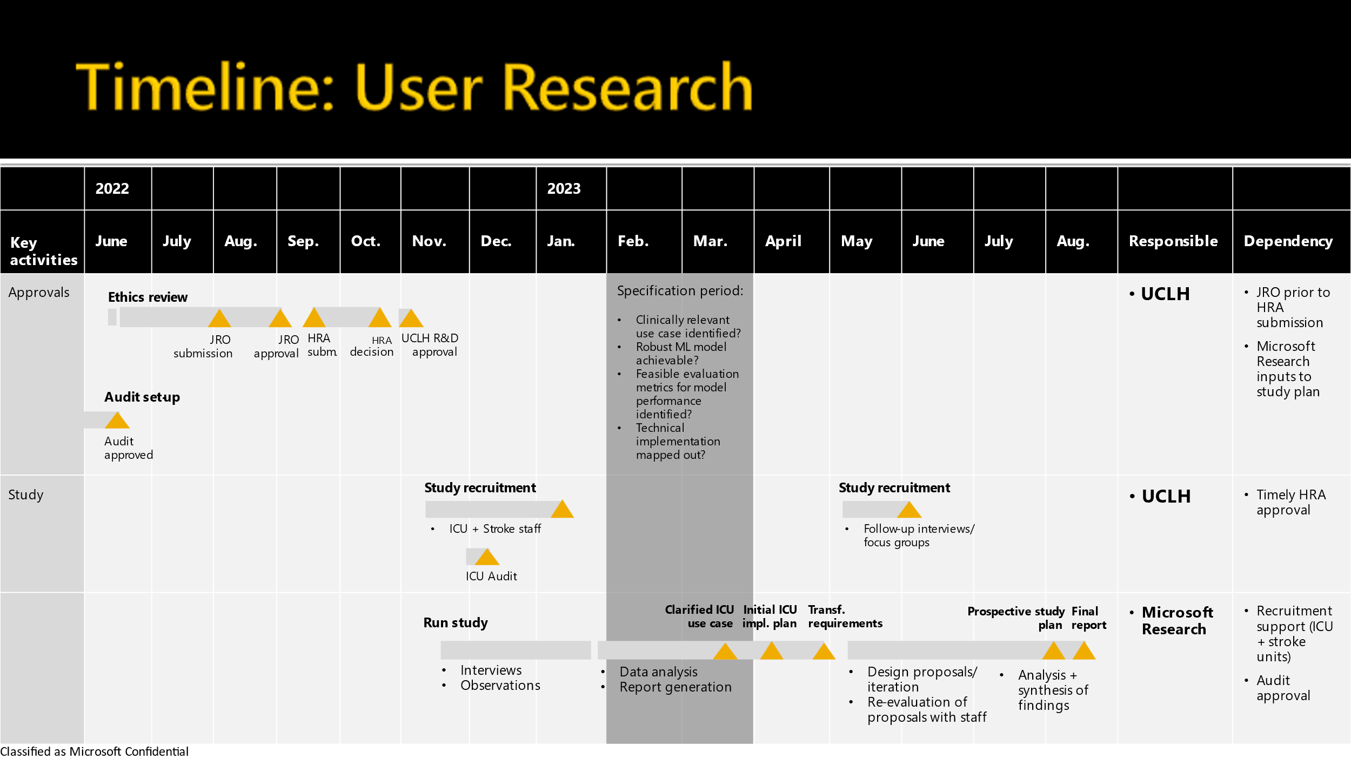

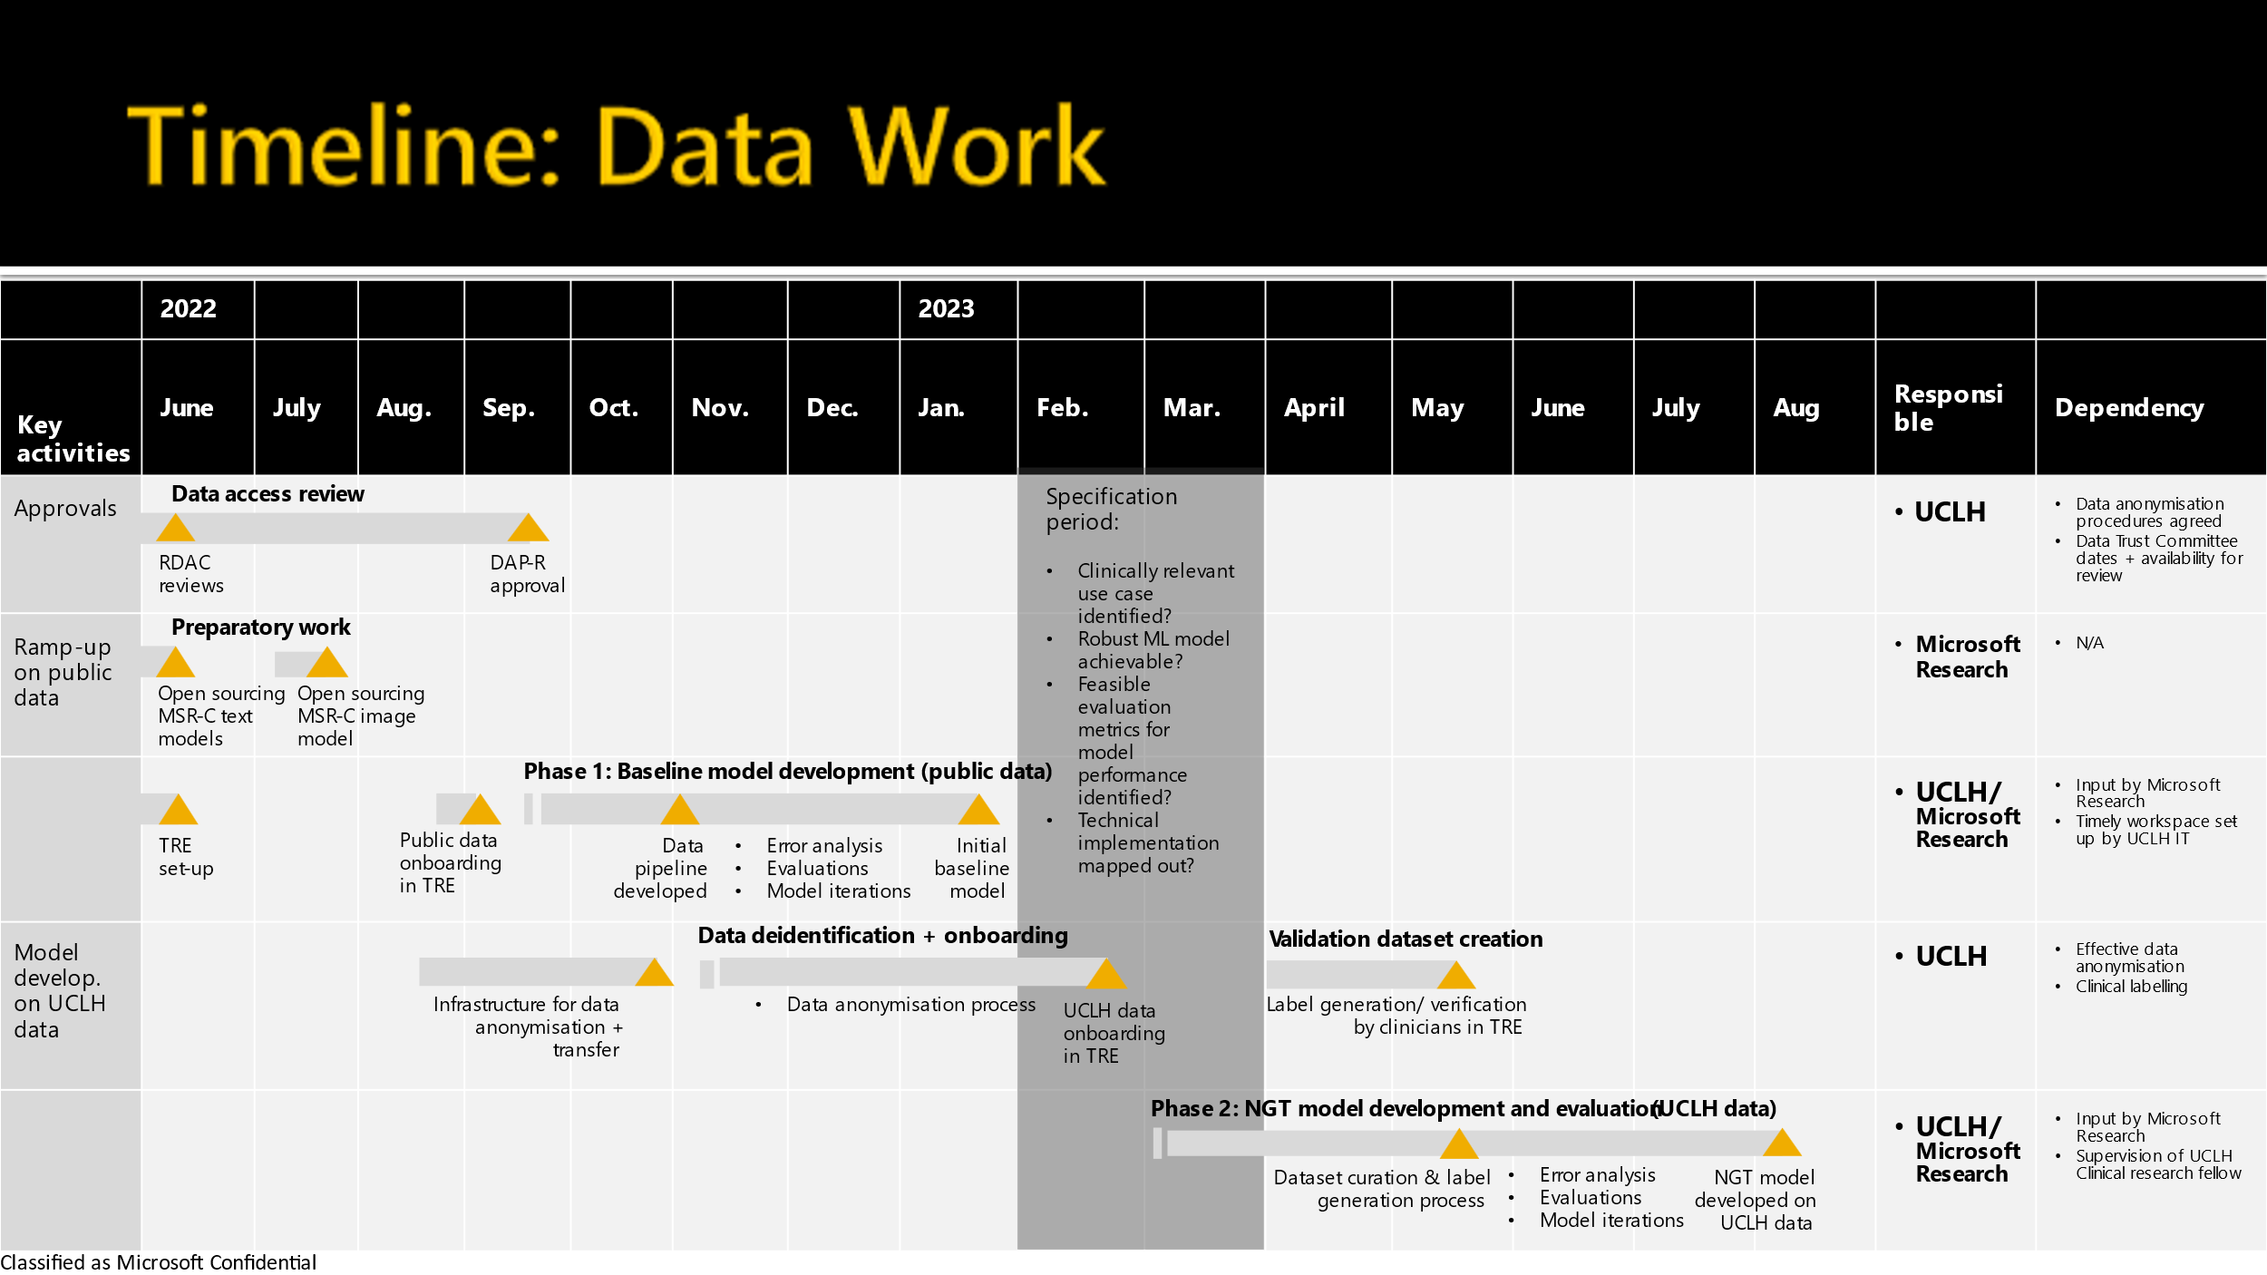

**Risks and interdependencies**

* Risk: The de-identification approach proposed above is meant to minimise the risk of researchers being exposed to PII. It is not possible to completely eliminate the risk of a privacy incident happening.   
  Proposed mitigation: DPIA to confirm roles and responsibilities of each party with regards to data handling, and include an agreed upon process for the prompt reporting and addressing of any privacy incidents.
* Dependency: timely set-up and configuration of a dedicated TRE workspace.   
  Recommendation: early collaboration and planning with the UCLH IT team (led by Richard Clarke) to confirm capacity, timely IG/ IS approvals, etc.

**References**

1. Milan Aryal, and Nasim Yahyasoltani. 2021. Identifying Catheter and Line Position in Chest X-Rays Using GANs. In *2021 20th IEEE International Conference on Machine Learning and Applications (ICMLA)*, pp. 122-127. IEEE, 2021. DOI: <https://doi.org/10.1109/ICMLA52953.2021.00027>
2. Matthew Brown. 2019. Device Placement Confirmation System Aims to Bring AI into Clinical Setting. UCLA Health Newsletter: <https://www.uclahealth.org/radiology/workfiles/Newsletter/2019W_DevicePlacement.pdf>
3. Abdelfettah Elaanba, Mohammed Ridouani, and Larbi Hassouni. 2021. Automatic detection Using Deep Convolutional Neural Networks for 11 Abnormal Positioning of Tubes and Catheters in Chest X-ray Images. In 2021 IEEE World AI IoT Congress (AIIoT), pp. 0007-0012. IEEE, 2021. DOI: <https://doi.org/10.1109/AIIoT52608.2021.9454205>
4. Robert DE Henderson, Xin Yi, Scott J. Adams, and Paul Babyn. 2020. Automatic classification of multiple catheters in neonatal radiographs with deep learning. arXiv preprint arXiv:2011.07394 (2020). Link: <https://arxiv.org/pdf/2011.07394.pdf>
5. E-Fong Kao, Twei-Shiun Jaw, Chun-Wei Li, Ming-Chung Chou, and Gin-Chung Liu. 2015. Automated detection of endotracheal tubes in paediatric chest radiographs. Computer methods and programs in biomedicine 118, no. 1 (2015): 1-10. DOI: <https://doi.org/10.1016/j.cmpb.2014.10.009>
6. Matthew C. Koopmann, Kenneth A. Kudsk, Molly J. Szotkowski, and Susan M. Rees. 2011. A team-based protocol and electromagnetic technology eliminate feeding tube placement complications. Annals of surgery 253, no. 2 (2011): 297-302. DOI: <https://doi.org/10.1097/SLA.0b013e318208f550>
7. Hyunkwang Lee, Mohammad Mansouri, Shahein Tajmir, Michael H. Lev, and Synho Do. 2018. A deep-learning system for fully-automated peripherally inserted central catheter (PICC) tip detection. Journal of digital imaging 31, no. 4 (2018): 393-402. DOI: <https://doi.org/10.1007/s10278-017-0025-z>
8. Francis O'Connell, Justin Ong, Crystal Donelan, and Ali Pourmand. 2021. Emergency department approach to gastric tube complications and review of the literature. The American Journal of Emergency Medicine 39 (2021): 259-e5. DOI: <https://doi.org/10.1016/j.ajem.2020.07.038>
9. Ankit Rungta. 2021. Detection of the Malpositioned Catheters and Endotracheal Tubes on Radiographs using Deep Learning Methods. Masters thesis, Dublin, National College of Ireland. <http://norma.ncirl.ie/5219/>
10. Manan Shah, Derek Shu, VB Surya Prasath, Yizhao Ni, Andrew H. Schapiro, and Kevin R. Dufendach. 2021. Machine Learning for Detection of Correct Peripherally Inserted Central Catheter Tip Position from Radiology Reports in Infants." Applied Clinical Informatics 12, no. 04 (2021): 856-863. DOI: <https://doi.org/10.1055/s-0041-1735178>
11. Varun Singh, Varun Danda, Richard Gorniak, Adam Flanders, and Paras Lakhani. 2019. Assessment of critical feeding tube malpositions on radiographs using deep learning." Journal of digital imaging 32, no. 4 (2019): 651-655. <https://doi.org/10.1007/s10278-019-00229-9>
12. Ilyas Sirazitdinov, Matthias Lenga, Ivo M. Baltruschat, Dmitry V. Dylov, and Axel Saalbach. 2021. Landmark constellation models for central venous catheter malposition detection. In *2021 IEEE 18th International Symposium on Biomedical Imaging (ISBI)*, pp. 1132-1136. IEEE, 2021. DOI: <https://doi.org/10.1109/ISBI48211.2021.9434022>
13. Vaishnavi Subramanian, Hongzhi Wang, Joy T. Wu, Ken CL Wong, Arjun Sharma, and Tanveer Syeda-Mahmood. 2019. Automated detection and type classification of central venous catheters in chest x-rays. In *International Conference on Medical Image Computing and Computer-Assisted Intervention*, pp. 522-530. Springer, Cham, 2019. DOI: <https://doi.org/10.1007/978-3-030-32226-7_58>
14. Jennifer SN Tang, Jarrel CY Seah, Adil Zia, Jay Gajera, Richard N. Schlegel, Aaron JN Wong, Dayu Gai et al. 2021. CLiP, catheter and line position dataset. *Scientific Data* 8, no. 1 (2021): 1-7. DOI: <https://doi.org/10.1038/s41597-021-01066-8>
15. Tim Torsy, Renée Saman, Kurt Boeykens, Ivo Duysburgh, Mats Eriksson, Sofie Verhaeghe, and Dimitri Beeckman. 2020. Accuracy of the corrected nose-earlobe-xiphoid distance formula for determining nasogastric feeding tube insertion length in intensive care unit patients: a prospective observational study. International Journal of Nursing Studies 110 (2020): 103614. DOI: <https://doi.org/10.1016/j.ijnurstu.2020.103614>
16. Xin Yi, Scott J. Adams, Robert DE Henderson, and Paul Babyn. 2020. Computer-aided assessment of catheters and tubes on radiographs: How good is artificial intelligence for assessment?. Radiology: Artificial Intelligence 2, no. 1 (2020): e190082. <https://doi.org/10.1148/ryai.2020190082>
17. Xiaosong Wang, Yifan Peng, Le Lu, Zhiyong Lu, Mohammadhadi Bagheri, and Ronald M. Summers. 2017. Chestx-ray8: Hospital-scale chest x-ray database and benchmarks on weakly-supervised classification and localization of common thorax diseases. In Proceedings of the IEEE conference on computer vision and pattern recognition, pp. 2097-2106. 2017. Link: <https://openaccess.thecvf.com/content_cvpr_2017/papers/Wang_ChestX-ray8_Hospital-Scale_Chest_CVPR_2017_paper.pdf>
18. Dingding Yu, Kaijie Zhang, Lingyan Huang, Bonan Zhao, Xiaoshan Zhang, Xin Guo, Miaomiao Li et al. 2020. Detection of peripherally inserted central catheter (PICC) in chest X-ray images: A multi-task deep learning model. Computer Methods and Programs in Biomedicine 197 (2020): 105674. DOI: <https://doi.org/10.1016/j.cmpb.2020.105674>
19. Meng Zhang, Hong Zhu, Zheng Liu, and Xuexue Deng. 2021. Malposition of a Nasogastric Feeding Tube Into the Right Pleural Cavity of a Nasopharyngeal Carcinoma Patient After Radiotherapy and Chemotherapy: A Case Report." (2021). Link: <https://assets.researchsquare.com/files/rs-1022308/v1/95eddf19-0938-4d06-bc61-b7133642993c.pdf?c=1639382524>

**Appendix A**

NG TUBE insertion reports:

In a retrospective analyses of 30 days worth of CXR studies, 116 CXR studies were specifically performed at UCL hospitals for checking NG tube placement. 30% of these were at the National Hospital for Neurology and Neurosurgery (NHNN). 5/116 patients had no radiology report visible. There may have been more CXRs done for this reason, but which weren’t specifically coded as “NG tube insertion check”.

The mean time interval between the CXR being performed and being reported was 36.3 hours (range: 3 mins - 21.14 days). Excluding two outliers, the mean time interval between the CXR being performed and being reported was 30.2 hours (range: 3 mins - 4.86 days). The median time interval between the CXR being performed and being reported was 20.5 hours.

The 39 NHNN reports took a mean of **4.8** hours (range: 3 mins – 28.1 hours) to be reported. The 66 UCL reports took a mean of **45.6** hours (range: 68 mins - 4.86 days) to be reported (with the two outliers excluded).

10/111 (9%) CXRs showed misplaced NG tubes. 5/10 CXRs the NG tube needed advancing. In 5 cases it needed replacing, 2 of these because it was in the lung. Mean delay for report in these cases was 42 hours. Most CXRs from UCLH were reported by an outsourced company.

ITU CXR reports:

In a retrospective analyses of 30 days worth of CXR studies, 287 CXR studies were performed across three UCH ITU departments. 19/287 patients had no radiology report visible, though 17/287 of these CXRs had been performed between 12hours-6 days previously. The mean time interval between the CXR being performed and being reported was **47.6** hours (range: 20 mins - 5.4 days) excluding two outliers.

13/268 (5%) CXRs showed sub-optimally placed NG or ET tubes. 2/13 CXRs the ET tube was too low. In 3 cases it needed replacing, 2 cases of these because it was in the lung. Mean delay for report in these cases was 45 hours. Many CXRs were reported by an outsourced company.

**Appendix B**

Guidance on confirmation of correct placement at NHNN [UCLH Policy: NGT placement, p.20]

1. Delivery of feed directly into the stomach, duodenum or jejunum
2. NHS Never Events, <https://www.england.nhs.uk/patient-safety/revised-never-events-policy-and-framework/>
3. National Hospital for Neurology and Neurosurgery [[Link](https://www.uclh.nhs.uk/our-services/our-hospitals/national-hospital-neurology-and-neurosurgery)]
4. UCLH Policy document for ‘Nasogastric tube insertion and management (adults)’ [[Link](https://microsofteur.sharepoint.com/:b:/r/teams/RadiologyUCLH-MSR/Shared%20Documents/General/UCLH%20Documents%20-%20NGT%20placement/Nasogastric+tube+insertion+and+management+adults+policy.pdf?csf=1&web=1&e=kvw2nb)]
5. Qualified radiographer with post graduate qualifications in clinical reporting of radiographs
6. User research will need to investigate the desirability of this scenario, or the potential feasibility of prioritizing the reading order of CXRs for those images that are frequently outsourced for radiology review.
7. <https://www.accessdata.fda.gov/cdrh_docs/pdf21/K212690.pdf>