To do list SAG

Center align for all pages, also boxes and sub-headings and buttons should be center aligned also e.g. upload avatar image button

Developer’s Comment :- DONE

same with the news feed box, also change the controlling of the news feeds to the personal channel away from the profile "RSS subscriptions" and change it to "Newsfeed subscriptions"

Landing page pop up page texts should be with larger font
Date :-23 Apr
Developer’s Comment :- DONE

All the contents text size should be able to be changed from the profile same with the sounds like a general control room where ypu can do the basic settings for all and then individually start tuning them

All SU’s should receive a single token according the admin membership settings (RU’s 10 tokens same for UU’s)

Chat names to show our avatar names(support contacted, kailash&Anil cc:d)

Make the data country group texts visible to admin in data management

offer editing:
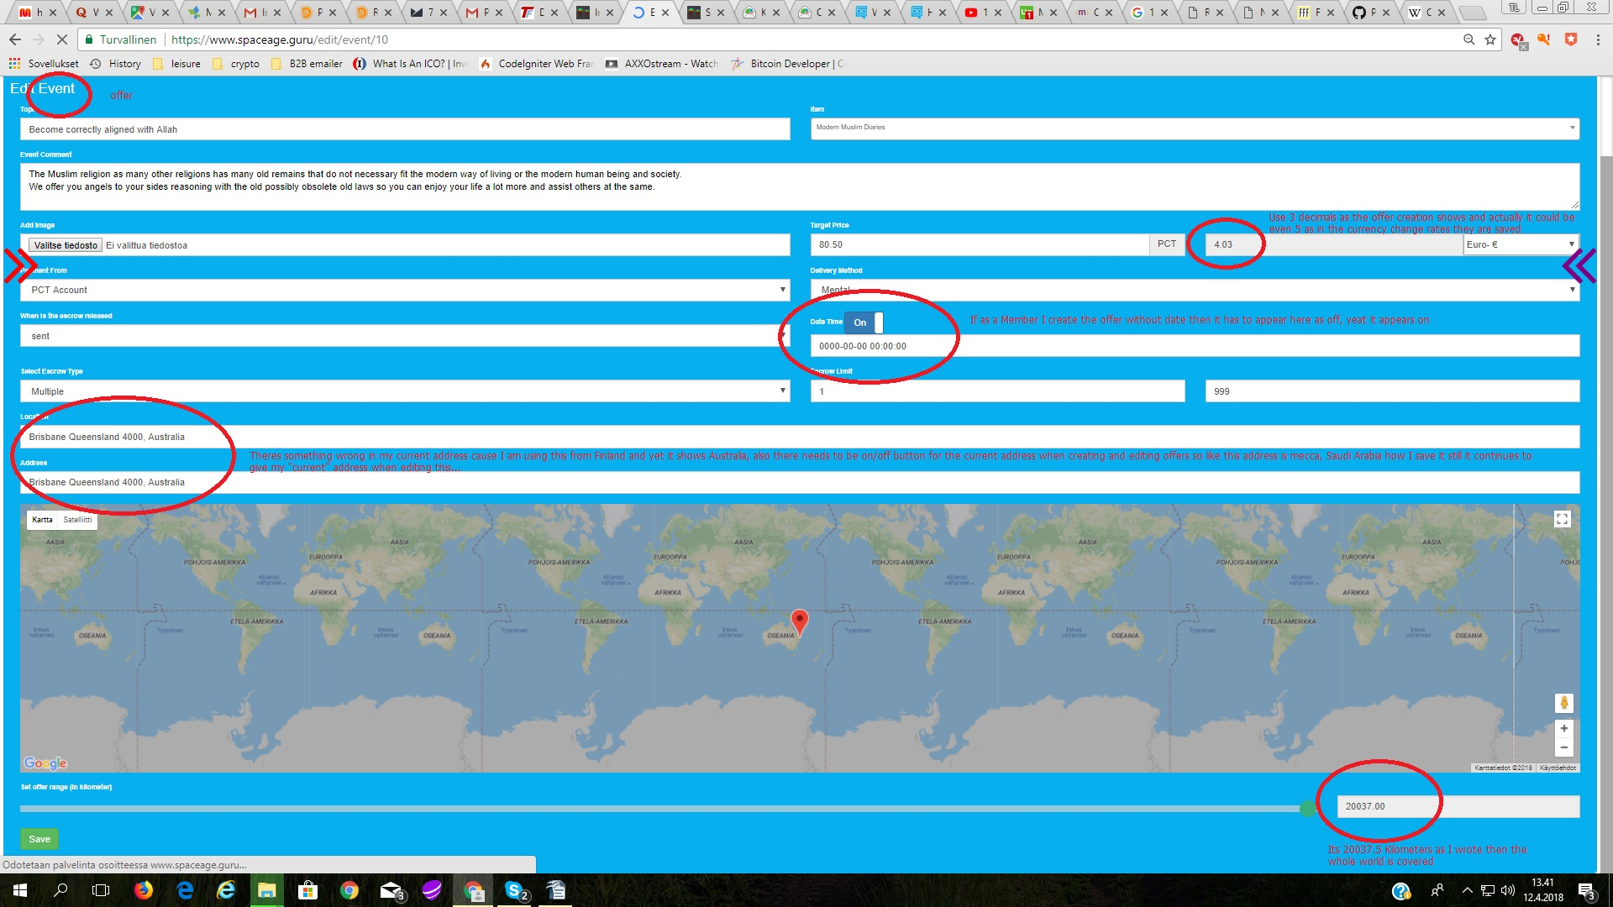
Developer’s Comment : DONE

Data saving automatically when you are just writing in it:

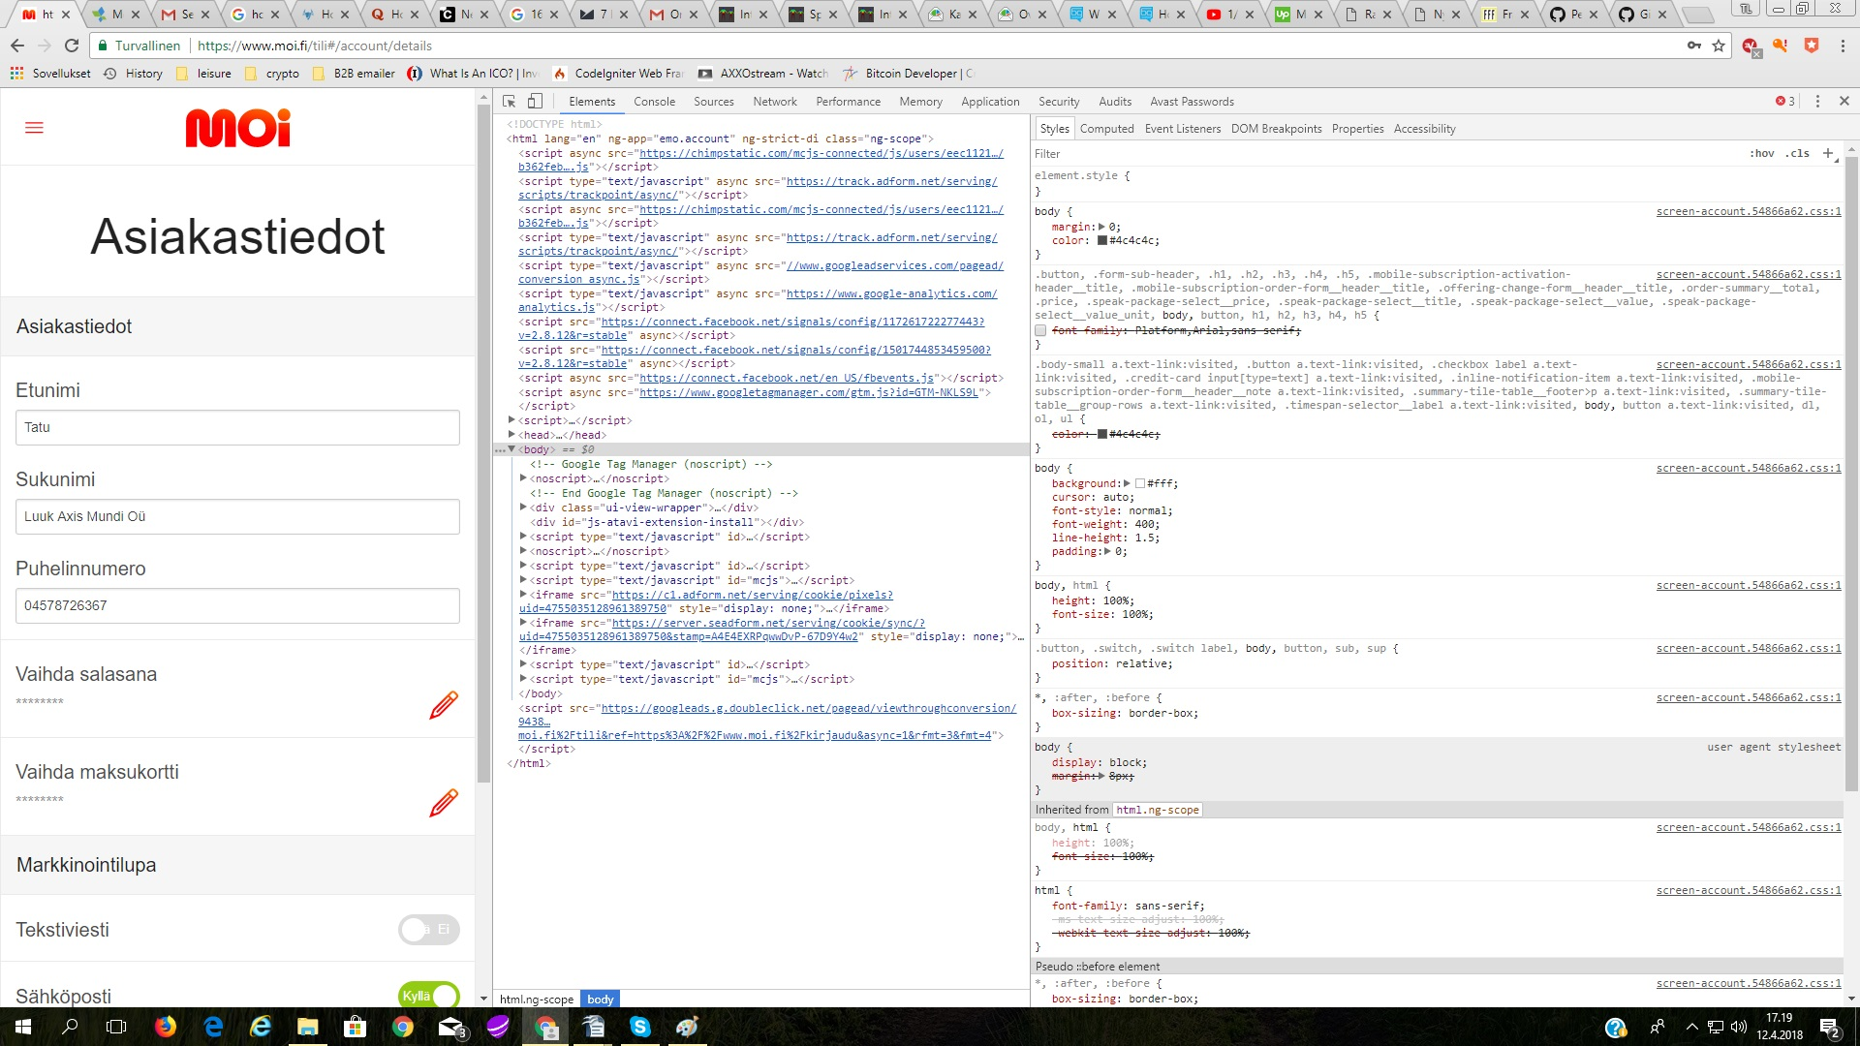
About layout:
Colors given by computer for the visitor, user/Member can change their color preferences.
clone site to satanclaus.club address with Satan Claus red/gold/blue color brand and logo, when the site is done.

Data physically available in these countries, but might contain some restrictions, please consult your lawyer and or doctor before acquiring it. (link to Medical opinion and Legal aid data topics)
https://www.dropbox.com/sh/wr0cowfiytc52fu/AAB03le6dPB0hNFpgXxzsPUka?dl=0

delivery tool, sub-escrow (This will be a job for another company we will talk about that later for you to quote it)
Data ownership transfers from admin and sales through escrow from Member and UU interface.
(in E-business/ Membership interface)

- Social Network

The commission view from escrow purchases

Additional Tentative Time – 24 Hours
Ranking system for seller and customer / Social network / Profile
- This is the basic line for the trust to rise between the members and Users to increase
sales and communication with trustworthy accounts.
Existing with data, should be existing with done escrows

- Social network arranging through different views: Member/User number, Distance from
User location, Rank or online status.
ideally working synchronized with the chat

- Possibility to decide by User what information User wants to share in User profile: Age
group=data subscriptions, location, task preference(from task&goals), current rank=Membership, registration information analysis=PQ´s.
For Higher Members (C and Above) this info should be available through the social network recommendation page from all users.

closest offers come first, needed for the blockchain to work properly

- PCT and blockchain connection to the escrow service, wallet and number game

SHOP

- make the PCT product work so that you can write the exact number of PCT you want to purchase
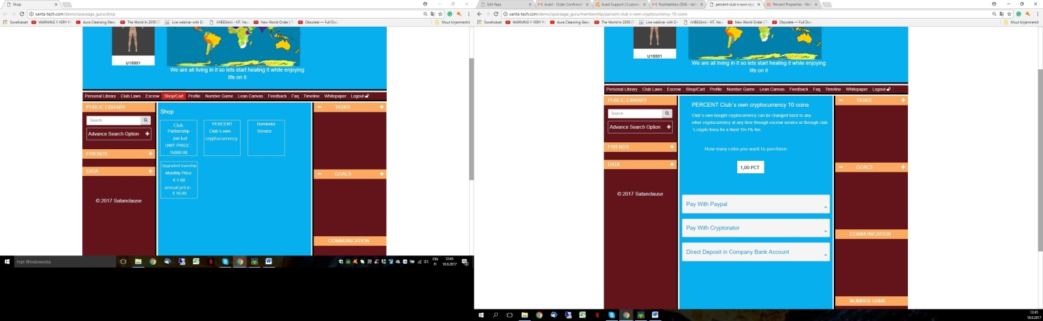

After buying the PCT user/Member wants they get a link to download the PCT wallet, we got to upload the PCT wallets (linux and windows options to our spaceage.guru site)
Source code:
https://www.walletbuilders.com/mycoin?coin=b0bc1f382e465b75fe1c16798c7dc4ceac27e84e80fc623e3c
wallet ideally to work like inside the program like the downloadable wallet

https://blockgeeks.com/guides/blockchain-coding/

- Security / hosting

Get the https:// SSL secured connection, servers working through Raspberry Pi´s with possibility to get direct VPN connection YOGI?

Developer’s comment :- For SSL you will have to connect with your domain provider, so please get in touch with godaddy, We got to talk this through cause they will test the code to give a better SSL sertification so we got to know when the site is ready for that

We got to skype about this we want to purchase the higher SSL certification which demands an audit from the SSL/GoDaddy to the code.

- Search Algorithm working, using following data in descending order:

The actual search word
3 What questions from registration
profile
PQ´s
tasks and goals
personal library acquirements
likes for data

with Wikipedia searches and 3rd party searches
Maybe this helps for wikipedia 3rd party search API challenge:
https://www.mediawiki.org/wiki/MediaWiki
Browser inside the browser view for sites without API´s
sometimes the algorithm just goes crazy and shows the obvious result as last and doesn´t notice tags at all.
Like writing ki which is a tag of Qigong and shows it as the last options on the search page even though it should be the first.
Developer’s comment :- At the moment we have implemented that code which searches for the result from the database itself, as asked earlier from you to get the search done on third party sites we will have to get the web api’s, so please provide and we will implement this.
INFO Requited from Tatu.

- Number game
The entertaining and teaching part of the program:
The idea is that the program offers those spiritual guidance tasks for a minute at max cause the transaction has to be done in a minute so then if there aren’t enough clicks then the supports and unsupports have to come automatically and mentally from the house(SAG) and existing database and about the spiritual guidance roles we got plenty of them in the admin added and more to add + many others that work more through the blockchain&mental connection with Akash and holographic phone calls.
Everything clear to code the spiritual guidance cards?
At this moment you need to code it so that the current number, the upgrades and the connection is written up in JavaScript so we can start combining these pieces to the Blockchain
the spiritual guidance roles we got plenty of them in the admin added and more to add + many others that work more through the blockchain&mental connection with Akash and holographic phone calls

We also created rainbow letters for the number game with colored numbers as images, how can we apply these?

Developer’s comment:- Can you please explain more detail about this, or let’s have a call to better understand this and we will get this done

Info required from Client

What is still needed sketches are made to make the admin add to create the numbers

- A section in admin/Members page to select PQ choices and subscriptions in excel tab lookalike form to narrow users to specific user groups with what one can search as advanced search feature users for marketing of data and sending communication offers

https://www.dropbox.com/s/afx4x7dymstojni/PQ%20tool%20Admin%20and%20Member%20view.xlsx?dl=0

Developer’s comment:- Can you please explain more detail about this, or let’s have a call to better understand this and we will get this done,

We had this call, do we need to have it again? If yes then book it!

Things we are still missing according the original task and milestones and mockup 0.2

- Blogs by Users to promote the webpage and gain Users.
(as one of the add data options for some reason it was taken of when the articles etc. were updated)

8. Security tool
- Originally worked and conceived with a global holographic secure file cabinet
system based on phonetic alphabets studied in field of NLP and DHE.
- There needs to be build a system or consciousness about phishing of any
information of the Club from outside the Club or within the Club against the TOUS.
Such as finding out information up from the chain of command.
- Possibility to counter intelligence the source of infiltration, its methods, motives the
damage it did how to repair it and how can we ensure that this source is
terminated from entering our network ever again.

(big part of it, also part of the future works since it still not yet done)

Info required from Client

Book a skype meeting

9. Accounts and layer design
- There needs to be different access levels for different level of supervisors, we got 8
member levels and 2 user levels one for the promissory note holders and one for
the users who fill personality profile without monetary investment.

kind of working with chat feature, Kailash was supposed to write an email to cometchat about this on 11.10 from sending contact requests to higher ranking Members.
We have an extra work quote from cometchat.

11. Icons synchronized with all apps and web version

13. Delivery tool, changed to escrow,
status updates and money transfers when finalizing the escrow still not working.
All our payments to Xanta will come through this channel in future so you better get it working.

15. Integration of tools / Front end and back end development

Number game,
- Giving tasks and receiving them for some reward, be it financial, emotional or
educational.
number game admin and UI, sketches done waiting for the delivery

Aid for legal
- Sample case list with key methods and notes what to avoid to be legal for basic
things in each key country.
legal notes, should have the feature showing only 1/3rd of the file before paying and acquiring it to the personal library same for all data.

- Instant aid, either a phone call with instant charging from User to service provider /
Member or news feedlist of sample cases/key words to purchase specific
information
links to Legal opinion data

Wiki encyclopedia of all the products and services available in the world.
- General information
club data writing section working, Wikipedia api pending
- How to consume the good or try the service safely
can be written, should have a separate box where to write for products and services
- Transparently telling the hazards and protocol in a case of overdose
etc. if one eats 480 bananas in a day there is a potassium overdose and
instant death. Helpline where to contact in a case of emergency or
dispatch of location for another friendly User/Member or proper
authorities.
can be written, should have a separate box where to write for products and services
.
16. Field evaluation
- 1 month for 20 key countries with desirably 420 Members and 4000 Users per country
giving totally 88 000 opinions and constructive feedback. To enhance constructive
feedback we can make simple mandatory daily 1-3 question survey.
With what can we do the 1-3 question daily survey? Can we use chat to ask these questions?
Cometchat has an option working on it to get it part of our deal, Mixpanel that analyzes the app traffic also, we need to fine adjust this

- Changes

Mutual to do list from which tasks can be assigned by the admin and Members can take and reserve tasks for immediate execution with escrow creation

18. Finalization
Android, IoS and web version synchronized and controlled from admin

19. Presentation / Launch
When finalization is done, resend the invitation to all emails on the email list as an emailer with PR-announcement: Lets start healing the world!

