B.M.S College Of Engineering

Bull Temple Road,

Bangalore-560019

Department Of Computer Science and Engineering

Course : Programming with C++

Course Code : 15CI3GCPCP



Self Study Project Report

Project Report on

BUS RESERVATION SYSTEM

(C++ Project)

Faculty In Charge:

Pradeep Sadand

Department Of CSE

BMSCE

Submitted By:

1.Puneeth.K

(1BM17CS067)

2.Ravi Prakash

(1BM17CS074)

3.Ragavendhra.R

(1BM17CS069)

Department of Computer Science and Engineering

B.M.S College of Engineering

Bangalore-560019

**CERTIFICATE**

This is to certify that the project work entitled **“Bus Reservation System”** carried out by **Puneeth K (1BM17CS067)**, **Ragavendra R (1BM17CS069)**, **Ravi Prakash (1BM17CS074)** bona fide students of BMS College of Engineering in partial fulfillment for the completion of the course “Programming with C++” in **Computer Science and Engineering** of BMS College of Engineering during the year **2018-19** is found to be satisfactory.

Signature of the Guide Signature of the HOD

Name of the examiners Signature with date

1.

2.

ACKNOWLEDGMENT

In performing our assignment, we had to take the help and guideline of some respected persons, who deserve our greatest gratitude. The completion of this assignment gives us much pleasure. We would like to show our gratitude ***Pradeep Sadand,Course instructor,BMS College of Engineering***for giving us a good guideline for assignment throughout numerous consultations. We would also like to expand our deepest gratitude to all those who have directly and indirectly guided us in writing this assignment.

Many people, especially our classmates and team members itself, have made valuable comment suggestions on this proposal which gave us an inspiration to improve our assignment. We thank all the people for their help directly and indirectly to complete our assignment.

Abstract

Bus reservation system as the name is a system that helps user to book tickets for travel. In this system one can see the list of all the buses available and can book tickets based on the bus availability. One can also change the name in which the ticket has been booked. To facilitate real world application tickets can be cancelled and also the details of the ticket can be printed. We were able the solve minor problems along the development process which include limited size of the bus list due to use of arrays which was replaced by using a STL container Vectors. To make this system applicable for use in real world inclusion of files to handle the data for the bus and reservation details can be used.

Table Of Contents:

1. Overview of C++
2. Introduction

2.1. Problem Statement

2.2. Objective

3. Requirement Analysis

3.1. Hardware Requirements

3.2. Software Requirements

4. Implementation

4.1. List of Header files used

4.2. List of functionalities added

5. Concepts used

6. Screenshot of the working project

7. Shortcomings and Limitations

8. Bibliography

# Overview Of C++

C++ is a general purpose object oriented programming language developed by Bjarne Stroustrup. Initially it was called “C with Classes” and was renamed as “C++” in the year 1983 .

C++ based on the language C, combines both the high level ideas of classes with low level machine handling capacities of C making it a very robust and a reliable programming language. C++ is a strongly typed and a fast programming language.

C++ is a superset of C. Any program written in C is also a legal program in C++. C++ is standardised by ISO, which has released five versions of C++ standard and also currently working on the sixth version C++20.

## Features Of C++:

C++ fully supports the object oriented aspect of programming which was the primary reasons for its invention by Bjarne Stroustrup. The four import features of C++ as an object oriented programming language is

* + - * Data Encapsulation
      * Data Hiding
      * Inheritance
      * Polymorphism

To make sure the programs written in C++ are portable over a variety of domains it implements the ANSI (American National Standards Institute) standard. This standardisation is an attempt to make sure that all C++ programs are portable meaning a code written for Microsoft’s compiler will compile without giving any errors on a compiler on Mac, Unix or any other operating system.

All the major compilers designed for C++ supports the ANSI standard.

## Advantages of Using C++:

C++ is a robust improvement over an already incredible programming language C. C++ offers a verity of excellent features making it an incredible programming language to code with. C++ has a lot of advantages. Few of them are:

* + - * Use of classes makes it an incredibly flexible programming language
      * A large pool of functions are available through the C++ standard library
      * Easy portability due to the implementation of the ANSI Standard
      * One can easy move from programming with C to programming with C++ due to the same program structure

## Applications Of C++:

* Operating systems like Microsoft Windows, MacOS X or Linux are all programmed in C++. Since it a strongly typed and a fast programming language it is an ideal choice to program operating systems in C++
* Since graphical applications require very fast rendering, C++ helps with reducing the latency.
* Databases like Postgres and MySQL the two of the most widely used database applications are written in C and C++
* Since C++ is a low level programming language many compilers written for other languages use

C++ as the backend

* Many high-level libraries use C++ as the core programming language. For instance, TensorFlow the most widely use machine learning library uses C++ as the backend programming language.

Introduction

# Problem Statement

Bus Reservation System:

We were given a system which could be used to book bus tickets. But one could not use this system as seamlessly as possible as few of the functionalities that one would find in a real world reservation system were missing.

Issues: One could not cancel or print the ticket details after the seat is reserved

Method: By adding extra features/functions these above stated issues can be solved.

# Objective

Everyone travels from one place to another. Most cannot use airways as a medium of transport as it is very expensive and many rely upon buses to go from one place to another. Buying the ticket just before the travel sometimes can be very hard. But buying the ticket for travel before hand can relive tension off the traveller. This can be done using a Reservation System.

Our team has written code to make the process of reserving tickets for travel easier. One can also change the name of the traveller after booking the ticket. Sometimes due to unavoidable circumstances one can not travel and would need to cancel the ticket which our code provides.Right after booking ticket the traveller would need the confirmation of the booking which will be displayed.

Requirements

## Hardware Requirements

* More than 128 Mega Bytes of RAM
* 10 Mega Bytes of Hard Disk Storage

## Software Requirements

* Microsoft Window 7 or Higher
* Mac OS X
* Any C++ integrated development environment

Implementation

# List of Header Files Used

## IOSTREAM.H:

This header file is used to make use of the member functions cin and cout. These two functions facilitate to take input from the user and output onto the console. We have made use of the STD namespace to bring the STD keyword to the program namespace or else we would have to use the “std::” keyword for using the cin and cout functions everywhere.

## STRING.H:

This header file is used to make use all the strings functionality.We have made use of the string functions strcmp() to compare two strings which are passed as the parameter to the function.This function returns

* A value 0 if both the strings are same.
* A value greater than 0 if the first matching character in the left string has a greater ASCII value
* A value lesser than 0 if the first matching character in the left string has a lesser ASCII value

We have also made use of the function strcpy(). Two strings are passed as parameters to the function. It copies the contents of the right string and puts in the left string

## VECTOR:

Vectors are dynamic arrays. They can resize themselves upon addition or deletion of the element in the vector.

# List of Functionalities Added

We were given a code with had already prebuilt functions like

* An install record function that would allow the admin to add a record of available buses, which would have the bus details like bus number, name of the driver, travel time, travel destination.
* A reserve function from which one could reserve the ticket for travel. This function would require bus number as the input and also the seat number in which the traveller would like to be seated in.
* An empty function which would allow us to check if the seat number entered is empty.
* A show function which would show the details of the bus which would contain it’s number, the driver name, the time of travel, its destination and also the number of seats available for reservation in that particular bus.
* An avail function that would list out all the available buses and the bus details.

But these functions were not enough to make the reservation system whole. We had to add a few features which would make the system usable. These new features are:

* Cancel function: One had to have the facility to cancel his/her booking in case the traveller decide against travelling. This would require a cancel booking function with the input as the bus number in which the traveller is travelling in and also the seat number that the traveller had booked to travel in.
* Change function: What if the the traveller had to send someone in his place to travel? We would have to change the name of the traveller in the booking details. This function would require the traveller to enter the bus number he was travelling in and also the seat number booked. Then he would have to enter the new traveller name.
* Print ticket function: Right after the traveller books the ticket, the traveller would need the details of the ticket booked. This is done using the print ticket function that would show the ticket details to the traveller.

# Concepts Used

The concept of classed and objects is extensively used in our code. We have created a class Bus which contains all the details of the bus. It also contains the member functions to facilitate seat reservation, a method to cancel the seat reserved, to check the list of all the buses used and also a method to show the details of the ticket used.

The concept of static variables is used. Static variables are used when we need the memory allocated to that variable only once in its program lifetime. We have used a static variable to have a count of the number of buses present currently. This variable’s value is carried over to the current function call from the previous function call.

We have made use of the Standard Template Library which provides us with vector which can replace arrays with fixed memory with a dynamic array which can resize itself based on the elements being deleted or elements being added to the vector. We have used a vector of class objects so that new instances of the class can be added without the worry of overflow.

Screenshots the project output

Login to the Bus Reservation System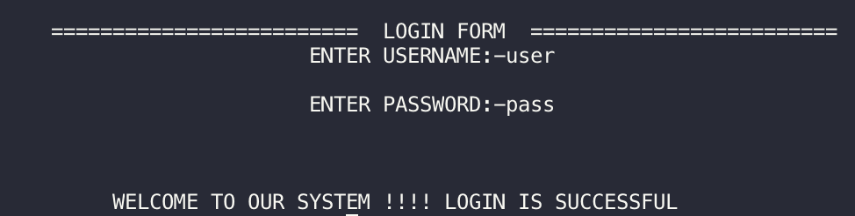

Creating Bus objects

Main Menu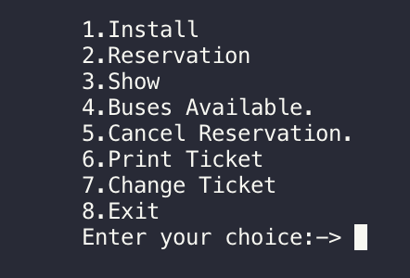

Install Bus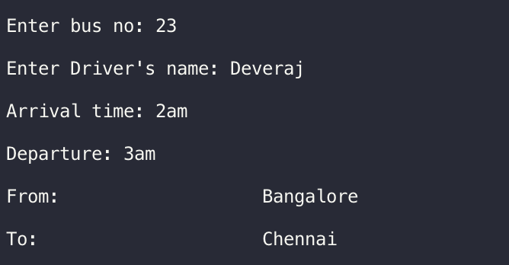

Show available buses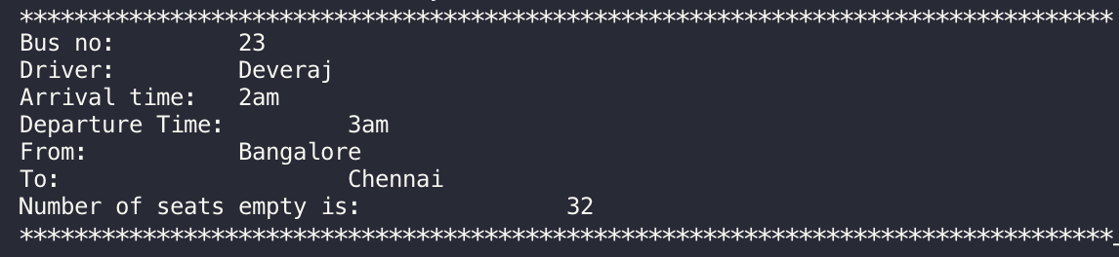

Reserve a ticket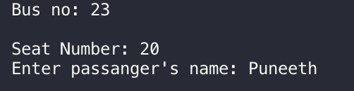

Show the booked ticket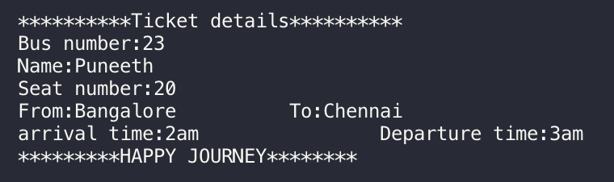

Show the seats that are empty and booked

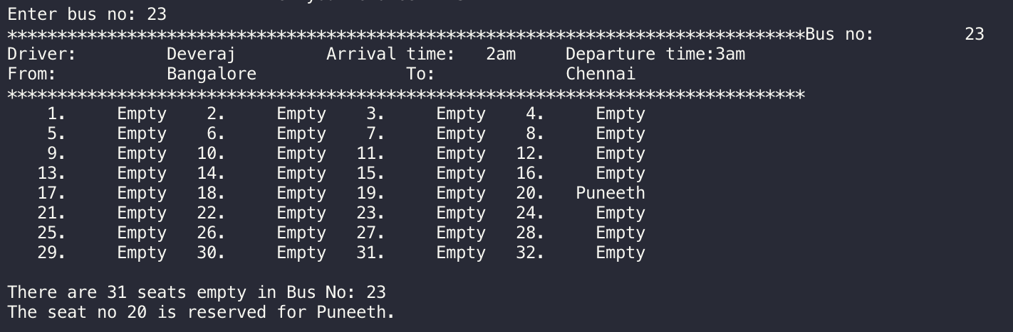

Change the name of the passenger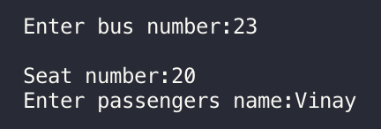

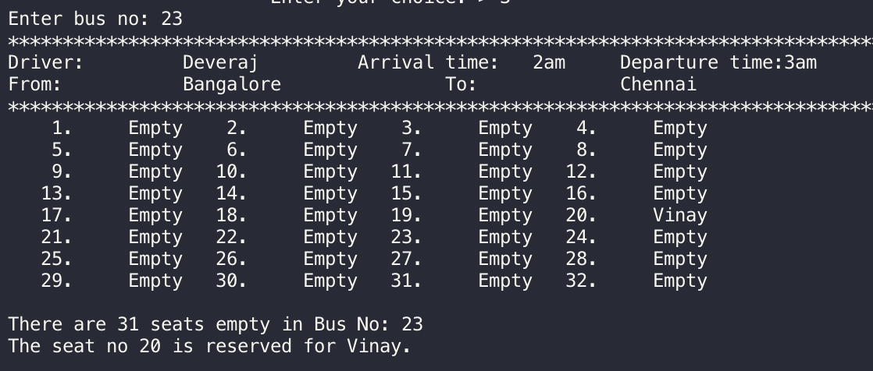

Cancel reservation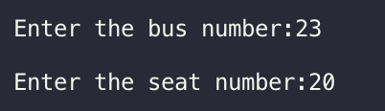

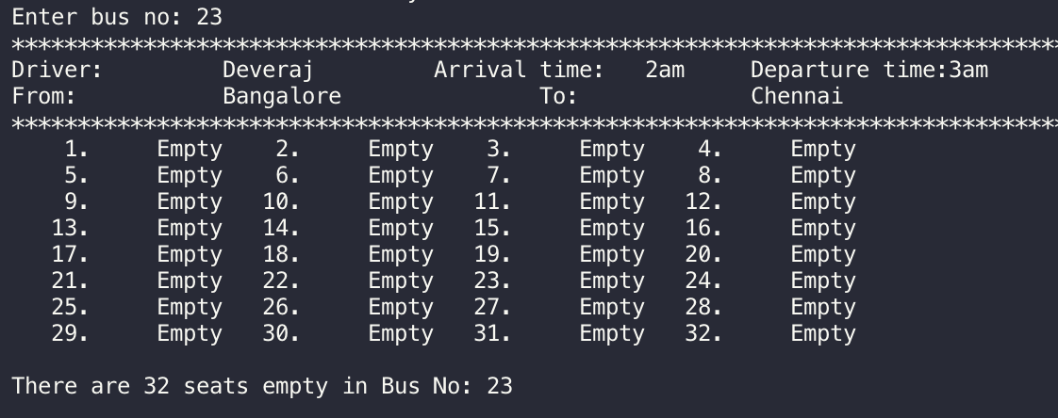

Shortcomings and limitations of the Project

* This system can only have a single admin who is incharge of installing bus records and maintaining the system.

Bibliography

* For details on the C++ language: <https://en.wikipedia.org/wiki/C%2B%2B>
* Static variable reference: <https://www.geeksforgeeks.org/static-keyword-cpp/>
* For C++ reference: <https://www.tutorialspoint.com/cplusplus/>
* For C++ resource: <http://www.cplusplus.com>
* For C++ Vector reference: https://www.geeksforgeeks.org/vector-in-cpp-stl/