EcoGrid.AI — Technical Stack & Core Logic Specification
Enterprise-Grade Quantum-Optimized Renewable Energy Distribution Framework
━━━━━━━━━━━━━━━━━━━━━━━━━━━━━━━━━━━━━━━━━━━━━━━━━━━━━━━━━
1. Architectural Overview & Constraints
EcoGrid.AI is a cutting-edge quantum energy optimization simulator built for hackathons under high operational constraints. The complete system runs under a flat, single-file monolithic structure (app.py) designed for high performance, local execution, and low latency.
- Offline Execution Model: The entire quantum simulation and resource allocation run locally on host CPUs. The engine relies on no third-party APIs or remote cloud-quantum services.
- Single-File Delivery: Logic, visual formatting, and numerical pipelines reside strictly inside app.py to bypass pathing and multi-repository linkage errors.
- Reactive State Management: Leverages Streamlit's session states to coordinate sliders, crisis preset scenarios, and optimal matrices seamlessly.
2. Ecosystem Dependencies & Tech Stack
The environment uses standard, robust open-source scientific packages to simulate quantum states and map supply-to-demand flow relationships:
- Streamlit (>= 1.30.0): Provides state holding, UI design widgets, and layouts. The interface leverages custom inline HTML & CSS for high-fidelity rendering.
- PennyLane (>= 0.34.0): Main variational quantum simulation framework. Used to establish the simulator device ('default.qubit') and QAOA circuit layout.
- Plotly (>= 5.18.0): Renders real-time, interactive Sankey Diagrams showing distribution flow from generators to residential/industrial zones.
- Pandas (>= 2.0.0): Structures the raw routing matrix rows (Source, Target, MW Flow) before and after optimal optimization loops.
3. System Architecture & Flowchart
The following diagram illustrates the functional logic pipeline. It traces how user slider inputs trigger the reactive flow—shifting from baseline unoptimized routing models into the variational PennyLane optimization circuit.
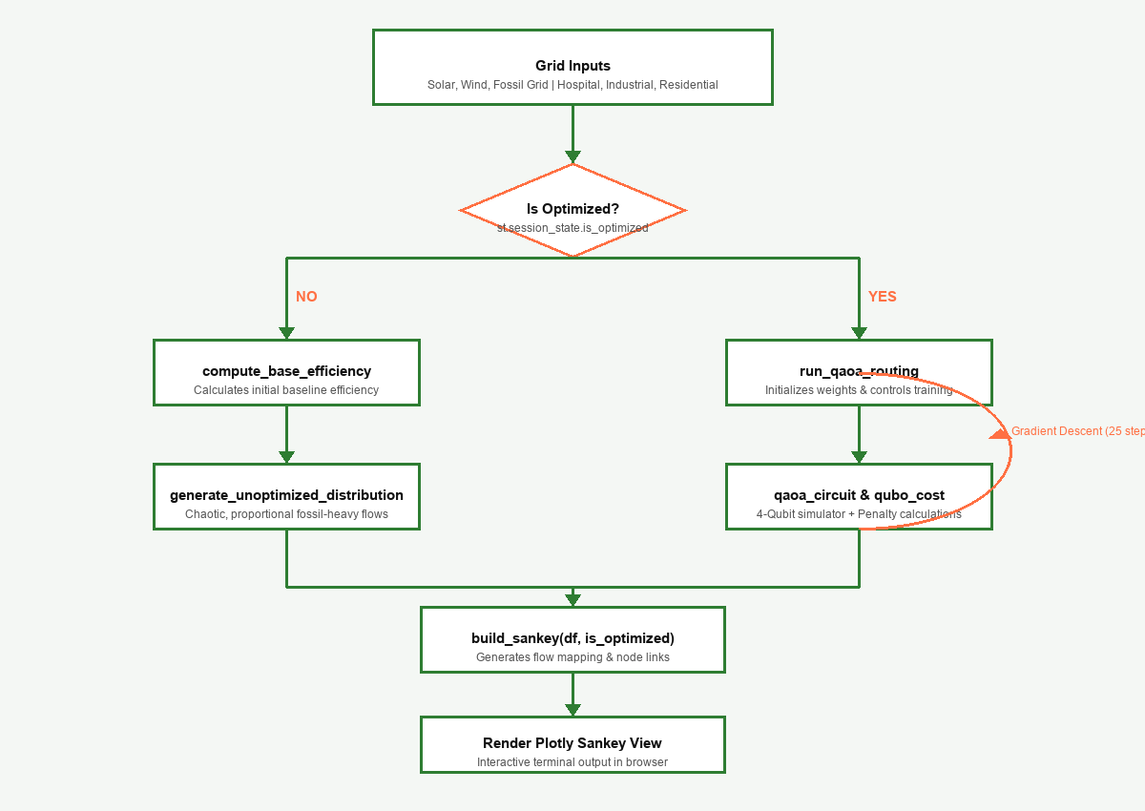
Figure 1.0: EcoGrid.AI Data Processing and Variational QAOA Optimization Circuit Pipeline.
4. Core Logical & Quantum Functions
The core code is organized into modular logical and mathematical layers. Below is a structured analysis of the primary functions powering the application:
Function Name | Logical Role | Mathematical Operation / Detail
compute_base_efficiency | Calculates the baseline efficiency score of the grid without QAOA optimization. | Compares supply vs demand. Penalizes fossil dependence: Penalty = (Fossil / Total) * 20. Clamps output between 10% and 70%.
generate_unoptimized_distribution | Creates a standard proportional supply-to-demand flow representing unoptimized conditions. | Spreads Solar, Wind, and Fossil fuel supply across sectors with heavy, unoptimized fossil bias.
qaoa_circuit | Defines the 4-qubit parameterized variational circuit on the PennyLane default.qubit simulator. | Prepares equal superposition with Hadamards, applies variational RX/RZ layer pairs, entangles via cyclic CNOT rings, and outputs 16-state probabilities.
qubo_cost | Cost function mapping optimization constraints and penalties onto quantum states. | Penalizes hospital shortages (+8.0), unnecessary fossil usage (+5.0), blackout risks (+4.0), and rewards renewable usage (-1.5 per active route).
run_qaoa_routing | Initializes weights and optimizes parameters, then decodes the quantum state into real power flows. | Runs GradientDescentOptimizer for 25 steps, extracts the argmax probability state, and converts binary nodes (Q0-Q3) into exact MW flow targets.
build_sankey | Generates a structured Plotly Sankey object mapping flows from sources to demand sinks. | Translates DataFrame rows into visual nodes and paths, adapting styling colors based on whether optimization is active.

5. In-Depth Variational Circuit Mapping
At the core of the quantum engine is the mapping of grid-distribution constraints to the Hilbert space of four qubits. Because each qubit represents a specific binary decision (e.g., routing solar/wind energy to the hospital or residential grids), the circuit optimizes the combination of these decisions simultaneously.
The QUBO cost function mathematically translates to a Hamiltonian:
H_cost = w_1 * P_hospital + w_2 * P_fossil_waste + w_3 * P_blackout - w_4 * R_green
During execution, the Gradient Descent loop updates the variational parameters to shift the probability amplitude toward the exact state that minimizes H_cost. In a stable system, the system converges on state combinations where critical systems are covered by green energy, fossil fuel backup usage is restricted only to crisis conditions, and carbon footprints are strictly minimized.

