Adoptions Report in Power BI

|  |  |  |
| --- | --- | --- |
| Version | Author | Date |
| 1.0 | Despoina Evangelakou | 2019 – 04 - 02 |

Contents

Report structure 1

In the following sections, I have outlined the structure of the report and how to update it. I have also added a section with common issues. 1

Fields displayed 1

Fields not displayed 2

Derived Fields 2

Data Input 2

Report Pages 5

Page: adoptions 5

Page: list unq adopters 6

Known Issues 6

Appendix A 7

The Adoptions report contains data for adoptions and inspection copies globally for all titles over the past 10 years.

Any **actions** to be taken in a regular or ad hoc basis:

**Weekly**: the data refreshes automatically, however one needs to push the updates to the App manually.

**Once a year**: The period is not updated automatically (currently), so you would need to update it manually when the year changes. Next change in Jan 2020.

# Report structure

# In the following sections, I have outlined the structure of the report and how to update it. I have also added a section with common issues.

## Fields displayed

**Adoption status** = Adopted / Inspection

**Adoption level** = essential / reading list / etc. This is relevant mainly for UK and it was added per request of a couple MM in the UK that are using the report.

**First Name** of the adopter

**Last Name** of the adopter

**Email** of the adopter

**Organization** the adopter is based

**Department** the adopter is based

**City** the organization is located

**State** the organization is located

**Country** the organization is located

**Course Discipline** = SAGE categorization of courses

**Course Category Name** = SAGE categorization of courses

**Course Code**= SAGE categorization of courses

**Course Name** = actual name of the course

**Term Year** = Term-Year the title was adopted/inspected for

**Enrolment** = number of enrolled students to said course, and hence, potential sales estimate

**ISBN** = adopted/inspected title’s ISBN

**Title** = adopted/inspected title

**Author Name** = author’s name of the title

## Fields not displayed

**Marketing Manager** -> this field is not displayed but is there in case it is requested in the future

**RingGold_ID** -> this field is only displayed as a filter

**Do Not Email** -> this field is not displayed but is there in case we need it in the future and for data validation

## Derived Fields

Course_Code_Name = New Column in PBI union table > course_code & course_name

rg_id_name = New Column in PBI union table > ringgold_id & organization

isbn_title = New Column in PBI union table > isbn & title

current_date = New Table in PBI > New Column to get and display the last refreshed date. See M-query in App A.

## Data Input

Data are imported via queries in PBI.

**Get Data** > SQL Server

**Server**: svrgac-sql-p08

**Database**: MDW

**Data Connectivity mode**: Import

Advanced options

**Timeout**: 360

(*repeat the data entry for the two separate queries*)

**Query Editor**:

--- pre-2017

-- 2017 - 2009 years

use mdw

select distinct

b.last_name AS [Last_Name],

b.first_name AS [First_Name],

b.individual_id,

b.email,

b.do_not_email,

o.country,

o.state,

o.city,

o.RinggoldID,

o.mail_organization_name AS [Organization],

b.department_name AS [Department],

d.course_category_name as [Course_Category_Name],

c.course_name as [Course_Name],

c.course_code as [Course_Code],

d.course_discipline_name AS [Course_Discipline],

c.number_of_students AS [Enrollment]

, c.term_year AS [Term_Year]

, a.isbn

, bk.title_printed as [Title]

, bc.name_printed as [Author Name]

, bk.marketing_manager

, case ISNULL(a.adoption_date,'') when '' then a.inspection_date

else a.adoption_date end as [Opportunity_Date]

, a.adoption_status as [Adoption_Status]

, 'N/A' as adoption_level

from adoptions a

join individual b

ON a.individual_id = b.individual_id

left join course_organization c

ON a.course_id = c.course_id

left join course_category d

ON c.course_code = d.course_code

left join organization o

on b.organization_id = o.organization_id

join book bk on a.book_id=bk.book_id

left join book_contributor bc

on bc.book_id = bk.book_id and (bc.authored_yn = 1 and bc.sequence = 1)

where

b.email like '%@%'

and (b.do_not_email Like 'N%' or b.do_not_email like 'D%')

and a.adoption_status in ('Adopted','Inspection')

and ( (year(a.inspection_date) >= 2019 - 10) and (a.inspection_date < '2017-01-01') )

-------------------------------------------------------------------------------------

--- post-2017 -- MSCRM

use mdw

select distinct

b.last_name AS [Last_Name],

b.first_name AS [First_Name],

b.individual_id,

b.email,

b.do_not_email,

o.country,

o.state,

o.city,

o.RinggoldID,

o.mail_organization_name AS [Organization],

b.department_name AS [Department],

co.course_category_name AS [Course_Category_Name],

co.course_name AS [Course_Name],

co.course_code AS [Course_Code],

cc.course_discipline_name AS [Course_Discipline],

opp.number_of_students AS [Enrollment]

, os.academic_term_year AS [Term_Year]

, bp.ean13_number AS [isbn]

, bk.title_printed as [Title]

, bc.name_printed as [Author Name]

, bk.marketing_manager

, opp.opportunity_created_date AS [Opportunity_Date]

, case ISNULL((prdSpec.adopted_flag),'') when 'Y' then 'Adopted'

else 'Inspection' end as [Adoption_Status]

, adoption_level

from f_opportunity opp

join individual b

on opp.individual_id=b.individual_id

left join individual_subject_code isc

on isc.individual_id = b.individual_id

join f_opportunity_product prd

on opp.mdw_opportunity_key=prd.mdw_opportunity_key

join d_opportunity_product_specification prdSpec

on prd.mdw_opportunity_product_specification_key = prdSpec.mdw_opportunity_product_specification_key

join d_opportunity_specification os

on opp.mdw_opportunity_specification_key = os.mdw_opportunity_specification_key

join organization o

on o.organization_id=b.organization_id

join book_product bp

on prd.book_product_id=bp.book_product_id

join book bk on bp.book_id=bk.book_id

left join d_course co on opp.mdw_course_key=co.mdw_course_key

left join course_category cc on co.course_code=cc.course_code

left join email_suppress es on

es.email_address = b.email

where

b.email like '%@%'

and es.email_address is null

and opp.opportunity_created_date >= '2017-01-01'

## Report Pages

### Page: adoptions

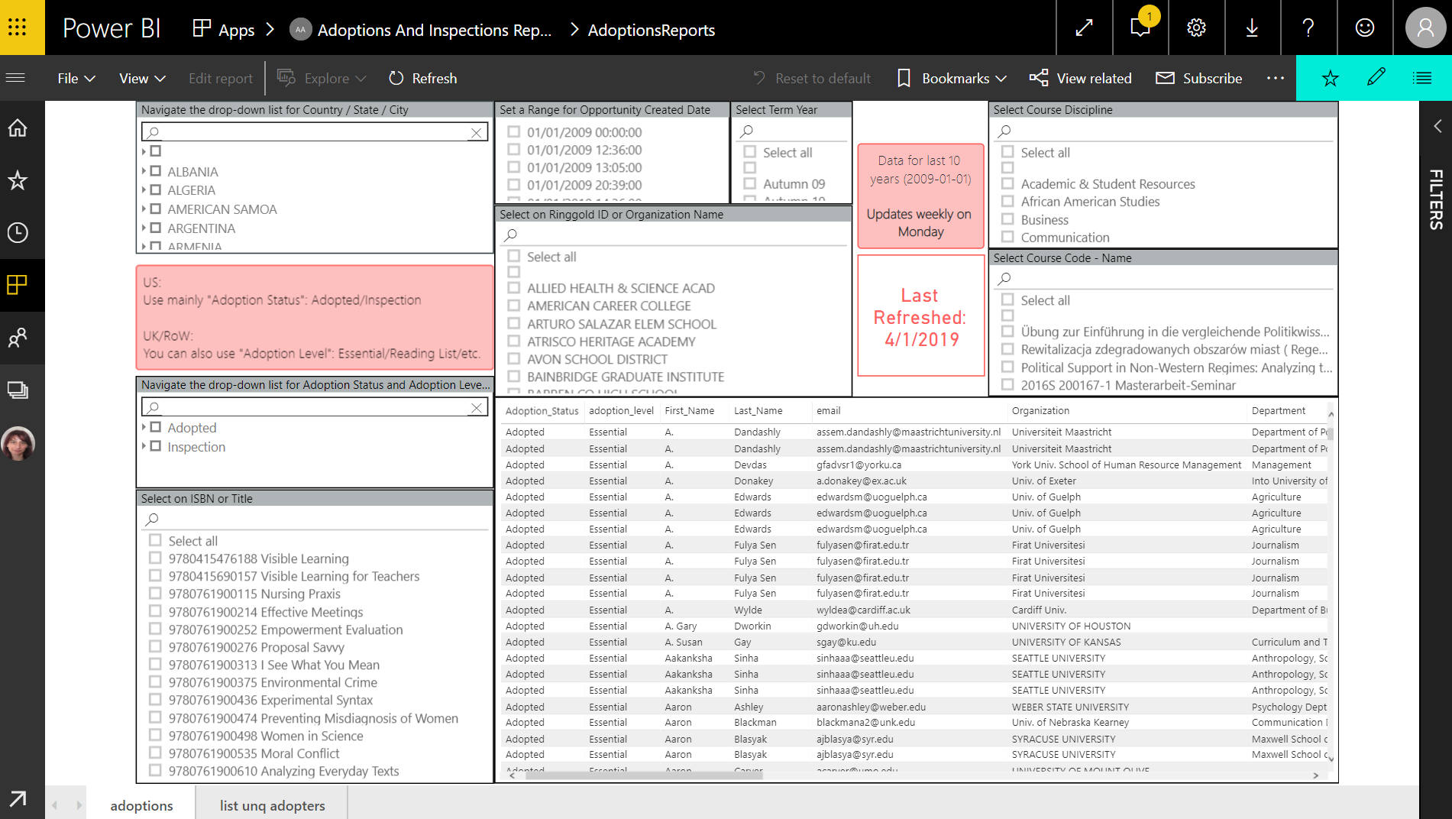

Main page with report data. Users are expected to use the filters provided in this page to extract the data they need from the table visual.

The table contains all the data fields that were listed as “fields displayed” and they can extracted for further analysis in Excel by going to the ellipse > Export Data > Summarized Data > xlsx > Export. I have set it so that users can only get summary data and not the full details. This can be changed in the workspace in PBI online.

The filters are:

* Country > State > City (drop-down)
* Adoption Status > Adoption Level (drop-down)
* ISBN – Title
* Opportunity Created Date: same name field in MSCRM table, or inspection/adoption date in older data
* Ringgold_ID – Organization
* Course Discipline
* Course Code – Course Name

In red, users can see the last updated date for the data. This updates automatically.

### Page: list unq adopters

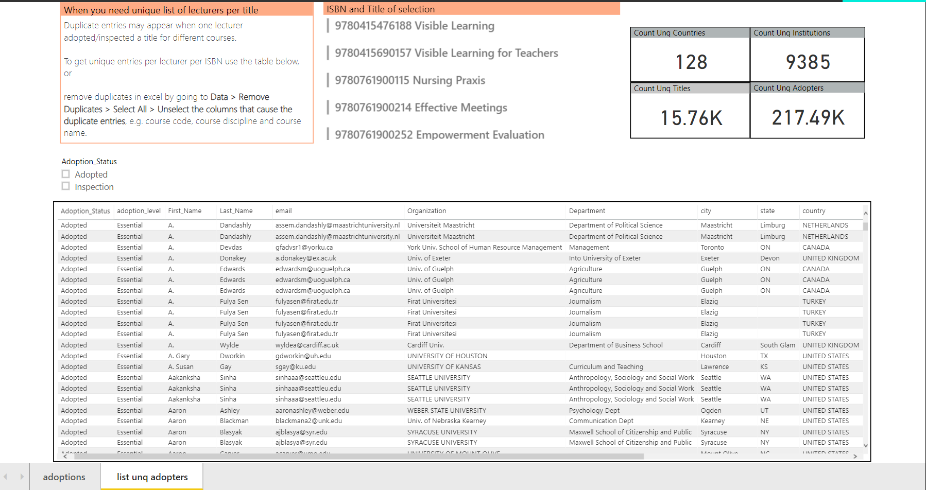

Secondary page for extracting unique adopters by ISBN. As US Editorial often only needs to reach out to lecturers of previous editions and are not interested in the adoptions per se, I have provided this additional table with adopters’ details and ISBN/title. All the filters from page one are automatically applied to this page, except for the drop downs. This is why I have added a simple Adoptions/Inspections filter on this page, too. I have also added unique counts of countries, institutions/organizations, adopters and titles. These can provide a quick overview of the data and sense check. Finally, there is a card with ISBN and titles for showing which pre-selection has been applied on the page.

# Known Issues

|  |  |  |  |  |  |
| --- | --- | --- | --- | --- | --- |
| Date reported | What | When | Why | How to | Fixed? |
| December 2018 | Data refresh fails | Occasionally | Server updates, Password update,  Gateway failure | Contact DJ,  Update your password | No – but in IT’s backlog |
| April 2019 | Join to email_suppress table slows down the data input and refresh to halt | Always |  | Removed the join for now |  |
|  |  |  |  |  |  |
|  |  |  |  |  |  |

# Appendix A

* M-query for current_date table:

**let**

**RefreshDateTime = DateTime.LocalNow(),**

**TimeZoneOffset = -5,**

**RefreshDateTimeAdjusted = RefreshDateTime + #duration(0,TimeZoneOffset,0,0),**

**RefreshDateAdjusted = DateTime.Date(RefreshDateTimeAdjusted),**

**TableCreate = Table.FromRecords({[CurrentDate = RefreshDateAdjusted]}),**

**DateType = Table.TransformColumnTypes(TableCreate,{"CurrentDate", type date})**

**in**

**DateType**

* New Measure for last refreshed date:

**Last Refresh Msg = VAR CurrentDateValue = MAX('current_date'[CurrentDate]) RETURN "Last Refreshed: " & CurrentDateValue**