**IMDB Movie Analysis**

**--By Sagir Mehmood**

**Kindly download my Jyputer Notebook:**

[**https://colab.research.google.com/drive/159hm2tehbj8bjAfWc4Ams73ETLaZC6TE?usp=sharing**](https://colab.research.google.com/drive/159hm2tehbj8bjAfWc4Ams73ETLaZC6TE?usp=sharing)

**Project Description:**

This dataset having various columns of different IMDB Movies. I have to use my knowledge of statistics and use different formulas in excel and draw necessary conclusions about the data.

**Approach:**

I analyzed it in the manner described below:

* Data cleaning
* EDA
* Analysis and conclusion

**Tech Used:** Here I sought assistance from Python Jupyter Notebook.

**Insights & Results:**

**QA. Data Cleaning:**

1. Dropping unnecessary columns (Not needed for this project):

'color','director_facebook_likes', 'actor_1_facebook_likes', 'actor_2_facebook_likes', 'actor_3_facebook_likes', 'actor_2_name', 'cast_total_facebook_likes', 'actor_3_name', 'duration', 'facenumber_in_poster', 'content_rating', 'country', 'movie_imdb_link', 'aspect_ratio', 'plot_keywords'

2. Removing the duplicate movie names, which are entered more than once.

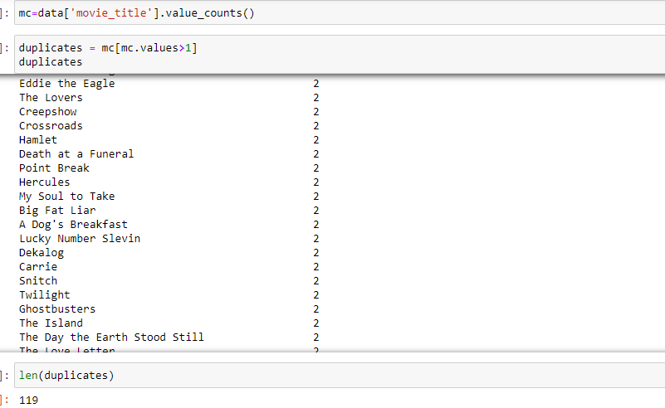

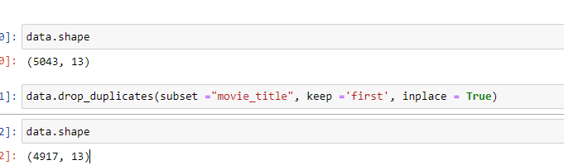

3. Checking for null values:

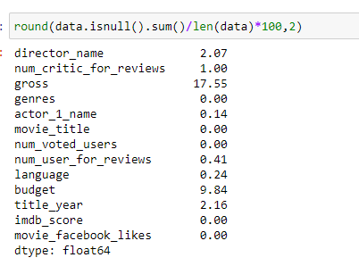

Here 'gross' and 'budget' columns have a large percentage (greater than 5%) of Null values. Here I dropped all the null rows in these two columns. Left are negligible.

After cleaning:

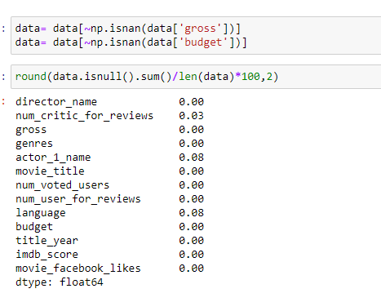

4. Data formatting:

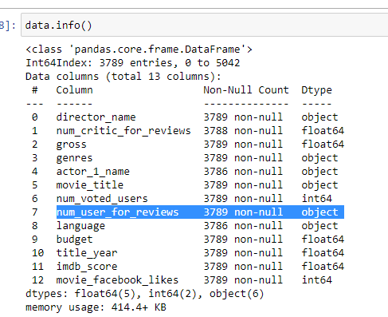

Here num_user_for_reviews column’s data are stored in object format, and I converted it to float type.

After converting:

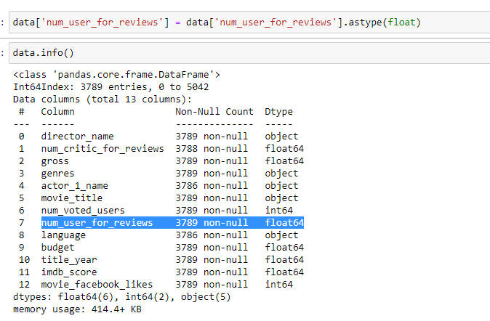

**B.**

**Movies with the highest profit:**

Profit = Gross – Budget



Here to 10 highest-earned movies are 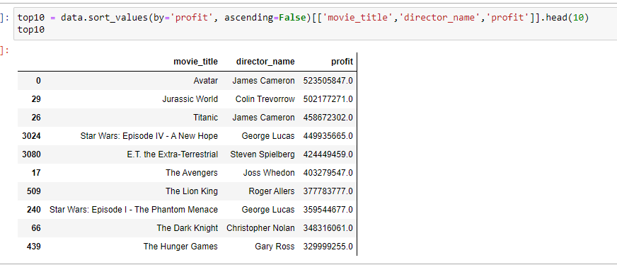

**Plot profit (y-axis) vs budget (x-axis)**

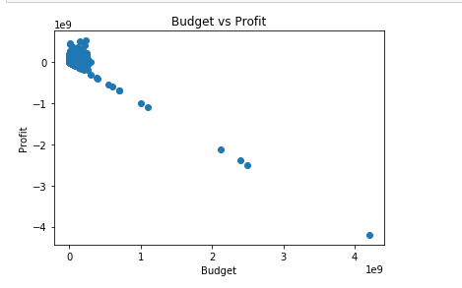

**C.**

**Top 250 movies with the highest IMDb Rating for all of these movies, the num_voted_users is greater than 25,000:**

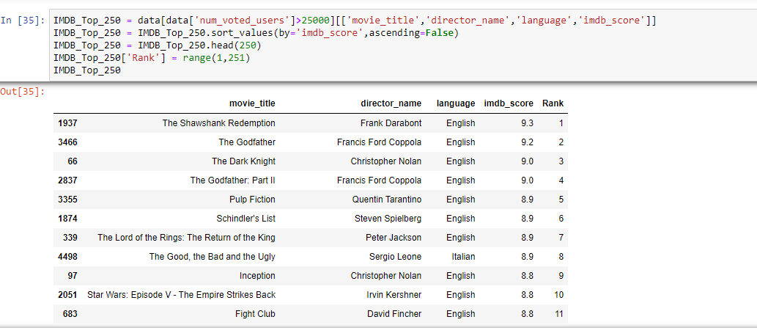

**Extract all the movies in the IMDb_Top_250 column which are not in the English language and store them in a new column named  Top_Foreign_Lang_Film:**

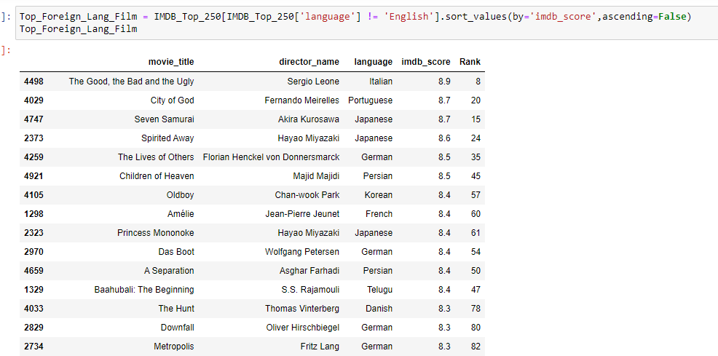

**D. Best Director (TOP-10):**

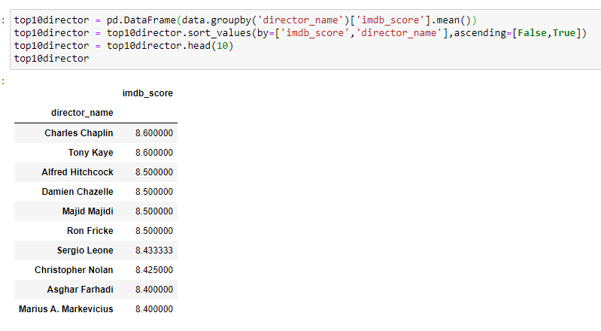

**E. Popular Genres:**

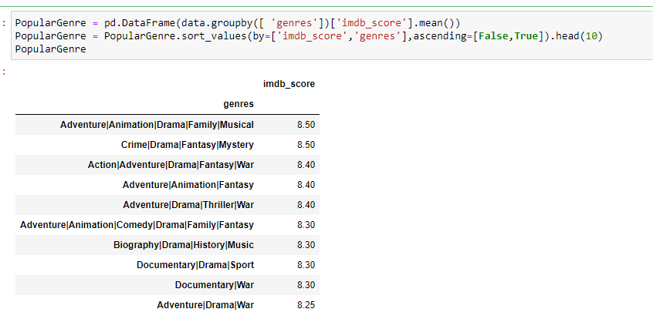

**F. Charts:**

**Movies by Leonardo DiCaprio, Brad Pitt, and Meryl Streep:**

##### Lead: Meryl Streep

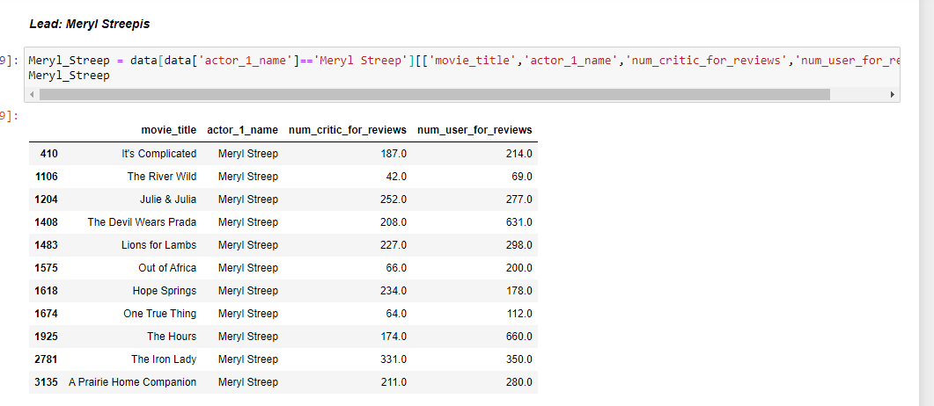

##### Lead: Leonardo Di Caprio

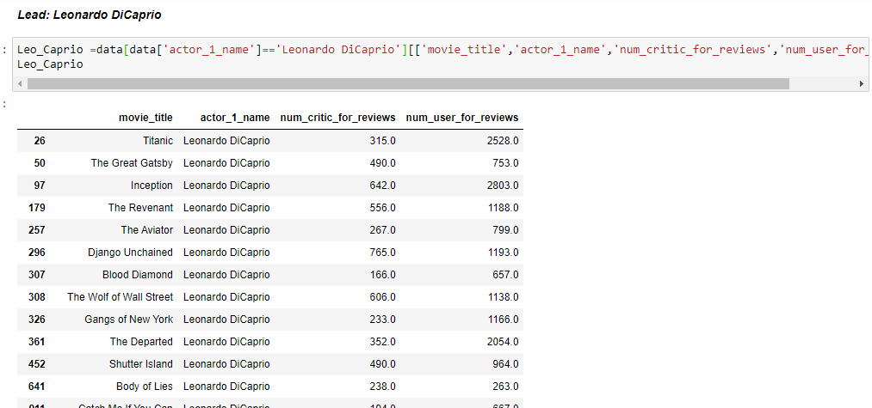

##### Lead: Brad Pitt

##### 

##### COMBINED:

##### 

**The mean of critic reviews and audience reviews from the above data:**

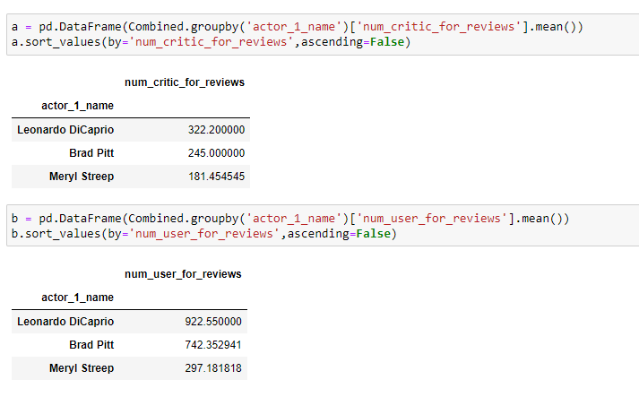

**The mean of critic reviews and audience reviews from overall data:**

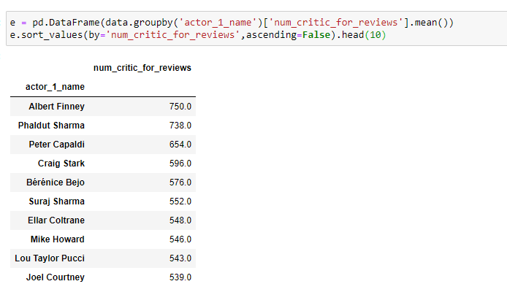

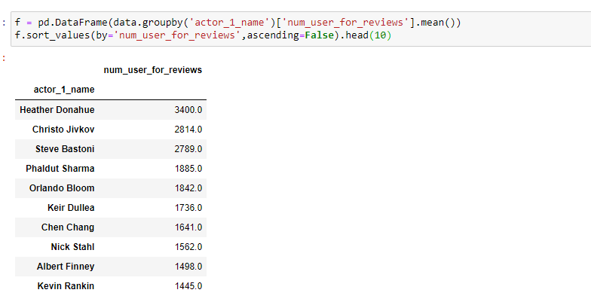

**The sum of users voted in each decade:**

Decade= year- remainder(decade/10)

Eg. Year= 2013

So, Remainder(2013/10) = 3

So, Decade = 2013-3 = 2010

