Supplementary Materials
Stage-Stratified Explainable Machine Learning Identifies a Reproducible Transcriptomic Classifier with Shifting Importance Structure in Colorectal Cancer: A Multi-Cohort Study

Table S1. Differential-Expression Concordance (R-limma vs Python)
Contrast | R DEGs | Python DEGs | Jaccard | log2FC Spearman | Direction agreement
Global | 4,810 | 4,807 | 0.995 | 1.000 | 100%
Stage I | 4,979 | 4,996 | 0.963 | 0.999 | 100%
Stage II | 4,865 | 4,857 | 0.989 | 1.000 | 100%
Stage III | 4,682 | 4,661 | 0.986 | 1.000 | 100%
Stage IV | 4,971 | 4,971 | 1.000 | 1.000 | 100%
DEG counts at FDR < 0.05 and |log2FC| ≥ 1. The two independent implementations agree near-perfectly, establishing the differential-expression layer as implementation-independent.

Table S2. Differential-Expression Statistics for the Ten Panel Genes
Gene | R log2FC | Python log2FC | R FDR | Direction match
CDH3 | +6.548 | +6.544 | 8.4 × 10⁻¹²⁸ | Yes
OTOP2 | −9.480 | −9.475 | 8.4 × 10⁻¹²⁸ | Yes
KRT80 | +6.710 | +6.713 | 2.6 × 10⁻¹⁰⁹ | Yes
ETV4 | +5.475 | +5.476 | 1.3 × 10⁻¹⁰¹ | Yes
ESM1 | +5.564 | +5.563 | 2.2 × 10⁻⁹⁹ | Yes
DHRS7C | −2.757 | −2.756 | 1.2 × 10⁻¹¹⁵ | Yes
AADACL2 | −2.761 | −2.760 | 5.3 × 10⁻¹¹⁴ | Yes
LGI1 | −4.567 | −4.563 | 6.7 × 10⁻⁹⁰ | Yes
TMEFF2 | −3.344 | −3.354 | 2.2 × 10⁻⁸² | Yes
KHDRBS2 | −2.474 | −2.472 | 1.2 × 10⁻⁷⁷ | Yes
All ten panel genes are significant in the canonical limma analysis with concordant direction and near-identical fold-changes across implementations.

Table S4. Two-Level Network Analysis of Panel Genes
Gene | Present at conf > 0.9 | Present at conf > 0.7 | Degree (0.7)
CDH3 | No | Yes | 2
OTOP2 | No | Yes | 1
LGI1 | Yes | Yes | 7
KRT80 | No | No | 0
ETV4 | No | No | 0
ESM1 | No | No | 0
DHRS7C | No | No | 0
AADACL2 | No | No | 0
TMEFF2 | No | No | 0
KHDRBS2 | No | No | 0
Panel genes are largely absent from or peripheral to the high-confidence STRING PPI network at both thresholds, and never interconnect, indicating complementarity to classical hub-gene approaches.

Table S5. Panel-Gene Membership in Robustly Enriched Pathways
Gene | # robust pathways | Representative pathway(s)
CDH3 | 9 | Wnt signalling; cell adhesion
LGI1 | 9 | synaptic / axon-guidance (neural)
ESM1 | 5 | angiogenesis; receptor signalling
DHRS7C | 5 | ion / metabolic homeostasis
ETV4 | 2 | signal transduction; differentiation
OTOP2 | 1 | ion transport
KRT80 | 1 | epithelial structure
KHDRBS2 | 1 | RNA binding
AADACL2 | 0 | (none)
TMEFF2 | 0 | (none)
Eight of ten panel genes belong to robustly enriched pathways; ESM1 maps to angiogenesis and CDH3 to Wnt/adhesion, linking the model's key genes to established CRC biology.

Table S6. Saudi Colorectal-Cancer Pathway Cross-Reference
Saudi-altered pathway | Convergent | Saudi frequency / source
Wnt/β-catenin | Yes | 65%; Alatwi et al. 2025 [56]
PI3K | Yes | 48%; Alatwi et al. 2025 [56]
TP53 | Yes | ~50%; Alsolme et al. 2023 [9]
KRAS/RAS–MAPK | Yes | variable; [9,56]
Homologous recombination | No | 61%; [56]
Four of five frequently altered Saudi CRC pathways converge with the robustly enriched pathways; the single non-convergence (homologous recombination) is reported transparently.

Table S7. Literature Corroboration of the Ten Panel Genes
Gene | Direction | Status | Representative evidence
KRT80 | Up | Strong | Most up-regulated gene in TCGA CRC; metastasis [52]
OTOP2 | Down | Strong | Down-regulated tumour suppressor in COAD [55]
CDH3 | Up | Strong | P-cadherin overexpressed; poor prognosis [53]
ESM1 | Up | Strong | Angiogenesis; advanced stage [50,51]
ETV4 | Up | Strong | Pro-metastatic ETS factor [54]
TMEFF2 | Down | Moderate | Methylation-silenced tumour suppressor
AADACL2 | Down | Novel | Poorly characterised in CRC
KHDRBS2 | Down | Novel | Poorly characterised in CRC
LGI1 | Down | Novel | Limited CRC-specific evidence
DHRS7C | Down | Novel | Poorly characterised in CRC
Six of ten genes have direct experimental support in CRC, all matching the differential-expression direction; four are presented as hypothesis-generating candidates.

Supplementary Figures
Figure S1. Per-stage exploratory survival analyses (Kaplan–Meier curves and per-stage concordance indices). All per-stage subgroups fall below the events-per-variable threshold (EPV < 10) and are reported as exploratory only.
Figure S2. Network-confidence sensitivity analysis comparing STRING confidence > 0.9 and > 0.7, underlying Figure 9C. Panel genes remain peripheral at both thresholds.
Figure S3. GEPIA2 expression box plots for all ten panel genes (tumour vs normal, TCGA + GTEx reference) and the ESM1 stage plot. All ten genes match the differential-expression direction; six reach the platform's significance threshold.
Note: Table S3 (the full 817-pathway triangulated enrichment table) is provided as a separate machine-readable file (triangulated_enrichment_all.csv) owing to its length.

Supplementary Figure Images
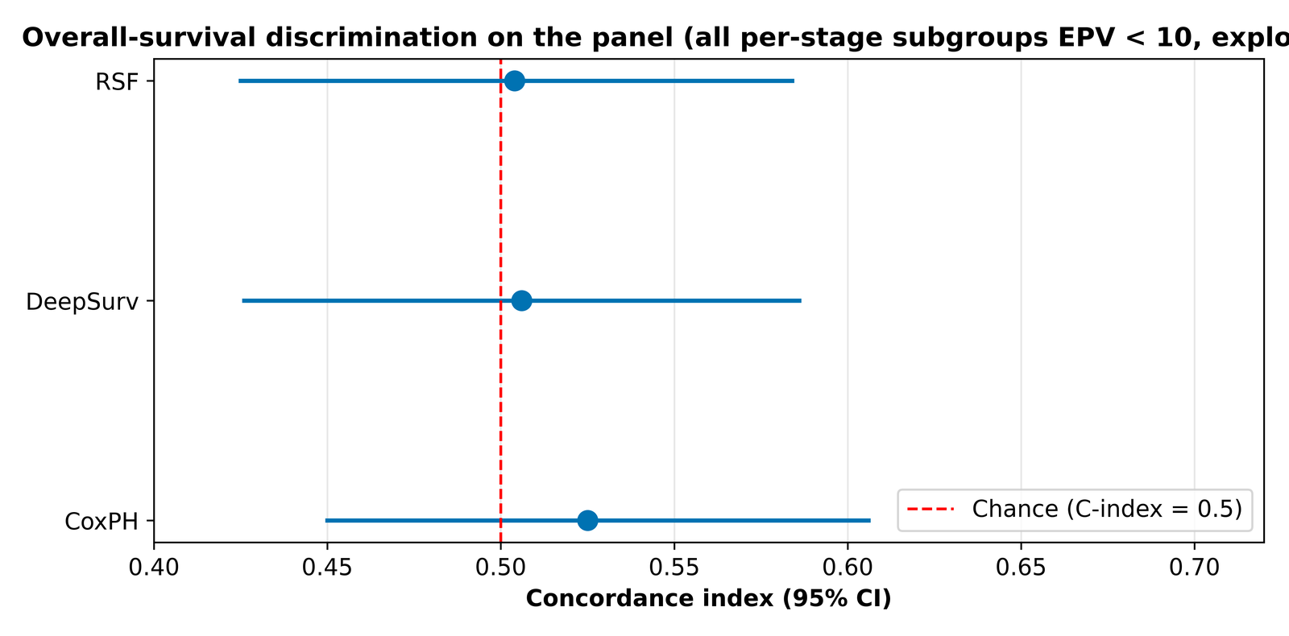
Figure S1. Overall-survival discrimination of the panel across three models, shown as concordance indices with 95% bootstrap confidence intervals against the chance reference; all per-stage subgroups were below the events-per-variable threshold and are exploratory.
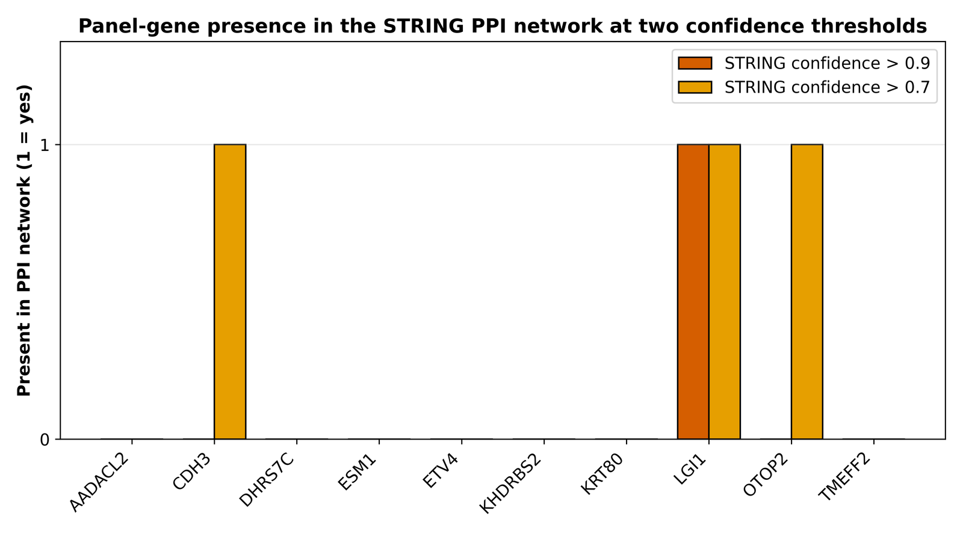
Figure S2. Presence of each panel gene in the STRING protein-protein interaction network at confidence thresholds of 0.9 and 0.7, underlying the topological analysis summarised in the main text.
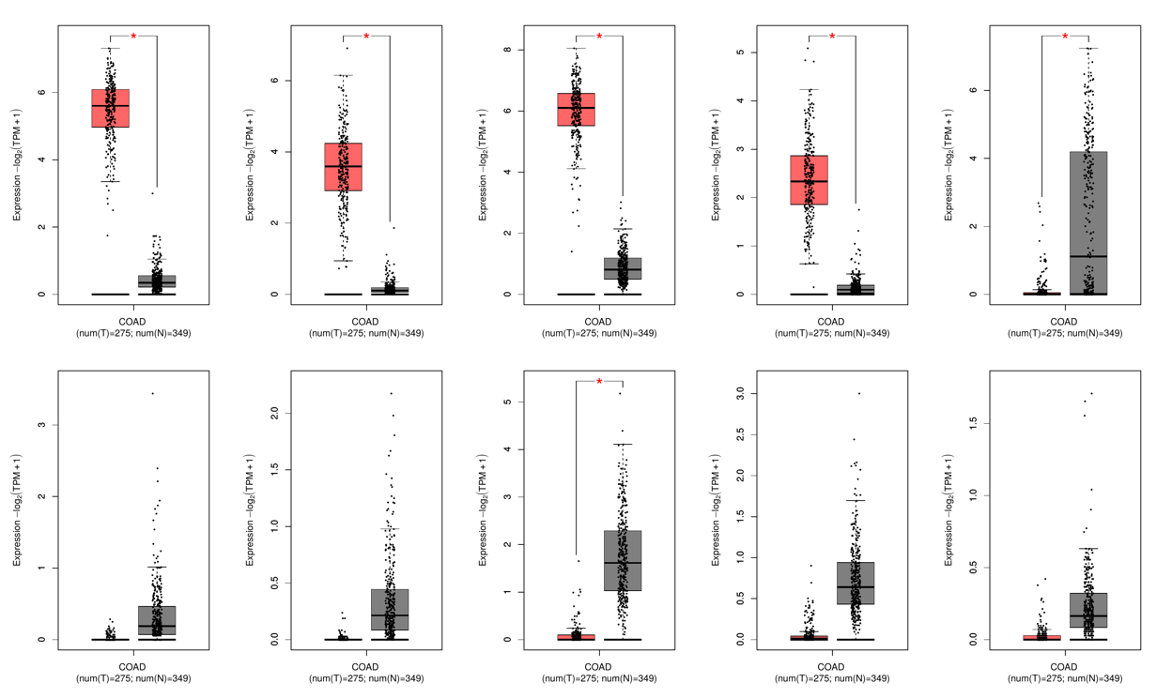
Figure S3. GEPIA2 expression box plots for the ten panel genes (tumour versus normal, TCGA plus GTEx reference), with the ESM1 stage plot; all ten genes match the differential-expression direction.

