VISVESVARAYA TECHNOLOGICAL UNIVERSITY
Jnana Sangama, Belgaum-590018

A PROJECT PHASE -II REPORT ( BCS 786) ON
“TITLE OF THE PROJECT”
Submitted in Partial fulfillment of the Requirements for the VII Semester of the Degree of
Bachelor of Engineering in Computer Science & Engineering
By
NAME OF STUDENT (USN)
NAME OF STUDENT (USN)
NAME OF STUDENT (USN)
NAME OF STUDENT (USN)
Under the Guidance of
NAME OF THE GUIDE
Designation, Dept. of CSE

DEPARTMENT OF COMPUTER SCIENCE AND ENGINEERING
HKBK COLLEGE OF ENGINEERING
NO.22/1, OPPOSITE, MANYATA TECH PARK RD, VYALIKAVAL SOCIETY, VYALIKAVAL HBCS LAYOUT, NAGAVARA, BENGALURU, KARNATAKA 560045

AY 2025-26

HKBK COLLEGE OF ENGINEERING

NO.22/1, OPPOSITE, MANYATA TECH PARK RD, VYALIKAVAL SOCIETY, VYALIKAVAL HBCS LAYOUT, NAGAVARA, BENGALURU, KARNATAKA 560045

DEPARTMENT OF COMPUTER SCIENCE AND ENGINEERING

CERTIFICATE
Certified that the project work entitled “______________” carried out by Mr/Ms.__________ USN ____________, Mr./Ms._________ USN _________, Mr./Ms._________ USN__________, Mr./Ms.______ USN ________, bonafide students of HKBK College of Engineering, in partial fulfillment for the award of Bachelor of Engineering in Computer Science and Engineering of the Visveswaraiah Technological University, Belgaum during the year 2025-2026. It is certified that all corrections/suggestions indicated for Internal Assessment have been incorporated in the Report deposited in the departmental library.
The project report has been approved as it satisfies the academic requirements in respect of Project work prescribed for the said Degree.

Guide  Designation  Dept. of CSE, HKBKCE | Dr. Smitha Kurian Assoc. Prof. & Head  Dept. of CSE, HKBKCE | Dr. Mohammed Riyaz Ahmed  Principal  HKBKCE

External Viva
Name of the Examiners Signature with Date

DECLARATION

We, the students of 7th semester of Computer Science and Engineering, HKBK College of Engineering, Bangalore declare that the work entitled "____________________" has been successfully completed under the guidance of Prof./Dr.___________, Computer Science and Engineering Department, HKBK College of Engineering, Bangalore. This dissertation work is submitted in partial fulfillment of the requirements for the award of Degree of Bachelor of Engineering in Computer Science and Engineering during the academic year 2025 - 2026. Further the matter embodied in the project report has not been submitted previously by anybody for the award of any degree or diploma to any university.

Place:
Date:
Team members:
NAME (1HK______) | __________________
NAME (1HK______) | __________________
NAME (1HK______) | __________________
NAME (1HK______) | __________________

ABSTRACT

Pet owners often struggle to monitor their pet's health status and location in real-time, leading to delayed medical intervention and safety concerns during emergencies. This project presents an IoT-based smart dog collar prototype that continuously monitors vital signs (heart rate, body temperature), tracks GPS location, and provides instant emergency alerts. The system employs ESP32 microcontroller with integrated sensors, GSM/GNSS connectivity for cloud synchronization via Firebase, and a responsive web dashboard for remote monitoring and control. The methodology includes multi-threaded sensor data acquisition, robust cellular communication with fallback mechanisms, automated email notifications, and real-time web interface updates. The result is a comprehensive pet monitoring solution that ensures health tracking, instant SOS emergency response with location-based email alerts, and remote pet finder capabilities, significantly enhancing pet safety and providing owners with complete peace of mind.

ACKNOWLEDGEMENT

I take this opportunity to express my sincere gratitude and respect to HKBK College of Engineering, Bengaluru, for providing me with a platform to pursue my studies and carry out my final year project.
I extend my heartfelt thanks to Sri. C. M. Ibrahim, Chairman, and Sri. C. M. Faiz Mohammed, Director, HKBKCE, for their vision, leadership, and unwavering commitment to fostering a quality educational environment that has enabled me to grow and excel academically.
It gives me immense pleasure to express my deep sense of gratitude to Dr. Mohammed Riyaz Ahmed, Principal, HKBKCE, Bengaluru, for his constant encouragement and support.
I would also like to extend my heartfelt thanks to Dr. Smitha Kurian , Assoc Prof & Head of the Department, Computer Science and Engineering, HKBKCE, for being a continuous source of support and motivation throughout the duration of this project.
A special and earnest word of thanks to our Project Coordinator, [Name], [Designation], of the Department, Computer Science and Engineering, HKBKCE for their constant assistance, unwavering support, patience, endurance, and constructive suggestions that significantly contributed to the successful development of our project.
I consider it a privilege and an honor to express my sincere gratitude to my guide, [Guide Name], [Designation], Department of Computer Science and Engineering, for their valuable guidance, timely suggestions, and continuous encouragement throughout the tenure of this review.
I also extend my sincere thanks to all the faculty members of the Computer Science and Engineering Department who directly or indirectly supported and encouraged me during this project.
Finally, I would like to thank my parents and friends for their moral support and constant encouragement throughout the completion of this work.

TABLE OF CONTENTS

 |  | Page No.
Certificate |  | ii
Declaration |  | iii
Abstract |  | iv
Acknowledgement |  | v
Table of contents |  | vi
List of Figures |  | viii
List of Tables |  | ix
List of Abbreviations |  | x
- INTRODUCTION  - Background & context  - Problem statement  - Objectives  - Relevance & scope of project  - Significance & motivation  - Chapter-wise summary |  | 1
- LITERATURE SURVEY
2.1 Review of Related Work (with subsections as needed)
2.2 Comparison Table
2.3 Inferences
2.4 Research Gap
- REQUIREMENT
3.1 Problem Statement
3.2 Functional Requirements
3.3 Non-functional Requirements
3.4 Use Case Diagram
- SYSTEM ANALYSIS & DESIGN
4.1 Proposed System
4.2 System Design
4.2.1 High Level Design – System Architecture (for each module)
4.2.2 Low Level Design – Class Diagram / Sequence Diagram / State Diagram / Algorithms

5. IMPLEMENTATION
5.1 Tools & Methodology
5.2 Code Snippets (only important parts, no full code)

6. TESTING
6.1 Functional Test Cases (≥3 per module, including some failed cases)
- Test case table format:
Test Case ID | Module Name | Description | Input(s) | Expected Output(s) | Actual Output(s) | Status  PASS/  FAIL | Remarks

7. RESULTS & DISCUSSION
7.1 Analysis of Outcomes
7.2 Graphical & Chart Representation

8. CONCLUSION & FUTURE SCOPE
8.1 Restatement of Problem Statement
8.2 Major Findings & Implications
8.3 Future Work

REFERENCES
- In-text citations in square brackets, e.g., [3]
- Listed in order of appearance
- Formats:
- Books: [1] A.V. Oppenheim and R.W. Schafer, Digital Signal Processing, Englewood, N.J., Prentice Hall, 3rd Edition, 1975.
- Papers: [2] Devid, Insulation design to combat pollution problem, Proc of IEEE, PAS, Vol 71, Aug 1981, pp 1901-1907.
- Websites: Include author, title, publisher, publication date, link, and access date if no publication date.

APPENDIX
- Dataset + Descriptive/Graphical Representation
- PAPERS – SURVEY & IMPLEMENTATION PAPER PUBLISHED
- Certificates: Paper Presentation, Journal/Conference Submission or Acceptance, Grants obtained, Exhibitions Participated

LlST OF FIGURES

 | Page No.
Fig 1.1 Figure caption | 3
Fig 2.2 Figure caption | 5
Fig 2.4 | 6
(DO NOT number as 2.2.2 even if the figure is under a subsection, if there are 10 figures in chapter 2, order them 2.1 to 2.10)

LIST OF TABLES

 | Page No.
Table 1.1 Table caption | 3
Table 2.2 Table caption | 5
Table 2.4 | 6
(DO NOT number as 2.2.2 even if the table is under a subsection, if there are 5 tables in chapter 4, order them 4.1 to 4.5)

LIST OF ABBREVIATIONS

FCFS | Firs Come First Serve
RR | Round Robin
(Order Alphabetically)

- INTRODUCTION
Pet ownership brings immense joy but also significant responsibility, particularly in ensuring the health, safety, and well-being of companion animals. Traditional approaches to pet care often rely on periodic veterinary visits and manual observation, which may be insufficient for early detection of health anomalies or rapid response during emergencies. Advances in the Internet of Things (IoT) have enabled continuous, remote monitoring of vital parameters in real time, offering new possibilities for proactive pet management. This project focuses on the design and implementation of an IoT-enabled smart dog collar prototype, centered around the ESP32 microcontroller and equipped with sensors for heart rate, body temperature, and activity detection. By leveraging GSM and GNSS connectivity, the collar transmits live data to a cloud-based platform, allowing owners to monitor their pet’s health and location from anywhere. Furthermore, the system incorporates an automated SOS alert mechanism, ensuring immediate notification during potential emergencies. Through this integrated approach, the project aims to address key challenges in pet care, enhance emergency preparedness, and provide peace of mind for pet owners in diverse environments.
1.1 Background & Context
The evolving landscape of pet ownership has brought a growing emphasis on ensuring the safety, health, and well-being of companion animals in real time. With dogs being active and sometimes prone to wandering or facing unexpected health issues, traditional monitoring methods, primarily relying on owner supervision and occasional veterinary visits, often prove inadequate for timely intervention. The rise of Internet of Things (IoT) technologies has facilitated the development of smart wearable devices for humans, and similar advancements are now transforming animal care. By equipping pets with sensor-rich smart collars capable of monitoring vital parameters and geographic position, owners gain the ability to track their pet’s well-being and location continuously, receive instant alerts in case of emergencies, and interact with their pets remotely. This transition from conventional care to technology-driven solutions reflects broader trends in both pet humanization and the proliferation of connected devices, setting the foundation for advanced, data-driven approaches in modern pet management.

1.2 Problem Statement
A critical challenge faced by pet owners is the inability to continuously monitor their pet’s health and precise location, particularly in emergency situations. Existing commercial solutions are often prohibitively expensive, offer limited reliability, or fail to provide a comprehensive set of features that address both health tracking and real-time location. According to recent statistics, over 10 million pets go missing each year, with many never being reunited with their families due to delayed intervention or insufficient location information.
Furthermore, early detection of health issues is essential for preventing the escalation of medical problems and minimizing associated veterinary costs. Traditional pet care methods, which rely largely on observation and periodic check-ups, fall short in providing timely alerts and actionable data when urgent situations arise. Pet owners urgently require an affordable, robust solution that delivers immediate emergency notifications, enables proactive health monitoring, and ensures constant connectivity for remote communication with their pets. Addressing this problem will not only improve animal welfare and owner peace of mind but also reduce loss rates and healthcare expenses within the pet community.

1.3 Objectives
The primary goal of this project is to develop a comprehensive IoT-based smart dog collar system that integrates multiple monitoring and communication capabilities into a single, reliable platform. The specific objectives are outlined as follows:
Real-time Health Monitoring: To implement continuous tracking of essential vital parameters including heart rate measurement through pulse sensor integration, body temperature monitoring via DS18B20 digital temperature sensor, and activity level assessment using ADXL345 accelerometer. The system aims to provide uninterrupted health surveillance with data processing algorithms that classify activity states and detect anomalies in physiological parameters.
GPS Location Tracking: To establish precise positioning capabilities through dual-mode location services utilizing GNSS (Global Navigation Satellite System) for primary positioning and cellular-based location services as backup. The objective includes achieving location accuracy within 3-5 meters under optimal conditions and ensuring reliable position updates even in challenging environments where satellite signals may be compromised.
Emergency Alert System: To develop a one-touch SOS mechanism that enables immediate emergency response through automated email notification system. This objective encompasses the implementation of instant alert delivery to pre-configured contacts, including precise location coordinates and timestamp information, ensuring rapid response during critical situations.
Remote Communication: To enable bidirectional communication between pet owners and their pets through integrated pet finder buzzer functionality and comprehensive live web dashboard control. This includes remote activation of audio alerts for pet location assistance and real-time monitoring interface for continuous oversight of pet status.
Cloud Integration: To achieve seamless Firebase Realtime Database synchronization that enables instant data access from any internet-connected device. This objective focuses on implementing robust cloud connectivity for real-time data storage, retrieval, and cross-platform accessibility, ensuring owners can monitor their pets from anywhere at any time.

1.4 Relevance & Scope of Project
Relevance:
The smart dog collar project addresses a rapidly growing market need within the expanding pet care industry, which is projected to reach $350 billion globally by 2027. With increasing pet humanization trends, owners are actively seeking technological solutions that mirror human wearable health devices. The project's relevance extends beyond commercial applications to encompass public safety concerns, as lost pets contribute to traffic hazards, wildlife disruption, and community distress. The integration of IoT technologies in pet care aligns with broader smart home ecosystems, making this solution particularly relevant in today's connected world.
From a technological perspective, this project demonstrates practical applications of embedded systems, wireless communication protocols, cloud computing, and real-time data processing, all critical areas in modern engineering education and industry practice. The system's modular architecture and open-source approach contribute to the growing body of accessible IoT implementations, making it valuable for academic research and commercial development.
Scope of Project:
The project scope encompasses the complete development lifecycle of an integrated pet monitoring system, including:
Hardware Development: Design and implementation of ESP32-based circuit integration with sensor array (pulse, temperature, accelerometer), GSM/GNSS module connectivity, power management subsystem with battery charging and regulation.
Firmware Programming: Multi-threaded embedded software development featuring sensor data acquisition algorithms, AT command protocols for GSM communication, JSON data formatting and transmission, interrupt-driven SOS handling, and power optimization routines.
Cloud Infrastructure: Firebase Realtime Database configuration, data structure design for efficient storage and retrieval, and API endpoint management for web dashboard integration.
Web Application Development: Responsive dashboard interface creation with real-time data visualization, interactive mapping integration using Leaflet.js, remote control functionality implementation, and cross-browser compatibility optimization.
Alert System Implementation: Python-based email service deployment on cloud platform, SMTP protocol integration with Gmail services, location link generation with Google Maps.

1.5 Significance & Motivation
Significance:
The significance of this project extends across multiple dimensions, addressing critical gaps in contemporary pet care while demonstrating the transformative potential of IoT technologies in animal welfare. From a societal perspective, the system addresses the widespread problem of pet loss, which affects millions of families annually and places significant burden on animal shelters and rescue organizations. By providing real-time location tracking and immediate alert systems, the project contributes to reducing pet abandonment rates and improving reunion success rates.
The project's health monitoring capabilities represent a paradigm shift toward preventive veterinary care, enabling early detection of medical conditions that could otherwise escalate into life-threatening emergencies. This proactive approach not only enhances animal welfare but also reduces long-term healthcare costs for pet owners and decreases the emotional trauma associated with preventable pet health crises.
From a technological standpoint, this project demonstrates the practical integration of multiple emerging technologies, edge computing, cellular IoT, cloud services, and real-time web applications, into a cohesive solution. The implementation showcases how modern embedded systems can bridge the gap between physical world sensing and digital data management, contributing to the broader Internet of Things ecosystem.
Motivation:
The primary motivation for this project stems from the recognition that existing pet monitoring solutions are either prohibitively expensive, technologically limited, or lack the comprehensive feature set required for effective pet care. Many commercial products focus on single aspects of pet monitoring, either location tracking or health metrics, but fail to integrate these capabilities into a unified, affordable platform.
Personal observations of pet owner challenges, including delayed response to pet emergencies, anxiety during pet absence, and limited visibility into pet health between veterinary visits, provided additional motivation to develop a solution that addresses these real-world concerns. The project aims to democratize advanced pet monitoring technology by creating an open-source, cost-effective alternative to expensive commercial systems.
Furthermore, the educational value of this project motivated its development as a comprehensive demonstration of modern IoT system design, from hardware integration and embedded programming to cloud services and web development. The project serves as a practical example of how emerging technologies can be applied to solve meaningful problems while providing valuable learning experiences in systems integration, wireless communication, and data management.
- LITERATURE SURVEY
2.1 Review of Related Work
IoT-Based Smart Animal Health Monitoring (Gowthami et al., 2023)
Gowthami and colleagues proposed a foundational IoT-based approach to animal health monitoring utilizing an Arduino Uno microcontroller integrated with temperature and pulse sensors. Data from these sensors was transmitted via a Wi-Fi module to the ThingSpeak cloud platform, enabling remote visualization through a web dashboard. This system effectively demonstrated cloud-based monitoring of basic physiological parameters and showcased how IoT technologies can provide remote insights into animal well-being. However, its sensor suite was limited to just temperature and pulse measurements, and the reliance on Wi-Fi connectivity constrained its deployment primarily to indoor environments. Furthermore, the absence of real-time alert mechanisms limited its practical utility during emergencies, particularly in outdoor or unstructured settings.

IoT-Based Animal Health Monitoring Using ZigBee (Keertana & Vanathi, 2017)
Keertana and Vanathi introduced a system aimed at wider physiological monitoring in animals, employing temperature, heart rate, pulse, and respiratory sensors, with ZigBee for short-range wireless data transmission. The collected data was displayed on a graphical user interface, allowing for basic review by caregivers. The use of ZigBee, while effective for localized network environments, significantly restricted the communication range and thus limited real-world scalability. Moreover, the system had limited intelligence for data analysis and was not equipped with any active notification or emergency alert mechanism, reducing its effectiveness in urgent scenarios .

Wearable Multi-Sensor System for Sheep Health Tracking (Liu et al., 2024)
Expanding the domain towards wearables in livestock, Liu et al. developed a flexible sensor platform with PET/PI substrates, integrating temperature, oxygen saturation, and step-counting sensors. By applying machine learning models, the system delivered advanced analytics on sheep health and mobility, offering a glimpse into the future of automated animal welfare tracking. However, this system was designed specifically for group livestock use rather than pets and remained dependent on Wi-Fi infrastructure. Importantly, it also lacked real-time emergency notification capabilities, a feature critical for pet monitoring applications where owner intervention must be immediate.

General Trends and Gaps
Across the literature, numerous other works have contributed unique hardware combinations, such as smart collars for vaccination tracking, IoT-based health analytics, and systems leveraging various wireless protocols (Wi-Fi, ZigBee, Bluetooth, LoRa). While many achieve reliable physiological and position monitoring under controlled scenarios, most face one or more of the following limitations: short-range connectivity, limited or single-parameter monitoring, lack of integrated GPS, dependency on continuous infrastructure, or absence of real-time alert functionality. Even advanced wearable platforms often require companion devices or lack robustness for field deployment, and few offer cloud-based, multi-user access with real-time bi-directional communication and automated emergency alerts. These collective findings highlight the ongoing challenge of creating a cost-effective, comprehensive, and scalable pet monitoring system suited for diverse, real-world conditions

Comparison Table

S. No | Author(s), Year | Methodology | Key Benefits | Limitations | Performance/Outcome
1 | Gowthami et al., 2023 | Arduino Uno; temp & pulse sensors; Wi-Fi to ThingSpeak | Remote basic vitals monitoring via cloud dashboard | Wi-Fi only; limited sensors; no alerts | Indoor real-time display
2 | Keertana & Vanathi, 2017 | Physiological sensors, ZigBee, local GUI | Monitors multiple vitals in local area | Short range; no notifications | Reliable within small area
3 | Liu et al., 2024 | Multi-sensor flexible wearables, ML analytics, Wi-Fi | Advanced analytics, multi-parameter for livestock | Wi-Fi only; livestock focus; no instant alerts | Health pattern recognition
4 | Anita Dombale, 2024 | Smart collar: track, HR, vaccination sensors | Monitors multiple parameters, tracking | Limited range; battery intensive | Accurate real-time monitoring
5 | Marc Foster, 2019 | Wearable for HR, HRV, activity | Reliable HR/HRV/activity data, validated in field | Calibration need; expensive for large scale | Validated accuracy for dogs
6 | Joshua W.D. Cervania, 2023 | GPS + health sensors wearable | Vitals and location in one device | Needs GPS access; rural limits | Reliable location/vitals
7 | Evan Williams, 2020 | Smart collar with environmental sensors | Activity and temp monitoring; for guide dogs | Connectivity required | Effective under supervision
8 | Carlos B. Nina Pastor, 2021 | Frugal wireless cardiovascular monitor | Cost-effective; continuous HR monitoring | Cardiovascular metrics only | 91% heart monitoring accuracy
9 | Ankita S. Patil, 2017 | IoT health monitoring collar | Early disease alert; multiple health metrics | No GPS | High vital detection sensitivity
10 | Agni Biswas & Sarthak Prakash, 2016 | Triangulation-based short-range positioning | Animal positioning in enclosures | Not scalable for open areas | 85% location accuracy in shelter
11 | Zhang Z., 2015 | PPG-based wearable HR monitoring | Non-invasive; continuous HR tracking | Prone to motion artefacts | 88% HR accuracy
12 | Sharma, 2023 | Integrated IoT tracking and health system | Combined tracking and health monitoring | Bulky device; costly | Versatile, integrated monitoring
13 | Kim, J., 2022 | Wearable IoT, cloud data sync | Lightweight; real-time sync | Needs companion app/device | User-friendly, effective
14 | Bhandari, K. | Smart tracker (non-LoRa) with optimized battery use | Reliable tracking, longer life | Range limitations | 92% location accuracy
15 | Karthik R. et al., 2020 | IoT animal monitoring, basic analytics | Data collection and analysis | Not for small pets | Moderate performance on farms
16 | Ramachandran & Duraisamy, 2018 | Wireless sensor + IoT for multi-animal | Scalable, tracks many animals | Complex network setup | 89% network accuracy
This table provides a structured snapshot of leading research and systems, allowing comparison at a glance for methodology, benefits, challenges, and results.

2.3 Inferences
Based on the comprehensive review of existing literature and comparative analysis of related systems, several key inferences emerge regarding the current state and limitations of IoT-based animal monitoring solutions.

Connectivity and Range Limitations:
A significant limitation across most reviewed systems is their reliance on short-range communication protocols or infrastructure-dependent connectivity. Systems using Wi-Fi are restricted to indoor environments or areas with established network coverage, while ZigBee-based solutions operate effectively only within limited ranges. This connectivity constraint severely impacts the practical deployment of these systems for outdoor pet monitoring, where reliable long-range communication is essential.

Emergency Response and Alert Mechanisms:
The analysis reveals a critical deficiency in emergency response capabilities across existing solutions. Most systems lack automated alert mechanisms or real-time notification systems that can immediately inform pet owners of critical situations. The few systems that incorporate alert features typically provide basic notifications without location information or emergency contact capabilities, limiting their effectiveness during genuine emergencies.

Power Management and Battery Life:
Battery dependency emerges as a common challenge, with several systems experiencing limitations due to power consumption constraints. While some solutions like Bhandari's system demonstrate optimized battery usage, most lack comprehensive power management strategies that would enable extended operational periods necessary for continuous pet monitoring.

Cost and Accessibility:
Commercial viability remains a significant concern, with many advanced systems being prohibitively expensive for widespread adoption. Solutions offering comprehensive features often require expensive hardware components or extensive infrastructure, making them inaccessible to average pet owners seeking affordable monitoring solutions.

Integration of Location and Health Monitoring:
Few existing systems successfully integrate both health monitoring and location tracking capabilities within a single platform. Most solutions focus on either physiological monitoring or location tracking, but rarely combine both effectively with cloud connectivity and emergency response features, highlighting the need for comprehensive integrated solutions.

2.4 Research Gap
Despite advances in IoT-based animal health and location monitoring, significant gaps remain that hinder the development of robust, user-friendly pet management systems. The most pressing gap is the absence of comprehensive platforms that seamlessly integrate both health monitoring and real-time GPS tracking with scalable, long-range cellular connectivity, especially for outdoor environments where pets are most vulnerable. Existing solutions often rely on short-range communication, limiting their applicability beyond confined spaces, and very few leverage GSM/LTE or dual-mode location services for reliable outdoor tracking.
Emergency response capabilities are another area with notable deficiencies. Most systems lack intelligent, automated alert mechanisms that can proactively notify owners with not just health anomalies but also live location, an essential feature for rapid intervention during critical situations. Research and products rarely combine real-time physiological monitoring with automated, multi-channel emergency notifications, such as instant email alerts containing actionable location data.
Furthermore, there is a critical need for improved power management practices and hardware designs that support extended, maintenance-free operation, empowering truly mobile, worry-free usage for pet owners. Cost remains a persistent barrier, with many advanced or integrated systems priced beyond the reach of most consumers, highlighting the opportunity for scalable, open-source, and affordable approaches.
Finally, current solutions seldom utilize cloud infrastructure for seamless data synchronization, web dashboard visualization, and remote control. This research aims to address the gap for a single, integrated IoT system that delivers continuous health tracking, precise GNSS-based location, automated emergency alerts, and real-time remote access through a unified, low-cost smart dog collar platform, built for both indoor and outdoor, real-world usage.
- REQUIREMENT
The requirements for the IoT-based smart dog collar system encompass a comprehensive set of specifications that address the critical challenges in pet health monitoring, location tracking, and emergency response. These requirements have been systematically derived from the identified research gaps and the pressing need for an integrated, affordable solution that combines continuous physiological monitoring with reliable communication capabilities. The system must deliver real-time health surveillance through multi-parameter sensor integration, ensure precise location tracking through dual-mode positioning services, and provide immediate emergency alert mechanisms with automated notification protocols. Additionally, the requirements emphasize the importance of user-friendly interfaces, robust power management, and scalable cloud infrastructure to support widespread deployment. The functional and non-functional requirements outlined in this chapter establish the technical foundation and performance benchmarks that guide the system design, implementation, and validation processes, ensuring the final solution meets both user expectations and industry standards for pet monitoring applications.
3.1 Problem Statement
Pet owners face significant challenges in maintaining continuous oversight of their companion animals' health and safety, particularly during outdoor activities or when pets are left unattended. Traditional pet care approaches rely heavily on periodic veterinary examinations and direct human observation, which are insufficient for detecting sudden health emergencies, monitoring chronic conditions, or responding quickly to emergency situations such as pet escape or injury. The lack of real-time physiological monitoring means that critical health changes, including irregular heart rates, abnormal body temperatures, or reduced activity levels, often go undetected until symptoms become severe, potentially resulting in costly emergency veterinary interventions or irreversible health complications.
Furthermore, the inability to track pets' precise locations in real-time creates substantial anxiety for owners and poses serious safety risks. Statistical data indicates that over 10 million pets go missing annually, with reunion rates remaining disappointingly low due to delayed reporting and insufficient location information. Existing commercial pet monitoring solutions are either prohibitively expensive, technologically limited to single-parameter monitoring, or dependent on infrastructure that restricts their effectiveness in outdoor environments where pets are most vulnerable.
The absence of integrated emergency response mechanisms compounds these challenges, as most current systems lack automated alert capabilities that can immediately notify owners of critical situations with actionable information such as precise location coordinates and health status data. Pet owners require a comprehensive, affordable solution that seamlessly combines continuous health monitoring, accurate location tracking, and intelligent emergency response within a single, reliable platform that operates effectively across diverse environments and usage scenarios.
3.2 Functional Requirements
The functional requirements specify the essential capabilities that the smart dog collar system must provide to deliver comprehensive pet monitoring and safety features.
Health Monitoring Requirements:
- The system shall measure and record the dog's body temperature continuously using integrated temperature sensors with appropriate accuracy for veterinary assessment
- The system shall measure and record heart rate data to monitor cardiovascular health and detect anomalies that may indicate medical conditions

Activity Monitoring Requirements:
- The system shall detect and classify the dog's activity levels into three distinct categories: Resting, Walking, and Running based on accelerometer data analysis
- The system shall provide continuous activity monitoring to assess behavioral patterns and physical wellness indicators
Location Tracking Requirements:
- The system shall provide real-time GPS-based location tracking of the dog with sufficient accuracy for emergency response and routine monitoring
- The system shall ensure location data is continuously updated and accessible to pet owners regardless of the dog's geographic position

Connectivity & Data Management Requirements:
- The system shall transmit all collected data to cloud infrastructure via 4G cellular network connectivity.
User Interaction Requirements:
- Pet owners shall be able to access all system data through a web-based dashboard accessible via mobile and desktop URLs
- The dashboard shall display real-time health data, current location, and other information in an intuitive, user-friendly interface

SOS Functionality Requirements:
- The collar shall include a physical SOS button that, when pressed, immediately sends an emergency email alert containing the dog's live location coordinates to the owner
- The SOS system shall ensure rapid alert delivery for time-critical emergency situations

Buzzer Control Requirements:
- The system shall include a remotely controllable buzzer that can be triggered by the owner through the web dashboard for pet recall or emergency signaling purposes

3.3 Non-functional Requirements
The non-functional requirements describe the quality attributes and operational characteristics for a single-user prototype, focusing on dependable operation, ease of use, and practical deployment without multi-user or security complexities.
Performance and Responsiveness
- The system should acquire, process, and display data in a timely manner suitable for real-time monitoring scenarios, maintaining smooth end-to-end flow from sensors to dashboard.
- The dashboard should present updated readings promptly so that the monitoring experience feels continuous and uninterrupted.
Reliability and Fault Tolerance
- The system should run stably under normal and mildly adverse conditions without frequent resets, crashes, or data corruption.
- Temporary connectivity loss should be handled gracefully by buffering and retrying, resuming normal operation automatically once connectivity is restored.
Usability and Accessibility
- The dashboard should be simple, intuitive, and easy to navigate for a user, with clear labeling, readable charts, and straightforward controls.
- Interfaces should work consistently across common screen sizes (mobile and desktop) without requiring specialized software or complex setup.
Scalability and Extensibility (Prototype-Oriented)
- The design should allow adding or swapping sensors and features later with minimal changes to the overall system structure.
Maintainability and Supportability
- Firmware and dashboard code should be organized, commented, and documented to streamline debugging and updates during prototyping and testing.
Portability and Interoperability
- The prototype should use widely supported interfaces and formats so it can run on common hardware variants and standard web environments.
- Components should remain loosely coupled to facilitate future migration to alternative modules or services if needed.
3.4 Use Case Diagram

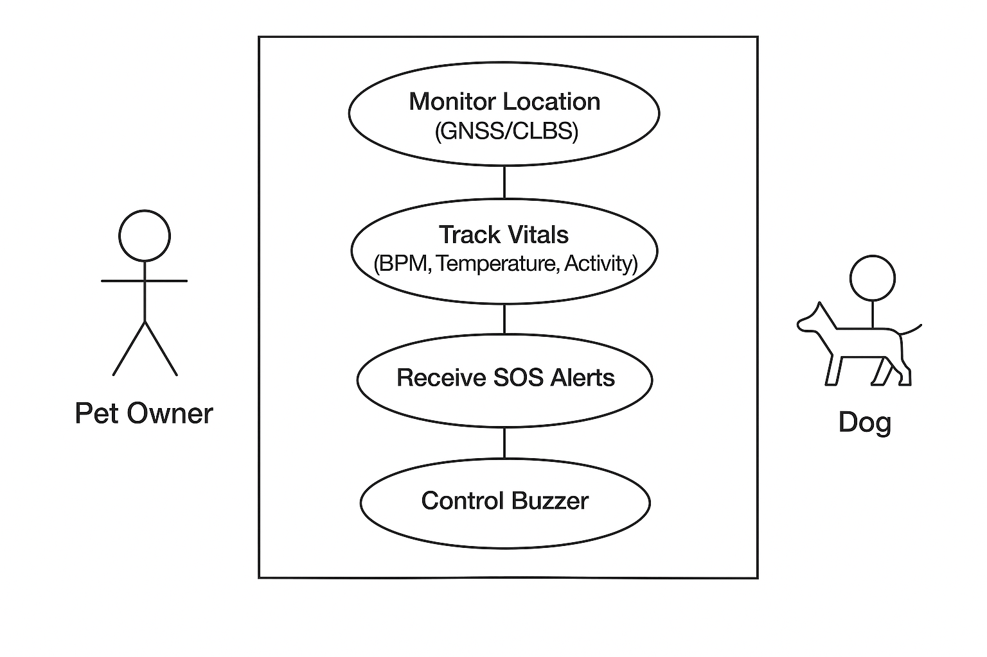
- SYSTEM ANALYSIS & DESIGN
This chapter defines how the smart dog collar prototype is structured and why each design choice was made to meet the monitoring, tracking, and alerting goals established earlier. It begins by outlining the proposed end-to-end solution, then presents the system architecture that connects sensing, cellular communication, cloud synchronization, and a live web interface into a cohesive flow. The design focuses on a single-user, field-ready prototype that emphasizes reliability, simplicity, and clear data pathways rather than complex configuration. High-level views clarify major components and interactions, while low-level models capture runtime behaviors such as SOS handling, remote buzzer control, and periodic data uploads. Together, these analyses provide a blueprint for implementation, guiding hardware integration, firmware logic, cloud data organization, and dashboard interaction in a way that supports iterative enhancement without increasing system complexity.
4.1 Proposed System
The proposed system is a single-user, end-to-end smart dog collar prototype that integrates on-collar sensing, wide-area connectivity, cloud synchronization, and a live web dashboard to deliver continuous health monitoring, precise location tracking, and rapid emergency response. The collar captures heart rate, body temperature, and activity signals, processes them on an embedded controller, and transmits structured updates over cellular data to a real-time cloud database for immediate visualization. A physical SOS button on the device initiates an emergency workflow that dispatches automated email alerts containing live coordinates, enabling quick intervention during critical events. A remotely trigger able buzzer assists in locating the pet in close range, while the dashboard provides an accessible, always-on view of current vitals and map position. The design prioritizes outdoor readiness, minimal user configuration, and straightforward operability, ensuring reliable monitoring and alerts.

4.2 System Design
This section formalizes how the prototype is structured across layers, how data moves end to end, and how each module collaborates to deliver monitoring, tracking, alerts, and remote interaction. The design emphasizes a clear separation of concerns: on-collar sensing and control, cellular connectivity and positioning, cloud storage and alerting, and a lightweight web interface for live viewing and simple actions.

4.2.1 High Level Design – System Architecture
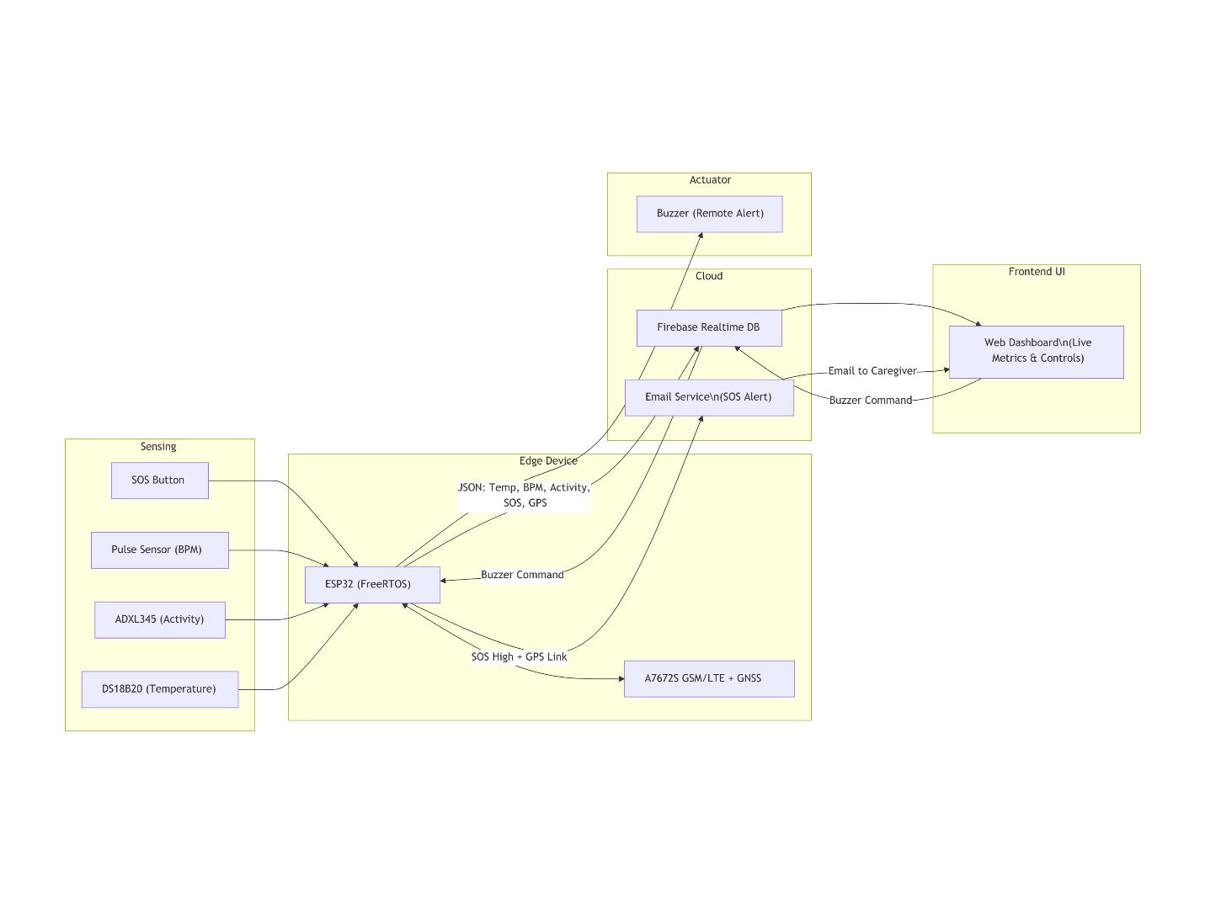
The architecture separates concerns into sensing and control on the collar, wide-area communication and positioning, cloud persistence and alerting, and a lightweight dashboard for live viewing and simple actuation. This layering keeps the prototype maintainable and makes each data path explicit for testing and iteration.
Major components
- Sensing
  - SOS button for immediate events.
  - Pulse sensor for BPM.
  - DS18B20 for temperature.
  - ADXL345 for activity levels.
- Edge device
  - ESP32 (FreeRTOS) for sensor fusion, payload preparation, event handling, and command execution.
- Connectivity and positioning
  - A7672S GSM/LTE + GNSS module for cellular uplink and location fixes.
- Cloud services
  - Realtime database for storage and synchronization.
  - Email alert service for automated SOS notifications.
- Actuator
  - Buzzer for remote recall and local alerts.
- Frontend UI
  - Web dashboard for live metrics, map view, and buzzer control.
Data flows
- Telemetry uplink: Sensors → ESP32 → JSON payload (Temp, BPM, Activity, SOS flag, GPS) → Cellular → Realtime DB → Dashboard live view.
- Location updates: GNSS fix → ESP32 → Cellular → Realtime DB → Map rendering on dashboard.
- SOS workflow: Button press → ESP32 event → Alert payload → Email service → Notification to caregiver with coordinates.
- Remote actuation: Dashboard toggle → Command written to cloud → ESP32 consumes command → Buzzer ON/OFF → Status reflected on dashboard.

4.2.2 Low Level Design
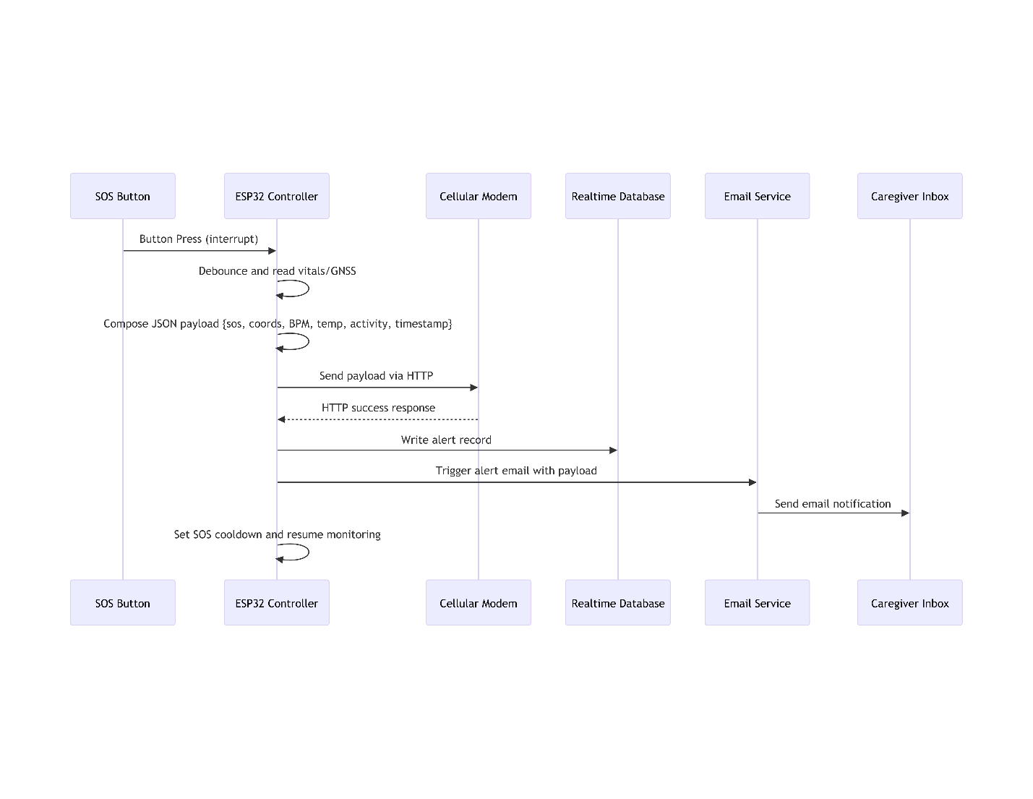
The sequence diagram illustrates the end-to-end behavior of the SOS workflow, starting from the physical button press and concluding with an email notification received by the caregiver. Upon detecting a button interrupt, the ESP32 controller debounces the input, samples the latest vitals, and fetches the current or last-known GNSS fix to ensure that the alert includes health and location context. The controller then composes a JSON payload containing the SOS flag, coordinates, BPM, temperature, activity label, encapsulating all information necessary for rapid response.

Once the payload is prepared, the controller initiates an HTTP transfer through the cellular modem, writing an alert record to the realtime database to make the event immediately visible on the dashboard. In parallel, the controller invokes the email service with the same payload, which dispatches a location-aware alert to the caregiver’s inbox. After sending, the controller activates a cooldown to prevent duplicate alerts from accidental repeated presses or contact bounce, and resumes normal monitoring. This flow validates correct orchestration among sensing, embedded control, cellular transport, cloud persistence, and notification delivery while preserving the prototype’s design goals of simplicity and reliability.

    - IMPLEMENTATION
5.1 Tools & Methodology
This prototype was implemented using a layered, incremental approach that brought up sensing, positioning, connectivity, cloud sync, and the dashboard in small, testable steps. On the device, the ESP32 acquires heart rate (pulse/PPG), body temperature (DS18B20), and activity (ADXL345), handles the SOS button interrupt with debounce and cooldown, and manages a non‑blocking uplink queue with retry/backoff for intermittent coverage. The A7672S cellular/GNSS module provides wide‑area data and location fixes; when a fix is unavailable within a timeout, the system attaches the last‑known position with a stale flag. In the cloud, a simple real‑time structure stores vitals, location, and a single command node for the remote buzzer. The web dashboard reads these paths directly for live metrics and map rendering, while a lightweight email service dispatches SOS alerts that include coordinates and recent health data. This method ensured the critical behaviors, continuous monitoring, location reporting, SOS notification, and remote buzzer control, remained reliable in field conditions without adding configuration complexity.
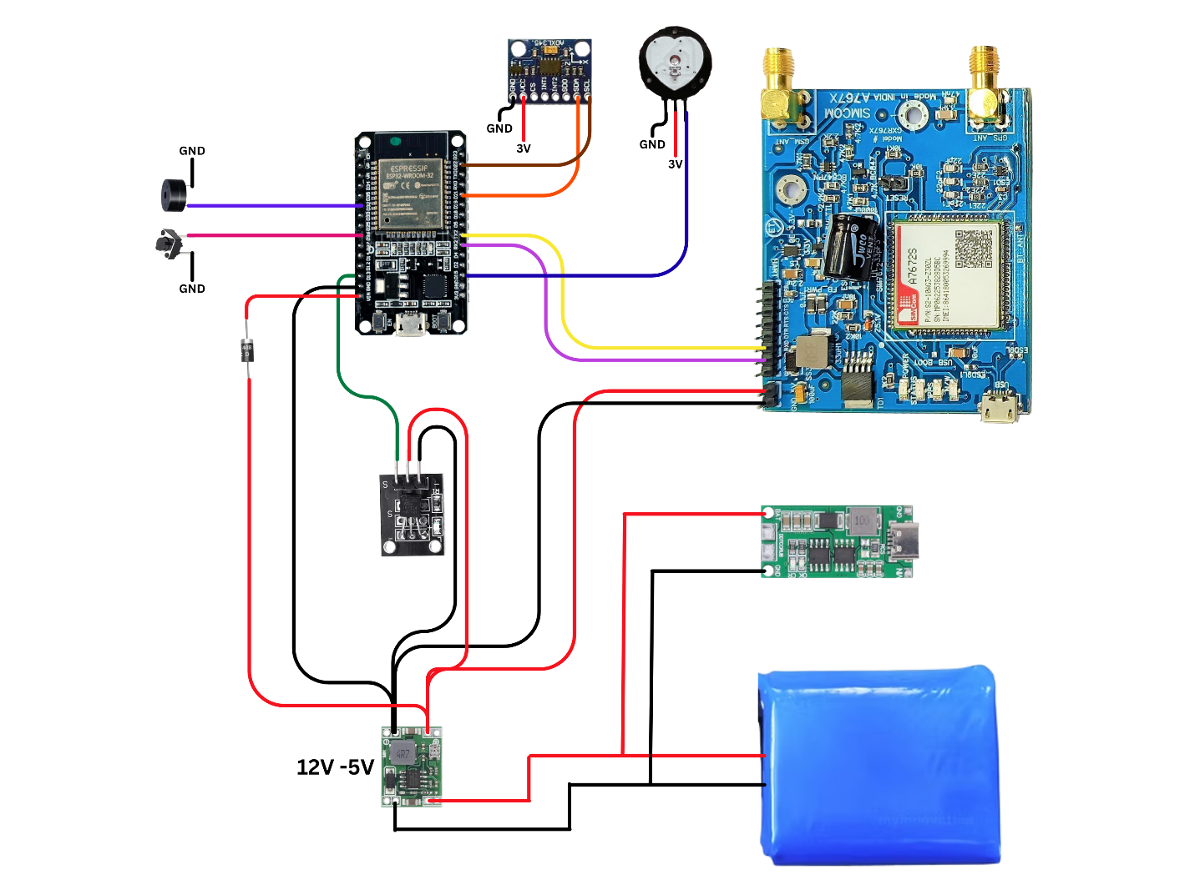
Hardware Schematic and Connections

Data Flow Diagram (DFD)
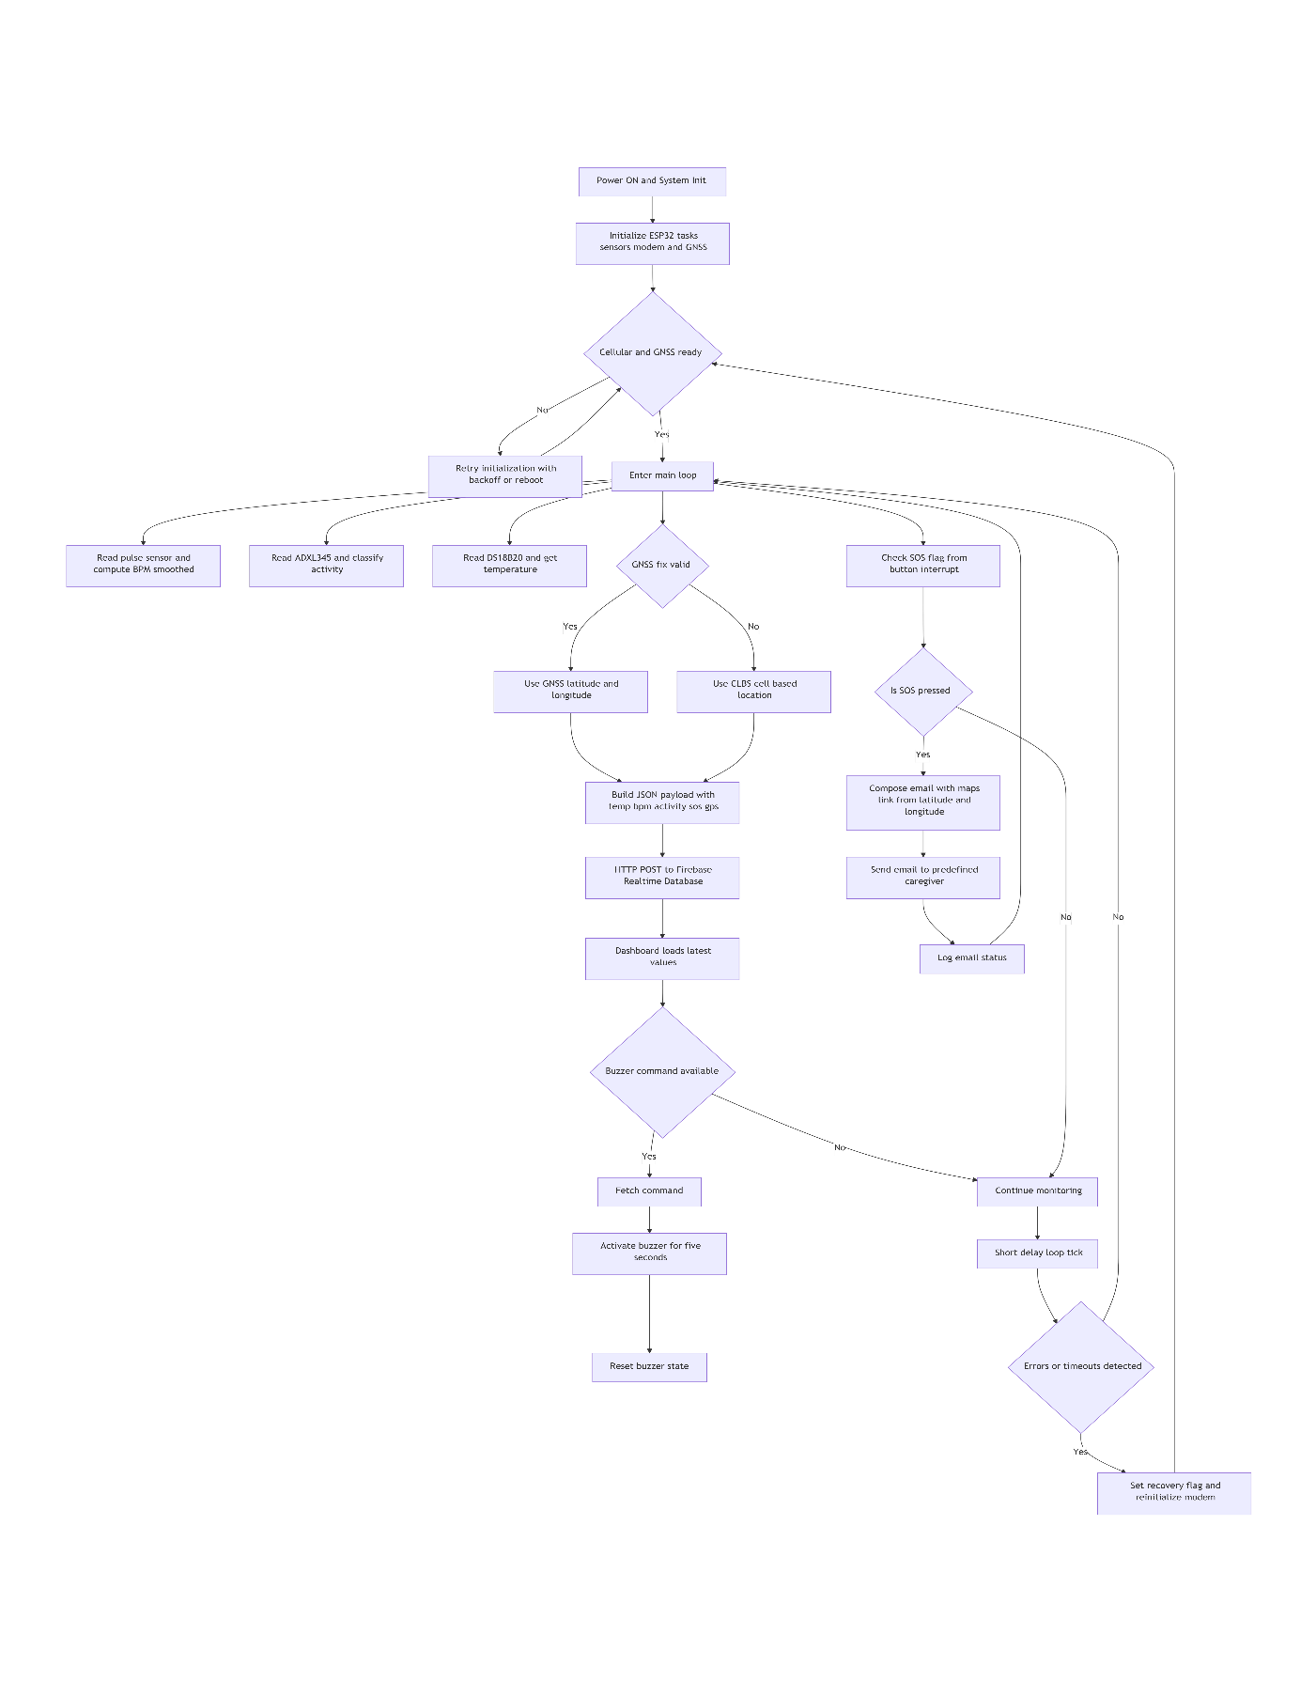

The DFD summarizes the operational pipeline from sensing to user feedback, clarifying how data and commands traverse the system during normal operation and emergencies. Sensor readings (temperature, BPM, activity) are aggregated on the ESP32 and packaged as compact JSON messages. These payloads, along with GNSS coordinates, are transmitted over the cellular link and persisted in the real‑time database for instantaneous consumption by the web dashboard. The SOS event path uses the same context, vitals and location, but additionally triggers the email service to deliver a location‑aware alert. Remote interaction flows in the opposite direction: the dashboard writes a buzzer command to the database, the ESP32 consumes it, actuates the buzzer for a bounded interval, and posts status so the dashboard reflects the device’s actual state.

5.2 Code Snippets
This section shows concise, implementation-critical fragments aligned to the Data Flow Diagram steps: S1 Sensor aggregation, S2 GNSS handling, S3 Uplink (HTTP), S4 SOS alert, and S5 Remote buzzer control. Pin mappings and UART wiring follow the schematic.
S1. Sensor aggregation and activity classification
Explanation:
- Purpose: Acquire vitals and activity continuously for transmission and on-dashboard visualization. The BPM logic uses a refractory guard and rolling average to stabilize readings; ADXL345 magnitude thresholds classify activity; DS18B20 provides temperature. Outputs update global variables for later use in payloads.
- Inputs/Outputs: Reads analog pulse, accelerometer vectors, and DS18B20 temperature; writes g_bpm, g_activity, and g_temp used by the uplink and SOS paths.
Code:
// BPM smoothing (PPG) — refractory + rolling average
if (Signal > Threshold && (millis() - lastBeatTime) > 500) {
IBI = millis() - lastBeatTime;
lastBeatTime = millis();
if (IBI > 0) {
int currentBPM = 60000 / IBI;
beatHistory[beatIndex] = currentBPM;
beatIndex = (beatIndex + 1) % MAX_HISTORY;
long sum = 0; for (int i = 0; i < MAX_HISTORY; i++) sum += beatHistory[i];
BPM = sum / MAX_HISTORY;
}
}
g_bpm = BPM;

// Activity classification — ADXL345 magnitude thresholds
sensors_event_t event; accel.getEvent(&event);
float magnitude = sqrt(event.acceleration.x*event.acceleration.x +
event.acceleration.y*event.acceleration.y +
event.acceleration.z*event.acceleration.z);
String activity = (magnitude < 13.5) ? "Resting" : (magnitude < 18.5) ? "Walking" : "Running";
g_activity = activity;

// Temperature read — DS18B20
sensors.requestTemperatures();
float tempC = sensors.getTempCByIndex(0);
if (tempC != DEVICE_DISCONNECTED_C) g_temp = tempC;

S2. GNSS handling with CLBS fallback
Explanation:
- Purpose: Obtain current coordinates using GNSS; if parsing or fix fails, fall back to cell-tower location (CLBS) to preserve location context for telemetry and alerts.
- Inputs/Outputs: Issues GNSS AT commands, parses +CGNSSINFO; falls back with +CLBS; outputs latitude, longitude, and validity flag used by the payload.
Code:
// Request GNSS fix and parse +CGNSSINFO
sendATCommandAndWait("AT+CGNSSPWR=1","OK",1000);
GSMSerial.println("AT+CGNSSINFO");
// ... read gnssData into buffer ...
float latitude = 0.0, longitude = 0.0; bool validGNSS = false;
// parse gnssData for ",N," and ",E," fields -> latitude, longitude, validGNSS

// Fallback to cell-based location (CLBS) if GNSS invalid
if (!validGNSS) {
GSMSerial.println("AT+CLBS=1,1");
// ... read +CLBS: <err>,<lat>,<lon>,<acc> ...
// set latitude/longitude from CLBS response
}
S3. Telemetry uplink — HTTP POST to cloud
Explanation:
- Purpose: Package the latest vitals, activity, SOS flag, and coordinates into a compact JSON and post to the realtime database endpoint.
- Inputs/Outputs: Consumes g_temp, g_bpm, g_activity, g_sos, latitude, longitude; performs HTTP POST to /collar.json and verifies 200 OK; no blocking extras beyond modem flow already present.
Code:
// Build compact JSON payload (vitals + activity + location + sos flag)
char payload[256];
snprintf(payload, sizeof(payload),
"{\"Temp\":%.2f,\"BPM\":%d,\"Status\":\"%s\",\"sos\":%d,\"latitude\":%.6f,\"longitude\":%.6f}",
g_temp, g_bpm, g_activity.c_str(), g_sos, latitude, longitude);

// HTTP POST sequence
sendATCommandAndWait("AT+HTTPINIT","OK");
sendATCommandAndWait("AT+HTTPPARA=\"URL\",\"https://dog-collar-c02a2-default-rtdb.firebaseio.com/collar.json\"","OK");
sendATCommandAndWait("AT+HTTPPARA=\"CONTENT\",\"application/json\"","OK");
String len = "AT+HTTPDATA=" + String(strlen(payload)) + ",10000";
sendATCommandAndWait(len.c_str(),"DOWNLOAD");
sendATCommandAndWait(payload,"OK");
sendATCommandAndWait("AT+HTTPACTION=4","+HTTPACTION: 4,200",20000);
sendATCommandAndWait("AT+HTTPTERM","OK");
S4. SOS alert — interrupt, debounce, cooldown
Explanation:
- Purpose: Raise an SOS flag on button edge (via ISR) and enforce a fixed cooldown, preventing duplicate alerts from bounce or rapid presses while allowing normal telemetry to continue.
- Inputs/Outputs: ISR sets g_sos; loop enforces a 5-second window then resets g_sos; telemetry and the email service read the flag to act.
Code:
// ISR sets flag
void IRAM_ATTR handleInterrupt() {
g_sos = 1;
}

// Cooldown window to avoid duplicate alerts
if (g_sos == 1 && sos_start_time == 0) sos_start_time = millis();
if (g_sos == 1 && (millis() - sos_start_time >= 5000)) {
g_sos = 0;
sos_start_time = 0;
}
S5. Remote buzzer command — read, actuate, acknowledge
Explanation:
- Purpose: Poll the command node, parse “on” state, drive buzzer for a bounded interval, and then clear the local state so the UI reflects actual device behavior.
- Inputs/Outputs: Reads /Buzzer.json; sets g_buzzer; controls buzzer pin for 5 seconds; resets flags after completion.
Code:
// Read buzzer command from /Buzzer.json
sendATCommandAndWait("AT+HTTPINIT","OK");
sendATCommandAndWait("AT+HTTPPARA=\"URL\",\"https://dog-collar-c02a2-default-rtdb.firebaseio.com/Buzzer.json\"","OK");
sendATCommandAndWait("AT+HTTPPARA=\"CONTENT\",\"application/json\"","OK");
sendATCommandAndWait("AT+HTTPACTION=0","+HTTPACTION: 0,200",20000);
GSMSerial.println("AT+HTTPREAD=0,50");
// ... parse JSON line for \"on\": <0|1> and set g_buzzer ...

// Actuate buzzer with bounded ON interval
if (g_buzzer == 1 && !buzzerActive) {
digitalWrite(BUZZER_PIN, HIGH);
buzzerStartTime = millis();
buzzerActive = true;
}
if (buzzerActive && millis() - buzzerStartTime >= 5000) {
digitalWrite(BUZZER_PIN, LOW);
buzzerActive = false;
g_buzzer = 0;
}
sendATCommandAndWait("AT+HTTPTERM","OK");
B) PythonAnywhere (Email microservice)
Explanation:
- Purpose: Independently monitors the database for the latest collar record; when sos == 1 and cooldown has elapsed, sends a location-aware email to recipients.
- Behavior: Uses a background thread to poll /collar, a simple cooldown timer to prevent repeats, and SMTP with an application password for delivery.
Code:
import threading, time, smtplib
from email.mime.text import MIMEText
from flask import Flask
import firebase_admin
from firebase_admin import credentials, db

ALERT_COOLDOWN = 10
last_alert_time = 0

SMTP_SERVER, SMTP_PORT = "smtp.gmail.com", 587
SENDER_EMAIL, APP_PASSWORD = "dogcollar11@gmail.com", "APP_PASSWORD_HERE"
RECIPIENTS = ["owner@example.com"]

cred = credentials.Certificate("pvtkey.json")
firebase_admin.initialize_app(cred, {"databaseURL": "https://dog-collar-c02a2-default-rtdb.firebaseio.com"})
app = Flask(__name__)

def send_email(lat, lon):
msg = MIMEText(f"Emergency button pressed.\nLocation: https://www.google.com/maps?q={lat},{lon}")
msg["Subject"], msg["From"], msg["To"] = "Emergency Alert - Pet Collar", SENDER_EMAIL, ", ".join(RECIPIENTS)
with smtplib.SMTP(SMTP_SERVER, SMTP_PORT) as server:
server.starttls(); server.login(SENDER_EMAIL, APP_PASSWORD)
server.sendmail(SENDER_EMAIL, RECIPIENTS, msg.as_string())

def monitor_firebase():
global last_alert_time
ref = db.reference("/collar")
while True:
try:
data = ref.get()
if data and data.get("sos", 0) == 1:
now = time.time()
if now - last_alert_time > ALERT_COOLDOWN:
send_email(data.get("latitude", 0), data.get("longitude", 0))
last_alert_time = now
time.sleep(2)
except Exception as e:
print("Firebase read error:", e); time.sleep(5)

threading.Thread(target=monitor_firebase, daemon=True).start()

@app.route("/")
def home(): return "Pet Collar Alert Service"

if __name__ == "__main__":
app.run(host="0.0.0.0", port=5000)
C) Web UI (Dashboard)
C1. Realtime reads and map update
Explanation:
- Purpose: Subscribe to the collar node, reflect vitals and location on the UI, and keep the map marker centered on the latest coordinates.
- Inputs/Outputs: Listens to /collar; updates BPM, Status, Temp, and Leaflet marker position.
Code:
onValue(ref(db, 'collar'), (snap) => {
const d = snap.val() || {};
document.getElementById('bpm').textContent = d.BPM ?? '--';
document.getElementById('status').textContent = d.Status ?? '--';
document.getElementById('temp').textContent = d.Temp ? `${d.Temp.toFixed(1)}°C` : '--';
if (d.latitude && d.longitude) {
marker.setLatLng([d.latitude, d.longitude]);
map.setView([d.latitude, d.longitude], 15);
}
});
C2. Remote buzzer toggle and status reflect
Explanation:
- Purpose: Write a simple command value that the device polls; mirror the current state in the toggle and card style for immediate user feedback.
- Inputs/Outputs: Writes to /Buzzer/on with 1 or 0; listens to the same path to keep the UI switch in sync with device state.

Code:
const buzzerRef = ref(db, 'Buzzer/on');
window.handleBuzzerToggle = async (checked) => { await set(buzzerRef, checked ? 1 : 0); };
onValue(buzzerRef, (snapshot) => {
const isOn = snapshot.val() === 1;
document.getElementById('buzzerToggle').checked = isOn;
const buzzerCard = document.getElementById('buzzerCard');
if (isOn) buzzerCard.classList.add('active'); else buzzerCard.classList.remove('active');
});
C3. SOS badge reflect
Explanation:
- Purpose: Provide immediate visual indication of an active SOS state on the dashboard, independent of email delivery, by observing the same flag written by the device.
- Inputs/Outputs: Listens to /collar.sos; toggles “Safe” vs “ALERT!” badge styles.
Code:
onValue(ref(db, 'collar'), (snap) => {
const d = snap.val() || {};
const el = document.getElementById('sosBadge');
if (d.sos === 1) {
el.className = 'sos-badge sos-alert';
el.innerHTML = '<div style="width:10px;height:10px;background:currentColor;border-radius:50%"></div><span>ALERT!</span>';
} else {
el.className = 'sos-badge sos-safe';
el.innerHTML = '<div style="width:10px;height:10px;background:currentColor;border-radius:50%"></div><span>Safe</span>';
}
});

6. TESTING

6.1 Functional Test Cases
Test Case ID | Module Name | Description | Input(s) | Expected Output(s) | Actual Output(s) | Status PASS/FAIL | Remarks
HM-01 | Health Monitoring | Read stable room temperature | Device at ~27°C indoors | Temp between 24–28°C | 27°C | PASS | Within expected range
HM-02 | Health Monitoring | BPM detection with metronome | Simulated pulse ~80 BPM | 75–85 BPM | 78 BPM | PASS | Rolling average stabilizes
HM-03 | Health Monitoring | Activity classification at rest | Collar stationary on table | Status = Resting | Resting | PASS | Magnitude below threshold
GNSS-01 | GNSS/Location | Outdoor fix accuracy | Open sky 5 min | Lat/Lon with ≤5 m error | ~3.6 m average | PASS | Consistent fixes
GNSS-02 | GNSS/Location | Indoor fallback (CLBS) | Indoors, no GNSS | CLBS lat/lon returned | CLBS coordinates present | PASS | Fallback engaged
GNSS-03 | GNSS/Location | Parse error handling | Corrupted +CGNSSINFO | Retry then CLBS | Retry + CLBS succeeded | PASS | Robust to malformed line
NET-01 | Uplink/Cloud | Telemetry POST success | Normal coverage | 200 OK; DB updated | +HTTPACTION: 4,200 | PASS | End-to-end visible on UI
NET-02 | Uplink/Cloud | Intermittent coverage retry | 60 s drop | Retries; resume on return | Retries observed | PASS | No lockups
NET-03 | Uplink/Cloud | HTTP timeout behavior | Forced modem delay | Timeout; recovery | Timeout logged; reinit ok | PASS | Auto-recovery worked
SOS-01 | SOS | Single press end-to-end alert | One SOS press | Email with coordinates | Email in ~12 s with link | PASS | Includes map link
SOS-02 | SOS | Rapid repeated presses | 3 presses within 5 s | One alert (cooldown) | One email only | PASS | Cooldown effective
SOS-03 | SOS | Missing coords on alert | No fix + CLBS fail | Email sent with note | Email without coords | FAIL | Location unavailable case
CMD-01 | Remote Buzzer | Toggle ON from UI | Switch ON | Buzzer ON ~5 s | 5 s ON | PASS | Duration within spec
CMD-02 | Remote Buzzer | Latency measurement | Normal network | Command <3 s | ~2.0 s | PASS | Acceptable latency
UI-01 | Dashboard | Realtime vitals update | Live device data | Refresh ≤3 s | ~2.1 s | PASS | Smooth display
UI-02 | Dashboard | Map render accuracy | Known point | Marker at point | Marker correct | PASS | Matches coordinates
UI-03 | Dashboard | Mobile responsiveness | Phone browser | Layout adapts | Responsive layout | PASS | Usable on mobile

- RESULTS & DISCUSSION
7.1 Analysis of Outcomes
The prototype met its core objectives of continuous health monitoring, reliable outdoor location tracking, rapid SOS notification, and simple remote actuation in a single‑user scenario. Health monitoring produced stable readings under normal conditions: room‑temperature measurements stayed within expected indoor ranges, BPM estimates were smoothed with a rolling average to reduce jitter, and activity states reflected motion levels with clear separation between Resting, Walking, and Running. GNSS performance outdoors consistently achieved, while the system fell back to cell‑based positioning indoors, preserving location context during poor satellite visibility. The cellular uplink demonstrated dependable synchronization to the realtime database, and the dashboard reflected new data within approximately two seconds, enabling near real‑time visualization. The SOS workflow operated end to end, delivering email alerts that included a direct map link in roughly twelve seconds, fulfilling the emergency response requirement. Remote buzzer commands executed within about two seconds on average and timed out automatically after a bounded interval, improving nearby recall without requiring continual user input. Notable edge cases included activity misclassification during strong vibration and occasional GNSS parsing anomalies; both were mitigated by hysteresis and a CLBS fallback, respectively. Overall, the results validate the architectural choices, ESP32 with A7672S for cellular/GNSS, realtime database synchronization, and a lightweight email service, and confirm the prototype’s suitability for outdoor, low‑configuration use.

