# **Non-Disclosure Agreement**

This Non-Disclosure Agreement ("Agreement") is made and entered into as of 17-Apr-2024, between **Aasma Technology Solutions**, located at 4D-2, Balaji Agora, Behind Agora Mall, Sughad, Gandhinagar, Gujarat – 382424, India, and Jemil Dharia, referred now onwards as ‘Consultant’ with a permanent address and contact details at B-56, Naginawadi society, Surat , [dhariajemil@gmail.com](mailto:dhariajemil@gmail.com) , +91 9662626000

**1. Confidential Information:**

"Confidential Information" shall mean all non-public information disclosed by either party ("Disclosing Party") to the other party ("Receiving Party"), whether orally or in writing, that is designated as confidential or that reasonably should be understood to be confidential given the nature of the information and the circumstances of disclosure. Confidential Information shall include, but not be limited to, business plans, customer lists, software, technology, processes, trade secrets, financial information, and any other information disclosed by the Disclosing Party to the Receiving Party.

**2. Obligations of Receiving Party:**

The Receiving Party agrees to:

(a) Hold all Confidential Information in strict confidence and take all reasonable precautions to protect the confidentiality of such information.

(b) Not disclose, or permit to be disclosed, any Confidential Information to any third party without the prior written consent of the Disclosing Party.

(c) Use the Confidential Information only for the purpose of fulfilling the Receiving Party's obligations under any agreement between the parties and for no other purpose.

(d) Limit access to the Confidential Information to employees, contractors, or agents of the Receiving Party who have a need to know such information for the purposes described herein and who are bound by written confidentiality obligations at least as restrictive as those set forth in this Agreement; and

(e) Immediately notify the Disclosing Party in writing of any unauthorized disclosure, use, or loss of Confidential Information.

**3. Government ID Requirement:**

The Consultant agrees to provide a valid government-issued identification document along with signing this NDA for verification purposes. <One Government ID proof will suffice>

**4. Non-Compete Clause:**

The Consultant agrees that for a period of one (1) year following the date of separation from Aasma Technology Solutions, the Consultant will not directly engage or contract with any client or prospective client of Aasma Technology Solutions, nor will the Consultant directly or indirectly solicit, entice, or encourage any client or prospective client of Aasma Technology Solutions for business.

**5. Exceptions:**

The obligations of confidentiality set forth in this Agreement shall not apply to any information that:

(a) Is or becomes publicly available through no fault of the Receiving Party.

(b) Is rightfully known to the Receiving Party without restriction on use or disclosure prior to its receipt from the Disclosing Party.

(c) Is rightfully disclosed to the Receiving Party by a third party without restriction on use or disclosure; or

(d) Is independently developed by the Receiving Party without reference to or use of the Confidential Information.

**6. Term and Termination:**

This Agreement shall be effective as of the date first written above and shall continue in effect until unless earlier terminated by either party upon thirty (30) days prior written notice. Upon termination of this Agreement, the Receiving Party shall promptly return or destroy all Confidential Information received from the Disclosing Party, including all copies, notes, or extracts thereof.

**7. Governing Law:**

This Agreement shall be governed by and construed in accordance with the laws of jurisdiction of the courts in Ahmedabad, Gujarat, India, without giving effect to any choice of law or conflict of law provision.

**8. Entire Agreement:**

This Agreement constitutes the entire understanding between the parties concerning the subject matter hereof and supersedes all prior agreements, negotiations, and discussions, whether oral or written, between the parties concerning the subject matter hereof.

IN WITNESS WHEREOF, the parties hereto have executed this Agreement as of the date first above written.

**Aasma Technology Solutions**

Signature: 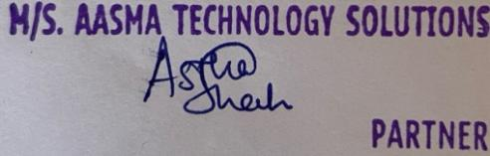

Name: Astha Shah

Date: 17-Apr-2024

**Consultant**

Signature: _______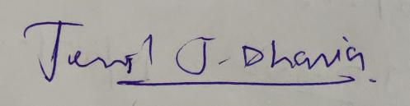_______________________________

Name: Jemil Dharia

Date: 29-Apr-2024