Software Requirements Specification

for

Railway Reservation System

Version 1.0 approved

Prepared by Sahaj Bhadja

Pandit Deendayal Energy University

October 17, 2022

Table of Contents

1. Introduction 1

1.1 Purpose 1

1.2 Document Conventions 1

1.3 Intended Audience and Reading Suggestions 1

1.4 Product Scope 1

2. Overall Description 2

2.1 Product Functions 2

2.2 User Classes and Characteristics 2

2.3 Operating Environment 2

2.4 Design and Implementation Constraints 3

2.5 User Documentation 3

2.6 Assumptions and Dependencies 3

3. External Interface Requirements 3

3.1 User Interfaces 3

3.2 Hardware Interfaces 4

3.3 Software Interfaces 4

3.4 Communications Interfaces 4

4. System features 4

5. Nonfunctional Requirements 4

6. Diagrams 6

6.1 Use Case Diagram: 6

6.2 Class Diagram: 6

6.3 Activity Diagram: 7

6.4 Sequence Diagram: 9

6.5 E-R Diagram: 10

Revision History

|  |  |  |  |
| --- | --- | --- | --- |
| **Name** | **Date** | **Reason For Changes** | **Version** |
| Railway reservation | 14-1-2022 | Could insert tatkal booking | Version 1.0 |

# Introduction

## Purpose

The document specifies the software requirements for a Railway reservation. The product is version 2.0 of the software ‘Railway reservation’. The system will book tickets for the passengers and will help to issuing the e-tickets. The software is for railway institutes like IRCTC. The document gives the detailed description of the both functional and non-functional requirements proposed by the client. The purpose of this project is to provide a friendly environment to maintain the details of the passengers and for the quick services provided to them. The main purpose of this project is to maintain easy circulation system using computers and to provide different reports.

## Document Conventions

* Convention for main title
* Font face: Arial
* Font style: Bold
* Font size: 20
* Convention for sub-title
* Font face: Arial
* Font style: Bold
* Font size: 16
* Convention for body
* Font face: Arial
* Font size: 12

## Intended Audience and Reading Suggestions

The document is intended for end users to understand the basic technologies being used. Also, the developers, project managers and testers can use the document as a guide for the workflow.

The document contains the purpose of the product, it’s functional and non-functional requirements and its implementation workflow.

It is suggested for the end users to read the purpose first and focus over the product’s functionality specifications. The technical team should priorly focus on the software-hardware requirements and then moved towards the purpose of the product.

## Product Scope

The Railway Reservation System is a tool for online ticket purchasing. Any customer may purchase tickets for various trains. Only available tickets can be reserved by the customer. The customer first looks up the availability of tickets, and if any are, he then books them by first filling out a form. I-ticket and e-ticket booking are the two methods available for purchasing tickets. In the case of i-ticket booking, customers can purchase tickets online and have them delivered by courier to a specific customer's address. However, when purchasing and cancelling e-tickets online, the client must print the ticket themselves. In both situations, the cost of the tickets is withdrawn from the customer's account.

# Overall Description

The product is the upgraded system for an existing Railway Booking in online mode, where a passenger can book tickets online and can issue a ticket by paying the charges of the tickets. The cancelation could also be done where the refund can be availed to the customer in the online mode only where the tickets status in a particular train could be shown and even the waiting list could also be displayed.

## Product Functions

User login:

* Login for Railway Admin Staff
* Login for Passengers

Formation of database:

* Train information
* Passenger information
* Availability

Payment and ticket issuing:

* Payment methods
* Identity confirmation
* E-Tickets issuing

## User Classes and Characteristics

The users of the product are:

* Railway Admin: The database will be managed by the admin displaying all the train details and the availability as well as the waiting list of all the trains and updating the train seats and others details accordingly.
* Passengers: Booking of the train tickets. Updating the user details and download the train tickets.

## Operating Environment

The software will be operated as a Web based application. It will work on any Chromium-based browsers, such as Google Chrome, Microsoft Edge, DuckDuckGo, Yahoo. Also, it will work on any Windows, Linux or MacOS operating system.

* Hardware platform:
* A device like mobile phone / laptop / pc with minimum 4 GB ram for smooth functioning having an internet access.

## Design and Implementation Constraints

The software stores the data of the users, this data should be protected as per the regulatory policies. Also, the software requires a qualitative web cam, for which 1080p is a fairly standard resolution, but if you really want to up your picture quality (or be able to crop your frame and keep it sharp), you will need a 4K webcam.

Technologies used:

Build With - Python 3.8

Module Used for App - Java, Flutter, React Native

Module Used for Website – Mongo DB, Express JS, Node JS, React , HTML, CSS, JavaScript

## User Documentation

The documentation for using Flutter modules:

https://docs.flutter.dev/

## Assumptions and Dependencies

The web-app works on Chromium Based Browsers like Chrome and Microsoft Edge. It is assumed that the user uses the latest versions available for the browser and has a web cam access. Since it is a web-based application, internet access is required.

# External Interface Requirements

## User Interfaces

The software provides good graphical interface for the Passenger and the Railway admin can operate on the system, performing the required task such as update, viewing, book ,etc the details of the Trains. 

* It allows user to view quick reports for particular time.
* It provides seats verification and search facility based on different criteria.
* The user interface must be customizable by the administrator
* All the modules provided with the software must fit into this graphical user interface and accomplish to the standard defined
* The design should be simple and all the different interfaces should follow a standard template
* The passengers’ interface should be able to interact with the Admin’s module and a part of the interface must be dedicated to the login/logout module

## Hardware Interfaces

The software can be used on any compatible browser from a device like mobile/pc/ laptop. 4 GB of Ram is suggested for the device for smooth functioning. The software requires a 4G internet connection that can be accessed from a browser.

## Software Interfaces

This software package is developed using HTML, CSS, JavaScript as front end. MySQL as the back end to store the database.

Operating System: Windows XP, windows 7 and higher versions. Language: HTML, CSS, JavaScript, PHP

Database: MySQL

## Communications Interfaces

* Indian Railway’s web-site, www.indianrail.gov.in offers PRS enquiries on the internet Berth/Seat availability, Passenger Status, Fare, Train Schedule etc,.
* National Train Enquiry System (NTES) website, www.trainenquiry.com gives dynamic information about the running status of any train and its expected arrival/departure at any given station.
* Mobile telephone based SMS enquiry service. A new mobile phone based facility for rail users’

# System features

1. Allow the Admin to add and update new trains and the current train details.
2. Allow the passenger to search for train based on name, Source and destination, date, etc., and find their availability for the seats in the train.
3. Users can request, reserve, or cancel a train ticket.
4. The system should notify the passenger and admin about times of the particular train as per the requirement and update the database accordingly.
5. The system calculates the charges if the passenger cancels the tickets after the confirmation time gets over.

# Nonfunctional Requirements

1. **Usability**

* Use of captcha and encryption to avoid bots from booking tickets
* Search results should populate within acceptable time limits
* User should be helped appropriately to fill in the mandatory fields, incase of invalid input
* System should accept payments via different payment methods, like PayPal, wallets, cards, vouchers, etc
* System should visually confirm as well as send booking confirmation to the user's contact

1. **Accuracy**

Accuracy is another important non-functional requirement for the Railway reservation system. The data stored about the trains and the fines calculated on cancellation should be correct, consistent, and reliable for the passenger.

1. **Availability**

The System should be available for 24x7 and must be recovered within few hour or less if it fails. The system should respond to the requests within one second or less.

1. **Maintainability**

The software should be easily maintainable and adding new features and making changes to the software must be as simple as possible. In addition to this, the software must also be portable.

1. **Safety Requirement**

The database may get crashed at any certain time due to virus or operating system failure. Therefore, it is required to take the database backup so that the database is not lost and the safety must be provided for the passenger details as the banking details and the other information’s protection of the user could be a problem if the system got hacked.

# Diagrams

## Use Case Diagram:

## Class Diagram:

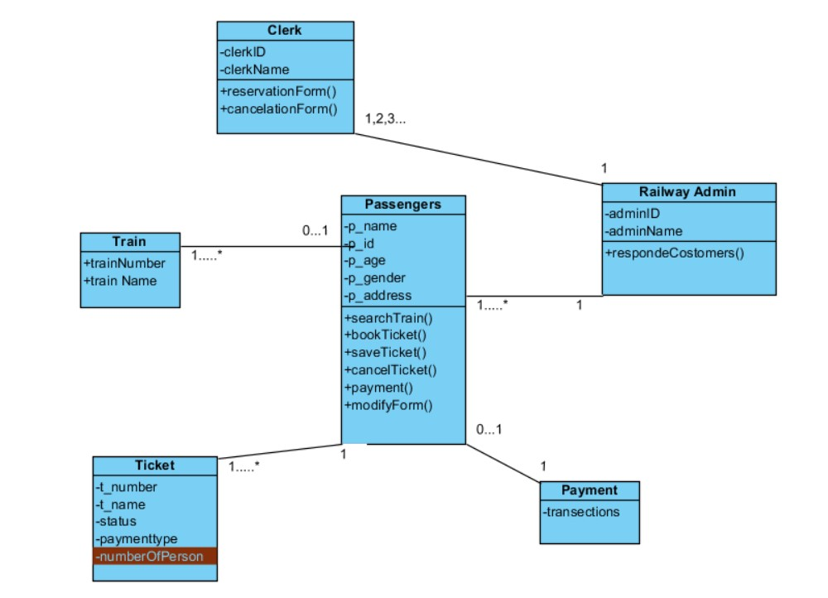

## Activity Diagram:

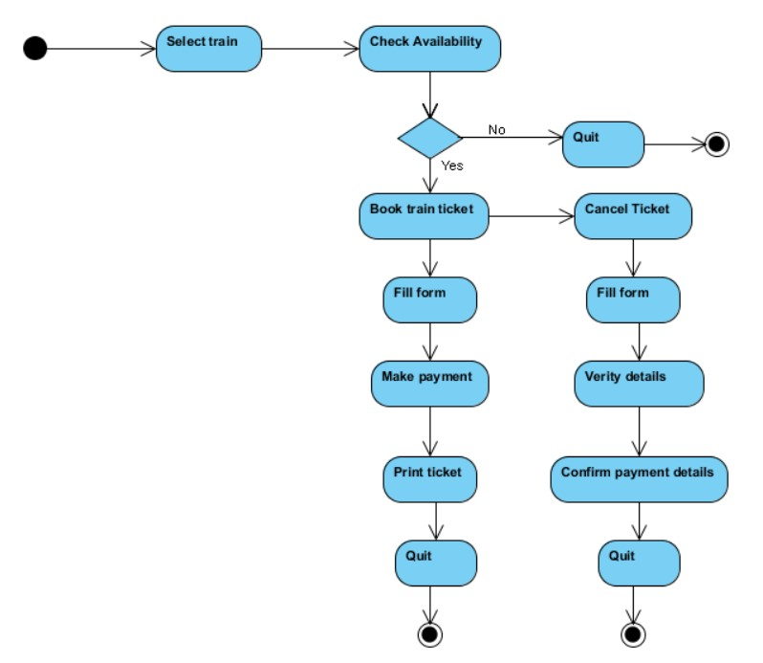

## Sequence Diagram:

## E-R Diagram: