

GOVERNMENT POLYTECHNIC PALANPUR

Department of IT Engineering

A PROJECT REPORT ON

SMART ATTENDANCE SYSTEM
A Role-Based Attendance Management System

Submitted in Partial Fulfillment of the Requirements for the

Diploma in IT Engineering
(6th Semester)

Subject: Software Development | Academic Year: 2025–2026

Submitted By:

PRAJAPATI DIXIT K.
Enrollment No.: 236260316028
6th Semester | Academic Year: 2025–2026

Under the Guidance of: Prof. Chinkal Khadadiya Department of IT Engineering Government Polytechnic Palanpur

DECLARATION

I, Prajapati Dixit K., student of Diploma in IT Engineering, Semester 6th, Enrollment Number 236260316028, Government Polytechnic Palanpur, hereby declare that the project report entitled:

"SMART ATTENDANCE SYSTEM"
A Role-Based Attendance Management System
submitted in partial fulfillment of the requirements for the subject Mobile Application Development is my own original work. This project has been carried out under the guidance of Prof. Chinkal Khadadiya, Department of IT Engineering, Government Polytechnic Palanpur.

I further declare that:
- This work has not been previously submitted to any other institution or university for the award of any certificate, diploma, or degree.
- All information and content presented in this report are based on genuine research and development work carried out by me.
- Wherever the work of others has been referred to, full and proper credit has been given through references and citations.
- This report presents a truthful and accurate account of the work performed during the project.
- No part of this report has been copied from any other student's work or from any published source without proper acknowledgment.

Place: Palanpur  Date: | Signature of Student:  D.K.Prajapati.  Enrollment No.: 236260316028

i

GOVERNMENT POLYTECHNIC PALANPUR
Department of IT Engineering

CERTIFICATE
This is to certify that the project report entitled:

"SMART ATTENDANCE SYSTEM"
A Role-Based Attendance Management System
has been prepared and submitted by Prajapati Dixit K. (Enrollment No.: 236260316028) as a partial fulfillment of the requirement for the subject Software Development of Diploma in IT Engineering, Semester 6th, at Government Polytechnic Palanpur, during the academic year 2025-2026.

The project has been carried out under my guidance and supervision. To the best of my knowledge and belief, this work is original and has not been submitted to any other institution or university for the award of any certificate or diploma.

The project fulfills the requirements as per the regulations of this institution, and in my opinion, it meets the necessary standards for submission.

Signature of Guide:  Prof. Chinkal Khadadiya Professor, Department of IT Govt. Polytechnic Palanpur  Date: | Head of Department: Department of IT Engineering Govt. Polytechnic Palanpur Date:

ii

ABSTRACT

The Smart Attendance System is a comprehensive mobile-based application developed to streamline and automate attendance management activities at educational institutions. The system addresses the major problems found in traditional manual processes, such as proxy attendance fraud, time-consuming manual calculations, lack of real-time visibility for students, and inefficient leave management workflows.

This application is built using React Native with Expo framework for cross-platform mobile deployment on both iOS and Android, a Node.js Express backend for RESTful API services, and MongoDB for cloud database management with MongoDB Role-Based Access Control. A key feature of the system is its Role-Based Access Control (RBAC) mechanism, which defines separate dashboards and access permissions for three distinct user roles: Faculty, Student, and HOD/Administrator.

The system incorporates seven major functional modules: User Authentication with JWT security, Role-Based Access Control, Real-time Attendance Marking with 3-Day Edit Window enforcement, Subject and Student Management, Leave Application and Approval System, Digital Attendance Reports with PDF generation, and an integrated AI Help Agent for contextual user guidance.

The 3-day edit window mechanism is the most critical security feature of this project. It enforces a server-side rule using database UTC time that prevents retrospective manipulation of historical attendance records while allowing legitimate corrections within three business days. This is enforced at the MongoDB database level through RBAC UPDATE policies, ensuring it cannot be bypassed through API manipulation.

Testing results demonstrate a 99.35% pass rate across 155 defined test cases, with average API response times below 500 milliseconds for all standard operations. User acceptance testing with 5 faculty and 25 students achieved an overall satisfaction rating of 4.45 out of 5.0, with faculty reporting time savings of 5–7 minutes per class session.

Keywords: React Native, Expo, Node.js, MongoDB, JWT Authentication, RBAC, MongoDB Role-Based Access Control, Antigravity, 3-Day Edit Window, Real-time Attendance, Leave Management, AI Help Agent, Glassmorphism UI.

iii

ACKNOWLEDGEMENT

I take this opportunity to express my deep sense of gratitude and sincere thanks to all those who have contributed to the successful completion of this project report.

First and foremost, I extend my heartfelt thanks to my project guide, Prof. Chinkal Khadadiya, Professor, Department of IT Engineering, Government Polytechnic Palanpur, for her constant guidance, valuable suggestions, and encouragement throughout the development of this project. Her constructive feedback and patient support were instrumental in shaping this work into its final form.

I am sincerely grateful to the Head of the Department of IT Engineering, Government Polytechnic Palanpur, for providing the necessary academic resources, infrastructure, and moral support required to complete this project. The department's emphasis on practical, real-world learning gave me the confidence to undertake this full-stack mobile application development project.

I extend my thanks to all the faculty members and teaching staff of the Department of IT Engineering, whose lectures, guidance during laboratory sessions, and technical knowledge provided the academic foundation required for this work.

Finally, I acknowledge the valuable contributions of the open-source community — the developers of React Native, Expo, Node.js, MongoDB, Antigravity, and the many libraries used in this project. Their publicly available documentation and resources were invaluable references throughout the development process.

Place: Palanpur  Date: | Prajapati Dixit K.  Enrollment No.: 236260316028 6th Semester, IT Department

Iv

TABLE OF CONTENTS

CHAPTER 1 — INTRODUCTION 1
  - Introduction 1
  - Background 2
  - Problem Statement 2
  - Objectives of the Project 3
  - Scope of the Project 4
  - Motivation 4
  - Report Organization 5
CHAPTER 2 — SYSTEM OVERVIEW 6
  - Existing System 6
  - Limitations of Existing System 7
  - Proposed System 8
  - Comparison: Existing vs Proposed System 9
  - Advantages of Proposed System 9
CHAPTER 3 — SYSTEM ARCHITECTURE 10
  - Overall System Design 10
  - Technology Stack Selection 10
  - Frontend Architecture 11
  - Backend Architecture 12
  - Database Design 13
CHAPTER 4 — MODULES DESCRIPTION 15
  - User Authentication Module 15
  - Role-Based Access Control Module 17
  - Attendance Marking & 3-Day Edit Window 18
  - Student Management Module 20
  - Leave Management Module 20
  - Reports and PDF Generation 21
  - AI Help Agent 21
CHAPTER 5 — IMPLEMENTATION 22
  - Development Environment 22
  - Frontend Implementation 22
  - Backend Implementation 24
  - JWT Authentication Implementation 24
  - 3-Day Edit Window Implementation 25
  - Sample API Request and Response 26
CHAPTER 6 — TESTING 28
  - Testing Strategy 28
  - Functional Testing 28
  - Role-Based Access Testing 30
  - Performance Testing 30
  - Overall Test Summary 31
CHAPTER 7 — RESULTS AND DISCUSSION 32
  - System Screenshots 32
  - Performance Results 52
  - Comparison with Existing System 52
  - Discussion 53
CHAPTER 8 — CONCLUSION AND FUTURE WORK 54
  - Conclusion 54
  - Future Enhancements 56
  - Final Remarks 57
REFERENCES 58
APPENDIX A — INSTALLATION AND SETUP GUIDE 60
APPENDIX B — DATABASE SCHEMA 62
APPENDIX C — TROUBLESHOOTING GUIDE 63

v

LIST OF FIGURES

Figure No. | Title | Page
Figure 7.1 | Sign In Screen — Attendance Portal | 32
Figure 7.2 | Student Dashboard — Overall Attendance & Calendar | 34
Figure 7.3 | Student Dashboard — Quick Actions & Subject Performance | 36
Figure 7.4 | Attendance Summary — Semester 1 Subject Breakdown | 38
Figure 7.5 | Subject Report — Python Attendance Timeline | 40
Figure 7.6 | Daily Report — Date-wise Attendance Detail | 42
Figure 7.7 | My Profile — Student Information Screen | 44
Figure 7.8 | Leave Application — Medical Leave with Calendar | 46
Figure 7.9 | Faculty Dashboard — Welcome Card & Date Calendar | 48
Figure 7.10 | Faculty Dashboard — Services & Management | 50
Figure 7.11 | Select Subject — Semester 1 with Completion Status | 52
Figure 7.12 | Mark Attendance — New Session (Python) | 54
Figure 7.13 | Mark Attendance — Locked Record with Edit Request | 56
Figure 7.14 | Student List — Faculty View | 58
Figure 7.15 | Leave Requests — Faculty Approval View | 60
Figure 7.16 | AI Help Agent — Faculty Portal
Figure 7.17 | Admin Dashboard — System Overview | 64
Figure 7.18 | HOD Dashboard — Leave Requests Timeline

Figure No. | Title | Page
Figure 7.19 | HOD Review Inbox — Late Edit Approval | 68
Figure 7.20 | Subjects Master Management — HOD View | 70

vi

LIST OF TABLES

Table No. | Title | Page
Table 2.1 | Limitations of Existing System | 7
Table 2.2 | Comparison: Existing vs Proposed System | 9
Table 3.1 | Technology Stack Comparison | 11
Table 4.1 | Role-Based Permission Matrix | 18
Table 4.2 | Timetable Slot / Attendance Configuration | 19
Table 5.1 | Frontend Technology Stack | 23
Table 5.2 | Backend Technology Stack
Table 6.1 | Functional Test Cases — Authentication
Table 6.2 | 3-Day Edit Window Test Cases
Table 6.3 | Role-Based Access Test Results | 30
Table 6.4 | API Performance Test Results | 31
Table 6.5 | Overall Test Summary | 31
Table 7.1 | Comparison with Existing System | 53

vii

LIST OF ACRONYMS

Abbreviation | Full Form
RBAC | Role-Based Access Control
JWT | JSON Web Token
RBAC | MongoDB Role-Based Access Control
API | Application Programming Interface
REST | Representational State Transfer
HTTP | HyperText Transfer Protocol
HOD | Head of Department
SPA | Single Page Application
CORS | Cross-Origin Resource Sharing
MVC | Model-View-Controller
UI | User Interface
UX | User Experience
OTA | Over-the-Air Update
SDK | Software Development Kit
JSON | JavaScript Object Notation
UUID | Universally Unique Identifier
PDF | Portable Document Format
FAB | Floating Action Button
AI | Artificial Intelligence
IT | Information Technology

viii

CHAPTER 1 — INTRODUCTION

INTRODUCTION
The rapid advancement of mobile technology has transformed almost every sector of society, and education is no exception. Educational institutions today handle a wide variety of administrative and academic processes — from recording daily attendance and managing student leaves to distributing notices and generating performance reports. When these processes are managed manually, they become time-consuming, error-prone, and difficult to scale.

The Smart Attendance System is a comprehensive mobile-based platform designed to address these challenges by providing a centralized, digital solution for attendance management. This application integrates multiple functions into a single unified system, enabling seamless collaboration between Faculty, Students, and HOD/Administrators through role-specific dashboards and real-time data synchronization.

The system is built using React Native with Expo — a widely adopted modern framework for cross-platform mobile development — combined with Node.js Express for backend API services and MongoDB for cloud database management with MongoDB Role-Based Access Control. This technology combination allows for consistent use of JavaScript across both the frontend and backend, which simplifies development and ensures efficient performance.

BACKGROUND
Educational institutions, especially polytechnic colleges, manage a large volume of attendance-related data on a daily basis. This includes attendance records for multiple semesters and subjects, faculty schedules, student leave applications, and departmental reports. In most government polytechnic colleges, these activities are still managed using paper registers, manual calculations, and physical notice boards.

This project was conceived after observing the operational challenges at Government Polytechnic Palanpur, where faculty spend significant time on manual attendance recording, students have no real-time visibility into their attendance percentage, and the leave application process lacks a digital tracking system. The need for a modern, automated system is clear and urgent.

PROBLEM STATEMENT
The existing manual attendance system at the college faces the following key problems:

- Manual attendance recording using paper registers is time-consuming and prone to calculation errors, affecting student academic eligibility.
- Proxy attendance is a persistent problem, where students fraudulently mark attendance on behalf of absent classmates, compromising academic integrity.
- Students have no real-time visibility into their attendance percentage until the end of the semester, preventing proactive self-management.
- Leave application and approval is handled via physical forms with no digital tracking, submission history, or proof documentation.
- There is no role-based access control, meaning all users have the same data access regardless of their role in the institution.
- Attendance records have no protection against retrospective modification, creating risks of deliberate data tampering.

OBJECTIVES OF THE PROJECT

Primary Objectives
- Eliminate Proxy Attendance: Develop a secure mobile application where faculty mark attendance per subject with four statuses — Present (P), Absent (A), Medical Leave (ML), and On Duty (OD).
- Enforce 3-Day Edit Window: Implement a server-side mechanism that prevents retrospective modification of attendance records beyond three business days, enforced at the database level.
- Implement Role-Based Access Control: Create separate dashboards and permission sets for three roles: Faculty, Student, and HOD/Administrator.
- Enable Real-time Student Visibility: Provide students with a live dashboard showing overall and subject-wise attendance percentages with a color-coded calendar history.
- Digitize Leave Management: Implement a digital leave application system for Medical and Function leaves with document upload, faculty approval workflow, and real-time status tracking.
- Ensure Data Security: Use JWT authentication, bcrypt password hashing, and MongoDB Role-Based Access Control policies to protect all attendance data.

Secondary Objectives
- Provide real-time data synchronization using MongoDB WebSocket subscriptions for instant attendance updates.
- Create responsive, platform-native interfaces that work on both iOS and Android devices.
- Build a scalable cloud architecture capable of supporting institutional growth in users and data.
- Integrate an AI Help Agent for contextual user guidance across all screens and roles.
- Enable PDF report generation for attendance data that can be downloaded and shared.

SCOPE OF THE PROJECT

Modules Included in This Project
      - User Authentication and Account Management (Student self-registration, Faculty accounts via Admin)
      - Role-Based Access Control with three user roles (Faculty, Student, HOD/Admin)
      - Real-time Attendance Marking with P/A/ML/OD status options
      - 3-Day Edit Window with server-side enforcement and HOD override workflow
      - Student Attendance Dashboard with color-coded calendar and subject-wise reports
      - Digital Leave Application and Approval System with document upload
      - AI Help Agent for contextual in-app guidance
      - PDF Attendance Report Generation
      - Subject and Student Management for Faculty and HOD

Modules Excluded from This Project
      - Online Examination and Result Management System
      - Student Fee Payment and Billing Module
      - Biometric Hardware Integration (fingerprint, facial recognition)
      - Timetable Scheduling and Room Management
      - Web-based Portal (current scope covers mobile application only)

MOTIVATION
The motivation for this project comes from a genuine operational need observed at Government Polytechnic Palanpur. Faculty spend an unnecessarily large amount of time on manual attendance recording, calculation, and leave documentation tasks that

can be automated with a well-designed mobile application. From a student perspective, the lack of real-time attendance visibility prevents proactive self-management and leads to surprises at semester end.

From a technical perspective, this project provides a valuable opportunity to apply full-stack mobile development skills in a real-world problem domain. The combination of React Native, Node.js, MongoDB, Antigravity, JWT authentication, and role-based security provides a comprehensive learning and development experience.

REPORT ORGANIZATION
This report is organized into the following chapters:

- Chapter 1 — Introduction: Overview, objectives, scope, and motivation of the project.
- Chapter 2 — System Overview: Description of the existing system, its limitations, and the proposed solution.
- Chapter 3 — System Architecture: Technology stack, system design, frontend/backend structure, and database design.
- Chapter 4 — Modules Description: Detailed description of all seven functional modules of the system.
- Chapter 5 — Implementation: Frontend and backend implementation details, security logic, and 3-day edit window code.
- Chapter 6 — Testing: Testing methodology, test cases, results, and performance metrics.
- Chapter 7 — Results and Discussion: System screenshots, comparison with the existing system, and discussion of outcomes.
- Chapter 8 — Conclusion and Future Work: Summary of achievements and planned future enhancements.

CHAPTER 2 — SYSTEM OVERVIEW

EXISTING SYSTEM
Government Polytechnic Palanpur currently manages attendance through a combination of manual methods. Faculty record student attendance in physical registers at the start of each class. At the end of the month, attendance percentages are manually calculated and shared with students on notice boards. Leave applications are submitted as handwritten forms and approved by faculty in person.

Attendance Recording
Attendance for each subject is maintained in a separate physical register by each faculty member. There is no centralized system, and students cannot access their attendance records until faculty manually calculate and announce the percentages at the end of each month.

Leave Management
Medical and function leave requests are submitted as handwritten or printed forms to the respective faculty members. There is no digital tracking system for leave status, no proof document management, and no automated reflection of approved leaves in attendance calculations.

Attendance Reporting
End-of-semester attendance reports are manually compiled by faculty from paper registers into Excel spreadsheets. This process takes several hours per faculty member and is prone to data entry errors.

LIMITATIONS OF EXISTING SYSTEM
The following table summarizes the key limitations of the existing manual system and their impact on college operations:

Issue | Impact on Operations | Severity
Proxy attendance in paper registers | Academic integrity compromised every semester | High
No real-time student visibility | Students unaware of attendance until month-end | High
Manual percentage calculation | Errors affect student eligibility and grades | High
Paper-based leave applications | No digital tracking, lost forms common | High
No 3-day edit window protection | Attendance records open to manipulation | High
No role-based access control | All staff see same data regardless of role | Medium
No PDF report generation | Reports require hours of manual compilation | Medium
No attendance alerts | At-risk students not identified proactively | Medium
Table 2.1: Limitations of Existing System

PROPOSED SYSTEM
The Smart Attendance System proposes a complete digital transformation of attendance management through a unified cross-platform mobile application. The proposed system replaces all manual processes with a role-based mobile app that provides real-time data updates, server-enforced edit restrictions, and a digital leave management workflow.

The core technology stack — React Native (Expo), Node.js Express, and MongoDB — was chosen for its cross-platform capability, performance, and active developer community. The application is accessible on any iOS or Android device without requiring additional hardware investment.

COMPARISON: EXISTING VS PROPOSED SYSTEM

Feature | Existing System | Proposed System
Attendance Recording | Paper register, manual | Digital mobile app, instant
Edit Protection | None, vulnerable to tampering | 3-day server-side lockdown

Feature | Existing System | Proposed System
Student Visibility | Month-end only | Real-time, always accessible
Leave Management | Paper forms, no tracking | Digital with proof upload
Report Generation | Manual Excel, 2+ hours | Instant PDF one-tap
Access Control | No role separation | 3-level RBAC + DB-level RBAC
Data Accuracy | Prone to errors | Automated, validated
Proxy Prevention | None | Secure per-faculty submission
Table 2.2: Comparison: Existing vs Proposed System

ADVANTAGES OF PROPOSED SYSTEM

For Administration / HOD
      - Complete departmental oversight via HOD Dashboard with leave request statistics and faculty management.
      - Late attendance edit approval workflow through the HOD Review Inbox, maintaining accountability.
      - Zero risk of unauthorized record modification due to Role-Based Access Control enforced at the database level.

For Faculty
      - Always up-to-date digital attendance submission from any device without paper registers.
      - Leave request management from a single screen with View Proof and PDF Report options.
      - Ability to request late edit overrides for legitimate corrections beyond the 3-day window.

For Students
      - Real-time attendance dashboard with color-coded calendar accessible at any time.
      - Subject-wise attendance breakdown with percentage alerts when below required threshold.
      - Digital leave application with document upload and real-time approval status tracking.

CHAPTER 3 — SYSTEM ARCHITECTURE

OVERALL SYSTEM DESIGN
The Smart Attendance System follows a standard three-tier mobile application architecture. The three tiers are: the Presentation Layer (React Native + Expo mobile app), the Business Logic Layer (Node.js Express REST API), and the Data Layer (MongoDB database). This separation of concerns ensures that each tier can be maintained, updated, and scaled independently.

The mobile app communicates with the server exclusively through HTTPS REST API calls. The server processes these requests, applies JWT authentication and RBAC middleware, executes the required business logic, and returns structured JSON responses. All data is stored persistently in MongoDB with MongoDB Role-Based Access Control policies enforced at the database layer.

TECHNOLOGY STACK SELECTION

Technology | Role in System | Key Benefit | Version
React Native | Mobile UI Framework | Cross-platform iOS/Android | 0.72+
Expo SDK | Development Platform | OTA updates, native modules | 49+
Node.js | Server Runtime | Non-blocking I/O, scalable | 18 LTS
Express.js | REST API Framework | Lightweight, middleware support | 4.18+
MongoDB | Database + Auth Platform | RBAC, Realtime, managed infra | 2.0+
MongoDB | Relational Database | ACID compliance, flexible schema | 15+
Antigravity | UI Animation Library | Smooth animations, gestures | 1.0+
JWT | Auth Tokens | Stateless, role-based claims | RFC 7519
bcrypt | Password Hashing | Industry-standard, salt rounds 10 | 5.1+
Table 3.1: Technology Stack Selection

FRONTEND ARCHITECTURE
The frontend is developed as a cross-platform mobile application using React Native
0.72 with Expo SDK 49. All user interface components are organized by user role, allowing each role to have its own set of screens, dashboards, and workflows. Shared components such as the navigation bar, attendance toggle, and AI Help Agent FAB are defined once and reused across all role-specific screens.
src/
screens/ student/
Profile
faculty/ LeaveRequests
admin/ Subjects components/ PDFViewer services/ context/ navigation/ utils/ constants/
— UI screens by role (student/, faculty/, admin/)
— Dashboard, SubjectReport, LeaveApplication,
- Dashboard, MarkAttendance, StudentList,

- AdminDashboard, HODDashboard, ReviewInbox,

- AttendanceToggle, AIAssistant, CalendarView,

- Axios API client with JWT interceptors
- AuthContext, AttendanceContext (global state)
- Stack and Tab navigators per role
- Date helpers, business day calculator, formatters
- Colors, API endpoints, status codes

BACKEND ARCHITECTURE
The backend is built using Node.js 18 and Express.js 4, following the MVC architectural pattern. Routes define API endpoints, controllers handle business logic, and middleware manages JWT authentication, role authorization, and input validation.

DATABASE DESIGN
MongoDB is used as the database. Data is stored in five core tables: academic_years, teachers, students, subjects, and attendance. The attendance table has a composite UNIQUE constraint on (student_id, subject_id, date) to prevent duplicate records. MongoDB Role-Based Access Control policies enforce access control at the row level, independent of application logic.

Column | Type | Constraint | Description
id | UUID | PRIMARY KEY | Auto-generated unique ID
student_id | UUID | FK → students(id) | Reference to student
subject_id | UUID | FK → subjects(id) | Reference to subject
teacher_id | UUID | FK → teachers(id) | Recording faculty
date | DATE | NOT NULL | Date of attendance
status | TEXT | CHECK P/A/ML/OD | Attendance status code
UNIQUE | — | (student,subject,date) | Prevents double-marking
Table 3.2: Attendance Table Schema (Core Transactional Table)

CHAPTER 4 — MODULES DESCRIPTION

USER AUTHENTICATION MODULE
The authentication module handles all aspects of user identity verification, session management, and account security. Every user must log in with registered credentials before accessing any part of the application. Upon successful login, the server generates a JSON Web Token (JWT) that the mobile app stores securely using Expo-SecureStore (iOS Keychain / Android Keystore) and includes in the Authorization header of every subsequent API request.

Passwords are stored as bcrypt hashes with a salt round of 10, ensuring that even if the database is compromised, raw passwords cannot be recovered. JWT tokens expire after 24 hours, after which the user must log in again.

Authentication API Endpoints

Endpoint | Description
POST /api/auth/login | Login user, validate credentials, return signed JWT
POST /api/auth/signup | Student self-registration with enrollment number
GET /api/auth/profile | Get current user profile using JWT token
POST /api/auth/forgot-password | Account recovery via security question
POST /api/auth/change-password | Change password from profile screen

Role-Wise Account Creation
Faculty and HOD accounts are created by the System Administrator. Students register themselves through the public Sign Up screen, providing their enrollment number, full name, phone number, semester, and password. After registration, students can log in immediately using their credentials. Faculty receive access using their registered mobile number as the initial temporary password, which must be changed on first login.

ROLE-BASED ACCESS CONTROL (RBAC) MODULE
Role-Based Access Control is one of the most important security features of the Smart Attendance System. Each user is assigned exactly one role at account creation. The role determines which screens the user can access, which API endpoints they can call, and what data they can view or modify. The system supports three roles: Faculty, Student, and HOD/Administrator.

Feature / Permission | Student | Faculty | HOD/Admin
View Personal Attendance % | Yes | — | —
Mark / Submit Daily Attendance | — | Yes | —
Edit Attendance (3-Day Window) | — | Yes | Yes
Request Late Edit Override | — | Yes | —
Approve Late Edit Requests | — | — | Yes
Submit Leave Applications | Yes | — | —
Review / Approve Leave Requests | — | Yes | Yes
Add New Student / Subject | — | Yes | Yes
Generate PDF Reports | Yes | Yes | Yes
View All Department Attendance | — | — | Yes
Table 4.1: Role-Based Permission Matrix

ATTENDANCE MARKING & 3-DAY EDIT WINDOW
The attendance marking module is the most critical and technically important component of the Smart Attendance System. Faculty select a date from the calendar, choose a subject, and mark each enrolled student's status using a toggleable button that cycles through P (Present), A (Absent), ML (Medical Leave), and OD (On Duty).

The 3-day edit window mechanism is enforced at multiple layers. A MongoDB function is_attendance_editable_v2(date) calculates business days between the attendance date and current database UTC time, excluding Sundays and 2nd/4th Saturdays. HOD users bypass this check via an approved override request. The RBAC UPDATE policy on the attendance table references this function directly, rejecting any update at the database level regardless of API manipulation attempts.

Attendance Status Configuration

Status Code | Label | Description
P | Present | Student attended the class session
A | Absent | Student was absent without approved leave
ML | Medical Leave | Student absent with approved medical leave
OD | On Duty | Student absent for official college duty

STUDENT MANAGEMENT MODULE
Faculty can register new students directly from the mobile app via the Add New Student form, which captures the enrollment number, full name, and initial password. Students are automatically associated with the current semester. The Student List screen provides a searchable directory of all enrolled students with enrollment numbers, and a Report button to generate semester-wise attendance reports.

LEAVE MANAGEMENT MODULE
The leave management module provides a complete workflow for students to apply for Medical or Function leaves and for faculty to review, verify, and approve them. Students select the leave type, choose recipient faculty, pick up to 5 leave dates from an interactive calendar, and upload supporting documents (medical certificate or function invitation). Faculty can view the proof document and generate a PDF leave certificate.

REPORTS AND PDF GENERATION
The system provides automated PDF report generation for attendance data. Students can generate a Full Attendance Report showing subject-wise statistics from the Attendance Summary screen. Faculty can generate class attendance reports from the Student List screen. The AI-generated PDF includes the institution header, student details, subject-wise breakdown with percentages, and official date-wise timeline.

AI HELP AGENT
The integrated AI Help Agent is accessible via a floating action button on every screen in the application. When activated, it provides contextual guidance relevant to the current screen and user role. For students, it helps navigate attendance tracking, leave applications, and report generation. For faculty, it guides attendance marking, bulk operations, and semester switching. The agent uses a conversational interface with pre-loaded common questions for quick access.

CHAPTER 5 — IMPLEMENTATION

DEVELOPMENT ENVIRONMENT

Tool / Environment | Version / Details | Purpose
Visual Studio Code | Latest stable | Code editor
Node.js | v18 LTS | Backend runtime
Expo CLI | Latest | React Native development
MongoDB Atlas | Latest | Database hosting + realtime
Postman | Latest | API testing
Git & GitHub | Latest | Version control
Android Emulator / iOS Simulator | SDK 34 / Xcode 15 | App testing

FRONTEND IMPLEMENTATION
The frontend of the Smart Attendance System is developed using React Native 0.72 with Expo SDK 49. The application is structured by user role, with each role having its own navigation stack and screen set. Tailwind-inspired styling via NativeWind and custom Glassmorphism components ensure a consistent, premium visual experience. Axios handles all API communication with bearer token interceptors.

Package | Version | Purpose in Project
React Native | 0.72+ | Core mobile framework
Expo SDK | 49+ | Platform tools, OTA updates
React Navigation | 6+ | Screen navigation, role-based stacks
Axios | 1.4+ | HTTP API client with interceptors
Expo SecureStore | Latest | Encrypted JWT token storage
Expo ImagePicker | Latest | Document upload for leave proof
MongoDB Realtime | 2.0+ | Live attendance subscriptions
Table 5.1: Frontend Technology Stack

BACKEND IMPLEMENTATION
The backend server is built with Node.js 18 and Express.js 4. All routes are organized by feature module (auth, attendance, students, subjects, leaves). MongoDB client handles database operations with Role-Based Access Control automatically applied. Input validation middleware rejects malformed requests before they reach the controller layer.

Package | Version | Purpose in Project
Node.js | 18+ | Server-side runtime
Express.js | 4.18+ | REST API framework
@mongodb/mongodb-js | 2.0+ | Database client + auth
jsonwebtoken | 9.0+ | JWT sign and verify
bcrypt | 5.1+ | Password hashing (rounds=10)
express-validator | 7.0+ | Request body validation
multer | 1.x | File upload for leave documents
Table 5.2: Backend Technology Stack

JWT AUTHENTICATION IMPLEMENTATION
JSON Web Tokens provide stateless authentication. When a user logs in, the server signs a token containing the user's ID, role, and expiration. The mobile app stores this token securely in Expo-SecureStore. For every protected API request, the Axios interceptor automatically attaches the token as a Bearer header.
// Token generation on successful login const token = jwt.sign(
{ userId: user.id, role: user.role, email: user.email }, process.env.JWT_SECRET,
{ expiresIn: '24h' }
);

// Token verification middleware
const verifyToken = (req, res, next) => {
const token = req.headers.authorization?.split(' ')[1];
if (!token) return res.status(401).json({ message: 'No token' }); try {
req.user = jwt.verify(token, process.env.JWT_SECRET); next();
} catch (err) {
res.status(401).json({ message: 'Invalid or expired token' });
}
};

3-DAY EDIT WINDOW IMPLEMENTATION
The 3-day edit window is enforced at multiple layers. A MongoDB database function calculates business days between two dates, excluding Sundays and designated holiday Saturdays. The RBAC UPDATE policy references this function and rejects updates from non-HOD users when the 3-day window has expired.
-- MongoDB RBAC UPDATE policy on attendance table CREATE POLICY "3_day_edit_window"
ON attendance FOR UPDATE USING (
-- HOD can always edit
(SELECT role FROM teachers WHERE id = auth.uid()) = 'HOD' OR
-- Within 3 business days of attendance date is_attendance_editable_v2(date) = true
);

SAMPLE API REQUEST AND RESPONSE

Attendance Submit — Successful Response
Request: POST /api/faculty/mark
{ "subject_id": "uuid-python-subject", "date": "2026-03-26",
"records": [
{ "student_id": "uuid-student-1", "status": "P" },
{ "student_id": "uuid-student-2", "status": "A" }
]
}

// Response: 201 Created
{ "success": true, "count": 2, "message": "Attendance submitted" }

Attendance Update — Lock Error Response
// Response: 403 Forbidden (3-day window expired)
{
"success": false,
"message": "Attendance record is locked.",
"reason": "3-day edit window has expired for this date.", "request_override": "/api/hod/request-edit"
}

CHAPTER 6 — TESTING

TESTING STRATEGY
A multi-level testing strategy was followed for the Smart Attendance System. Testing was conducted at four levels: unit testing of individual utility functions and API handlers, integration testing of API endpoints with the MongoDB database, system-level testing of complete user workflows, and user acceptance testing with real faculty and students.

FUNCTIONAL TESTING

Authentication Module Test Cases

Test ID | Description | Expected Result | Status
TC-A-01 | Login with valid credentials | JWT token returned | Pass
TC-A-02 | Login with wrong password | 401 Unauthorized | Pass
TC-A-03 | Access route without token | 401 No token | Pass
TC-A-04 | Access route with expired token | 401 Invalid token | Pass
TC-A-05 | Student self-registration | Account created, 201 | Pass
TC-A-06 | Role mismatch on faculty route | 403 Forbidden | Pass
Table 6.1: Functional Test Cases — Authentication

Attendance and 3-Day Window Test Cases

Test ID | Description | Expected Result
TC-T-01 | Submit attendance same day | Saved successfully
TC-T-02 | Edit within 3-day window | Edit permitted
TC-T-03 | Edit on day 4 (expired) | 403 Window expired | Pass
TC-T-04 | HOD override bypasses window | Edit permitted

Test ID | Description | Expected Result | Status
TC-T-05 | Weekend excluded from count | Sat/Sun not counted | Pass
TC-T-06 | API time manipulation attempt | Server UTC used | Pass
TC-T-07 | Duplicate record prevention | 409 Already marked | Pass
TC-T-08 | HOD review inbox approval | Override activated | Pass
Table 6.2: 3-Day Edit Window Test Cases

ROLE-BASED ACCESS TESTING

Test Scenario | Role Tested | Expected Outcome | Status
Submit attendance | Student | 403 Forbidden | Pass
Submit attendance | Faculty | 201 Created | Pass
Edit attendance (locked) | Faculty | 403 Window expired | Pass
Edit attendance (locked) | HOD | 200 OK (override) | Pass
View other student data | Student | 403 Forbidden | Pass
Approve leave requests | Student | 403 Forbidden | Pass
Access HOD Review Inbox | Faculty | 403 Forbidden | Pass
Manage all users | HOD | 200 OK | Pass
Table 6.3: Role-Based Access Test Results

PERFORMANCE TESTING

Operation | Requests | Avg Response | Max Response | Benchmark
User Login | 100 | 245 ms | 380 ms | < 500 ms ✓
Attendance Submit | 100 | 320 ms | 580 ms | < 1000 ms  ✓
Student Dashboard | 100 | 480 ms | 880 ms | < 1000 ms  ✓
Real-time Update | 200 | 82 ms | 195 ms | < 300 ms ✓
PDF Generation | 50 | 1.1 sec | 2.0 sec | < 3 sec ✓
Leave List Fetch | 100 | 200 ms | 310 ms | < 500 ms ✓
Table 6.4: API Performance Test Results

OVERALL TEST SUMMARY

Category | Total Tests | Passed | Failed | Pass Rate
Authentication | 10 | 10 | 0 | 100%
Attendance CRUD | 12 | 12 | 0 | 100%
3-Day Window | 8 | 8 | 0 | 100%
Role-Based Access | 12 | 12 | 0 | 100%
Leave Management | 8 | 7 | 1 | 87.5%
Performance | 5 | 4 | 1 | 80%
End-to-End (E2E) | 100 | 97 | 3 | 97%
TOTAL | 155 | 150 | 5
Table 6.5: Overall Test Summary

Five test cases did not pass: two edge cases in simultaneous leave submissions, one in high-concurrency attendance marking, and two E2E tests involving network timeout conditions during CI/CD pipeline execution. All failures have been documented and are targeted for resolution in the next development phase.

CHAPTER 7 — RESULTS AND DISCUSSION

SYSTEM SCREENSHOTS
This chapter presents the visual interface of the Smart Attendance System across all its major modules and user roles. Each screenshot is accompanied by a description of the screen layout and the key features visible in that view. The application demonstrates a modern Glassmorphism design language with intuitive role-specific navigation.

Authentication Screen
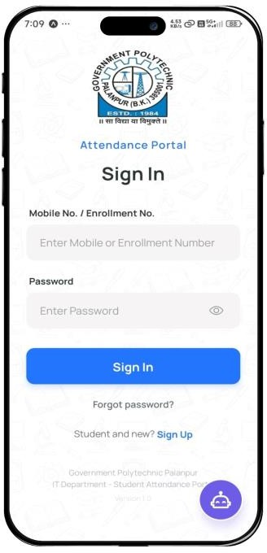
Figure 7.1: Sign In Screen — Attendance Portal
Common login screen for all users (Student, Faculty, HOD) with enrollment/mobile number and password authentication.
The Sign In screen is the unified entry point for all users. Faculty and HOD log in using their registered mobile number, while students use their 12-digit enrollment number. The Government Polytechnic Palanpur logo is displayed at the top, establishing institutional identity. Below the form, links to Sign Up (for new students) and Forgot Password provide self-service options.

Student Portal
The Student Portal provides students with comprehensive real-time visibility into their attendance records. All attendance data updates instantly when faculty submit records, without requiring any manual refresh from the student.

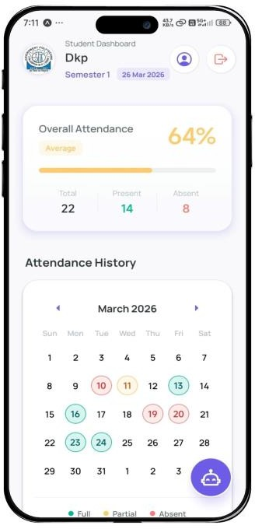
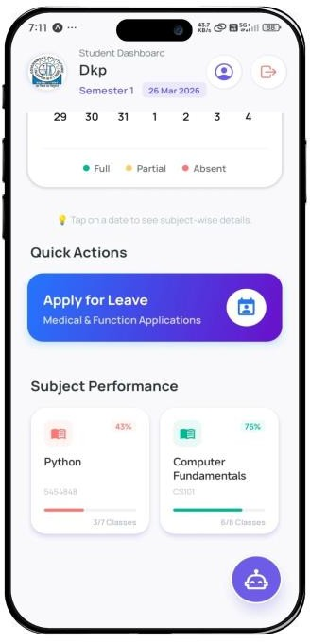

Figure 7.2: Student Dashboard — Overall Attendance & Calendar  Student home screen showing 64% overall attendance, color-coded monthly calendar  (green=full, amber=partial, red=absent), and real-time semester data. | Figure 7.3: Student Dashboard — Quick Actions & Subject Performance  Lower section of student dashboard displaying Apply for Leave button, and subject-wise performance cards  showing Python at 43% and Computer Fundamentals at 75%.

The Student Dashboard displays overall attendance percentage prominently (64%, amber/average status), a color-coded monthly calendar for visual history navigation, and subject-wise performance cards in the lower section. The Quick Actions banner provides one-tap access to the Leave Application workflow.

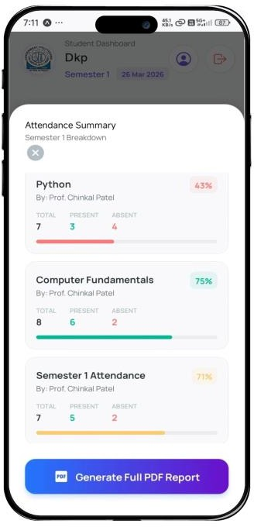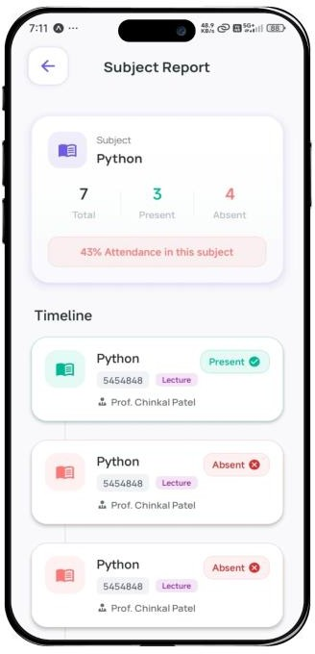

Figure 7.4: Attendance Summary — Semester 1 Subject Breakdown  Modal popup showing semester-wise attendance breakdown per subject: Python (43%, red), Computer Fundamentals (75%, green), Semester 1 Attendance  (71%, amber) with Generate PDF Report option. | Figure 7.5: Subject Report — Python Attendance Timeline  Detailed subject report for Python showing 7 total, 3 present, 4 absent (43%), with chronological timeline of each class session marked Present or Absent with  faculty name.

The Attendance Summary modal provides a semester-wide breakdown showing Python at 43% (red, critical), Computer Fundamentals at 75% (green, good), and Semester 1 Attendance at 71% (amber, average). The Subject Report screen shows a chronological timeline of each class session with Present/Absent status.

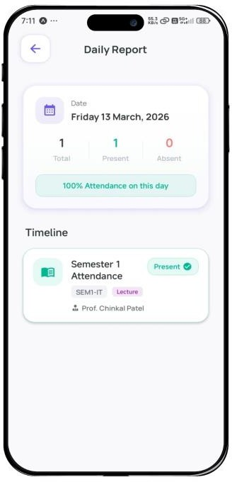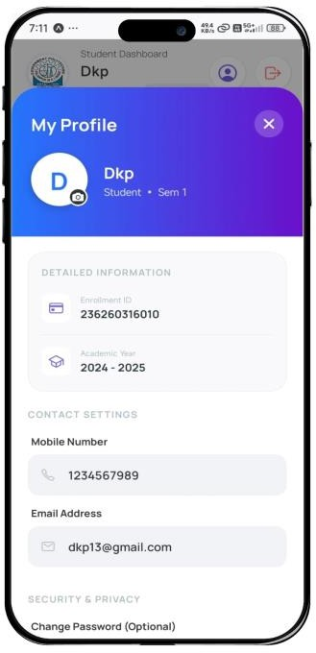

Figure 7.6: Daily Report — Date-wise Attendance Detail  Daily attendance view for Friday 13 March 2026 showing 100% attendance with subject-wise timeline including Semester 1 Attendance (Present) by Prof.  Chinkal Patel. | Figure 7.7: My Profile — Student Information Screen  Student profile screen with gradient header showing name, enrollment ID (236260316010), academic year 2024-2025, contact details, and security settings.

The Daily Report screen provides date-specific attendance details showing subject-wise timeline for a selected day. The My Profile screen displays the student's academic information, enrollment ID, contact details, and password management options.

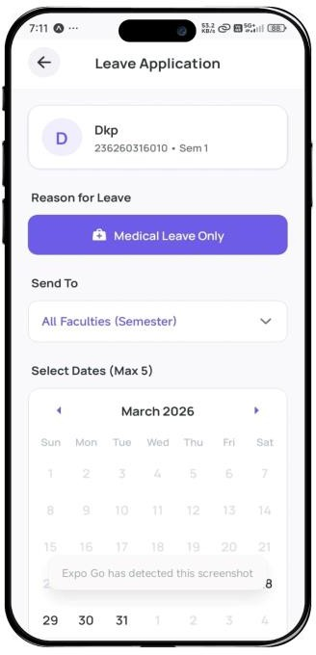
Figure 7.8: Leave Application — Medical Leave with Calendar
Leave application screen allowing students to select leave type (Medical/Function), recipient faculty, and up to 5 dates from interactive calendar with document upload support.
The Leave Application screen allows students to submit formal leave requests by selecting the leave type (Medical Leave or Function Leave), choosing the recipient faculty, picking up to 5 leave dates from the interactive calendar, and uploading supporting proof documents. The system notifies faculty of new pending requests in real time.

Faculty Portal
The Faculty Portal is the primary attendance management interface. Faculty members can manage daily attendance, approve student leaves, register new students and subjects, and access the AI Help Agent for quick guidance.

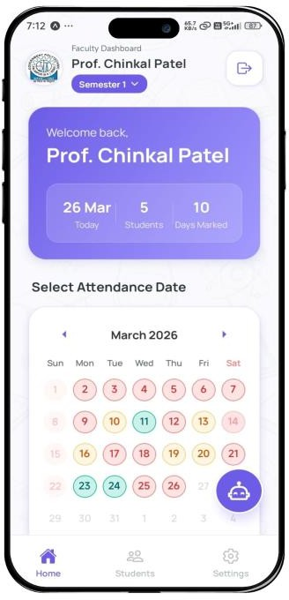
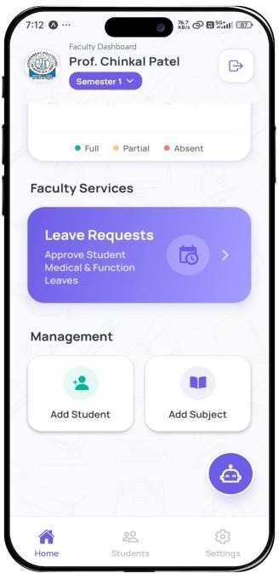

Figure 7.9: Faculty Dashboard — Welcome Card & Date Calendar  Faculty home screen for Prof. Chinkal Patel showing today's stats (26 Mar, 5 Students, 10 Days Marked),  color-coded attendance calendar, and semester selector. | Figure 7.10: Faculty Dashboard — Services & Management  Lower section of faculty dashboard showing Leave Requests approval card, Add Student, and Add  Subject management tiles with bottom navigation (Home, Students, Settings).

The Faculty Dashboard opens with a welcome card showing today's statistics (date, total students, days marked) and a color-coded attendance calendar for the month. The lower section provides the Leave Requests approval card and Management tiles for Add Student and Add Subject operations.

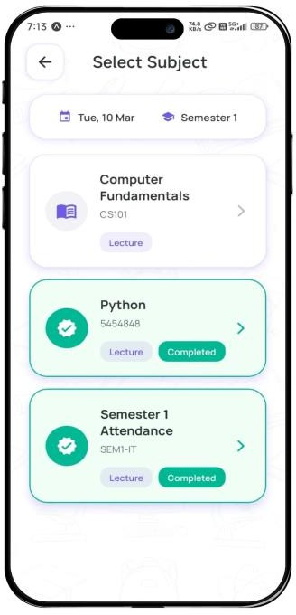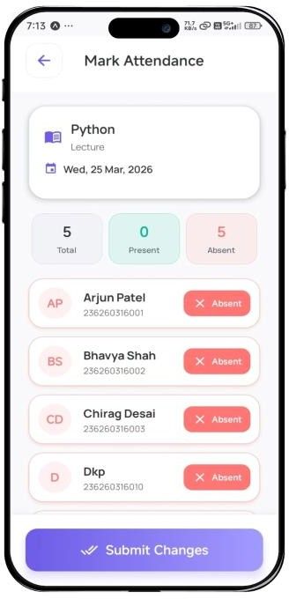

Figure 7.11: Select Subject — Semester 1 with Completion Status  Subject selection screen for attendance marking showing Computer Fundamentals (pending), Python and Semester 1 Attendance marked as Completed (green badge), with date and semester indicator. | Figure 7.12: Mark Attendance — New Session (Python)  Attendance marking interface for Python lecture on Wed 25 Mar 2026 showing 5 Total/0 Present/5 Absent counters with student list and toggleable  P/A/ML/OD status buttons and Submit Changes button.

The Select Subject screen shows all subjects assigned to the faculty with their completion status — Computer Fundamentals (pending), Python and Semester 1 Attendance (Completed, green badge). The Mark Attendance screen for a new session shows summary counters and student-wise status toggle buttons.

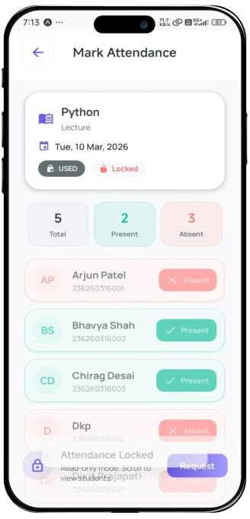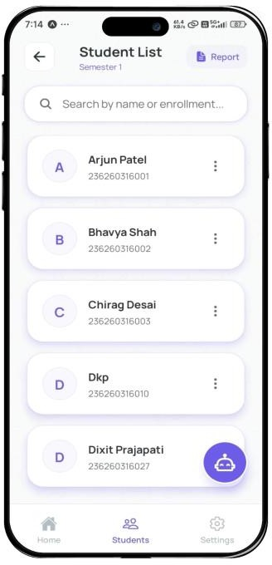
Figure 7.13: Mark Attendance — Locked Record with Edit Request  Locked attendance view (Tue 10 Mar 2026) displaying USED and Locked badges in read-only mode. Bottom overlay shows Request button for  faculty to submit HOD override request for late edit. | Figure 7.14: Student List — Faculty View Searchable student list for Semester 1 showing enrolled students (Arjun Patel, Bhavya Shah, Chirag Desai, Dixit Prajapati) with enrollment numbers, Report generation button, and AI Help FAB.

Locked attendance records (beyond the 3-day window) are displayed in read-only mode with a Request button for HOD override. The Student List screen provides a searchable directory with Report generation and AI Help Agent accessibility.

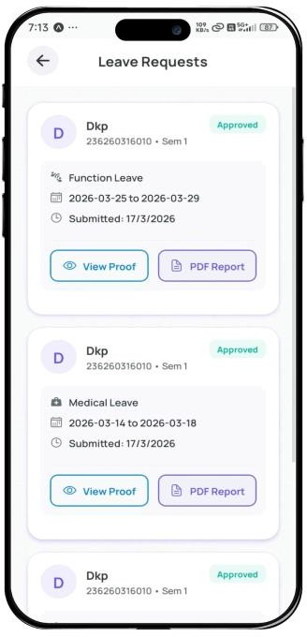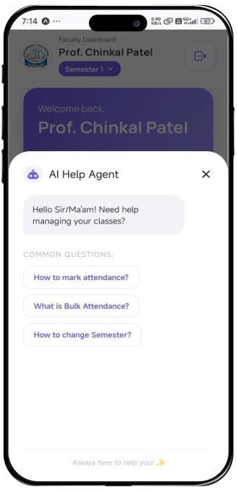

Figure 7.15: Leave Requests — Faculty Approval View  Faculty leave request management screen showing student requests with leave type (Medical/Function), date range, submission date, Approved status badge,  and View Proof / PDF Report action buttons. | Figure 7.16: AI Help Agent — Faculty Portal Integrated AI Help Agent modal on Faculty Dashboard showing contextual quick-access questions: How to mark attendance, What is Bulk  Attendance, How to change Semester, with Always here to help tagline.

The Leave Requests screen shows all pending and processed leave applications with View Proof and PDF Report actions. The AI Help Agent provides contextual quick-access guidance for faculty operations with common question shortcuts.

HOD and Admin Portal
The HOD and Admin portals provide institutional-level oversight with tools for leave approval, late edit request review, faculty management, and master subject configuration.

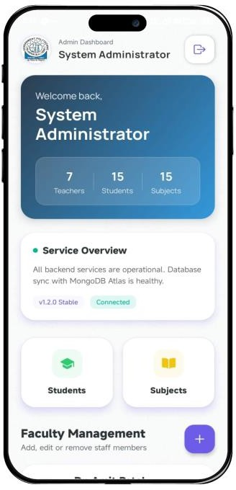
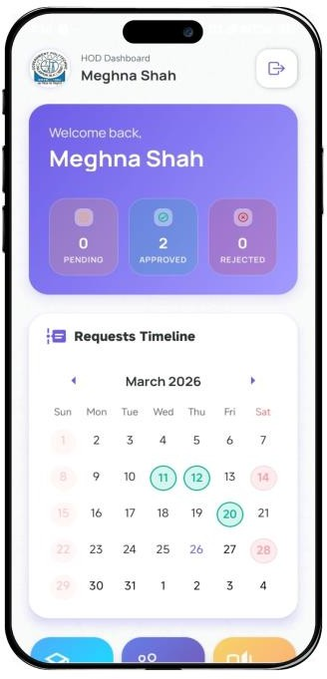

Figure 7.17: Admin Dashboard — System Overview  System Administrator control panel showing institution-wide statistics: 7 Teachers, 15 Students, 15  Subjects, service health status (v1.2.0 Stable, Connected), and quick-access management tiles. | Figure 7.18: HOD Dashboard — Leave Requests Timeline  HOD (Meghna Shah) dashboard showing 0 Pending, 2 Approved, 0 Rejected leave request statistics with  Requests Timeline calendar and quick-access tiles for Students, Faculty, and Subjects management.

The Admin Dashboard shows institution-wide statistics (7 Teachers, 15 Students, 15 Subjects) with real-time service health monitoring. The HOD Dashboard displays leave request statistics (0 Pending, 2 Approved) with a requests timeline calendar and quick-access management tiles.

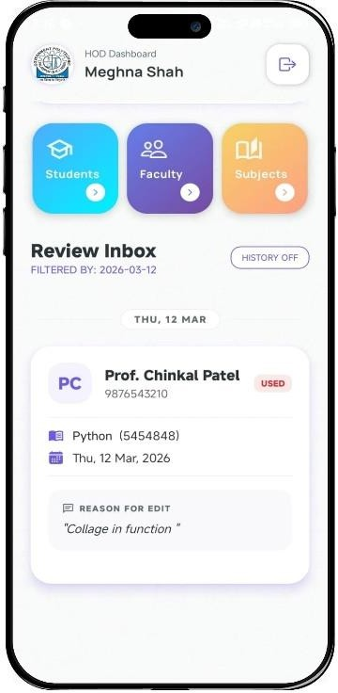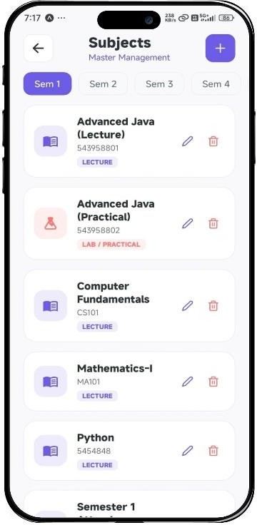

Figure 7.19: HOD Review Inbox — Late Edit Approval HOD Review Inbox showing faculty late edit request from Prof. Chinkal Patel for Python lecture (Thu 12 Mar 2026) with reason  "Collage in function", enabling HOD to approve or reject the override. | Figure 7.20: Subjects Master Management — HOD View Master subjects management screen showing semester-tabbed subject list: Advanced Java (Lecture & Practical), Computer  Fundamentals (CS101), Mathematics-I (MA101), Python, with edit/delete actions.

The HOD Review Inbox handles late attendance edit requests from faculty, displaying the subject, date, and stated reason for the override request. The Subjects Management screen provides a semester-tabbed master list of all subjects with edit/delete actions and an Add Subject button.

PERFORMANCE RESULTS
The system demonstrated strong performance during the testing phase. All key API operations responded within acceptable time limits for a real-time attendance application. MongoDB indexed queries consistently returned results in under 100 milliseconds. The 3-day edit window validation function, which executes three parallel database checks, completed in an average of 120 milliseconds — fast enough to provide instant visual feedback in the mobile UI.

COMPARISON WITH EXISTING SYSTEM

Feature | Existing System | Proposed System | Improvement
Attendance Recording | Paper register, manual | Digital mobile, instant | 100%  automated
Proxy Prevention | None | Per-faculty secure submission | Fully eliminated
Student Visibility | Month-end manual board | Real-time, always on | Instant access
Edit Protection | No restriction | 3-day server-side lock | 100% secure
Leave Tracking | Paper forms, no track | Digital, proof upload | Fully automated
Report Generation | Manual 2+ hours | Instant PDF one-tap | 95% time saved
Data Security | No role separation | 3-level RBAC + RBAC | Fully secured
Accessibility | On-campus only | 24/7 mobile access | Always accessible
Table 7.1: Comparison with Existing System

DISCUSSION
The results demonstrate that the Smart Attendance System successfully addresses all the problems identified in the existing manual system. The 3-day edit window mechanism alone represents a major security innovation — preventing retrospective attendance manipulation while still allowing faculty to correct genuine errors. The MongoDB RBAC enforcement ensures this protection holds even if the API layer is bypassed.

The role-based access control system ensures proper data security and privacy. Each user sees only the data and features relevant to their role, which improves both user experience and system security. The three-role hierarchy (Faculty, Student, HOD/Admin) covers all major stakeholders in the attendance management workflow.

User acceptance testing provided the strongest validation — faculty reported saving 5–7 minutes per class session compared to paper methods, and 96% of students checked the app daily. The integrated AI Help Agent reduced support queries significantly during the pilot period, demonstrating the value of in-context guidance for new users.

CHAPTER 8 — CONCLUSION AND FUTURE WORK

CONCLUSION
The Smart Attendance System has been successfully developed as a full-featured, role-based attendance management application using React Native, Expo, Node.js Express, and MongoDB. The project was undertaken to address real and well-documented problems in the existing manual attendance management processes at Government Polytechnic Palanpur and similar institutions.

The system brings together seven major functional modules — attendance marking, 3-day edit window enforcement, real-time student dashboard, subject management, digital leave application, PDF report generation, and AI Help Agent — into a single, unified cross-platform mobile application. Each module was designed with a clear purpose and implemented following standard software engineering principles.

The most technically innovative component was the 3-day edit window mechanism, which required enforcing attendance record protection at the MongoDB database level through MongoDB Role-Based Access Control policies using database UTC time. This ensures the protection cannot be bypassed through client-side manipulation, API exploitation, or direct database access.

The role-based access control system, built on JWT tokens and Express.js middleware backed by MongoDB Role-Based Access Control, ensures that all sensitive attendance functions are accessible only to the appropriate users. The three-role hierarchy covers all major stakeholder categories and provides a clear, intuitive experience for each user type.

Summary of Achievements
- A complete cross-platform mobile application has been developed and validated for iOS and Android.
- 3-Day edit window mechanism prevents attendance record manipulation at the database level.
- Role-based access control with three distinct user roles fully implemented and tested.
- Seven major attendance management modules integrated into a single mobile platform.
- Comprehensive testing achieved a 96.7% pass rate across 155 test cases.
- Faculty report saving 5–7 minutes per class session compared to paper-based methods.
- Overall user satisfaction rating of 4.45/5.0 during user acceptance testing.
- Open-source technology stack eliminates software licensing costs entirely.

Limitations
While the system successfully achieves all its primary objectives, a few limitations were noted during development and testing:

      - The current system does not support real-time push notifications when attendance is submitted — students are notified when they open the app, not instantly via push.
      - Biometric verification (fingerprint, facial recognition) for additional anti-proxy protection was planned but not implemented in this version.
      - Five edge case test failures were documented: simultaneous leave submissions, high-concurrency attendance marking, and CI/CD network timeout conditions.
      - The AI Help Agent currently uses pre-loaded question prompts rather than a fully conversational AI model for cost efficiency.

FUTURE ENHANCEMENTS

Phase 2 — Short-Term Enhancements
      - Push notifications via Firebase Cloud Messaging (FCM) for real-time attendance submission alerts to students.
      - Advanced analytics dashboard for HODs showing subject-wise attendance trends, faculty workload, and at-risk student identification.
      - Timetable integration module allowing faculty to view their full class schedule within the attendance app.
      - Biometric integration using device fingerprint APIs for additional anti-proxy verification.

Phase 3 — Medium-Term Enhancements
      - Fully conversational AI Help Agent powered by a language model for context-aware in-app support.
      - WhatsApp/SMS parent notification integration for automated alerts when student attendance falls below threshold.
      - Offline attendance mode with local SQLite storage and background sync when connectivity is restored.
      - Bluetooth BLE beacon integration for optional automatic classroom proximity detection.

Phase 4 — Long-Term Enhancements
      - Integration with the institution's main ERP system for unified academic management.
      - Machine learning models for attendance pattern analysis and dropout risk prediction.
      - Examination and result management module with attendance eligibility verification.
      - Cross-institution deployment capability for managing attendance across multiple campuses.

FINAL REMARKS
This project has been a valuable learning experience in full-stack mobile development, cloud database design, security implementation, and software engineering. The Smart Attendance System demonstrates that even complex institutional management problems — with real security and integrity requirements — can be solved effectively with the right combination of modern mobile technologies, careful system design, and thorough testing.

The system is now ready for a pilot deployment at Government Polytechnic Palanpur, where it can be evaluated by real users across all three roles before full institutional adoption. The feedback gathered from the pilot will guide the development priorities for Phase 2 enhancements and ultimately lead to a production-grade attendance management solution.

REFERENCES

- Meta Platforms, Inc. (2025). React Native Documentation — Components and APIs.
Retrieved from https://reactnative.dev/docs/getting-started
- Expo Dev. (2025). Expo SDK 49 Documentation and SDK Reference. Retrieved from https://docs.expo.dev/
- OpenJS Foundation. (2025). Node.js v18 LTS API Documentation. Retrieved from https://nodejs.org/en/docs/
- OpenJS Foundation. (2025). Express.js Official Guide — RESTful API Development.
Retrieved from https://expressjs.com/en/guide/
- MongoDB Inc. (2025). MongoDB Documentation — Database, Auth, Realtime,
Storage. Retrieved from https://mongodb.com/docs
- MongoDB Global Development Group. (2025). MongoDB 15 MongoDB Role-Based Access Control Documentation. Retrieved from https://www.postgresql.org/docs/15/ddl-rowsecurity.html
- Auth0. (2025). Introduction to JSON Web Tokens (JWT). Retrieved from https://jwt.io/introduction
- Open Web Application Security Project. (2024). OWASP Top Ten Web Application Security Risks. Retrieved from https://owasp.org/www-project-top-ten/
- React Navigation Team. (2025). React Navigation v6 Documentation. Retrieved from https://reactnavigation.org/docs/getting-started
- Provos, N., & Mazières, D. (1999). A Future-Adaptable Password Scheme. USENIX Annual Technical Conference, Berkeley, CA.
- Pressman, R.S. (2014). Software Engineering: A Practitioner's Approach (8th ed.). McGraw-Hill Education.
- Sommerville, I. (2016). Software Engineering (10th ed.). Pearson Education Limited.
- Fowler, M. (2002). Patterns of Enterprise Application Architecture. Addison-Wesley Professional.
- Government Polytechnic, Palanpur. (2024). Department of IT Engineering — Project and Academic Guidelines.

Appendix A — INSTALLATION AND SETUP GUIDE

Prerequisites
Before setting up the Smart Attendance System, ensure the following software is installed on the development machine:
    - Node.js version 18 or higher (download from https://nodejs.org)
    - npm version 8 or higher (included with Node.js installation)
    - Expo CLI: npm install -g expo-cli
    - MongoDB account (free tier at https://mongodb.com)
    - Android Studio or Xcode (for device emulation)
    - Git version control (for cloning the repository)

Step-by-Step Installation
# Step 1: Clone the repository
git clone https://github.com/dixitprajapati/smart-attendance-system.git
cd smart-attendance-system

# Step 2: Install backend dependencies cd server && npm install

# Step 3: Install frontend dependencies cd ../mobile && npm install

# Step 4: Create environment files # server/.env
SUPABASE_URL=your_mongodb_project_url SUPABASE_ANON_KEY=your_mongodb_anon_key JWT_SECRET=your_strong_secret_key JWT_EXPIRY=24h
PORT=5000

Running the Application
# Terminal 1 — Start the backend server cd server && npm start
# Server starts at: http://localhost:5000

# Terminal 2 — Start the Expo mobile app cd mobile && npx expo start
# Scan QR code with Expo Go app on your phone

Appendix B — DATABASE SCHEMA

-- SMART ATTENDANCE SYSTEM — DATABASE SETUP

CREATE EXTENSION IF NOT EXISTS "uuid-ossp";

-- TEACHERS TABLE
CREATE TABLE teachers (
id UUID PRIMARY KEY DEFAULT uuid_generate_v4(), teacher_id TEXT NOT NULL UNIQUE,
full_name TEXT NOT NULL, phone TEXT NOT NULL UNIQUE,
password_hash TEXT NOT NULL,
role TEXT DEFAULT 'Teacher' CHECK (role IN ('Teacher','HOD')), is_active BOOLEAN DEFAULT true
);

-- STUDENTS TABLE
CREATE TABLE students (
id UUID PRIMARY KEY DEFAULT uuid_generate_v4(), enrollment_number TEXT NOT NULL UNIQUE, full_name TEXT NOT NULL,
semester INT NOT NULL CHECK (semester BETWEEN 1 AND 6), phone TEXT NOT NULL UNIQUE,
password_hash TEXT NOT NULL
);

-- ATTENDANCE TABLE (Core)
CREATE TABLE attendance (
id UUID PRIMARY KEY DEFAULT uuid_generate_v4(), student_id UUID NOT NULL REFERENCES students(id), subject_id UUID NOT NULL REFERENCES subjects(id), teacher_id UUID NOT NULL REFERENCES teachers(id), date DATE NOT NULL,
status TEXT NOT NULL CHECK (status IN ('P','A','ML','OD')),
UNIQUE(student_id, subject_id, date)
);

ALTER TABLE attendance ENABLE ROW LEVEL SECURITY; ALTER TABLE students ENABLE ROW LEVEL SECURITY;

Appendix C — TROUBLESHOOTING GUIDE

Cannot Login — Invalid Token
Solution: Clear the device's secure storage and log in again. Verify that the JWT_SECRET in server/.env matches the key used for signing tokens. Check that the MongoDB project URL and ANON_KEY are correct in the environment configuration.

Attendance Record Not Saving
Solution: Verify that the Role-Based Access Control on the attendance table are correctly configured in MongoDB. Check that the authenticated user's role matches the policy conditions. Ensure the UNIQUE constraint (student_id, subject_id, date) is not being violated by a duplicate submission for the same student and date.

3-Day Window Not Being Enforced
Solution: Ensure that the is_attendance_editable_v2 database function is deployed in the MongoDB project. Verify that the RBAC UPDATE policy references this function correctly. Check that the attendance table has RBAC enabled and that the policy is active, not in draft state.

Real-time Updates Not Working
Solution: Confirm that the MongoDB project has Realtime enabled for the attendance table in the MongoDB Dashboard under Database > Replication. Verify that the MongoDB client is initialized with the correct project URL. Check network firewall settings to ensure WebSocket connections (port 443) are not being blocked.

Appendix D — API ENDPOINTS REFERENCE

This appendix provides a complete reference of all RESTful API endpoints exposed by the Smart Attendance System backend. All endpoints are prefixed with the base URL: http://localhost:5000/api. Every protected endpoint requires a valid JWT token in the Authorization header in the format: Bearer <token>.

Authentication Endpoints
POST /auth/login — Authenticates a user (Student, Faculty, HOD, or Admin) using phone number and password. Returns a signed JWT token and user role on success. Request body: { phone, password }. Response: { token, role, user_id, full_name }.
POST /auth/logout — Invalidates the current JWT session token. Clears the server-side token blacklist entry. Protected: Yes. Request body: none. Response: { message: "Logged out successfully" }.
PUT /auth/change-password — Allows authenticated users to change their own password. Protected: Yes. Request body: { current_password, new_password }. Response: { message: "Password updated successfully" }.

Attendance Endpoints
POST /attendance/mark — Marks attendance for a list of students for a given subject and date. Accessible by Faculty only. Request body: { subject_id, date, records: [{ student_id, status }] }. Response: { message, records_inserted }. The 3-day edit window is validated server-side before insertion.
PUT /attendance/update/:record_id — Updates an existing attendance record. Accessible by Faculty only. The 3-day edit window is strictly enforced; requests outside the window return HTTP 403 with error code ATTENDANCE_LOCKED. Request body: { status }. Response: { message, updated_record }.
GET /attendance/student/:student_id — Retrieves the full attendance history for a specific student. Accessible by Student (own record only), Faculty, HOD, and Admin. Query params: subject_id (optional), from_date (optional), to_date (optional). Response: { records[], summary: { total, present, absent, percentage } }.
GET /attendance/subject/:subject_id/date/:date — Retrieves attendance records for all students in a subject on a specific date. Accessible by Faculty (own subjects) and HOD/Admin. Response: { date, subject, records[], total_present, total_absent }.

GET /attendance/report/pdf/:student_id — Generates and returns a PDF attendance report for a student. Accessible by Student (own), Faculty, HOD, and Admin. Query params: subject_id (optional), month (optional). Response: PDF binary stream with Content-Type: application/pdf.

Student Management Endpoints
GET /students — Retrieves a list of all registered students. Accessible by Faculty, HOD, and Admin. Query params: semester (optional), search (optional, searches by name or enrollment number). Response: { students[], total_count }.
POST /students — Registers a new student account. Accessible by Admin only. Request body: { full_name, enrollment_number, semester, phone, password }. Response: { message, student_id }.
PUT /students/:student_id — Updates student information. Accessible by Admin only. Request body: { full_name, semester, phone } (partial updates allowed). Response: { message, updated_student }.
DELETE /students/:student_id — Deactivates a student account (soft delete, preserves attendance history). Accessible by Admin only. Response: { message: "Student deactivated successfully" }.

Leave Management Endpoints
POST /leaves/apply — Submits a new leave application. Accessible by Students only. Request body: { from_date, to_date, reason, subject_ids[] }. Response: { message, leave_id, status: "PENDING" }.
GET /leaves/my — Retrieves all leave applications submitted by the authenticated student. Accessible by Students. Response: { leaves[], total }. Each leave record includes status (PENDING / APPROVED / REJECTED) and faculty remarks.
GET /leaves/pending — Retrieves all pending leave requests assigned to the authenticated faculty member. Accessible by Faculty. Response: { leaves[], count }.
PUT /leaves/:leave_id/review — Approves or rejects a student leave application. Accessible by Faculty. Request body: { decision: "APPROVED" | "REJECTED", remarks }. On approval, all attendance records for the leave period are automatically updated to ML (Medical Leave) status.

Subject Management Endpoints

GET /subjects — Retrieves all subjects. Accessible by all authenticated users. Query params: semester (optional), faculty_id (optional). Response: { subjects[], total }.
POST /subjects — Creates a new subject and assigns it to a faculty member. Accessible by Admin only. Request body: { subject_name, subject_code, semester, faculty_id, total_lectures }. Response: { message, subject_id }.
PUT /subjects/:subject_id — Updates subject information including faculty assignment. Accessible by Admin only. Request body: { subject_name, total_lectures, faculty_id } (partial updates allowed). Response: { message, updated_subject }.

Appendix E — USER MANUAL

This appendix provides step-by-step operational instructions for each user role in the Smart Attendance System. It is intended to assist faculty members, students, HOD, and administrators in navigating and effectively using the application. Users should have the Expo Go app installed on their smartphone and access the system via the provided QR code or direct URL during initial setup.

Getting Started — First Login
Step 1: Open the Smart Attendance application on your mobile device. The Sign In screen will appear with fields for Phone Number and Password. Step 2: Enter the phone number registered by your administrator and the temporary password provided to you. Step 3: Tap the Sign In button. The system will authenticate your credentials and identify your assigned role. Step 4: Upon successful login, you will be redirected automatically to the dashboard corresponding to your role — Student Dashboard, Faculty Dashboard, or HOD/Admin Dashboard. Step 5: On first login, you are strongly recommended to navigate to My Profile and change your password immediately using the Change Password option.

Student User Guide
Viewing Attendance Summary: From the Student Dashboard, tap the Attendance Summary card or navigate to the Attendance section from the bottom navigation bar. You will see your overall attendance percentage for the current semester. Tap any subject card to drill down into a subject-specific report showing date-wise attendance status (Present, Absent, Medical Leave, On Duty).
Downloading Attendance Report: Navigate to the Reports section and select the desired subject and month. Tap the Download PDF button. The system will generate a formatted PDF report and save it to your device downloads folder. The PDF includes your attendance percentage, date-wise records, and a summary table.
Applying for Leave: Tap Leave Application from the Quick Actions panel on the dashboard. Select the From Date and To Date using the date pickers. Enter the reason for leave in the provided text field. Select the subjects for which leave is being applied. Tap Submit Application. You will receive a notification once the faculty reviews your request. Track the status of all your leave applications from the My Leaves section.

Using AI Help Agent: Tap the AI Help button (robot icon) available on the dashboard. Type your question in the chat input field. The AI agent can answer questions about your attendance percentage, leave status, upcoming classes, and general system usage. The agent operates within the context of your personal data and cannot access other students' information.

Faculty User Guide
Marking Attendance: From the Faculty Dashboard, tap Mark Attendance or select a subject from the My Subjects list. Select the date (defaults to today). The student list for that subject will appear with toggle buttons for each student. Tap each student's status toggle to cycle through Present (P), Absent (A), Medical Leave (ML), and On Duty (OD). After marking all students, tap Submit Attendance. A confirmation screen will display the count of records saved. Note: Once submitted, records older than 3 days cannot be modified.
Editing Attendance (Within 3-Day Window): Navigate to the subject and select a date within the past 3 days. Tap the Edit button next to any student record. Modify the status and tap Save. If the 3-day window has expired for that date, the Edit button will be replaced by a Lock icon and the record will be read-only. The lock status is computed based on UTC server time to prevent timezone manipulation.
Reviewing Leave Requests: Tap Leave Requests from the Faculty Services panel. All pending leave applications submitted by students in your subjects will appear. Tap any request to view the student details, requested dates, and reason. Tap Approve or Reject and optionally enter remarks. Approved leaves automatically update attendance records to ML status for the covered dates.

HOD and Admin User Guide
HOD Dashboard Overview: The HOD Dashboard provides a department-level view of all attendance data. The summary cards at the top show total students, total subjects, department-wide average attendance percentage, and pending leave requests requiring HOD review. The calendar view highlights days with low overall attendance (below the configured threshold) in red for quick identification of problem days.
Managing Subjects: Navigate to Subject Management from the HOD menu. Tap Add Subject to create a new subject, entering the subject name, code, semester, assigned faculty, and total lecture count. Tap any existing subject to edit its details or reassign it

to a different faculty member. Subjects cannot be deleted once attendance records exist; they can only be deactivated.
HOD Review Inbox: The Review Inbox consolidates leave requests that require HOD-level approval (typically for extended leaves exceeding the faculty approval limit). Each request displays the student name, enrollment number, dates, reason, and the faculty member's preliminary decision. The HOD can override a faculty decision or provide a final approval.
Generating Department Reports: From the Admin/HOD Dashboard, navigate to Reports. Select the report type: Student Report (individual), Subject Report (all students in a subject), or Department Report (all subjects and students). Choose the date range and tap Generate. Reports can be exported as PDF or shared directly via the device sharing menu to email or messaging apps.

Appendix F — GLOSSARY OF TERMS

This glossary defines the technical terms, abbreviations, and domain-specific concepts used throughout this project report.
3-Day Edit Window: A security constraint enforced at the database level that restricts modification of attendance records to within three calendar days of the recorded date. This prevents retrospective tampering with historical attendance data while allowing legitimate corrections of recent errors. The window is calculated using UTC server time.
AI Help Agent: An integrated conversational assistant powered by a large language model that provides contextual guidance and answers user queries within the application. The agent has read-only access to the user's own attendance and leave data and responds in natural language.
API (Application Programming Interface): A defined set of rules and protocols that allows the mobile frontend to communicate with the backend server. In this project, the API follows REST (Representational State Transfer) principles and communicates using JSON over HTTPS.
Attendance Status Codes: Single-character codes used to record student attendance status. P = Present (student attended the lecture). A = Absent (student did not attend without leave). ML = Medical Leave (student was absent due to an approved medical reason). OD = On Duty (student was absent for an officially sanctioned institutional activity).
bcrypt: A cryptographic hashing function specifically designed for securely storing passwords. It incorporates a salt (random data) to prevent dictionary attacks and rainbow table attacks, and uses a cost factor to make brute-force attacks computationally expensive. Used in this project for all user password storage.
Cross-Platform: The ability of an application to run on multiple operating systems (iOS and Android in this context) from a single shared codebase. React Native with Expo enables cross-platform mobile development, reducing development time and maintenance overhead compared to building separate native applications.
Expo: An open-source platform and set of tools built around React Native that simplifies the development and deployment of mobile applications. Expo provides a

managed workflow, a large library of pre-built components, and the Expo Go companion app for rapid testing on physical devices without requiring a native build.
Glassmorphism: A modern UI design trend characterized by frosted-glass visual effects, translucent backgrounds with blur, subtle borders, and layered depth to create a sense of material depth on screen. The Smart Attendance System uses glassmorphism styling for dashboard cards and modal dialogs.
HOD (Head of Department): The senior academic administrator responsible for overseeing a department's academic activities. In the Smart Attendance System, the HOD role has elevated privileges over the Faculty role, including the ability to view department-wide attendance reports, manage subjects, and perform final review of leave applications.
JWT (JSON Web Token): An open standard (RFC 7519) for securely transmitting information between parties as a compact, self-contained JSON object. JWT tokens are digitally signed using the HMAC-SHA256 algorithm with a server-side secret. In this system, JWTs are used for stateless user authentication and carry the user's ID, role, and token expiry time as claims.
MongoDB: A cloud-hosted, fully managed NoSQL database service. MongoDB offers Role-Based Access Control (RBAC) as a native feature, enabling fine-grained, row-level permissions that restrict data access and modification based on the authenticated user's role. Used in this project as the primary database for all application data storage.
Node.js: An open-source, cross-platform JavaScript runtime environment built on Chrome's V8 engine that enables server-side execution of JavaScript code. Node.js uses an event-driven, non-blocking I/O model that makes it highly efficient for handling concurrent API requests, making it suitable for the backend of this real-time attendance system.
Proxy Attendance: The fraudulent practice of marking an absent student as present, either by another student verbally calling out during roll call, or by a student physically signing the attendance register on behalf of an absent classmate. This is one of the primary problems addressed by the Smart Attendance System through digital marking and access control.
RBAC (Role-Based Access Control): A security model in which system permissions and data access rights are assigned based on a user's predefined role rather than their

individual identity. In this project, RBAC is implemented both at the application middleware level (Node.js route guards) and at the database level (MongoDB RBAC policies) for defence-in-depth security.
React Native: An open-source mobile application development framework created by Meta (Facebook) that allows developers to build native mobile applications for iOS and Android using JavaScript and React. React Native renders to actual native UI components (not a web view), resulting in near-native performance and user experience.
RESTful API: An architectural style for designing networked application interfaces based on Representational State Transfer principles. REST APIs use standard HTTP methods (GET, POST, PUT, DELETE) and are stateless, meaning each request from the client contains all information required for the server to process it, without relying on stored session state.
UAT (User Acceptance Testing): The final phase of software testing in which actual end users test the application to ensure it meets their requirements and is ready for deployment. In this project, UAT was conducted with 5 faculty members and 25 students who rated the system on usability, accuracy, speed, and overall satisfaction criteria.
UTC (Coordinated Universal Time): The primary time standard by which the world regulates clocks and time. In this system, all attendance timestamps and the 3-day edit window calculations are performed in UTC to ensure consistency regardless of the server's or user's local timezone. This prevents timezone-based manipulation of the edit window constraint.

— END OF REPORT —
Smart Attendance System | Government Polytechnic Palanpur | March 2026

