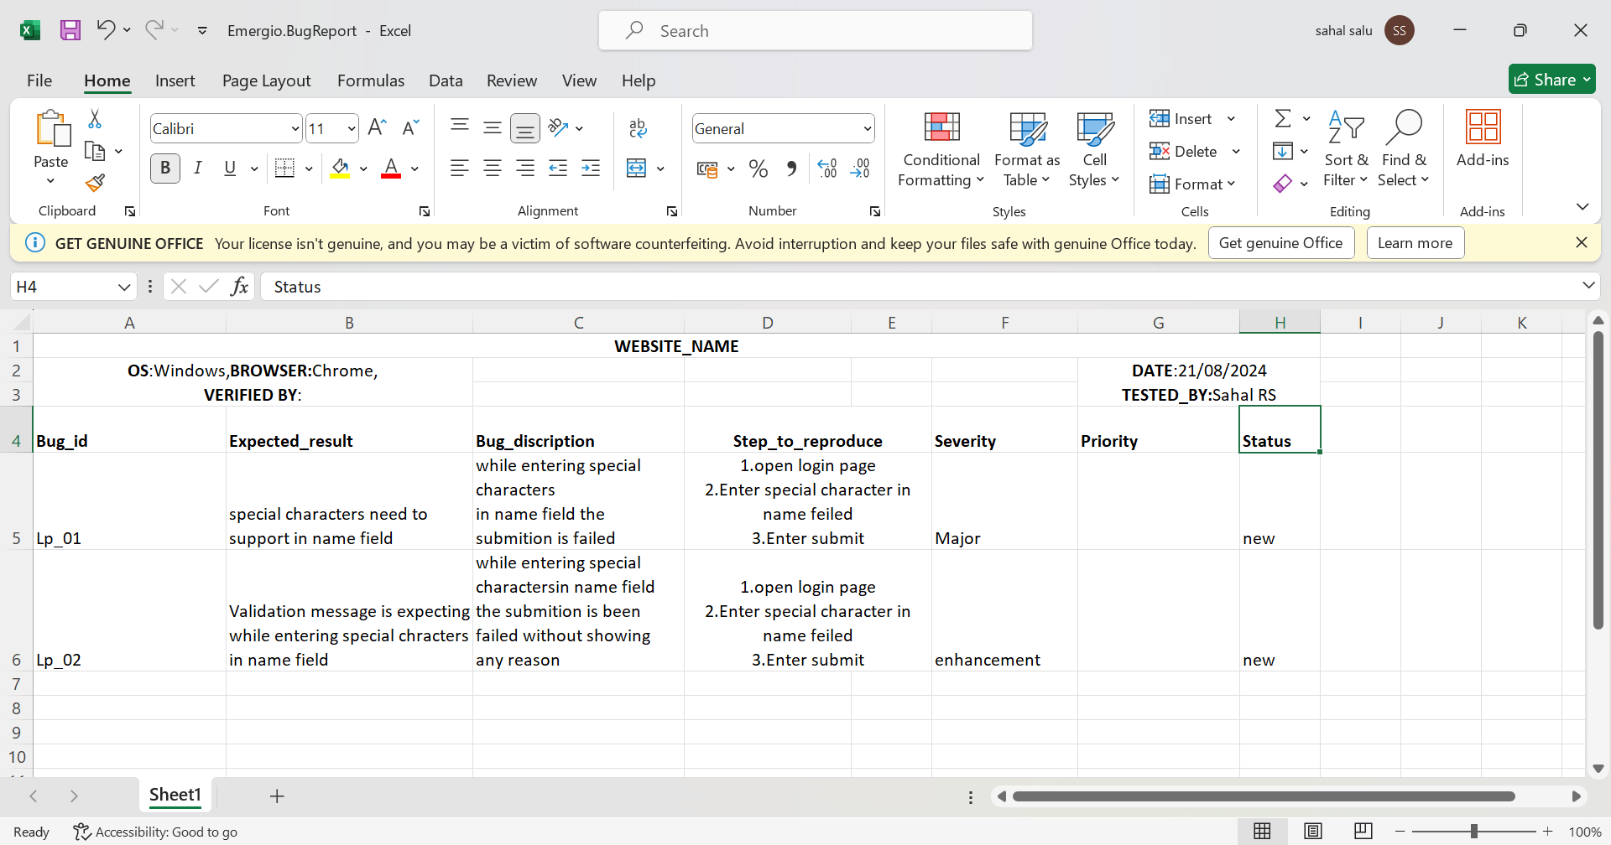

2Ans

1.Check whether the username and password is valid

2.Check whether the captcha shows different image or letters in each time when user try to login

3.Check whether user can login only while correcting the 3 fields in the authentication process.

4.Check whether user cannot login while inputing incorrect format name,password and captcha

5.Check whether username,password and captcha field is works properly

6.Check whether the submit button works properly

3Ans.

**TEST PLAN**

**INTRODUCTION**

To ensure the mobile banking app meets functional, performance, security, and usability requirements before deployment. The testing will identify and address any defects, ensuring a seamless and secure user experience.

**SCOPE**

Functional Testing: Validate core banking functionalities such as account management, fund transfers, bill payments, and balance checks.

Performance Testing: Assess the app's performance under normal and peak loads, including response times and stability.

Security Testing: Ensure the app is secure against common threats such as data breaches, unauthorized access, and financial fraud.

Usability Testing: Evaluate the app’s user interface and user experience, ensuring ease of use and accessibility.

Compatibility Testing: Ensure the app functions correctly across different mobile devices, operating systems, and screen sizes.

Compliance Testing: Verify that the app adheres to relevant regulatory and compliance standards.

**TEST STRATEGY**

• API Testing: Test all the developed APIs even before they are integrated with the UI.

• UX Testing (Usability/User Experience Testing): Test the user-friendliness of the application.

• GUI Functional Testing: Test the features for functionality against requirements.

• Automation Testing: Run available automation scripts.

• Smoke Testing: Run smoke tests on each new build.

**Test Levels:**

• System Testing: Test the entire application as a whole.

• Acceptance Testing: The user tests the application.

**ENVIRONMENT DETAILS**

• Windows Server: Staging QA

• Operating System on Test Machines: Windows 11

• Browser : Chrome – Version 121.0.6167.139

• Network – Wi-Fi

• Excel: For creating test cases

• Jira: For Bug Tracking

**STAFFING AND TRAINING NEEDS**

• Staffing

• Manual Testers: Tester1, Tester2

• QA Lead: Test Lead1

• Automation Tester: Auto Tester1, Auto Tester2

• Training

• Excel is used for test case writing: 20 hours

• Jira is used for Bug tracking

**TEST SCHEDULE AND ESTIMATION**

• Test case design:

• Start Date – 21-08-2024

• End Date – 01-09-2024

**TEST DELIVERABLES**

• Test Plan: Prepared and submitted before the start of the testing phase.

• Test Cases: Prepared and delivered during the test design phase.

• Bug Report: Prepared and shared at the end of each day throughout the execution cycle.

• Test Summary Report: Prepared and submitted at the end of the testing phase.

**EXIT CRITERIA**

• All test cases are executed, exploratory testing is done and there are no functional bugs.

• All unresolved bugs are of low severity.

• No more than 10% of medium-severity bugs are unresolved.

**SUSPENSION AND RESEMPTION CRITERIA**

The following criteria can be considered

• Suspend testing when

• Critical bugs are open.

• An open bug blocks many of the test cases in the test suite.

• Testing can be resumed when

• Critical bugs are resolved and test cases can be executed.

**RESPONSIBILITIES**

|  |  |  |
| --- | --- | --- |
| **NAME** | **EMAIL** | **ROLE** |
| Manager 1 | manager1@gmail.com | Test Manager |
| Test Lead 1 | lead1@gmail.com | Test Lead |
| Manual Tester1 | mtester1@gmail.com | Manual Tester |
| Manual Tester 2 | mtester2@gmail.com | Manual Tester |
| Automation Tester 1 | atester1@gmail.com | Automation Tester |
| Automation Tester 2 | atester2@gmail.com | Automation Tester |

**RISK AND CONTINGENCIES**

|  |  |
| --- | --- |
| **RISK** | **MITIGATION** |
| QA Environment is down | Keep an alternate environment |
| Unplanned leaves | Monitor this risk |
| Lack of essential skill | Hire skilled resource or plan for an on the job training |

ASSUMPTIONS

• Application features are deployed and available for testing on time.

• License(s) of the tool(s) used were procured in time before the start of the testing phase.

TEST REFERENCE

• UI design

• User Stories

• Requirements/Specification document

• System Design document

REVIEW AND APPROVALS

• Test Manager: (sign)

• Project Manager: (sign)

4Ans.

Create a request in postman tool and enter the url and select the Http method (Get)and send the message to the server and the result shown in the same interface.if need to send another message to the server click on test and enter the code for it.here have many by default codes available for conduct a test.

5Ans.

WebDriver driver=new ChromeDriver();

driver.get(“url”);

String Expected_title=”Expected title name”;

String Actual_title=driver.gettitle();

If(Expected_title==Actual_title)

{

System.out,println(“Title is valid”)  
}

Else

{

System.out,println(“Title is invalid”)

}

6Ans

Select Registration id,Username,date,amount from tableNAme Where date Between ‘2002-05-04’ and ‘2002-05-29’ ORDERBY date

7Ans

1.Complex Navigation-The user may defficult to identify their needs because of the complexity of Navigation

2.Taking time for loading pages-Taking so much of time for loading a page

3.Poor Mobile optimization-It is defficult for user a that website is not fully optimized for mobile devices

8Ans

Mainly I am familiar with usability testing using manual testing.testing the website on various browsers and operating systems.

9Ans

.Create a Test plan

.Add Thread Group🡪Setting number of Users ,Time and Loop count for simulating user behaviour

.Add Sampler(Http Request)🡪Provide Server name ,Port and Path to simulate Http Request

.Add Listener🡪Add any Common listeners(View Result tree,Summery Report etc.)

.Add Assertion🡪Add any Assertions (Size Assertion,Time Assertion etc.)

.Run the Test and Analys the Result

10Ans

Sql injectction

Test input fields by entering sql payload like ‘’ OR ‘1’=’’or’admin’—‘.observe if the application responds with error messages or unexpected behavior.

I am not familiar with SQL Injeuction I know some of descriptions that I mentioned above