*Predictive Analysis Based on Availability of Doctors and Medicines in Government Hospitals*

Sahana Reddy R, Deepika R,Lisha S, Srabana Pramanik

Student, BTech (Computer Science and Engineering), PU, Bengaluru

Student, BTech (Computer Science and Engineering), PU, Bengaluru

Student, BTech (Computer Science and Engineering), PU, Bengaluru

Department Of Computer Science &Engineering

Presidency University, Bengaluru, India

sahanareddyr@gmail.com, rdeepika9123@gmail.com, lishasuresh.jadav@gmail.com, srabana.pramanik@presidencyuniveristy.in

**Abstract**

In today’s technology-driven world, healthcare is rapidly evolving with the integration of predictive analytics and advanced algorithms. This paper explores how predictive analytics can transform traditional healthcare systems into more efficient, data-driven frameworks. By leveraging digital tools, health care can move beyond the traditional clinical approach, providing easier access to information on doctors, medicines, and patient records. Our system allows users to register and access hospital information, optimizing resources while minimizing fraud and inefficiencies. A robust, predictive healthcare information system, affordable and accessible, can serve as a crucial advancement for public health. In government hospitals, treatment is provided based on the patient’s diagnosis with all patient data-past and present stored in the cloud. Our system enables users to register their details, which are stored in an admin database. Using predictive algorithms, users can view hospital locations and obtain information on doctors, medicines, and specialist availability, helping patients access comprehensive details about government hospitals.

Keywords: Predictive analysis, healthcare system, data-driven framework, efficiency, patient's database, algorithm technology, patient's diagnosis.

**INTRODUCTION**

The decade has seen an increase in the use of technology and research tools in

medicine. The integration of predictive analytics and digital data into traditional healthcare systems are changing the way medical information is linked to personal information. It will be difficult to manage doctors and medicines during busy times; leaving. Predictive algorithms can also identify patients at risk for certain diseases, allowing doctors to take preventive measures in consultation. Tracking drug products and disease patterns allows hospitals to prepare for potential outbreaks based on the principle that “prevention is better than cure.” Enter price. This approach improves overall patient care and efficiency by keeping patients engaged, updated on their health status, and informed about upcoming appointments. Systems that use patient data can predict medication needs at any location. They can also predict doctor needs based on patient admission, type of illness, and historical trends. This helps manage doctor availability to include busy hours, weekends, and holidays, reducing the likelihood that patients won’t be able to get to the doctors they need. Predictive analytics can help solve this problem by analyzing big data from patient histories, clinical outcomes, and clinical trials to predict what doctors and nurses need. Predictive analytics helps predict treatment response, infection risk, admission rates, and more by uncovering patterns and relationships that may not be immediately apparent. By digitizing and analyzing medical records, especially using AI, major organizations can provide better, more useful information to the public.

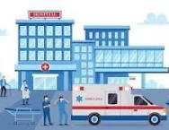





**2.LITERATURE SURVEY**

1. TITLE: Shaikh Karnool Afsa, Khandhakar Nayeem Rejwam, Dada Khalandar “Predictive mechanism for medicines availability in government health centers”, publications on ijeat ,2024

Predictive analytics has emerged as a crucial tool in healthcare, addressing issues such as medicine shortages and optimizing resource allocation. By using ML models, healthcare systems can predict patient inflow and disease trends, which helps hospitals maintain adequate stocks of critical medicines. Regression algorithms, as used in this study, are the backbone of predictive systems, correlating historical and real-time patient data to identify patterns and predict future requirements. Big data technologies, like Hive, when integrated with Python libraries like NumPy, Pandas, Scikit-learn, and Matplotlib, enhance the efficiency and accuracy of data processing and analysis. These tools facilitate preprocessing, modeling, and visualization, offering insights that support decision-making. Previous research has demonstrated the efficacy of predictive analytics in various domains, including anticipating infection risks, monitoring communicable diseases, and optimizing hospital readmissions. Studies also highlight the significance of EHRs in holding and analyzing big data to identify relationships in health care data. The incorporation of predictive models with big data analytics has been quite effective in bridging the gaps between resource availability and patient needs. For example, the analysis of real-time data helped to reduce the shortage of medicines during peak periods of disease, thus enabling patients to receive timely treatment and improved outcomes. Moreover, predictive tools help the government and health agencies make data-driven decisions to enhance service delivery and public health infrastructure. This literature underlines the importance of machine learning and big data in transforming healthcare into a proactive and efficient system that can predict and address problems before they become unmanageable. By building on these foundations, the proposed system of this study aims to revolutionize medicine management in government hospitals, ensuring availability during critical times and ultimately improving the quality of care.

2.TITLE: M.D Boomija,M.I Almas Banu,k Anu priya “Analysis on medicine and Doctor in government hospital”, Publications on ijraset, 2019

The integration of predictive analytics has helped improve the operational efficiency of government hospitals in large measures. Predictive models with the help of historical as well as current patient data help to estimate medicine requirements and optimize the availability of doctors and specialists. The analytics of big data will identify variables influencing resource allocation and develop strategies for improved service delivery. Advanced tools such as R, HTML, and predictive algorithms like Random Forest enable the development of robust models for decision-making. These innovations ensure timely patient care, reduce human effort, and streamline hospital operations. Studies highlight the importance of data analytics in improving healthcare outcomes, identifying patient needs, and enhancing the efficiency of public health systems. The adoption of predictive analytics also helped in the better resources management, fraud reduction as well as improved patient satisfaction owing to timely access to medicines and specialists.

3. TITLE: Predictive Analytics on healthcare, www.ijsr.net

This paper delves on the application of predictive analytics into healthcare, which would help develop better quality care at relatively lower costs. It takes into account data mining techniques - classification, association, and clustering - to address all healthcare issues like risk estimation, patient tracking, fraud detection, and so many more. The study encompasses tools such as the Charlson Comorbidity Index estimating health risks and offers a comparative review of existing predictive tools in use. The paper emphasizes transitioning healthcare systems from reactive to proactive approaches, with predictive analytics reducing readmissions and enabling cost-efficient, high-quality care. Challenges include privacy concerns, data integration, and standardization.

4. TITLE: Smitha Jhajharia,Seema verma,Manish kumar “Predictive Analytics for better health and disease reduction”, publication on predictive analytics today ,2021

Predictive analytics is changing healthcare as it helps assess vast datasets to uncover patterns, predict outcomes, and optimize decision-making processes. Sophisticated techniques, including regression models, data mining, and machine learning, provide insights into patient management and resource allocation. Factors such as age, prematurity, and hemoglobin levels have been shown to be major predictors of ICU stays for pediatric cardiac surgery patients; hence, the necessity for data-driven preoperative planning. Predictive models improve clinical efficiency and save costs by identifying risks and reducing postoperative complications. Fraud detection, marketing, and preventive medicine are other applications of predictive analytics that demonstrate its utility in improving healthcare outcomes. With healthcare organizations digitizing their data, predictive tools allow for customized treatments, better resource allocation, and informed policy decisions that shift the focus toward precision medicine and better patient care

5.TITLE: Damien S. E Brokharst,Rogier van de wetering,Ward Ooms,Remko W.Helms “Deploying Predictive Analytics to enhance patient agility and patient value in hospital”, publications on Elsevier ,2023

The purpose of this paper is to discuss the role that predictive analytics plays in improving the agility and value of a patient within a hospital system. It discusses the reactionary ability of current hospital capabilities, focusing on the need for an active, predictive approach in healthcare. Predictive analytics enables hospitals to sense patient needs before problems arise, preventing negative trends and better patient outcomes. The research proposal calls for a multi-stakeholder perspective and a comprehensive conceptual framework that integrates biomedical and health service needs. Using predictive analytics, hospitals can enhance evidence-based medical practices, manage capacity, and streamline healthcare pathways. The paper also outlines the potential for an innovation ecosystem that facilitates collaborative data exchange among stakeholders to foster improved healthcare delivery. Future research directions include examining predictive analytics in diverse healthcare settings, exploring related analytics types, and optimizing resource allocation to maximize patient agility and value.

6.TITLE: Sharique Ahmad, Priyesh Srivastava Tanish Baqar “Predictive Analytics in medical healthcare: a meta-Analysis", publication on Research gate, 2024

Advanced analytics, predictive and big data analytics, transform the healthcare landscape by enabling data-driven decision-making. Predictive analytics uses historical medical data, statistical models, and machine learning to predict future outcomes, thus being a proactive approach to health care management. Key applications include disease prediction, personalized treatment plans, resource optimization, and fraud detection. For instance, predictive models have been successfully deployed in identifying patients who are at a high risk of readmission or sepsis. This saves costs and ensures better outcomes. Big data analytics, in turn, applies the "4 Vs," which include volume, velocity, variety, and veracity, in extracting actionable insights from a diverse set of datasets like electronic health records and social media. The technologies Hadoop and machine learning provide real-time analytics, hence improving care quality and operational efficiency. Despite the promise, the integration of these technologies is challenged by data privacy, standardization, interoperability, and algorithmic bias, among other ethical issues. Interdisciplinary approaches are suggested to address these problems, including compliance with regulatory frameworks and improving the interpretability of black-box models. The recent advancements that include genomic data integration and telehealth applications highlight the growing role of predictive analytics in precision medicine and remote monitoring. However, there are still challenges such as data fragmentation and organizational resistance to the widespread adoption of this technology. Success stories, such as resource optimization using predictive analytics during the COVID-19 pandemic, highlight the potential for revolutionizing patient care. Future research is focused on improving model transparency, addressing data quality issues, and integrating emerging technologies like IoT and AI to promote holistic, personalized healthcare systems. Predictive and big data analytics are enormous in their promise to innovate, improve patient outcomes, and streamline healthcare delivery with further progress and ethical vigilance.

7.TITLE: Mohammed Badawy,Nagy Ramadan and Hesham Ahmed hefny “Healthcare predictive analytics using ML and DL technique: a survey", publications on Springer open,2023

This paper is a thorough review on the integration of ML and DL techniques into predictive healthcare analytics. The author draws attention to the fact that AI is transforming the realm of medical diagnostics with respect to early disease detection and the design of personalized treatment planning. Different types of ML models including linear regression, decision trees, and random forests, besides DL architectures like CNNs and LSTM, are discussed to establish their effectiveness in healthcare prediction. Some of the challenges in using such models include dealing with large, heterogeneous datasets, achieving accuracy, and eliminating biases in the prediction algorithms. The study also delves into supervised, unsupervised, and reinforcement learning models, which can be applied to prognosis, diagnosis, therapy optimization, and enhancement of clinical workflow. Future work is in the refinement of these models to improve scalability, reduce computational complexity, and ensure ethical data governance in healthcare applications.

8.TITLE: Wullinarllur Raghupathi and Viju Raghupathi “Big data analytics in. Healthcare: promise and potential”, Publications on Springer 2014

This paper will outline the transformative potential of big data analytics in healthcare through using vast, diverse datasets to glean insights that improve outcomes and reduce costs. The paper defines key concepts such as the "4 Vs" of volume, velocity, variety, and veracity, and describes frameworks like Hadoop for managing and analyzing healthcare data. Examples of successful applications include disease surveillance, fraud detection, and personalized medicine. Despite its promise, challenges remain in data standardization, privacy, and skill gaps. The paper concludes by advocating for advanced platforms, tools, and policies to realize the full potential of big data in healthcare.

9.TITLE: Yichung Wang, Leeann Kung, Choachi Ting “Beyond a technical perspective: understanding big data capabilities in healthcare", publication on ResearchGate,2021

The document is a discussion of the potential strategic applications of big data in the healthcare industry. While previous studies have mostly concentrated on the technological aspects of big data, this paper is based on its strategic implications to bridge the gap between technical capabilities and healthcare management needs.

The authors describe the architecture and functionalities of big data that enable oneto process vast quantities of disparate data with various platforms like Hadoop and NoSQL systems. All these are meant to facilitate integrating, transforming, and storing data and help health institutions analyze both structured and unstructured data effectively. Based on such research, a study can point out important

10.TITLE: Neeraj ,Pradeep kumar “Predictive analysis on availability of medicines and doctors in government hospitals”, publications on ijeat,2020

The literature survey is focused on the applications of predictive analytics and big data technologies in healthcare and related areas. Predictive analytics has been found to have huge potential in improving resource management and decision-making by establishing patterns and trends. Research reveals the integration of structured and unstructured data, thus emphasizing the need to shift from traditional systems towards advanced hybrid models for higher efficiency and performance. The research underlines the transformative role of technology in predictive modeling and its application in healthcare, ensuring data-driven strategies and efficient operation.

**3. PROPOSED METHODS**

1. Problem Statement: Predict doctors and medicines availability in health facilities for better patient care and resource utilization. Both short-term (daily/weekly) and long-term (monthly/quarterly) predictions are to be considered.

2. Data Gathering: Checking the availability of doctors and medicines requires a holistic approach, integrating various sources to ensure accuracy, timeliness, and usability of the data.

3. Data Preprocessing

Data Cleaning:

Handle missing data.For example, interpolation or imputation for gaps in stock logs.

Remove duplicates or irrelevant records.

Feature Engineering:

Build derived metrics such as daily/weekly inflow average patient or stock turnover rate

Encode categorical variables. Example: medicine types and specialties of doctors

Time Series Structuring:

Prepare data in temporal analysis with trends, seasonality, and irregularity in mind

4. Developing a Predictive Model

Model Selection: Hybrid approach is used combining machine learning, and time-series models are used. For checking availability for doctors, we use some machine language models like Random Forest, Gradient Boosting or neural networks for predicting availability based on roasters, past attendances. Time-series models AIRMA, LSTM models for trends and seasonality.

For medicines inventory models such as Economic Oder Quantity (EOQ) or ABC analysis is used. For demand forecasting linear regression, Prophet, or recurrent neural networks (RNN) for stock depletion prediction.

5. Performance Metrics:

Precision in prediction (Mean Absolute Error, Root Mean Square Error).

6. Visualization and Reporting:

Dashboards: Prepare live dashboards with predictive insight for the hospital administrators. Run out of medicines warnings based on a time interval set.

7. Implementation and Deployment:

Software Integration: Model using Python with tools like Pandas, TensorFlow, Scikit-learn, or R. Deploys models using tools such as Flask, Fast API, or cloud-based ML services, including AWS Sage Maker or Google Cloud AI.

8. Feedback and Iteration

Compare predictions to real-life outcomes to fine-tune your models. Use feedback loops to continually improve the accuracy of the model.

**4. BACKGROUND WORKS**

A. Machine Learning

The AI model is just piece of code; a designer or information researcher makes it truly to getting ready with information like this one, in case you give refuse to the model, you will get rubbish automatically, for example prepared model will give false or incorrect expectations.

Python Libraries utilized:

i. Pandas

ii. Numpy

iii. Label Encoder

iv. Random

v. Matplotlib

vi. Linear Regression

i. Pandas

Pandas is a very powerful Python library for data science. It provides data structures such as Data Frame, Series, etc. to efficiently work with and manage structured data. The following list explains the importance of using Pandas.

Import and export data in the desired formats such as CSV, Excel, JSON, etc.

Clean, transform, and analyze data.

Handle missing values and perform operations such as grouping, merging, etc.

ii. Numpy

NumPy, or Numerical Python, is a basic library in numerical computing support for Python.

•Managing large, multi-dimensional arrays and matrices of numeric data.

•Mathematical functions for operations like linear algebra, statistics, and much more.

• High-performance operations on arrays, much faster than Python lists.

iii. Label Encoder

Label Encoder is a feature of the scikit-learn library that converts categorical data, such as strings or labels, into numeric form. It is used when preprocessing data for machine learning models. For example:

•The labels ["dog", "cat", "bird"] could be encoded as [2, 1, 0].

•It helps machine learning algorithms process categorical data effectively.

iv. Random

The random module in Python provides functions to generate random numbers or perform random operations. It is used for:  
• Random integer, floating-point number, or sequence generation.  
• Random samples are drawn from lists or ranges.  
• Shuffling of data, which is used in splitting of datasets into training and testing.

v. Matplotlib

Matplotlib is a prominent Python library for data visualization. It helps the user in creating static, animated, as well as interactive visualizations like:

•Line plots, bar graphs, scatter plots, histograms, etc.

• Chart customizations with titles, axes, labels, and legends

•Visual interpretation of data insights in a legible manner

vi. Linear Regression

Linear Regression is used as a statistical technique with the help of machine learning that models the relationship between an independent and dependent variable in nature. It assumes about the following:

•A linear relationship with variables.

• The objective is to identify the best-fitting line that will minimize the differences between predicted and actual values. It is commonly used in predicting continuous outcomes such as prices, scores, or trends.

**5.OUTCOMES**

The actual predictions (the availability of doctors and medicines) depend on the random data, the trained models, and the input dataset. The Random Forest models are trained based on the available data, but since the availability labels are randomly generated for demonstration, the predictions might not necessarily reflect real-world logic.

The models use the trained data and predictions are based on the features of doctors and medicines. However, since some of the feature creation steps have elements of random assignment, predictions seem inconsistent or arbitrary at some points.

When the user interacts with the menu, they will see a list of doctors and medicines, based on machine learning models, along with predicted availability. The predictions are driven by the features in the dataset: doctor data, hospital, specialist, stock quantity, etc.

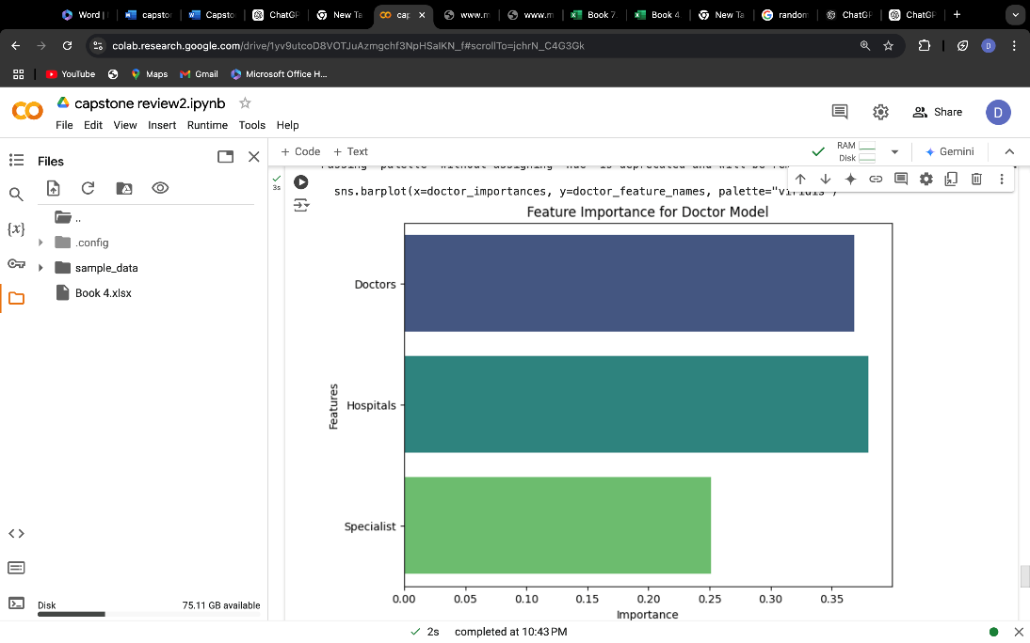

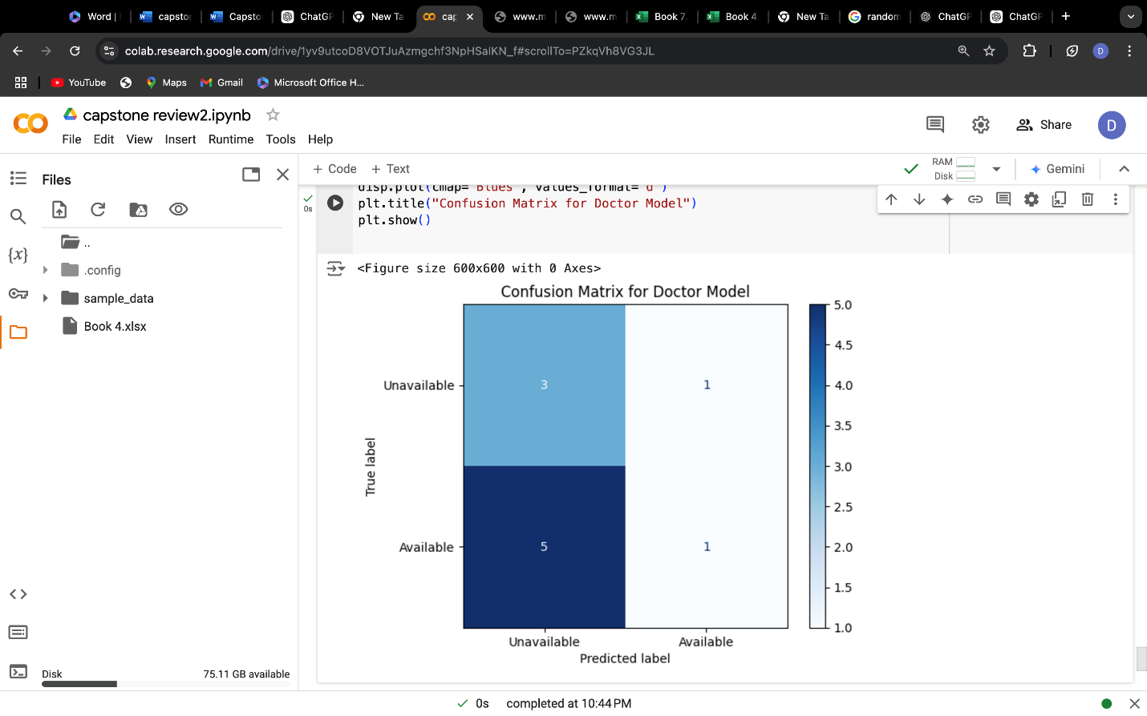

**Pseudocode:**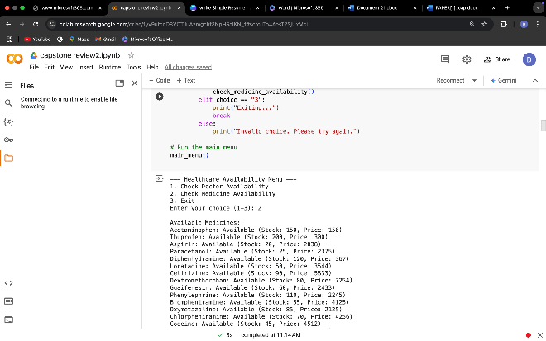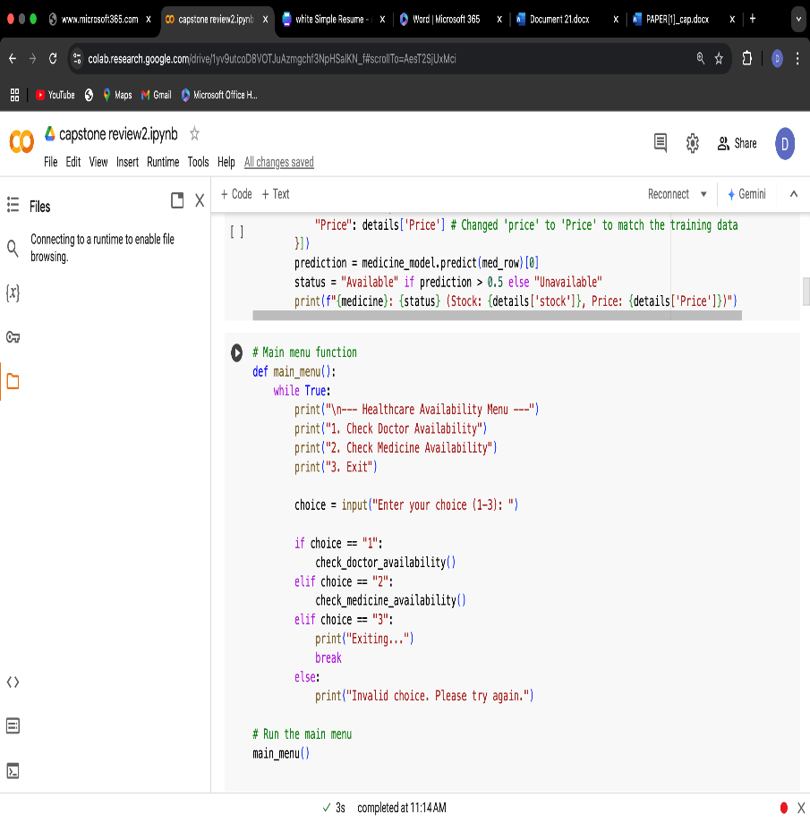

**OUTPUT:**

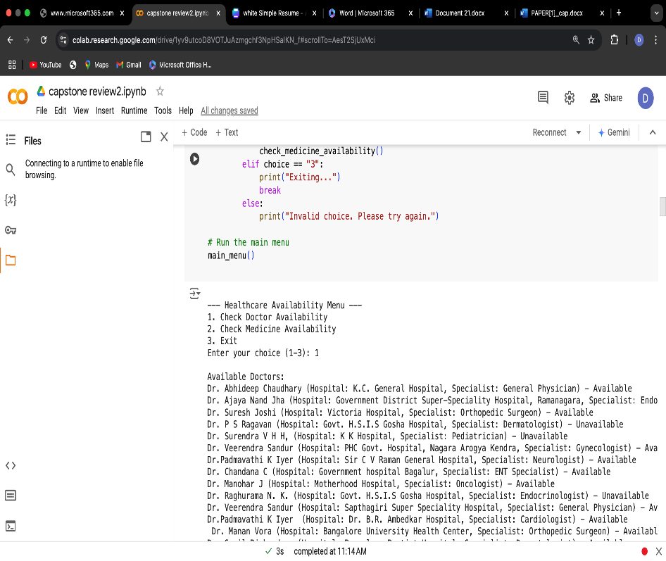

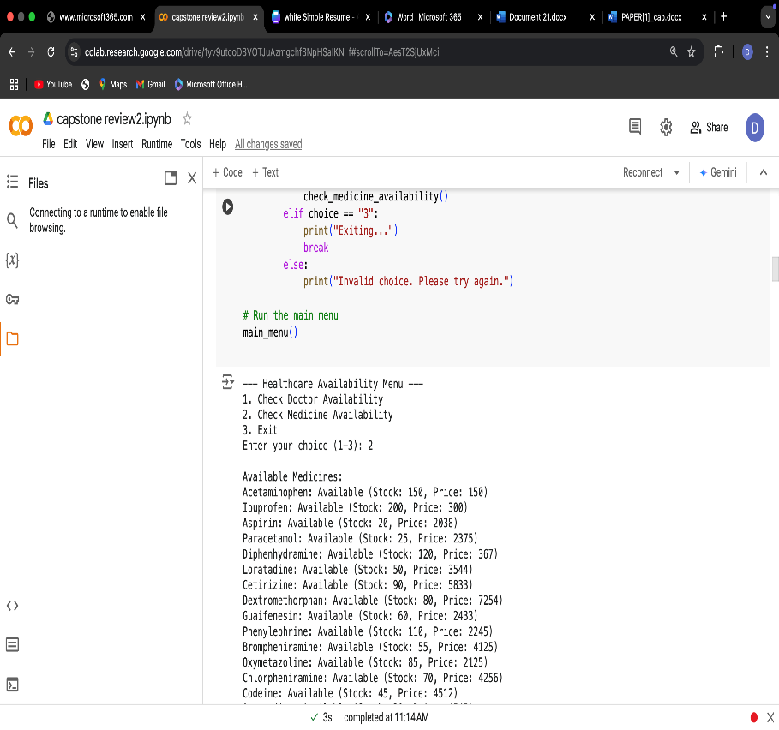

**6. DRAWBACKS**

Data Quality: The model will be abstinent with the practicum data; however, incomplete or noisy data discharges the accuracy of the model and randoms in labelling during the practicum do not appear to have a trend in real time.

Model Limitations: Random Forest models suffer from overfitting on small datasets, random forest, however, hyperparameter tuning is limited hence, the performance of the model.

No Real-Time Updates: A static-based model does not keep pace with dynamic fluctuations of doctor-time schedules and medicines running out.

User Experience: Console-based output does not offer user-friendly interfaces and visualization tools for decision-making.

Ethics implications: Data privacy risks and the biases of biases in the data result in equipoise inequities in predictions.

**7. CONCLUSION**

Predictive analysis of medicines and doctors in government hospitals is a very transformative approach with great implications. Using data-driven insights, predictive models can help enhance medicine supply chains through predicting medicine demand based on historical data, seasonal trends, and patient demographics. This reduces the instances of stockouts and overstocking to ensure that patients have access to drugs whenever needed.

Improve Doctor Availability: Using scheduling data and patient influx trends, predictive analytics can optimize resource allocation, with enough doctors available during peak times, but not so many during low-influx periods.

Assist in Proactive Health Management: Predictive tools will identify patterns in patient admissions, predict surges in demand, and enable hospitals to strategically allocate resources, thereby reducing wait times and improving care delivery.

Reduce Costs and Inefficiencies: Precise predictions will assist hospitals to optimize procurement and workforce to cut unnecessary wastages that reduce operational efficiencies.

Build Strong Public Health Outcomes: Closing gaps regarding medicine availability and doctors on the ground actually leads to care that is well improved while cutting wait time and assuring that treatments can be timely served.

In conclusion, the integration of predictive analytics in government hospitals is a step toward smarter healthcare management. It not only resolves logistical challenges but also strengthens the trust and efficiency of public healthcare systems. However, successful implementation requires robust data collection systems, trained personnel, and supportive policies to maximize its benefits.

**8.REFERENCE**

1. Shaikh Karnool Afsa, Khandhakar Nayeem Rejwam, Dada Khalandar “Predictive mechanism for medicines availability in government health centers”, publications on ijeat ,2024

2.M.D Boomija,M.I Almas Banu,k Anu priya “Analysis on medicine and Doctor in government hospital”, Publications on ijraset, 2019

3.Predictive Analytics on healthcare, www.ijsr.net

4.Smitha Jhajharia,Seema verma,Manish kumar “Predictive Analytics for better health and disease reduction”, publication on predictive analytics today ,2021

5.Damien S. E Brokharst,Rogier van de wetering,Ward Ooms,Remko W.Helms “Deploying Predictive Analytics to enhance patient agility and patient value in hospital”, publications on Elsevier ,2023

6. Sharique Ahmad, Priyesh Srivastava Tanish Baqar “Predictive Analytics in medical healthcare: a meta-Analysis", publication on Research gate, 2024

7.Mohammed Badawy,Nagy Ramadan and Hesham Ahmed hefny “Healthcare predictive analytics using ML and DL technique: a survey", publications on Springer open,2023

8.Wullinarllur Raghupathi and Viju Raghupathi “Big data analytics in. Healthcare: promise and potential”, Publications on Springer 2014

9.Yichung Wang, Leeann Kung, Choachi Ting “Beyond a technical perspective: understanding big data capabilities in healthcare", publication on ResearchGate,2021

10. Neeraj ,Pradeep kumar “Predictive analysis on availability of medicines and doctors in government hospitals”, publications on ijeat,2020

11. Guanhua Lee, Sijia Wang,Lian Leng “Leveraging on Predictive Analytics to Manage Clinic No-Show and Improve Accessibility of Care”, publications on IEEE,2017

12. Mimoh Oiha,Dr Kirti Mathur “Proposed Application of Big Data Analytics in Healthcare at Maharaja Yashwantrao Hospital”, Publications on IEEE,2016