**Predictive analysis of city based crops using Internet of Things based Hydroponic system**

Nikhil K   
Student  
VIT UniversityVellore, India  
kavuru.nikhil2018@vitstudent.ac.in

S A Hariprasad   
Student  
VIT UniversityVellore, India  
Sa.hariprasad2018@vitstudent.ac.in

Yokesh Babu S   
Professor  
VIT UniversityVellore, India  
yokeshbabu.s@vit.ac.in

*Abstract*—***This paper tells about the best and optimum conditions in which one can grow crops using Hydroponic farming. For this work, we are growing coriander plant in a controlled environment with constant monitoring, the controlled environment being restricted water supply I,e Hydroponic farming. Various parameters like Soil pH, Moisture levels etc. are recorded on daily basis and made into a data set. This data set, then  with the help of Supervised Machine Learning algorithms we are going to Co-Relate the data collected via IOT by the help of Regression Models ,find the trends within the taken parameters and give an idea as to which conditions give a better yield.***

Keywords— Supervised Machine Learning Algorithms, Regression Models, Controlled Environment, Hydroponic

# Introduction

In a rapidly developing country like India, which has the world’s highest growing GDP Urbanization is being seen in every nuke and corner of the country. The difference between the population density of the cities and rural areas are very high. The population of the cities are growing exponentially every year, because of which the agricultural farms in and around the cities are being converted into residential sky scrapers. The need and demand for crops and food is growing up but the area to grow is going down. Due to this alarming scenario, hydroponic agriculture has risen in popularity and practice. It is a form of agriculture in which the plants are grown with restricted water supply.

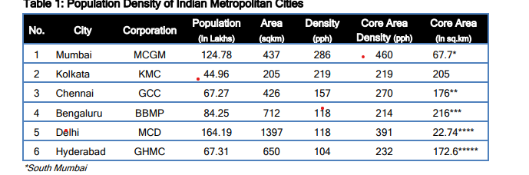

Figure 1:Population Density of Indian Metropolitan Cities

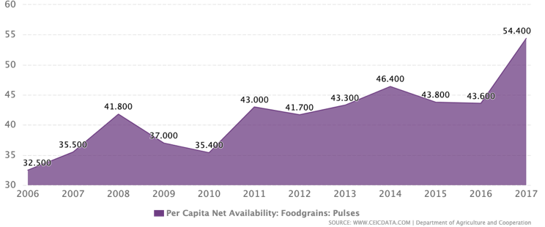

Figure 2: Per Capita Net Availability: Food grains: Pulses

Agriculture is the primary occupation in India and is the backbone of Indian economic system. Agriculture provides employment opportunities to rural people on a large scale in underdeveloped and developing countries in addition to providing food. It is the process of producing food, fibre and many other desired products by the cultivation and raising of domestic animals. Agriculture is the primary source of livelihood for about more than 58% of India’s population.

As the population of the city grows significantly the need to feed the city heavily lays on the need of agricultural land. As most of the agriculture lands are dried up due to lack of water the need for starvation increases. Hence cities have to start cultivating crops and the need for automated farming in cities becomes crucial.

Climate changes will have a significant impact on agriculture by increasing water demand and limiting crop productivity in areas where irrigation is most needed. Irrigation system, rain fed agriculture, groundwater irrigation are some of the methods introduced to produce healthier crops which may not use water efficiently. In order to use water efficiently a smart system is designed. In the system farmers need not make the water flow into fields manually, but the system automatically does that efficiently.

The traditional methods practiced by people may result in huge wastage of water. Hence, the concept of robotized farming with a mix of IoT has been developed. The technological advancements began to increase the efficiency of production remarkably thus, making it a reliable system. The knowledge of properties of soil determines the water supply to be driven in a smart way. The practice of agriculture in a smart way helps to acquire knowledge of soil and temperature conditions. Developing the smart agriculture using IoT based systems not only increases the production but also avoids wastage of water

# Background

Hydroponic farming is heavily dependent upon the water retention. The limited amount of water available will be retained with the help of a special soil mixture provided whose key role is to maintain the water level without losing the soil moisture.

A lot of work has already been done on the aspect of hydroponic farming. We have gone through various papers and found the following drawbacks and concepts.

Feature Selection has not yet been used in the creation of the machine learning model in this study. As a result, the outcome was less than satisfactory. The lettuce was standing straight one day and swaying to the side the next due to the blowing wind. Other errors were influenced by the amount of sunlight and temperature on that particular day. A lot of sunlight causes the plant to wither and unfold. When measured on a day with less sunlight and temperature, the width is smaller than when measured on a day with more sunlight and temperature.[4] Finally, these flaws caused the model to fail to produce a good learning result.

This work focuses on a model which maintains soil moisture level which is optimum for the crop growth.

This level of soil moisture will be maintained constantly for the next 24 hours with no impact and consideration of the weather condition. This work also talks about smart irrigation system which helps in apt water management and provides ideal crop suggestions based on historic soil data.

This work also provides the type and quantity of various minerals needed.[9] This work does not talk about the plant diseases, this can further be extended so as to detect diseases and automated dispersal of pesticides and insecticides.

This work emphasizes on the importance of IoT based technologies in agriculture. This paper works on the use of Low-Power Wide-Area Network(LPWAN) to reduce the power consumption and increasing the wireless range by eliminating the unnecessary dependency of third party and backhaul networks. It also describes the comparisons between Coverage Range, Quality of Service, Battery Life, Latency, Scalability, Payload Length and Development model between LPWAN technologies. The only major drawback of the paper is the maintenance the LPWAN requires to keep it running as the technology used won’t have the ideal conditions to run in an agricultural setup even though the batter life and power consumption are ideal.[7]

Multi-Level IOT framework, which uses Application Layer, Internet Layer, Sensor and Actuator Framework along with Distribution middleware and follows MQTT protocol. In the output, the End User Experiences VPS interaction in one aspect and in the other aspect, it uses VPS and Local Server Interaction. This works falls back in implementing limiting factors such as nitrate, nitrate and ammonia via the electronic sensors. Automated data collection can be implemented into this work so that the system can function with better efficiency and maybe it could send alerts to the sender if there is any change or drastic changes in the parameters.[1]

The paper focuses on five main concepts, namely

Hydroponics, Need for Automation Control, Climate Statistics, Data Analytics and Cloud, Proposed System.

The sensors record analog Data through Hydroponic system with the help of MCP 3008 ADC. This work acts as an eye mainly to farmers but this technology can sometimes act more of an ban than a boon for the farmers. This work is done solely done on the famer end so, it can be implemented in other factors as well[2].

# System Architecture

## Hydroponic Farming

In the present fast pace world, the form of hydroponic farming is taking over. The ongoing research paved new ways and paths for a better and substantial way of farming. Noticing the ways and researching the present trends, mainly followed in metropolitan cities and technologically advanced countries makes lives a lot easier in terms of hydroponic farming.

The work done by us addresses the key issues of automation and IoT integration into the way of sustainable farming in constraints such as limited water supply and space.

## Necessity for automation

The work being done needs constant monitoring as various sensors are used in an confined and controlled environment. But as Human Beings, we tend to make mistakes. To avoid such mistakes that in other ways cannot be avoided, automation is the way.

With the help of Arduino , ESp 8266 and aurd Spread Sheet the reading from the sensors are directly stored into the spreads sheet with almost no error. The readings are recorded once every 10 minutes which without automation requires a immense amount of man power which intern may lead to loss or errors in recorded results.

## Climate Maintained

Farming mainly depends on ambient climatic conditions but the city environment is not suitable for the growth of crops in the traditional way.

For our work as we targeted the metropolitan cities we made sure that the temperature rage varied from 28 degree Celsius to 36 degree Celsius. In hydroponic farming, the crops are not exposed to sunlight throughout. Rather than exposing them to sunlight throughout, we made sure that an adequate sunlight was available which in the day reaches approximately 240 candela and in the night for the integrity of the results, we made sure no light from any source was available which resulted in 0 candela.

Speaking about the soil moisture, for better understating of the impact of moisture retention of the soil we grew the crops in early summer because of which there is humidity in the air than normal. The humidity varied from 40 percent to 80 percent which is the normal range in a coastal city.

TABLE 1: Range of Parameters Full Phase of crop growth

|  |  |  |
| --- | --- | --- |
| **PARAMETER** | **MAX** | **MIN** |
| PH | 27.13 | 6.68 |
| LUMINOUS INTENSITY | 226 | 0 |
| HUMIDITY | 82.5 | 47.8 |
| TEMPERATURE | 38.6 | 25.7 |
| SOIL MOISTURE | 687 | 579 |
| WATER LEVEL | 731 | 153 |

Table 2:Range of Parameters Initial Phase of crop growth

|  |  |  |
| --- | --- | --- |
| **PARAMETER** | **MAX** | **MIN** |
| PH | 27.13 | 6.68 |
| LUMINOUS INTENSITY | 226 | 0 |
| HUMIDITY | 82.5 | 47.8 |
| TEMPERATURE | 38.6 | 25.7 |
| SOIL MOISTURE | 687 | 579 |
| WATER LEVEL | 731 | 153 |

Table 3:Range of Parameters Growing Phase of crop growth

|  |  |  |
| --- | --- | --- |
| **PARAMETER** | **MAX** | **MIN** |
| PH | 12.59 | 0 |
| LUMINOUS INTENSITY | 220 | 0 |
| HUMIDITY | 72.7 | 43.6 |
| TEMPERATURE | 36.3 | 27.7 |
| SOIL MOISTURE | 685 | 676 |
| WATER LEVEL | 661 | 272 |

Table 4:Range of Parameters Harvesting Phase of crop growth

|  |  |  |
| --- | --- | --- |
| **PARAMETER** | **MAX** | **MIN** |
| PH | 27.13 | 6.68 |
| LUMINOUS INTENSITY | 226 | 0 |
| HUMIDITY | 82.5 | 47.8 |
| TEMPERATURE | 38.6 | 25.7 |
| SOIL MOISTURE | 687 | 579 |
| WATER LEVEL | 731 | 153 |

## Data Analysis

All the information collected from the sensors is stored in the personal systems directly rather than cloud as clod is heavily dependent upon an uninterrupted internet connection which sometimes may not be possible.

The data collected is stored and processed with the help of python to create results which help in better understanding of the data.

## Proposed System

An innovative form of hydroponic farming is used. A coco pit is used as an soil replacement as the water retention capacity is much higher in this compared to general soil. The coco pit is connected to water supply which is regulated. Six different sensors are connected to the system. The sensors being, pH sensor which monitors the pH of the water in the coco pit. The water in coco pit pH initially at the time of laying it down was 6.5. The second sensor used is Luminous Intensity Sensor. This sensor monitors the amount of luminescence around the setup. The third sensor is Humidity sensor, this sensor monitors the humidity in the surroundings of the setup. Next sensor used was temperature sensor, this sensor monitors the temperature of the surroundings. The fifth sensor used was soil moisture sensor, this sensor measured the amount of moisture in coco pit throughout the experiment. The final sensor used is water level sensor, this sensor measures the amount of water provided to the system daily. The seeds used were coriander seeds as they take less time to grow which afforded us a chance to cross verify the results by repeating the experiment.

# Experimental Process

According to the proposed system, the experiment is designed in such a way that it is a prototypical implementation. The design procedures are explained with a block Diagram.

## Block Diagram

### In the following proposed system, the analoge and digital sensors collect information from the hydrophonic setup. With the help of Arduno Mega 2560 data is send to spreadsheet in a very smooth and effective manner. The data is collected and saved in database using a wifi module. The block figure is represented for the proposed system.

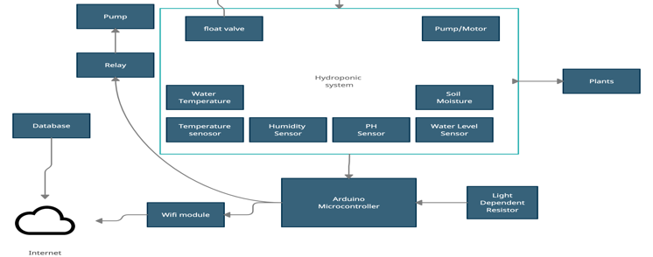

Figure 3: Block diagram of proposed Hydroponic system

Major Steps explained in proposed system is mentioned as flow chart.

## Circuit diagram and components

The proposed circuit is created in such a way that the cost of components is economical and also the quality the components is not comparamised and also the performance of the components are very good.

The Major components invloved in proposed system are:

* Arduino Mega 2560
* Temperature sensor (DHT-22)
* Humidity Sensor (DHT-22)
* Water Level Sensor
* Soil Moisture Sensor
* PH Sensor
* Luminous Intensity Sensor
* WIFI module (ESP 8266)
* Breadboard
* Jumper wires
* Pump
* Water Tube
* 5V motor
* 5V power supply

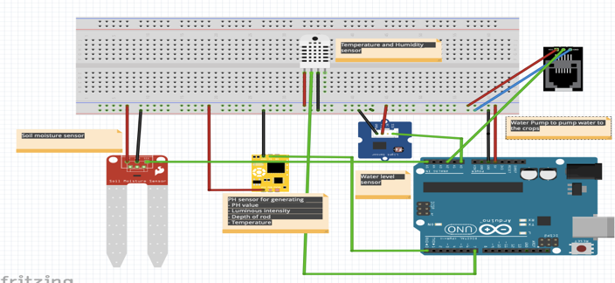

Figure 4: Circuit diagram of proposed Hydroponic System

The main component of the automated system is Arduino Uno Mega 2560 which is a very stable model which provides propper power supply and also helps in uploading large bundle of code.

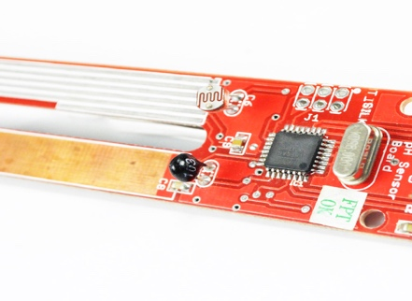

Figure 5: Economic PH sensor with Luminous intensity sensor

PH Sensor - In both soil and hydroponics gardening, optimal pH levels are crucial for healthy plants and excellent harvests. Maintaining those ideal values necessitates frequent, reliable pH testing, especially in soilless growth systems. A plant's nutrient uptake is maximised at ideal pH values. The vigour and productivity of a plant are increased as a result of these nutrients. Luminous Intensity Sensor helps to capture the amount of sunlight hitting the product

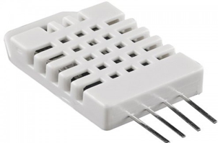

Figure 6: DHT-22 Humidity and Temperature Sensor

DHT22 Temperature/Humidity Sensor - The DHT22 is a humidity and temperature sensor with a single wire digital interface. The sensor is calibrated so you can get right to measuring relative humidity and temperature.

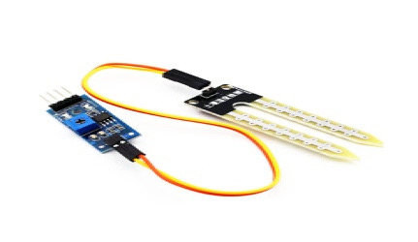

Figure 7: Image of soil moisture Sensor

Soil Moisture Sensor - This soil moisture sensor can be used to detect soil moisture or evaluate if there is water around the sensor. It also tells you if the plants in the mesh pot need to be watered.

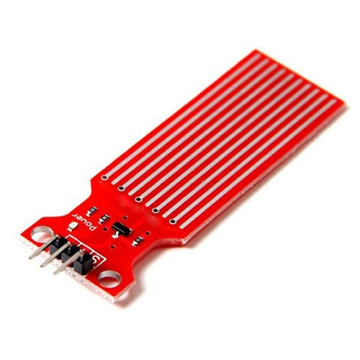

Figure 8: Image of Water Level Sensor

Water-Level Sensor - A water-level sensor is a device that detects the level of water in a container. Maintaining the water level allows the roots to absorb the proper amount of water and prevents the plant from being spoilt.

# Dataset Analysis

## Variation of PH with respect to time

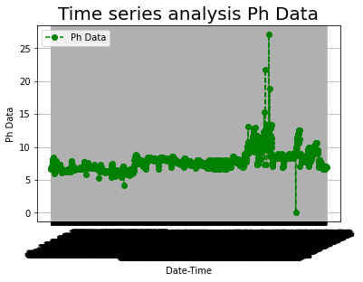

Figure 9: Time series Analysis of PH

(100 words)

## Variation of Sunlight with respect to time

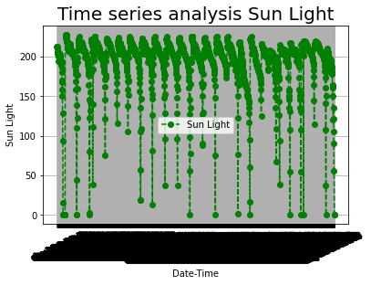

Figure 10: Time series Analysis of Luminous Intensity/ Sunlight for plant

(100 words)

## Variation of Humidity with respect to time

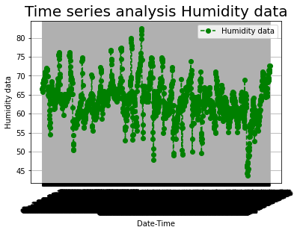

Figure 11: Time series Analysis of Humidity

(100 words)

## Variation of Temperature with respect to time

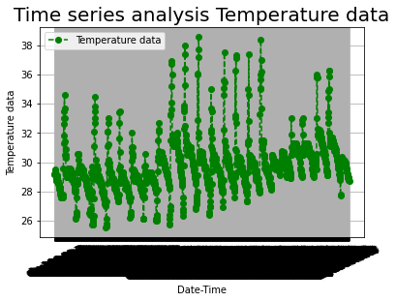

Figure 12: Time series Analysis of Temperature

(100 words)

## Variation of Soilmoisture with respect to time

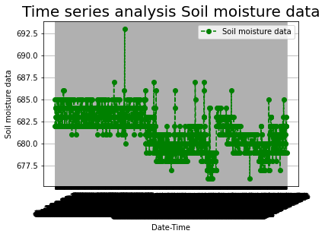

Figure 13: Time series Analysis of Soil Moisture

(100 words)

## Variation of Water Level with respect to time

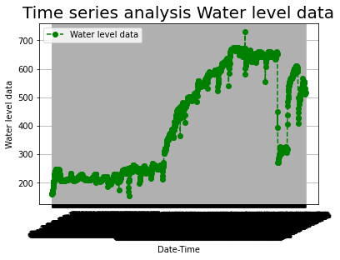

Figure 14: Time series Analysis of Water Level

(100 words)

# Result And discussion

The Evaluation Parameters used for regression models are:

* Mean Absolute Error (MAE)
* Root Mean Square Error (MASE)
* Root Mean Square Log Error (RMSE)
* R Squared(R2)

## Predictive Analysis of parameters using Linear Regression

Table 5: Linear Regression Between Parameters for Initial Phase of Coriander Plant Growth

|  |  |  |  |  |  |  |
| --- | --- | --- | --- | --- | --- | --- |
| **PARAMETER VS PARAMETER** | **PH** | **SUNLIGHT** | **HUMIDITY** | **TEMPERATURE** | **SOILMOISTURE** | **WATER LEVEL** |
| PH | X | MAE=26.54 MASE=1702.59 RMSE=41.26 R2=-0.00288 | MAE=3.13 MASE=17.055 RMSE=4.1298 R2= 0.03718 | MAE=0.9522 MASE=2.0584 RMSE=1.43474 R2=-0.003785 | MAE=0.9161 MASE=1.1950 RMSE=1.0931 R2=-0.011836 | MAE= 11.9423. MASE= 233.031 RMSE= 15.265 R2=-0.0039 |
| SUNLIGHT | MAE=0.3905 MASE= 0.2885 RMSE= 0.5371 R2= -0.00707 | X | MAE= 2.9133 MASE= 16.551 RMSE= 4.0683 R2= 0.0650 | MAE= 0.7492 MASE= 1.268 RMSE= 1.126 R2= 0.145 | MAE=0.902 MASE=1.160 RMSE= 1.077 R2=-0.0417 | MAE=1.0388 MASE= 1.521 RMSE= 1.233 R2=0.078 |
| HUMIDITY | MAE=0.3817 MASE=0.253 RMSE= 0.503 R2=-0.0074 | MAE=21.29 MASE= 1630.14 RMSE= 40.375 R2= 0.157 | X | MAE= 0.831 MASE= 1.205 RMSE= 1.097 R2= 0.517 | MAE=0.875 MASE=1.06 RMSE=1.033 R2= -0.0056 | MAE=9.843 MASE=174.68 RMSE=13.21 R2=0.0941 |
| TEMPERATURE | MAE=0.409 MASE=0.316 RMSE= 0.562 R2=0.0032 | MAE=22.06 MASE=1529.58 RMSE=39.109 R2=0.216 | MAE=2.64 MASE=10.3 RMSE=3.214 R2=0.505 | X | MAE=0.9160 MASE=1.190 RMSE=1.090 R2=-0.012 | MAE=9.714 MASE=168.86 RMSE=12.99 R2=0.087 |
| SOILMOISTURE | MAE= 0.389 MASE= 0.278 RMSE= 0.527 R2= = -0.0094 | MAE=24.12 MASE= 1462.23 RMSE= 38.23 R2=0.0032 | MAE= 0.933 MASE=2.1119 RMSE= 1.453 R2= -0.0231 | MAE=2.890 MASE=15.77 RMSE= 3.97 R2=-0.018 | X | MAE=11.212 MASE=229.93 RMSE= 15.16 R2= -0.0049 |
| WATER LEVEL | MAE= 0.339 MASE=0.232 RMSE=0.4819 R2=0.0221 | MAE= 22.450 MASE= 1350.67 RMSE= 36.75 R2= 0.190 | MAE= 3.35 MASE=2.043 RMSE=1.4296 R2=0.0010 | MAE=3.356 MASE=18.41 RMSE=4.29 R2=0.039 | MAE=0.797 MASE=1.540 RMSE= 1.240 R2= 0.0032 | X |

(100 words)

Table 6: Linear Regression Between Parameters for Growing Phase of Coriander Plant Growth

|  |  |  |  |  |  |  |
| --- | --- | --- | --- | --- | --- | --- |
| **PARAMETER VS PARAMETER** | **PH** | **SUNLIGHT** | **HUMIDITY** | **TEMPERATURE** | **SOILMOISTURE** | **WATER LEVEL** |
| PH | X | MAE=21.157 MASE=1228.42 RMSE=35.04 R2=-0.0048 | MAE=3.400 MASE=21.329 RMSE=4.618 R2= -0.0108 | MAE=1.155 MASE=3.1804 RMSE=1.783 R2=-0.0061 | MAE=1.6315 MASE=3.9975 RMSE=1.999 R2=0.0096 | MAE= 136.46. MASE= 23789.17 RMSE= 154.2 R2=0.1199 |
| SUNLIGHT | MAE=0.944 MASE= 2.5054 RMSE= 1.582 R2= 0.0000523 | X | MAE= 3.309 MASE= 20.457 RMSE= 4.522 R2=0.194 | MAE= 1.010 MASE= 2.544 RMSE= 1.595 R2= 0.1704 | MAE=1.556 MASE=3.836 RMSE= 1.958 R2=0.0247 | MAE=1.562 MASE= 3.678 RMSE= 1.917 R2=0.033 |
| HUMIDITY | MAE=0.9677 MASE=2.328 RMSE= 1.525 R2=0.00814 | MAE=19.44 MASE= 1072.59 RMSE= 32.750 R2= 0.1304 | X | MAE= 0.943 MASE= 1.686 RMSE= 1.298 R2= 0.5603 | MAE=1.6009 MASE=3.845 RMSE=1.96 R2= 0.00245 | MAE=134.715 MASE=24155.87 RMSE=155.42 R2=0.1037 |
| TEMPERATURE | MAE=0.8932 MASE=1.6079 RMSE=1.268 R2=-0.0076 | MAE=18.107 MASE=888.58 RMSE=29.80 R2=0.165 | MAE=2.487 MASE=10.05 RMSE=3.171 R2=0.563 | X | MAE=1.780 MASE=4.511 RMSE=2.123 R2=-0.0042 | MAE=142.16 MASE=25289.25  RMSE=159.02 R2=0.0057 |
| SOILMOISTURE | MAE= 0.959 MASE= 2.385 RMSE= 1.544 R2= = 0.01081 | MAE=19.289 MASE= 834.443 RMSE= 28.88 R2=0.0037 | MAE= 1.0317 MASE=2.1168 RMSE=1.454 R2= -0.0373 | MAE=3.3324 MASE=21.27 RMSE= 4.612 R2=-0.00273 | X | MAE=130.00 MASE=23137.316  RMSE= 152.109  R2= 0.0110 |
| WATER LEVEL | MAE= 0.886 MASE=2.728 RMSE=1.65 R2=0.1177 | MAE= 20.0011 MASE= 1183.82 RMSE= 34.406 R2= 0.0038 | MAE= 1.563 MASE=3.701 RMSE= 1.923 R2=0.0199 | MAE=3.494 MASE=20.4542 RMSE=4.5226 R2=0.073 | MAE=1.173 MASE=2.624 RMSE= 1.62 R2= 0.0017 | X |

(100 words)

Table 7: Linear Regression Between Parameters for Harvesting Phase of Coriander Plant Growth

|  |  |  |  |  |  |  |
| --- | --- | --- | --- | --- | --- | --- |
| **PARAMETER VS PARAMETER** | **PH** | **SUNLIGHT** | **HUMIDITY** | **TEMPERATURE** | **SOILMOISTURE** | **WATER LEVEL** |
| PH | X | MAE=22.685 MASE=1027.818 RMSE=32.059 R2=-0.020 | MAE=4.589 MASE=33.367 RMSE=5.77 R2= -0.154 | MAE=0.906 MASE=1.836 RMSE=1.35 R2=0.0653 | MAE=1.1328 MASE=1.821 RMSE=1.349 R2=0.032 | MAE= 100.54. MASE=15723.309 RMSE= 125.392 R2=-0.05177 |
| SUNLIGHT | MAE=0.9731 MASE= 1.421 RMSE= 1.192 R2= -0.0967 | X | MAE= 3.446 MASE= 20.575 RMSE= 4.535 R2= 0.1587 | MAE= 0.7630 MASE=1.6451 RMSE= 1.282 R2= 0.2184 | MAE=0.945 MASE=1.470 RMSE= 1.212 R2=-0.0047 | MAE=1.0651 MASE= 1.972 RMSE= 1.404 R2=0.00676 |
| HUMIDITY | MAE=0.8707 MASE=1.2903 RMSE= 1.1359 R2=0.153 | MAE=19.1465 MASE= 1114.27 RMSE= 33.38 R2= 0.205 | X | MAE=0.725 MASE= 1.277 RMSE= 1.130 R2= 0.290 | MAE=1.008 MASE=1.796 RMSE=1.340 R2= 0.01474 | MAE=108.25 MASE=14820.36 RMSE=121.738 R2=0.207 |
| TEMPERATURE | MAE=0.9607 MASE=1.441 RMSE=1.2004 R2=0.075 | MAE=20.242 MASE=1750.404 RMSE=41.837 R2=0.2634 | MAE=3.8819 MASE=25.495 RMSE=5.049 R2=0.3559 | X | MAE=1.130 MASE=2.060 RMSE=1.435 R2=0.00103 | MAE=111.24 MASE=16898.54RMSE=129.99 R2=0.026065 |
| SOILMOISTURE | MAE= 0.9433 MASE= 2.2974 RMSE= 1.515 R2= = -0.0189 | MAE=23.149 MASE= 1434.32 RMSE= 37.87 R2=-0.00766 | MAE= 1.0291 MASE=1.813 RMSE= 1.346 R2= -0.1067 | MAE=4.599 MASE=33.304 RMSE= 5.770 R2=-0.0732 | X | MAE=105.00 MASE=16357.032 RMSE=127.894 R2= -0.004 |
| WATER LEVEL | MAE= 0.9163 MASE=1.311 RMSE=1.145 R2=0.0459 | MAE= 28.312 MASE= 2365.95 RMSE= 48.641 R2= 0.000481 | MAE=1.055 MASE=1.63225 RMSE=1.2775 RE=0.0771 | MAE=4.03624 MASE= 25.24 RMSE=5.024 R2=0.16178 | MAE=0.9096 MASE=1.342 RMSE= 1.158 R2= 0.0436 | X |

(100 words)

Table 8: Linear Regression Between Parameters for Full Phase of Coriander Plant Growth

|  |  |  |  |  |  |  |
| --- | --- | --- | --- | --- | --- | --- |
| **PARAMETER VS PARAMETER** | **PH** | **SUNLIGHT** | **HUMIDITY** | **TEMPERATURE** | **SOILMOISTURE** | **WATER LEVEL** |
| PH | X | MAE=23.313 MASE=1591.03 RMSE=39.88 R2=0.00118 | MAE=3.9601 MASE=27.939 RMSE=5.285 R2= 0.00598 | MAE=1.210 MASE=3.0650 RMSE=1.750 R2=0.0599 | MAE=1.8210 MASE=4.899 RMSE=2.213 R2=0.0378 | MAE= 137.684 MASE= 22732.459 RMSE= 150.772 R2=0.2893 |
| SUNLIGHT | MAE=1.0360 MASE= 2.128 RMSE= 1.459 R2= -0.000246 | X | MAE= 3.419 MASE= 21.26 RMSE= 4.61 R2= 0.157 | MAE= 1.147 MASE= 2.604 RMSE= 1.613 R2= 0.185 | MAE=1.921 MASE=5.188 RMSE= 2.277 R2=-0.0118 | MAE=1.8404 MASE= 4.6457 RMSE=2.155 R2=-0.0026 |
| HUMIDITY | MAE=0.9411 MASE=1.633 RMSE= 1.278 R2=0.0245 | MAE=20.003 MASE= 1241.13 RMSE= 35.22 R2= 0.1857 | X | MAE= 0.929 MASE= 1.478 RMSE= 1.216 R2= 0.375 | MAE=1.811 MASE=4.672 RMSE=2.161 R2= 0.023 | MAE=165.664 MASE=31591.99 RMSE=31591.99 R2=0.02649 |
| TEMPERATURE | MAE=0.9259 MASE=2.554 RMSE= 1.598 R2=0.0676 | MAE=20.468 MASE=1358.52 RMSE=36.85 R2=0.176 | MAE=3.1046 MASE=16.046 RMSE=4.005 R2=0.4775 | X | MAE=1.658 MASE=4.024 RMSE=2.006 R2=0.0590 | MAE=166.6700 MASE=31745.512 RMSE=178.172 R2=0.0422 |
| SOILMOISTURE | MAE= 0.936 MASE= 1.618 RMSE= 1.27 R2= =0.113 | MAE=22.930 MASE= 1473.35 RMSE= 38.23 R2=-0.0140 | MAE=1.185 MASE=3.058 RMSE= 1.748 R2= 0.0505 | MAE=3.6435 MASE=24.41 RMSE= 4.94 R2=0.0159 | X | MAE=125.65 MASE=22858.07 RMSE= 151.18 R2= 0.288 |
| WATER LEVEL | MAE= 0.850 MASE=1.518 RMSE=1.23 R2=0.2719 | MAE= 23.489 MASE= 1536.91 RMSE= 39.20 R2= 0.0056 | MAE= 3.864 MASE= 28.33 RMSE= 5.322 R2= 0.0316 | MAE=1.185 MASE=2.916 RMSE=1.707 R2=0.0823 | MAE=1.451 MASE=3.329 RMSE= 1.824 R2= 0.3089 | X |

(100 words)

## Predictive Analysis of parameters using Support Vector Regression

Table 9: Support Vector Regression Between Parameters for Initial Phase of Coriander Plant Growth

|  |  |  |  |  |  |  |
| --- | --- | --- | --- | --- | --- | --- |
| **PARAMETER VS PARAMETER** | **PH** | **SUNLIGHT** | **HUMIDITY** | **TEMPERATURE** | **SOILMOISTURE** | **WATER LEVEL** |
| **PH** | X | MAE=22.102 MASE=2351.64 RMSE=48.493 R2=-0.0852 | MAE=2.9432 MASE=15.363 RMSE=3.919 R2= 0.2227 | MAE=0.82803 MASE=1.598 RMSE=1.2642 R2=0.0446 | MAE=0.8812 MASE=1.423 RMSE=1.193 R2=-0.174 | MAE= 10.6116 MASE= 218.732 RMSE= 14.789 R2=-0.0377 |
| **SUNLIGHT** | MAE=0.3460 MASE= 0.227 RMSE= 0.4766 R2= -0.0458 | X | MAE= 2.836 MASE=13.770 RMSE= 3.710 R2= 0.264 | MAE= 0.518 MASE= 0.871 RMSE= 0.933 R2= 0.450 | MAE=0.8686 MASE=1.362 RMSE= 1.167 R2=-0.120 | MAE=0.989 MASE= 1.627 RMSE= 1.275 R2=-0.225 |
| **HUMIDITY** | MAE=0.310 MASE=0.174 RMSE= 0.417 R2=0.275 | MAE=17.27 MASE= 1259.407 RMSE= 35.48 R2= 0.0078 | X | MAE= 0.683 MASE= 0.825 RMSE=0.908 R2= 0.3423 | MAE=0.833 MASE=1.378 RMSE=1.174 R2= -0.057 | MAE=9.329 MASE=169.081 RMSE=13.0031 R2=0.0302 |
| **TEMPERATURE** | MAE=0.396 MASE=0.317 RMSE= 0.563 R2=0.00755 | MAE=13.68 MASE=1172.59 RMSE=34.24 R2=0.2142 | MAE=2.742 MASE=11.737 RMSE=3.425 R2=0.466 | X | MAE=0.842 MASE=1.325 RMSE=1.151 R2=-0.1810 | MAE=7.9547 MASE=137.199 RMSE=11.713 R2=0.25006 |
| **SOILMOISTURE** | MAE= 0.348 MASE= 0.199 RMSE= 0.4461 R2= = -0.0110 | MAE=20.962 MASE= 2052.051 RMSE= 45.299 R2=-0.0695 | MAE=3.7415 MASE=23.297 RMSE=4.8267 R2= -0.0293 | MAE=0.896 MASE=1.852 RMSE= 1.3611 R2=-0.1329 | X | MAE=8.9695 MASE=161.8012 RMSE= 12.7201 R2= -0.00836 |
| **WATER LEVEL** | MAE= 0.359 MASE=0.2667 RMSE=0.5165 R2=-0.0788 | MAE= 23.2524 MASE= 2417.059 RMSE= 49.1636 R2=0.0059 | MAE= 2.9750 MASE=16.440 RMSE=4.05465 R2=0.02438 | MAE=1.00006 MASE=2.70294 RMSE=1.6440 R2=0.1164 | MAE=0.7492 MASE=1.0809 RMSE= 1.0396 R2= -0.1662 | X |

(100 words)

Table 10: Support Vector Regression Between Parameters for Growing Phase of Coriander Plant Growth

|  |  |  |  |  |  |  |
| --- | --- | --- | --- | --- | --- | --- |
| PARAMETER VS PARAMETER | PH | SUNLIGHT | HUMIDITY | TEMPERATURE | SOILMOISTURE | WATER LEVEL |
| PH | X | MAE=17.013 MASE=1014.28 RMSE=31.84 R2=-0.0743 | MAE=3.8003 MASE=25.36 RMSE=5.0361 R2= 0.0470 | MAE=0.995 MASE=2.330 RMSE=1.526 R2=0.1112 | MAE=1.638 MASE=4.429 RMSE=2.104 R2=0.0109 | MAE= 120.94.  MASE= 24176.55  RMSE= 155.48  R2=0.026 |
| SUNLIGHT | MAE=1.005 MASE= 4.719 RMSE= 2.172 R2= -0.0719 | X | MAE= 3.602 MASE=23.974 RMSE=4.896 R2= 0.1506 | MAE= 0.802 MASE=1.444 RMSE=1.2019 R2=0.430 | MAE=1.6199 MASE=4.0536 RMSE=2.013 R2=0.0220 | MAE=139.698  MASE=29287.10 RMSE=171.134  R2=-0.1414 |
| HUMIDITY | MAE=0.822 MASE=1.879 RMSE= 1.370 R2=-0.0892 | MAE=17.210 MASE=1090.04 RMSE=33.015 R2= 0.0421 | X | MAE=0.745 MASE=0.958 RMSE=0.979 R2= 0.7400 | MAE=1.749 MASE=4.602 RMSE=2.1453 R2=0.0295 | MAE=134.739  MASE= 24557.95 RMSE=156.709  R2=-0.0675 |
| TEMPERATURE | MAE=0.839 MASE=1.934 RMSE=1.391 R2=-0.0447 | MAE=18.473 MASE=1451.83 RMSE=38.102 R2=0.1318 | MAE=2.618 MASE=11.78 RMSE=3.43 R2=0.572 | X | MAE=1.564 MASE=3.69 RMSE=1.922 R2=0.0255 | MAE=139.68 MASE=26889.48  RMSE=163.980 R2=-0.00359 |
| SOILMOISTURE | MAE= 0.886 MASE= 2.831 RMSE=1.682 R2= -0.037 | MAE=18.183 MASE= 1149.82 RMSE= 33.909 R2=-0.0549 | MAE= 4.1329 MASE=30.32 RMSE= 5.5065 R2= 0.0070 | MAE=1.1566 MASE=3.419 RMSE= 1.84 R2=-0.0083 | X | MAE=136.775 MASE=24782.89 RMSE=157.42 R2=0.0698 |
| WATER LEVEL | MAE=0.5868 MASE=1.542 RMSE=1.241 R2=0.3133 | MAE=17.654 MASE=1008.07 RMSE=31.750 R2=-0.04008 | MAE=3.581 MASE=24.307 RMSE=4.930 R2=0.1196 | MAE=1.176 MASE=3.361 RMSE=1.83 R2=0.0380 | MAE=1.2847 MASE=2.611 RMSE=1.616 R2=0.368 | X |

(100 words)

Table 11: Support Vector Regression Between Parameters for Harvesting Phase of Coriander Plant Growth

|  |  |  |  |  |  |  |
| --- | --- | --- | --- | --- | --- | --- |
| PARAMETER VS PARAMETER | PH | SUNLIGHT | HUMIDITY | TEMPERATURE | SOILMOISTURE | WATER LEVEL |
| PH | X | MAE=14.519 MASE=1121.40 RMSE=33.487 R2=-0.055 | MAE=3.750 MASE=23.179 RMSE=4.814 R2= 0.2572 | MAE=0.8486 MASE=1.7209 RMSE=1.311 R2=0.0536 | MAE=1.2121 MASE=2.518 RMSE=1.586 R2=0.0438 | MAE= 109.77  MASE= 21901.17  RMSE= 147.99  R2=-0.1792 |
| SUNLIGHT | MAE=0.975 MASE= 1.782 RMSE= 1.334 R2= 0.0502 | X | MAE= 3.642 MASE= 23.84 RMSE= 4.883 R2= 0.2922 | MAE= 0.5587 MASE= 0.9602 RMSE= 0.979 R2= 0.537 | MAE=1.033 MASE=1.731 RMSE= 1.315 R2=-0.109 | MAE=110.02  MASE=21459.37  RMSE= 146.49  R2=0.334 |
| HUMIDITY | MAE=0.733 MASE=1.0997 RMSE=1.0487 R2=0.1170 | MAE=15.693 MASE= 1416.608 RMSE=37.637 R2=0.1004 | X | MAE=0.6907 MASE=1.549 RMSE=1.244 R2=0.144 | MAE=1.197 MASE=2.227 RMSE=1.492 R2= -0.087 | MAE=112.208  MASE=21545.41  RMSE=146.783  R2=-0.1230 |
| TEMPERATURE | MAE=0.848 MASE=1.307 RMSE= 1.143 R2=-0.0404 | MAE=7.830 MASE=209.74 RMSE=14.482 R2=0.491 | MAE=2.654 MASE=13.02 RMSE=3.609 R2=0.3560 | X | MAE=0.9160 MASE=1.190 RMSE=1.090 R2=-0.012 | MAE=103.405 MASE=18617.395  RMSE=136.445 R2=-0.0513 |
| SOILMOISTURE | MAE=0.908 MASE=1.576 RMSE=1.255 R2=0.0711 | MAE=14.502 MASE=1074.906 RMSE=32.785 R2=-0.0437 | MAE=4.892 MASE=38.307 RMSE=6.189 R2= 0.0917 | MAE=1.027 MASE=2.190 RMSE=1.480 R2=-0.0648 | X | MAE=117.428 MASE=22258.28 RMSE=149.192 R2= 0.1749 |
| WATER LEVEL | MAE=0.868 MASE=2.479 RMSE=1.574 R2=0.069 | MAE=13.670 MASE=525.301 RMSE=22.919 R2= -0.1050 | MAE= 3.9546 MASE=25.571 RMSE=5.056 R2=0.3047 | MAE=0.785 MASE=1.084 RMSE=1.041 R2=-0.011 | MAE=0.9191 MASE=1.329 RMSE= 1.152 R2=0.298 | X |

(100 words)

Table 12: Support Vector Regression Between Parameters for Full Phase of Coriander Plant Growth

|  |  |  |  |  |  |  |
| --- | --- | --- | --- | --- | --- | --- |
| PARAMETER VS PARAMETER | PH | SUNLIGHT | HUMIDITY | TEMPERATURE | SOILMOISTURE | WATER LEVEL |
| PH | X | MAE=18.38 MASE=1347.984 RMSE=36.71 R2=-0.0432 | MAE=3.538 MASE=22.984 RMSE=4.7942 R2=0.0380 | MAE=1.002 MASE=2.368 RMSE=1.539 R2=0.189 | MAE=1.506 MASE=3.971 RMSE=1.992 R2=0.1733 | MAE= 127.77. MASE= 22839.3 RMSE= 151.12 R2=0.288 |
| SUNLIGHT | MAE=0.9430 MASE= 2.927 RMSE=1.711 R2= -0.00975 | X | MAE= 3.621 MASE= 23.651 RMSE= 4.8632 R2=0.21463 | MAE= 1.111 MASE=2.539 RMSE=1.593 R2= 0.3130 | MAE=1.9406 MASE=5.305 RMSE= 2.3033 R2=-0.0322 | MAE=162.013 MASE= 31499.0 RMSE=177.479 R2=0.0218 |
| HUMIDITY | MAE=0.9039 MASE=1.6860 RMSE=1.298 R2=-0.0062 | MAE=18.2066 MASE=1258.105 RMSE=35.469 R2= 0.0738 | X | MAE= 0.974 MASE= 1.814 RMSE= 1.3470 R2=0.486 | MAE=1.715 MASE=4.422 RMSE=2.102 R2= 0.0019 | MAE=161.61 MASE=30181.06 RMSE=173.72 R2=0.057 |
| TEMPERATURE | MAE=0.898 MASE=2.785 RMSE= 1.668 R2=0.0656 | MAE=18.518 MASE=1583.68 RMSE=39.109 R2=0.115 | MAE=2.86 MASE=13.61 RMSE=3.689 R2=0.4670 | X | MAE=1.609 MASE=4.139 RMSE=2.034 R2=0.0995 | MAE=136.567 MASE=26169.03 RMSE=161.76 R2=0.148 |
| SOILMOISTURE | MAE=0.8068 MASE=1.744 RMSE=1.320 R2=0.0942 | MAE=20.280 MASE=1555.81 RMSE= 39.443 R2=-0.055 | MAE= 3.8521 MASE=27.5794 RMSE= 5.251 R2= 0.0213 | MAE=1.179 MASE=3.128 RMSE= 1.768 R2=0.0436 | X | MAE=110.411 MASE=21951.64 RMSE=148.160 R2= 0.312 |
| WATER LEVEL | MAE= 0.682 MASE=1.331 RMSE=1.153 R2=0.388 | MAE= 19.253 MASE= 1462.55 RMSE= 38.243 R2= -0.0474 | MAE= 3.608 MASE=25.069 RMSE=5.0069 R2=-0.00369 | MAE=1.0911 MASE=2.591 RMSE=1.609 R2=0.1359 | MAE=1.237 MASE=2.696 RMSE= 1.642 R2= 0.4985 | X |

(100 words)

## Predictive Analysis of parameters using Decision Tree Regression

Table 13: Decision Tree Regression Between Parameters for Initial Phase of Coriander Plant Growth

|  |  |  |  |  |  |  |
| --- | --- | --- | --- | --- | --- | --- |
| PARAMETER VS PARAMETER | PH | SUNLIGHT | HUMIDITY | TEMPERATURE | SOILMOISTURE | WATER LEVEL |
| PH | X | MAE=25.117 MASE=1570.68 RMSE=39.631 R2=-0.0493 | MAE=3.4989 MASE=21.020 RMSE=4.584 R2=0.262 | MAE=1.085 MASE=2.704 RMSE=1.644 R2=-0.415 | MAE=0.952 MASE=1.3727 RMSE=1.171 R2=-0.1289 | MAE=11.330 MASE=266.11 RMSE= 16.312 R2=-0.303 |
| SUNLIGHT | MAE=0.4213 MASE= 0.329 RMSE=0.573 R2= -0.227 | X | MAE= 3.117 MASE=16.69 RMSE=4.085 R2= 0.216 | MAE= 0.637 MASE=1.028 RMSE=1.014 R2=0.5450 | MAE=1.126 MASE=2.266 RMSE=1.505 R2=-0.0655 | MAE=0.996 MASE=1.558 RMSE= 1.248 R2=-0.3035 |
| HUMIDITY | MAE=0.408 MASE=0.292 RMSE=0.541 R2=-0.365 | MAE=36.44 MASE=4653.88 RMSE=68.219 R2=-0.3042 | X | MAE=0.9103 MASE=1.477 RMSE=1.215 R2=0.174 | MAE=1.0399 MASE=2.304 RMSE=1.517 R2=-0.2165 | MAE=11.833 MASE=332.31 RMSE=18.22 R2=-1.0522 |
| TEMPERATURE | MAE=0.389 MASE=0.280 RMSE= 0.529 R2=-0.0033 | MAE=23.802 MASE=2150.406 RMSE=46.37 R2=0.322 | MAE=2.903 MASE=11.880 RMSE=3.446 R2=0.410 | X | MAE=1.1320 MASE=1.858 RMSE=1.363 R2=-0.433 | MAE=8.271 MASE=122.69 RMSE=11.07 R2=0.303 |
| SOILMOISTURE | MAE= 0.406 MASE=0.294 RMSE= 0.542 R2= = -0.0160 | MAE=28.44 MASE= 2407.91 RMSE=49.070 R2=-0.0055 | MAE=3.018 MASE=16.75 RMSE=4.093 R2= -0.020 | MAE=0.7735 MASE=1.104 RMSE=1.050 R2=-0.0059 | X | MAE=11.341 MASE=217.46 RMSE=14.74 R2= -0.205 |
| WATER LEVEL | MAE= 0.334 MASE=0.218 RMSE=0.4672 R2=-0.129 | MAE=21.03 MASE=1526.93 RMSE=39.075 R2=0.2402 | MAE= 3.323 MASE=18.834 RMSE=4.339 R2=0.05843 | MAE=0.919 MASE=2.70294 RMSE=1.5006 R2=0.0072 | MAE=1.0835 MASE=1.879 RMSE=1.3707 R2= -0.5531 | X |

(100 words)

Table 14: Decision Tree Regression Between Parameters for Growing Phase of Coriander Plant Growth

|  |  |  |  |  |  |  |
| --- | --- | --- | --- | --- | --- | --- |
| PARAMETER VS PARAMETER | PH | SUNLIGHT | HUMIDITY | TEMPERATURE | SOILMOISTURE | WATER LEVEL |
| PH | X | MAE=23.487 MASE=1556.330 RMSE=39.450 R2=-0.133 | MAE=4.4440 MASE=33.518 RMSE=5.789 R2= -0.066 | MAE=1.067 MASE=2.294 RMSE=1.514 R2=0.0555 | MAE=1.662 MASE=4.845 RMSE=2.201 R2=0.0173 | MAE= 86.23 MASE=14214.92 RMSE= 119.22 R2=0.422 |
| SUNLIGHT | MAE=1.210 MASE=5.287 RMSE=2.299 R2= -0.220 | X | MAE=3.764 MASE=24.775 RMSE=4.977 R2=0.1022 | MAE=0.902 MASE=2.036 RMSE= 2.036 R2= 0.3970 | MAE=1.852  MASE=5.100 RMSE=2.258  R2=-0.126 | MAE=140.63 MASE=28070.58 RMSE=167.54 R2=-0.131 |
| HUMIDITY | MAE=1.085 MASE=2.475 RMSE= 1.57 R2=-0.264 | MAE=19.74 MASE= 1059.71 RMSE= 32.55 R2= -0.2786 | X | MAE=0.9107 MASE=1.569 RMSE=1.252 R2=0.438 | MAE=1.816  MASE=5.153 RMSE=2.270  R2= -0.4041 | MAE=142.944 MASE=32162.22 RMSE=179.338 R2=-0.161 |
| TEMPERATURE | MAE=0.947 MASE=1.723 RMSE=1.312 R2=-0.142 | MAE=15.279 MASE=791.16 RMSE=28.127 R2=0.2953 | MAE=2.512 MASE=11.047 RMSE=3.323 R2=0.475 | X | MAE=1.775 MASE=4.988  RMSE=2.233 R2=-0.105 | MAE=134.80 MASE=25756.83 RMSE=160.48 R2=-0.010 |
| SOILMOISTURE | MAE=1.0263 MASE=4.360 RMSE=2.088 R2= =-0.0082 | MAE=21.63 MASE= 1319.71 RMSE=36.32 R2=-0.0284 | MAE=3.285 MASE=19.059 RMSE=4.365 R2= -0.0023 | MAE=1.063 MASE=2.231 RMSE=1.493 R2=0.0132 | X | MAE=121.68 MASE=22438.58 RMSE=149.79 R2=0.1508 |
| WATER LEVEL | MAE= 0.698 MASE=1.371 RMSE=1.171 R2=0.0499 | MAE=22.549 MASE=1676.62 RMSE=40.94 R2=-0.261 | MAE=3.063 MASE=20.044 RMSE=4.477 R2=0.2023 | MAE=1.067 MASE=3.0071 RMSE=1.734 R2=0.09765 | MAE=1.528 MASE=3.8184 RMSE=1.9540 R2= 0.0723 | X |

(100 words)

Table 15: Decision Tree Regression Between Parameters for Harvesting Phase of Coriander Plant Growth

|  |  |  |  |  |  |  |
| --- | --- | --- | --- | --- | --- | --- |
| PARAMETER VS PARAMETER | PH | SUNLIGHT | HUMIDITY | TEMPERATURE | SOILMOISTURE | WATER LEVEL |
| PH | X | MAE=22.732 MASE=2045.76 RMSE=45.230 R2=-0.0708 | MAE=4.569 MASE=45.141 RMSE=6.718 R2= -0.4399 | MAE=0.882 MASE=2.502 RMSE=1.581 R2=-0.225 | MAE=1.471 MASE=4.134 RMSE=2.0333 R2=-0.8793 | MAE= 83.55 MASE= 18340.29 RMSE=135.42 R2=-0.069 |
| SUNLIGHT | MAE=1.146 MASE=2.743 RMSE=1.656 R2= -0.0261 | X | MAE=3.395 MASE=21.554 RMSE=4.642 R2=0.414 | MAE= 0.6377 MASE= 1.307 RMSE=1.143 R2= 0.498 | MAE=1.5740 MASE=3.8384 RMSE=1.959 R2=-0.453 | MAE=129.51 MASE=25884.24 RMSE=160.885 R2=0.4367 |
| HUMIDITY | MAE=1.062 MASE=2.186 RMSE=1.478 R2=-0.724 | MAE=15.92 MASE=505.16 RMSE=22.47 R2=0.59 | X | MAE=0.841 MASE=2.206 RMSE=1.485 R2= -0.262 | MAE=1.522 MASE=3.722 RMSE=1.929 R2= -0.926 | MAE=87.022 MASE=15484.1 RMSE=124.43 R2=0.135 |
| TEMPERATURE | MAE=0.723 MASE=0.985 RMSE=0.992 R2=0.4802 | MAE=7.183 MASE=198.86 RMSE=14.102 R2=0.787 | MAE=3.359 MASE=23.251 RMSE=4.822 R2=0.342 | X | MAE=1.123 MASE=1.954 RMSE=1.397 R2=-0.4325 | MAE=93.27 MASE=15132.8 RMSE=123.01 R2=-0.0493 |
| SOILMOISTURE | MAE=1.046 MASE=1.781 RMSE= 1.33 R2= = -0.018 | MAE=28.62 MASE=2623.48 RMSE=51.220 R2=-0.0750 | MAE=4.297 MASE=29.772 RMSE=5.456 R2= -0.190 | MAE=1.060 MASE=1.905 RMSE=1.380 R2=-0.3879 | X | MAE=117.64 MASE=22102.11 RMSE=148.66 R2= -0.1676 |
| WATER LEVEL | MAE= 0.7400 MASE=1.444 RMSE=1.201 R2=0.158 | MAE=22.803 MASE=1843.464 RMSE=42.935 R2=-0.616 | MAE=4.103 MASE=32.056 RMSE=5.661 R2=0.0454 | MAE=1.00740 MASE=2.8656 RMSE=1.6928 R2=-0.9196 | MAE=1.197 MASE=2.6819 RMSE=1.6376 R2= -0.33059 | X |

(100 words)

Table 16: Decision Tree Regression Between Parameters for Full Phase of Coriander Plant Growth

|  |  |  |  |  |  |  |
| --- | --- | --- | --- | --- | --- | --- |
| PARAMETER VS PARAMETER | PH | SUNLIGHT | HUMIDITY | TEMPERATURE | SOILMOISTURE | WATER LEVEL |
| PH | X | MAE=23.667 MASE=1574.28 RMSE=39.67 R2=-0.0871 | MAE=3.77 MASE=26.197 RMSE=5.118 R2= 0.0070 | MAE=1.162 MASE=3.1117 RMSE=1.764 R2=0.0277 | MAE=1.375 MASE=3.4744 RMSE=1.863 R2=0.2968 | MAE= 70.152 MASE=13362.83 RMSE=115.597 R2=0.589 |
| SUNLIGHT | MAE=1.0190 MASE=2.469 RMSE=1.571 R2= -0.1476 | X | MAE=3.674 MASE=22.97 RMSE=4.7930 R2=0.171 | MAE=1.0661 MASE=2.232 RMSE=1.494 R2=0.2434 | MAE=1.857 MASE=5.101 RMSE=2.258 R2=-0.155 | MAE=163.11 MASE=34396.27 RMSE=185.46 R2=-0.0659 |
| HUMIDITY | MAE=1.032 MASE=1.956 RMSE=1.398 R2=-0.219 | MAE=22.217 MASE=1540.602 RMSE=39.250 R2=0.1037 | X | MAE=0.961 MASE=1.620 RMSE=1.272 R2=0.3378 | MAE=1.906 MASE=5.624 RMSE=2.371 R2= -0.1596 | MAE=162.59 MASE=36533.3 RMSE=191.13 R2=-0.152 |
| TEMPERATURE | MAE=0.911 MASE=1.703 RMSE=1.305 R2=0.11710 | MAE=17.664 MASE=1005.81 RMSE=31.714 R2=0.0440 | MAE=3.0675 MASE=16.238 RMSE=4.0296 R2=0.3001 | X | MAE=1.650 MASE=4.224 RMSE=2.055 R2=0.0587 | MAE=147.269 MASE=29019.5 RMSE=170.351 R2=0.1299 |
| SOILMOISTURE | MAE=0.9751 MASE=2.7447 RMSE=1.656 R2=0.0873 | MAE=20.854 MASE=1216.04 RMSE=34.87 R2=0.00587 | MAE=3.995 MASE=28.318 RMSE=5.321 R2= -0.0553 | MAE=1.0834 MASE=2.619 RMSE=1.618 R2=0.109 | X | MAE=112.74 MASE=20885.92 RMSE=144.519 R2= 0.3583 |
| WATER LEVEL | MAE= 0.706 MASE=1.328 RMSE=1.152 R2=0.210 | MAE=23.019 MASE=1913.38 RMSE=43.74 R2=0.0553 | MAE=3.665 MASE=25.972 RMSE=5.096 R2=0.0735 | MAE=1.1366 MASE=3.302 RMSE=1.8172 R2=-0.2404 | MAE=1.253 MASE=2.836 RMSE=1.684 R2=0.4258 | X |

(100 words)

# Conclusion

##### References

1. G. Eason, B. Noble, and I. N. Sneddon, “On certain integrals of Lipschitz-Hankel type involving products of Bessel functions,” Phil. Trans. Roy. Soc. London, vol. A247, pp. 529–551, April 1955. *(references)*
2. J. Clerk Maxwell, A Treatise on Electricity and Magnetism, 3rd ed., vol. 2. Oxford: Clarendon, 1892, pp.68–73.
3. I. S. Jacobs and C. P. Bean, “Fine particles, thin films and exchange anisotropy,” in Magnetism, vol. III, G. T. Rado and H. Suhl, Eds. New York: Academic, 1963, pp. 271–350.
4. K. Elissa, “Title of paper if known,” unpublished.
5. R. Nicole, “Title of paper with only first word capitalized,” J. Name Stand. Abbrev., in press.
6. Y. Yorozu, M. Hirano, K. Oka, and Y. Tagawa, “Electron spectroscopy studies on magneto-optical media and plastic substrate interface,” IEEE Transl. J. Magn. Japan, vol. 2, pp. 740–741, August 1987 [Digests 9th Annual Conf. Magnetics Japan, p. 301, 1982].
7. M. Young, The Technical Writer’s Handbook. Mill Valley, CA: University Science, 1989.

**IEEE conference templates contain guidance text for composing and formatting conference papers. Please ensure that all template text is removed from your conference paper prior to submission to the conference. Failure to remove template text from your paper may result in your paper not being published.**

We suggest that you use a text box to insert a graphic (which is ideally a 300 dpi TIFF or EPS file, with all fonts embedded) because, in an MSW document, this method is somewhat more stable than directly inserting a picture.

To have non-visible rules on your frame, use the MSWord “Format” pull-down menu, select Text Box > Colors and Lines to choose No Fill and No Line.