**Review - 2**

**Predictive analysis of ambient conditions for crop growth using Internet Of Things**

S A Hariprasad

18BCE0868

9444115062

Sa.hariprasad2018@vitstudent.ac.in

Nikhil K

18BCE2321

8897795645

kavuru.nikhil2018@vitstudent.ac.in

Yokesh Babu S

Assistant Professor(Selection Grade)

9600205336

Yokeshbabu.s@vit.ac.in

**B.Tech.**

in

**Computer Science and Engineering**

**School of Computer Science & Engineering**

**®**



**Abstract:**

In a rapidly developing country like India, which has the world’s highest growing GDP Urbanization is being seen in every nuke and corner of the country. The difference between the population density of the cities and rural areas are very high. The population of the cities are growing exponentially every year, because of which the agricultural farms in and around the cities are being converted into residential sky scrapers. The need and demand for crops and food is growing up but the area to grow is going down. Due to this alarming scenario, hydropic agriculture has risen in popularity and practice. It is a form of agriculture in which the plants are grown with restricted water supply. In this work, we are growing coriander plant in a controlled environment with constant monitoring, the controlled environment being restricted water supply I,e Hydroponic farming. Various parameters like Soil pH, Moisture levels etc. are recorded on daily basis and made into a data set. This data set, then  with the help of Supervised Machine Learning algorithms we are going to Co-Relate the data collected via IOT by the help of Regression Models ,find the trends within the taken parameters and give an idea as to which conditions give a better yield.

***Keywords*: Supervised Machine Learning Algorithms, Regression Models, Controlled Environment, Hydroponic, Urbanization**

**System Architecture**

Architecture Diagram

* **Water-Level Sensor** - A water-level sensor is a device used in the detection of the water level.
* **pH Sensor** - Optimal pH levels are critical to healthy plants and high yields in both soil and hydroponics gardening. Maintaining those optimal levels, especially in soilless growing systems, calls for frequent, accurate pH testing. Ideal pH levels maximize a plant’s nutrient uptake. Those nutrients, in turn, increase a plant’s vigor and productivity.
* **Soil Moisture Sensor** - This soil moisture sensor can be used to detect the moisture of soil or judge if there is water around the sensor, let's you know if the plants in the mesh pot require water or not.
* **DHT22 Temperature/Humidity Sensor** - The DHT22 is a humidity and temperature sensor with a single wire digital interface. The sensor is calibrated so you can get right to measuring relative humidity and temperature.
* **Luminous Intensity Sensor**- Helps to capture the amount of sunlight hitting the product

Circuit Diagram

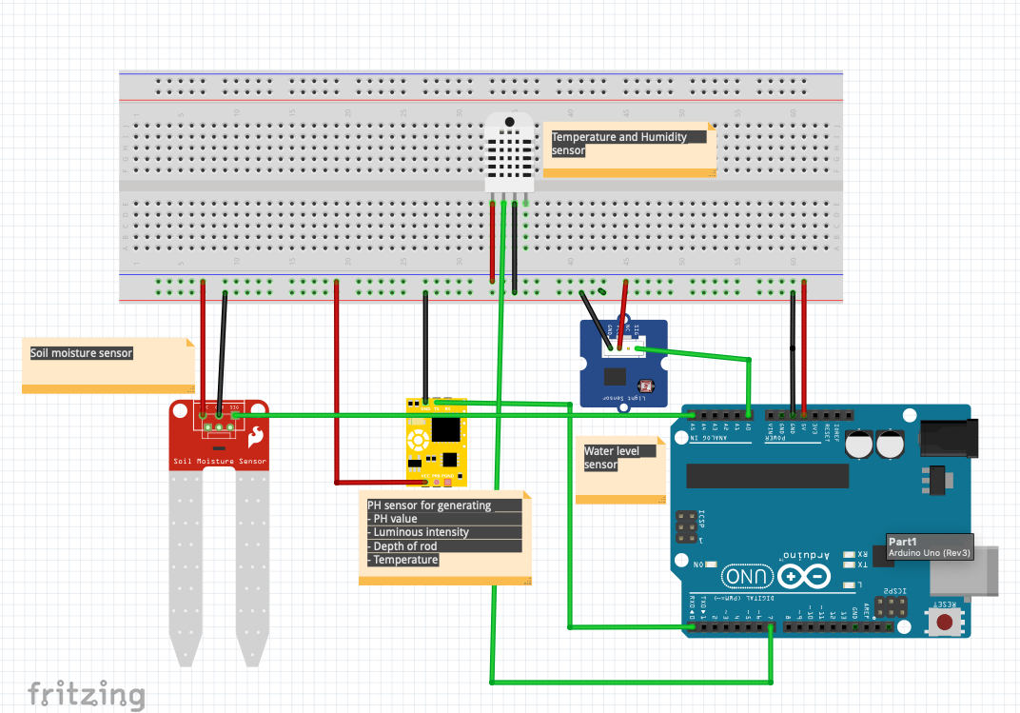

|  |  |  |
| --- | --- | --- |
| **Sensor connection from Arduino** | | |
|  |  |  |
| **SENSOR** | FROM | TO |
| **PH SENSOR** | TX | RX |
| VCC | VCC |
| GND | GND |
| **DHT 22** |  |  |
| VCC | VCC |
| GND | GND |
| **SOIL MOISTURE** | DATA | A1 |
| VCC | VCC |
| GND | GND |
| **WATER LEVEL SENSOR** | DATA | A2 |
| VCC | VCC |
| GND | GND |

**Methodology Adapted**

Hydroponic Farming

In the present fast pace world, the form of hydroponic farming is taking over. The ongoing research paved new ways and paths for a better and substantial way of farming. Noticing the ways and researching the present trends, mainly followed in metropolitan cities and technologically advanced countries makes lives a lot easier in terms of hydroponic farming. The work done by us addresses the key issues of automation and IoT integration into the way of sustainable farming in constraints such as limited water supply and space.

Necessity for automation

The work being done needs constant monitoring as various sensors are used in an confined and controlled environment. But as Human Beings, we tend to make mistakes. To avoid such mistakes that in other ways cannot be avoided, automation is the way. With the help of Arduino , ESP 8266 and Aurd Spread Sheet the reading from the sensors are directly stored into the spreads sheet with almost no error.The readings are recorded once every 10 minutes which without automation requires a immense amount of man power which intern may lead to loss or errors in recorded results.

Climate Maintained

Farming mainly depends on ambient climatic conditions but the city environment is not suitable for the growth of crops in the traditional way.For our work as we targeted the metropolitan cities we made sure that the temperature rage varied from 28 degree Celsius to 36 degree Celsius. In hydroponic farming, the crops are not exposed to sunlight throughout. Rather than exposing them to sunlight throughout, we made sure that an adequate sunlight was available which in the day reaches approximately 240 candela and in the night for the integrity of the results, we made sure no light from any source was available which resulted in 0 candela. Speaking about the soil moisture, for better understating of the impact of moisture retention of the soil we grew the crops in early summer because of which there is humidity in the air than normal. The humidity varied from 40 percent to 80 percent which is the normal range in a coastal city.

Data Analysis

All the information collected from the sensors is stored in the personal systems directly rather than cloud as clod is heavily dependent upon an uninterrupted internet connection which sometimes may not be possible. The data collected is stored and processed with the help of python to create results which help in better understanding of the data.

Proposed System

An innovative form of hydroponic farming is used. Coco pit is used as an soil replacement as the water retention capacity is much higher in this compared to general soil. The coco pit is connected to water supply which is regulated. Six different sensors are connected to the system. The sensors being, pH sensor which monitors the pH of the water in the coco pit. The water in coco pit pH initially at the time of laying it down was 6.5. The second sensor used is Luminous Intensity Sensor. This sensor monitors the amount of luminescence around the setup. The third sensor is Humidity sensor, this sensor monitors the humidity in the surroundings of the setup. Next sensor used was temperature sensor, this sensor monitors the temperature of the surroundings. The fifth sensor used was soil moisture sensor, this sensor measured the amount of moisture in coco pit throughout the experiment. The final sensor used is water level sensor, this sensor measures the amount of water provided to the system daily. The seeds used were coriander seeds as they take less time to grow which afforded us a chance to cross verify the results by repeating the experiment.

Table1: Regression within parameters in a hydroponic system for initial phase of crop Growth

|  |  |  |  |  |  |  |
| --- | --- | --- | --- | --- | --- | --- |
| **PARAMETER VS PARAMETER** | **PH** | **SUNLIGHT** | **HUMIDITY** | **TEMPERATURE** | **SOILMOISTURE** | **WATER LEVEL** |
| **PH** | X | MAE=26.54 MASE=1702.59 RMSE=41.26 R2=-0.00288 | MAE=3.13 MASE=17.055 RMSE=4.1298 R2= 0.03718 | MAE=0.9522 MASE=2.0584 RMSE=1.43474 R2=-0.003785 | MAE=0.9161 MASE=1.1950 RMSE=1.0931 R2=-0.011836 | MAE= 11.9423. MASE= 233.031 RMSE= 15.265 R2=-0.0039 |
| **SUNLIGHT** | MAE=0.3905 MASE= 0.2885 RMSE= 0.5371 R2= -0.00707 | X | MAE= 2.9133 MASE= 16.551 RMSE= 4.0683 R2= 0.0650 | MAE= 0.7492 MASE= 1.268 RMSE= 1.126 R2= 0.145 | MAE=0.902 MASE=1.160 RMSE= 1.077 R2=-0.0417 | MAE=1.0388 MASE= 1.521 RMSE= 1.233 R2=0.078 |
| **HUMIDITY** | MAE=0.3817 MASE=0.253 RMSE= 0.503 R2=-0.0074 | MAE=21.29 MASE= 1630.14 RMSE= 40.375 R2= 0.157 | X | MAE= 0.831 MASE= 1.205 RMSE= 1.097 R2= 0.517 | MAE=0.875 MASE=1.06 RMSE=1.033 R2= -0.0056 | MAE=9.843 MASE=174.68 RMSE=13.21 R2=0.0941 |
| **TEMPERATURE** | MAE=0.409 MASE=0.316 RMSE= 0.562 R2=0.0032 | MAE=22.06 MASE=1529.58 RMSE=39.109 R2=0.216 | MAE=2.64 MASE=10.3 RMSE=3.214 R2=0.505 | X | MAE=0.9160 MASE=1.190 RMSE=1.090 R2=-0.012 | MAE=9.714 MASE=168.86 RMSE=12.99 R2=0.087 |
| **SOILMOISTURE** | MAE= 0.389 MASE= 0.278 RMSE= 0.527 R2= = -0.0094 | MAE=24.12 MASE= 1462.23 RMSE= 38.23 R2=0.0032 | MAE= 0.933 MASE=2.1119 RMSE= 1.453 R2= -0.0231 | MAE=2.890 MASE=15.77 RMSE= 3.97 R2=-0.018 | X | MAE=11.212 MASE=229.93 RMSE= 15.16 R2= -0.0049 |
| **WATER LEVEL** | MAE= 0.339 MASE=0.232 RMSE=0.4819 R2=0.0221 | MAE= 22.450 MASE= 1350.67 RMSE= 36.75 R2= 0.190 | MAE= 3.35 MASE=2.043 RMSE=1.4296 R2=0.0010 | MAE=3.356 MASE=18.41 RMSE=4.29 R2=0.039 | MAE=0.797 MASE=1.540 RMSE= 1.240 R2= 0.0032 | X |

**Expected Results**

Just like our linear regression table we will be performing regressions within our parameters to evaluate the correlation between the parameters.

This will be performed for all 3 phases of farming and also for the complete dataset and the evaluation parameters will be explained with graphical representation.

The evaluation parameters used for our project we will be calculating Mean Absolute Error (MAE), Root Mean Square Error (MASE),Root Mean Square Log Error (RMSE),R Squared(R2).

We will also be doing a comparative study between multiple regression models.

With respect to hardware component we will be incorporating a water pump with water supply and GUI interface to provide water to the crops. This will provide a completely automated hydroponic system.

**Implementation**

Dataset Collection

|  |  |  |
| --- | --- | --- |
| PARAMETERS | CHART | OBSERVATION |
| PH |  | * The minimum value recorded is 5.5 on the ph scale and this was recorded during the Initial phase of the experiment. * The maximum recorded is 13 and it was recorded during the growth phase due to the addition of mineral water to the water supply, it became more basic. * After the growth phase we supplied general water again so, the pH dropped gradually making it more neutral. * Ideally the crop grows in soil’s with a PH value of 7-8 which has been followed in the hydroponic system. |
| LUMINOUS INTENSITY |  | * The least recorded is Zero as during the night, it is made sure that the experimental setup is not exposed to any form of light energy. * The highest value recorded is around 250 candela during the day. * The recorded values only account for the amount of sunlight received by the crop. * Ideally the crops grown in field receives sunlight from 225-250 candela which has been the case for an hydroponic system as well. |
| HUMIDITY |  | * The humidity in the surroundings of the setup. * As the experiment setup was in a coastal city, the humidity is relatively high but is under the normal humidity levels for the city. * The lowest recoded is 45% and the highest is around 80%. * To make sure that the humidity level doesn’t go overboard, we conducted the experiment during early summer. |
| TEMPERATURE |  | * The temperature kept on raising during the experiment gradually. * The lowest recoded temperature was 26 degree Celsius and highest was 36 degree Celsius. * The lowest average temperature was during the initial phase and the highest average was during the harvesting phase. * The ideal temperature for crops the grow is 28-32 degrees which has been mostly observed in our system. |
| SOIL MOISTURE |  | * During the initial phase the moisture level was between 682-686. * The moisture level was highest during the growth phase which ranges between 680-692. * The moisture level during the harvest phase is lowest in terms of average, its range varies from 676-680. * Soil moisture is normally very high in a hydroponic system and even with high temperature the coco pit was able to retain moisture and keep the soil moisture constant throughout the growth of the crop. |
| WATER LEVEL |  | * The water level gradually increases till the growth phase and decreases there on. * The water level during the initial phase was between 160 and 240ml, during growth phase it is between 200ml and 650ml. * During the harvest phase, the water level required is low , it ranges from 200-500ml. * The trends were similar to crops grown in fields hence it will be ideal for plants to grow easily In a city based hydroponic system. |

Range of parameters

|  |  |  |
| --- | --- | --- |
| PARAMETER | MAX | MIN |
| PH | 27.13 | 0 |
| LUMINOUS INTENSITY | 228 | 0 |
| HUMIDITY | 82.5 | 43.6 |
| TEMPERATURE | 38.6 | 25.5 |
| SOIL MOISTURE | 693 | 676 |
| WATER LEVEL | 731 | 153 |

Dataset Description

|  |  |
| --- | --- |
| TYPE | DESCRIPTION |
| Data set Characteristic | Multivariant |
| Attribute Characteristics | Timestamp, Integer, Real |
| Associated Tasks | Regression |
| Number of Instances | 1559 |
| Number of attributes | 8 |

Attribute Information

1. Day(1-28)
2. Timestamp(HH:MM:SS)
3. Ph value
4. Luminous intensity
5. Humidity
6. Temperature
7. Water level
8. Soil Moisture

DATASET DESCRIPTION

Linear Variation of Soil Moisture with parameters

|  |  |  |  |  |
| --- | --- | --- | --- | --- |
| PARAMETER | Initial  Phase | Growing  Phase | Harvesting  Phase | Full  Phase |
| Sunlight |  |  |  |  |
| Humidity |  |  |  |  |
| Temperature |  |  |  |  |
| PH |  |  |  |  |
| Water Level |  |  |  |  |

**Hardware Implementation**

**Arduino Code**

#define DHTPIN 7

#define DHTTYPE DHT22

DHT dht(DHTPIN, DHTTYPE);

int chk;

float hum; //Stores humidity value

float temp; //Stores temperature value

int soilMoistVal() {

int sensorValue = analogRead(A14);

return sensorValue;

}

void phValue() {

float a, b, c, d;

String strs = Serial.readString();

int str_len = strs.length() + 1;

char str[str_len];

strs.toCharArray(str, str_len);

for (int i = 0, j; str[i] != '\0'; ++i) {

while (!(str[i] >= '0' && str[i] <= '9') && !(str[i] == '\0') && !(str[i] == ',') && !(str[i] == '.')) {

for (j = i; str[j] != '\0'; ++j) {

str[j] = str[j + 1];

}

str[j] = '\0';

}

}

int k = 0;

char* token = strtok(str, ",");

a = atof(token);

token = strtok(NULL, ",");

b = atof(token);

token = strtok(NULL, ",");

c = atof(token);

token = strtok(NULL, ",");

d = atof(token);

token = strtok(NULL, ",");

Serial.print(a);

Serial.print("\t");

Serial.print(b);

Serial.print("\t");

Serial.print(c);

Serial.print("\t");

Serial.print(d);

Serial.print("\t");

}

int waterLevel() {

const int sensorMin = 0;

const int sensorMax = 1024;

int sensorReading = analogRead(A0);

int range = map(sensorReading, sensorMin, sensorMax, 0, 3);

return sensorReading;

}

void setup() {

Serial.begin(9600);

dht.begin();

}

void loop() {

float* reqVal;

hum = dht.readHumidity();

temp = dht.readTemperature();

int valSensorSoil = soilMoistVal();

int valSensorWaterLevel = waterLevel();

phValue();

Serial.print(hum);//B

Serial.print("\t");

Serial.print(temp);//C

Serial.print("\t");

Serial.print(valSensorSoil);//D

Serial.print("\t");

Serial.print(valSensorWaterLevel);//E

Serial.print("\t");

Serial.println();

//delay(2000); // 2 seconds

delay(600000); //10 minutes

}

**Details of Hardware and Software**

Hardware requirements

* Arduino Mega 2560
* Temperature sensor (DHT-22)
* Humidity Sensor (DHT-22)
* Water Level Sensor
* Soil Moisture Sensor
* PH Sensor
* Luminous Intensity Sensor
* WIFI module (ESP 8266)
* Breadboard
* Jumper wires
* Pump
* Water Tube
* 5V motor
* 5V power supply

Software requirements

* Python Version 3.9.0
* Sklearn (Machine learning Library and Evaluation )
* Pandas (Handling CSV files)
* Numpy (Handling Arrays in python)
* Arduino Software (To upload code to UNO board)
* MAC OS version 11.6 128GB storage
* VS code editor

**Reference:**

 Journal:

1. A. Nichani, S. Saha, T. Upadhyay, A. Ramya and M. Tolia, "Data Acquisition and Actuation for Aquaponics using IoT," 2018 3rd IEEE International Conference on Recent Trends in Electronics, Information & Communication Technology (RTEICT), 2018, pp. 46-51, doi: 10.1109/RTEICT42901.2018.9012260.

2. H. K. Srinidhi, H. S. Shreenidhi and G. S. Vishnu, "Smart Hydroponics system integrating with IoT and Machine learning algorithm," 2020 International Conference on Recent Trends on Electronics, Information, Communication & Technology (RTEICT), 2020, pp. 261-264, doi: 10.1109/RTEICT49044.2020.9315549.

3. P. Srivani, Y. Devi C. and S. H. Manjula, "A Controlled Environment Agriculture with Hydroponics: Variants, Parameters, Methodologies and Challenges for Smart Farming," 2019 Fifteenth International Conference on Information Processing (ICINPRO), 2019, pp. 1-8, doi: 10.1109/ICInPro47689.2019.9092043.

4. C. Joshitha, P. Kanakaraja, K. S. Kumar, P. Akanksha and G. Satish, "An eye on hydroponics: The IoT initiative," 2021 7th International Conference on Electrical Energy Systems (ICEES), 2021, pp. 553-557, doi: 10.1109/ICEES51510.2021.9383694.

5. S. Gertphol, P. Chulaka and T. Changmai, "Predictive models for Lettuce quality from Internet of Things-based hydroponic farm," 2018 22nd International Computer Science and Engineering Conference (ICSEC), 2018, pp. 1-5, doi: 10.1109/ICSEC.2018.8712676.

6. S. Jaisankar, P. Nalini and K. K. Rubigha, "A Study on IoT based Low-Cost Smart Kit for Coconut Farm Management," 2020 Fourth International Conference on I-SMAC (IoT in Social, Mobile, Analytics and Cloud) (I-SMAC), 2020, pp. 161-165, doi: 10.1109/I-SMAC49090.2020.9243486.

7. M. S. Farooq, S. Riaz, A. Abid, K. Abid and M. A. Naeem, "A Survey on the Role of IoT in Agriculture for the Implementation of Smart Farming," in IEEE Access, vol. 7, pp. 156237-156271, 2019, doi: 10.1109/ACCESS.2019.2949703.

Introduction

Theoretical Background

Motivation

Aim of the proposed Work

Objective(s) of the proposed work

Report Organization

Literature Survey

Survey of the Existing Models/Work

Summary/Gaps identified in the Survey

Overview of the Proposed System

Introduction

Framework, Architecture or Module for the Proposed System(with explanation)

Proposed System Model(ER Diagram/UML Diagram/Mathematical Modeling)

Proposed System Analysis and Design(As Per IEEE Standard)

Introduction

Requirement Analysis

Functional Requirements

Product Perspective

Product features

User characteristics

Assumption & Dependencies

Domain Requirements

User Requirements

Non Functional Requirements

Product Requirements

Efficiency (in terms of Time and Space)

Reliability

Portability

Usability

Engineering Standard Requirements (Explain the applicability for your work w.r.to the following operational requirement(s))

Economic

Environmental

Social

Political

Ethical

Health and Safety

Sustainability

Legality

Inspectability

System Requirements

H/W Requirements(details about Application Specific Hardware)

S/W Requirements(details about Application Specific Software)

Results and Discussion(As Per IEEE Standard)

Sample Test Cases(Use standard template for test cases refer Annexure - I)

Summary of the Result

Conclusion, Limitations and Scope for future Work

Appendix (if needed)

Annexure – I

References

**Title Page**

Title Page i

Declaration ii

Certificate iii

Acknowledgement iv

Table of Contents v

List of Tables vi

List of Figures vii

List of Abbreviations viii

Abstract ix