CSE3501-INFORMATION SECURITY ANALYSIS AND AUDIT

LAB assignment-3

BY
S A HARIPRASAD
18BCE0686
L35+L36

Options:

-h, --help Show basic help message and exit

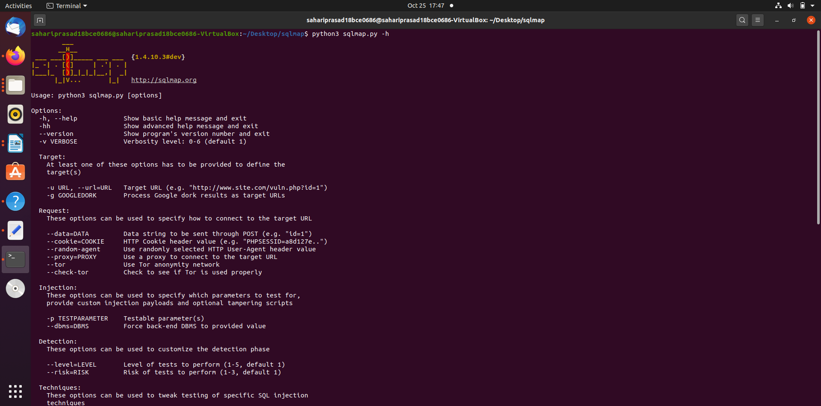

-hh Show advanced help message and exit

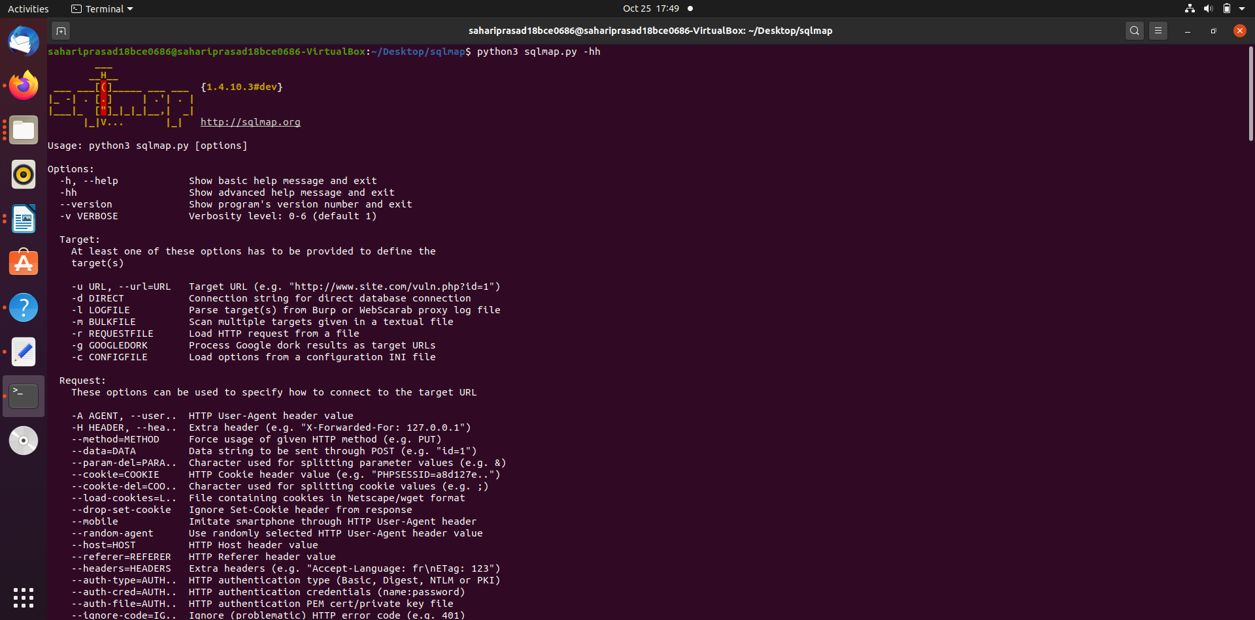

--version Show program's version number and exit

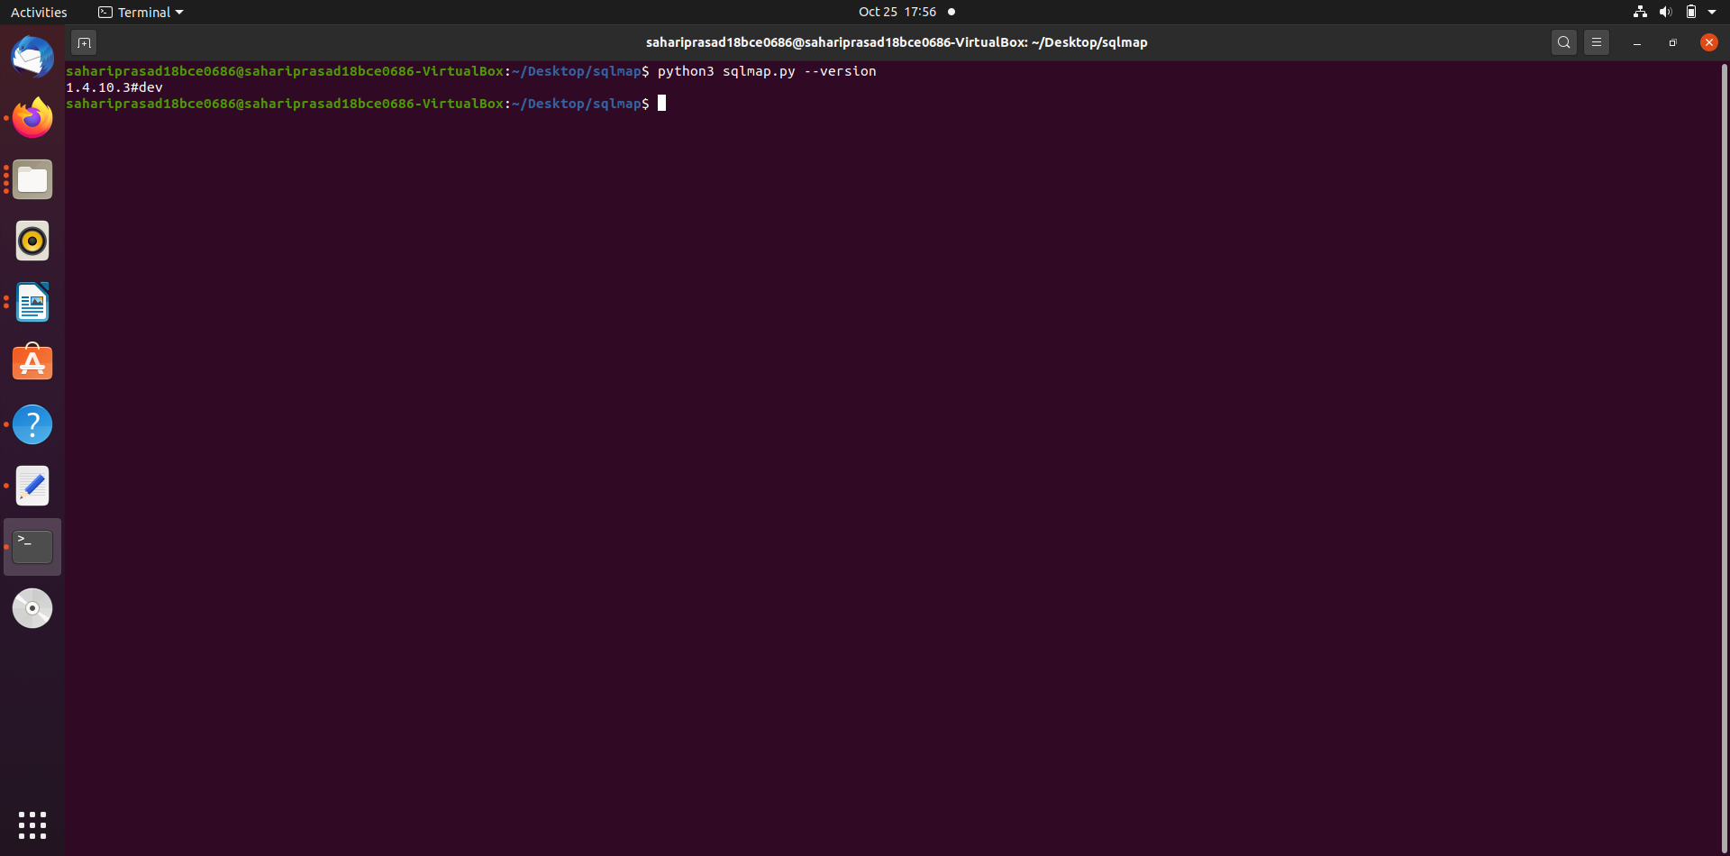

-v VERBOSE Verbosity level: 0-6 (default 1)

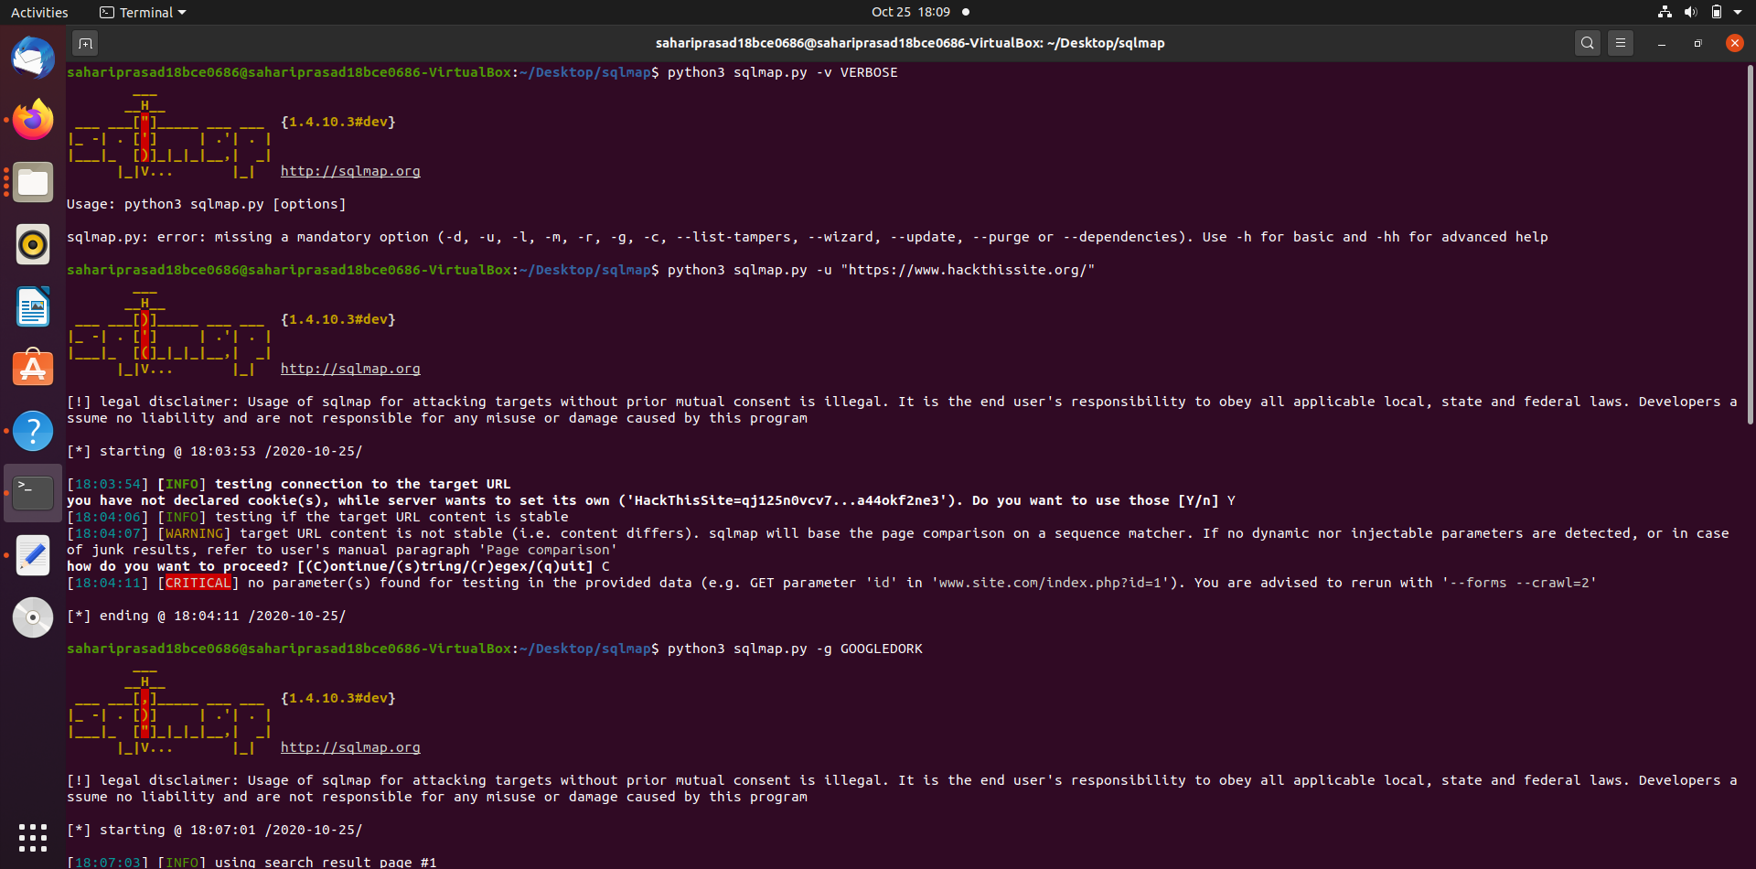

Target:

-u URL, --url=URL Target URL (e.g. "http://www.site.com/vuln.php?id=1")

-g GOOGLEDORK Process Google dork results as target URLs

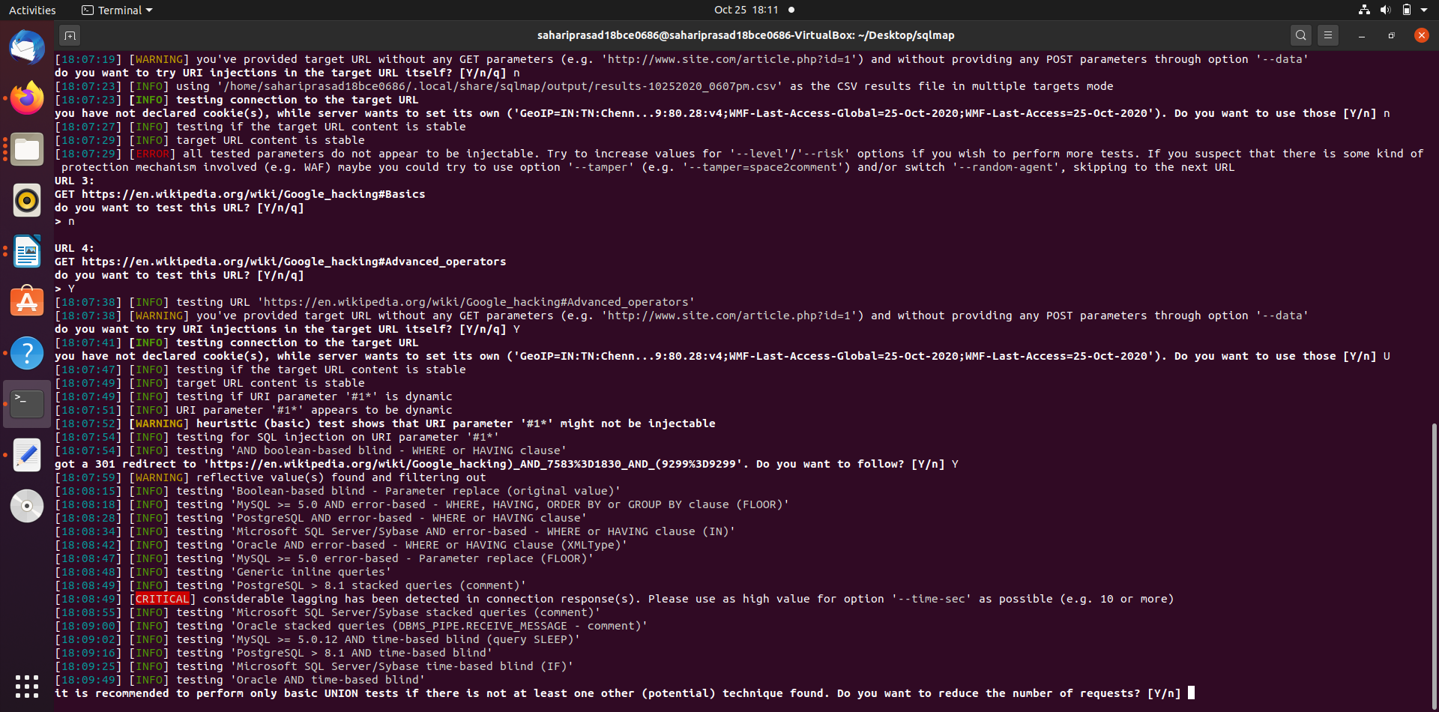

Request:

These options can be used to specify how to connect to the target URL

--data=DATA Data string to be sent through POST (e.g. "id=1")

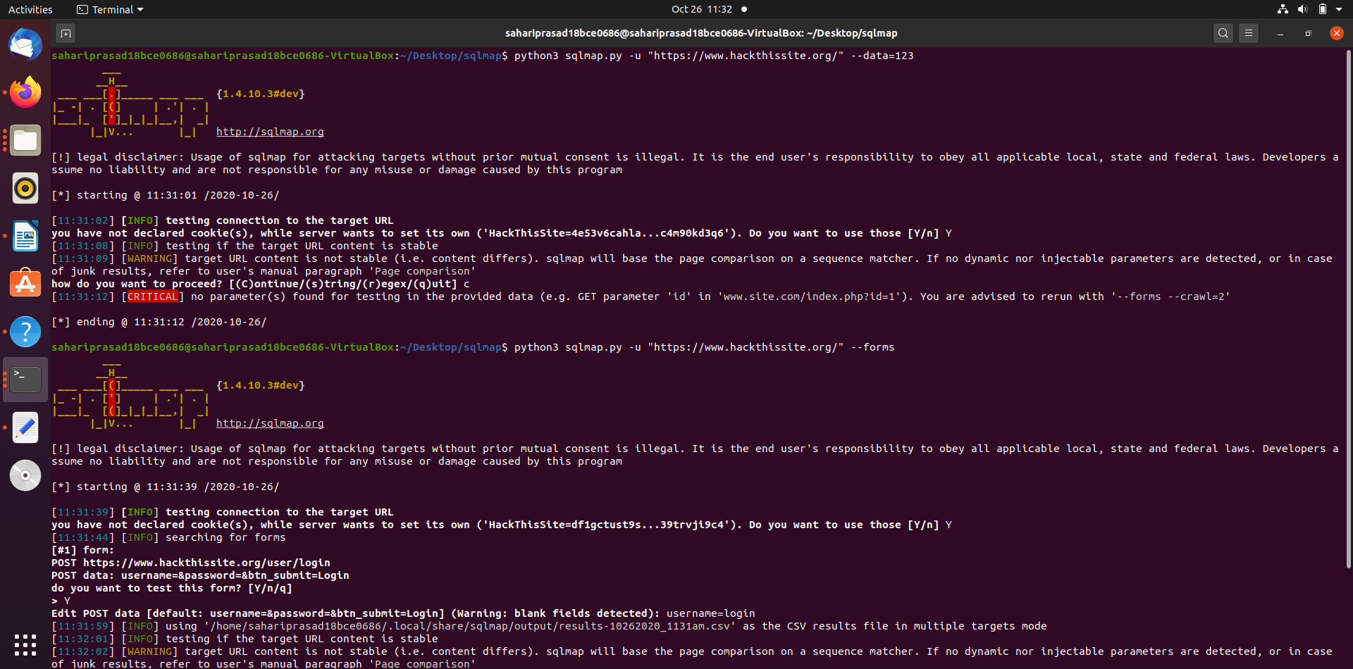

--cookie=COOKIE HTTP Cookie header value (e.g. "PHPSESSID=a8d127e..")

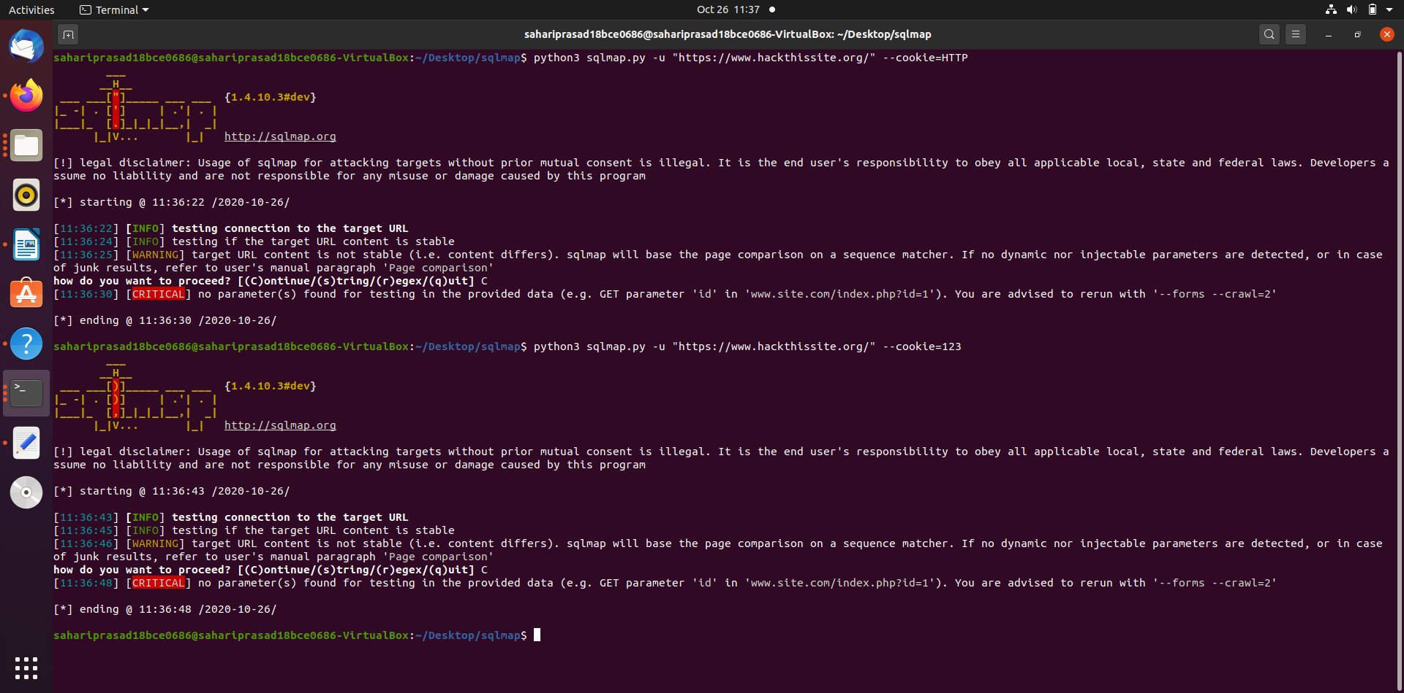

--random-agent Use randomly selected HTTP User-Agent header value

--proxy=PROXY Use a proxy to connect to the target URL

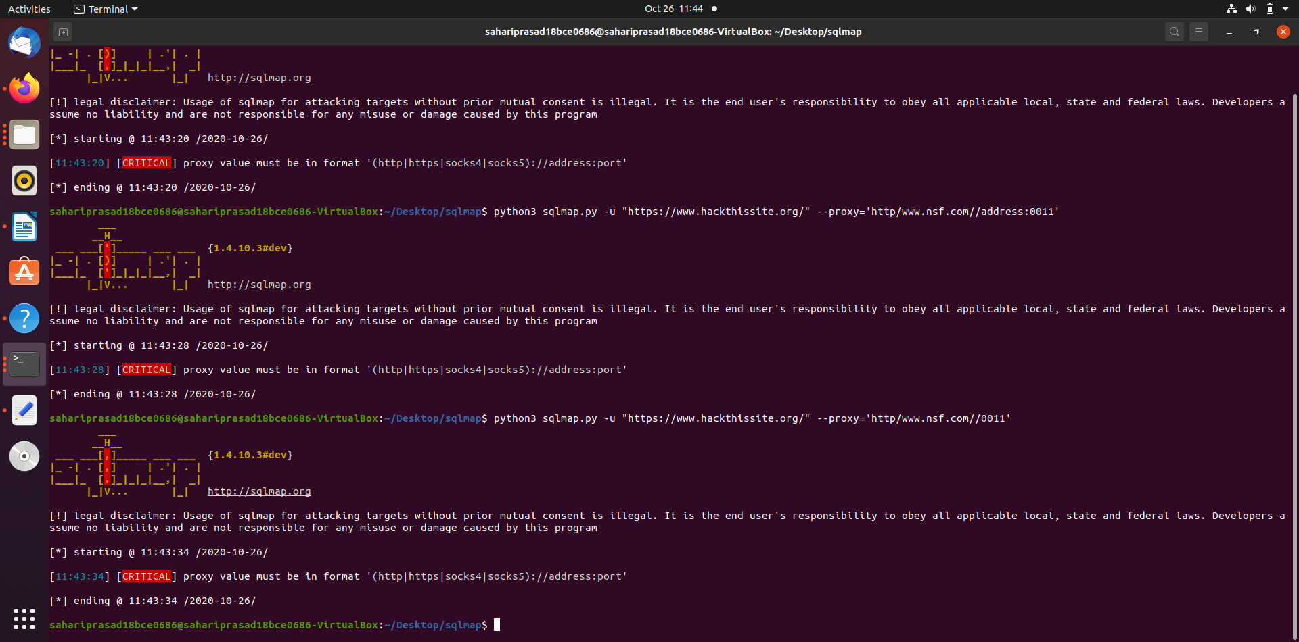

--tor Use Tor anonymity network
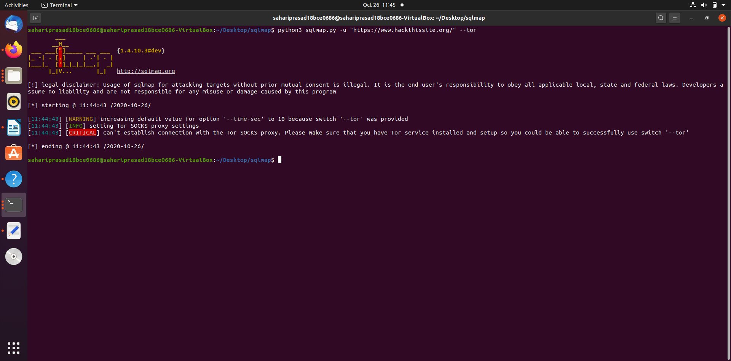

--check-tor Check to see if Tor is used properly

Injection:
These options can be used to specify which parameters to test for, provide custom injection payloads and optional tampering scripts

-p TESTPARAMETER Testable parameter(s)

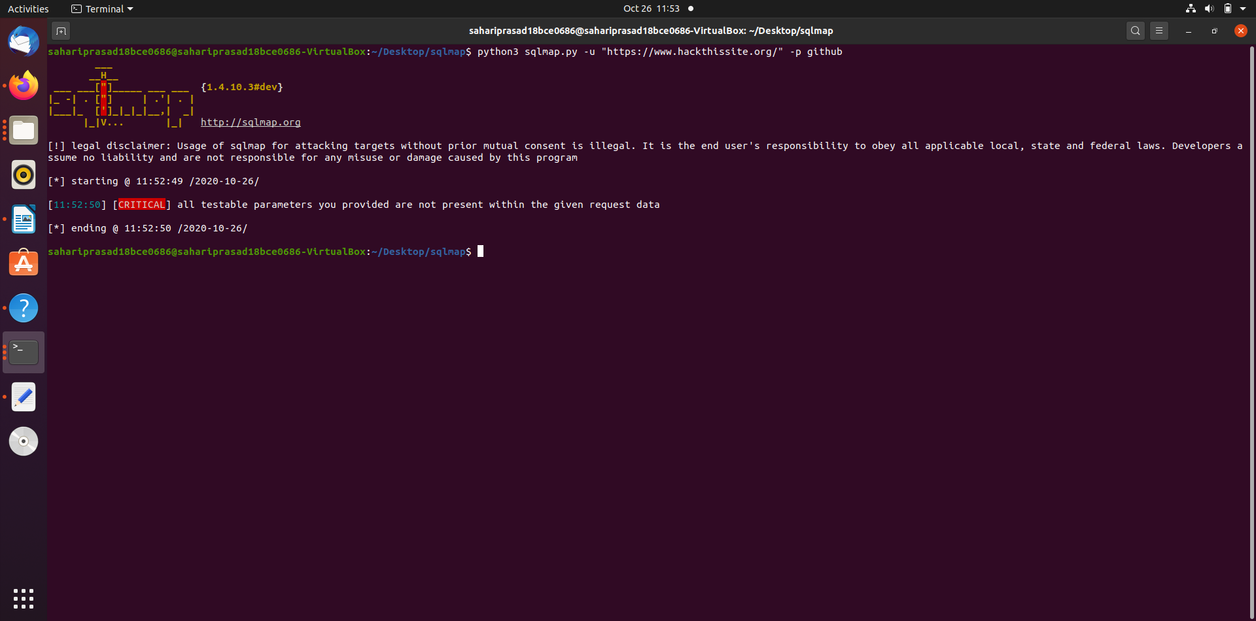

--dbms=DBMS Force back-end DBMS to provided value

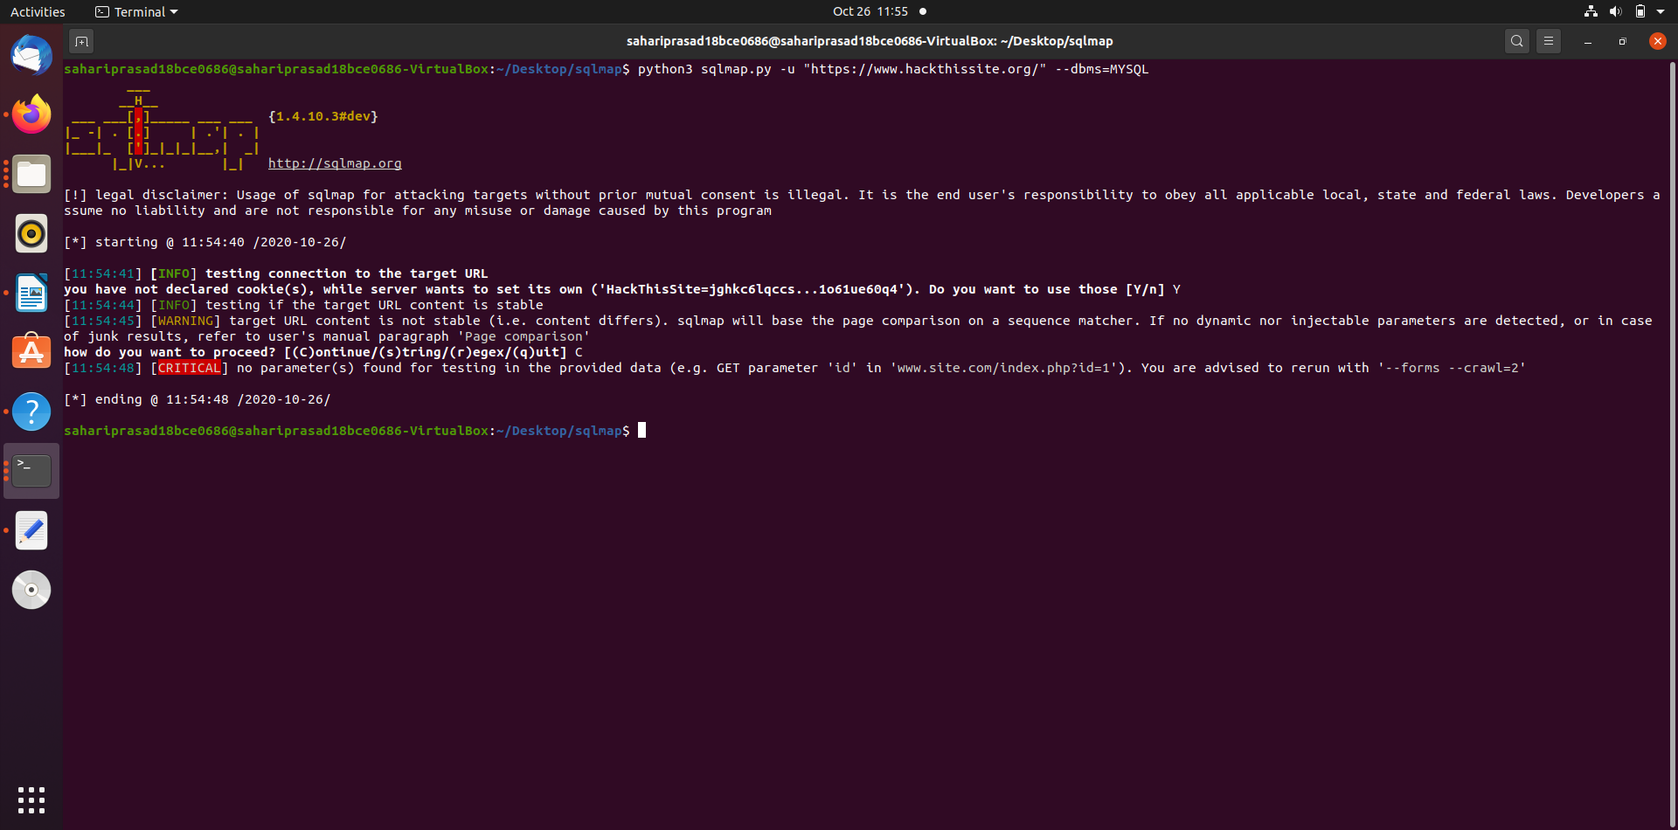

Detection:

These options can be used to customize the detection phase

--level=LEVEL Level of tests to perform (1-5, default 1)

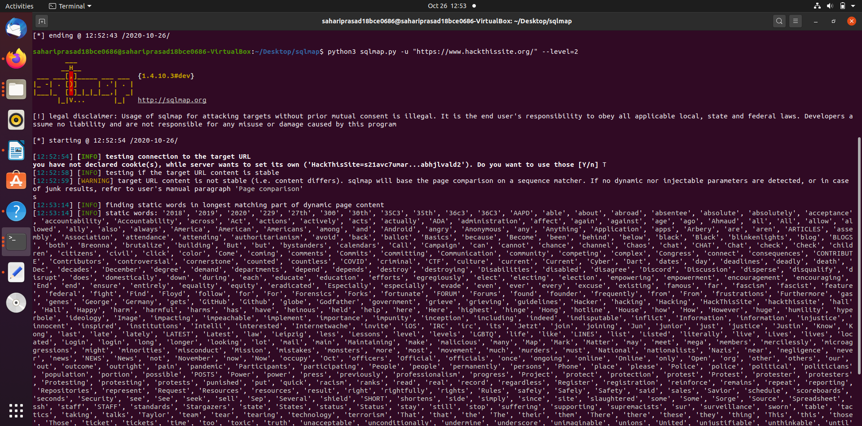

--risk=RISK Risk of tests to perform (1-3, default 1)
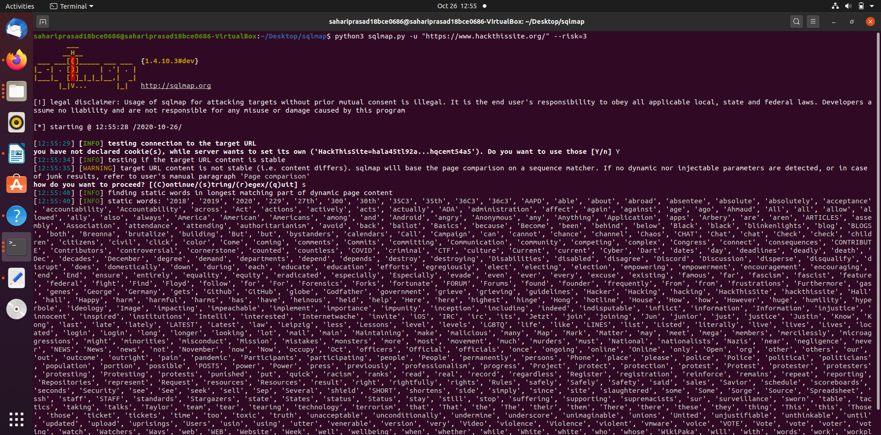

Techniques:

These options can be used to tweak testing of specific SQL injection techniques

--technique=TECH.. SQL injection techniques to use (default "BEUSTQ")

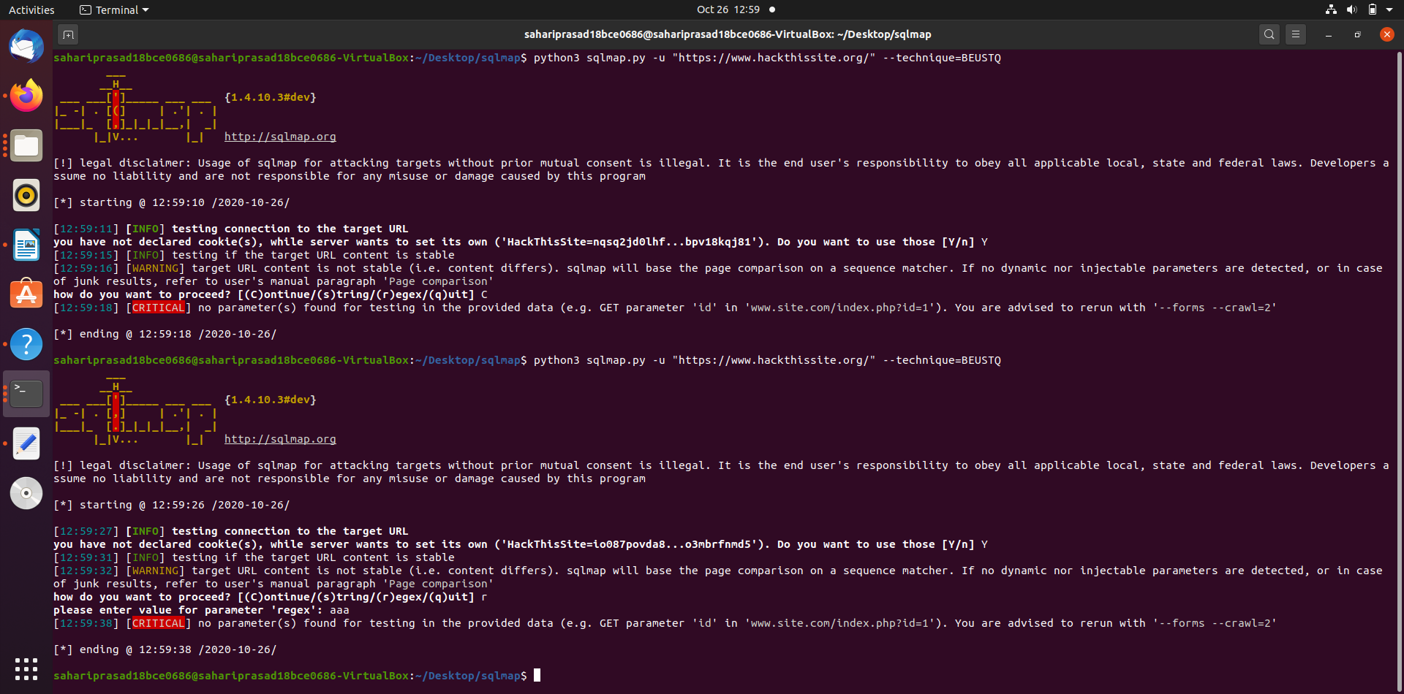

Enumeration:

These options can be used to enumerate the back-end database management system information, structure and data contained in the tables

-a, --all Retrieve everything

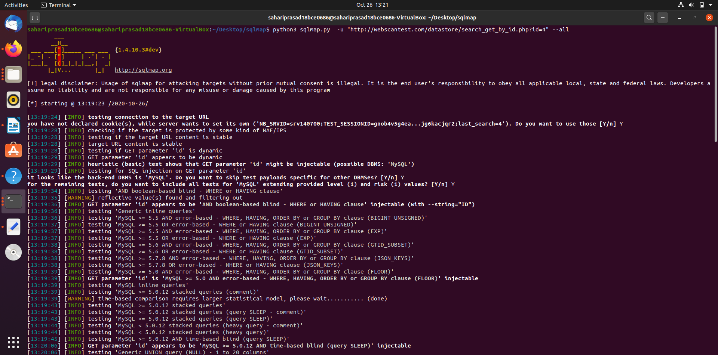

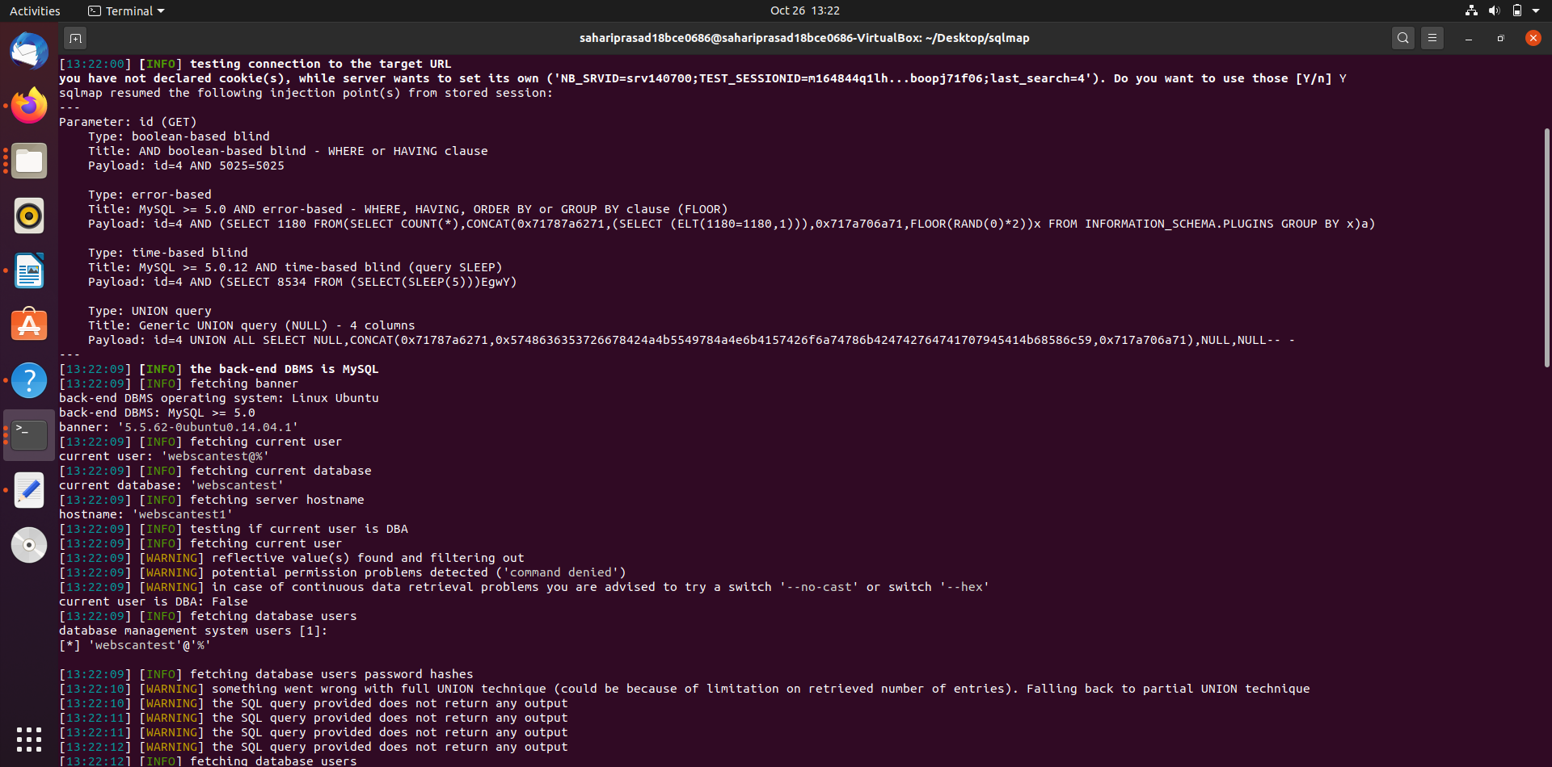

-b, --banner Retrieve DBMS banner

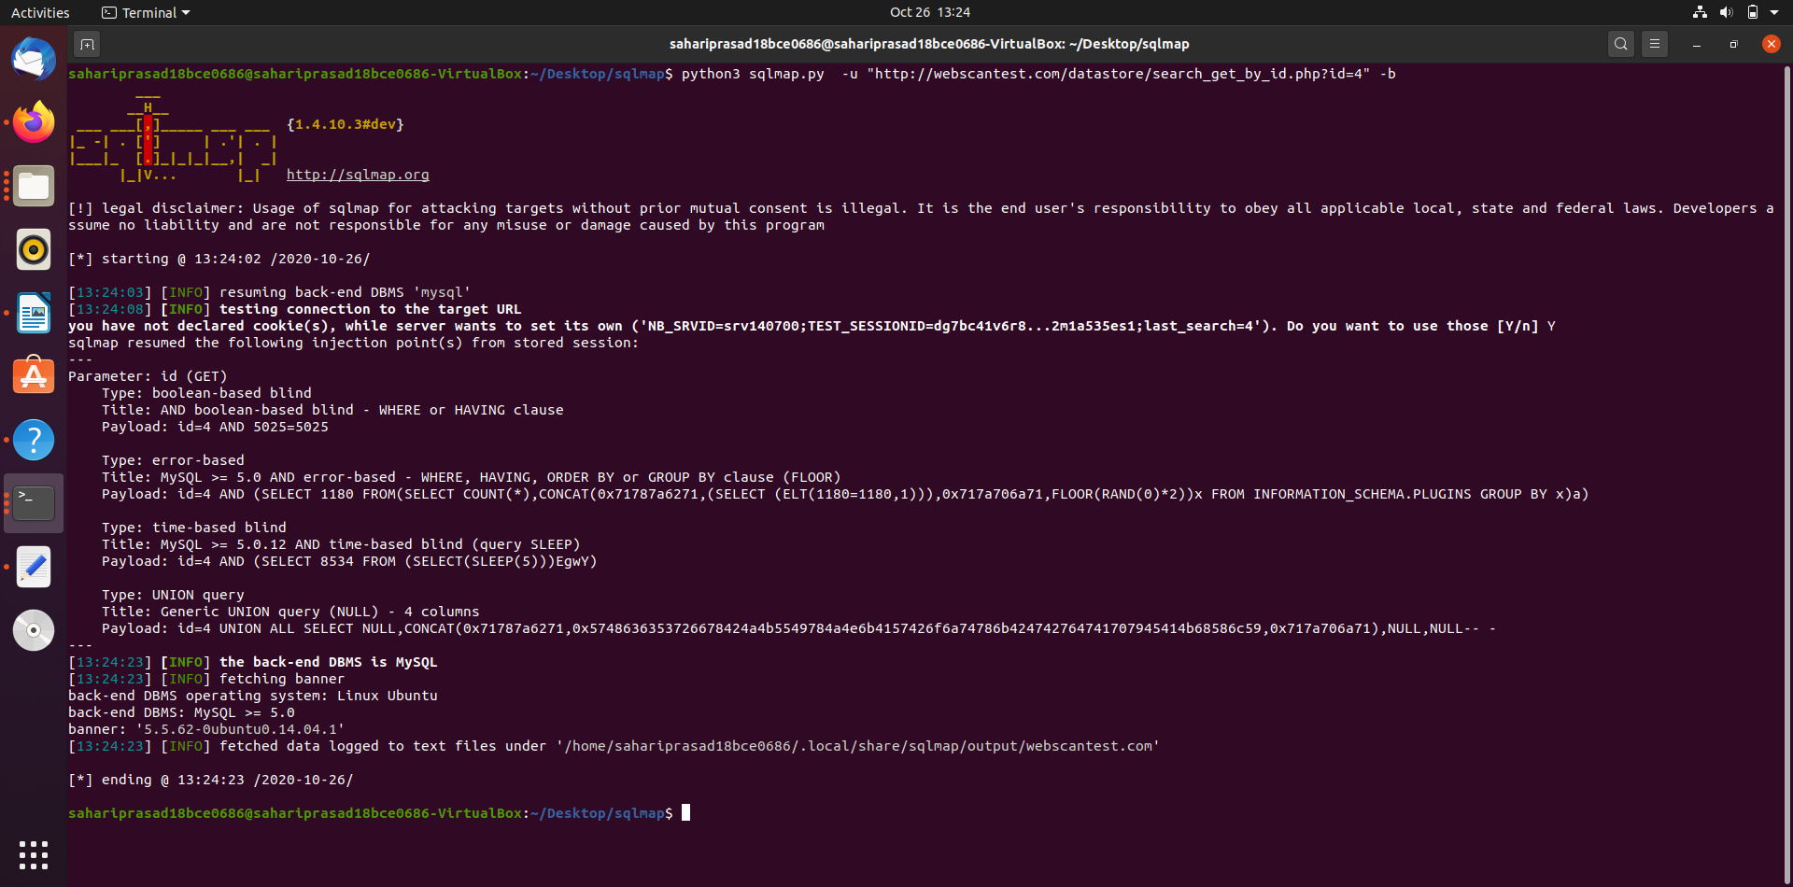

--current-user Retrieve DBMS current user
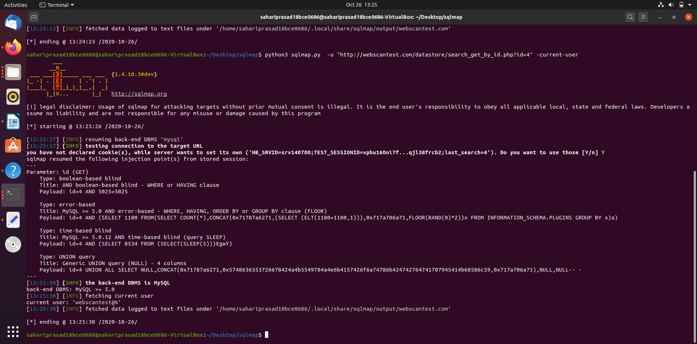

--current-db Retrieve DBMS current database

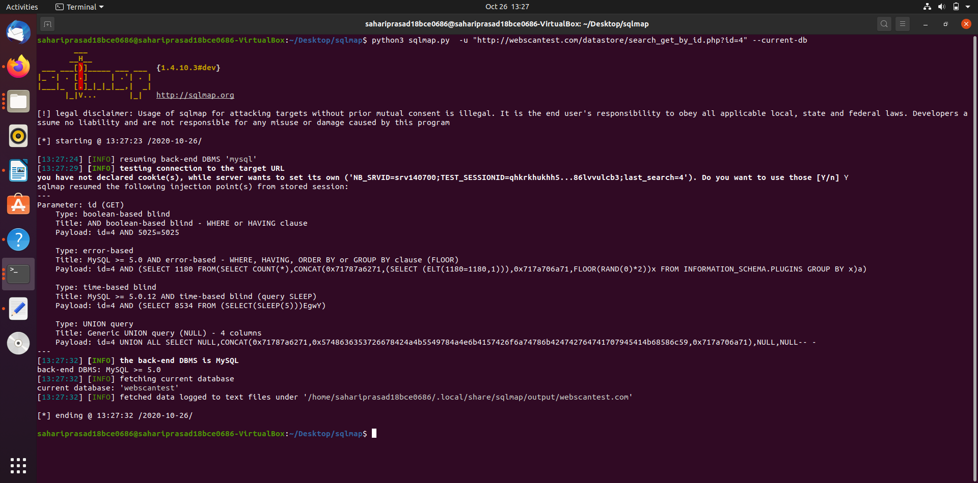

--passwords Enumerate DBMS users password hashes

--tables Enumerate DBMS database tables
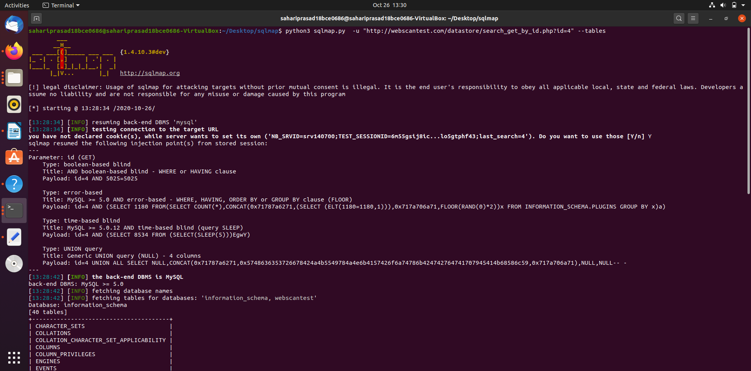

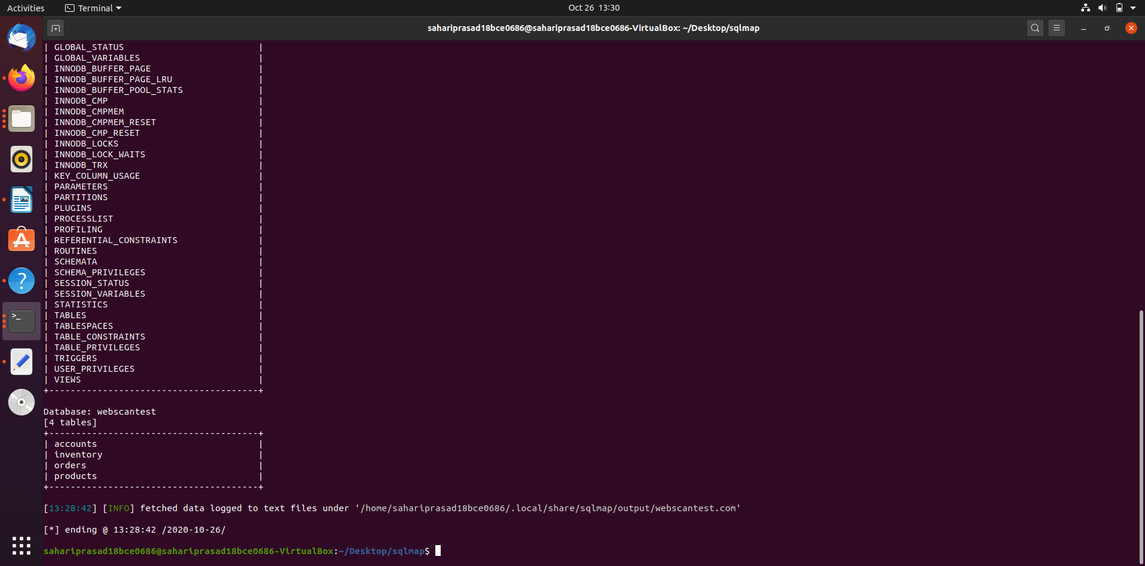

--columns Enumerate DBMS database table columns

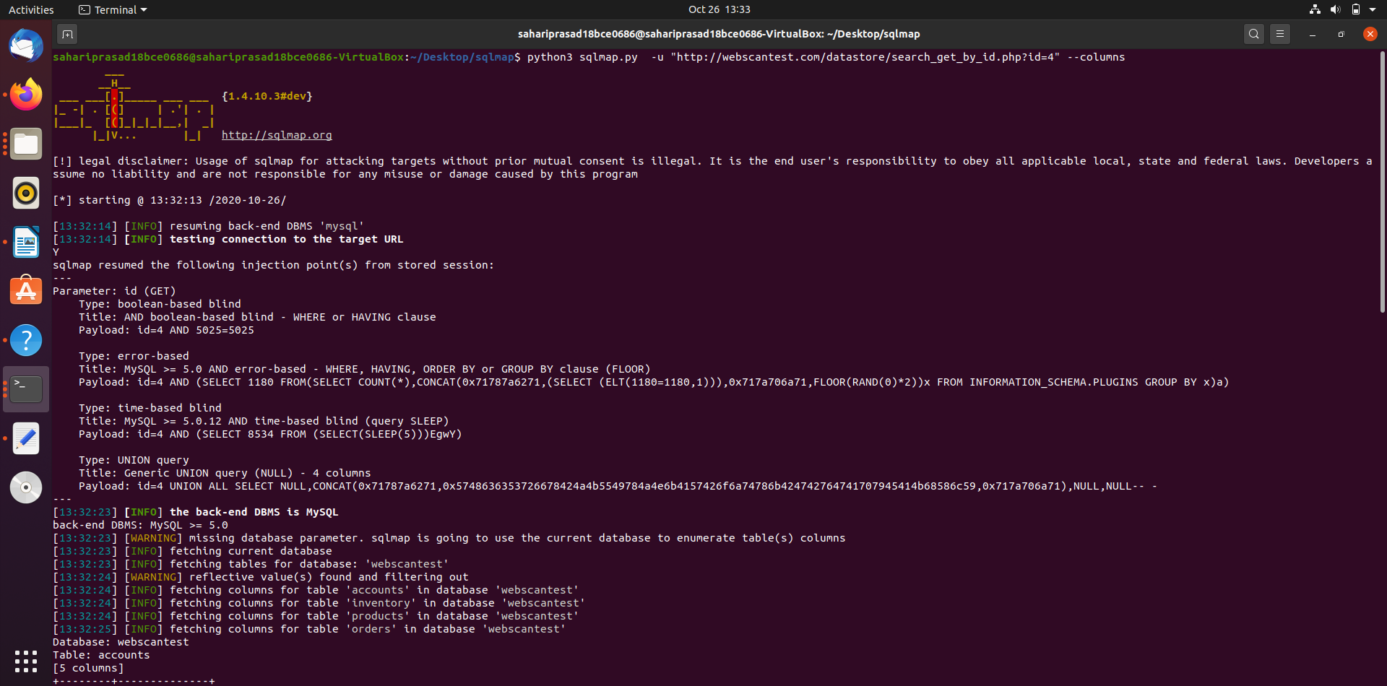

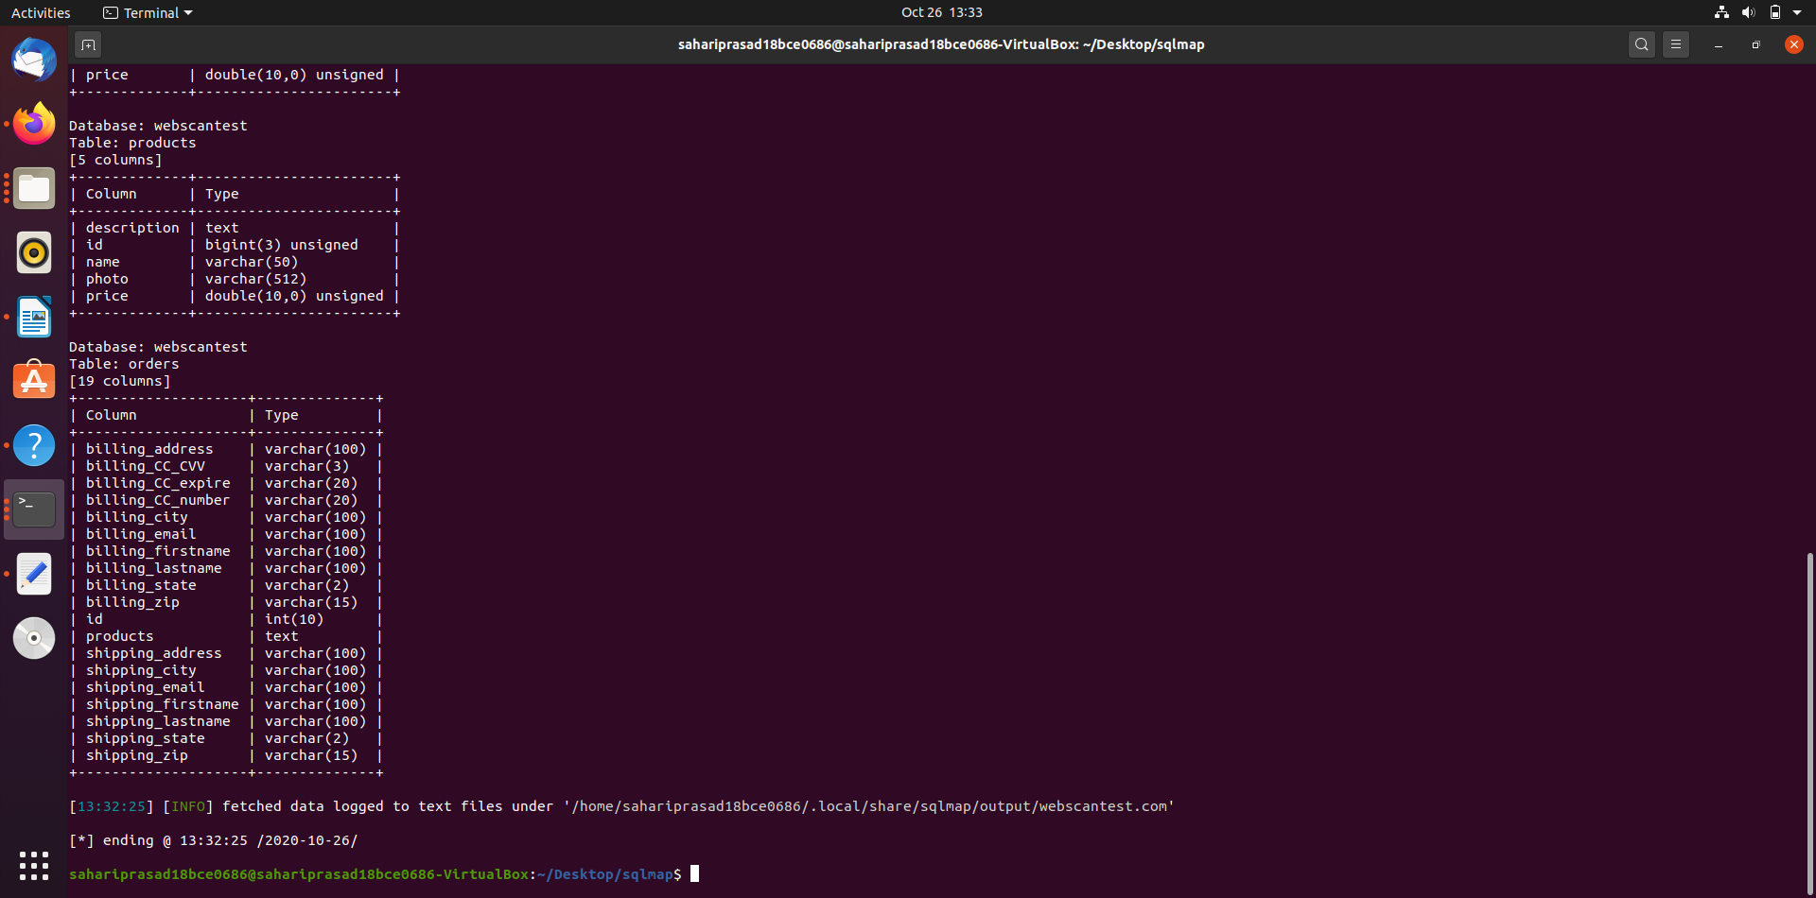

--schema Enumerate DBMS schema

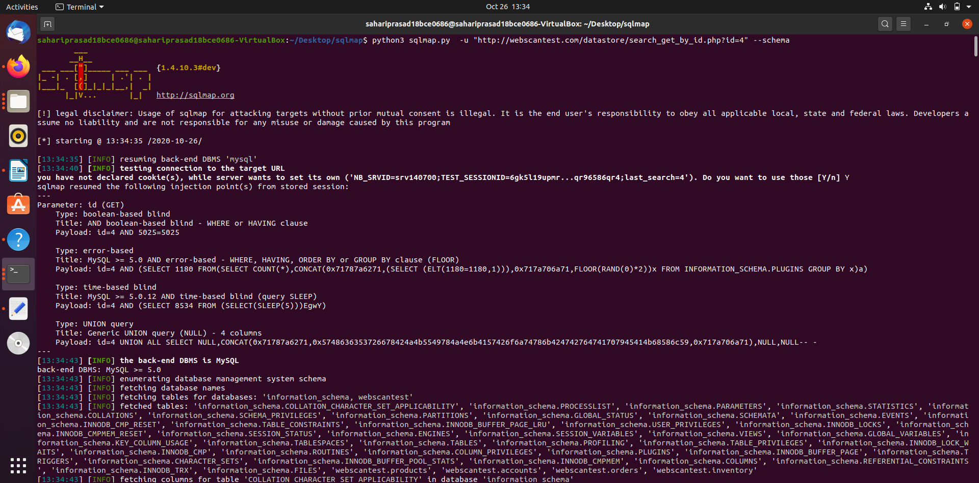

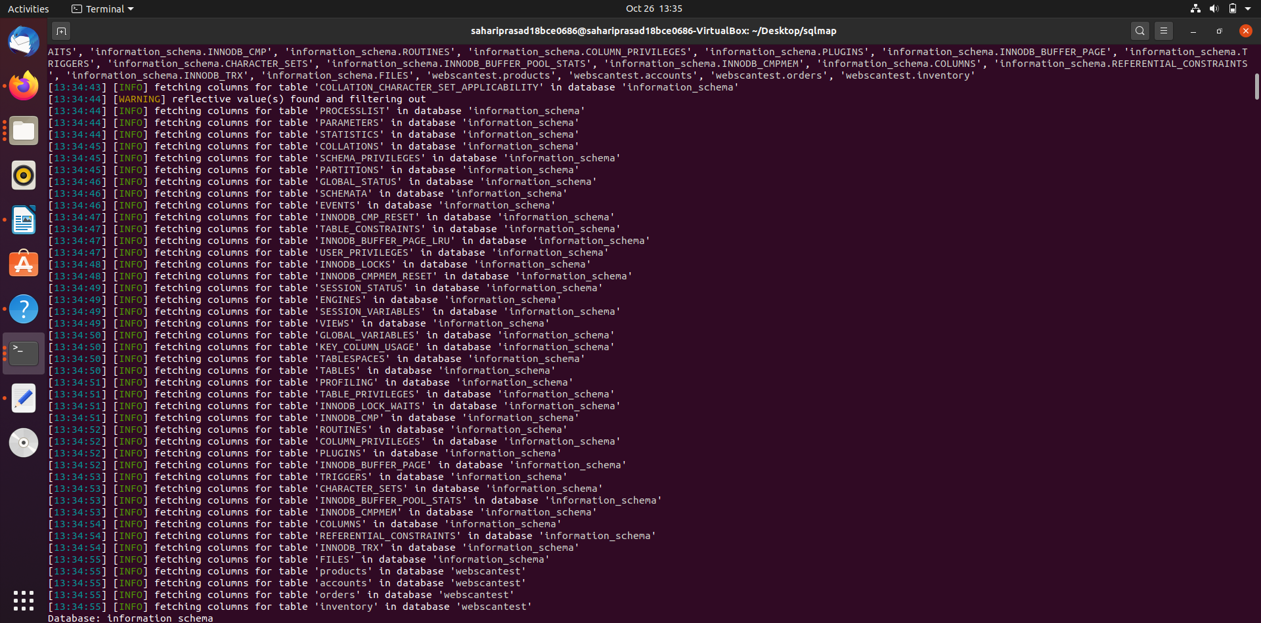

--dump Dump DBMS database table entries

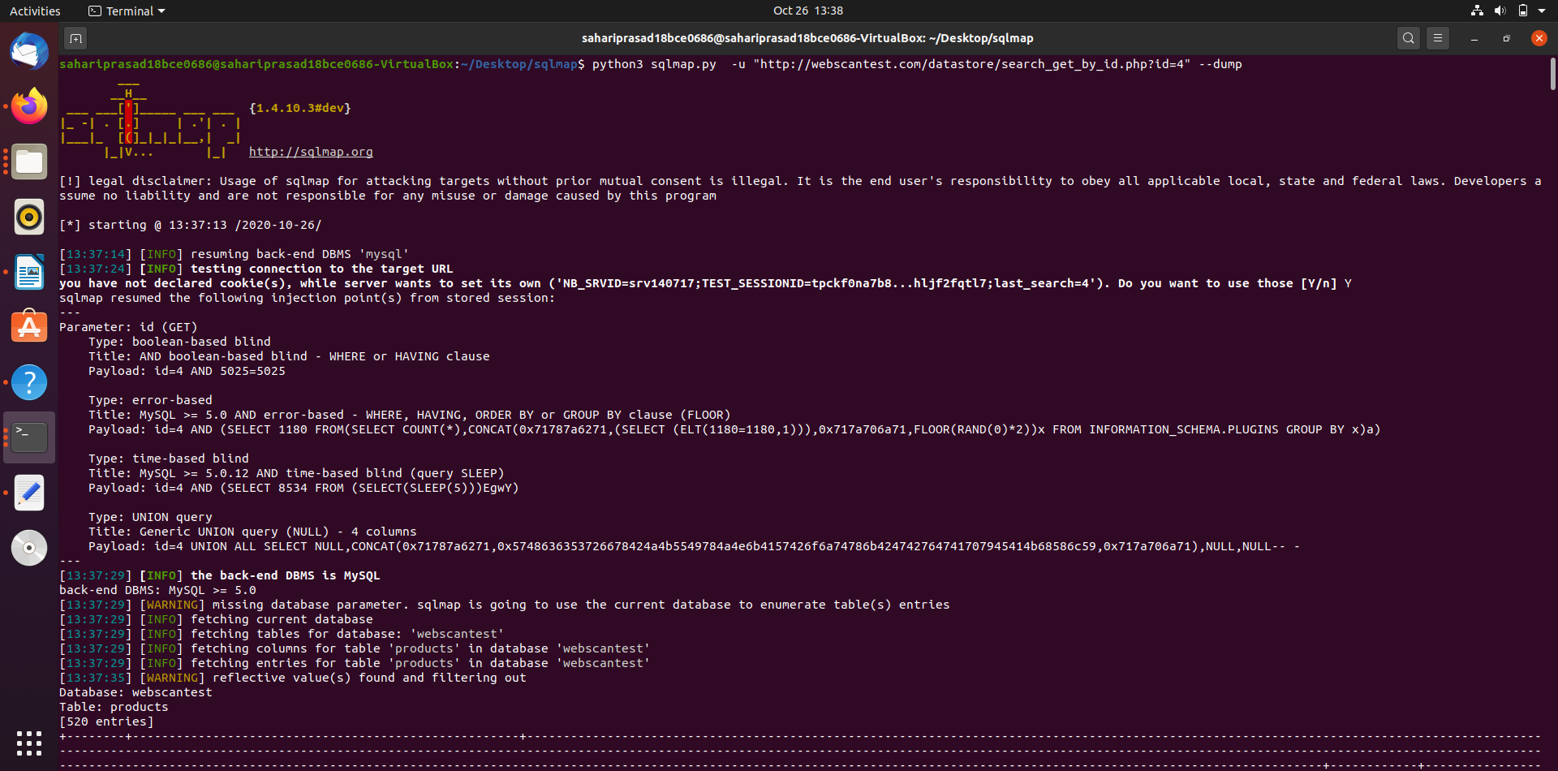

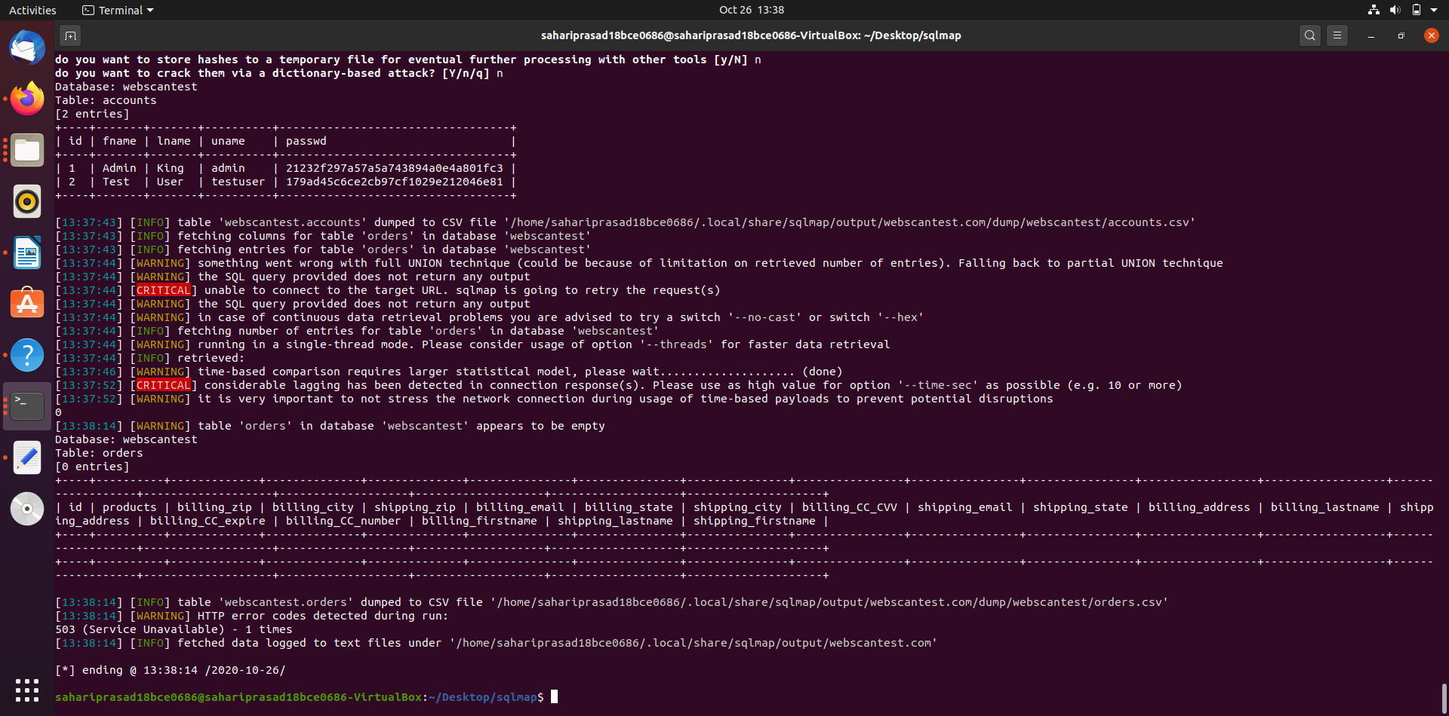

--dump-all Dump all DBMS databases tables entries

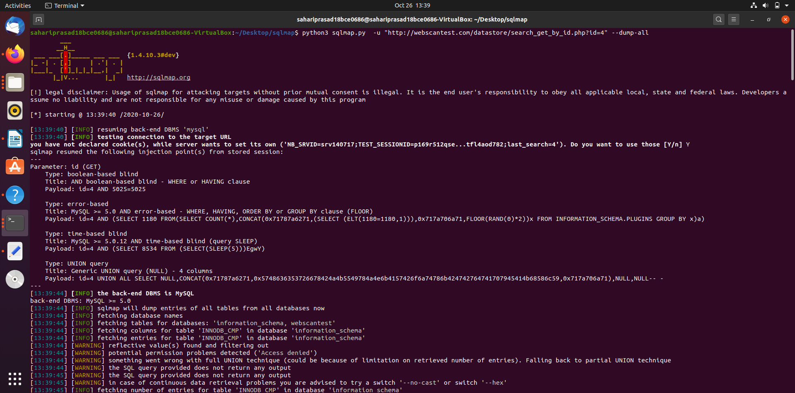

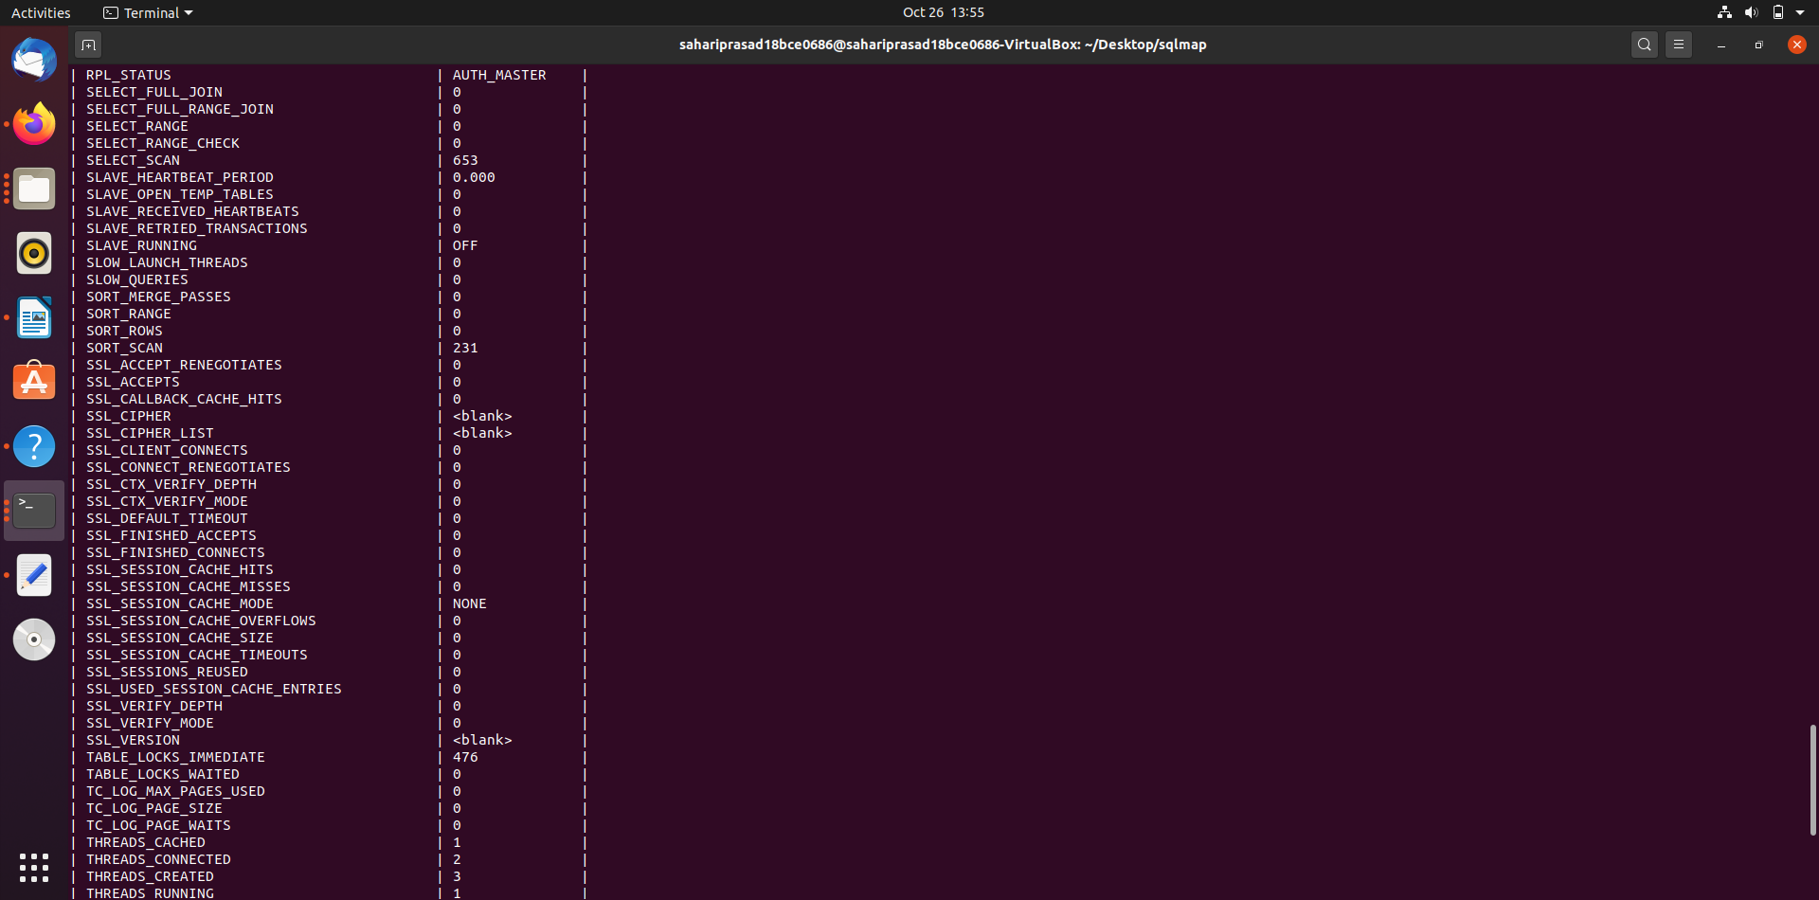

-D DB DBMS database to enumerate

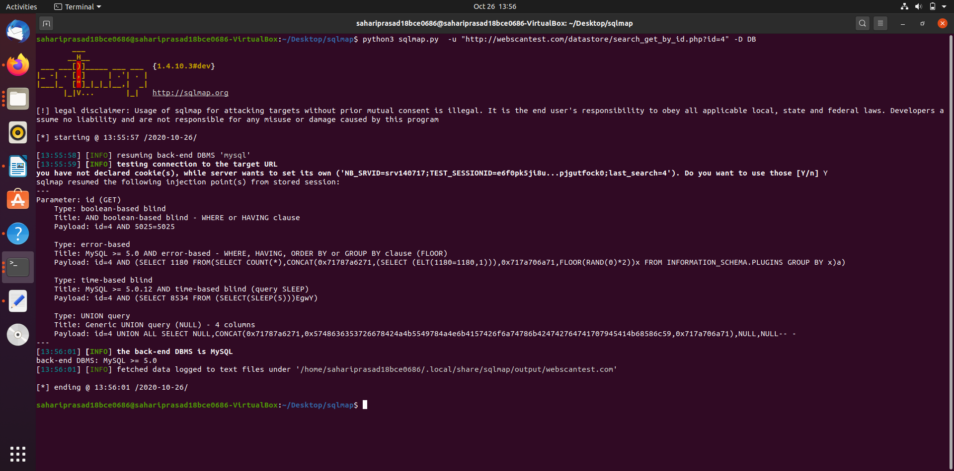

-T TBL DBMS database table(s) to enumerate

-C COL DBMS database table column(s) to enumerate

Operating system access:

These options can be used to access the back-end database management system underlying operating system

--os-shell Prompt for an interactive operating system shell

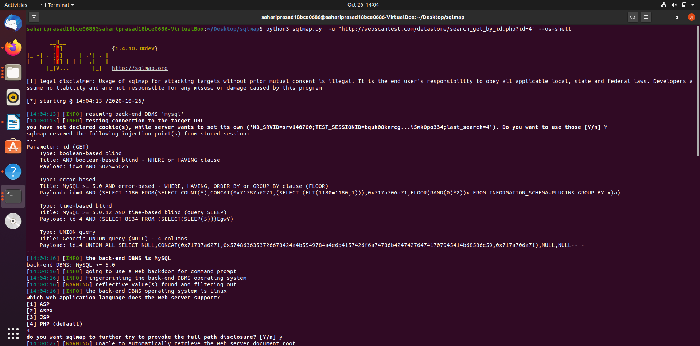

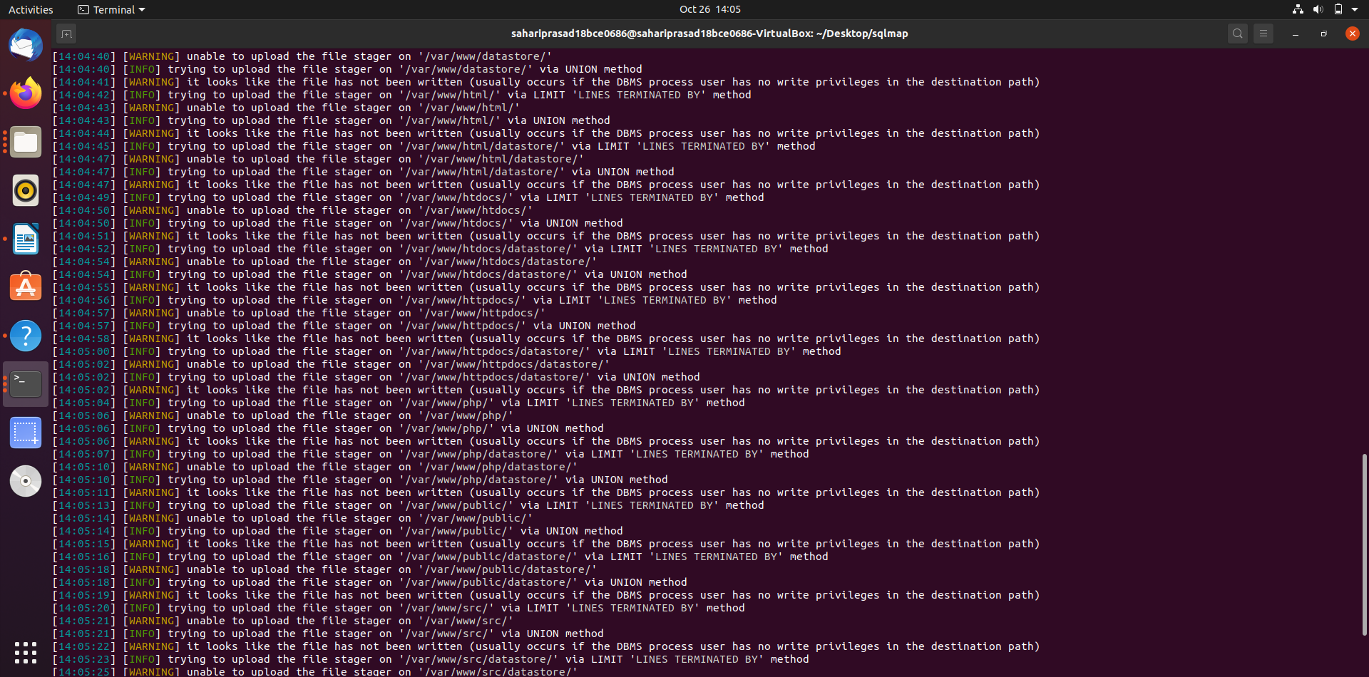

--os-pwn Prompt for an OOB shell, Meterpreter or VNC

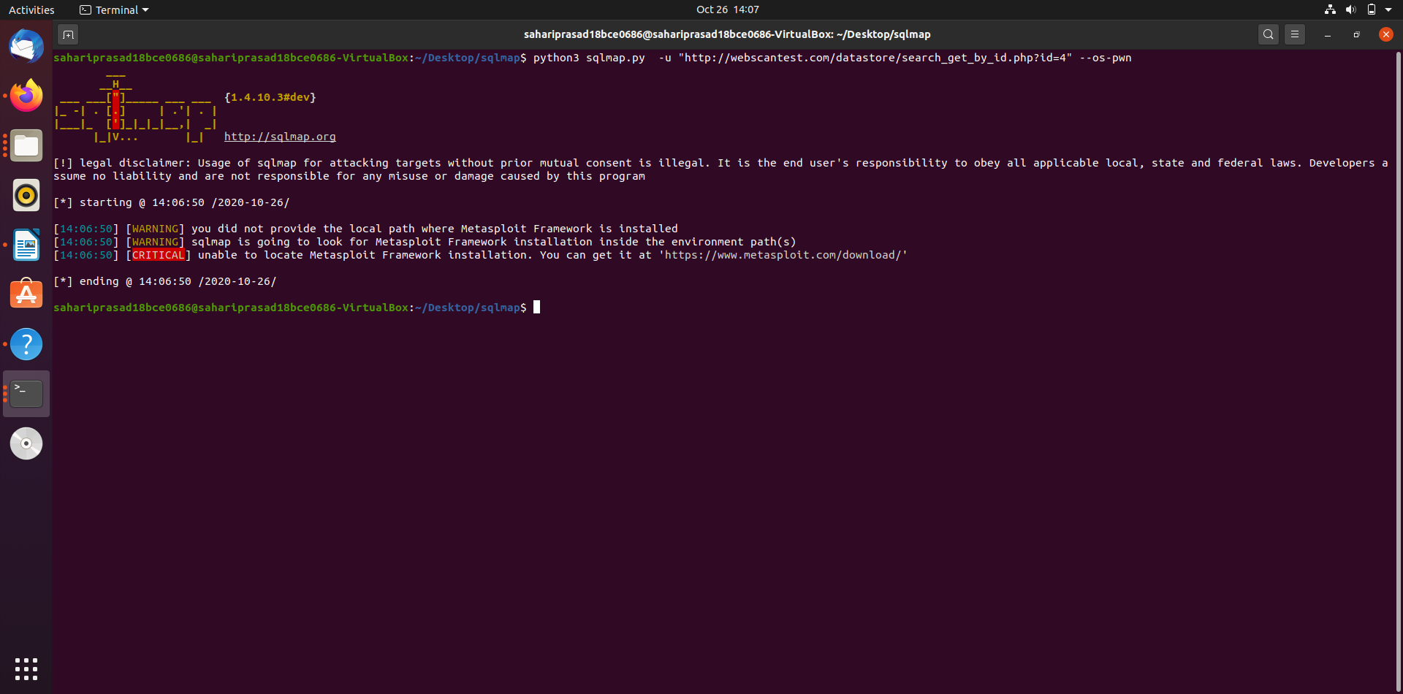

General:

These options can be used to set some general working parameters

--batch Never ask for user input, use the default behavior

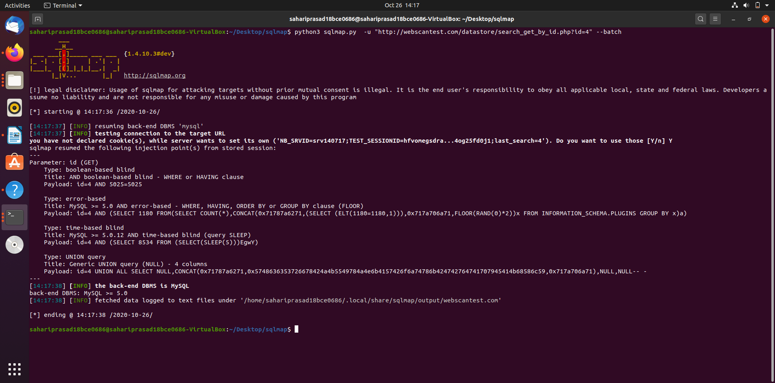

--flush-session Flush session files for current target

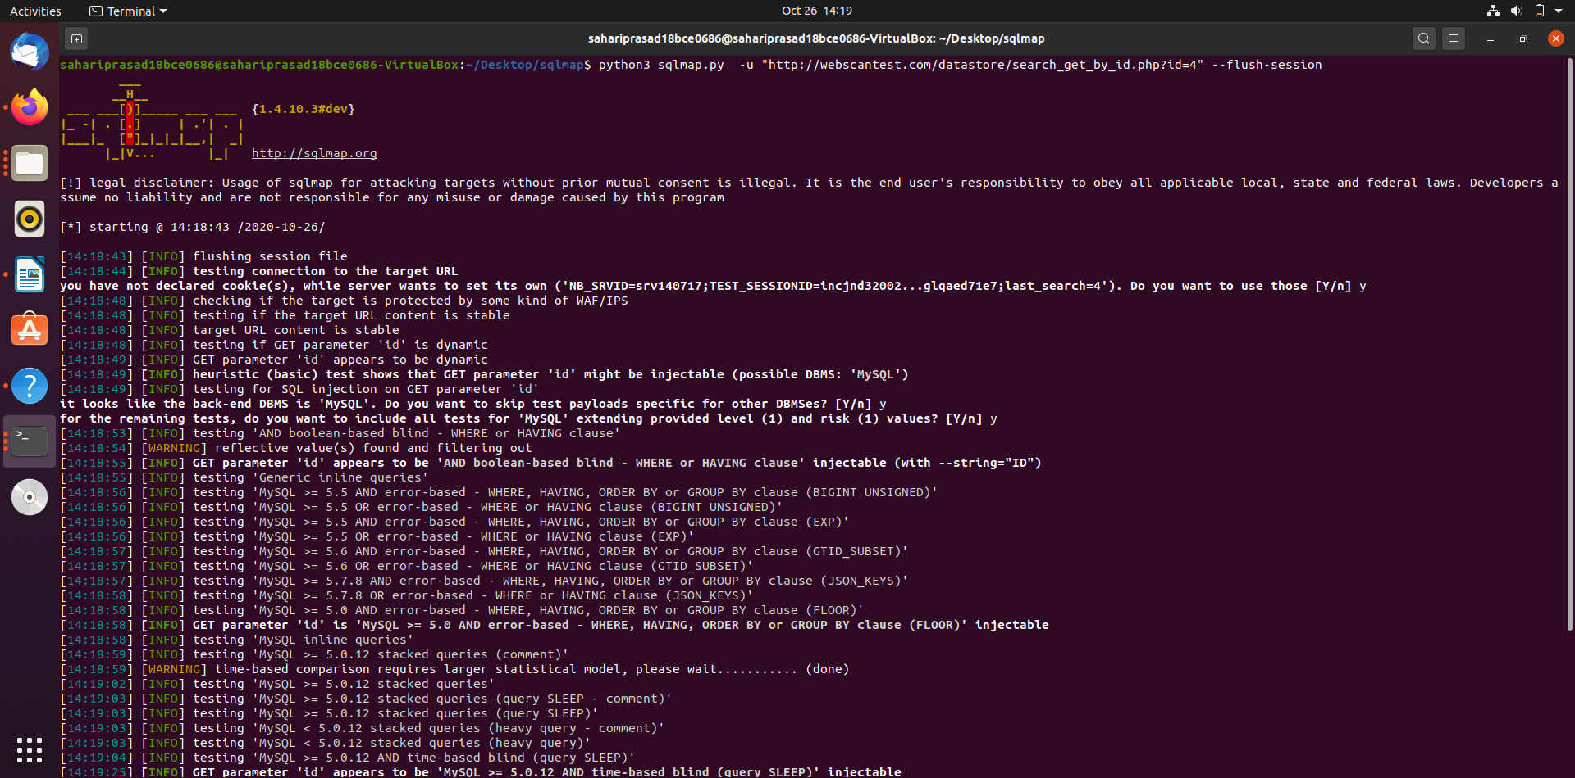

Miscellaneous:

--sqlmap-shell Prompt for an interactive sqlmap shell

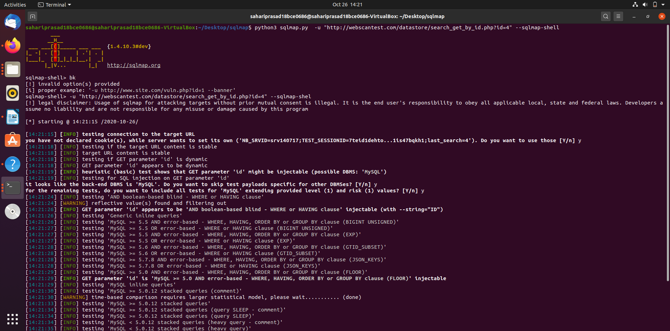

--wizard Simple wizard interface for beginner users


