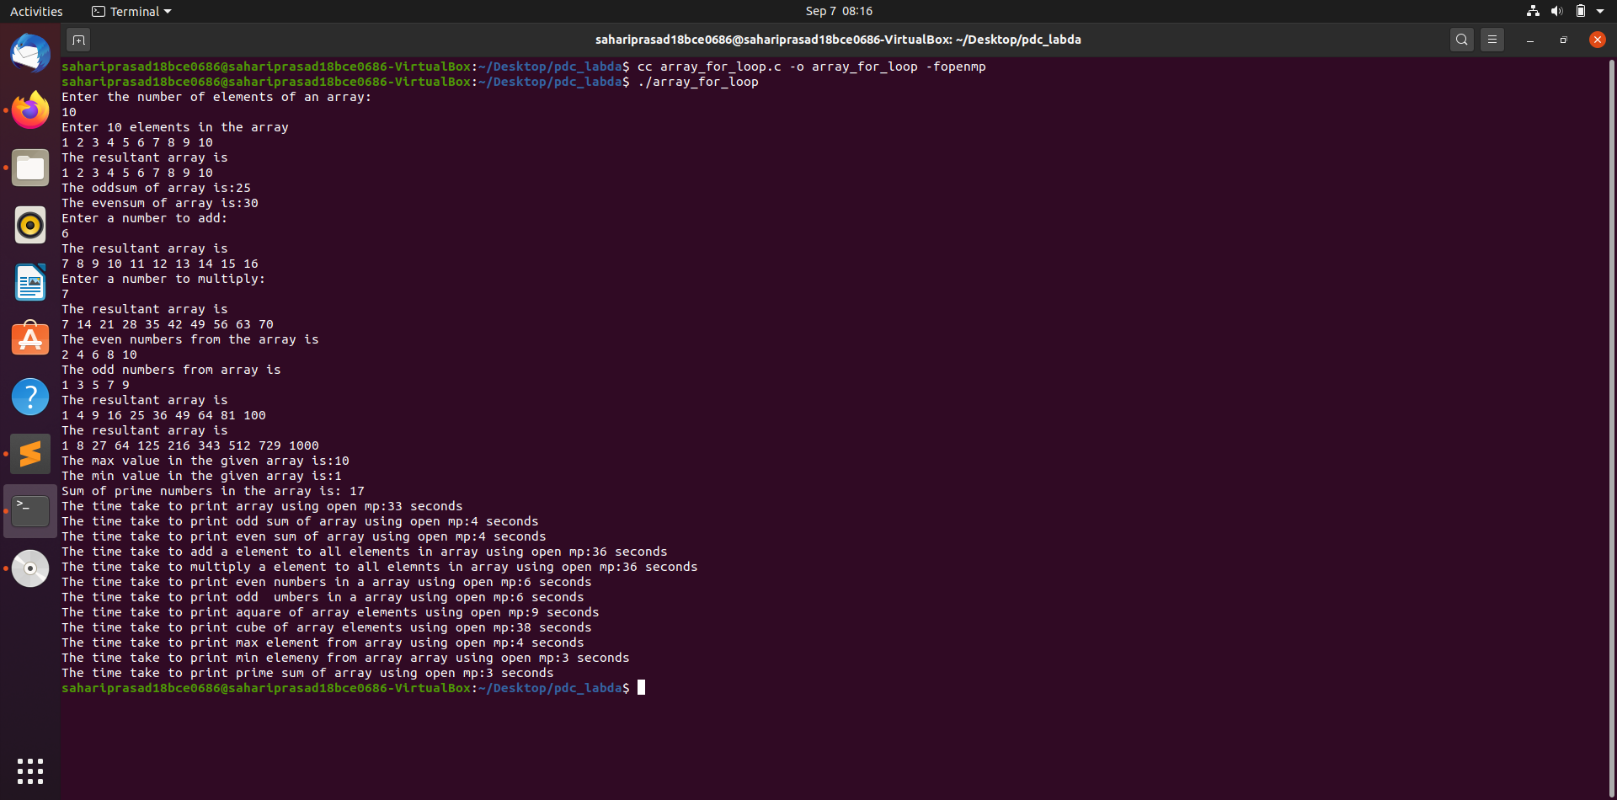
Nj

code:

#include<stdio.h>
#include<omp.h>
#include <math.h>
#include <time.h>
int isprime(int n)
{ int flag;
for (int i = 2; i <= n / 2; ++i) {
if (n % i == 0) {
return 0;
}
}
return 1;
}
void prime_sum_array(int a[],int n)
{
int sum=0;
#pragma omp parallel for
for(int i = 0; i < n; ++i)
{
if(isprime(a[i]) && a[i]!=1)
sum=sum+a[i];
}
printf("Sum of prime numbers in the array is: %d\n",sum);

}

void print_arr(int a[],int count)
{
printf("The resultant array is \n");
#pragma omp parallel for
for (int i = 0; i < count; ++i)
{
printf("%d ",a[i]);
}
printf("\n");
}
void square_arr(int a[],int count)
{
printf("The resultant array is \n");
#pragma omp parallel for
for (int i = 0; i < count; ++i)
{
printf("%d ",a[i]*a[i]);
}
printf("\n");
}
void cube_arr(int a[],int count)
{
printf("The resultant array is \n");
#pragma omp parallel for
for (int i = 0; i < count; ++i)
{
printf("%d ",a[i]*a[i]*a[i]);
}
printf("\n");
}
void add_arr(int a[],int count)
{
int n;
printf("Enter a number to add:\n");
scanf("%d",&n);
printf("The resultant array is \n");
#pragma omp parallel for
for (int i = 0; i < count; ++i)
{
printf("%d ",a[i]+n);
}
printf("\n");
}
void mlp_arr(int a[],int count)
{
int n;
printf("Enter a number to multiply:\n");
scanf("%d",&n);
printf("The resultant array is \n");
#pragma omp parallel for
for (int i = 0; i < count; ++i)
{
printf("%d ",a[i]*n);
}
printf("\n");
}
void print_sum(int a[],int n)
{ int sum=0;
#pragma omp parallel for shared(sum)
for (int i = 0; i < n; i++)
{
#pragma omp critical
sum = sum + a[i];

}
printf("The sum of array is:%d",sum);
printf("\n");
}
void print_oddsum(int a[],int n)
{ int sum=0;
#pragma omp parallel for shared(sum)
for (int i = 0; i <n; i=i+2)
{
#pragma omp critical
sum = sum + a[i];

}
printf("The oddsum of array is:%d",sum);
printf("\n");
}
void print_evensum(int a[],int n)
{ int sum=0;
#pragma omp parallel for shared(sum)
for (int i =1; i <n; i=i+2)
{
#pragma omp critical
sum = sum + a[i];

}
printf("The evensum of array is:%d",sum);
printf("\n");
}
void print_oddnum(int a[],int count)
{
printf("The odd numbers from array is \n");
#pragma omp parallel for
for (int i = 0; i < count; ++i)
{
if(a[i]%2!=0)
printf("%d ",a[i]);
}
printf("\n");
}
void print_evennum(int a[],int count)
{
printf("The even numbers from the array is \n");
#pragma omp parallel for
for (int i = 0; i < count; ++i)
{
if(a[i]%2==0)
printf("%d ",a[i]);
}
printf("\n");
}
void max_array(int A[],int n)
{
int i;
int max_val=A[0];

#pragma omp parallel for
for (i = 1; i < n; i++)
max_val = max_val > A[i] ? max_val : A[i];

printf("The max value in the given array is:%d\n",max_val) ;
}
void min_array(int A[],int n)
{
int i;
int min_val=A[0];

#pragma omp parallel for
for (i = 1; i < n; i++)
min_val = min_val < A[i] ? min_val : A[i];

printf("The min value in the given array is:%d\n",min_val);
}
int main()
{

clock_t s1,s2,s3,s4,s5,s6,s7,s8,s9,s10,s11,s12;
clock_t e1,e2,e3,e4,e5,e6,e7,e8,e9,e10,e11,e12;
int a[1000],b[1000];
int i,number_of_digits;
printf("Enter the number of elements of an array:\n");
scanf("%d",&number_of_digits);
printf("Enter %d elements in the array\n",number_of_digits);
for (i = 0; i < number_of_digits; i++) {

scanf("%d",&a[i]);
}

//To print the array elements-
s1=clock(); print_arr(a,number_of_digits); e1=clock();

//To find the sum / odd sum / even sum of the array elements
s2=clock(); print_oddsum(a,number_of_digits); e2=clock();
s3=clock(); print_evensum(a,number_of_digits); e3=clock();
//To add /multiply a value to each element and print the sum
s4=clock(); add_arr(a,number_of_digits); e4=clock();
s5=clock(); mlp_arr(a,number_of_digits); e5=clock();
//To count the odd and even elements in the array
s6=clock(); print_evennum(a,number_of_digits);e6=clock();
s7=clock(); print_oddnum(a,number_of_digits);e7=clock();
//To find the sum of square’sand cubesof array elements//
s8=clock(); square_arr(a,number_of_digits);e8=clock();
s9=clock(); cube_arr(a,number_of_digits);e9=clock();
//To find the maximum and minimum in an array
s10=clock(); max_array(a,number_of_digits);e10=clock();
s11=clock(); min_array(a,number_of_digits);e11=clock();
//To count the prime numbers and their sum in the array
s12=clock(); prime_sum_array(a,number_of_digits);e12=clock();
printf("The time take to print array using open mp:%ld seconds\n",e1-s1);
printf("The time take to print odd sum of array using open mp:%ld seconds\n",e2-s2);
printf("The time take to print even sum of array using open mp:%ld seconds\n",e3-s3);
printf("The time take to add a element to all elements in array using open mp:%ld seconds\n",e4-s4);
printf("The time take to multiply a element to all elemnts in array using open mp:%ld seconds\n",e5-s5);
printf("The time take to print even numbers in a array using open mp:%ld seconds \n",e6-s6);
printf("The time take to print odd umbers in a array using open mp:%ld seconds\n",e7-s7);
printf("The time take to print aquare of array elements using open mp:%ld seconds\n",e8-s8);
printf("The time take to print cube of array elements using open mp:%ld seconds\n",e9-s9);
printf("The time take to print max element from array using open mp:%ld seconds\n",e10-s10);
printf("The time take to print min elemeny from array array using open mp:%ld seconds\n",e11-s11);
printf("The time take to print prime sum of array using open mp:%ld seconds\n",e12-s12);
return 0;
}

ss 1:

code:
#include <stdio.h>
#include <omp.h>
void work1()
{
printf("Work1 processing\n");
}
void work2()
{
printf("work2processing\n");
}
void single_example()
{
#pragma omp parallel
{
#pragma omp single
printf("Beginning work1.\n");
work1();
#pragma omp single
printf("Finishing work1.\n");
#pragma omp single nowait
printf("Finished work1 and beginning work2.\n");
work2();
}
}
float w1(int i)
{ return 1.0 * i;}
float w2(int i)
{ return 2.0 * i;}
void atomic_example(float *x, float *y, int *index, int n)
{ int i;
#pragma omp parallel for shared(x, y, index, n)
for (i=0; i<n; i++)
{
#pragma omp atomic update
x[index[i]] += w1(i);
y[i] += w2(i);
}
printf("work done through automic contruct value of y:\n");
for (i = 0; i < 10; ++i)
{
printf("%f ",y[i]);
}
}
void sharing_section_directive()
{
int N=10;
int i, nthreads, tid;
float a[N], b[N], c[N], d[N];

/* Some initializations */
for (i=0; i<N; i++) {
a[i] = i * 1.5;
b[i] = i + 22.35;
c[i] = d[i] = 0.0;
}

#pragma omp parallel shared(a,b,c,d,nthreads) private(i,tid)
{
tid = omp_get_thread_num();
if (tid == 0)
{
nthreads = omp_get_num_threads();
printf("Number of threads = %d\n", nthreads);
}
printf("Thread %d starting...\n",tid);

#pragma omp sections
{
#pragma omp section
{
printf("Thread %d doing section 1\n",tid);
for (i=0; i<N; i++)
{
c[i] = a[i] + b[i];
printf("Thread %d: c[%d]= %f\n",tid,i,c[i]);
}
}

#pragma omp section
{
printf("Thread %d doing section 2\n",tid);
for (i=0; i<N; i++)
{
d[i] = a[i] * b[i];
printf("Thread %d: d[%d]= %f\n",tid,i,d[i]);
}
}

} /* end of sections */

printf("Thread %d done.\n",tid);

} /* end of parallel section */

}
void for_loop_sharing()
{
int CHUNKSIZE=10;
int N=10;
int nthreads, tid, i, chunk;
float a[N], b[N], c[N];

/* Some initializations */
for (i=0; i < N; i++)
a[i] = b[i] = i * 1.0;
chunk = CHUNKSIZE;

#pragma omp parallel shared(a,b,c,nthreads,chunk) private(i,tid)
{
tid = omp_get_thread_num();
if (tid == 0)
{
nthreads = omp_get_num_threads();
printf("Number of threads = %d\n", nthreads);
}
printf("Thread %d starting...\n",tid);

#pragma omp for schedule(dynamic,chunk)
for (i=0; i<N; i++)
{
c[i] = a[i] + b[i];
printf("Thread %d: c[%d]= %f\n",tid,i,c[i]);
}

} /* end of parallel section */

}
int main (void)
{
int i = 10;
printf("using privrte in openmp\n\n");
//to elobrate the private variable using openMP
#pragma omp parallel private(i)
{
printf("thread %d: i = %d\n", omp_get_thread_num(), i);
i = 1000 + omp_get_thread_num();
}

printf("i = %d\n", i);
int section_count = 0;
omp_set_dynamic(0);
omp_set_num_threads(4);
printf("using first privrte in openmp\n\n");
//to elobrate the first private variable in openMP
#pragma omp parallel
#pragma omp sections firstprivate( section_count )
{
#pragma omp section
{
section_count++;
/* may print the number one or two */
printf( "section_count %d\n", section_count );
}
//to elobrate about section directive in OpenMP
#pragma omp section
{
section_count++;
/* may print the number one or two */
printf( "section_count %d\n", section_count );
}
}
printf("using last private in openmp\n\n");
//to elobrate last private using openMP
int val = 123456789;

printf("Value of \"val\" before the OpenMP parallel region: %d.\n", val);
#pragma omp parallel for lastprivate(val)
for(int i = 0; i < omp_get_num_threads(); i++)
{
val = omp_get_thread_num();
}

// Value after the parallel region; unchanged.
printf("Value of \"val\" after the OpenMP parallel region: %d. Thread %d was therefore the last one to modify it.\n", val, val);
printf("using single work contruct in openmp\n\n");
//elobrating single work construce
single_example();
float x[1000];
float y[10000];
int index[10000];

for (i = 0; i < 10000; i++)
{
index[i] = i % 1000;
y[i]=0.0;
}
for (i = 0; i < 1000; i++)
x[i] = 0.0;
printf("using atopmic in openmp\n\n");

//elobrating atomic contruct
atomic_example(x, y, index, 10000);
printf("using for loop sharing in openmp\n\n");
//for loop sharing
for_loop_sharing();
printf("using section loop sharing in openmp\n\n");
//section loop sharing()
sharing_section_directive();

return 0;
}

screen shotes

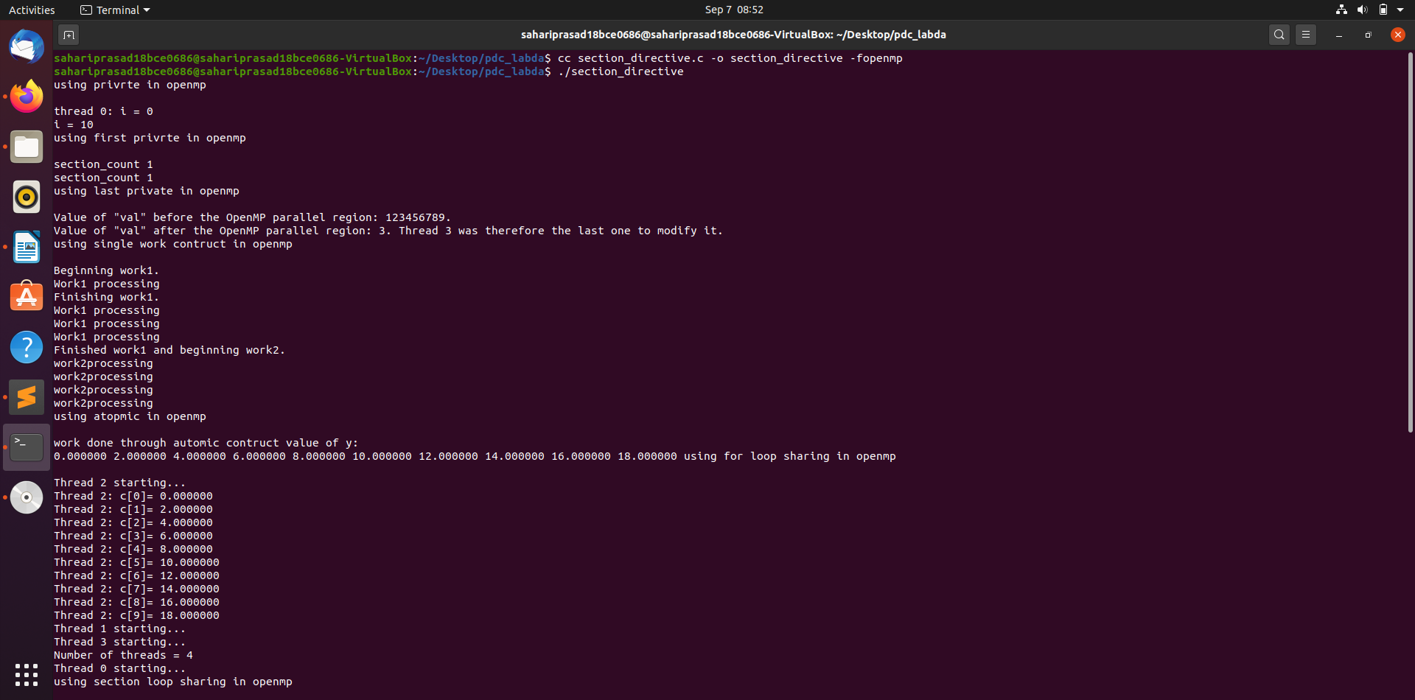
adas
sas
