S A HARIPRASAD 18BCE0686 L35+L36

i) Using nmap Perform the following
a. scan open ports,

nmap –open 192.168.
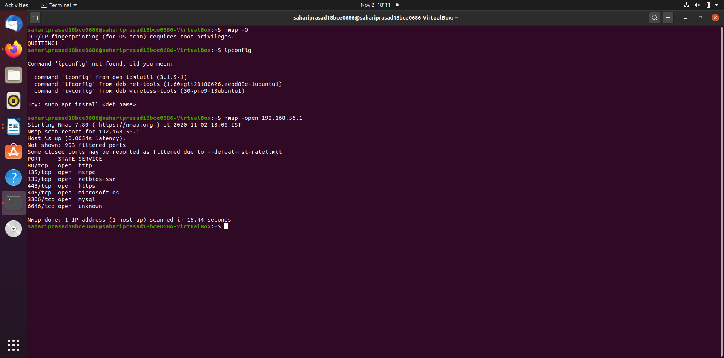

b. perform OS fingerprinting

c. Perform a ping scan,

nmap -sp 192.100.1.1/24

d. Perform tcp port scan,

nmap –sT 192.168.0.1

e. Perform udp port scan.
nmap –sU –p 80,130,255 192.168.0.1

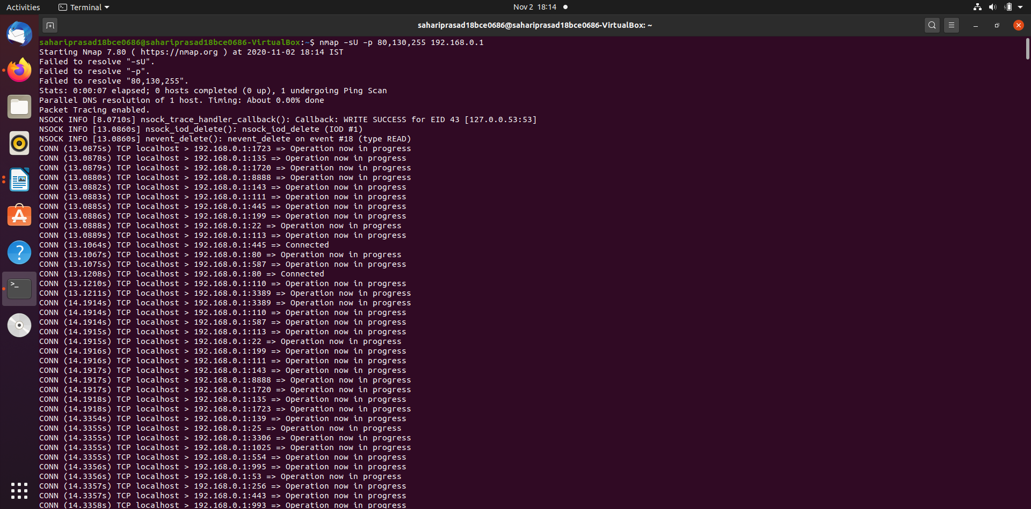

f. Perform scan for the list of ip address stored in a txt file.

nmap –iL textlist.txt
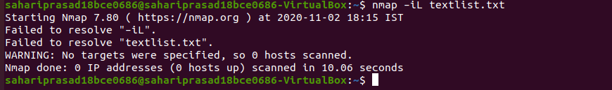
g. To identify DNS IP Address
namp -sL <IP address>
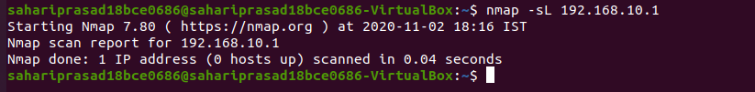
h. TO know the OS version
nmap –A 192.168.0.1
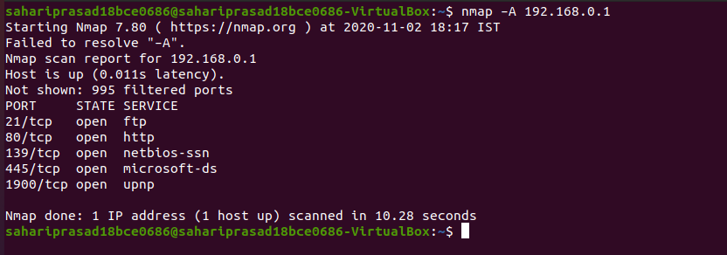
i. How to use nmap to detect remote OS?
nmap -O -v scanme.nmap.org
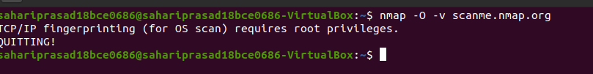

j. How to check whether NMAP already installed or not?
nmap --version

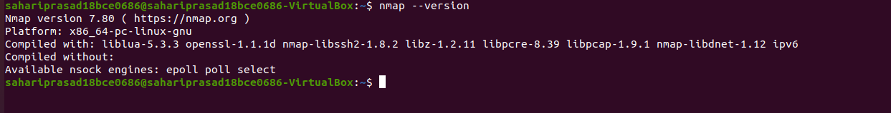

(ii) By using Nessus tool Configure Scan Settings and scan the network for vulnerabilities.

