# Design and Implementation of a Driver For In-Wheel Brushless Motors for Unmanned Vehicles

# Introduction

Electric motors made their first appearances in the XIX century and since then their utility has been increasing day by day. Due to the industrial revolution and the reduction of the prices of metals, electric motors became available for a large range of applications up to the point that nowadays we interact with them in our daily life, sometimes without even noticing it, we have electric motors in small applications like home appliances and hand-held gadgets, to large applications like robotics, automotive and aerospace.

As the complexity of the application increases, also the need for accuracy and efficiency does, leading to the development of more advanced electric motor technologies and therefore, more complex motion control techniques.

The development of electric motor drives is one of the topics that draws the interest of many engineers and scientists due to the multidisciplinary approach needed to reach the speed, torque and efficiency required to drive the development that the inventions of tomorrow require. The electronic approach to improve the motor driving is directly related to the development of complex control algorithms in embedded software that improve the performance of the motor.

One of the most complex applications for motor control is robotics. The motion in robotic systems is part of its definition, therefore a robotic system needs an almost perfect driving system to fulfil its purpose.

…

# Problem Statement

As motion applications become more complex, the need for a more complex and robust driving system arises, and with it, the need to make decisions regarding the technologies to be used for them. For example, when a robotics project begins, one of the main concerns is the motion system. The selection of the motor that is going to be used in a project is not an easy task, since many details must be considered, like the speed and torque required by the application, which lead to the selection of the motor technology, which might be limited by the available power source and computing power. These aspects have a strong dependency between each other and choosing each one of them represents a trade-off that must be studied in detail to reach an optimal result for the desired application.

One of the goals for researchers nowadays is to reduce the trade-offs dependency in engineering applications by developing systems with the best available technologies depending on the application requirements. Following this goal, motor drives are one of the main research topics since their development is crucial to drive the innovation of future inventions.

A complicated trade-off to deal with is the cost of a motor drive, which is one of the most limiting characteristics project developments, both for research activities and for industrial and consumer applications. If a project is not expected to generate an income after its development or it’s not backed up by a research institute with resources, the price of a motor drive might be the weak side in a trade-off analysis and the development of the project might not be optimal, since it might require more work to reach a good result.

The cost of a project leads to another important trade-off on engineering systems: the learning curve. In some areas like robotics, a professional engineering development requires thousands of hours of man-work to reach a desirable result. An important amount of time in these projects is used in learning theory and how the available tools work. This time consumed in learning to develop a project is called “learning curve”. The amount of work necessary to reach a good result makes most of the engineering projects expensive or it makes its development slow, since it would require a lot of time of a researcher that could be used for developing another part of the project.

With the aim to solve these two important trade-off factors in motor driving systems, we decided to study the possibility to reduce the cost of a motor driver by using a system based on a cheap architecture which can be easily modified and allows to understand in a fast way how the motor driver works, making the development around it faster and easier for future projects.

To set up the design specifications for the motor driver to be studied, we based the requirements in the drive characteristics of a robot designed for robotic agriculture designed by the engineering group of the AIRLab of the Politecnico di Milano called “Robi”. This robot is driven by four Permanent Magnet Synchronous Motors (PMSM) that will be described in detail in chapter 4.

Having the objective defined, we looked for an already available platform to develop a motor driver with aims to look for points to improve and define a platform that could be used for different projects involving Permanent Magnet Alternating Current (PMAC) motors, both Brushless Direct Current (BLDC) and PMSM. With this aim, we found a board called VESC Board, developed by the Swedish engineer Benjamin Vedder, who made available all the files for its production, including the schematic circuits, the bill of materials, the PCB layout files and the source code. Vedder’s circuit was very appealing since it had many ports available and it was based on a technology that is easy to study since it’s based in a design proposed by Texas Instrument for tree-phase motors.

Since this motor driver was needed to be used in robotics applications, we had the necessity to modify the source code of the microcontroller to apply motor control methods that would be different to the ones available for the VESC board since the code available was designed to drive an electric skateboard. For this aim, we decided to develop our own source code, this way we would have control over everything developed by us and the expansion of the code would follow up without the need of doing reverse engineering over the code that was already available.

Since the motors of the wheels of the robot are PMSM, they have a sinusoidal configuration, and therefore, a sinusoidal waveform was needed to be applied into the motor to reach an optimal efficiency and to control the speed even in low speeds. (…)

# Motor Control Theory

In this chapter, we will review some theoretical principles that concern us regarding motor control. First, we will review the physical principles that rule over the electric motors and we will explain the different motor technologies and its configurations, focusing in the Permanent Magnet Alternating Current (PMAC) motors. Later, we will review the motor drives, the configuration of a driver and the different driving techniques for the PMAC motors. Finally, we will explain the control methods applied to the different PMAC motors.

## The Electric Motor

An electric motor is an electric machine that transforms electrical energy (product between voltage, current and time)

into mechanical energy (product between Torque, rotational speed and time):

The generation of torque in electric motors is based in the interaction of two magnetic fields, one generated by magnets or windings placed in the stator and the other one generated by magnets or windings placed in the rotor.

The physical laws that rule over the functioning of the electric motor are mainly three: The Lorentz Law, which help us define the torque generated by the motor due to the current crossing though the windings; Faradays Law of Electromagnetic Inductance, which explains the generation of the Back Electromotive Force (BEMF) in the motor coils depending on the speed of the rotor; and the Ampere-Laplace Law, which allows us to calculate the magnetic field of a current loop in a point defined by a vector.

which defines a force F acting over an electric charge q moving with a speed v in a magnetic field with intensity B:

By defining a current I crossing through a conductor with length l we can transform equation (1) into the following:

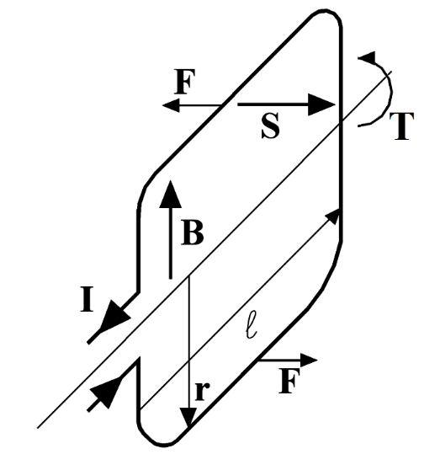

(…)

By feeding the windings in the right way, we look forward to having a 90° de-phase between the two magnetic fields in aims to obtain the maximum torque generation.

In the case of the DC motor, the perpendicularity condition is maintained by the commutator, therefore, the torque obtained is independent from the position of the rotor and it’s proportional to the amplitude of the power source.

In the case of the brushless motors, the perpendicularity condition is maintained by feeding in the right time the windings in function of the angular position of the rotor.

## Permanent Magnet Alternating Current Motors

### Permanent Magnet Synchronous Motor

### Brushless Direct Current Motor

## Motor Drives

### Inverter

### Peripherals

## PMAC Motors Driving Methods

### Six-Step Drive

### Sinusoidal Drive

## Motor Control Methods

### Speed Control

### Torque Control

### Field Oriented Control

### Speed Control with Field Oriented Control

# Study Case: Robi

# Implementation

(…)

## VESC Board

The electric drive subject of this study is based on an open source project developed by the Swedish engineer Benjamin Vedder called VESC - Open Source ESC, which consists in the hardware design of a Printed Circuit Board (PCB) and the source code used to drive a BLDC motor.

The VESC board was conceived and designed to be used in electric skateboards with the intention to create one of the best ESC drives available. Since it was planned to be used in a skateboard, it has a small form-factor and it can be used for different applications with similar power demand. The hardware can also be modified by changing specific components to drive motors with higher power demand or by modifying the PCB following the schematic design.

The board consists of the following blocks:

1. Voltage supply input
2. Power MOSFETs three-phase inverter
3. MOSFET driver
4. Microcontroller unit
5. Peripherals
   1. Temperature sensors
      1. Motor temperature sensor
      2. Board temperature sensor
   2. Hall effect sensors
   3. RC Servomotor Output
   4. Debug LEDs
6. Communication interfaces
   1. USB
   2. CAN
   3. USART
   4. SPI
   5. I2C

## Power Supply Input

The power is supplied into the board by means of soldering 2 wires into large pads placed closely to the three-phase inverter nodes V_SUPPLY and GND. V_SUPPLY and GND are the positive and negative nodes of the power supply source respectively. The power is supplied from a power regulator for static applications or from a battery for mobile applications. It is also specified that there should be a decoupling capacitor connected in parallel to the power supply port.

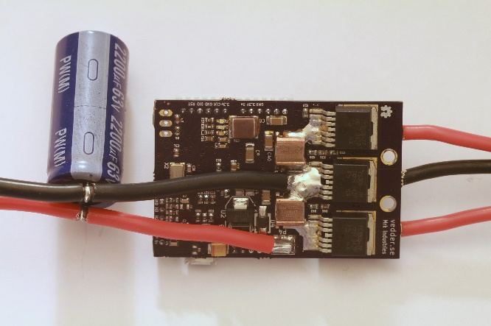

### Power Supply Wiring

The strategy of soldering the wires directly to the pads in the PCB helps reduce the size and price of the board since it avoids the use of large power traces in that would be needed if a regular receptacle connector was to be used.

The practice of soldering a wire directly to a PCB is discouraged mainly in circuits that will be mounted in a system designed to be in movement (i.e. automotive or aerospace applications) because the wire used in these applications is made of delicate copper strands which can break easily with movement of the board or of the wires and cause a short circuit or a loose contact, both of which might lead to catastrophic failures [https://electronics.stackexchange.com/questions/129907/what-is-the-best-way-to-solder-these-wires-to-circuit-board], so there is a risk in this board since it will be mounted in systems that will be in constant movement [http://uk.rs-online.com/web/generalDisplay.html?id=solutions/pcb-connectors]­. Since this board was designed this way to reduce space consumption, the trade-off between safety and size was balanced into the size constraints, therefore some cautions must be taken to avoid problems, mainly because these wires carry a considerable amount of current and they pass over many components of the board as seen in figure X.

The first consideration to be made is the wire gauge and insulation type. The wire gauge is a measurement of the wire diameter, which determines the amount of electric current that a wire can safely carry, as well as its electrical resistance and weight [https://en.wikipedia.org/wiki/Wire_gauge]. Since the wire has an implicit resistance depending on its diameter as stated by Pouillet’s Law:

where ρ is the electrical resistivity of the material, L is the length of the wire and A is the cross-sectional area of the wire [https://en.wikipedia.org/wiki/Electrical_resistivity_and_conductivity], there is also a voltage drop in the transmission line depending on the current flowing through the wire. This voltage drop can be neglected or not depending on the length of the wire being used, which defines 2 types of wiring: chassis wiring and transmission line wiring. For this board, it is suggested to use short wires to avoid a large voltage drop and to ease the handling of such wire until it reaches the output of the enclosure that will protect the circuit. In either case, the wire can be considered as chassis wiring since a transmission line wiring is considered for wires larger than 2 meters [ref].

The second consideration regarding the wire selection is the insulation material. Since the current passing through the copper also implies power consumption due to the resistance of the copper, there is heat transfer from the wire to its surroundings. To protect the copper strands from its surroundings and vice versa, wires are covered by an insulating material, which has low thermal and electrical conductivity.

* (…something about wire material…) HO7RNF
* Flexibility

Since the heat exchange calculation of the wire would require many assumptions, it’s a normal practice to select the type of wire using tables that consider the temperature rise in the wire according to different currents and lengths. In the case of the PMSM motor used in Robi, the maximum current would be 13.88A, therefore we can use a table of wire gauges and currents under (…) [https://www.powerstream.com/Wire_Size.htm]

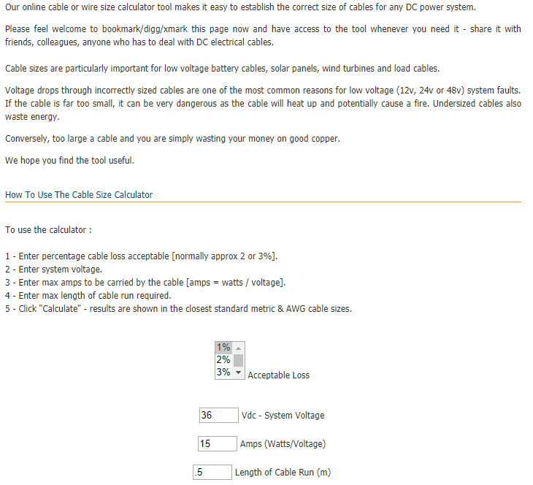

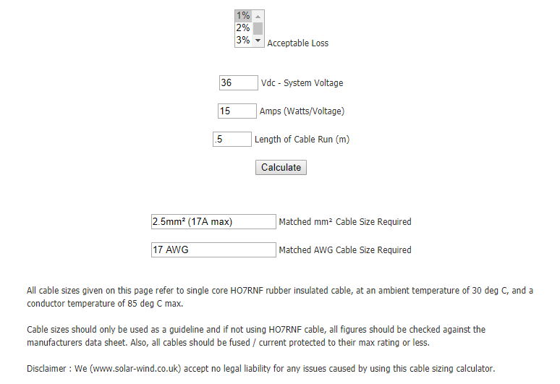

### Voltage Supply Range

The voltage range of the VESC board is defined by the MOSFET driver integrated circuit DRV8302, which specifies an operating supply voltage range from 8V to 60V, but allows a maximum voltage supply up to 65V [ref to the datasheet]. All the other components of the board, mainly capacitors and power MOSFETs, must be selected according to this voltage range.

(…?)

### Bulk Electrolytic Capacitor

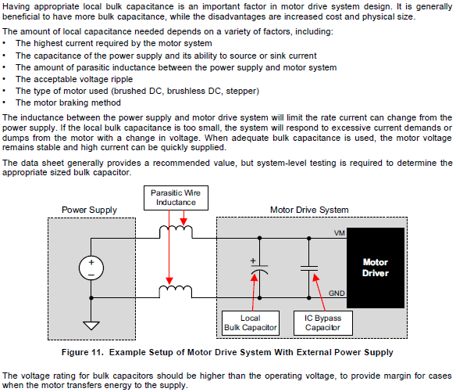

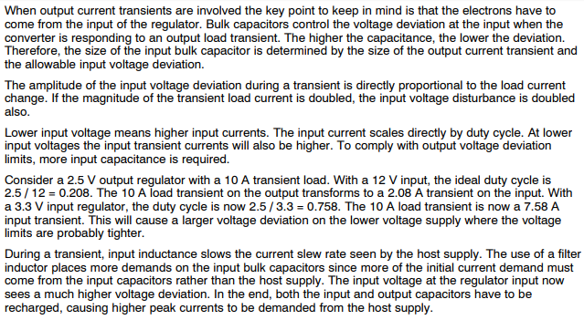

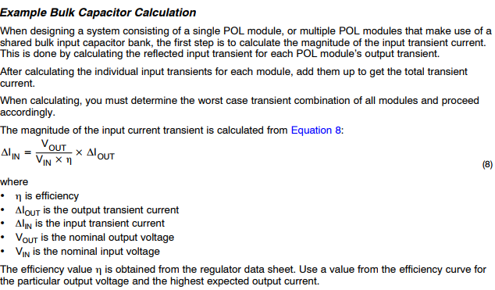

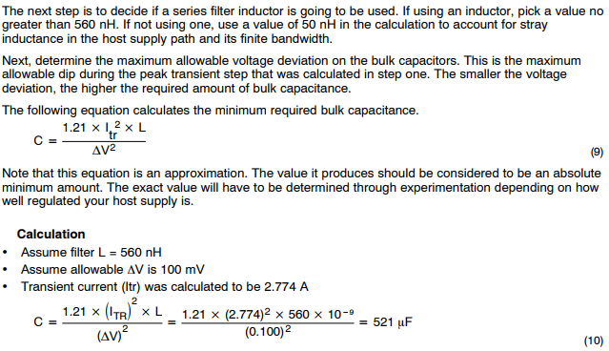

The proposed capacitor is 2200uF at 50V

[http://www.ti.com/lit/an/slta055/slta055.pdf]

[http://www.analog.com/media/en/training-seminars/tutorials/MT-101.pdf]

## Power MOSFET Three-Phase Inverter

The three-phase inverter used in the VESC board is based on the power MOSFET IRFS7530-7PPbF by the semiconductor company International Rectifier.

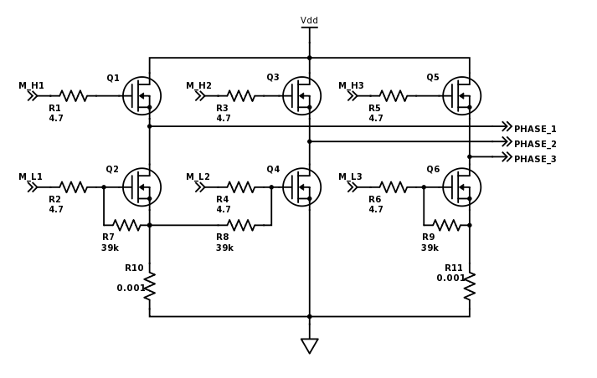

This MOSFET is based on the HEXFET Power MOSFET technology, which is a Vertical Double-diffused MOS transistor (VDMOS) with hexagonal elementary cells in parallel which maximizes the W/L ratio of the transistor, reducing its on-resistance RDS(ON). [ref to Gionni and the datasheet].

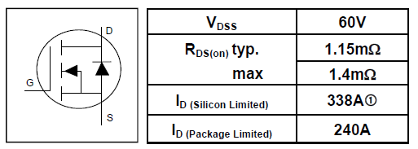

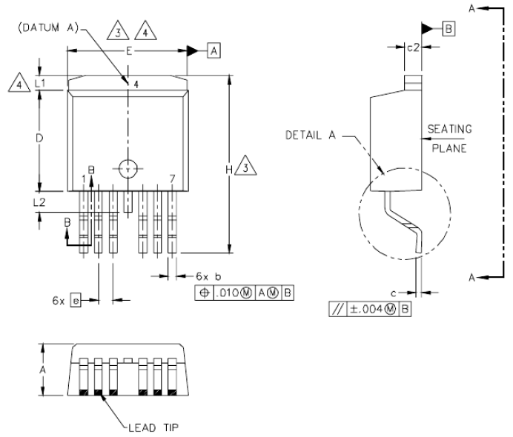

### Voltage and Current Limits

The DC Voltage limit in the inverter is defined by the drain-source breakdown voltage (V(BR)DSS) of the MOSFETs which is 60V

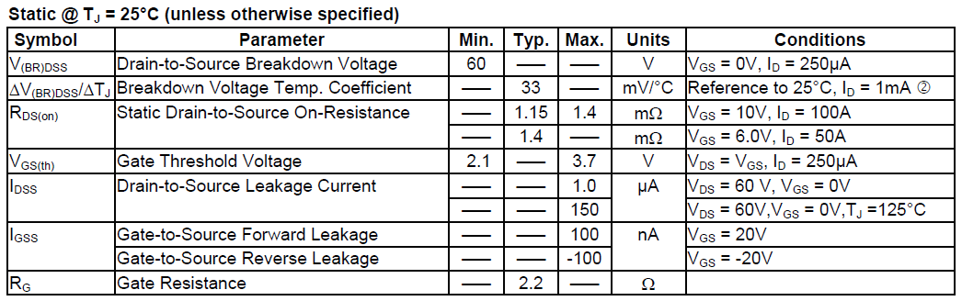

### Switching Times

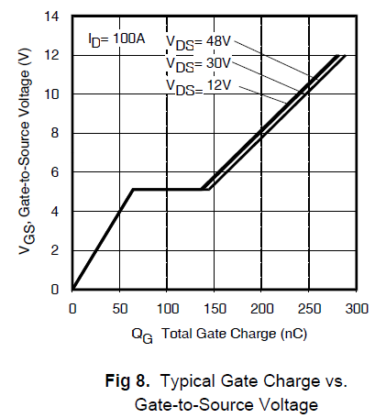

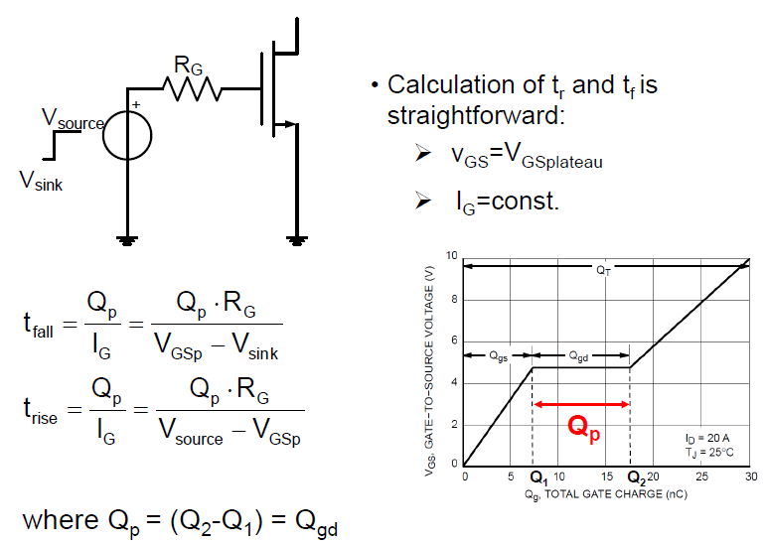

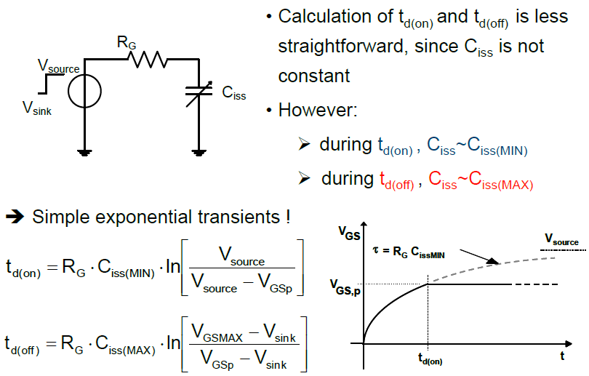

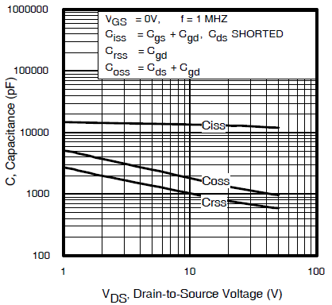

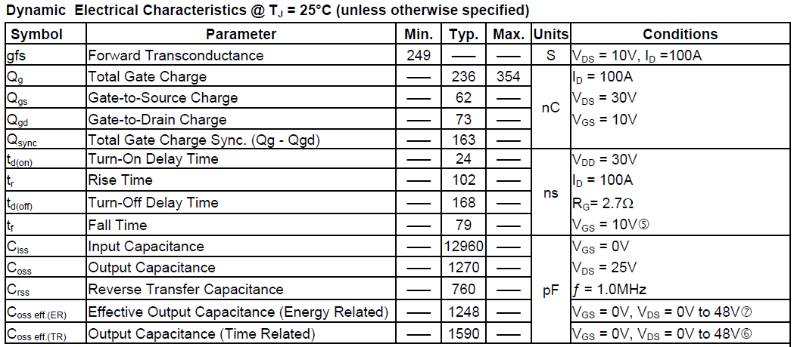

VGS is defined by the MOSFET Driver and the rise and fall times can be calculated better…

## MOSFET Driver

The central component in the VESC board around which the rest of the circuit was designed is the integrated circuit DRV8302, a brushless motor inverter driver manufactured by Texas Instruments.

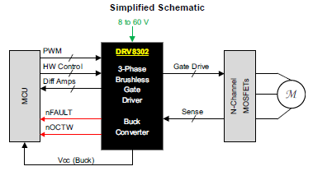

* The DRV8302 provides three half bridge drivers capable of driving two N-channel MOSFETs each.
* The device supports up to 1.7-A source and 2.3-A peak current capability.
* The DRV8302 can operate off of a single power supply with a wide range from 8-V to 60-V.
* It uses a bootstrap gate driver architecture with trickle charge circuitry to support 100% duty cycle.
* The DRV8302 uses automatic hand shaking when the high side or low side MOSFET is switching to prevent current shoot through.
* Integrated VDS sensing of the high and low side MOSFETs is used to protect the external power stage against overcurrent conditions.
* The DRV8303 includes two current shunt amplifiers for accurate current measurement. The amplifiers support bi-directional current sensing and provide and adjustable output offset up to 3 V.
* The DRV8302 also includes an integrated switching mode buck converter with adjustable output and switching frequency. The buck converter can provide up to 1.5 A to support MCU or additional system power needs.
* A hardware interface allows for configuring various device parameters including dead time, overcurrent, PWM mode, and amplifier settings. Error conditions are reported through the nFAULT and nOCTW pins. 3.3-V and 5-V Interface Support.

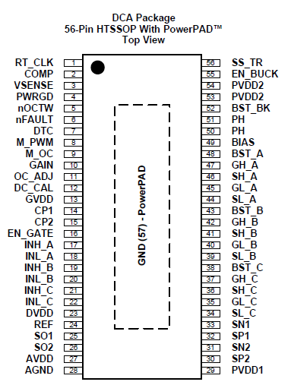

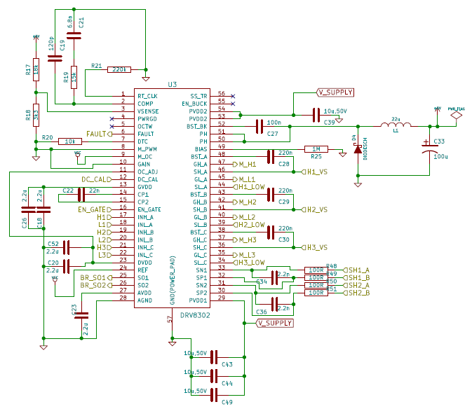

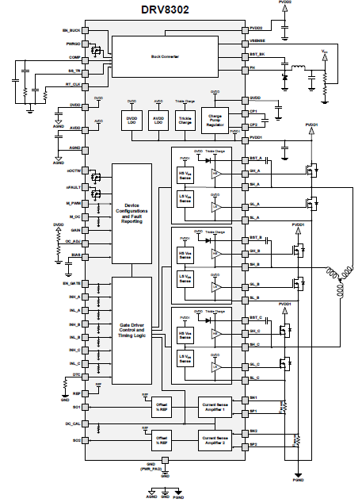

## MCU

The processor for which this board was designed is the STM32F405rg: a 64-pin IC microcontroller of the STMicroelectronics family of 32-bit devices with an ARM Cortex-M4 CPU and a core operating frequency up to 168 MHz. The Cortex-M4 core features a Floating point unit (FPU) single precision which supports all ARM single-precision data-processing instructions and data types. It also implements a full set of DSP instructions, which makes it ideal for the signal processing required to drive PMAC motors. This microcontroller also includes three 12-bit ADCs and supports USART, I2C, SPI, USB and CAN communication interfaces, improving the versatility of the VESC board. The memory of the microcontroller consists in 1024 kB of Flash memory and 192 kB of SRAM memory [6].