# ~~Politecnico di Milano~~

~~Facoltà di Ingegneria~~

~~Scuola di Ingegneria Industriale e dell’Informazione~~

~~Dipartimento di Elettronica, Informazione e Bioingegneria~~

~~Master of Science in Electronics Engineering~~

# ~~Recorte de pantalla~~

# ~~Design and Implementation of a Driver For In-Wheel Brushless Motors for Unmanned Vehicles~~

~~Supervisor:~~

~~Prof. Giambattista Gruosso~~

~~Co-Supervisor:~~

~~Prof. Luca Bascetta~~

~~Examiner:~~

~~Prof. Luigi Piegari~~

~~Thesis submitted by:~~

~~Arturo Montúfar Arreola~~

~~ID: 840541~~

~~Academic Year 2017-2018~~

~~Acknowledgments~~

~~Professor Giambattista Gruosso, for giving me the opportunity to develop such an interesting thesis project~~

~~Professor Luca Bascetta, for guiding me through the research of the motor control theory.~~

~~Professor Luigi Piegari, for his support on the final tests and the examination of the thesis.~~

~~Marco Bauer, for his support in everything related to the mechanics of the project.~~

~~Giulio Fontana, for his support while working in the AIRLab.~~

~~Professor Luigi Colombo for the information regarding the thermal analysis~~

~~Stefano Bianchi…~~

~~Milica Jovanovic for helping me with the documentation of the software.~~

Introduction

~~Electric motors made their first appearances in the middle of the XIX century right after the invention of the battery, the generation of a magnetic field from an electric current and the invention of the electromagnet. After these foundations were laid, the development of a machine that generates mechanical power from electrical power has been improving day by day and, along with that improvement, also its utility increased [1].~~

~~Due to the reduction of the prices of metals and manufacture processes, electric motors became available for a large range of applications, up to the point that nowadays we interact with them in our daily life, sometimes without even noticing it. We have electric motors from small applications like home appliances and hand-held gadgets, to large applications like in robotics, automotive and aerospace. As the complexity of the application increases, also the need for accuracy and efficiency does, leading to the development of more advanced electric motor technologies which lead to complex motion control techniques.~~

~~One of the most complex applications for motor control is robotics. The motion in a robotic system is part of its definition of automatic movement, therefore a robotic system needs a predictable driving system to fulfil its purpose. A challenging application for motors in robotics is the wheel driving, since it needs to be precise and powerful at the same time to transport the robotic system around large surfaces in an automatic way. For example, in robotic agriculture, which is the reason why this work was developed, a robot must transport itself around in farms, where the road represents harsh conditions for transportation, introducing the need for a precise drive to deal with small crops, a high torque to transport the robot in an uneven ground and a good range of speeds to displace itself in large field areas in the fastest way possible.~~

~~With aims to propose a solution for robotic agriculture applications and different applications that might benefit from what is explained in this work, different types of motor technologies were studied, finding out that in-wheel brushless motors are one of the most suitable and currently used solutions to develop electric vehicles, since they don’t need an extra system for the power transmission from the motor to the wheels, taking advantage of the high stall torque property of the electric motors.~~

~~To correctly drive in-wheel motors, there is the need of applying a proper driving technique for brushless motors, which becomes a complex task when the goal is to achieve the desired characteristics mentioned previously: precision, high torque and a large range of speed.~~

~~The development of electric motor drives is one of the topics that draws the interest of many engineers and scientists due to the multidisciplinary approach needed to reach the speed, torque and efficiency required to drive the development that the inventions of tomorrow require. The electronic approach to improve the motor driving is directly related to the development of complex control algorithms in embedded software that improve the performance and efficiency of the different kinds of motor.~~

~~Since the brushless motor technology is quite recent in comparison with the rest, there is still a lot of development going on regarding its driving, with aims to reach the highest efficiency possible at the lowest cost. The objective of this work was to develop an electronic driver to control in-wheel brushless motors, taking as a study case the in-wheel motors that transport a skid-steering robot designed for robotic agriculture. We studied available electronic architectures to design a motor driver, the different approaches to drive these motors, like the trapezoidal and the sinusoidal drive and the peripherals needed to make these driving happen.~~

~~Problem Statement~~

~~As motion applications become more complex, the need for a more complex and robust driving system arises, and with it, the need to make decisions regarding the technologies to be used for them. For example, when a robotics project begins, one of the main concerns is the motion system. The selection of the motor that is going to be used in a project is not an easy task, since many details must be considered, like the speed and torque required by the application, which lead to the selection of the motor technology, which might be limited by the available power source and computing power. These aspects have a strong dependency between each other and choosing each one of them represents a trade-off that must be studied in detail to reach an optimal result for the desired application.~~

~~One of the goals for researchers nowadays is to reduce the trade-offs dependency in engineering applications by developing systems with the best available technologies depending on the application requirements. Following this goal, motor drives are one of the main research topics since their development is crucial to drive the innovation of future inventions.~~

~~A complicated trade-off to deal with is the cost of a motor drive, which is one of the most limiting characteristics project developments, both for research activities and for industrial and consumer applications. If a project is not expected to generate an income after its development or it’s not backed up by a research institute with resources, the price of a motor drive might be the weak side in a trade-off analysis and the development of the project might not be optimal, since it might require more work to reach a good result.~~

~~The cost of a project leads to another important trade-off on engineering systems: the learning curve. In some areas like robotics, a professional engineering development requires thousands of hours of man-work to reach a desirable result. An important amount of time in these projects is used in learning theory and how the available tools work. This time consumed in learning to develop a project is called “learning curve”. The amount of work necessary to reach a good result makes most of the engineering projects expensive or it makes its development slow, since it would require a lot of time of a researcher that could be used for developing another part of the project.~~

~~With the aim to solve these two important trade-off factors in motor driving systems, we decided to study the possibility to reduce the cost of a motor driver by using a system based on a cheap architecture which can be easily modified and allows to understand in a fast way how the motor driver works, making the development around it faster and easier for future projects.~~

~~To set up the design specifications for the motor driver to be studied, we based the requirements in the drive characteristics of a robot designed for robotic agriculture designed by the engineering group of the AIRLab of the Politecnico di Milano called “Robi”. This robot is driven by four Permanent Magnet Synchronous Motors (PMSM) that will be described in detail in chapter 4.~~

~~Having the objective defined, we looked for an already available platform to develop a motor driver with aims to look for points to improve and define a platform that could be used for different projects involving Permanent Magnet Alternating Current (PMAC) motors, both Brushless Direct Current (BLDC) and PMSM. With this aim, we found a board called VESC Board, developed by the Swedish engineer Benjamin Vedder, who made available all the files for its production, including the schematic circuits, the bill of materials, the PCB layout files and the source code. Vedder’s circuit was very appealing since it had many ports available and it was based on a technology that is easy to study since it’s based in a design proposed by Texas Instrument for tree-phase motors.~~

~~Since this motor driver was needed to be used in robotics applications, we had the necessity to modify the source code of the microcontroller to apply motor control methods that would be different to the ones available for the VESC board since the code available was designed to drive an electric skateboard. For this aim, we decided to develop our own source code, this way we would have control over everything developed by us and the expansion of the code would follow up without the need of doing reverse engineering over the code that was already available.~~

~~Since the motors of the wheels of the robot are PMSM, they have a sinusoidal configuration, and therefore, a sinusoidal waveform was needed to be applied into the motor to reach an optimal efficiency and to control the speed even in low speeds. (…)~~

# ~~Motor Control Theory~~

~~In this chapter, we will review some theoretical principles that concern us regarding motor control. First, we will review the physical principles that rule over the electric motors and we will explain the different motor technologies and its configurations, focusing in the Permanent Magnet Alternating Current (PMAC) motors. Later, we will review the motor drives, the configuration of a driver and the different driving techniques for the PMAC motors. Finally, we will explain the control methods applied to the different PMAC motors.~~

## ~~The Electric Motor~~

~~An electric motor is an electric machine that transforms electrical energy (product between voltage, current and time)~~

~~into mechanical energy (product between torque, angular speed and time)~~

~~The generation of torque in electric motors is based in the interaction of two magnetic fields, one generated by magnets or windings placed in the stator and the other one generated by magnets or windings placed in the rotor.~~

~~The physical laws that rule over the electric motor are mainly four: The Lorentz’s Law, which helps us define the torque generated by an electric charge moving inside a magnetic field; Faraday’s Law of Electromagnetic Inductance and the Lenz’s Law, which explain the generation of the Back Electromotive Force (BEMF) in the motor coils depending on the speed of the rotor and the influence of the magnetic field generated due to this BEMF respectively; and the Ampere-Laplace Law, which allows us to calculate the magnetic field of a current loop and the mechanical interaction between two magnetic fields.~~

**~~Lorentz’s Law~~** ~~defines a force~~ **~~F~~**~~, which acts over an electric charge~~ **~~q~~** ~~moving with a speed~~ **~~v~~** ~~inside a magnetic field with intensity~~ **~~B~~**~~:~~

~~By defining a current~~ **~~I~~** ~~crossing through a conductor with length~~ **~~l~~** ~~we can transform equation (1) into the following:~~

~~Considering the current~~ **~~I~~** ~~crossing through a conductive loop as the one in figure (x1) with sides lengths~~ **~~l~~** ~~and~~ **~~h~~** ~~we can see that there is a force F generated as the cross product of the current~~ **~~I~~** ~~and the magnetic field~~ **~~B~~**~~. The maximum force~~ **~~F~~** ~~is generated in the sides of the loop where the current I is perpendicular to the magnetic field B direction (ab and cd), while on the other two sides (ad and bc) the forces generated are cancelled with each other due to the direction of the current respect to the magnetic field.~~

~~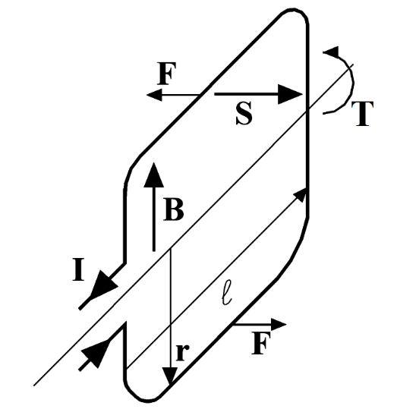~~

~~(Change this image…)~~

~~figure x1~~

~~Since the forces F generated on the sides ab and cd have the same magnitude but different direction, they create a torque on the y axis defined by the force generated and by the length of the sides of the coils as following:~~

~~From equation (x) we can see that when the angle between sides ad – bc and the direction of the magnetic field θ is ±π/2 degrees, the torque T is cancelled and when the angle θ is ±π the torque is the maximum available.~~

**~~Faraday’s Law of Electromagnetic Inductance~~** ~~states that~~

~~“In every circuit under the effect of a magnetic field, an electromotive force is induced equal to the derivative respect to the time of the magnetic flux passing though the circuit, with negative sign.”~~

~~therefore, by indicating with E the electromotive force and with φ~~~~m~~ ~~the magnetic flux, we have:~~

~~If we consider a case like the one in figure (x1) we can calculate the magnetic flux passing though the loop as:~~

~~where S is the surface of the loop and un is the direction normal to the plane of the loop. Therefore, we get an induced electromotive force of:~~

~~where ω is the angular speed of the loop. We can see that the induced electromotive force depends on the angular speed in the same way than the acting torque depends on the current.~~

~~If the rotation of the loop is generated by the circulation of a current inside a magnetic field, the induced electromotive force will try to oppose to the pass of the current, that’s why it’s normally referred to as back electromotive force (BEMF).~~

~~After the definition of the BEMF, we move on to the~~ **~~Lenz’s Law~~**~~, which states that the induced current in a loop has the direction that creates a magnetic field that opposes the change in magnetic flux through the area enclosed by the loop, therefore, the induced current tends to keep the magnetic flux φ~~~~m~~ ~~from changing in the circuit.~~

~~The last piece to understand the transformation of electrical energy into mechanical energy is the~~ **~~Ampere-Laplace Law~~**~~, which lets us calculate the magnetic field generated by a closed loop conducting current in a point defined by a vector p:~~

~~where u0 is the vacuum magnetic permeability constant, I is the current circulating through the loop, ut is the versor with direction of the current in the infinitesimal element dl and ur and r are versor and module that define the point p respect to the infinitesimal element of the loop.~~

~~Given that the magnetic fields can be generated both by permanent magnets and by current circulation, the electromechanical conversion is obtained due to the interaction of two magnetic fields according to the alignment principle:~~

~~“In a region of space which hosts two magnetic fields, there is a mechanical action that tends to align both fields.”~~

~~So, if we consider the loop from figure (x1), we can see that there is a magnetic field generated around the loop as seen in figure (x2), and due to the alignment principle, we will get the strongest coupling torque when the magnetic fields are perpendicular to each other.~~

~~In the case of electrical motors, there are two different magnetic fields generated in the airgap due to the permanent magnets or to the windings placed in the stator and the rotor which can be considered in radial direction, described by two magnetic fields Br(θ,t) and Bs(θ,t), from which interaction we get the electromechanical conversion, since we have the generation of a torque which tends to align the two fields angles where they have the largest intensity. The alignment torque will be an expression of the type:~~

~~where gamma is the de-phasing angle between the two fields and the maximum torque will be when gamma = Pi / 2.~~

~~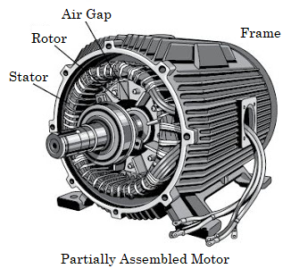~~

~~In conclusion, by feeding the windings in the right way, we look forward to having a constant 90° de-phase between the two magnetic fields in aims to obtain the maximum torque generation.~~

~~In the case of the DC motor, the perpendicularity condition is maintained by the commutator, therefore, the torque obtained is independent from the position of the rotor and it’s proportional to the amplitude of the power source.~~

~~In the case of the brushless motors, the perpendicularity condition is maintained by feeding in the right time the windings in function of the angular position of the rotor, which is one of the main goals to be achieved and explained in this work.~~

## ~~Permanent Magnet Alternating Current Motors~~

### ~~Permanent Magnet Synchronous Motor~~

### ~~Brushless Direct Current Motor~~

## ~~Motor Drives~~

### ~~Inverter~~

### ~~Peripherals~~

## PMAC Motors Driving Methods

### Six-Step Drive

### Sinusoidal Drive

## Motor Control Methods

### Speed Control

### Torque Control

### Field Oriented Control

### Speed Control with Field Oriented Control

# Study Case: Robi

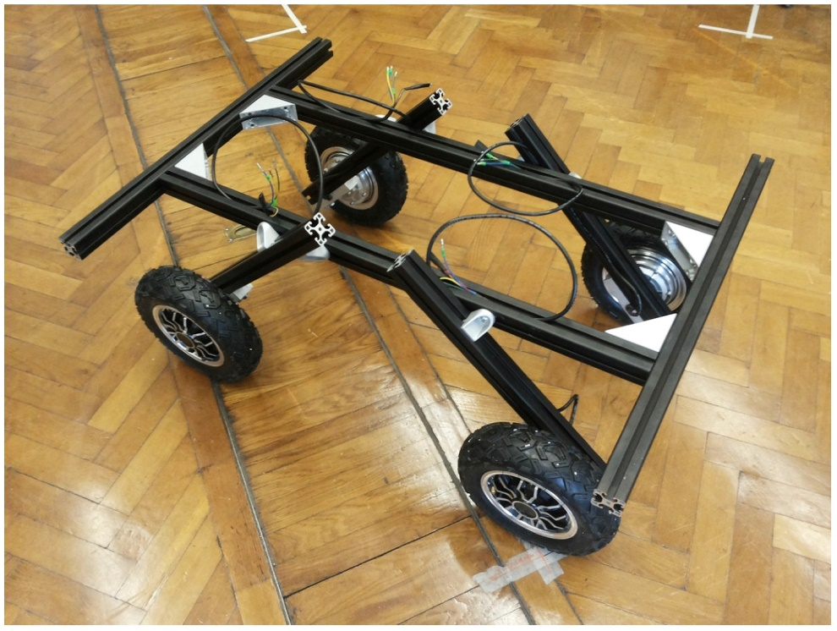

# Implementation

(…)

## VESC Board

The electric drive subject of this study is based on an open source project developed by the Swedish engineer Benjamin Vedder called VESC - Open Source ESC, which consists in the hardware design of a Printed Circuit Board (PCB) and the source code used to drive a BLDC motor.

The VESC board was conceived and designed to be used in electric skateboards with the intention to create one of the best ESC drives available. Since it was planned to be used in a skateboard, it has a small form-factor and it can be used for different applications with similar power demand. The hardware can also be modified by changing specific components to drive motors with higher power demand or by modifying the PCB following the schematic design.

The board consists of the following blocks:

1. Voltage supply input
2. Power MOSFETs three-phase inverter
3. MOSFET driver
4. Microcontroller unit
5. Peripherals
   1. Temperature sensors
      1. Motor temperature sensor
      2. Board temperature sensor
   2. Hall effect sensors
   3. RC Servomotor Output
   4. Debug LEDs
6. Communication interfaces
   1. USB
   2. CAN
   3. USART
   4. SPI
   5. I2C

## Power Supply Input

The power is supplied into the board by means of soldering 2 wires into large pads placed closely to the three-phase inverter nodes V_SUPPLY and GND. V_SUPPLY and GND are the positive and negative nodes of the power supply source respectively. The power is supplied from a power regulator for static applications or from a battery for mobile applications. It is also specified that there should be a decoupling capacitor connected in parallel to the power supply port.

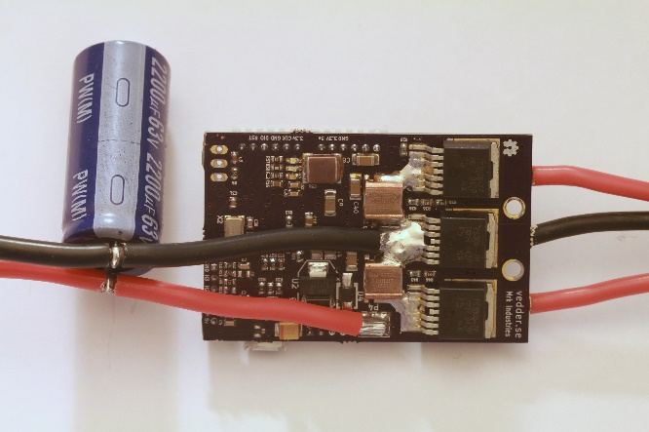

### Power Supply Wiring

The strategy of soldering the wires directly to the pads in the PCB helps reduce the size and price of the board since it avoids the use of large power traces in that would be needed if a regular receptacle connector was to be used.

The practice of soldering a wire directly to a PCB is discouraged mainly in circuits that will be mounted in a system designed to be in movement (i.e. automotive or aerospace applications) because the wire used in these applications is made of delicate copper strands which can break easily with movement of the board or of the wires and cause a short circuit or a loose contact, both of which might lead to catastrophic failures [https://electronics.stackexchange.com/questions/129907/what-is-the-best-way-to-solder-these-wires-to-circuit-board], so there is a risk in this board since it will be mounted in systems that will be in constant movement [http://uk.rs-online.com/web/generalDisplay.html?id=solutions/pcb-connectors]­. Since this board was designed this way to reduce space consumption, the trade-off between safety and size was balanced into the size constraints, therefore some cautions must be taken to avoid problems, mainly because these wires carry a considerable amount of current and they pass over many components of the board as seen in figure X.

The first consideration to be made is the wire gauge and insulation type. The wire gauge is a measurement of the wire diameter, which determines the amount of electric current that a wire can safely carry, as well as its electrical resistance and weight [https://en.wikipedia.org/wiki/Wire_gauge]. Since the wire has an implicit resistance depending on its diameter as stated by Pouillet’s Law:

where ρ is the electrical resistivity of the material, L is the length of the wire and A is the cross-sectional area of the wire [https://en.wikipedia.org/wiki/Electrical_resistivity_and_conductivity], there is also a voltage drop in the transmission line depending on the current flowing through the wire. This voltage drop can be neglected or not depending on the length of the wire being used, which defines 2 types of wiring: chassis wiring and transmission line wiring. For this board, it is suggested to use short wires to avoid a large voltage drop and to ease the handling of such wire until it reaches the output of the enclosure that will protect the circuit. In either case, the wire can be considered as chassis wiring since a transmission line wiring is considered for wires larger than 2 meters [ref].

The second consideration regarding the wire selection is the insulation material. Since the current passing through the copper also implies power consumption due to the resistance of the copper, there is heat transfer from the wire to its surroundings. To protect the copper strands from its surroundings and vice versa, wires are covered by an insulating material, which has low thermal and electrical conductivity.

* (…something about wire material…) HO7RNF
* Flexibility

Since the heat exchange calculation of the wire would require many assumptions, it’s a normal practice to select the type of wire using tables that consider the temperature rise in the wire according to different currents and lengths. In the case of the PMSM motor used in Robi, the maximum current would be 13.88A, therefore we can use a table of wire gauges and currents under (…) [https://www.powerstream.com/Wire_Size.htm]

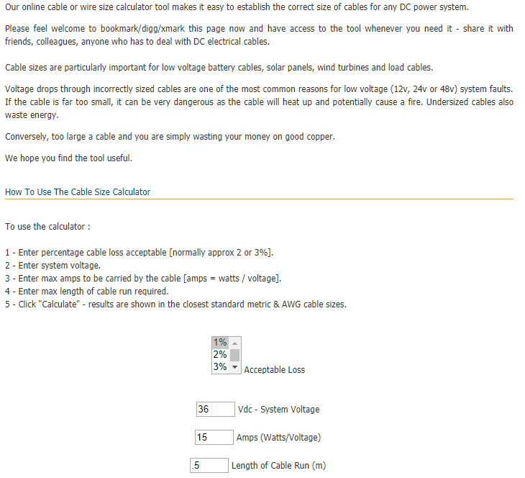

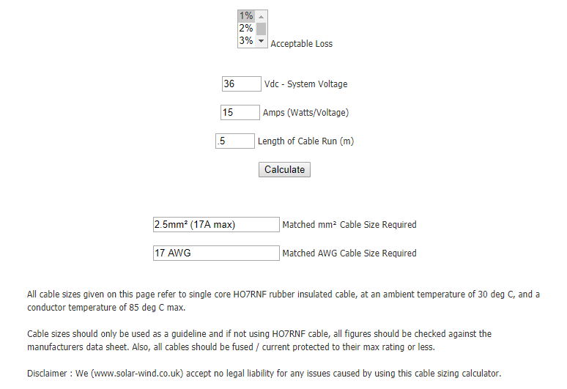

### Voltage Supply Range

The voltage range of the VESC board is defined by the MOSFET driver integrated circuit DRV8302, which specifies an operating supply voltage range from 8V to 60V, but allows a maximum voltage supply up to 65V [ref to the datasheet]. All the other components of the board, mainly capacitors and power MOSFETs, must be selected according to this voltage range.

(…?)

### Bulk Electrolytic Capacitor

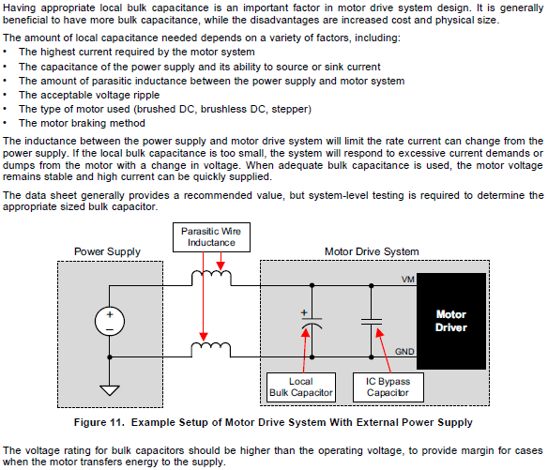

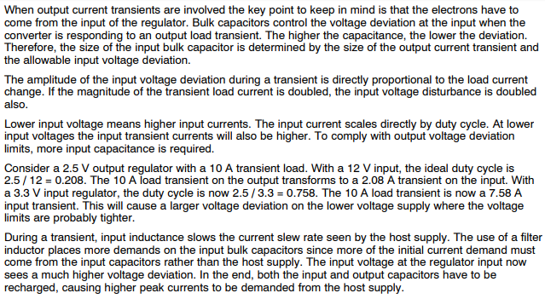

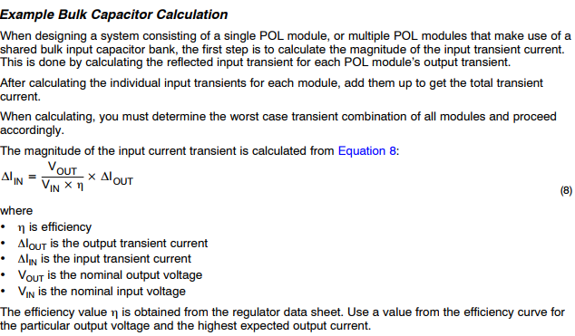

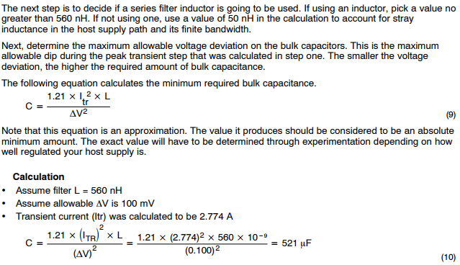

The proposed capacitor is 2200uF at 50V

[http://www.ti.com/lit/an/slta055/slta055.pdf]

[http://www.analog.com/media/en/training-seminars/tutorials/MT-101.pdf]

## Power MOSFET Three-Phase Inverter

The three-phase inverter used in the VESC board is based on the power MOSFET IRFS7530-7PPbF by the semiconductor company International Rectifier.

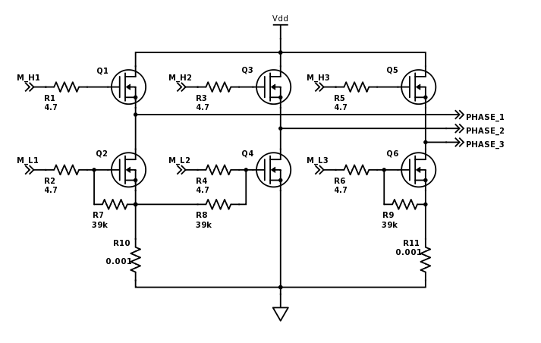

This MOSFET is based on the HEXFET Power MOSFET technology, which is a Vertical Double-diffused MOS transistor (VDMOS) with hexagonal elementary cells in parallel which maximizes the W/L ratio of the transistor, reducing its on-resistance RDS(ON). [ref to Gionni and the datasheet].

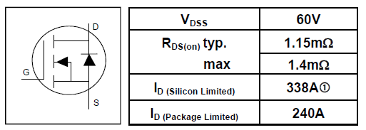

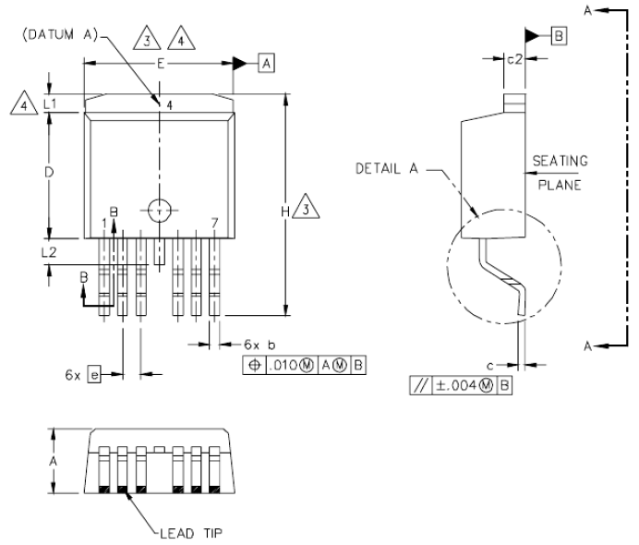

### Voltage and Current Limits

The DC Voltage limit in the inverter is defined by the drain-source breakdown voltage (V(BR)DSS) of the MOSFETs which is 60V

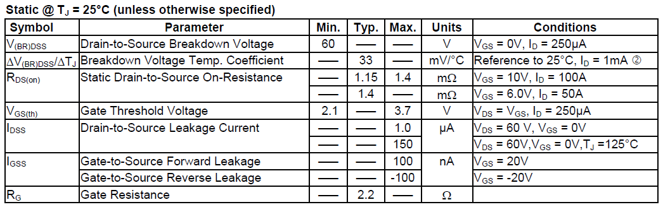

### Switching Times

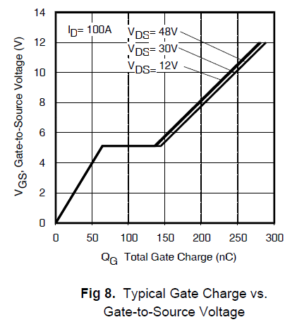

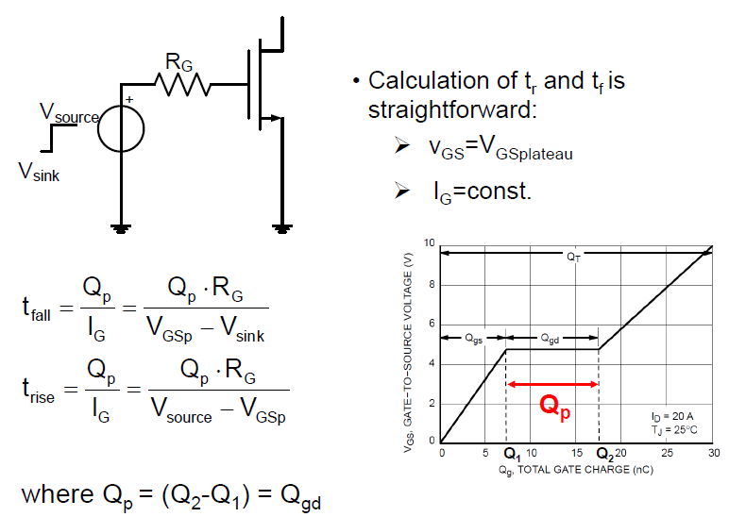

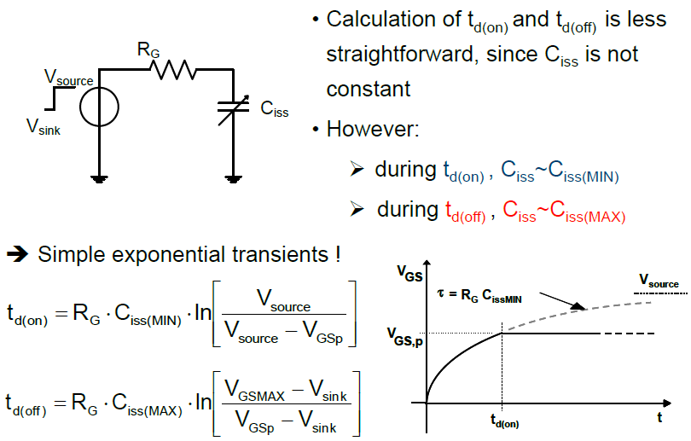

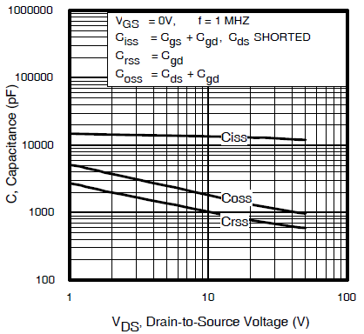

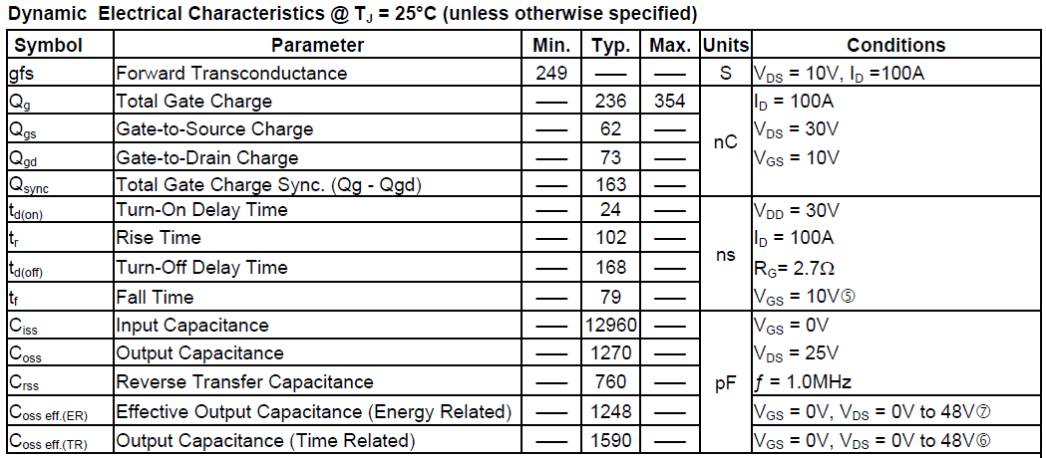

VGS is defined by the MOSFET Driver and the rise and fall times can be calculated better…

## MOSFET Driver

The central component in the VESC board around which the rest of the circuit was designed is the integrated circuit DRV8302, a brushless motor inverter driver manufactured by Texas Instruments.

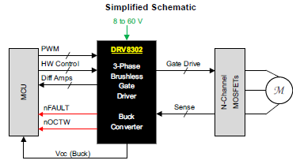

* The DRV8302 provides three half bridge drivers capable of driving two N-channel MOSFETs each.
* The device supports up to 1.7-A source and 2.3-A peak current capability.
* The DRV8302 can operate off of a single power supply with a wide range from 8-V to 60-V.
* It uses a bootstrap gate driver architecture with trickle charge circuitry to support 100% duty cycle.
* The DRV8302 uses automatic hand shaking when the high side or low side MOSFET is switching to prevent current shoot through.
* Integrated VDS sensing of the high and low side MOSFETs is used to protect the external power stage against overcurrent conditions.
* The DRV8303 includes two current shunt amplifiers for accurate current measurement. The amplifiers support bi-directional current sensing and provide and adjustable output offset up to 3 V.
* The DRV8302 also includes an integrated switching mode buck converter with adjustable output and switching frequency. The buck converter can provide up to 1.5 A to support MCU or additional system power needs.
* A hardware interface allows for configuring various device parameters including dead time, overcurrent, PWM mode, and amplifier settings. Error conditions are reported through the nFAULT and nOCTW pins. 3.3-V and 5-V Interface Support.

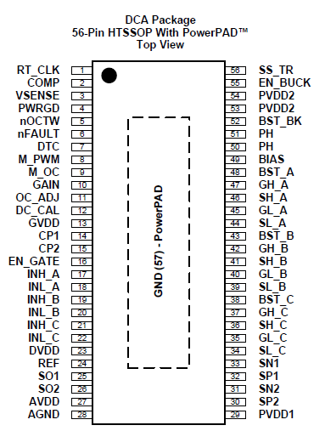

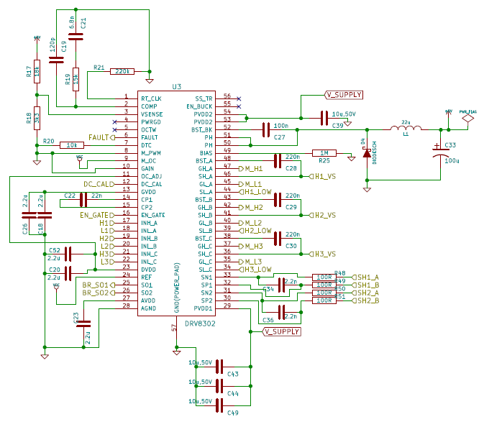

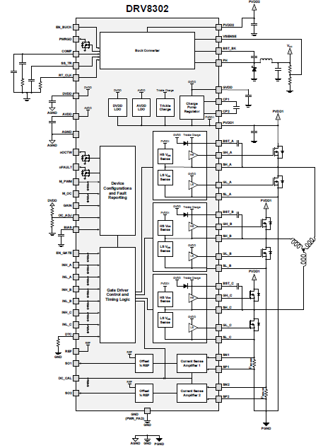

## MCU

The processor for which this board was designed is the STM32F405rg: a 64-pin IC microcontroller of the STMicroelectronics family of 32-bit devices with an ARM Cortex-M4 CPU and a core operating frequency up to 168 MHz. The Cortex-M4 core features a Floating point unit (FPU) single precision which supports all ARM single-precision data-processing instructions and data types. It also implements a full set of DSP instructions, which makes it ideal for the signal processing required to drive PMAC motors. This microcontroller also includes three 12-bit ADCs and supports USART, I2C, SPI, USB and CAN communication interfaces, improving the versatility of the VESC board. The memory of the microcontroller consists in 1024 kB of Flash memory and 192 kB of SRAM memory [6].

## PCB Layout

## Measurement Board

## Angular Position Sensor

## Operating System

## Test Setup

### Graphical User Interface

### Robi Setup

### Torque Load

## Algorithms Implementation

Test bench

The tests were realized by applying two types of driving methods: the six-step drive and the sinusoidal drive. Both driving methods were tested under two conditions: loaded and unloaded.

The load used for the loaded tests was a DC voltage generator attached to the HUB in-wheel motor. The generator acted as a load by attaching a small resistance to its terminals. The torque of the generator could be regulated by changing the field excitation voltage. The torque was measured with a load cell that was attached to the “floating” stator (how is this configuration named?). The deformation of the load cell was translated into a voltage signal by using the instrumentation amplifier HX711, which has a serial interface used to transfer the measured voltage which was later translated into torque by an Arduino Mega, used as an interface with a computer to read the torque applied for the following tests.

The power was supplied by a PeakTech (?) power supply with a voltage range up to 30 V and a current limit at 10 A. The voltage of the tests was 24 V.

All the control parameters of the test were modified and obtained “on-the-run” with a user interface developed in LabView.

Six-Step Drive – Open Loop

The trapezoidal waveform of the phase voltage on the motor was obtained by applying a six-step sequence drive on the coils of the motor, applying a PWM on each phase commutating from VDD to 0V, depending on the position of the hall-effect sensors.



Figure 1 - Plot of the different speeds achieved applying a certain duty cycle using an open loop six-step drive with different loads

Figure 1 shows the different speeds achievable by applying different duty cycles to the six-step drive sequence with different torque loads. The curves on the plot start on different duty cycles since the torque load couldn’t reach a steady value until a certain speed was stablished. For example, for the measurement with a load equal to 3 Nm, the curve starts at a duty cycle equal to 30%, since at a duty cycle lower than this or a speed lower than 10 rad/s, the load can’t be generated by the test bench, which would give 2 Nm for example, therefore those measurements were not considered for the plot. On the other hand, the curves that don’t show large duty cycle values (5 and 6 Nm), is because the power supply couldn’t feed enough current to the driver to reach such torque.

The following images show the different waveforms obtained according to the load applied to the motor and to the duty cycle.

# Voltage Waveforms:



Figure 2 - Duty Cycle = 10%, no load applied



Figure 3 - Duty Cycle = 50%, no load applied



Figure 4 - Duty Cycle = 100%, no load applied



Figure 5 - Duty Cycle = 10%, load = 1 Nm



Figure 6 - Duty Cycle = 50%, load = 1 Nm



Figure 7 - Duty Cycle = 100%, load = 1 Nm



Figure 8 - Duty Cycle = 50%, load = 3 Nm



Figure 9 - Duty Cycle = 100%, load = 3 Nm



Figure 10 - Duty Cycle = 70%, load = 6 Nm

# Current Waveforms



Figure 11 - Duty Cycle = 10%, no load applied



Figure 12 - Duty Cycle = 50%, no load applied



Figure 13 - Duty Cycle = 100%, no load applied



Figure 14 - Duty Cycle = 10%, load = 1 Nm



Figure 15 - Duty Cycle = 50%, load = 1 Nm



Figure 16 - Duty Cycle = 100%, load = 1 Nm



Figure 17 - Duty Cycle = 50%, load = 3 Nm



Figure 18 - Duty Cycle = 100%, load = 3 Nm



Figure 19 - Duty Cycle = 70%, load = 6 Nm

Six-Step Drive – Speed Control

To see the behaviour of the speed control, different unit step signals were applied with different loads and different controller parameters.

The torque loads were setup first at a steady speed to know the correct excitation voltage of the field, then the motor was stopped and step signal was applied.



Figure 20 - Step response to a 10 rad/s signal without load applied



Figure 21 - Step response to a 40 rad/s signal without load applied



Figure 22 - Step response to a 10 rad/s signal with a 3 Nm load



Figure 23 - Step response to a 40 rad/s signal with a 3 Nm load

It is possible to see also the speed behaviour of the system compared with the duty cycle applied by the control algorithm:



Figure 24 - Step response to a 10 rad/s signal without load, compared to its driving duty cycle signal



Figure 25 - Step response to a 20 rad/s signal with a 3 Nm load, compared to its driving duty cycle signal

Sinusoidal Drive – Open Loop

This test was applied at the beginning of the development of the Field Oriented Control to test the generation of a sinusoidal waveform depending on the angular position of the rotor. The signals were generated by applying a constant amplitude value.

The following images are current waveforms with different reference quadrature voltages without any load applied.



Figure 26 - Sinusoidal drive with 1 V as quadrature voltage



Figure 27 - Sinusoidal drive with 2 V as quadrature voltage



Figure 28 - Sinusoidal drive with 5 V as quadrature voltage

In figure 28, it can be appreciated that the current in the highest and lowest side of the signal are limited by the LEM current sensor of the measurement board.

Sinusoidal Drive – Field Oriented Control

These tests were applied by exciting the field of the generator to the maximum available, so by setting up a reference quadrature current, the motor would reach a steady state speed when the torque applied by the load is equal to the torque applied by the motor.



Figure 29 - FOC signal with a 1 Nm load



Figure 30 - FOC signal with a 3 Nm load



Figure 31 - FOC signal with a 5 Nm load

Sinusoidal Drive – Speed Control

In the following waveforms can be appreciated the behaviour of the driver with different reference speeds and load conditions.



Figure 32 - 5 rad/s, no load applied



Figure 33 - 20 rad/s, no load applied



Figure 34 - 40 rad/s, no load applied



Figure 35 - 1 rad/s, load = 1 Nm

By analysing the frequency of the signal in figure 35 we can see the ability of the controller to move the motor at a low speed with a load applied. It will be necessary to tune the controller parameters to drive the robot in the way that it’s needed.



Figure 36 - 10 rad/s, load = 1 Nm



Figure 37 - 20 rad/s, load = 1 Nm



Figure 38 - 30 rad/s, load = 1 Nm

It can be appreciated in figures 33, 34, 37 and 38 that the signal gets distorted when a certain speed is reached. This is due to the maximum frequency achievable by the angular position sensor, which limits the sampling frequency and modifies the behaviour of the controller at speeds higher than 20 rad/s. Currently it represents a trade-off between the six-step drive, which works fine at high speeds since the angular position feedback is given by the hall effect sensors, and the sinusoidal drive, which works fine at low speeds but at high speeds becomes unpredictable.



Figure 39 - 10 rad/s, load = 3 Nm



Figure 40 - 20 rad/s, load = 3 Nm



Figure 41 - Step response to a 10 rad/s signal and a load of 1Nm



Figure 42 - Step response to a 10 rad/s signal with different loads

In figure 42 we can see the comparison of the behaviour of the controller with the same step signal (0 to 10 rad/s) but with different load. When the load is 3 Nm, the slope of the signal becomes limited by the controller parameter *I_MAX*, which defines the saturation of the integral part of the controller to avoid current peaks. This parameter can be modified accordingly to the capacities of the system, but caution must be taken since this can provoke malfunctioning of the circuit.

In the following current waveforms, we can appreciate the current settling to a steady state after a step signal is commanded to the controller.



Figure 43 - Step response to 10 rad/s, load = 3 Nm



Figure 44 - Step response to 10 rad/s, load = 3 Nm



Figure 45 - Step Response 10 rad/s, Load = 1 Nm



Figure 46 - Step Response 10 rad/s, Load = 1 Nm



Figure 47 - Step Response 10 rad/s, Load = 1 Nm

# Conclusions

references:

[1] https://www.eti.kit.edu/english/1376.php