Appendix

The objective of this project is to detect the over speed for vehicles on the highway road. Although the maximum speed limit on the highway, many accidents keep on because of over speed driving. It is necessary to solve these problems. This project describes speed detection system for vehicles. The highway traffic police will get easy way to check over speed by using this system. This system mainly consists of Arduino UNO, two IR sensors, 16x2A LCD display and buzzer as shown in figure 5.1. The detected speed is displayed on LCD. Moreover, if the vehicle crosses the speed limit of 50km/hrs., this system displays the condition of over speed on LCD and the buzzer is alarmed.

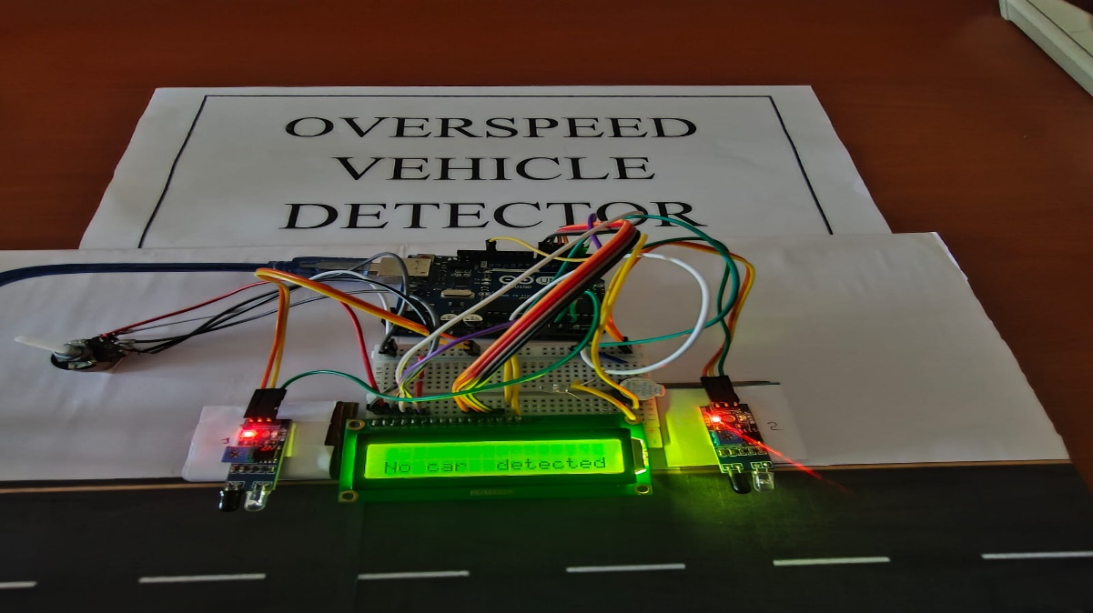

Figure 5
Arduino code
Written, compiled and dumped to Arduino using the Arduino IDE.

Code:
#include<LiquidCrystal.h>
LiquidCrystal lcd(2, 3, 4, 5, 6, 7);
int timer1;
int timer2;
float Time;
int flag1 = 0;
int flag2 = 0;
float distance = 5.0;
float speed;
int ir_s1 = A0;
int ir_s2 = A1;
int buzzer = 13;
int Led = 12;
void setup(){
pinMode(ir_s1, INPUT);
pinMode(ir_s2, INPUT);
pinMode(buzzer, OUTPUT);
pinMode(Led, OUTPUT);
lcd.begin(16,2);
lcd.clear();
lcd.setCursor(0,0);
lcd.print(" WELCOME TO ");
lcd.setCursor(0,1);
lcd.print("THE PROJECT");
delay(2000);//2000
lcd.clear();
}

void loop() {
if(digitalRead (ir_s1) == LOW && flag1==0){timer1 = millis(); flag1=1;}
if(digitalRead (ir_s2) == LOW && flag2==0){timer2 = millis(); flag2=1;}
if (flag1==1 && flag2==1){
if(timer1 > timer2){Time = timer1 - timer2;}
else if(timer2 > timer1){Time = timer2 - timer1;}
Time=Time/1000; //converting millisecond to second
speed=(distance/Time); //v=d/t
speed=speed*3600; //multiplying by seconds per hr
speed=speed/1000; //division by meters per Km
}
if(speed==0){
lcd.setCursor(0, 1);
if(flag1==0 && flag2==0)
{
lcd.print("No car detected");
digitalWrite(Led, LOW);
}
else{lcd.print("waiting.......... ");}
}
else{
lcd.clear();
lcd.setCursor(0, 0);
lcd.print("Speed:");
lcd.print(speed,1);
lcd.print("Km/Hr ");
lcd.setCursor(0, 1);
if(speed > 50){lcd.print(" Over Speeding ");
digitalWrite(buzzer, HIGH);}
else{lcd.print(" Normal Speed "); }
delay(1000);
digitalWrite(buzzer, LOW);
speed = 0;
flag1 = 0;
flag2 = 0;
}
}
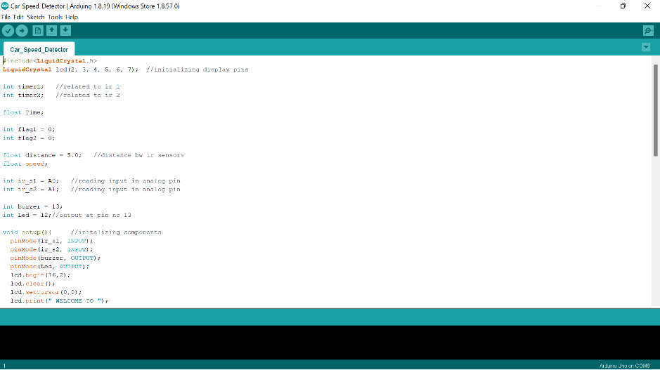

Figure 6

