**Weekly Progress Report**

Name: Sahil Mishra Devendra

Domain: Full Stack Web Development

Date of submission: 05/09/2025

Week Ending: Final Report

**ServiceHub Project Report**

**Project Overview**

ServiceHub is a web-based platform designed to streamline the discovery, booking, and management of professional services. It connects service providers with clients efficiently, offering a user-friendly interface and robust backend support. The platform supports seamless service listing, booking, review management, and communication between users and providers.

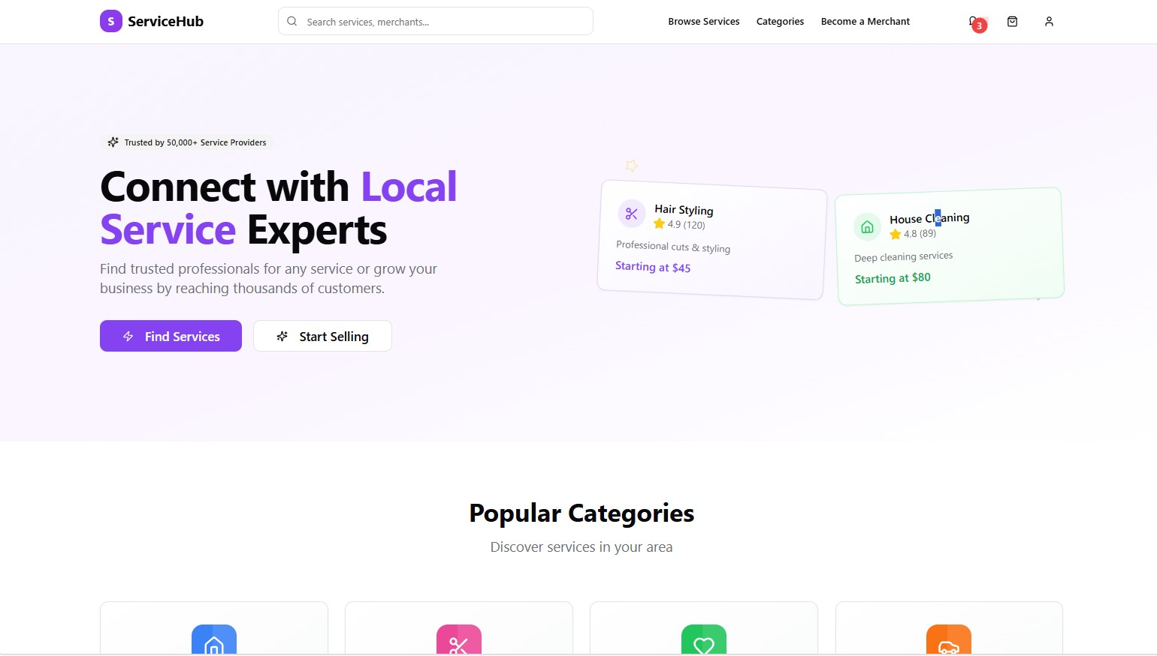

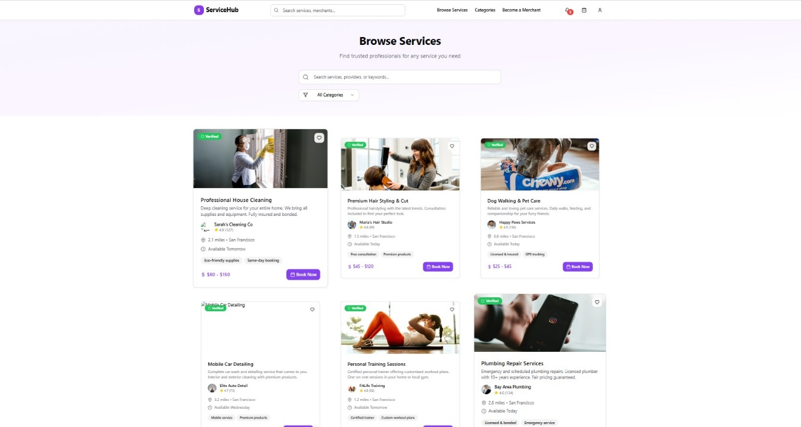

**Objectives**

* Create a centralized platform for users to find and book services easily.
* Enable service providers to manage listings, bookings, and client interactions.
* Implement a scalable and responsive system with secure data handling.
* Provide analytics and feedback features for continuous service improvement.

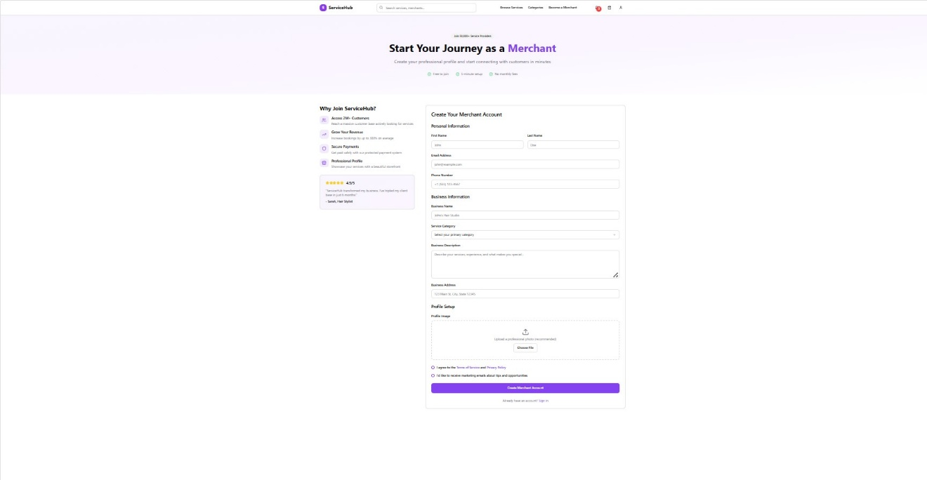

**Features**

1. User Management
   * Registration and login for clients and service providers.
   * Profile management, including service history and preferences.
2. **Service Listings**
   * Add, edit, or delete services.
   * Categorization and search functionality for easy discovery.
3. **Booking & Scheduling**
   * Real-time booking with calendar integration.
   * Notifications and reminders for upcoming appointments**.**
4. **Payment Integration**
   * Secure online payment gateway.
   * Transaction history for users and service providers.
5. **Ratings & Reviews**
   * Clients can rate and review services.
   * Providers can respond to feedback, maintaining transparency.
6. **Analytics Dashboard**
   * Insights on service popularity, bookings, and customer engagement.
   * Data-driven recommendations for service improvement.

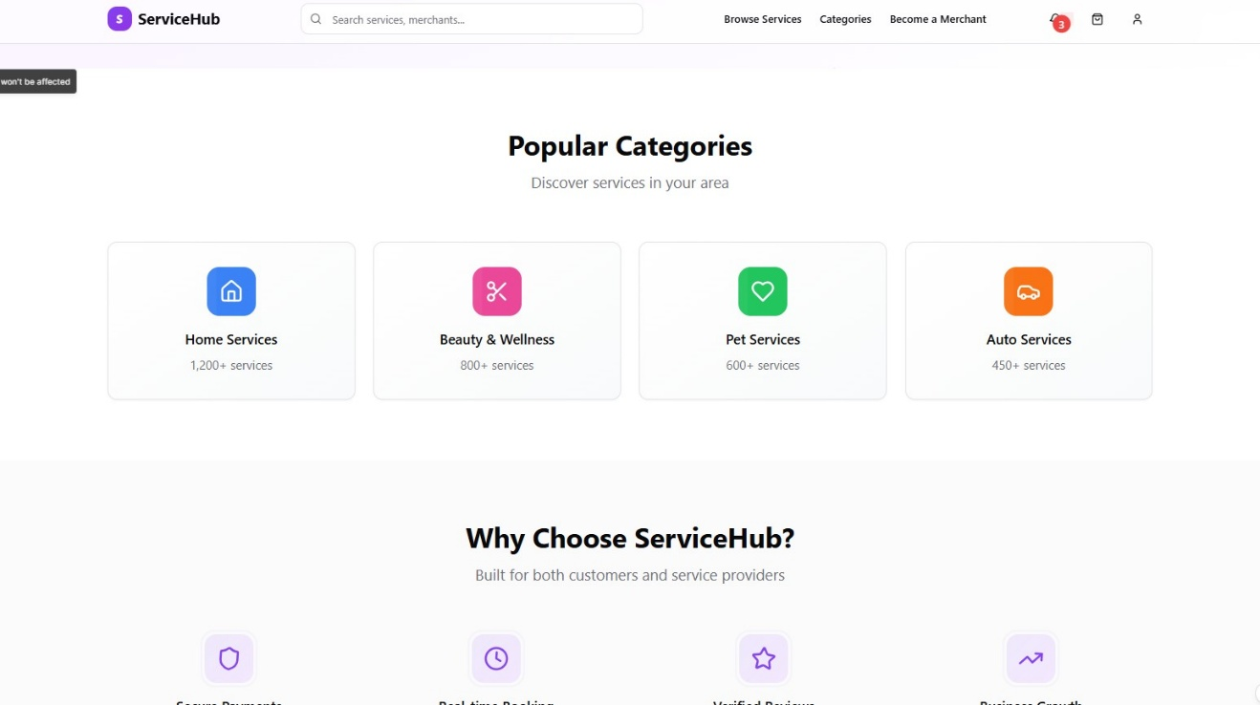

**Tech Stack**

* Frontend: HTML5, CSS3, JavaScript, Bootstrap
* Backend: Node.js, Express.js
* Database: MySQL
* Version Control: GitHub
* Tools: VS Code, Postman, Chrome DevTools

**Implementation Details**

* Frontend: Responsive design using Bootstrap; dynamic interactions with JavaScript.
* Backend: RESTful APIs with Node.js and Express.js to handle requests and data management.
* Database: MySQL for storing user data, service listings, bookings, and feedback.
* Security: Input validation, password hashing, and secure payment processing.
* Testing: Unit testing for APIs and functional testing for user interface components.

**Challenges & Solutions**

* Challenge: Handling concurrent bookings.  
  Solution: Implemented transaction management in MySQL to avoid double bookings.
* Challenge: Maintaining responsive design across devices.  
  Solution: Used Bootstrap grid system and media queries for consistency.
* Challenge: Securing user data.  
  Solution: Applied password hashing, prepared statements, and HTTPS protocols.

**Future Enhancements**

* Mobile application integration for on-the-go access.
* AI-driven recommendations for services based on user behavior.
* Advanced analytics for providers to track trends and improve offerings.
* Chat support for instant client-provider communication.

**Conclusion**

ServiceHub provides an intuitive, secure, and scalable platform that bridges the gap between service seekers and providers. The project successfully demonstrates the integration of modern web technologies with practical solutions for real-world service management, paving the way for further enhancements and deployment.