Bayesian Small Area Estimation of Under-5 Malaria Prevalence in West Africa
  - A Space-Time BYM2 Fay-Herriot Model Across Ghana, Burkina Faso, and Côte d’Ivoire

2026-06-12
Table of Contents

Data

About the Demographic and Health Surveys (DHS)
The Demographic and Health Surveys are nationally representative household surveys using a stratified two-stage cluster sampling design. The first stage selects enumeration areas (clusters) within strata defined by region and urban/rural status; the second stage selects households within each cluster. Children aged 6–59 months are tested for malaria parasitaemia using a rapid diagnostic test (RDT) (Florey 2014; Croft et al. 2018). Cluster GPS coordinates are jittered by up to 5 km (urban) or 10 km (rural) for respondent confidentiality. The household member recode (PR) file contains the individual-level biomarker; the cluster GPS shapefile provides the spatial reference.

Surveys Used in This Study
Country | Round 1 | Round 2
Burkina Faso | DHS 2010 | DHS/MIS 2021
Côte d’Ivoire | DHS 2011 | DHS/MIS 2021
Ghana | DHS 2014 | DHS 2022

District Boundaries
load_districts <- function(iso) {
if (iso == "GHA") {
gadm(country = iso, level = 2, path = "boundaries/") %>%
st_as_sf() %>% st_transform(crs = 4326) %>%
rename(district_name = NAME_2, district_code = GID_2) %>%
mutate(iso = iso)
} else {
gadm(country = iso, level = 3, path = "boundaries/") %>%
st_as_sf() %>% st_transform(crs = 4326) %>%
rename(district_name = NAME_3, district_code = GID_3) %>%
mutate(iso = iso)
}
}
districts_raw <- list(
GHA = load_districts("GHA"),
BFA = load_districts("BFA"),
CIV = load_districts("CIV")
)
# Create numeric district lookups (Stan requires integer indices)
district_lookups <- map(districts_raw, function(d) {
d %>% st_drop_geometry() %>%
select(district_name, district_code, iso) %>%
mutate(district_id = row_number())
})
# Districts ordered by district_id for adjacency matrix construction
districts_ordered <- map2(districts_raw, district_lookups, function(d, lk) {
d %>% left_join(lk, by = c("district_name", "district_code", "iso")) %>%
arrange(district_id)
})
map_dfr(district_lookups, ~tibble(districts = nrow(.x)), .id = "iso")
## # A tibble: 3 × 2
## iso districts
## <chr> <int>
## 1 GHA 260
## 2 BFA 351
## 3 CIV 113

Survey Index and PR Files
survey_index <- tribble(
~country, ~iso, ~year, ~round_id, ~pr_path, ~gps_path,
"Ghana", "GHA", 2014, 1L,
"dhs_gh_14/GHPR72DT/GHPR72FL.DTA", "dhs_gh_14/GHGE71FL/GHGE71FL.shp",
"Ghana", "GHA", 2022, 2L,
"dhs_gh_22/GHPR8CDT/GHPR8CFL.DTA", "dhs_gh_22/GHGE8AFL/GHGE8AFL.shp",
"Burkina", "BFA", 2010, 1L,
"dhs_bf_10/BFPR62DT/BFPR62FL.DTA", "dhs_bf_10/BFGE61FL/BFGE61FL.shp",
"Burkina", "BFA", 2021, 2L,
"dhs_bf_21/BFPR81DT/BFPR81FL.DTA", "dhs_bf_21/BFGE81FL/BFGE81FL.shp",
"Cote d'Ivoire", "CIV", 2012, 1L,
"dhs_ci_12/CIPR62DT/CIPR62FL.DTA", "dhs_ci_12/CIGE61FL/CIGE61FL.shp",
"Cote d'Ivoire", "CIV", 2021, 2L,
"dhs_ci_21/CIPR81DT/CIPR81FL.DTA", "dhs_ci_21/CIGE81FL/CIGE81FL.shp"
)
load_pr <- function(pr_path, gps_path, iso, year, round_id,
districts_ordered, district_lookup) {
gps <- read_sf(gps_path) %>%
rename(cluster_id = DHSCLUST) %>%
st_transform(crs = 4326)
gps_joined <- st_join(gps, districts_ordered, join = st_nearest_feature) %>%
select(cluster_id, district_name, district_code) %>%
st_drop_geometry() %>%
left_join(district_lookup, by = c("district_name", "district_code")) %>%
select(cluster_id, district_id, district_name)
pr <- read_dta(pr_path) %>%
rename_with(tolower) %>%
select(cluster_id = hv001, hh_id = hv002, line_id = hvidx,
weight_raw = hv005, stratum = hv023,
age_months = hc1, malaria = hml32) %>%
filter(age_months < 60, malaria %in% c(0, 1)) %>%
mutate(weight = weight_raw / 1e6,
malaria = as.integer(malaria),
cluster_id = as.integer(cluster_id),
stratum = as.integer(stratum),
country = iso, year = year, round_id = round_id) %>%
left_join(gps_joined, by = "cluster_id")
pr
}
pr_list <- pmap(survey_index, function(country, iso, year, round_id, pr_path, gps_path) {
load_pr(pr_path, gps_path, iso, year, round_id,
districts_ordered[[iso]], district_lookups[[iso]])
})

Direct Estimation
For each observed district $i$ at time $t$, the design-based prevalence is computed using the Hájek ratio estimator (Hájek 1971),
pitw=k​dk zkk​dk,
where $z_{k}$ is the binary RDT outcome for child $k$ and $d_{k}$ is the DHS sampling weight. Design-based standard errors are obtained via Taylor-series linearisation (Binder 1983) using the survey package (Lumley 2010), respecting the stratified two-stage cluster design.
For the Fay-Herriot likelihood (Wakefield et al. 2020), the prevalence is transformed to the logit scale and the delta method is applied to the SE:
$$y_{it}=logit({\hat{p}}_{it}^{w}), \hat{SE}(y_{it})=\frac{\hat{SE}({\hat{p}}_{it}^{w})}{{\hat{p}}_{it}^{w}(1-{\hat{p}}_{it}^{w})}.$$
For numerical stability, prevalences are bounded to $[0.02,0.98]$ and logit-scale SEs to $[0.1,2.0]$.
get_direct_estimates <- function(pr) {
design <- svydesign(
ids = ~cluster_id, strata = ~stratum, weights = ~weight,
data = pr, nest = TRUE
)
svyby(formula = ~malaria, by = ~district_id, design = design,
FUN = svymean, na.rm = TRUE, keep.var = TRUE) %>%
rename(p_hat = malaria, se_p = se) %>%
filter(!is.na(p_hat), !is.na(se_p),
se_p > 0, p_hat > 0, p_hat < 1) %>%
mutate(
country = pr$country[1],
iso = pr$country[1],
year = pr$year[1],
round_id = pr$round_id[1],
p_bounded = pmax(0.02, pmin(0.98, p_hat)),
y_i = log(p_bounded / (1 - p_bounded)),
logit_var = se_p^2 / (pmax(0.02, p_hat)^2 * pmax(0.02, 1 - p_hat)^2),
psi_i = pmax(0.1, pmin(sqrt(logit_var), 2.0))
) %>%
filter(is.finite(y_i), is.finite(psi_i)) %>%
select(country, iso, year, round_id, district_id, y_i, psi_i)
}
direct_est_list <- map(pr_list, get_direct_estimates)
direct_est_all <- bind_rows(direct_est_list)
direct_est_all %>% count(country, year, name = "observed_districts")
## country year observed_districts
## 1 BFA 2010 232
## 2 BFA 2021 153
## 3 CIV 2012 80
## 4 CIV 2021 103
## 5 GHA 2014 153
## 6 GHA 2022 124

Panel Construction
build_panel <- function(country_iso, district_lookup, direct_est_all) {
rounds <- direct_est_all %>%
filter(country == country_iso) %>%
distinct(year) %>% arrange(year) %>%
mutate(round_id = row_number())
est_clean <- direct_est_all %>%
filter(country == country_iso) %>%
select(district_id, year, y_i, psi_i)
expand_grid(
district_id = district_lookup$district_id,
year = rounds$year
) %>%
left_join(district_lookup %>% select(district_id, district_name, district_code),
by = "district_id") %>%
left_join(est_clean, by = c("district_id", "year")) %>%
left_join(rounds, by = "year") %>%
arrange(year, district_id) %>%
mutate(country = country_iso,
observed = as.integer(!is.na(y_i)))
}
panels <- map(c("GHA", "BFA", "CIV"),
~build_panel(.x, district_lookups[[.x]], direct_est_all))
names(panels) <- c("GHA", "BFA", "CIV")
map_dfr(panels, function(p) {
p %>% group_by(year) %>%
summarise(total = n(), observed = sum(observed == 1),
pct = round(100 * observed / total, 1), .groups = "drop")
}, .id = "country")
## # A tibble: 6 × 5
## country year total observed pct
## <chr> <dbl> <int> <int> <dbl>
## 1 GHA 2014 260 153 58.8
## 2 GHA 2022 260 124 47.7
## 3 BFA 2010 351 232 66.1
## 4 BFA 2021 351 153 43.6
## 5 CIV 2012 113 80 70.8
## 6 CIV 2021 113 103 91.2

Spatial Adjacency and BYM2 Scaling Factor
District adjacency is defined via queen contiguity using the spdep package (Bivand et al. 2013). Disconnected components are reconnected via a snap tolerance to ensure a proper ICAR prior (Freni-Sterrantino et al. 2018). The BYM2 scaling factor $s$ (Riebler et al. 2016) makes the mixing parameter $ϕ$ interpretable as the proportion of structured variance regardless of graph topology.
compute_scaling_factor <- function(nb, D) {
adj_mat <- nb2mat(nb, style = "B", zero.policy = TRUE)
Q_icar <- Diagonal(x = rowSums(adj_mat)) - as(adj_mat, "sparseMatrix")
eps <- 0.001
Q_reg <- Q_icar + eps * Diagonal(D)
Q_inv_diag <- diag(solve(Q_reg))
exp(mean(log(Q_inv_diag)))
}
build_spatial <- function(iso, districts_ordered) {
D <- nrow(districts_ordered)
nb <- poly2nb(districts_ordered, queen = TRUE)
if (sum(sapply(nb, length) == 0) > 0) {
nb <- poly2nb(districts_ordered, queen = TRUE, snap = 0.1)
}
adj_mat <- nb2mat(nb, style = "B", zero.policy = TRUE)
edges <- which(adj_mat == 1, arr.ind = TRUE) %>%
as.data.frame() %>%
filter(row < col)
scaling_factor <- compute_scaling_factor(nb, D)
list(D = D, nb = nb,
node1 = edges$row, node2 = edges$col,
N_edges = nrow(edges),
scaling_factor = scaling_factor)
}
spatial <- map(c("GHA", "BFA", "CIV"),
~build_spatial(.x, districts_ordered[[.x]]))
names(spatial) <- c("GHA", "BFA", "CIV")
map_dfr(spatial, function(s) {
tibble(N = s$D, N_edges = s$N_edges, scaling_factor = round(s$scaling_factor, 3))
}, .id = "country")
## # A tibble: 3 × 4
## country N N_edges scaling_factor
## <chr> <int> <int> <dbl>
## 1 GHA 260 709 4.36
## 2 BFA 351 973 3.36
## 3 CIV 113 296 9.30

Covariates: Harmonised Multi-Country Panel
Seven covariates are assembled at the district-round level: elevation (SRTM, population-weighted), rainfall (CHIRPS v2.0, Sep–Dec mean), nighttime lights (NASA Black Marble VIIRS) (Elvidge et al. 2013), temperature (CRU TS v4.09, Sep–Dec mean), travel time (Weiss/MAP 2020, population-weighted), log population density (WorldPop 2020), and multidimensional poverty (OPHI MPI / national census headcount). All covariates are standardised within country. Pairwise correlations are kept below 0.7 (Dormann et al. 2013).
covariates_panel <- read_csv("three_country_model_panel.csv") %>%
select(country, district_id, district_name, time, year, label,
elev_std, rainfall_std, ntl_std, temp_std,
travel_std, pop_dens_std, poverty_std)
covariates_panel %>% count(country, time, name = "rows")
## # A tibble: 6 × 3
## country time rows
## <chr> <dbl> <int>
## 1 BFA 1 351
## 2 BFA 2 351
## 3 CIV 1 113
## 4 CIV 2 113
## 5 GHA 1 260
## 6 GHA 2 260
join_covariates <- function(iso) {
panels[[iso]] %>%
left_join(
covariates_panel %>%
filter(country == iso) %>%
select(district_id, time,
elev_std, rainfall_std, ntl_std, temp_std,
travel_std, pop_dens_std, poverty_std),
by = c("district_id", "round_id" = "time")
)
}
panels <- list(
GHA = join_covariates("GHA"),
BFA = join_covariates("BFA"),
CIV = join_covariates("CIV")
)
# Verify covariates are present
panels[["GHA"]] %>% select(district_id, year, ends_with("_std")) %>% head()
## # A tibble: 6 × 9
## district_id year elev_std rainfall_std ntl_std temp_std travel_std
## <dbl> <dbl> <dbl> <dbl> <dbl> <dbl> <dbl>
## 1 1 2014 0.639 -0.101 -0.600 -0.663 0.264
## 2 2 2014 0.411 -0.0293 -0.614 -0.694 -0.0426
## 3 3 2014 0.909 -0.119 -0.413 -1.30 -0.0370
## 4 4 2014 0.320 -0.0987 -0.578 -0.858 -0.381
## 5 5 2014 1.07 -0.0598 -0.582 -1.56 -0.654
## 6 6 2014 1.35 -0.0164 -0.569 -1.41 -0.480
## # ℹ 2 more variables: pop_dens_std <dbl>, poverty_std <dbl>

Exploratory Data Analysis

Correlation Heatmap
covariate_cols <- c("elev_std", "rainfall_std", "ntl_std", "temp_std",
"travel_std", "pop_dens_std", "poverty_std")
cor_matrix <- covariates_panel %>%
select(all_of(covariate_cols)) %>%
cor(use = "complete.obs")
ggcorrplot(
cor_matrix,
type = "lower",
lab = TRUE, lab_size = 3.5,
colors = c("#2166ac", "white", "#b2182b"),
title = "Pairwise correlations among standardised covariates",
ggtheme = ggplot2::theme_minimal()
) +
theme(plot.title = element_text(hjust = 0.5))
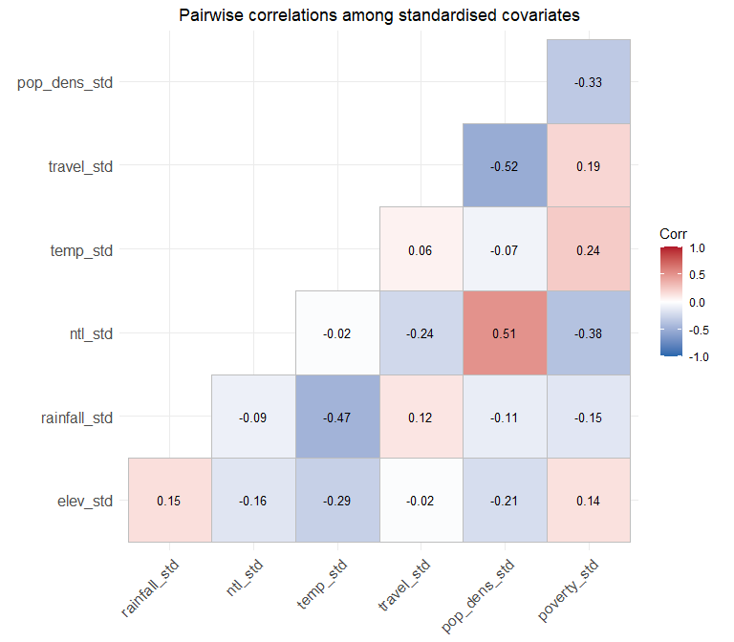

Distribution of Direct Estimates
direct_est_all %>%
mutate(prevalence = plogis(y_i)) %>%
ggplot(aes(x = factor(year), y = prevalence)) +
geom_violin(fill = "steelblue", alpha = 0.4) +
geom_jitter(width = 0.1, alpha = 0.4, size = 0.5) +
facet_wrap(~country, scales = "free_x") +
scale_y_continuous(labels = scales::percent_format(accuracy = 1)) +
labs(x = NULL, y = "Direct prevalence estimate (district)",
title = "Distribution of district-level direct estimates by country and round",
subtitle = "Each point is one district; violin shows the distribution") +
theme_minimal(base_size = 11)
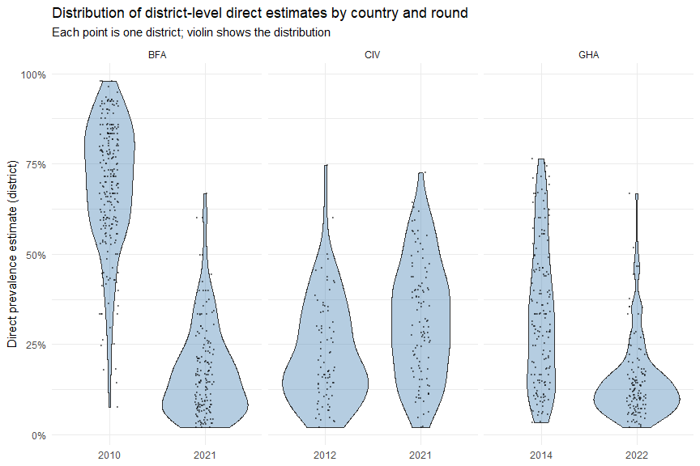

Adjacency Graph (Ghana)
gha_with_id <- districts_raw[["GHA"]] %>%
left_join(district_lookups[["GHA"]] %>% select(district_id, district_code),
by = "district_code") %>%
arrange(district_id)
centroid_coords <- suppressWarnings(st_coordinates(st_centroid(gha_with_id)))
centroids <- tibble(
district_id = gha_with_id$district_id,
x = centroid_coords[, "X"], y = centroid_coords[, "Y"]
)
sp <- spatial[["GHA"]]
edges_df <- tibble(from_id = sp$node1, to_id = sp$node2) %>%
left_join(centroids %>% rename(x_from = x, y_from = y),
by = c("from_id" = "district_id")) %>%
left_join(centroids %>% rename(x_to = x, y_to = y),
by = c("to_id" = "district_id"))
ggplot() +
geom_sf(data = districts_raw[["GHA"]],
fill = "grey95", colour = "grey60", linewidth = 0.2) +
geom_segment(data = edges_df,
aes(x = x_from, y = y_from, xend = x_to, yend = y_to),
colour = "#b2182b", alpha = 0.55, linewidth = 0.3) +
geom_point(data = centroids, aes(x = x, y = y),
colour = "black", size = 0.6) +
labs(title = "District adjacency graph used for the ICAR prior, Ghana",
subtitle = paste(sp$D, "districts,", sp$N_edges, "edges (queen contiguity)")) +
theme_void(base_size = 11)
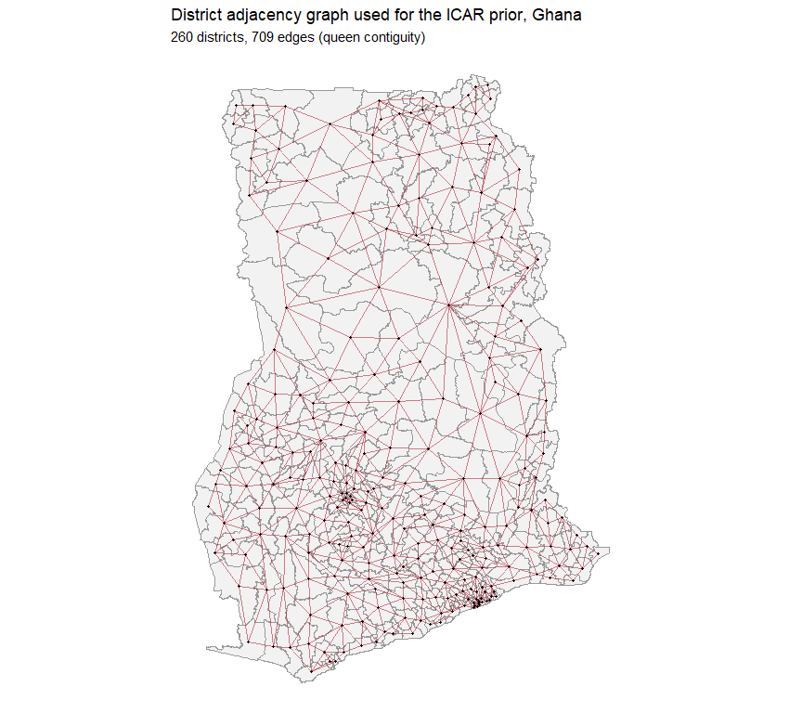

Common Methodology
All four models in this work share a common methodological core: a Fay-Herriot area-level likelihood, a BYM2 spatial random effect, and a shared set of priors. Each subsequent model section gives only the specification elements unique to that model, then proceeds directly to fitting, results and diagnostics.

Fay-Herriot Likelihood
$$y_{it}∼N(θ_{it},ψ_{it}^{2}),$$
where $θ_{it}$ is the latent logit prevalence and $ψ_{it}^{2}$ is treated as known (Section ).

BYM2 Spatial Random Effect
The district-level spatial random effect is given by (Riebler et al. 2016):
$$b_{i}=σ_{b}\left(\sqrt{1-ϕ} v_{i}+\sqrt{ϕ/s} u_{i}\right), v_{i}∼N(0,1), u_{i}∼ICAR(W),$$
written in non-centred form to avoid funnel geometry in the posterior. $W$ is the adjacency matrix of the relevant graph; $s$ is the BYM2 scaling factor; $σ_{b}$ is the marginal spatial SD; and $ϕ∈(0,1)$ is the proportion of structured variance.

Shared Priors
Parameter | Prior | Rationale
$$μ$$ | $$N(-1.85,1)$$ | Centred near logit of moderate prevalence
$$σ_{b}$$ | $$Exp(4.6)$$ | PC-style; $P(σ_{b}>1)=0.01$ (Simpson et al. 2017)
$$ϕ$$ | $$Beta(3,2)$$ | Mild preference for structured > IID
$$β_{k}$$ | $$N(0,1)$$ | Weakly informative on standardised covariates
$$σ_{γ}$$ | $$Exp(2)$$ | PC-style on interaction SD (Models 2–3)
$$τ_{k}$$ | $$Exp(2)$$ | PC-style on between-country SD (Models 3–4)

Computation
All models are fitted in Stan (Stan Development Team 2024) via cmdstanr, using the No-U-Turn Sampler with non-centred parameterisations throughout. Four chains, 1500 warmup and 2000 sampling iterations each. Cross-sectional and country-level space-time models use adapt_delta = 0.99 and max_treedepth = 14; pooled models use adapt_delta = 0.97 and max_treedepth = 13. Convergence is assessed via $\hat{R}$ (Vehtari et al. 2017), bulk/tail ESS, and trace/rank/pairs plots. Models are compared by approximate leave-one-out cross-validation (Vehtari et al. 2017) using the loo package.

Stan Data Builders
build_stan_data_cs <- function(iso, panels, spatial, year, covar_cols = NULL) {
panel <- panels[[iso]] %>% filter(year == !!year)
sp <- spatial[[iso]]
obs_idx <- which(panel$observed == 1)
if (!is.null(covar_cols)) {
available <- intersect(covar_cols, names(panel))
X <- if (length(available) > 0) as.matrix(panel[, available]) else matrix(0, nrow(panel), 0)
K <- ncol(X)
} else {
X <- matrix(0, nrow(panel), 0)
K <- 0L
}
list(N = sp$D, N_obs = length(obs_idx),
obs_idx = obs_idx,
y = panel$y_i[obs_idx], psi = panel$psi_i[obs_idx],
N_edges = sp$N_edges, node1 = sp$node1, node2 = sp$node2,
scaling_factor = sp$scaling_factor,
K = K, X = X)
}
build_stan_data_st <- function(iso, panels, spatial, covar_cols = NULL) {
panel <- panels[[iso]]
sp <- spatial[[iso]]
obs_idx <- which(panel$observed == 1)
if (!is.null(covar_cols)) {
available <- intersect(covar_cols, names(panel))
X <- if (length(available) > 0) as.matrix(panel[, available]) else matrix(0, nrow(panel), 0)
K <- ncol(X)
} else {
X <- matrix(0, nrow(panel), 0)
K <- 0L
}
list(N = sp$D, T = 2L, NT = nrow(panel),
N_obs = length(obs_idx), obs_idx = obs_idx,
district = panel$district_id, time = panel$round_id,
y = panel$y_i[obs_idx], psi = panel$psi_i[obs_idx],
N_edges = sp$N_edges, node1 = sp$node1, node2 = sp$node2,
scaling_factor = sp$scaling_factor,
K = K, X = X)
}
covar_cols <- c("elev_std", "rainfall_std", "ntl_std", "temp_std",
"travel_std", "pop_dens_std", "poverty_std")
stan_data <- list()
# Cross-sectional reference: Ghana 2022 only
stan_data[["GHA_CS_2022"]] <- build_stan_data_cs(
"GHA", panels, spatial, year = 2022, covar_cols = covar_cols
)
# Space-time models for all three countries
stan_data[["GHA_ST"]] <- build_stan_data_st("GHA", panels, spatial, covar_cols = covar_cols)
stan_data[["BFA_ST"]] <- build_stan_data_st("BFA", panels, spatial, covar_cols = covar_cols)
stan_data[["CIV_ST"]] <- build_stan_data_st("CIV", panels, spatial, covar_cols = covar_cols)
map_dfr(stan_data, function(d) {
tibble(
N = d$N,
NT = ifelse(is.null(d$NT), d$N, d$NT),
N_obs = d$N_obs, K = d$K,
N_edges = d$N_edges,
scaling_factor = round(d$scaling_factor, 3)
)
}, .id = "model")
## # A tibble: 4 × 7
## model N NT N_obs K N_edges scaling_factor
## <chr> <int> <int> <int> <int> <int> <dbl>
## 1 GHA_CS_2022 260 260 124 7 709 4.36
## 2 GHA_ST 260 520 277 7 709 4.36
## 3 BFA_ST 351 702 385 7 973 3.36
## 4 CIV_ST 113 226 183 7 296 9.30

Model 1: Cross-Sectional Ghana Baseline

Specification
For each Ghana district $i$ observed in Round 2,
$$θ_{i}=μ+b_{i}+x_{i}^{⊤}β,$$
with $b_{i}$ the BYM2 random effect on the Ghana-only adjacency graph. For comparison, we fit two alternatives that turn off one spatial component each: a pure IID model ($ϕ=0$) and a pure ICAR model ($ϕ=1$).

Fitting: IID
iid_code <- '
data {
int<lower=1> N;
int<lower=1> N_obs;
array[N_obs] int<lower=1, upper=N> obs_idx;
vector[N_obs] y;
vector<lower=0>[N_obs] psi;
int<lower=1> K;
matrix[N, K] X;
}
parameters {
real mu;
vector[N] v;
real<lower=0> sigma_b;
vector[K] beta;
}
transformed parameters {
vector[N] theta;
theta = mu + sigma_b * v + X * beta;
}
model {
mu ~ normal(-1.85, 1.0);
sigma_b ~ exponential(4.6);
beta ~ normal(0, 1);
v ~ std_normal();
y ~ normal(theta[obs_idx], psi);
}
generated quantities {
vector[N_obs] log_lik;
vector[N] prevalence;
for (i in 1:N_obs)
log_lik[i] = normal_lpdf(y[i] | theta[obs_idx[i]], psi[i]);
for (i in 1:N)
prevalence[i] = inv_logit(theta[i]);
}
'
writeLines(iid_code, "fh_iid.stan")
mod_iid <- cmdstan_model("fh_iid.stan")
sd_cs <- stan_data[["GHA_CS_2022"]]
fit_iid <- mod_iid$sample(
data = sd_cs, chains = 4, parallel_chains = 4,
iter_warmup = 1000, iter_sampling = 1500,
adapt_delta = 0.95, max_treedepth = 12, refresh = 500
)
##
## All 4 chains finished successfully.
## Mean chain execution time: 5.4 seconds.
## Total execution time: 6.5 seconds.
fit_iid$diagnostic_summary()
## $num_divergent
## [1] 0 0 0 0
##
## $num_max_treedepth
## [1] 0 0 0 0
##
## $ebfmi
## [1] 0.8424842 0.8708316 0.9646964 0.8644790
# Persist + restore draws so the fit survives across knit sessions
fit_iid <- ensure_fit(fit_iid, "m1_iid")

IID Model: Full Posterior Summary
# Full posterior summary of the IID-only cross-sectional model
tryCatch(print(fit_iid$summary(), n = Inf),
error = function(e) cat("[IID summary failed:", conditionMessage(e), "]
"))
## # A tibble: 914 × 10
## variable mean median sd mad q5 q95 rhat
## <chr> <dbl> <dbl> <dbl> <dbl> <dbl> <dbl> <dbl>
## 1 lp__ -1.91e+2 -1.91e+2 1.30e+1 12.9 -2.13e+2 -1.71 e+2 1.00
## 2 mu -1.82e+0 -1.82e+0 1.15e-1 0.113 -2.01e+0 -1.64 e+0 1.00
## 263 sigma_b 6.66e-1 6.63e-1 5.70e-2 0.0557 5.78e-1 7.67 e-1 1.00
## 264 beta[1] -6.67e-2 -6.94e-2 9.56e-2 0.0939 -2.21e-1 9.56 e-2 1.00
## 265 beta[2] -1.33e-1 -1.29e-1 2.73e-1 0.270 -5.96e-1 3.14 e-1 1.00
## 266 beta[3] -2.88e-1 -2.92e-1 2.60e-1 0.260 -7.09e-1 1.43 e-1 1.00
## 267 beta[4] -1.32e-1 -1.30e-1 1.30e-1 0.131 -3.45e-1 8.33 e-2 1.00
## 268 beta[5] 2.09e-1 2.08e-1 8.52e-2 0.0857 7.15e-2 3.52 e-1 1.00
## 269 beta[6] 3.55e-1 3.57e-1 2.28e-1 0.229 -2.27e-2 7.24 e-1 1.00
## 270 beta[7] 1.33e-1 1.34e-1 1.15e-1 0.117 -5.69e-2 3.22 e-1 1.01

Fitting: ICAR
icar_code <- '
data {
int<lower=1> N;
int<lower=1> N_obs;
array[N_obs] int<lower=1, upper=N> obs_idx;
vector[N_obs] y;
vector<lower=0>[N_obs] psi;
int<lower=1> N_edges;
array[N_edges] int<lower=1, upper=N> node1;
array[N_edges] int<lower=1, upper=N> node2;
real<lower=0> scaling_factor;
int<lower=1> K;
matrix[N, K] X;
}
parameters {
real mu;
vector[N] u_raw;
real<lower=0> sigma_b;
vector[K] beta;
}
transformed parameters {
vector[N] theta;
vector[N] u = u_raw - mean(u_raw);
theta = mu + sigma_b * u / sqrt(scaling_factor) + X * beta;
}
model {
mu ~ normal(-1.85, 1.0);
sigma_b ~ exponential(4.6);
beta ~ normal(0, 1);
target += -0.5 * dot_self(u_raw[node1] - u_raw[node2]);
sum(u_raw) ~ normal(0, 0.001 * N);
y ~ normal(theta[obs_idx], psi);
}
generated quantities {
vector[N_obs] log_lik;
vector[N] prevalence;
for (i in 1:N_obs)
log_lik[i] = normal_lpdf(y[i] | theta[obs_idx[i]], psi[i]);
for (i in 1:N)
prevalence[i] = inv_logit(theta[i]);
}
'
writeLines(icar_code, "fh_icar.stan")
mod_icar <- cmdstan_model("fh_icar.stan")
fit_icar <- mod_icar$sample(
data = sd_cs, chains = 4, parallel_chains = 4,
iter_warmup = 1000, iter_sampling = 1500,
adapt_delta = 0.95, max_treedepth = 12, refresh = 500
)
## All 4 chains finished successfully.
## Mean chain execution time: 15.0 seconds.
## Total execution time: 15.8 seconds.
fit_icar$diagnostic_summary()
## $num_divergent
## [1] 0 0 0 0
##
## $num_max_treedepth
## [1] 0 0 0 0
##
## $ebfmi
## [1] 0.8100185 0.8644997 0.8536301 0.8762742
# Persist + restore draws so the fit survives across knit sessions
fit_icar <- ensure_fit(fit_icar, "m1_icar")

ICAR Model: Full Posterior Summary
# Full posterior summary of the ICAR-only cross-sectional model
tryCatch(print(fit_icar$summary(), n = Inf),
error = function(e) cat("[ICAR summary failed:", conditionMessage(e), "]
"))
## # A tibble: 1,174 × 10
## variable mean median sd mad q5 q95 rhat
## <chr> <dbl> <dbl> <dbl> <dbl> <dbl> <dbl> <dbl>
## 1 lp__ -209. -2.09e+2 1.34e+1 1.33e+1 -2.32e+2 -1.88 e+2 1.00
## 2 mu -1.72 -1.72e+0 1.41e-1 1.40e-1 -1.96e+0 -1.48 e+0 1.00
## 263 sigma_b 2.65 2.64e+0 2.26e-1 2.29e-1 2.29e+0 3.03 e+0 1.01
## 264 beta[1] -0.147 -1.47e-1 1.76e-1 1.67e-1 -4.37e-1 1.47 e-1 1.00
## 265 beta[2] -0.187 -1.89e-1 4.06e-1 4.07e-1 -8.55e-1 4.82 e-1 1.00
## 266 beta[3] -0.546 -5.46e-1 2.79e-1 2.70e-1 -1.01e+0 -8.94 e-2 1.00
## 267 beta[4] -0.194 -1.96e-1 2.45e-1 2.54e-1 -6.00e-1 2.06 e-1 1.01
## 268 beta[5] 0.310 3.11e-1 9.79e-2 9.75e-2 1.50e-1 4.69 e-1 1.01
## 269 beta[6] 0.336 3.28e-1 2.43e-1 2.42e-1 -5.08e-2 7.48 e-1 1.00
## 270 beta[7] 0.127 1.27e-1 1.31e-1 1.31e-1 -9.13e-2 3.41 e-1 1.00
## # ℹ 2 more variables: ess_bulk <dbl>, ess_tail <dbl>

Fitting: BYM2 (with log_lik for LOO)
mod_cs <- cmdstan_model("fh_bym2_cross_sectional.stan")
fit_gha_cs <- mod_cs$sample(
data = stan_data[["GHA_CS_2022"]],
chains = 4,
parallel_chains = 4,
iter_warmup = 1500,
iter_sampling = 2000,
adapt_delta = 0.99,
max_treedepth = 14,
seed = 123,
refresh = 500
)
## Running MCMC with 4 parallel chains...
## All 4 chains finished successfully.
## Mean chain execution time: 77.7 seconds.
## Total execution time: 94.1 seconds.
fit_gha_cs$diagnostic_summary()
## $num_divergent
## [1] 0 0 0 0
##
## $num_max_treedepth
## [1] 0 0 0 0
##
## $ebfmi
## [1] 0.9217798 0.9765577 0.9138345 0.8735361
# Persist + restore draws so the fit survives across knit sessions
fit_gha_cs <- ensure_fit(fit_gha_cs, "m1_bym2_gha")
fit_gha_cs$print(c(
"mu", "sigma_b", "phi", "p_national",
"beta[1]", "beta[2]", "beta[3]", "beta[4]",
"beta[5]", "beta[6]", "beta[7]"
))
## variable mean median sd mad q5 q95 rhat ess_bulk ess_tail
## mu -1.82 -1.82 0.12 0.12 -2.02 -1.62 1.00 2136 3892
## sigma_b 0.88 0.85 0.15 0.14 0.68 1.15 1.00 1361 2452
## phi 0.44 0.45 0.17 0.18 0.17 0.72 1.00 1160 2214
## p_national 0.14 0.14 0.01 0.01 0.12 0.17 1.00 2136 3892
## beta[1] -0.06 -0.06 0.11 0.11 -0.24 0.11 1.00 1015 2555
## beta[2] -0.12 -0.12 0.29 0.29 -0.60 0.36 1.00 1630 3113
## beta[3] -0.32 -0.32 0.26 0.26 -0.75 0.11 1.00 2208 3840
## beta[4] -0.14 -0.14 0.15 0.15 -0.38 0.10 1.00 1111 2027
## beta[5] 0.21 0.21 0.09 0.09 0.06 0.35 1.00 1528 3242
## beta[6] 0.33 0.34 0.23 0.23 -0.05 0.72 1.00 1562 3093
##
## # showing 10 of 11 rows (change via 'max_rows' argument or 'cmdstanr_max_rows' option)

BYM2 Cross-Sectional Model: Full Posterior Summary
# Full posterior summary of the BYM2 cross-sectional model — every
# parameter including all betas, mu, sigma_b, phi, and the prevalences.
tryCatch(print(fit_gha_cs$summary(), n = Inf),
error = function(e) cat("[BYM2 summary failed:", conditionMessage(e), "]
"))
## # A tibble: 1,696 × 10
## variable mean median sd mad q5 q95 rhat
## <chr> <dbl> <dbl> <dbl> <dbl> <dbl> <dbl> <dbl>
## 1 lp__ -3.27e+2 -3.27 e+2 17.6 1.79e+1 -3.56e+2 -2.99e+2 1.00
## 2 mu -1.82e+0 -1.82 e+0 0.121 1.21e-1 -2.02e+0 -1.62e+0 1.00
## # ℹ 2 more variables: ess_bulk <dbl>, ess_tail <dbl>
# Compact view of the key BYM2 parameters
key_bym2_params <- c(
"mu", "sigma_b", "phi", "p_national",
paste0("beta[", 1:7, "]")
)
available <- fit_gha_cs$metadata()$stan_variables
base_names <- sub("\\[.*$", "", key_bym2_params)
keep <- key_bym2_params[base_names %in% available]
if (length(keep) > 0L) {
tryCatch(fit_gha_cs$print(keep),
error = function(e) cat("[key params failed:", conditionMessage(e), "]
"))
} else {
cat("[no key parameters matched]
")
}
## variable mean median sd mad q5 q95 rhat ess_bulk ess_tail
## mu -1.82 -1.82 0.12 0.12 -2.02 -1.62 1.00 2136 3892
## sigma_b 0.88 0.85 0.15 0.14 0.68 1.15 1.00 1361 2452
## phi 0.44 0.45 0.17 0.18 0.17 0.72 1.00 1160 2214
## p_national 0.14 0.14 0.01 0.01 0.12 0.17 1.00 2136 3892
## beta[1] -0.06 -0.06 0.11 0.11 -0.24 0.11 1.00 1015 2555
## beta[2] -0.12 -0.12 0.29 0.29 -0.60 0.36 1.00 1630 3113
## beta[3] -0.32 -0.32 0.26 0.26 -0.75 0.11 1.00 2208 3840
## beta[4] -0.14 -0.14 0.15 0.15 -0.38 0.10 1.00 1111 2027
## beta[5] 0.21 0.21 0.09 0.09 0.06 0.35 1.00 1528 3242
## beta[6] 0.33 0.34 0.23 0.23 -0.05 0.72 1.00 1562 3093
##
## # showing 10 of 11 rows (change via 'max_rows' argument or 'cmdstanr_max_rows' option)

LOO Model Comparison
library(loo)
# Make sure each fit's draws are still accessible. If the temp CSVs have
# been cleaned up, ensure_fit() restores from the persisted .rds.
fit_iid <- ensure_fit(fit_iid, "m1_iid")
fit_icar <- ensure_fit(fit_icar, "m1_icar")
fit_gha_cs <- ensure_fit(fit_gha_cs, "m1_bym2_gha")
# Helper: compute LOO if log_lik is present, else return NULL with a message.
safe_loo <- function(fit, name) {
if (!("log_lik" %in% fit$metadata()$stan_variables)) {
message(name, ": no log_lik variable; skipping LOO.")
return(NULL)
}
tryCatch(
fit$loo(variables = "log_lik"),
error = function(e) {
message(name, " LOO failed: ", conditionMessage(e))
NULL
}
)
}
loo_iid <- safe_loo(fit_iid, "IID")
loo_icar <- safe_loo(fit_icar, "ICAR")
loo_bym2 <- safe_loo(fit_gha_cs, "BYM2")
# If BYM2 fit has no log_lik (older Stan file), refit a LOO-capable version.
if (is.null(loo_bym2)) {
message("Refitting BYM2 with log_lik for LOO comparison...")
bym2_loo_code <- "
data {
int<lower=1> N;
int<lower=1> N_obs;
array[N_obs] int<lower=1, upper=N> obs_idx;
vector[N_obs] y;
vector<lower=0>[N_obs] psi;
int<lower=1> N_edges;
array[N_edges] int<lower=1, upper=N> node1;
array[N_edges] int<lower=1, upper=N> node2;
real<lower=0> scaling_factor;
int<lower=1> K;
matrix[N, K] X;
}
parameters {
real mu;
vector[N] v;
vector[N] u_raw;
real<lower=0> sigma_b;
real<lower=0, upper=1> phi;
vector[K] beta;
}
transformed parameters {
vector[N] theta;
vector[N] u = u_raw - mean(u_raw);
vector[N] b = sigma_b * (sqrt(1 - phi) * v + sqrt(phi / scaling_factor) * u);
theta = mu + b + X * beta;
}
model {
mu ~ normal(-1.85, 1.0);
sigma_b ~ exponential(4.6);
phi ~ beta(3, 2);
beta ~ normal(0, 1);
v ~ std_normal();
target += -0.5 * dot_self(u_raw[node1] - u_raw[node2]);
sum(u_raw) ~ normal(0, 0.001 * N);
y ~ normal(theta[obs_idx], psi);
}
generated quantities {
vector[N_obs] log_lik;
vector[N] prevalence;
for (i in 1:N_obs)
log_lik[i] = normal_lpdf(y[i] | theta[obs_idx[i]], psi[i]);
for (i in 1:N)
prevalence[i] = inv_logit(theta[i]);
}
"
writeLines(bym2_loo_code, "fh_bym2_loo.stan")
mod_bym2_loo <- cmdstan_model("fh_bym2_loo.stan")
fit_bym2_loo <- mod_bym2_loo$sample(
data = sd_cs, chains = 4, parallel_chains = 4,
iter_warmup = 1000, iter_sampling = 1500,
adapt_delta = 0.95, max_treedepth = 12, refresh = 500
)
fit_bym2_loo <- ensure_fit(fit_bym2_loo, "m1_bym2_loo")
loo_bym2 <- safe_loo(fit_bym2_loo, "BYM2 (refit)")
}
## Running MCMC with 4 parallel chains...
##
## All 4 chains finished successfully.
## Mean chain execution time: 36.5 seconds.
## Total execution time: 37.4 seconds.
loo_list <- list(IID = loo_iid, ICAR = loo_icar, BYM2 = loo_bym2)
loo_list <- Filter(Negate(is.null), loo_list)
if (length(loo_list) >= 2L) {
loo_comp <- loo_compare(loo_list)
print(loo_comp, simplify = FALSE)
loo_df <- as_tibble(loo_comp, rownames = "Model")
p_loo <- loo_df %>%
mutate(Model = factor(Model, levels = rev(Model))) %>%
ggplot(aes(x = Model, y = elpd_diff)) +
geom_col(aes(fill = Model), width = 0.6, alpha = 0.8) +
geom_errorbar(aes(ymin = elpd_diff - 2 * se_diff,
ymax = elpd_diff + 2 * se_diff), width = 0.2) +
geom_hline(yintercept = 0, linetype = "dashed", colour = "grey40") +
scale_fill_manual(values = c("BYM2" = "#a80050", "ICAR" = "#2563eb", "IID" = "#f5a623")) +
coord_flip() +
labs(title = "LOO-CV: IID vs ICAR vs BYM2 (Ghana 2022)",
subtitle = "Delta ELPD relative to best model (higher = better)",
x = NULL, y = "Delta ELPD") +
theme_minimal(base_size = 12) +
theme(legend.position = "none")
ggsave("output/figures/loo_cv_comparison.png", p_loo,
width = 9, height = 5, dpi = 300, bg = "white")
p_loo
} else {
message("Fewer than two LOO objects available; skipping comparison plot.")
}
## elpd_diff se_diff elpd_loo se_elpd_loo p_loo se_p_loo looic se_looic
## BYM2 0.0 0.0 -105.9 7.6 68.8 4.2 211.7 15.2
## IID -0.3 1.3 -106.1 7.6 69.3 4.2 212.2 15.2
## ICAR -7.3 3.8 -113.1 9.1 72.8 5.2 226.3 18.3
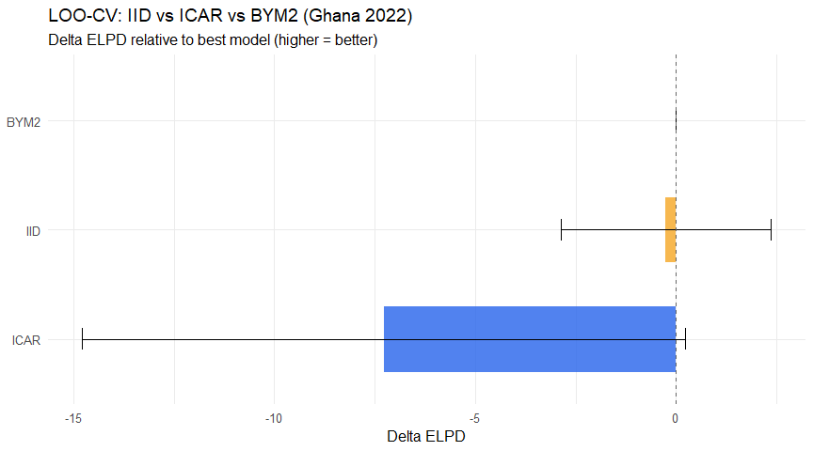

Maps: Direct vs IID vs ICAR vs BYM2
# Extract prevalence from each model
get_prev <- function(fit) {
s <- fit$summary("prevalence")
s$median
}
prev_iid_v <- get_prev(fit_iid)
prev_icar_v <- get_prev(fit_icar)
# BYM2: use fit_gha_cs or fit_bym2_loo (whichever has prevalence)
if ("prevalence" %in% fit_gha_cs$metadata()$stan_variables) {
prev_bym2_v <- get_prev(fit_gha_cs)
} else {
prev_bym2_v <- get_prev(fit_bym2_loo)
}
D_gha_cs <- stan_data[["GHA_CS_2022"]]$N
model_prev <- bind_rows(
tibble(district_id = 1:D_gha_cs, prev = prev_iid_v[1:D_gha_cs], model = "IID"),
tibble(district_id = 1:D_gha_cs, prev = prev_icar_v[1:D_gha_cs], model = "ICAR"),
tibble(district_id = 1:D_gha_cs, prev = prev_bym2_v[1:D_gha_cs], model = "BYM2"),
panels[["GHA"]] %>% filter(round_id == 2) %>%
mutate(prev = ifelse(observed == 1, plogis(y_i), NA_real_), model = "Direct") %>%
select(district_id, prev, model)
) %>%
mutate(model = factor(model, levels = c("Direct", "IID", "ICAR", "BYM2")))
# Join to shapefile via district_id
gha_shp <- districts_raw[["GHA"]] %>%
mutate(district_id = row_number())
maps_comp <- map_dfr(levels(model_prev$model), function(m) {
gha_shp %>%
left_join(model_prev %>% filter(model == m), by = "district_id") %>%
mutate(model = m)
}) %>%
mutate(model = factor(model, levels = c("Direct", "IID", "ICAR", "BYM2")))
p_comp <- ggplot(maps_comp) +
geom_sf(aes(fill = prev), colour = "grey50", linewidth = 0.1) +
scale_fill_viridis_c(name = "Prevalence",
labels = scales::percent_format(accuracy = 1),
option = "magma", direction = -1,
na.value = "grey80") +
facet_wrap(~model, nrow = 1) +
labs(title = "Model comparison: Direct vs IID vs ICAR vs BYM2 (Ghana 2022)",
subtitle = "Grey = unobserved in direct estimates. Spatial models fill all 260 districts.") +
theme_void(base_size = 11) +
theme(legend.position = "bottom",
strip.text = element_text(size = 12, face = "bold"))
ggsave("output/figures/model_comparison_maps_ghana.png", p_comp, width = 14, height = 6, dpi = 300, bg = "white")
p_comp
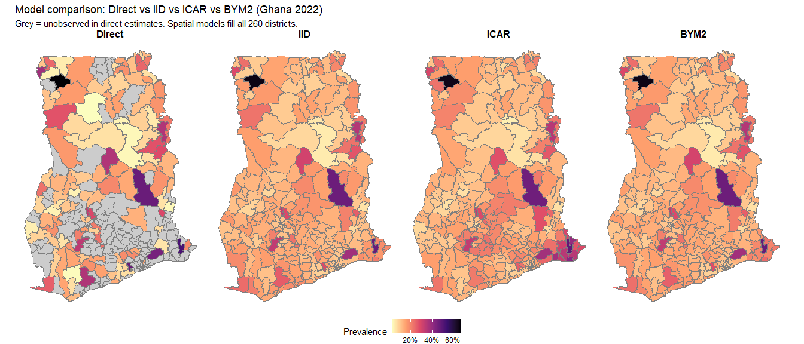

Posterior Predictive Checks
y_obs_cs <- stan_data[["GHA_CS_2022"]]$y
y_rep_cs <- fit_gha_cs$draws("y_rep", format = "matrix")
ppc_dens_overlay(y = y_obs_cs, yrep = y_rep_cs[1:100, ]) +
labs(title = "PPC: Density overlay (Ghana 2022 cross-sectional)")
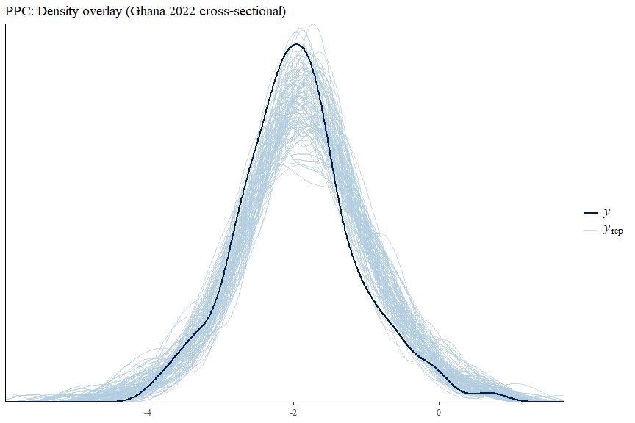
ppc_stat(y = y_obs_cs, yrep = y_rep_cs, stat = "mean") +
labs(title = "PPC: Mean of y")
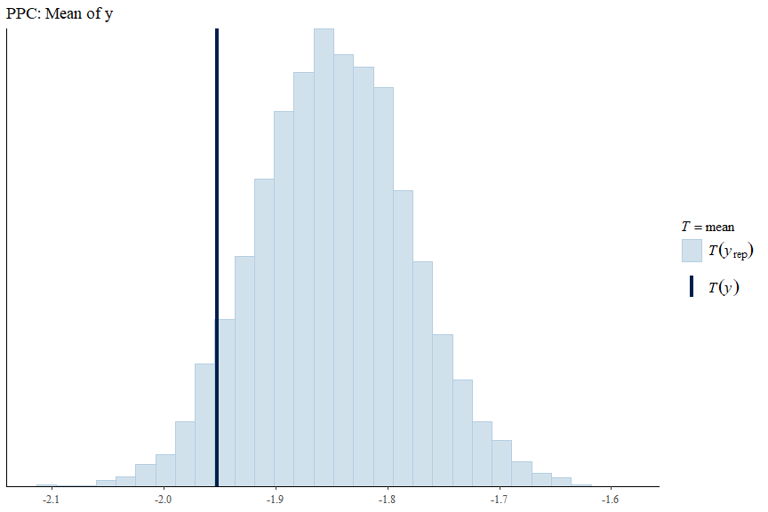
ppc_stat(y = y_obs_cs, yrep = y_rep_cs, stat = "sd") +
labs(title = "PPC: Standard deviation of y")
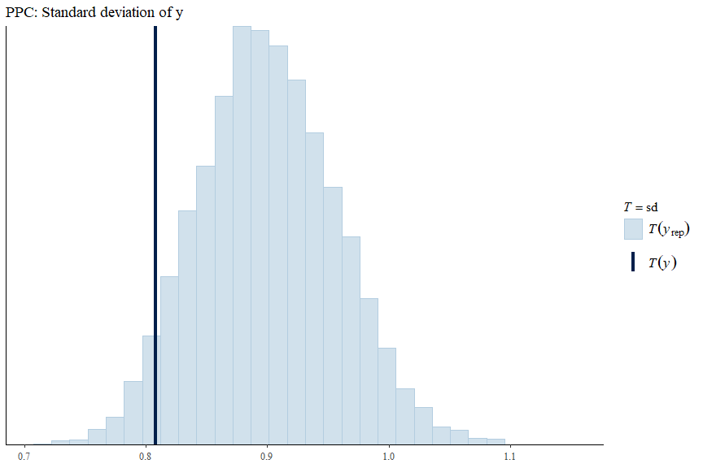

Convergence Diagnostics
mcmc_trace(fit_gha_cs$draws(c("mu", "sigma_b", "phi")))
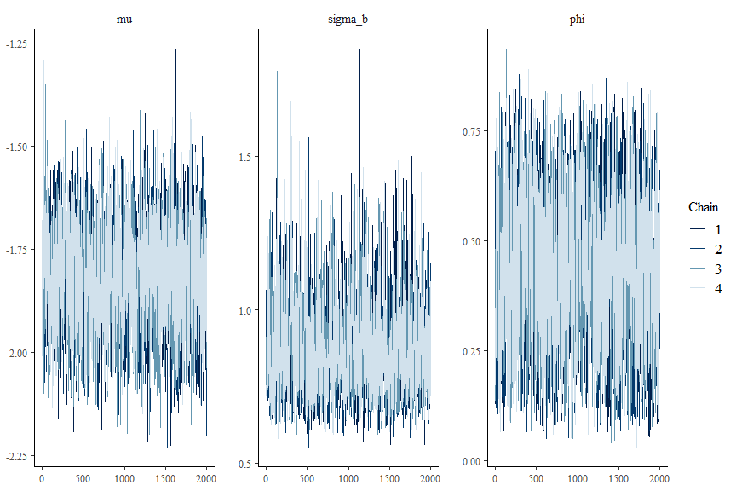

Model 2: Country-Level Space-Time Models

Specification
For each country $c$ fitted separately,
$$θ_{it}=μ^{(c)}+b_{i}^{(c)}+δ_{t}^{(c)}+γ_{it}^{(c)}+x_{it}^{⊤}β^{(c)},$$
with $b_{i}^{(c)}$ the BYM2 effect on the country-specific graph and $γ_{it}^{(c)}∼N(0,σ_{γ}^{2})$ the Knorr-Held Type I (Knorr-Held 2000) interaction. With $T=2$, Type I is the honest choice: structured temporal or space-time interactions are not identifiable (Goicoa et al. 2018).

Fitting: All Three Countries
mod_st <- cmdstan_model("fh_bym2_typeI.stan")
fit_st <- list()
for (iso in c("GHA", "BFA", "CIV")) {
cat("\n========== Fitting space-time model for", iso, "==========\n")
fit_st[[iso]] <- mod_st$sample(
data = stan_data[[paste0(iso, "_ST")]],
chains = 4,
parallel_chains = 4,
iter_warmup = 1500,
iter_sampling = 2000,
adapt_delta = 0.99,
max_treedepth = 14,
seed = 1729,
refresh = 500
)
cat("\nDiagnostics for", iso, ":\n")
print(fit_st[[iso]]$diagnostic_summary())
# Persist + restore draws so the fit survives across knit sessions
fit_st[[iso]] <- ensure_fit(fit_st[[iso]], paste0("m2_st_", iso))
}
##
## ========== Fitting space-time model for GHA ==========
##
##
## Diagnostics for CIV :
## $num_divergent
## [1] 0 0 0 0
##
## $num_max_treedepth
## [1] 0 0 0 0
##
## $ebfmi
## [1] 0.8417835 0.8843729 0.7428408 0.7995709

Country-Level Space-Time: Full Posterior Summaries
# Helper: print full posterior summary of a fit, robust to errors.
safe_full_summary <- function(fit, label) {
cat("
========== ", label, " ==========
", sep = "")
tryCatch(
{
print(fit$summary(), n = Inf)
},
error = function(e) {
cat(" [could not print full summary:", conditionMessage(e), "]
")
}
)
}
# Helper: print a compact view of named parameters, dropping any that the
# fit does not contain (so we never crash on a name mismatch).
safe_print <- function(fit, params, label = NULL) {
if (!is.null(label)) cat("
--- ", label, " ---
", sep = "")
available <- fit$metadata()$stan_variables
# `params` may include names like "beta[1]" — strip indexing for the check
base_names <- sub("\\[.*$", "", params)
keep <- params[base_names %in% available]
if (length(keep) == 0L) {
cat(" [none of the requested parameters exist in this fit]
")
return(invisible(NULL))
}
tryCatch(fit$print(keep),
error = function(e) cat(" [print failed:", conditionMessage(e), "]
"))
}
# --- Full per-country summaries ---
for (cc in names(fit_st)) {
safe_full_summary(fit_st[[cc]], paste(cc, "SPACE-TIME"))
}
##
## ========== GHA SPACE-TIME ==========
## # A tibble: 2,895 × 10
## variable mean median sd mad q5 q95 rhat
## <chr> <dbl> <dbl> <dbl> <dbl> <dbl> <dbl> <dbl>
## 1 lp__ -5.35e+2 -5.35e+2 22.6 22.9 -5.73e+2 -4.99 e+2 1.00
## 2 mu -8.25e-1 -8.25e-1 0.0698 0.0703 -9.39e-1 -7.11 e-1 1.00
1.00
## 785 gamma_raw[26… -3.54e-3 -8.95e-3 1.01 1.01 -1.66e+0 1.63 e+0 1.00
## 786 sigma_gamma 5.21e-1 5.19e-1 0.0439 0.0437 4.52e-1 5.95 e-1 1.00
## 787 beta[1] -1.14e-1 -1.14e-1 0.0746 0.0723 -2.37e-1 1.02 e-2 1.00
## 788 beta[2] 1.55e-1 1.57e-1 0.146 0.148 -8.77e-2 3.89 e-1 1.00
## 789 beta[3] -3.06e-1 -3.04e-1 0.159 0.158 -5.70e-1 -4.34 e-2 1.00
## 790 beta[4] -2.38e-1 -2.38e-1 0.0847 0.0849 -3.78e-1 -1.01 e-1 1.00
## 791 beta[5] 1.69e-1 1.70e-1 0.0637 0.0635 6.36e-2 2.73 e-1 1.00
## 792 beta[6] 1.37e-1 1.37e-1 0.162 0.160 -1.31e-1 4.03 e-1 1.00
## 793 beta[7] 1.95e-1 1.95e-1 0.0939 0.0924 3.96e-2 3.51 e-1 1.00
## 1314 delta[1] 0 0 0 0 0 0 NA
## 1315 delta[2] -1.14e+0 -1.14e+0 0.0984 0.0971 -1.31e+0 -9.76 e-1 1.00
##
## ========== BFA SPACE-TIME ==========
## # A tibble: 3,913 × 10
## variable mean median sd mad q5 q95 rhat
## <chr> <dbl> <dbl> <dbl> <dbl> <dbl> <dbl> <dbl>
## 1 lp__ -7.31 e+2 -7.31e+2 26.1 26.1 -7.74e+2 -6.89e+2 1.00
## 2 mu 9.09 e-1 9.11e-1 0.102 0.103 7.38e-1 1.07e+0 1.00
## 705 sigma_b 1.04 e+0 1.02e+0 0.178 0.175 7.80e-1 1.36e+0 1.01
## 706 phi 6.36 e-1 6.54e-1 0.144 0.145 3.69e-1 8.40e-1 1.01
## 707 delta_2 -2.52 e+0 -2.52e+0 0.193 0.195 -2.82e+0 -2.19e+0 1.01
1.000
## 1059 sigma_gamma 5.15 e-1 5.14e-1 0.0397 0.0403 4.53e-1 5.84e-1 1.00
## 1060 beta[1] -1.01 e-1 -9.95e-2 0.0787 0.0797 -2.33e-1 2.72e-2 1.000
## 1061 beta[2] 7.57 e-2 7.49e-2 0.122 0.124 -1.22e-1 2.76e-1 1.00
## 1062 beta[3] -1.21 e-1 -1.21e-1 0.0394 0.0394 -1.85e-1 -5.50e-2 1.00
## 1063 beta[4] -4.40 e-2 -3.98e-2 0.161 0.162 -3.13e-1 2.16e-1 1.00
## 1064 beta[5] 3.77 e-2 3.68e-2 0.0705 0.0698 -7.53e-2 1.54e-1 1.00
## 1065 beta[6] -2.73 e-1 -2.72e-1 0.0692 0.0672 -3.86e-1 -1.59e-1 1.00
## 1066 beta[7] 5.59 e-2 5.56e-2 0.0554 0.0544 -3.49e-2 1.48e-1 1.00
## 1769 delta[1] 0 0 0 0 0 0 NA
## 1770 delta[2] -2.52 e+0 -2.52e+0 0.193 0.195 -2.82e+0 -2.19e+0 1.01
## ========== CIV SPACE-TIME ==========
## # A tibble: 1,331 × 10
## variable mean median sd mad q5 q95 rhat
## <chr> <dbl> <dbl> <dbl> <dbl> <dbl> <dbl> <dbl>
## 1 lp__ -2.72e+2 -2.71e+2 1.60e+1 1.58e+1 -2.99e+2 -2.46 e+2 1.00
## 2 mu -1.56e+0 -1.56e+0 1.12e-1 1.12e-1 -1.75e+0 -1.38 e+0 1.00
## 229 sigma_b 8.18e-1 7.77e-1 2.14e-1 1.88e-1 5.54e-1 1.23 e+0 1.01
## 230 phi 5.86e-1 6.01e-1 1.89e-1 2.04e-1 2.50e-1 8.65 e-1 1.01
## 231 delta_2 7.77e-1 7.75e-1 1.72e-1 1.69e-1 4.95e-1 1.06 e+0 1.00
## 345 sigma_gamma 4.77e-1 4.75e-1 4.91e-2 4.80e-2 4.01e-1 5.62 e-1 1.00
## 346 beta[1] -1.37e-1 -1.39e-1 1.44e-1 1.42e-1 -3.71e-1 1.08 e-1 1.00
## 347 beta[2] -7.71e-2 -7.81e-2 1.11e-1 1.11e-1 -2.60e-1 1.07 e-1 1.00
## 348 beta[3] -3.63e-1 -3.64e-1 8.69e-2 8.65e-2 -5.05e-1 -2.22 e-1 1.00
## 349 beta[4] -1.63e-1 -1.63e-1 1.39e-1 1.36e-1 -3.89e-1 6.30 e-2 1.00
## 350 beta[5] -1.59e-1 -1.59e-1 7.27e-2 7.21e-2 -2.76e-1 -3.62 e-2 1.00
## 351 beta[6] -1.33e-1 -1.33e-1 9.42e-2 9.51e-2 -2.85e-1 2.11 e-2 1.00
## 352 beta[7] 8.66e-2 8.95e-2 1.10e-1 1.10e-1 -9.94e-2 2.62 e-1 1.00
## 579 delta[1] 0 0 0 0 0 0 NA
## 580 delta[2] 7.77e-1 7.75e-1 1.72e-1 1.69e-1 4.95e-1 1.06 e+0 1.00
# Key parameters across the three country-level space-time models
key_st_params <- c(
"mu", "sigma_b", "phi", "sigma_gamma",
"delta2", "delta[2]", # alternative naming
"p_national[1]", "p_national[2]",
paste0("beta[", 1:7, "]")
)
for (cc in names(fit_st)) {
safe_print(fit_st[[cc]], key_st_params, label = cc)
}
##
## --- GHA ---
## variable mean median sd mad q5 q95 rhat ess_bulk ess_tail
## mu -0.83 -0.82 0.07 0.07 -0.94 -0.71 1.00 3421 5142
## sigma_b 0.72 0.70 0.12 0.11 0.56 0.94 1.01 1647 2610
## phi 0.47 0.47 0.16 0.17 0.20 0.73 1.01 1579 2763
## sigma_gamma 0.52 0.52 0.04 0.04 0.45 0.60 1.00 2125 3708
## delta[2] -1.14 -1.14 0.10 0.10 -1.31 -0.98 1.00 2132 3418
## beta[1] -0.11 -0.11 0.07 0.07 -0.24 0.01 1.00 1429 3283
## beta[2] 0.15 0.16 0.15 0.15 -0.09 0.39 1.00 2935 4735
## beta[3] -0.31 -0.30 0.16 0.16 -0.57 -0.04 1.00 3129 4685
## beta[4] -0.24 -0.24 0.08 0.08 -0.38 -0.10 1.00 1039 2660
## beta[5] 0.17 0.17 0.06 0.06 0.06 0.27 1.00 2576 4154
##
## # showing 10 of 12 rows (change via 'max_rows' argument or 'cmdstanr_max_rows' option)
##
## --- BFA ---
## variable mean median sd mad q5 q95 rhat ess_bulk ess_tail
## mu 0.91 0.91 0.10 0.10 0.74 1.07 1.00 642 1442
## sigma_b 1.04 1.02 0.18 0.18 0.78 1.36 1.01 578 777
## phi 0.64 0.65 0.14 0.15 0.37 0.84 1.01 588 874
## sigma_gamma 0.52 0.51 0.04 0.04 0.45 0.58 1.00 1313 2463
## delta[2] -2.52 -2.52 0.19 0.20 -2.82 -2.19 1.01 560 1167
## beta[1] -0.10 -0.10 0.08 0.08 -0.23 0.03 1.00 2194 4387
## beta[2] 0.08 0.07 0.12 0.12 -0.12 0.28 1.00 762 1773
## beta[3] -0.12 -0.12 0.04 0.04 -0.18 -0.06 1.00 7722 6183
## beta[4] -0.04 -0.04 0.16 0.16 -0.31 0.22 1.00 900 2017
## beta[5] 0.04 0.04 0.07 0.07 -0.08 0.15 1.00 2944 4291
##
## # showing 10 of 12 rows (change via 'max_rows' argument or 'cmdstanr_max_rows' option)
##
## --- CIV ---
## variable mean median sd mad q5 q95 rhat ess_bulk ess_tail
## mu -1.56 -1.56 0.11 0.11 -1.75 -1.38 1.00 1394 3086
## sigma_b 0.82 0.78 0.21 0.19 0.55 1.23 1.01 1114 1657
## phi 0.59 0.60 0.19 0.20 0.25 0.86 1.01 1023 1686
## sigma_gamma 0.48 0.47 0.05 0.05 0.40 0.56 1.00 1608 2959
## delta[2] 0.78 0.78 0.17 0.17 0.50 1.06 1.00 1341 2661
## beta[1] -0.14 -0.14 0.14 0.14 -0.37 0.11 1.00 1428 2672
## beta[2] -0.08 -0.08 0.11 0.11 -0.26 0.11 1.00 1317 2448
## beta[3] -0.36 -0.36 0.09 0.09 -0.51 -0.22 1.00 2757 4019
## beta[4] -0.16 -0.16 0.14 0.14 -0.39 0.06 1.00 1369 2573
## beta[5] -0.16 -0.16 0.07 0.07 -0.28 -0.04 1.00 1786 3373
##
## # showing 10 of 12 rows (change via 'max_rows' argument or 'cmdstanr_max_rows' option)

Summary Across Countries
summary_all <- map_dfr(c("GHA", "BFA", "CIV"), function(iso) {
draws <- fit_st[[iso]]$draws(
variables = c("mu", "delta_2", "sigma_b", "phi", "sigma_gamma",
"p_round1", "p_round2"),
format = "draws_matrix"
)
tibble(
country = iso,
variable = colnames(draws),
mean = colMeans(draws),
median = apply(draws, 2, median),
lower = apply(draws, 2, quantile, 0.025),
upper = apply(draws, 2, quantile, 0.975),
rhat = apply(draws, 2, posterior::rhat),
ess_bulk = apply(draws, 2, posterior::ess_bulk)
)
})
print(n = 25, summary_all)
## # A tibble: 21 × 8
## country variable mean median lower upper rhat ess_bulk
## <chr> <chr> <dbl> <dbl> <dbl> <dbl> <dbl> <dbl>
## 1 GHA mu -0.825 -0.825 -0.964 -0.691 1.00 3366.
## 2 GHA delta_2 -1.14 -1.14 -1.33 -0.947 1.00 2097.
## 3 GHA sigma_b 0.720 0.702 0.536 0.996 1.00 1653.
## 4 GHA phi 0.471 0.473 0.154 0.766 1.00 1582.
## 5 GHA sigma_gamma 0.521 0.519 0.440 0.613 1.00 2122.
## 6 GHA p_round1 0.305 0.305 0.276 0.334 1.00 3366.
## 7 GHA p_round2 0.123 0.123 0.106 0.141 1.00 3051.
## 8 BFA mu 0.909 0.911 0.704 1.10 1.00 656.
## 9 BFA delta_2 -2.52 -2.52 -2.87 -2.12 1.00 566.
## 10 BFA sigma_b 1.04 1.02 0.748 1.43 1.00 590.
## 11 BFA phi 0.636 0.654 0.310 0.862 1.00 595.
## 12 BFA sigma_gamma 0.515 0.514 0.443 0.597 1.00 1299.
## 13 BFA p_round1 0.712 0.713 0.669 0.751 1.00 656.
## 14 BFA p_round2 0.168 0.167 0.139 0.201 1.00 720.
## 15 CIV mu -1.56 -1.56 -1.78 -1.34 1.00 1382.
## 16 CIV delta_2 0.777 0.775 0.436 1.12 1.00 1330.
## 17 CIV sigma_b 0.818 0.777 0.525 1.35 1.01 1088.
## 18 CIV phi 0.586 0.601 0.193 0.895 1.01 979.
## 19 CIV sigma_gamma 0.477 0.475 0.388 0.582 1.00 1604.
## 20 CIV p_round1 0.174 0.173 0.144 0.207 1.00 1382.
## 21 CIV p_round2 0.313 0.313 0.274 0.356 1.00 1867.
# fit_st$print(c(
# "mu", "sigma_b", "phi", "p_national",
# "beta[1]", "beta[2]", "beta[3]", "beta[4]",
# "beta[5]", "beta[6]", "beta[7]"
# ))

Prior vs Posterior Comparison
post_draws <- fit_st[["GHA"]]$draws(
c("mu", "delta_2", "sigma_b", "phi", "sigma_gamma"),
format = "draws_df"
)
prior_post_plot <- function(post_var, prior_fun, x_range, label) {
ggplot() +
geom_function(fun = prior_fun, xlim = x_range,
aes(colour = "Prior"), linewidth = 0.9) +
geom_density(data = post_draws,
aes(x = .data[[post_var]], colour = "Posterior"),
linewidth = 0.9) +
scale_colour_manual(values = c(Prior = "grey50", Posterior = "#b2182b")) +
labs(x = label, y = "Density", colour = NULL) +
theme_minimal(base_size = 10) +
theme(legend.position = "none")
}
p_mu <- prior_post_plot("mu", ~ dnorm(.x, -1.85, 1), c(-4, 0), expression(mu))
p_delta <- prior_post_plot("delta_2", ~ dnorm(.x, 0, 5), c(-3, 3), expression(delta[2]))
p_sigb <- prior_post_plot("sigma_b", ~ dexp(.x, 4.6), c(0, 2), expression(sigma[b]))
p_phi <- prior_post_plot("phi", ~ dbeta(.x, 3, 2), c(0, 1), expression(phi))
p_siggam <- prior_post_plot("sigma_gamma", ~ dexp(.x, 2), c(0, 2), expression(sigma[gamma]))
(p_mu | p_delta | p_sigb) / (p_phi | p_siggam | plot_spacer()) +
plot_annotation(title = "Prior vs posterior, space-time BYM2 model (Ghana)")
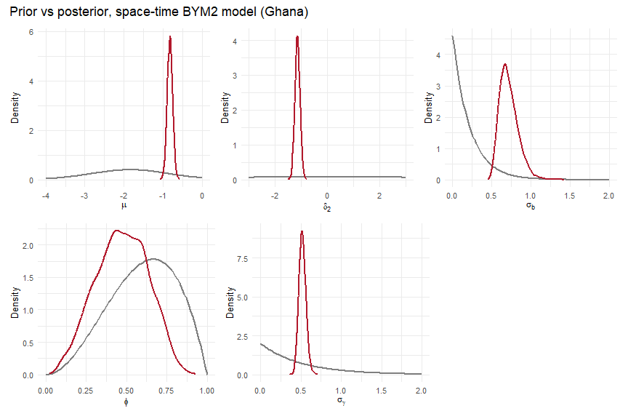

Covariate Effects Across Countries (Country-Specific Models)
covar_labels <- c("Elevation", "Rainfall", "Nighttime lights", "Temperature",
"Travel time", "Pop. density (log)", "Poverty")
# 2. Process directly from your pre-calculated summary_all dataframe
beta_all <- summary_all %>%
# Filter only the rows where the variable starts with "beta["
filter(str_detect(variable, "^beta\\[")) %>%
mutate(
# Extract the numeric index from "beta[1]", "beta[2]", etc.
beta_idx = as.integer(str_extract(variable, "\\d+")),
# Map the index to the correct human-readable label
covariate = covar_labels[beta_idx],
# Calculate significance strictly using the lower/upper bounds in the table
# If both bounds are greater than 0, or both are less than 0, it is significant
is_significant = (lower > 0) | (upper < 0),
sig_marker = ifelse(is_significant, "*", "")
)
# 3. Factor the covariates and countries to preserve plotting order
beta_all$covariate <- factor(beta_all$covariate, levels = rev(covar_labels))
beta_all$country <- factor(beta_all$country, levels = c("GHA", "BFA", "CIV"))
# 4. Generate the plot
p_covars <- ggplot(beta_all, aes(x = mean, y = covariate, colour = country, group = country)) +
geom_pointrange(aes(xmin = lower, xmax = upper),
position = position_dodge(width = 0.6), size = 0.8) +
# FIXED ALIGNMENT: Added hjust = 0 and locked the dodge with group = country
geom_text(aes(x = upper + 0.02, label = sig_marker),
position = position_dodge(width = 0.6),
size = 7, # Slightly larger for visibility on a slide
vjust = 0.75, # Pulls the top-heavy asterisk down to center it with the line
hjust = 0, # Left-aligns it exactly 0.02 units away from the line
show.legend = FALSE,
colour = "black") +
geom_vline(xintercept = 0, linetype = "dashed", colour = "grey40", linewidth = 0.8) +
scale_colour_brewer(palette = "Dark2", name = "Country") +
scale_x_continuous(expand = expansion(mult = c(0.05, 0.15))) +
labs(x = "Coefficient (logit scale)", y = NULL,
title = "Covariate effects: Individual Space-Time Models",
subtitle = "Posterior mean and credible intervals. Asterisks (*) denote significant effects.") +
theme_minimal(base_size = 13) +
theme(
legend.position = "bottom",
panel.grid.minor = element_blank(),
plot.title = element_text(face = "bold")
)
ggsave("output/figures/individual_covariate_effects.png", p_covars, width = 10, height = 7, dpi = 300, bg = "white")
p_covars
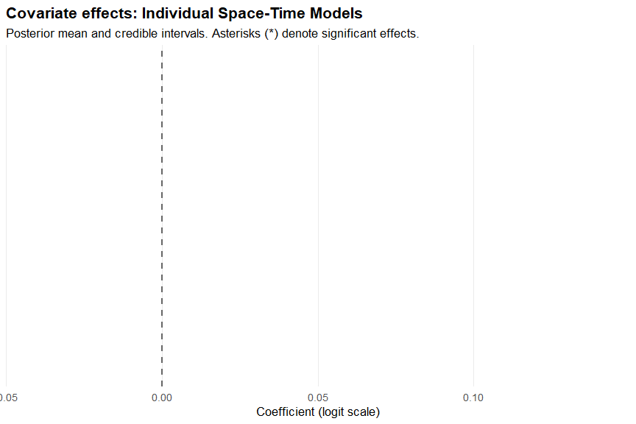

Prevalence Maps: All Countries, Both Rounds
make_prev_map_df <- function(iso, round) {
prev_sum <- fit_st[[iso]]$summary("prevalence",
median = ~ median(.x),
lower = ~ quantile(.x, 0.025),
upper = ~ quantile(.x, 0.975)
) %>%
mutate(row_id = as.integer(gsub("prevalence\\[|\\]", "", variable))) %>%
left_join(
panels[[iso]] %>% mutate(row_id = row_number()) %>%
select(row_id, district_id, round_id),
by = "row_id"
) %>%
filter(round_id == round) %>%
left_join(district_lookups[[iso]] %>% select(district_id, district_code),
by = "district_id")
districts_raw[[iso]] %>%
left_join(prev_sum, by = "district_code") %>%
mutate(country = iso, round_label = paste("Round", round))
}
all_maps <- map_dfr(c("GHA", "BFA", "CIV"),
function(iso) bind_rows(
make_prev_map_df(iso, 1),
make_prev_map_df(iso, 2)
))
ggplot(all_maps) +
geom_sf(aes(fill = median), colour = "grey40", linewidth = 0.1) +
scale_fill_viridis_c(name = "Prevalence",
labels = scales::percent_format(accuracy = 1),
option = "magma", direction = -1) +
facet_grid(country ~ round_label) +
labs(title = "Under-5 malaria prevalence across three West African countries",
subtitle = "Posterior medians from BYM2 space-time model") +
theme_void(base_size = 11) +
theme(legend.position = "right")
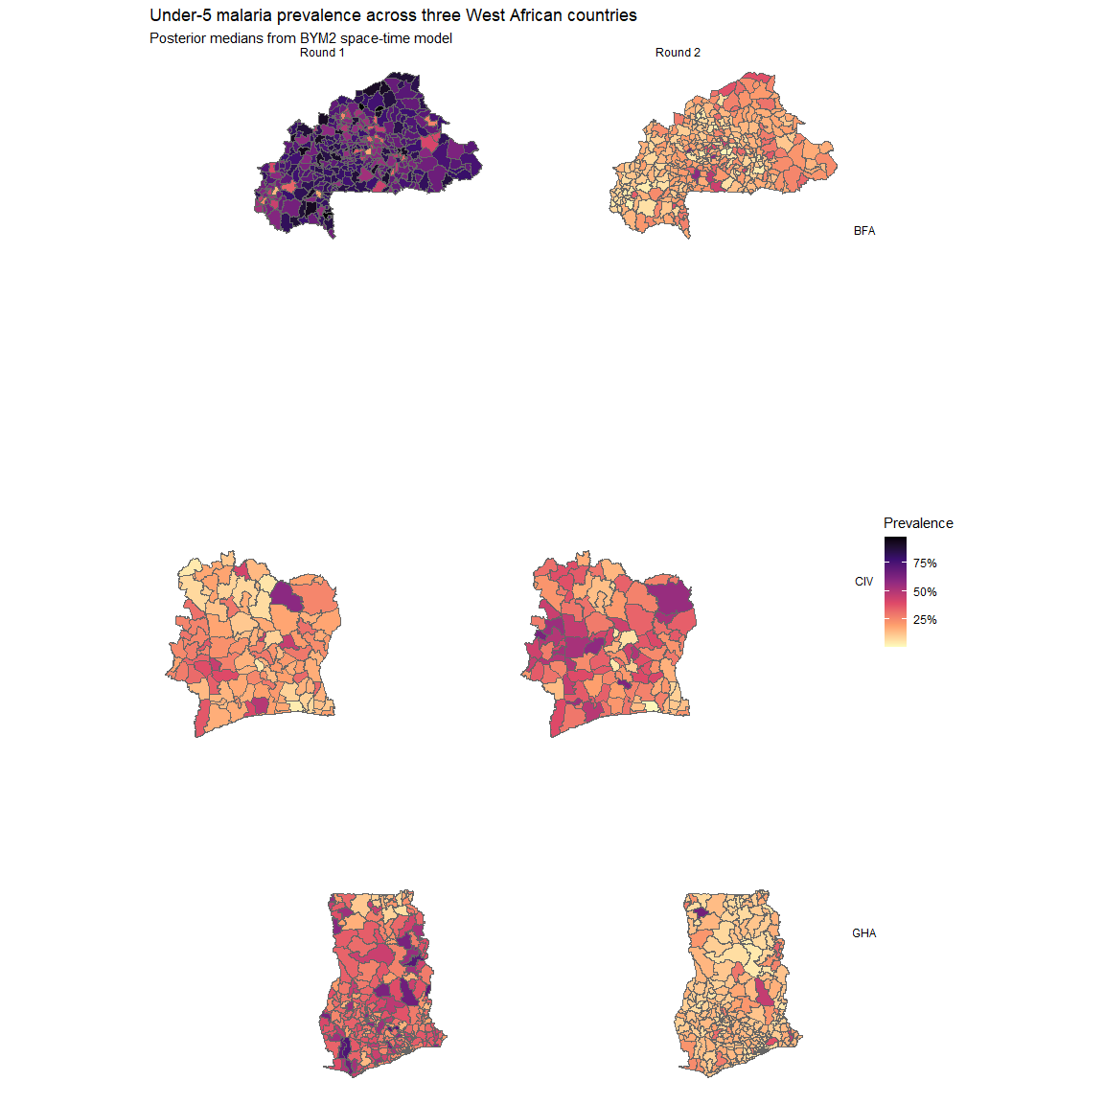

District Trend Deviations
dev_summary_gha <- fit_st[["GHA"]]$summary("gamma_star",
median = ~ median(.x),
lower = ~ unname(quantile(.x, 0.025)),
upper = ~ unname(quantile(.x, 0.975))
) %>%
mutate(
district_id = as.integer(gsub("gamma_star\\[|\\]", "", variable)),
confident = (lower > 0) | (upper < 0)
) %>%
left_join(district_lookups[["GHA"]] %>%
select(district_id, district_code, district_name),
by = "district_id")
map_dev <- districts_raw[["GHA"]] %>%
left_join(dev_summary_gha, by = "district_code")
dev_limit <- max(abs(range(map_dev$median, na.rm = TRUE)))
ggplot(map_dev) +
geom_sf(aes(fill = median), colour = "grey40", linewidth = 0.1) +
scale_fill_gradient2(
name = expression(gamma[i]^"*"),
low = "#2166ac", mid = "white", high = "#b2182b",
midpoint = 0, limits = c(-dev_limit, dev_limit)
) +
geom_sf(data = map_dev %>% filter(confident),
fill = NA, colour = "black", linewidth = 0.4) +
labs(
title = "District-level deviation from national malaria trend, Ghana 2014–2022",
subtitle = "Blue: faster decline than national. Red: slower / rising. Bold outline: 95% CI excludes 0."
) +
theme_void(base_size = 11)
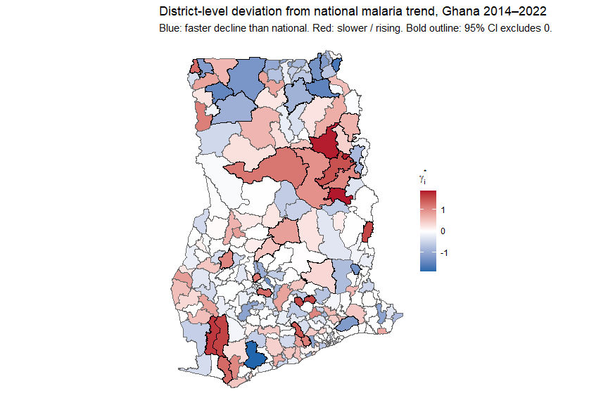

Top Trend-Deviating Districts
top_neg <- dev_summary_gha %>% arrange(median) %>% head(10) %>%
mutate(direction = "Faster decline")
top_pos <- dev_summary_gha %>% arrange(desc(median)) %>% head(10) %>%
mutate(direction = "Slower / rising")
bind_rows(top_neg, top_pos) %>%
mutate(district_name = fct_reorder(district_name, median)) %>%
ggplot(aes(x = median, y = district_name, colour = direction)) +
geom_pointrange(aes(xmin = lower, xmax = upper)) +
geom_vline(xintercept = 0, linetype = "dashed") +
scale_colour_manual(values = c("Faster decline" = "#2166ac",
"Slower / rising" = "#b2182b")) +
labs(x = expression(gamma[i]^"*" * " (logit scale)"), y = NULL,
title = "Top districts with credible deviation from national trend, Ghana",
colour = NULL) +
theme_minimal(base_size = 11) +
theme(legend.position = "bottom")
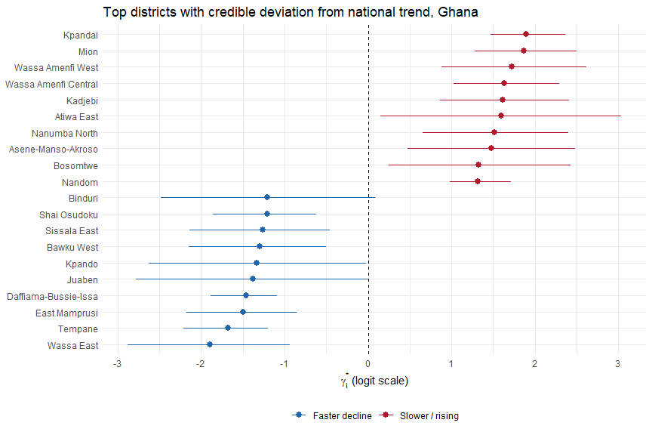

Uncertainty Maps
make_uncertainty_df <- function(iso, round) {
unc <- fit_st[[iso]]$summary("prevalence",
width = ~ unname(quantile(.x, 0.975) - quantile(.x, 0.025))
) %>%
mutate(row_id = as.integer(gsub("prevalence\\[|\\]", "", variable))) %>%
left_join(
panels[[iso]] %>% mutate(row_id = row_number()) %>%
select(row_id, district_id, round_id, observed),
by = "row_id"
) %>%
filter(round_id == round) %>%
left_join(district_lookups[[iso]] %>% select(district_id, district_code),
by = "district_id")
districts_raw[[iso]] %>%
left_join(unc, by = "district_code") %>%
mutate(country = iso)
}
unc_r2 <- map_dfr(c("GHA", "BFA", "CIV"),
function(iso) make_uncertainty_df(iso, 2))
ggplot(unc_r2) +
geom_sf(aes(fill = width), colour = "grey40", linewidth = 0.1) +
scale_fill_viridis_c(name = "95% CI width",
labels = scales::percent_format(accuracy = 1),
option = "cividis") +
facet_wrap(~country) +
labs(title = "Posterior uncertainty in Round 2 prevalence estimates",
subtitle = "Wider intervals = greater reliance on spatial smoothing (no direct data)") +
theme_void(base_size = 11)
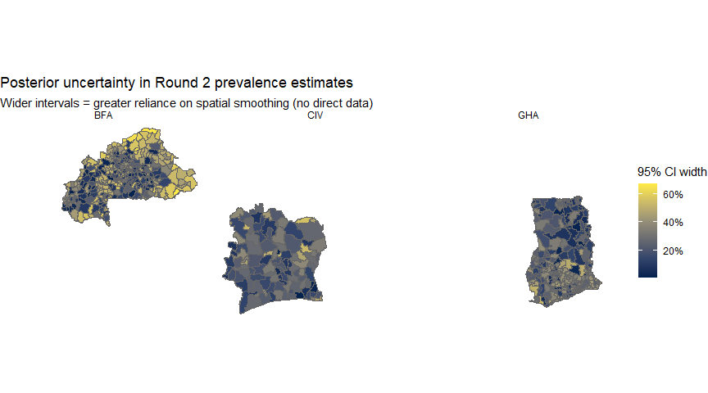

Observed vs Unobserved Districts
make_obs_map <- function(iso, round) {
panel_round <- panels[[iso]] %>% filter(round_id == round)
obs_by_district <- panel_round %>%
select(district_id, observed) %>%
mutate(status = ifelse(observed == 1, "Observed", "Unobserved")) %>%
left_join(district_lookups[[iso]] %>% select(district_id, district_code),
by = "district_id")
districts_raw[[iso]] %>%
left_join(obs_by_district, by = "district_code") %>%
mutate(country = iso,
round_label = paste("Round", round))
}
obs_maps <- map_dfr(c("GHA", "BFA", "CIV"),
function(iso) bind_rows(
make_obs_map(iso, 1),
make_obs_map(iso, 2)
))
p_obs <- ggplot(obs_maps) +
geom_sf(aes(fill = status), colour = "grey50", linewidth = 0.1) +
scale_fill_manual(
values = c("Observed" = "#2563eb", "Unobserved" = "#fbbf24"),
name = "Survey data"
) +
facet_grid(country ~ round_label) +
labs(
title = "Districts with direct DHS data vs unobserved districts",
subtitle = "Unobserved districts rely entirely on spatial borrowing from neighbours and covariates"
) +
theme_void(base_size = 11) +
theme(legend.position = "bottom",
strip.text = element_text(size = 11, face = "bold"))
ggsave("output/figures/observed_vs_unobserved_map.png", p_obs, width = 10, height = 10, dpi = 300, bg = "white")
p_obs
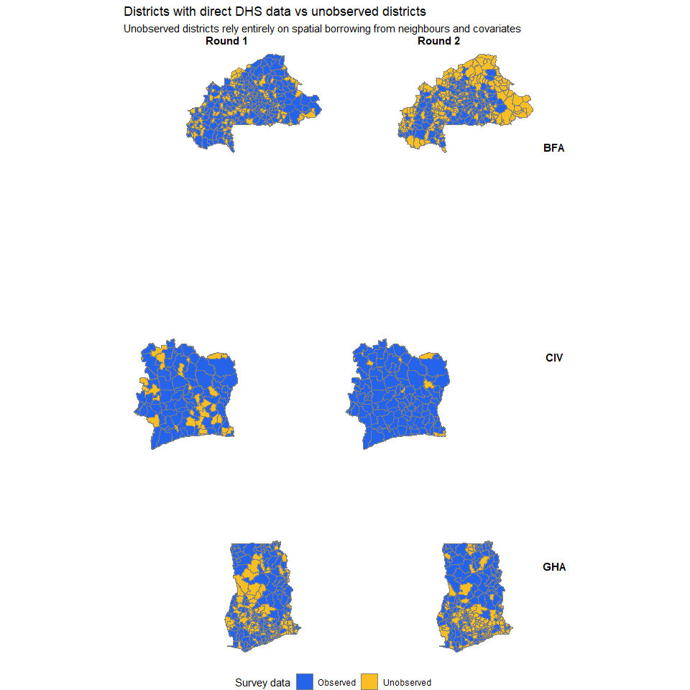

Credible Interval Comparison: Observed vs Unobserved
make_ci_comparison <- function(iso, round) {
D <- stan_data[[paste0(iso, "_ST")]]$N
# Use default summary (returns q5, q95, mean, median, sd, etc.)
prev_summary <- fit_st[[iso]]$summary("prevalence") %>%
mutate(row_id = as.integer(gsub("prevalence\\[|\\]", "", variable))) %>%
left_join(
panels[[iso]] %>% mutate(row_id = row_number()) %>%
select(row_id, district_id, round_id, observed),
by = "row_id"
) %>%
filter(round_id == round) %>%
mutate(
ci_width = q95 - q5,
status = ifelse(observed == 1, "Observed", "Unobserved"),
country = iso
) %>%
left_join(district_lookups[[iso]] %>% select(district_id, district_name),
by = "district_id")
prev_summary
}
ci_all <- map_dfr(c("GHA", "BFA", "CIV"),
function(iso) make_ci_comparison(iso, 2))
# Boxplot comparing CI widths
p_ci_box <- ggplot(ci_all, aes(x = status, y = ci_width, fill = status)) +
geom_boxplot(alpha = 0.7, outlier.size = 0.8) +
facet_wrap(~country, scales = "free_y") +
scale_fill_manual(values = c("Observed" = "#2563eb", "Unobserved" = "#fbbf24")) +
scale_y_continuous(labels = scales::percent_format(accuracy = 1)) +
labs(
title = "Width of 90% credible intervals: observed vs unobserved districts",
subtitle = "Round 2 estimates. Unobserved districts have wider intervals (more uncertainty)",
x = NULL, y = "Width of 90% CrI",
fill = NULL
) +
theme_minimal(base_size = 12) +
theme(legend.position = "bottom")
ggsave("output/figures/ci_comparison_obs_unobs.png", p_ci_box, width = 10, height = 6, dpi = 300, bg = "white")
p_ci_box
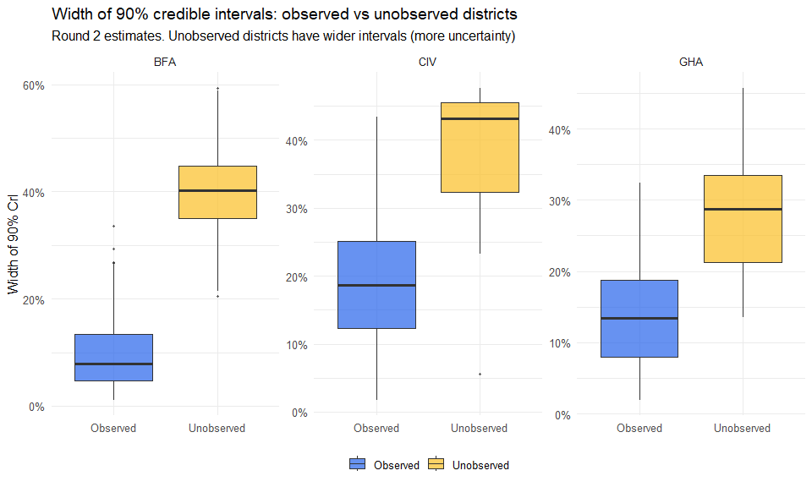

Caterpillar Plot: Sorted Prevalence with Credible Intervals
ci_gha <- ci_all %>%
filter(country == "GHA") %>%
arrange(median) %>%
mutate(rank = row_number())
p_cat <- ggplot(ci_gha, aes(x = rank, y = median, colour = status)) +
geom_linerange(aes(ymin = q5, ymax = q95), alpha = 0.5, linewidth = 0.3) +
geom_point(size = 0.6) +
scale_colour_manual(values = c("Observed" = "#2563eb", "Unobserved" = "#fbbf24")) +
scale_y_continuous(labels = scales::percent_format(accuracy = 1)) +
labs(
title = "Caterpillar plot: district prevalence estimates, Ghana Round 2",
subtitle = "260 districts sorted by posterior median. Gold = unobserved (wider CrI).",
x = "District (sorted)", y = "Prevalence (posterior median and 90% CrI)",
colour = NULL
) +
theme_minimal(base_size = 12) +
theme(legend.position = "bottom")
ggsave("output/figures/caterpillar_plot_ghana_r2.png", p_cat, width = 10, height = 7, dpi = 300, bg = "white")
p_cat
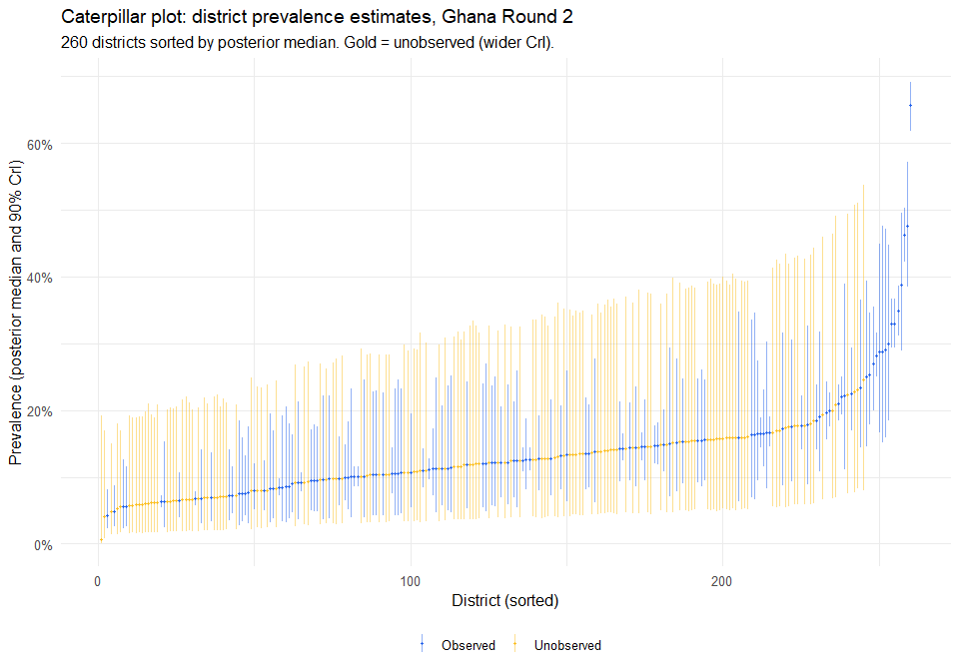

Direct vs Model-Smoothed Estimates
gha_panel_r2 <- panels[["GHA"]] %>% filter(round_id == 2)
gha_direct <- gha_panel_r2 %>%
filter(observed == 1) %>%
mutate(direct_prev = plogis(y_i))
gha_model <- fit_st[["GHA"]]$summary("prevalence") %>%
mutate(row_id = as.integer(gsub("prevalence\\[|\\]", "", variable))) %>%
left_join(
panels[["GHA"]] %>% mutate(row_id = row_number()) %>%
select(row_id, district_id, round_id),
by = "row_id"
) %>%
filter(round_id == 2)
shrinkage_df <- gha_direct %>%
select(district_id, direct_prev) %>%
left_join(gha_model %>% select(district_id, model_prev = median,
model_lower = q5, model_upper = q95),
by = "district_id") %>%
left_join(district_lookups[["GHA"]] %>% select(district_id, district_name),
by = "district_id")
p_shrink <- ggplot(shrinkage_df, aes(x = direct_prev, y = model_prev)) +
geom_abline(slope = 1, intercept = 0, linetype = "dashed", colour = "grey50") +
geom_linerange(aes(ymin = model_lower, ymax = model_upper),
alpha = 0.15, colour = "#a80050") +
geom_point(alpha = 0.6, colour = "#a80050", size = 1.5) +
scale_x_continuous(labels = scales::percent_format(accuracy = 1)) +
scale_y_continuous(labels = scales::percent_format(accuracy = 1)) +
labs(
title = "BYM2 shrinkage: direct estimates vs model-smoothed posteriors",
subtitle = "Ghana Round 2. Points below diagonal = model pulled estimate down. Bars = 90% CrI.",
x = "Direct estimate (design-based)",
y = "Model posterior median"
) +
theme_minimal(base_size = 12)
ggsave("output/figures/direct_vs_smoothed_ghana_r2.png", p_shrink, width = 9, height = 7, dpi = 300, bg = "white")
p_shrink
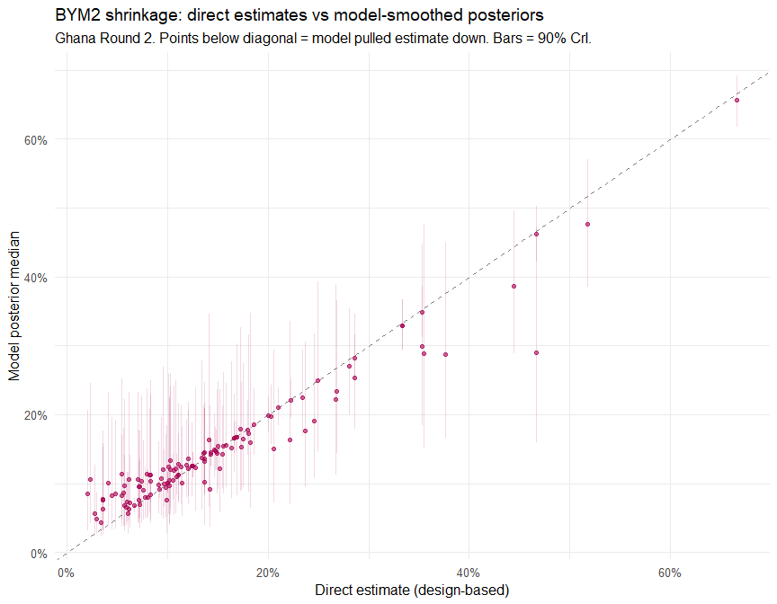

Space-Time Convergence Diagnostics
mcmc_rank_overlay(fit_st[["GHA"]]$draws(
c("mu", "delta_2", "sigma_b", "phi", "sigma_gamma")
))
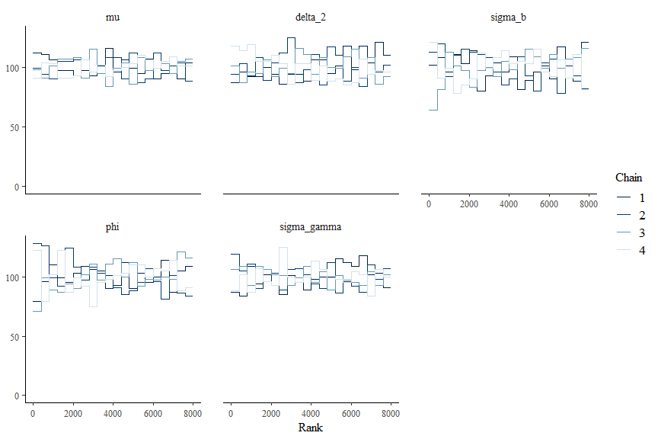
mcmc_pairs(
fit_st[["GHA"]]$draws(c("sigma_b", "phi", "sigma_gamma", "delta_2")),
off_diag_args = list(size = 0.5, alpha = 0.3)
)
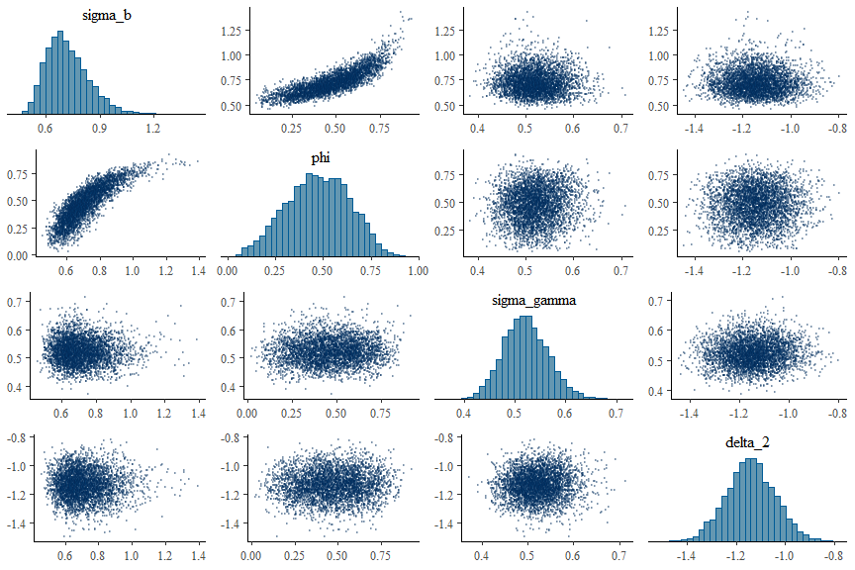

Model 3: Pooled Three-Country Space-Time Model

Motivation
The country-specific models in Section treat each country as a spatial island, despite shared borders, shared Anopheles vectors and shared West African monsoon dynamics. The pooled model relaxes this by smoothing across the combined 724-district adjacency graph (including cross-border edges following (saldarriaga2020?)) and by partially pooling country-specific covariate slopes through a hierarchical prior $β_{ck}∼N({\overset{‾}{β}}_{k},τ_{k}^{2})$.

Construction
gha_sf <- districts_raw[["GHA"]] %>%
mutate(country = "GHA", country_id = 1L,
local_id = row_number())
civ_sf <- districts_raw[["CIV"]] %>%
mutate(country = "CIV", country_id = 2L,
local_id = row_number())
bfa_sf <- districts_raw[["BFA"]] %>%
mutate(country = "BFA", country_id = 3L,
local_id = row_number())
D_gha <- nrow(gha_sf) # 260
D_civ <- nrow(civ_sf) # 113
D_bfa <- nrow(bfa_sf) # 351
D_all <- D_gha + D_civ + D_bfa # 724
#assigning glboal IDs
gha_sf$global_id <- 1:D_gha
civ_sf$global_id <- (D_gha + 1):(D_gha + D_civ)
bfa_sf$global_id <- (D_gha + D_civ + 1):D_all
# binding them all together
all_sf <- bind_rows(gha_sf, civ_sf, bfa_sf)
# constracting the queens contiguity on the combined spatial shapefile
nb_all <- poly2nb(all_sf)
# counting cross border edges
cross_border <- 0
within_country <- 0
for (i in seq_along(nb_all)) {
for (j in nb_all[[i]]) {
if (j > i) { # avoid double counting
if (all_sf$country[i] != all_sf$country[j]) {
cross_border <- cross_border + 1
} else {
within_country <- within_country + 1
}
}
}
}
cross_border
## [1] 78
# Extracting edge list for Stan
edges <- nb_to_edgelist <- function(nb) {
n1 <- c(); n2 <- c()
for (i in seq_along(nb)) {
for (j in nb[[i]]) {
if (j > i) {
n1 <- c(n1, i)
n2 <- c(n2, j)
}
}
}
list(node1 = n1, node2 = n2, N_edges = length(n1))
}
el <- nb_to_edgelist(nb_all)
cat(" Edges extracted:", el$N_edges, "\n")
## Edges extracted: 2056
# Computing the BYM2 scaling factor based on the combined spatial dataset
Q <- -nb2mat(nb_all, style = "B", zero.policy = TRUE)
diag(Q) <- -rowSums(Q)
Q_scaled <- INLA::inla.scale.model(Q, constr = list(A = matrix(1, 1, D_all), e = 0))
scaling_factor_all <- exp(mean(log(diag(Q_scaled))))
# Country index for each district (1=GHA, 2=CIV, 3=BFA)
country_vec <- all_sf$country_id # length 724
# Re-index panels with global district IDs
# Each country's panel has: district_id (local 1:D), round_id (1 or 2),
# y_i, psi_i, observed, and covariates
remap_panel <- function(iso, offset) {
panels[[iso]] %>%
mutate(
global_district_id = district_id + offset,
country = iso
)
}
panel_pooled <- bind_rows(
remap_panel("GHA", 0),
remap_panel("CIV", D_gha),
remap_panel("BFA", D_gha + D_civ)
) %>%
arrange(global_district_id, round_id)
NT <- nrow(panel_pooled)
cat(" Panel rows (NT):", NT, "(should be", D_all * 2, ")\n")
## Panel rows (NT): 1448 (should be 1448 )
# Observation indices
obs_mask <- panel_pooled$observed == 1
obs_idx <- which(obs_mask)
N_obs <- sum(obs_mask)
cat(" Observed:", N_obs, "/ Total:", NT, "\n")
## Observed: 845 / Total: 1448
# Build X matrix from model panel (already standardised within country)
model_panel <- read_csv("output/three_country_model_panel.csv",
show_col_types = FALSE)
# Join covariates in the same order as panel_pooled
cov_names <- c("elev_std", "rainfall_std", "ntl_std", "temp_std",
"travel_std", "pop_dens_std", "poverty_std")
K <- length(cov_names)
X_pooled <- panel_pooled %>%
select(-any_of(cov_names)) %>%
left_join(model_panel %>% select(country, district_id, time, all_of(cov_names)),
by = c("country",
"district_id" = "district_id",
"round_id" = "time")) %>%
select(all_of(cov_names)) %>%
as.matrix()
cat(" X matrix:", nrow(X_pooled), "x", ncol(X_pooled), "\n")
## X matrix: 1448 x 7
cat(" NAs in X:", sum(is.na(X_pooled)), "\n")
## NAs in X: 0
# Assemble Stan data
stan_data_pooled <- list(
N = D_all,
T = 2L,
NT = NT,
C = 3L,
K = K,
N_obs = N_obs,
obs_idx = obs_idx,
y = panel_pooled$y_i[obs_idx],
psi = panel_pooled$psi_i[obs_idx],
district = panel_pooled$global_district_id,
time = panel_pooled$round_id,
country = country_vec,
X = X_pooled,
N_edges = el$N_edges,
node1 = el$node1,
node2 = el$node2,
scaling_factor = scaling_factor_all
)
cat("\n Stan data assembled.\n")
##
## Stan data assembled.
cat(" N =", stan_data_pooled$N, "\n")
## N = 724
cat(" NT =", stan_data_pooled$NT, "\n")
## NT = 1448
cat(" C =", stan_data_pooled$C, "\n")
## C = 3
cat(" K =", stan_data_pooled$K, "\n")
## K = 7
cat(" N_obs =", stan_data_pooled$N_obs, "\n")
## N_obs = 845
cat(" N_edges =", stan_data_pooled$N_edges, "\n")
## N_edges = 2056
###############################################################################
# STEP 3: Compile and fit
###############################################################################
cat("\n", strrep("=", 70), "\n")
##
## ======================================================================
cat(" STEP 3: Fitting pooled model\n")
## STEP 3: Fitting pooled model
cat(strrep("=", 70), "\n\n")
## ======================================================================
mod_pooled <- cmdstan_model("fh_bym2_pooled_3country.stan")
mod_pooled$check_syntax(pedantic = TRUE)
fit_pooled <- mod_pooled$sample(
data = stan_data_pooled,
chains = 4,
parallel_chains = 4,
iter_warmup = 1500,
iter_sampling = 2000,
adapt_delta = 0.97,
max_treedepth = 13,
refresh = 200
)
## Running MCMC with 4 parallel chains...
## All 4 chains finished successfully.
## Mean chain execution time: 1650.1 seconds.
## Total execution time: 1939.7 seconds.
# Persist + restore draws so the fit survives across knit sessions
fit_pooled <- ensure_fit(fit_pooled, "m3_pooled")

Covariate Effects Across Countries (Pooled Model)
covar_labels <- c("Elevation", "Rainfall", "Nighttime lights", "Temperature",
"Travel time", "Pop. density (log)", "Poverty")
# Ensure this matches your Stan output exactly: 1=GHA, 2=CIV, 3=BFA
country_names <- c("GHA", "CIV", "BFA")
# 1. Extract the country-specific slopes (using 0.05 and 0.95 for a 90% CI)
beta_pooled <- fit_pooled$summary("beta",
mean = mean,
median = median,
lower = ~ unname(quantile(.x, 0.05)),
upper = ~ unname(quantile(.x, 0.95))) %>%
tidyr::extract(variable, into = c("country_idx", "covariate_idx"),
regex = "beta\\[(\\d+),(\\d+)\\]", convert = TRUE) %>%
mutate(
country = factor(country_names[country_idx], levels = c("GHA", "BFA", "CIV")),
covariate = covar_labels[covariate_idx],
# A covariate is significant if the 90% CI does not contain 0
is_significant = (lower > 0) | (upper < 0),
sig_marker = ifelse(is_significant, "*", "")
)
# 2. Extract the global means (using 0.05 and 0.95 for a 90% CI)
beta_bar <- fit_pooled$summary("beta_bar",
mean = mean,
lower = ~ unname(quantile(.x, 0.05)),
upper = ~ unname(quantile(.x, 0.95))) %>%
mutate(
covariate_idx = row_number(),
covariate = covar_labels[covariate_idx],
country = "Global Mean",
is_significant = (lower > 0) | (upper < 0),
sig_marker = ifelse(is_significant, "*", "")
)
# 3. Factor the covariates to preserve plotting order
beta_pooled$covariate <- factor(beta_pooled$covariate, levels = rev(covar_labels))
beta_bar$covariate <- factor(beta_bar$covariate, levels = rev(covar_labels))
# 4. Generate the plot
p_pooled_covars <- ggplot(beta_pooled, aes(x = mean, y = covariate, colour = country, group = country)) +
# LAYER 1: The deep background (Zero line)
# Made this solid black and slightly thinner so it stands out against the grey bands
geom_vline(xintercept = 0, linetype = "dashed", colour = "black", linewidth = 0.6) +
# LAYER 2: THE GLOBAL MEAN (beta_bar) AS A GREY BACKGROUND BAND
# This replaces the meaningless grid lines with the actual 90% CrI of the global average
# geom_linerange(data = beta_bar,
# aes(xmin = lower, xmax = upper, y = covariate),
# inherit.aes = FALSE,
# colour = "grey85", linewidth = 5) +
# Adds a diamond in the exact center of the grey global band
geom_point(data = beta_bar,
aes(x = mean, y = covariate),
inherit.aes = FALSE,
colour = "grey", shape = 18, size = 3) +
# LAYER 3: The foreground (Country-specific estimates)
geom_pointrange(aes(xmin = lower, xmax = upper),
position = position_dodge(width = 0.6), size = 0.8) +
# LAYER 4: The text/asterisks (Country level)
geom_text(aes(x = upper + 0.02, label = sig_marker),
position = position_dodge(width = 0.6),
size = 7, vjust = 0.75, hjust = 0, show.legend = FALSE, colour = "black") +
# Global Mean Asterisks
geom_text(data = beta_bar,
aes(x = upper + 0.02, y = covariate, label = sig_marker),
inherit.aes = FALSE,
colour = "grey50", size = 7, vjust = 0.75, hjust = 0) +
# Formatting
scale_colour_brewer(palette = "Dark2", name = "Country") +
scale_x_continuous(expand = expansion(mult = c(0.05, 0.15))) +
labs(x = "Coefficient (logit scale)", y = NULL,
title = "Covariate effects: Pooled Hierarchical Model",
subtitle = "Thick grey bands represent the Global Mean (90% CrI). Asterisks (*) denote significance.") +
theme_minimal(base_size = 13) +
theme(
legend.position = "bottom",
panel.grid.major.y = element_blank(), # Keeps the background clean
panel.grid.minor = element_blank(),
plot.title = element_text(face = "bold")
)
# Save and print
ggsave("output/figures/pooled_covariate_effects.png", p_pooled_covars, width = 10, height = 7, dpi = 300, bg = "white")
p_pooled_covars
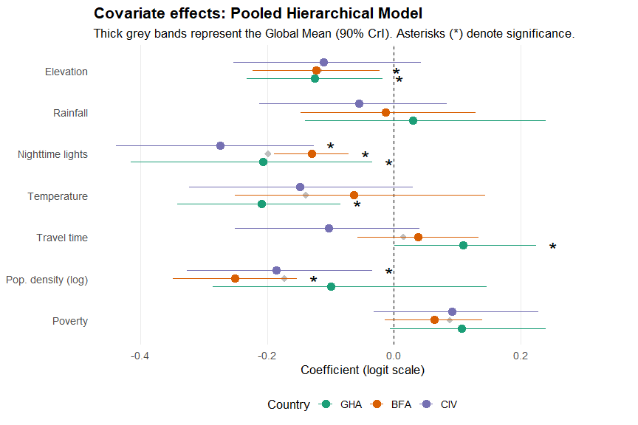

Pooled Model: Full Posterior Summary
# Full posterior summary of the pooled three-country space-time model
tryCatch(print(fit_pooled$summary(), n = Inf),
error = function(e) cat("[pooled summary failed:", conditionMessage(e), "]
"))
## # A tibble: 9,611 × 10
## variable mean median sd mad q5 q95 rhat
## <chr> <dbl> <dbl> <dbl> <dbl> <dbl> <dbl> <dbl>
## 1 lp__ -1.90 e+3 -1.90 e+3 42.8 42.5 -1.97 e+3 -1.83e+3 1.00
## 2 mu -8.61 e-1 -8.59 e-1 0.121 0.121 -1.06 e+0 -6.67e-1 1.01
## 3 alpha_raw[… -5.72 e-1 -5.74 e-1 0.211 0.208 -9.19 e-1 -2.26e-1 1.02
## 4 alpha_raw[… 1.78 e+0 1.78 e+0 0.217 0.210 1.42 e+0 2.13e+0 1.01
## 5 delta_2[1] -1.13 e+0 -1.13 e+0 0.112 0.113 -1.32 e+0 -9.51e-1 1.00
## 6 delta_2[2] 7.42 e-1 7.39 e-1 0.168 0.166 4.67 e-1 1.02e+0 1.00
## 7 delta_2[3] -2.53 e+0 -2.53 e+0 0.156 0.159 -2.79 e+0 -2.28e+0 1.00
1.00
## 1456 sigma_b 6.54 e-1 6.54 e-1 0.164 0.162 3.97 e-1 9.22e-1 1.01
## 1457 phi 8.28 e-1 8.63 e-1 0.131 0.100 5.68 e-1 9.71e-1 1.02
## 1458 beta_raw[1… -4.60 e-2 -5.58 e-2 0.846 0.811 -1.42 e+0 1.34e+0 1.00
## 1459 beta_raw[2… 7.48 e-2 6.77 e-2 0.874 0.854 -1.34 e+0 1.54e+0 1.00
## 1460 beta_raw[3… -2.28 e-2 -2.90 e-2 0.828 0.804 -1.37 e+0 1.33e+0 1.00
## 1461 beta_raw[1… 2.68 e-1 2.82 e-1 0.869 0.834 -1.19 e+0 1.69e+0 1.00
## 1462 beta_raw[2… -2.94 e-1 -3.06 e-1 0.827 0.791 -1.64 e+0 1.10e+0 1.00
## 1463 beta_raw[3… 2.04 e-2 2.23 e-2 0.829 0.799 -1.35 e+0 1.39e+0 1.00
## 1464 beta_raw[1… -2.64 e-2 -1.30 e-2 0.815 0.788 -1.36 e+0 1.30e+0 1.00
## 1465 beta_raw[2… -4.96 e-1 -4.85 e-1 0.794 0.757 -1.81 e+0 7.99e-1 1.00
## 1466 beta_raw[3… 5.07 e-1 4.83 e-1 0.769 0.744 -7.05 e-1 1.81e+0 1.00
## 1467 beta_raw[1… -4.44 e-1 -4.39 e-1 0.805 0.773 -1.79 e+0 8.79e-1 1.00
## 1468 beta_raw[2… -3.96 e-2 -5.30 e-2 0.795 0.767 -1.31 e+0 1.26e+0 1.00
## 1469 beta_raw[3… 4.53 e-1 4.55 e-1 0.806 0.770 -8.65 e-1 1.77e+0 1.00
## 1470 beta_raw[1… 5.74 e-1 5.55 e-1 0.733 0.691 -6.08 e-1 1.81e+0 1.00
## 1471 beta_raw[2… -7.10 e-1 -6.88 e-1 0.752 0.724 -2.00 e+0 4.82e-1 1.00
## 1472 beta_raw[3… 1.31 e-1 1.29 e-1 0.687 0.655 -1.00 e+0 1.26e+0 1.00
## 1473 beta_raw[1… 4.55 e-1 4.52 e-1 0.839 0.800 -9.22 e-1 1.83e+0 1.00
## 1474 beta_raw[2… -1.53 e-2 -3.05 e-2 0.799 0.764 -1.29 e+0 1.30e+0 1.000
## 1475 beta_raw[3… -4.84 e-1 -4.79 e-1 0.787 0.760 -1.77 e+0 7.81e-1 1.00
## 1476 beta_raw[1… 1.83 e-1 1.76 e-1 0.861 0.847 -1.24 e+0 1.59e+0 1.00
## 1477 beta_raw[2… 5.85 e-2 5.31 e-2 0.839 0.803 -1.30 e+0 1.43e+0 1.00
## 1478 beta_raw[3… -2.31 e-1 -2.30 e-1 0.824 0.788 -1.60 e+0 1.12e+0 1.00
## 1479 beta_bar[1] -1.18 e-1 -1.19 e-1 0.103 0.0728 -2.64 e-1 3.70e-2 1.00
## 1480 beta_bar[2] -1.18 e-2 -1.66 e-2 0.134 0.0960 -2.02 e-1 1.93e-1 1.00
## 1481 beta_bar[3] -1.99 e-1 -1.90 e-1 0.158 0.0982 -4.31 e-1 9.35e-3 1.00
## 1482 beta_bar[4] -1.39 e-1 -1.42 e-1 0.158 0.113 -3.70 e-1 1.05e-1 1.00
## 1483 beta_bar[5] 1.48 e-2 1.66 e-2 0.158 0.0984 -2.15 e-1 2.41e-1 1.00
## 1484 beta_bar[6] -1.73 e-1 -1.87 e-1 0.157 0.105 -3.79 e-1 8.03e-2 1.00
## 1485 beta_bar[7] 8.80 e-2 8.55 e-2 0.112 0.0689 -5.90 e-2 2.49e-1 1.00
## 1486 tau[1] 1.09 e-1 6.65 e-2 0.135 0.0673 5.61 e-3 3.62e-1 1.00
## 1487 tau[2] 1.50 e-1 9.81 e-2 0.168 0.0978 9.03 e-3 4.84e-1 1.00
## 1488 tau[3] 1.92 e-1 1.40 e-1 0.188 0.112 1.83 e-2 5.41e-1 1.00
## 1489 tau[4] 1.89 e-1 1.38 e-1 0.185 0.121 1.37 e-2 5.46e-1 1.00
## 1490 tau[5] 2.17 e-1 1.64 e-1 0.192 0.120 3.10 e-2 5.80e-1 1.00
## 1491 tau[6] 1.85 e-1 1.29 e-1 0.191 0.119 1.34 e-2 5.50e-1 1.00
## 1492 tau[7] 1.16 e-1 7.29 e-2 0.140 0.0723 6.36 e-3 3.68e-1 1.00
## 9603 p_national… 3.35 e-1 3.35 e-1 0.0101 0.0100 3.18 e-1 3.52e-1 1.00
## 9604 p_national… 2.24 e-1 2.24 e-1 0.00954 0.00939 2.09 e-1 2.40e-1 1.000
## 9605 p_national… 6.97 e-1 6.97 e-1 0.00650 0.00652 6.87 e-1 7.08e-1 1.00
## 9606 p_national… 1.48 e-1 1.48 e-1 0.00815 0.00814 1.35 e-1 1.62e-1 1.00
## 9607 p_national… 3.11 e-1 3.11 e-1 0.00803 0.00806 2.98 e-1 3.24e-1 1.00
## 9608 p_national… 1.92 e-1 1.92 e-1 0.00830 0.00835 1.79 e-1 2.06e-1 1.00
## 9609 odds_ratio… 3.24 e-1 3.22 e-1 0.0364 0.0361 2.68 e-1 3.86e-1 1.00
## 9610 odds_ratio… 2.13 e+0 2.09 e+0 0.363 0.348 1.60 e+0 2.79e+0 1.00
## 9611 odds_ratio… 8.05 e-2 7.95 e-2 0.0126 0.0126 6.13 e-2 1.03e-1 1.00
## # ℹ 2 more variables: ess_bulk <dbl>, ess_tail <dbl>
# Key hyperparameters and national prevalences (compact form).
# Uses the safe_print helper defined in the m2-summaries chunk; if that
# chunk has not been run, define a minimal local fallback.
if (!exists("safe_print")) {
safe_print <- function(fit, params, label = NULL) {
if (!is.null(label)) cat("
--- ", label, " ---
", sep = "")
available <- fit$metadata()$stan_variables
base_names <- sub("\\[.*$", "", params)
keep <- params[base_names %in% available]
if (length(keep) == 0L) {
cat(" [none of the requested parameters exist]
"); return(invisible(NULL))
}
tryCatch(fit$print(keep),
error = function(e) cat(" [print failed:", conditionMessage(e), "]
"))
}
}
key_pooled_params <- c(
"mu", "sigma_b", "phi", "sigma_gamma",
paste0("alpha[", 1:3, "]"),
# country-specific time shifts (Stan may name these delta_country or delta_ct)
"delta_country[1,2]", "delta_country[2,2]", "delta_country[3,2]",
"delta_ct[1,2]", "delta_ct[2,2]", "delta_ct[3,2]",
paste0("tau[", 1:7, "]"),
paste0("beta_bar[", 1:7, "]")
)
safe_print(fit_pooled, key_pooled_params, label = "Pooled key parameters")
##
## --- Pooled key parameters ---
## variable mean median sd mad q5 q95 rhat ess_bulk ess_tail
## mu -0.86 -0.86 0.12 0.12 -1.06 -0.67 1.01 245 620
## sigma_b 0.65 0.65 0.16 0.16 0.40 0.92 1.01 275 263
## phi 0.83 0.86 0.13 0.10 0.57 0.97 1.02 310 584
## sigma_gamma 0.71 0.71 0.03 0.03 0.66 0.76 1.01 501 878
## alpha[1] 0.00 0.00 0.00 0.00 0.00 0.00 NA NA NA
## alpha[2] -0.57 -0.57 0.21 0.21 -0.92 -0.23 1.02 350 788
## alpha[3] 1.78 1.78 0.22 0.21 1.42 2.13 1.01 171 500
## tau[1] 0.11 0.07 0.14 0.07 0.01 0.36 1.00 3853 4766
## tau[2] 0.15 0.10 0.17 0.10 0.01 0.48 1.00 3671 4758
## tau[3] 0.19 0.14 0.19 0.11 0.02 0.54 1.00 2784 3557
##
## # showing 10 of 21 rows (change via 'max_rows' argument or 'cmdstanr_max_rows' option)
# Country-specific beta coefficients: 3 countries x 7 covariates = 21 betas.
# In the pooled Stan model these are typically `beta[c, k]` (a 3x7 matrix).
if (!exists("safe_print")) {
safe_print <- function(fit, params, label = NULL) {
if (!is.null(label)) cat("
--- ", label, " ---
", sep = "")
available <- fit$metadata()$stan_variables
base_names <- sub("\\[.*$", "", params)
keep <- params[base_names %in% available]
if (length(keep) == 0L) {
cat(" [none of the requested parameters exist]
"); return(invisible(NULL))
}
tryCatch(fit$print(keep),
error = function(e) cat(" [print failed:", conditionMessage(e), "]
"))
}
}
cov_names_short <- c("elev", "rain", "nightlights", "temp",
"travel", "popdens", "poverty")
country_labels <- c("GHA", "CIV", "BFA") # Stan index 1=GHA, 2=CIV, 3=BFA
for (cc in 1:3) {
params <- sprintf("beta[%d,%d]", cc, 1:7)
safe_print(fit_pooled, params,
label = paste0("Country ", cc, " (", country_labels[cc],
") covariate effects"))
}
##
## --- Country 1 (GHA) covariate effects ---
## variable mean median sd mad q5 q95 rhat ess_bulk ess_tail
## beta[1,1] -0.12 -0.12 0.07 0.06 -0.23 -0.02 1.00 1026 3159
## beta[1,2] 0.03 0.02 0.12 0.11 -0.14 0.24 1.00 2542 5175
## beta[1,3] -0.21 -0.20 0.12 0.10 -0.42 -0.03 1.00 3917 4995
## beta[1,4] -0.21 -0.21 0.08 0.08 -0.34 -0.08 1.00 568 2095
## beta[1,5] 0.11 0.11 0.07 0.07 0.00 0.22 1.00 2499 4668
## beta[1,6] -0.10 -0.12 0.14 0.13 -0.29 0.15 1.00 2538 4119
## beta[1,7] 0.11 0.10 0.08 0.07 -0.01 0.24 1.00 3492 4737
##
## --- Country 2 (CIV) covariate effects ---
## variable mean median sd mad q5 q95 rhat ess_bulk ess_tail
## beta[2,1] -0.11 -0.11 0.09 0.08 -0.25 0.04 1.00 2637 4449
## beta[2,2] -0.06 -0.05 0.09 0.09 -0.21 0.08 1.00 2487 4003
## beta[2,3] -0.27 -0.27 0.10 0.10 -0.44 -0.13 1.00 3365 5811
## beta[2,4] -0.15 -0.15 0.11 0.10 -0.32 0.03 1.00 2205 4016
## beta[2,5] -0.10 -0.10 0.09 0.09 -0.25 0.04 1.00 1682 4257
## beta[2,6] -0.18 -0.19 0.09 0.08 -0.33 -0.03 1.00 3083 4565
## beta[2,7] 0.09 0.09 0.08 0.07 -0.03 0.23 1.00 3227 4701
##
## --- Country 3 (BFA) covariate effects ---
## variable mean median sd mad q5 q95 rhat ess_bulk ess_tail
## beta[3,1] -0.12 -0.12 0.06 0.06 -0.22 -0.02 1.00 2012 4030
## beta[3,2] -0.01 -0.02 0.08 0.08 -0.15 0.13 1.00 1163 2163
## beta[3,3] -0.13 -0.13 0.04 0.04 -0.19 -0.07 1.00 7231 6801
## beta[3,4] -0.06 -0.07 0.12 0.13 -0.25 0.14 1.00 827 2484
## beta[3,5] 0.04 0.04 0.06 0.06 -0.06 0.13 1.00 2985 4130
## beta[3,6] -0.25 -0.25 0.06 0.06 -0.35 -0.15 1.00 2420 4366
## beta[3,7] 0.06 0.06 0.05 0.04 -0.01 0.14 1.00 2483 3758

Pooled Discussion

Cross-Sectional vs Space-Time Comparison

Pooled Model Maps
full_panel <- read_csv("output/three_country_full_panel.csv", show_col_types = FALSE)
# Fix the coastal extraction artifacts, then filter for Round 2
panel_r2_cov <- full_panel %>%
# Group by country to calculate a safe replacement value
group_by(country, time) %>%
mutate(
# Calculate the median rainfall for the country (ignoring the negative outliers)
safe_rainfall = median(rainfall_sep_dec[rainfall_sep_dec >= 0], na.rm = TRUE),
# If rainfall is negative, swap it with the safe regional median
rainfall_sep_dec = ifelse(rainfall_sep_dec < 0, safe_rainfall, rainfall_sep_dec)
) %>%
ungroup() %>%
filter(time == 2) %>%
select(country, district_id, district_name,
nightlights, elev_mean_pw, rainfall_sep_dec, temp_sep_dec,
travel_time_pw, census_pop_density, poverty_H)
# Join to the shapefile
covar_map_df <- all_sf %>%
left_join(panel_r2_cov, by = c("country", "local_id" = "district_id"))
covar_map_df <- all_sf %>%
left_join(panel_r2_cov, by = c("country", "local_id" = "district_id"))
country_borders <- all_sf %>%
group_by(country) %>%
summarise(geometry = st_union(geometry), .groups = "drop")
make_covar_map <- function(data, var, title, palette = "viridis",
direction = 1, trans = "identity") {
ggplot() +
geom_sf(data = data, aes(fill = .data[[var]]), colour = "grey50", linewidth = 0.05) +
geom_sf(data = country_borders, fill = NA, colour = "black", linewidth = 0.8) +
scale_fill_viridis_c(name = title, option = palette, direction = direction,
trans = trans, na.value = "grey80") +
theme_void(base_size = 10) +
labs(title = title) +
theme(legend.position = "right",
plot.title = element_text(size = 11, face = "bold"))
}
p_ntl <- make_covar_map(covar_map_df, "nightlights", "Nightlights\n(nW/cm2/sr)", "magma")
p_elev <- make_covar_map(covar_map_df, "elev_mean_pw", "Elevation\n(m)", "terrain", direction = -1)
p_rain <- make_covar_map(covar_map_df, "rainfall_sep_dec", "Rainfall\nSep-Dec (mm)", "Blues")
p_temp <- make_covar_map(covar_map_df, "temp_sep_dec", "Temperature\nSep-Dec (C)", "inferno")
p_trav <- make_covar_map(covar_map_df, "travel_time_pw", "Travel time\n(minutes)", "YlOrRd")
p_pov <- make_covar_map(covar_map_df, "poverty_H", "Poverty\nheadcount", "RdYlGn", direction = -1)
p_all_covars <- (p_ntl | p_elev | p_rain) / (p_temp | p_trav | p_pov) +
plot_annotation(
title = "District-level covariates across Ghana, Burkina Faso, and Cote d'Ivoire",
subtitle = "Raw (non-standardised) values for Round 2. Heavy lines = country borders."
)
ggsave("output/figures/three_country_covariates_all.png", p_all_covars,
width = 14, height = 10, dpi = 300, bg = "white")
p_all_covars
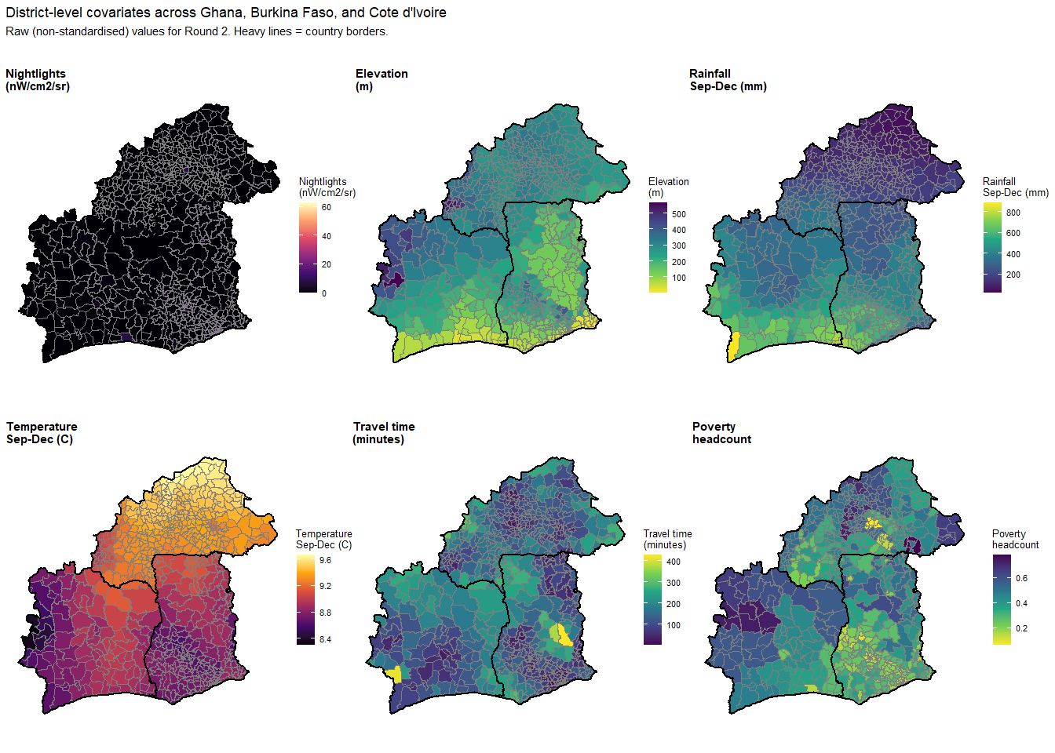
p_ntl_big <- ggplot() +
geom_sf(data = covar_map_df, aes(fill = nightlights), colour = "grey50", linewidth = 0.05) +
geom_sf(data = country_borders, fill = NA, colour = "black", linewidth = 0.8) +
scale_fill_viridis_c(name = "Nightlights\n(nW/cm2/sr)", option = "magma",
trans = "log1p", na.value = "grey80") +
labs(title = "Nightlights (VIIRS, log scale)") +
theme_void(base_size = 12) +
theme(legend.position = "right", plot.title = element_text(size = 13, face = "bold"))
pooled_prev_r2 <- fit_pooled$summary("prevalence", median = median) %>%
mutate(row_id = as.integer(gsub("prevalence\\[|\\]", "", variable))) %>%
left_join(panel_pooled %>% mutate(row_id = row_number()), by = "row_id") %>%
filter(round_id == 2)
pooled_map_df <- all_sf %>%
left_join(pooled_prev_r2, by = c("global_id" = "global_district_id"))
p_prev_big <- ggplot() +
geom_sf(data = pooled_map_df, aes(fill = median), colour = "grey50", linewidth = 0.05) +
geom_sf(data = country_borders, fill = NA, colour = "black", linewidth = 0.8) +
scale_fill_viridis_c(name = "Prevalence",
labels = scales::percent_format(accuracy = 1),
option = "magma", direction = -1, na.value = "grey80") +
labs(title = "Under-5 malaria prevalence (pooled model)") +
theme_void(base_size = 12) +
theme(legend.position = "right", plot.title = element_text(size = 13, face = "bold"))
p_ntl_vs_prev <- p_ntl_big | p_prev_big
ggsave("output/figures/nightlights_vs_prevalence.png", p_ntl_vs_prev,
width = 14, height = 7, dpi = 300, bg = "white")
p_ntl_vs_prev
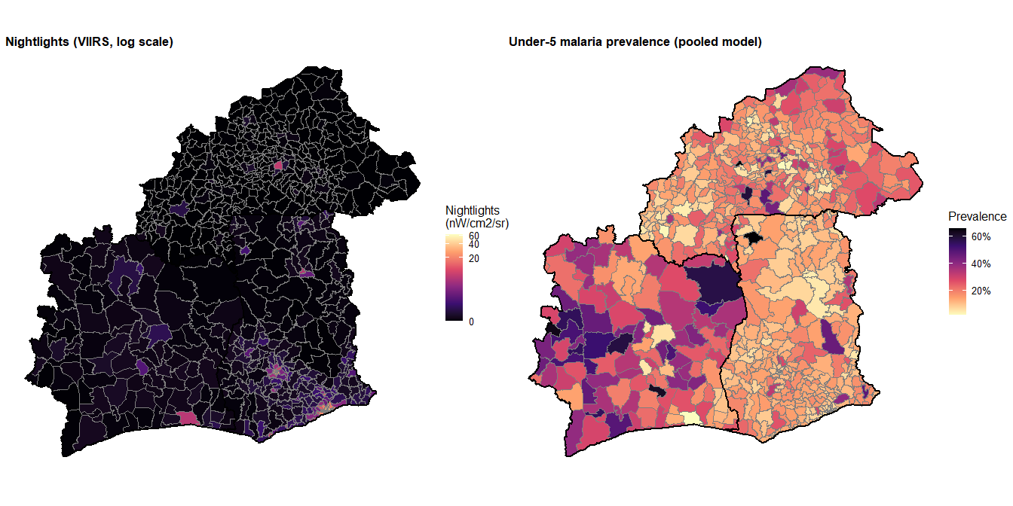
p_pooled_map <- ggplot() +
geom_sf(data = pooled_map_df, aes(fill = median), colour = "grey40", linewidth = 0.1) +
geom_sf(data = country_borders, fill = NA, colour = "black", linewidth = 0.8) +
scale_fill_viridis_c(name = "Prevalence",
labels = scales::percent_format(accuracy = 1),
option = "magma", direction = -1) +
labs(title = "Unified West African Under-5 Malaria Prevalence (2021/2022)",
subtitle = "Posterior medians from the 724-district pooled hierarchical model") +
theme_void(base_size = 14) +
theme(legend.position = "right")
ggsave("output/figures/pooled_prevalence_map.png", p_pooled_map,
width = 10, height = 8, dpi = 300, bg = "white")
p_pooled_map
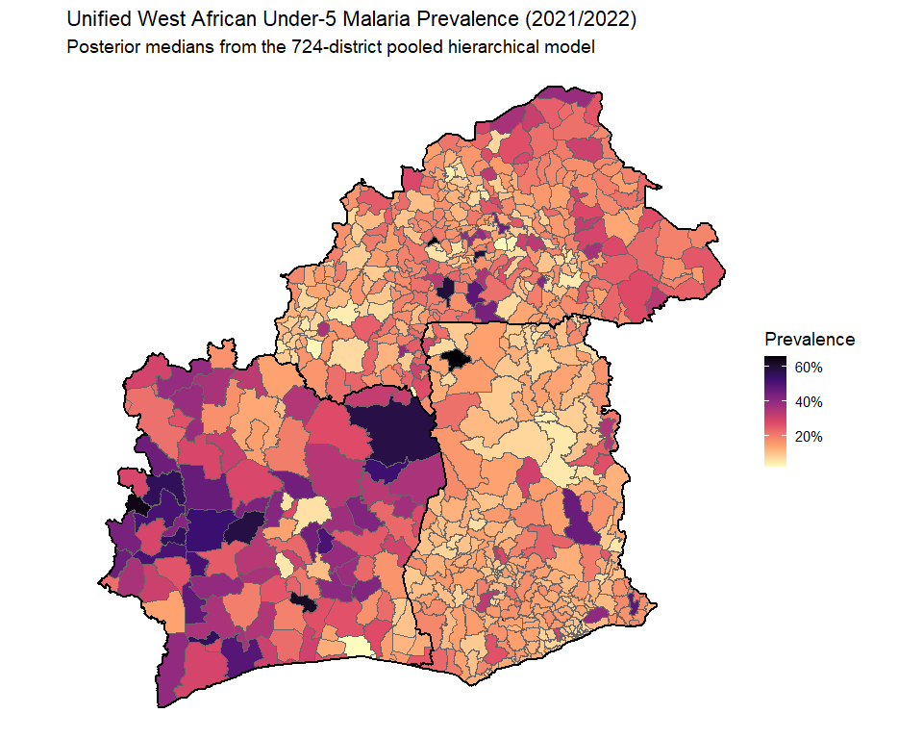
centroids_all <- st_centroid(all_sf)
coords_all <- st_coordinates(centroids_all)
edges_all_df <- tibble(
from = el$node1, to = el$node2,
x_from = coords_all[el$node1, 1], y_from = coords_all[el$node1, 2],
x_to = coords_all[el$node2, 1], y_to = coords_all[el$node2, 2],
edge_type = ifelse(all_sf$country[el$node1] == all_sf$country[el$node2],
"Within-country", "Cross-border")
)
n_within <- sum(edges_all_df$edge_type == "Within-country")
n_cross <- sum(edges_all_df$edge_type == "Cross-border")
p_adj_3country <- ggplot() +
geom_sf(data = all_sf, fill = "grey95", colour = "grey80", linewidth = 0.05) +
geom_segment(data = edges_all_df %>% filter(edge_type == "Within-country"),
aes(x = x_from, y = y_from, xend = x_to, yend = y_to),
colour = "#93c5fd", alpha = 0.12, linewidth = 0.15) +
geom_segment(data = edges_all_df %>% filter(edge_type == "Cross-border"),
aes(x = x_from, y = y_from, xend = x_to, yend = y_to),
colour = "#dc2626", alpha = 0.85, linewidth = 0.6) +
geom_sf(data = country_borders, fill = NA, colour = "black", linewidth = 1) +
labs(title = paste0("Combined 724-district adjacency graph"),
subtitle = paste0("Within-country edges (blue): ", n_within,
" | Cross-border edges (red): ", n_cross)) +
theme_void(base_size = 12)
ggsave("output/figures/three_country_adjacency.png", p_adj_3country,
width = 10, height = 8, dpi = 300, bg = "white")
p_adj_3country
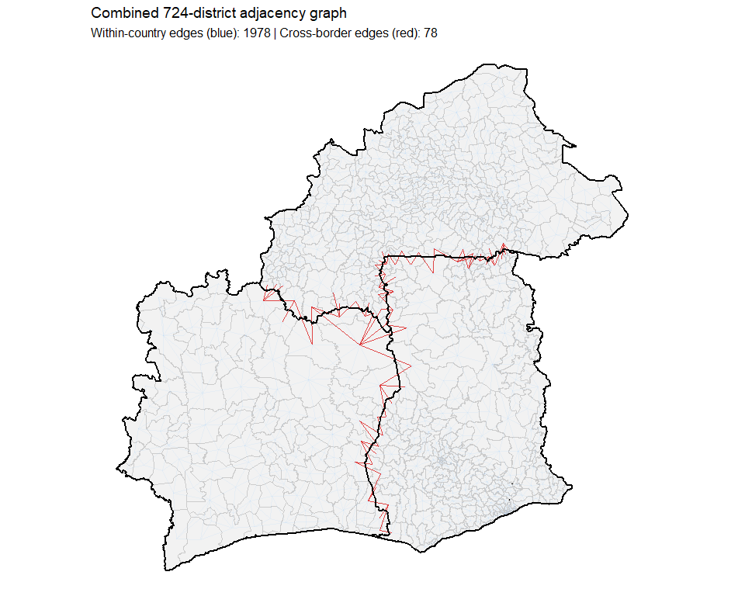

Pooled Model Reliability: CV Analysis
cv_df <- direct_est_all %>%
filter(round_id == 2) %>%
mutate(
p_hat = plogis(y_i),
se_p = psi_i * p_hat * (1 - p_hat),
cv = se_p / p_hat,
# UNIFIED THRESHOLDS
reliability = case_when(
cv < 0.16 ~ "Reliable (CV < 16%)",
cv < 0.33 ~ "Caution (CV 16-33%)",
TRUE ~ "Unreliable (CV > 33%)"
),
reliability = factor(reliability, levels = c(
"Reliable (CV < 16%)",
"Caution (CV 16-33%)",
"Unreliable (CV > 33%)"
))
)
# 2. Generate the faceted scatter plot
p_cv_direct <- ggplot(cv_df, aes(x = p_hat, y = cv, fill = reliability)) +
geom_hline(yintercept = 0.16, linetype = "dashed", colour = "#16a34a", linewidth = 0.8) +
geom_hline(yintercept = 0.33, linetype = "dashed", colour = "#dc2626", linewidth = 0.8) +
geom_point(shape = 21, colour = "grey20", size = 2.5, alpha = 0.85) +
facet_wrap(~country, ncol = 3) +
scale_fill_manual(
name = "Estimate Reliability",
values = c(
"Reliable (CV < 16%)" = "#16a34a",
"Caution (CV 16-33%)" = "#f59e0b",
"Unreliable (CV > 33%)" = "#dc2626"
)
) +
scale_x_continuous(labels = scales::percent_format(accuracy = 1)) +
# LOCKED Y-AXIS (0 to 1)
scale_y_continuous(labels = scales::percent_format(accuracy = 1), limits = c(0, 1)) +
labs(
title = "Direct Estimates: High Uncertainty (Survey Data Only)",
subtitle = "Raw estimates before spatial smoothing.",
x = "Direct Prevalence Estimate",
y = "Coefficient of Variation"
) +
theme_minimal(base_size = 13) +
theme(
legend.position = "bottom",
strip.text = element_text(size = 12, face = "bold")
)
ggsave("output/figures/direct_cv_scatter_fixed.png", p_cv_direct, width = 12, height = 5, dpi = 300, bg = "white")
# --- Plot 2: Pooled Estimates (Fixed Axes and Thresholds) ---
# 1. Process the posterior pooled data
pooled_full <- fit_pooled$summary("prevalence",
mean = mean, median = median, sd = sd) %>%
mutate(row_id = as.integer(gsub("prevalence\\[|\\]", "", variable))) %>%
left_join(panel_pooled %>% mutate(row_id = row_number()), by = "row_id") %>%
filter(round_id == 2) %>%
mutate(
cv = sd / mean,
# UNIFIED THRESHOLDS (Matches Direct plot exactly)
reliability = case_when(
cv < 0.16 ~ "Reliable (CV < 16%)",
cv < 0.33 ~ "Caution (CV 16-33%)",
TRUE ~ "Unreliable (CV > 33%)"
),
reliability = factor(reliability, levels = c(
"Reliable (CV < 16%)",
"Caution (CV 16-33%)",
"Unreliable (CV > 33%)"
))
)
# 2. Generate the faceted scatter plot
p_cv_pooled <- ggplot(pooled_full, aes(x = median, y = cv, fill = reliability)) +
geom_hline(yintercept = 0.16, linetype = "dashed", colour = "#16a34a", linewidth = 0.8) +
geom_hline(yintercept = 0.33, linetype = "dashed", colour = "#dc2626", linewidth = 0.8) +
geom_point(shape = 21, colour = "grey20", size = 2.5, alpha = 0.85) +
facet_wrap(~country, ncol = 3) +
scale_fill_manual(
name = "Estimate Reliability",
values = c(
"Reliable (CV < 16%)" = "#16a34a",
"Caution (CV 16-33%)" = "#f59e0b",
"Unreliable (CV > 33%)" = "#dc2626"
)
) +
scale_x_continuous(labels = scales::percent_format(accuracy = 1)) +
# LOCKED Y-AXIS (0 to 1)
scale_y_continuous(labels = scales::percent_format(accuracy = 1), limits = c(0, 1)) +
labs(
title = "Pooled Model: Dramatic Reduction in Uncertainty",
subtitle = "Hierarchical smoothing rescues unobserved and noisy districts.",
x = "Posterior Median Prevalence",
y = "Coefficient of Variation",
fill = NULL
) +
theme_minimal(base_size = 13) +
theme(
legend.position = "bottom",
strip.text = element_text(size = 12, face = "bold")
)
ggsave("output/figures/cv_reliability_scatter_pooled_fixed.png", p_cv_pooled, width = 12, height = 5, dpi = 300, bg = "white")
# 1. Merge the direct and pooled dataframes using inner_join
# This will only keep the districts that actually had survey data
cv_comparison <- cv_df %>%
select(district_id, country, cv_direct = cv) %>% # Ensure district_id exists in cv_df
inner_join(
pooled_full %>% select(district_id, cv_pooled = cv),
by = c("district_id") # Adjust join keys if you use row_id instead
)
# 2. Generate the Variance Reduction Plot
p_cv_comparison <- ggplot(cv_comparison, aes(x = cv_direct, y = cv_pooled)) +
# The 45-degree line: Anything below this line represents a reduction in variance
geom_abline(intercept = 0, slope = 1, linetype = "dashed", colour = "grey40", linewidth = 1) +
# The 20% Policy Threshold lines
geom_vline(xintercept = 0.20, colour = "#e3342f", linetype = "dotted", linewidth = 0.8) +
geom_hline(yintercept = 0.20, colour = "#10b981", linetype = "dotted", linewidth = 0.8) +
# The data points, colored by country
geom_point(aes(fill = country), shape = 21, colour = "white", size = 3, alpha = 0.7) +
scale_fill_brewer(palette = "Dark2", name = "Country") +
# Force both axes to have the exact same scale and limits so the geometry is honest
scale_x_continuous(labels = scales::percent_format(accuracy = 1), limits = c(0, 1)) +
scale_y_continuous(labels = scales::percent_format(accuracy = 1), limits = c(0, 1)) +
# Annotations
annotate("text", x = 0.75, y = 0.15, label = "Variance Reduced",
colour = "#10b981", fontface = "bold", size = 5) +
labs(
title = "Variance Reduction: Direct vs. Pooled CV",
subtitle = "Points below the dashed line indicate precision gained by the hierarchical model.",
x = "Direct Estimate CV (Survey Data)",
y = "Pooled Model CV (Hierarchical Smoothing)"
) +
theme_minimal(base_size = 14) +
theme(legend.position = "bottom")
ggsave("output/figures/variance_reduction_45deg.png", p_cv_comparison, width = 8, height = 8, dpi = 300, bg = "white")
p_cv_comparison
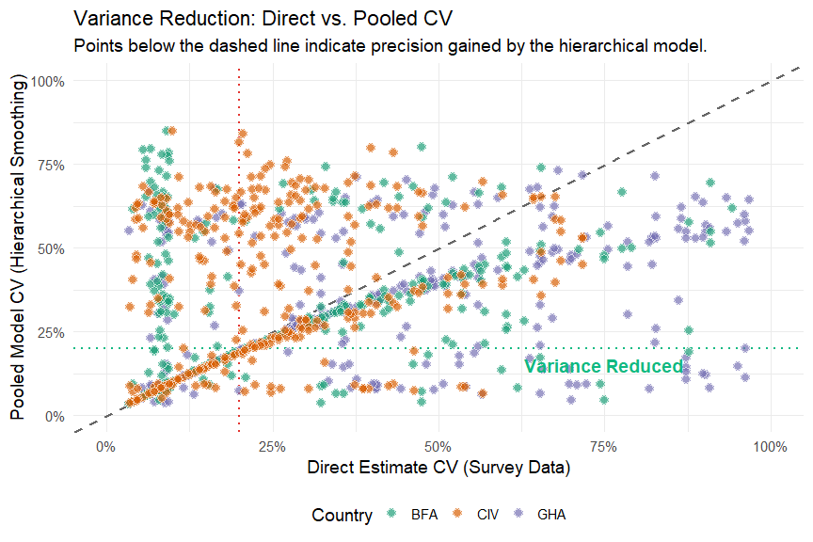
# 1. Categorize all districts based on strict StatCan guidelines
rescue_df <- pooled_full %>%
filter(round_id == 2) %>%
select(district_id, country, cv_pooled = cv) %>%
left_join(
cv_df %>% filter(round_id == 2) %>% select(district_id, cv_direct = cv),
by = "district_id"
) %>%
mutate(
# Categorize the "Before" state (Raw DHS Data)
status_before = case_when(
is.na(cv_direct) ~ "1. No Data (Unobserved)",
cv_direct <= 0.165 ~ "2. Acceptable (CV ≤ 16.5%)",
cv_direct <= 0.333 ~ "3. Marginal (CV 16.6-33.3%)",
TRUE ~ "4. Unacceptable (CV > 33.3%)"
),
# Categorize the "After" state (Pooled Model)
status_after = case_when(
cv_pooled <= 0.165 ~ "Acceptable (CV ≤ 16.5%)",
cv_pooled <= 0.333 ~ "Marginal (CV 16.6-33.3%)",
TRUE ~ "Unacceptable (CV > 33.3%)"
)
)
# 2. Generate the Transition Matrix Table
transition_matrix <- rescue_df %>%
count(status_before, status_after) %>%
pivot_wider(names_from = status_after, values_from = n, values_fill = 0) %>%
arrange(status_before)
print(transition_matrix)
## # A tibble: 4 × 4
## status_before Unacceptable (CV > 33.3%…¹ Acceptable (CV ≤ 16.…²
## <chr> <int> <int>
## 1 1. No Data (Unobserved) 147 0
## 2 2. Acceptable (CV ≤ 16.5%) 130 186
## 3 3. Marginal (CV 16.6-33.3%) 101 19
## 4 4. Unacceptable (CV > 33.3%) 236 53
## # ℹ abbreviated names: ¹​`Unacceptable (CV > 33.3%)`, ²​`Acceptable (CV ≤ 16.5%)`
## # ℹ 1 more variable: `Marginal (CV 16.6-33.3%)` <int>
# 3. Calculate the "Hero Metric" (Rescued into the Acceptable tier)
rescued_districts <- rescue_df %>%
filter(
status_before %in% c("1. No Data (Unobserved)", "3. Marginal (CV 16.6-33.3%)", "4. Unacceptable (CV > 33.3%)") &
status_after == "Acceptable (CV ≤ 16.5%)"
) %>%
nrow()
cat("\nTotal districts rescued into the Acceptable zone:", rescued_districts, "\n")
##
## Total districts rescued into the Acceptable zone: 72
# Extract prevalence and CV from the pooled model (Round 2)
pooled_full <- fit_pooled$summary("prevalence",
mean = mean, median = median, sd = sd) %>%
mutate(row_id = as.integer(gsub("prevalence\\[|\\]", "", variable))) %>%
left_join(panel_pooled %>% mutate(row_id = row_number()), by = "row_id") %>%
filter(round_id == 2) %>%
mutate(
cv = sd / mean,
reliability = case_when(
cv < 0.16 ~ "Reliable (CV < 16%)",
cv < 0.33 ~ "Caution (CV 16-33%)",
TRUE ~ "Unreliable (CV > 33%)"
),
reliability = factor(reliability, levels = c("Reliable (CV < 16%)",
"Caution (CV 16-33%)",
"Unreliable (CV > 33%)"))
)
p_cv_reliability <- ggplot(pooled_full, aes(x = median, y = cv, colour = reliability)) +
geom_point(alpha = 0.6, size = 1.5) +
geom_hline(yintercept = 0.16, linetype = "dashed", colour = "#16a34a", linewidth = 0.5) +
geom_hline(yintercept = 0.33, linetype = "dashed", colour = "#dc2626", linewidth = 0.5) +
scale_colour_manual(values = c("Reliable (CV < 16%)" = "#16a34a",
"Caution (CV 16-33%)" = "#f59e0b",
"Unreliable (CV > 33%)" = "#dc2626")) +
scale_x_continuous(labels = scales::percent_format(accuracy = 1)) +
scale_y_continuous(labels = scales::percent_format(accuracy = 1)) +
facet_wrap(~country) +
labs(
title = "Pooled model: prevalence vs coefficient of variation by reliability",
subtitle = "Green dashed = 16% CV threshold. Red dashed = 33% threshold. Most districts now in the reliable region.",
x = "Posterior median prevalence", y = "Coefficient of variation",
colour = NULL
) +
theme_minimal(base_size = 12) +
theme(legend.position = "bottom",
strip.text = element_text(size = 12, face = "bold"))
ggsave("output/figures/cv_reliability_scatter_pooled.png", p_cv_reliability,
width = 12, height = 6, dpi = 300, bg = "white")
p_cv_reliability
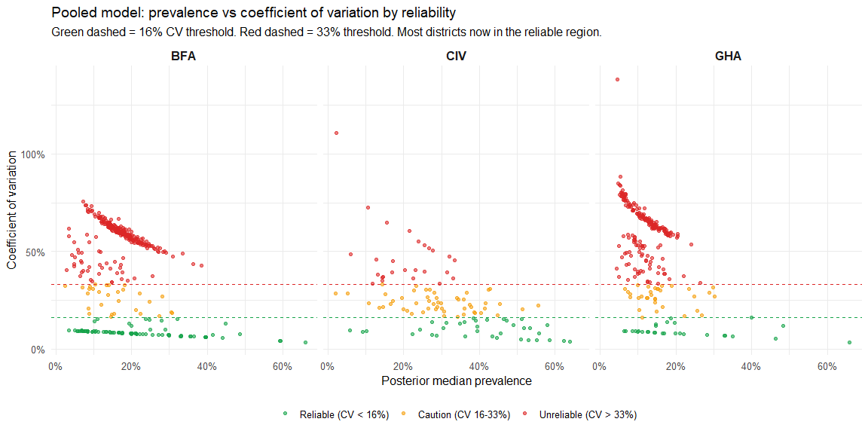
# Print summary
pooled_full %>%
count(country, reliability) %>%
pivot_wider(names_from = reliability, values_from = n, values_fill = 0) %>%
print()
## # A tibble: 3 × 4
## country `Reliable (CV < 16%)` `Caution (CV 16-33%)` `Unreliable (CV > 33%)`
## <chr> <int> <int> <int>
## 1 BFA 82 29 240
## 2 CIV 35 52 26
## 3 GHA 29 33 198
pooled_cv_df <- pooled_full %>%
select(global_district_id, cv)
pooled_cv_map <- all_sf %>%
left_join(pooled_cv_df, by = c("global_id" = "global_district_id"))
p_pooled_cv <- ggplot() +
geom_sf(data = pooled_cv_map, aes(fill = cv), colour = "grey40", linewidth = 0.1) +
geom_sf(data = country_borders, fill = NA, colour = "black", linewidth = 0.8) +
scale_fill_viridis_c(name = "CV",
labels = scales::percent_format(accuracy = 1),
option = "cividis", direction = -1) +
labs(title = "Coefficient of Variation: Pooled 3-Country Model (Round 2)",
subtitle = "Low CV (dark) = high confidence. High CV (bright) = greater uncertainty.") +
theme_void(base_size = 14) +
theme(legend.position = "right")
ggsave("output/figures/pooled_cv_map.png", p_pooled_cv,
width = 10, height = 8, dpi = 300, bg = "white")
p_pooled_cv
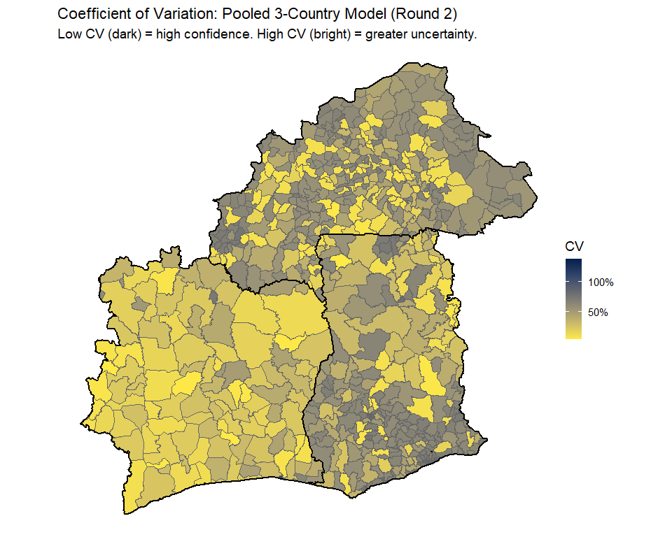
prev_draws <- fit_pooled$draws("prevalence", format = "df") %>%
as_tibble() %>%
select(starts_with("prevalence["), .draw) %>%
pivot_longer(starts_with("prevalence["), names_to = "variable", values_to = "prev") %>%
mutate(row_id = as.integer(gsub("prevalence\\[|\\]", "", variable)))
# 2. Join the draws to your panel data to get country, time, and population weights
prev_full <- prev_draws %>%
left_join(full_panel %>% mutate(row_id = row_number()), by = "row_id")
# 3. Calculate the population-weighted national prevalence for EVERY SINGLE DRAW
national_posteriors <- prev_full %>%
group_by(.draw, country, time) %>%
summarise(
national_prev = weighted.mean(prev, w = census_pop, na.rm = TRUE),
.groups = "drop"
) %>%
mutate(
Round = factor(ifelse(time == 1, "Round 1 (Baseline)", "Round 2 (Follow-up)"),
levels = c("Round 1 (Baseline)", "Round 2 (Follow-up)"))
)
# 4. Generate the Posterior Boxplot
p_national_post <- ggplot(national_posteriors, aes(x = national_prev, y = country, fill = Round)) +
# Grouped boxplots to show Round 1 and Round 2 side-by-side
geom_boxplot(
alpha = 0.85,
position = position_dodge(width = 0.75),
outlier.alpha = 0.05,
outlier.size = 0.5,
colour = "grey20"
) +
# Custom colors (e.g., Gold for Baseline, Blue for Follow-up)
scale_fill_manual(
values = c("Round 1 (Baseline)" = "#e6b000", "Round 2 (Follow-up)" = "#3182bd")
) +
scale_x_continuous(labels = scales::percent_format(accuracy = 1)) +
labs(
title = "Posterior Uncertainty: National Malaria Prevalence",
subtitle = "Population-weighted aggregation of 724 district-level posterior draws.",
x = "Estimated Prevalence",
y = NULL,
fill = NULL
) +
theme_minimal(base_size = 14) +
theme(
legend.position = "bottom",
panel.grid.minor = element_blank(),
plot.title = element_text(face = "bold")
)
ggsave("output/figures/posterior_boxplot_prevalence.png", p_national_post, width = 10, height = 6, dpi = 300, bg = "white")

Model 4: Round-2-Only Pooled Sensitivity Model

Motivation
The full three-country pooled model joins two DHS rounds per country. The Round 1 surveys, however, span four calendar years across countries (Burkina Faso 2010, Côte d’Ivoire 2011, Ghana 2014), while the Round 2 surveys are tightly clustered within a single year (Burkina Faso 2021, Côte d’Ivoire 2021, Ghana 2022). Because the BYM2 component smooths spatial residuals across the combined cross-border adjacency graph, the Round 1 calendar offset raises a legitimate concern that cross-border edges may absorb temporal as well as spatial variation during a period of substantial intervention scale-up across the region (Bhatt et al. 2015; Weiss et al. 2020).
To isolate the cross-border spatial story from this temporal-misalignment concern, we fit a Round-2-only pooled model. Restricting to the 2021–2022 window guarantees that cross-border smoothing operates on contemporaneous prevalence surfaces; the published cross-border SAE precedent of (saldarriaga2020?) used a comparable two-year alignment window (2007–2009). With a single time point, the Knorr-Held Type I interaction $γ_{it}$ and the country-specific time shifts $δ_{c,t}$ become unnecessary, and the model reduces to a pure spatial BYM2 with hierarchical country-specific covariate effects. Findings shared between this model and the full space-time pooled specification are the most robust results of the analysis; differences localise the contribution of the Round 1 data and the cross-temporal smoothing.

Specification
For each observed Round 2 district $i$, the design-based logit prevalence direct estimate $y_{i}$ retains the same Fay-Herriot likelihood used throughout (Wakefield et al. 2020):
$$y_{i}∼N​\left(θ_{i}, ψ_{i}^{2}\right),$$
with $ψ_{i}$ obtained by Taylor-series linearisation (Binder 1983; Lumley 2010) and transformed to the logit scale via the delta method, exactly as in the space-time models.
The latent logit prevalence decomposes as
$$θ_{i}=μ+α_{c[i]}+b_{i}+x_{i}^{⊤}β_{c[i]},$$
where $μ$ is the regional logit intercept across the three countries, $α_{c[i]}$ is a country-specific deviation with the sum-to-zero constraint c​αc=0 for identifiability with $μ$, $b_{i}$ is the BYM2 spatial random effect on the combined 724-district graph, and $β_{c[i]}$ is the country-specific vector of covariate effects on the seven standardised covariates.
The BYM2 spatial effect uses the same scaled, non-centred parameterisation as the space-time models (Riebler et al. 2016):
$$b_{i}=σ_{b}\left(\sqrt{1-ϕ} v_{i}+\sqrt{ϕ/s} u_{i}\right), v_{i}\overset{iid}{∼}N(0,1), u_{i}∼ICAR(W),$$
with $u_{i}$ sum-constrained, $W$ the combined adjacency matrix including cross-border queen-contiguity edges, and $s$ the scaling factor of Riebler et al. (2016) making $ϕ∈(0,1)$ interpretable as the structured- variance fraction. Disconnected components are reconnected by snap tolerance to ensure a proper ICAR (Freni-Sterrantino et al. 2018).
Country-specific covariate effects are partially pooled through a hierarchical prior,
$$β_{ck} ∼ N​\left({\overset{‾}{β}}_{k},τ_{k}^{2}\right), c∈\{1,2,3\}, k∈\{1,…,7\},$$
where ${\overset{‾}{β}}_{k}$ is the regional consensus effect of covariate $k$ and $τ_{k}$ the between-country standard deviation. Small $τ_{k}$ indicates that countries share a common relationship between covariate $k$ and malaria risk; large $τ_{k}$ allows the slopes to diverge. The slopes are implemented non-centred as $β_{ck}={\overset{‾}{β}}_{k}+τ_{k}z_{ck}$ with $z_{ck}∼N(0,1)$.

Priors
Priors match those used in the country-specific and full pooled models so that posterior comparisons are not driven by prior changes: $μ∼N(-1.85,1)$, $α_{\text{raw}}∼N(0,1)$ with sum-to-zero, $σ_{b}∼Exp(4.6)$ (PC-style; approximates $P(σ_{b}>1)=0.01$ (Simpson et al. 2017)), $ϕ∼Beta(3,2)$, ${\overset{‾}{β}}_{k}∼N(0,1)$, $τ_{k}∼Exp(2)$.

Stan implementation
bym2_r2_pooled_code <- "
data {
int<lower=1> N;
int<lower=1> C;
array[N] int<lower=1, upper=C> country;
int<lower=1> N_obs;
array[N_obs] int<lower=1, upper=N> obs_idx;
vector[N_obs] y;
vector<lower=0>[N_obs] psi;
int<lower=1> N_edges;
array[N_edges] int<lower=1, upper=N> node1;
array[N_edges] int<lower=1, upper=N> node2;
real<lower=0> scaling_factor;
int<lower=1> K;
matrix[N, K] X;
}
parameters {
real mu;
vector[C] alpha_raw;
vector[N] v;
vector[N] u_raw;
real<lower=0> sigma_b;
real<lower=0, upper=1> phi;
vector[K] beta_bar;
vector<lower=0>[K] tau;
matrix[C, K] beta_z;
}
transformed parameters {
vector[C] alpha = alpha_raw - mean(alpha_raw);
vector[N] u = u_raw - mean(u_raw);
vector[N] b = sigma_b * (sqrt(1 - phi) * v
+ sqrt(phi / scaling_factor) * u);
matrix[C, K] beta;
for (c in 1:C)
for (k in 1:K)
beta[c, k] = beta_bar[k] + tau[k] * beta_z[c, k];
vector[N] theta;
for (i in 1:N) {
int ci = country[i];
theta[i] = mu + alpha[ci] + b[i] + dot_product(X[i], beta[ci]');
}
}
model {
mu ~ normal(-1.85, 1.0);
alpha_raw ~ normal(0, 1.0);
sigma_b ~ exponential(4.6);
phi ~ beta(3, 2);
v ~ std_normal();
target += -0.5 * dot_self(u_raw[node1] - u_raw[node2]);
sum(u_raw) ~ normal(0, 0.001 * N);
beta_bar ~ normal(0, 1);
tau ~ exponential(2);
to_vector(beta_z) ~ std_normal();
y ~ normal(theta[obs_idx], psi);
}
generated quantities {
vector[N_obs] log_lik;
for (i in 1:N_obs)
log_lik[i] = normal_lpdf(y[i] | theta[obs_idx[i]], psi[i]);
vector[N] prevalence;
for (i in 1:N)
prevalence[i] = inv_logit(theta[i]);
vector[C] p_national;
for (c in 1:C) {
real sum_p = 0;
int n_c = 0;
for (i in 1:N) {
if (country[i] == c) {
sum_p += prevalence[i];
n_c += 1;
}
}
p_national[c] = sum_p / n_c;
}
}
"
writeLines(bym2_r2_pooled_code, "fh_bym2_pooled_3country_round2.stan")

Build Stan data for Round 2 and fit
The Round-2-only model reuses the same combined adjacency graph (el, scaling_factor_all), the same country index vector (country_vec), and the same district-id frame (D_all = 724) used by the full pooled model. Only the panel and covariate matrix are subset to $t=2$.
# Subset the pooled panel to Round 2 only
panel_r2 <- panel_pooled %>% filter(round_id == 2L)
obs_mask_r2 <- panel_r2$observed == 1
obs_idx_r2 <- which(obs_mask_r2)
N_obs_r2 <- length(obs_idx_r2)
# Round-2 covariate matrix in the same district order
X_r2 <- panel_r2 %>%
select(-any_of(cov_names)) %>%
left_join(
model_panel %>% filter(time == 2L) %>%
select(country, district_id, all_of(cov_names)),
by = c("country", "district_id" = "district_id")
) %>%
select(all_of(cov_names)) %>%
as.matrix()
stan_data_r2 <- list(
N = D_all,
C = 3L,
country = country_vec,
N_obs = N_obs_r2,
obs_idx = obs_idx_r2,
y = panel_r2$y_i[obs_idx_r2],
psi = panel_r2$psi_i[obs_idx_r2],
N_edges = el$N_edges,
node1 = el$node1,
node2 = el$node2,
scaling_factor = scaling_factor_all,
K = length(cov_names),
X = X_r2
)
cat("Round-2 pooled Stan data assembled.\n")
cat(" N =", stan_data_r2$N, "\n")
cat(" N_obs =", stan_data_r2$N_obs, "\n")
cat(" K =", stan_data_r2$K, "\n")
cat(" N_edges =", stan_data_r2$N_edges, "\n")
mod_r2 <- cmdstan_model("fh_bym2_pooled_3country_round2.stan")
mod_r2$check_syntax(pedantic = TRUE)
fit_r2 <- mod_r2$sample(
data = stan_data_r2,
chains = 4,
parallel_chains = 4,
iter_warmup = 1500,
iter_sampling = 2000,
adapt_delta = 0.97,
max_treedepth = 13,
seed = 2026,
refresh = 200
)
fit_r2$summary(c("mu", "alpha", "sigma_b", "phi",
"beta_bar", "tau", "p_national"))

Comparison to the full pooled model
Three diagnostics localise what the Round 1 data contribute to the full pooled posterior, and whether the cross-border component depends on cross-temporal smoothing.
# Spatial hyperparameters: do sigma_b and phi shift when Round 1 is removed?
spatial_compare <- bind_rows(
fit_pooled$summary(c("sigma_b", "phi")) %>%
mutate(model = "Full space-time pooled (R1 + R2)"),
fit_r2$summary(c("sigma_b", "phi")) %>%
mutate(model = "Round-2-only pooled")
)
spatial_compare
A stable $ϕ$ across the two models supports the interpretation that the high $ϕ$ found in the full pooled model is driven by genuine spatial structure rather than by cross-temporal smoothing of the Round 1 calendar offset. A substantial drop in $ϕ$ between models would suggest the converse.
# Regional consensus covariate effects: stable across models?
covar_labels <- c("Elevation", "Rainfall", "Nighttime lights", "Temperature",
"Travel time", "Pop. density (log)", "Poverty")
bbar_full <- fit_pooled$summary("beta_bar",
mean = mean,
lower = ~ unname(quantile(.x, 0.05)),
upper = ~ unname(quantile(.x, 0.95))) %>%
mutate(covariate = covar_labels,
model = "Full space-time pooled")
bbar_r2 <- fit_r2$summary("beta_bar",
mean = mean,
lower = ~ unname(quantile(.x, 0.05)),
upper = ~ unname(quantile(.x, 0.95))) %>%
mutate(covariate = covar_labels,
model = "Round-2-only pooled")
bind_rows(bbar_full, bbar_r2)
Differences between the regional means ${\overset{‾}{β}}_{k}$ across the two models identify covariate effects whose estimated value depends on the Round 1 data — e.g., covariates whose effect plausibly changed over time or whose Round 1 measurement quality differed (poverty in particular, which was only available from the most recent census in Ghana).
# District-level Round 2 prevalences: how much does adding Round 1 move them?
prev_full_r2 <- fit_pooled$summary("prevalence", median = median) %>%
mutate(row_id = as.integer(gsub("prevalence\\[|\\]", "", variable))) %>%
left_join(panel_pooled %>% mutate(row_id = row_number()),
by = "row_id") %>%
filter(round_id == 2) %>%
transmute(country, district_id, prev_full = median)
prev_r2_only <- fit_r2$summary("prevalence", median = median) %>%
mutate(row_id = as.integer(gsub("prevalence\\[|\\]", "", variable))) %>%
left_join(panel_r2 %>% mutate(row_id = row_number()),
by = "row_id") %>%
transmute(country, district_id, prev_r2 = median)
prev_compare <- prev_full_r2 %>%
inner_join(prev_r2_only, by = c("country", "district_id")) %>%
mutate(diff = prev_full - prev_r2)
summary(prev_compare$diff)
If the median absolute district-level prevalence difference is small (say, under 1–2 percentage points), the Round 2 estimates are robust to the inclusion of the temporally misaligned Round 1 data, and the full pooled model’s Round 2 inferences can be reported with confidence. If the differences are large, the Round-2-only estimates should be treated as the primary Round 2 result.

Interpretation
The Round-2-only pooled model functions as one of three complementary specifications in this analysis. The country-specific space-time models provide the temporal-change story (national odds ratios between rounds, district-level deviations $γ_{it}^{ *}$) under the methodologically conservative convention of fitting each country independently (Wakefield et al. 2020). The Round-2-only pooled model presented here provides the cross-border borrowing story — the regional consensus covariate effects ${\overset{‾}{β}}_{k}$, the spatial parameters $σ_{b}$ and $ϕ$ on the combined graph, and the hierarchical rescue of country-specific signals — under temporal alignment guaranteed by construction. The full space-time pooled model integrates both extensions, with the Round 1 calendar offset acknowledged as a limitation. Findings that are stable across all three specifications are the most robust results of this work.

Round-2 Pooled Model: Full Posterior Summary
# Full posterior summary of the Round-2-only pooled model
tryCatch(print(fit_r2$summary(), n = Inf),
error = function(e) cat("[R2-only summary failed:", conditionMessage(e), "]
"))
if (!exists("safe_print")) {
safe_print <- function(fit, params, label = NULL) {
if (!is.null(label)) cat("
--- ", label, " ---
", sep = "")
available <- fit$metadata()$stan_variables
base_names <- sub("\\[.*$", "", params)
keep <- params[base_names %in% available]
if (length(keep) == 0L) {
cat(" [none of the requested parameters exist]
"); return(invisible(NULL))
}
tryCatch(fit$print(keep),
error = function(e) cat(" [print failed:", conditionMessage(e), "]
"))
}
}
key_r2_params <- c(
"mu", "sigma_b", "phi",
paste0("alpha[", 1:3, "]"),
paste0("tau[", 1:7, "]"),
paste0("beta_bar[", 1:7, "]"),
paste0("p_national[", 1:3, "]")
)
safe_print(fit_r2, key_r2_params, label = "R2-only pooled key parameters")
if (!exists("safe_print")) {
safe_print <- function(fit, params, label = NULL) {
if (!is.null(label)) cat("
--- ", label, " ---
", sep = "")
available <- fit$metadata()$stan_variables
base_names <- sub("\\[.*$", "", params)
keep <- params[base_names %in% available]
if (length(keep) == 0L) {
cat(" [none of the requested parameters exist]
"); return(invisible(NULL))
}
tryCatch(fit$print(keep),
error = function(e) cat(" [print failed:", conditionMessage(e), "]
"))
}
}
cov_names_short <- c("elev", "rain", "nightlights", "temp",
"travel", "popdens", "poverty")
country_labels <- c("GHA", "CIV", "BFA")
for (cc in 1:3) {
params <- sprintf("beta[%d,%d]", cc, 1:7)
safe_print(fit_r2, params,
label = paste0("Country ", cc, " (", country_labels[cc],
") covariate effects (R2-only)"))
}

References
Bhatt, Samir, Daniel J. Weiss, Ewan Cameron, et al. 2015. “The Effect of Malaria Control on Plasmodium Falciparum in Africa Between 2000 and 2015.” Nature 526 (7572): 207–11. https://doi.org/10.1038/nature15535.
Binder, David A. 1983. “On the Variances of Asymptotically Normal Estimators from Complex Surveys.” International Statistical Review 51 (3): 279–92. https://doi.org/10.2307/1402588.
Bivand, Roger S., Edzer Pebesma, and Virgilio Gómez-Rubio. 2013. Applied Spatial Data Analysis with r. 2nd ed. Springer. https://doi.org/10.1007/978-1-4614-7618-4.
Croft, Trevor N., Aileen M. J. Marshall, and Courtney K. Allen. 2018. Guide to DHS Statistics. ICF, Rockville, Maryland, USA. https://dhsprogram.com/Data/Guide-to-DHS-Statistics/.
Dormann, Carsten F., Jane Elith, Sven Bacher, et al. 2013. “Collinearity: A Review of Methods to Deal with It and a Simulation Study Evaluating Their Performance.” Ecography 36 (1): 27–46. https://doi.org/10.1111/j.1600-0587.2012.07348.x.
Elvidge, Christopher D., Kimberly E. Baugh, Mikhail Zhizhin, and Feng-Chi Hsu. 2013. “Why VIIRS Data Are Superior to DMSP for Mapping Nighttime Lights.” Proceedings of the Asia-Pacific Advanced Network 35: 62–69. https://doi.org/10.7125/APAN.35.7.
Florey, Lia. 2014. Measures of Malaria Parasitemia Prevalence in National Surveys: Agreement Between Rapid Diagnostic Testing and Microscopy. DHS Analytical Studies No. 43. ICF International, Rockville, Maryland, USA.
Freni-Sterrantino, Anna, Massimo Ventrucci, and Håvard Rue. 2018. “A Note on Intrinsic Conditional Autoregressive Models for Disconnected Graphs.” Spatial and Spatio-Temporal Epidemiology 26: 25–34. https://doi.org/10.1016/j.sste.2018.04.002.
Goicoa, Tomás, Aritz Adin, Marı́a Dolores Ugarte, and James S. Hodges. 2018. “In Spatio-Temporal Disease Mapping Models, Identifiability Constraints Affect PQL and INLA Results.” Stochastic Environmental Research and Risk Assessment 32 (3): 749–70. https://doi.org/10.1007/s00477-017-1405-0.
Hájek, Jaroslav. 1971. “Comment on ‘an Essay on the Logical Foundations of Survey Sampling, Part One’ by d. Basu.” Foundations of Statistical Inference, 236.
Knorr-Held, Leonhard. 2000. “Bayesian Modelling of Inseparable Space-Time Variation in Disease Risk.” Statistics in Medicine 19 (17-18): 2555–67. https://doi.org/10.1002/1097-0258(20000915/30)19:17/18<2555::AID-SIM587>3.0.CO;2-\#.
Lumley, Thomas. 2010. Complex Surveys: A Guide to Analysis Using R. Wiley.
Riebler, Andrea, Sigrunn H. Sørbye, Daniel Simpson, and Håvard Rue. 2016. “An Intuitive Bayesian Spatial Model for Disease Mapping That Accounts for Scaling.” Statistical Methods in Medical Research 25 (4): 1145–65. https://doi.org/10.1177/0962280216660421.
Simpson, Daniel, Håvard Rue, Andrea Riebler, Thiago G. Martins, and Sigrunn H. Sørbye. 2017. “Penalising Model Component Complexity: A Principled, Practical Approach to Constructing Priors.” Statistical Science 32 (1): 1–28. https://doi.org/10.1214/16-STS576.
Stan Development Team. 2024. Stan Modeling Language Users Guide and Reference Manual. https://mc-stan.org.
Vehtari, Aki, Andrew Gelman, and Jonah Gabry. 2017. “Practical Bayesian Model Evaluation Using Leave-One-Out Cross-Validation and WAIC.” Statistics and Computing 27 (5): 1413–32. https://doi.org/10.1007/s11222-016-9696-4.
Wakefield, Jon, Taylor Okonek, and Jon Pedersen. 2020. “Small Area Estimation for Disease Prevalence Mapping.” International Statistical Review 88 (2): 398–418. https://doi.org/10.1111/insr.12400.
Weiss, Daniel J., Andrew Nelson, Camilo A. Vargas-Ruiz, et al. 2020. “Global Maps of Travel Time to Healthcare Facilities.” Nature Medicine 26 (12): 1835–38. https://doi.org/10.1038/s41591-020-1059-1.

