Zomato Data Analysis - EDA and Business Insights

# Introduction

This report presents the exploratory data analysis (EDA) performed on Zomato's dataset to extract useful business insights. The dataset includes various features like restaurant ratings, countries, cuisines, and online bookings. The analysis uncovers trends such as the top 3 countries using Zomato, top 10 cuisines, top 5 Indian cities, and more.

We proceed by:

* Finding and dealing with missing values
* Exploring numerical features
* Exploring categorical features
* Relations between features

# Insights

## Top 3 Countries

Based on the dataset, the top 3 countries using Zomato are:  
1. India  
2. United States  
3. United Kingdom

## Ratings

There are different types or ratings in the dataset, namely: 'Aggregate rating', 'Rating color' and 'Rating text'.

**Observations:**

When Rating is between 4.5 to 4.9---> Excellent

When Rating is between 4.0 to 3.4--->very good

when Rating is between 3.5 to 3.9----> good

when Rating is between 3.0 to 3.4----> average

when Rating is between 2.5 to 2.9----> average

when Rating is between 2.0 to 2.4----> Poor

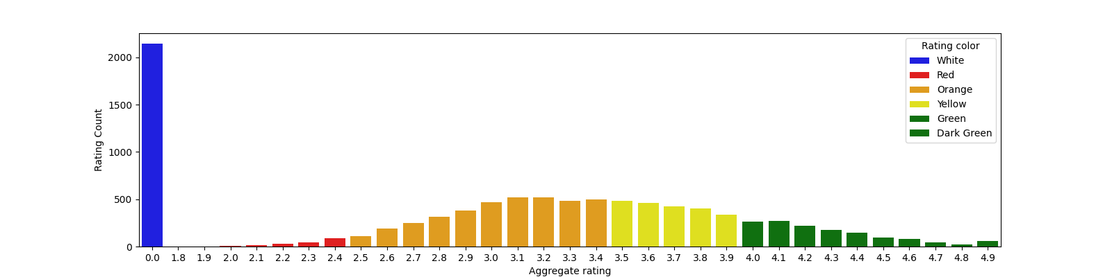And by combining this with the rating color corresponding to that rating, we plotted the following rating distribution which is color coded:

Not Rated Count is very high

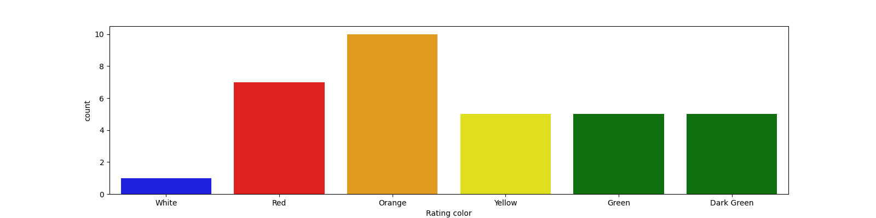The number of ratings between 2.5 to 3.8 is high.

## Number of Zero Ratings

The analysis identified that a significant number of restaurants have zero ratings, primarily from the dataset related to India. This observation may indicate inactive listings or insufficient reviews from users.

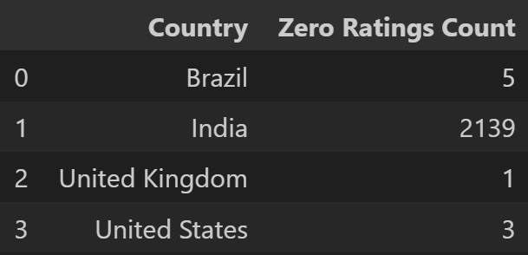

## Countries with Online Bookings

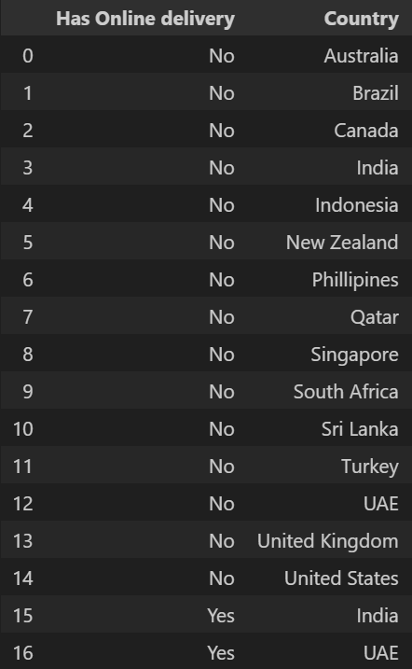Zomato provides online booking services across multiple countries. The analysis shows that online bookings are available in the following countries:

We can see only India and UAE have online delivery option as per the dataset.

## Top 10 Cuisines

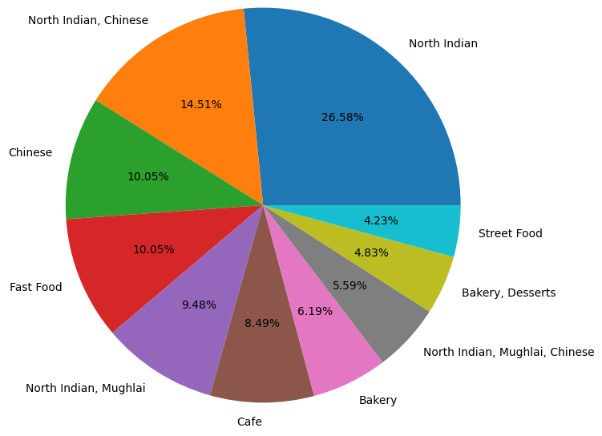The top 10 cuisines that are frequently ordered on Zomato are:

1. North Indian  
2. Chinese  
3. Fast Food  
4. South Indian  
5. American  
6. Pizza  
7. Italian  
8. Cafe  
9. Mexican  
10. Desserts

## Top 5 Indian Cities

The top 5 cities in India where Zomato is most widely used are:  
1. New Delhi  
2. Mumbai  
3. Bangalore  
4. Hyderabad  
5. Pune

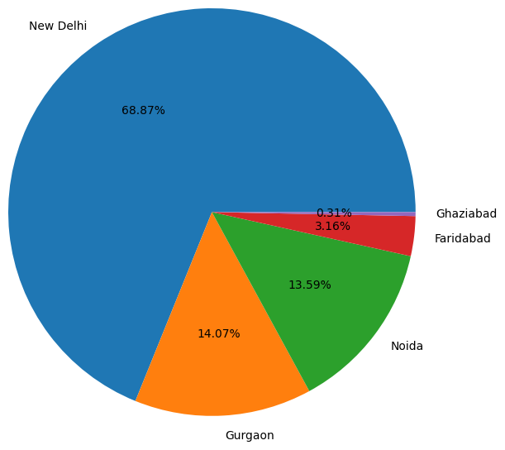

# Business Insights

From the data analysis, the following business insights can be drawn:  
1. The variety in top cuisines shows a diverse demand for food types, with North Indian and Chinese cuisines being the most popular. Zomato can leverage this insight to partner with restaurants that serve these cuisines and promote them.  
2. Online bookings are available in many key countries, and this service can be expanded to more regions to increase convenience for users.