SMART ID ENTRY SYSTEM USING RFID TECHNOLOGY

**A. Anusha 1, P. Varshith Naidu 2, V. Sai Charan 3, A. Sri Ram 4**

1Associate Professor, Department of Artificial Intelligence, Vidya Jyothi Institute of Technology, Aziz nagar, Hyderabad, 500075

2345UG Students, Department of Artificial Intelligence, Vidya Jyothi Institute of Technology, Aziz nagar, Hyderabad, 500075

# Abstract:

Access control is revolutionized by the Smart ID Entry System, which uses a single RFID card for numerous applications. It facilitates safe access to workplaces, labs, and restricted areas and is seamlessly connected with IoT. It guarantees effective control of multiple access points, such as server room access and doctor appointments, through real-time monitoring. This creative approach streamlines processes, and offers complete access control in a variety of settings.

The Smart ID Entry system also has a lot to offer in terms of operational effectiveness and convenience. Organizations can improve overall security protocols, minimize administrative overhead, and expedite operations by centralizing access control into a single, intelligent system. This comprehensive approach to access management offers a strong security architecture that can be tailored to various settings and applications, guaranteeing that all entry points are protected.

To put it briefly, the Smart ID Entry System is a cutting-edge system that combines RFID technology with the Internet of Things to improve security, convenience, and operational efficiency.

# Keywords:

Near-field communication (NFC), radio waves, microchip, frequency, EPC (Electronic Product Code), UHF (Ultra High Frequency), middleware, reader collision, tag collision, RFID tag, RFID reader, antenna, transponder, active RFID tag, passive RFID tag, ESP module, and Wi-Fi.

# Introduction:

Utilizing RFID technology, smart ID access systems are a revolution in access control that blend practicality, security, and efficiency to satisfy modern environment requirements. These spaces include homes, workplaces, schools, and other places where access control and security are essential. Electromagnetic fields are used by radio frequency identification (RFID) technology to identify and track electronic tags that are affixed to items and that RFID readers may read remotely. Users of the system are either placed on an ID card or key fob, or they are outfitted with RFID. In order to validate a user's credentials, the RFID reader scans the tag when they get close to the entrance point and connects with a central database. In most cases, the system opens the door and permits admission if the credentials are legitimate. Users' comfort and hygiene are increased when the procedure is kept as close to them as feasible; this is particularly crucial in places with high traffic or when there are issues with traffic health, like the spread of COVID-19. RFID tags, RFID readers, ESP32 microcontrollers, and interfaces with platforms like the Arduino IDE for programming and customisation are among the components. To ensure dependable and seamless functioning, an ESP32 microcontroller is needed to process data from the RFID reader and communicate with other devices. The device can also automatically record check-in and check-out times by connecting to online services like Google Sheets. Because of this connectivity, extensive access pattern monitoring and analysis are possible, improving performance and security. It offers superior security, to start.

using authentication and encryption methods to guarantee that data exchanges between tags, readers, and central data are not intercepted. Secondly, RFID technology offers better functionality. More tags and readers can be added to the current system as a company expands without requiring significant modifications. Long-term efficiency gains for RFID-based systems result from this modification. Automated tracking makes it possible to track people's movements instantly, which is crucial for counting people in an emergency and making sure everyone is there. The data collected can also be used for a variety of purposes, including attendance tracking, resource allocation, and optimizing business performance. In schools, for example, the system can record student attendance, save teachers time, and ensure data accuracy. In corporate offices, it can improve staff turnover, reduce water bottlenecks during peak hours, and improve overall water flow in the facility. Attendance software can be combined with other systems, such as payroll and even restaurant payments, to integrate across a variety of operational needs. The integration capability demonstrates the advantages of RFID technology and makes it useful in a wide range of applications. RFID systems help reduce the spread of diseases and infections, which has become a major factor in global health competition, considering that they are contactless. This contactless feature provides a safe environment for users by reducing the physical impact required by traditional access control systems. Safe and effective demand management. It meets the needs of today's management applications by combining the advantages of contactless operation, good security, seamless, scalability and advanced performance. This technology not only increases security and convenience, but also provides

useful information and sharing capabilities, making it an important tool for all organizations. Organizations looking to improve their access control systems.

# Literature Review:

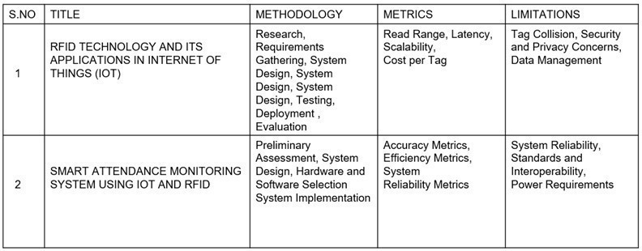

**Fig – 1:Literature Review**

Radio Frequency Identification (RFID) is an advanced automated technology that greatly improves object identification, metadata recording, and tracking of individual targets using radio waves. RFID technology allows machines or computers to communicate with RFID tags attached to objects, facilitating seamless identification and tracking. When connected to Internet terminals, RFID readers can identify, track, and monitor tagged objects globally, automatically, and in real time, providing a robust solution for a variety of applications.

In educational institutions, RFID technology is revolutionizing attendance tracking by replacing traditional, time-consuming methods. conventional attendance methods such as manual call or punch cards are error prone, time consuming and inefficient. By integrating RFID technology, schools and universities can automate and streamline attendance processes, greatly improving accuracy, efficiency and security.

Students who use an RFID-based attendance system wear RFID tags that are included into their ID cards. These tags are scanned by RFID readers that are positioned at entrance points, like classroom doors, as students enter.

After then, the data is moved to a central database, where real-time attendance tracking is done.

By eliminating the need for manual check-in, this automated procedure lowers mistake rates and guarantees correct attendance records. Administrators can track student attendance trends and spot issues early with the system's ability to provide reports and analytics.

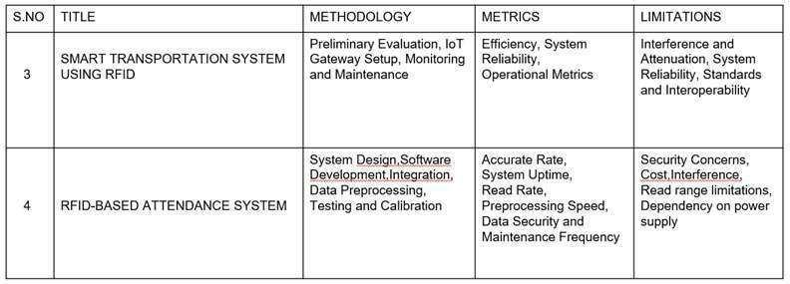

**Fig – 2: Literature Review**

RFID and IoT integration The merging of two significant technical trends— the Internet of Things (IoT) and RFID technology—offers more capabilities and a wider range of applications. Through the Internet of Things, objects can exchange data and communicate with one another, forming a network of interconnected devices. This network gains additional strength when RFID is included, allowing for the real-time tracking, management, and observation of tagged things.

An IoT-enabled RFID system at a school can transmit real-time attendance data to cloud platforms. Transparency and communication are improved because to this integration, which enables administrators, parents, and teachers to view attendance records remotely.. IoT can also make it easier to integrate RFID with other educational technologies, such payment processing, access control, and library administration, resulting in a more complete and effective ecosystem. The transportation industry will be greatly impacted by the combination of RFID and IoT technology, especially in the areas of smart parking and digital challan systems. These programs offer improved user experience,

cost effectiveness, and automation.

Assisting in increasing government operations' transparency and productivity. RFID and IoT are used by smart parking systems to address urban parking issues. Vehicles are equipped with RFID tags, and RFID scanners are positioned at the parking lot's entrances and exits. The RFID reader reads the tag and logs the entrance time when the car pulls into the parking lot. In order to cut down on the amount of time spent looking for parking, the system can then direct the driver to open spots. Upon the vehicle's departure, the parking cost is computed by the system and can be automatically billed to the driver's account. The reader records the time of departure.

By decreasing wait times and enhancing convenience, this automated procedure not only enhances the user experience but also boosts parking management effectiveness. Smart parking systems give city officials useful information on how parking is used, which they can use to better organize and maintain urban areas. Authorities can better allocate parking spots, control peak hours, and even modify pricing policies to balance demand by evaluating this data. Traffic fee administration and issuance are streamlined by digitalized challan systems that make use of RFID and IoT. RFID tags are installed on vehicles, and traffic cameras have RFID readers built in. The technology instantly creates a digital challan (fine) upon detection of a traffic infraction, which is then sent to the registered address or mobile device of the car owner. The RFID scanner identifies the offending vehicle. This system improves traffic management's accountability and openness. It makes sure that infractions are precisely recorded and promptly handled, and it lessens the chance of corruption and human error when fines are issued. Moreover, real- time data on traffic infractions is provided by digitalized challan systems, which helps law enforcement pinpoint problem areas and implement focused interventions to increase road safety. RFID- based attendance systems: Applications and advantages RFID technology is used by an RFID- based attendance system to automate and

streamline monitoring attendance. By providing real-

time attendance records, decreasing mistake rates, and substituting electronic data gathering for manual check-in procedures, it improves accuracy, efficiency, and security.

# Proposed system

In this project, an RFID reader, an ESP32 microcontroller, and the Arduino IDE are used to construct an RFID-based access control system that is divided into two main sections: access control and data registration. A thorough process for both sections is provided here, with an emphasis on setup, programming, data storage, and important implementation details.

Registration of RFID data Conditions: RFID reader (such as the MFRC522) Arduino IDE, Serial monitor, ESP32 microcontroller

Method: Hardware connections: Join the ESP32 microcontroller and the RFID reader. The SDA, SCK, MOSI, MISO, IRQ, GND, and RST pins of

the RFID reader must typically be connected to the matching pins on the ESP32 in order to accomplish this. Configuring software: Launch the Arduino IDE, then add the required ESP32 and RFID libraries. For RFID scanners, the MFRC522 library is frequently utilized. Use the Arduino Library Manager to install it.

Initial Code: To configure the ESP32 and RFID reader, write the initial code. This involves configuring the serial monitor for communication and initializing the RFID reader. Read the data from an RFID tag: To read data from RFID tags, implement code. Utilize the MFRC522 library's capabilities to read each RFID tag's unique ID. User Data Entry: To ask the user for information like name, phone number, address, and student ID, utilize Serial Monitor. This can be accomplished by capturing the input with Serial read String ().

Data formatting: Prepare the data that has been entered and save it on the RFID tag. Make sure the information is organized, perhaps by dividing distinct fields with delimiters.

Ask for Details: The system ought to ask the user for the necessary information whenever a new tag is scanned. Save your identifying information: Utilizing operations from the MFRC522 library, write identification information to the RFID tag. Verify that data is entered accurately and securely. Unique User Data: To avoid duplication and guarantee precise identification, make sure every RFID tag has unique user data. Robust error handling and data validation should be used in order to ensure that legitimate inputs are received and to stop inaccurate data from being recorded on labels. For instance, confirm that IDs are unique and phone numbers are numeric. RFID authorizing Conditions: RFID reader LCD display (such as a 16x2 or OLED display) ESP32 microcontroller link to the internet Google Sheets

Hardware connection: Join the ESP32 microcontroller with the RFID reader and LCD display. For data transfer, an LCD normally needs a power connection, a ground connection. Configure the ESP32 to establish a connection to a wireless network. In the Arduino code, this also includes configuring the Wi-Fi credentials. Set up Google Sheets: To record access information, create a Google Sheet. Activate the Google Sheets API and obtain the required credentials (OAuth 2.0 credentials, APIkey).

To read the data from an RFID tag, write code and scan the tag. putting the loaded info on show on the LCD panel. Display User Data: For simpler LCD manipulation, when a valid tag is scanned, display user data on the LCD by utilizing the LiquidCrystal_I2C library. Implement a feature to determine whether the RFID tag being scanned is permitted. In order to do this, the tag ID must be

compare to a list of approved IDs kept in the system.

Google Sheets Integration: API Settings: Send access data (such as username, ID, and timestamp) to Google Sheets via the Google Sheets API. In order to do this, the Arduino code must configure the HTTP client and structure the data appropriately for the API call. Update the Google Spreadsheet instantly each time a tag is scanned by having the machine do so. This entails contacting the Google Sheets API endpoint via HTTP POST requests that provide pertinent data Validation: Check the RFID tags' permission status. Give access and show a welcome message on the LCD if the tag is approved. If not, refuse entry and present an error message. Several Users: Make sure the system can accommodate several users and keep accurate logs of all inputs and outputs.

# Important points

Instantaneous Updates for Google Sheets: To ensure you have a precise record of all inputs and outputs, make sure Google Sheets updates are made in the real-time.

Unauthorized tags: Notify users by identifying and blocking access to unauthorized tags, and by showing relevant notifications on the LCD. correct Records: To effectively manage numerous users and guarantee seamless system functioning under load, maintain correct input/output records.

Error Handling: To guarantee that the system stays dependable and safe, provide strong error handling for network problems, invalid tag reads, and other unforeseen difficulties.

In summary Using the ESP32 and Arduino IDE, you may create a reliable RFID-based access control system by following the preceding

methods. With its seamless interaction with Google Sheets and real-time data tracking, this system guarantees effective and safe access control.

# Block Diagram:

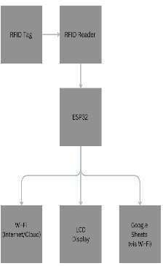

**Fig – 3: Block Diagram for Smart ID Entry System Using RFID TECH.**

The relationships between the main parts of the RFID-based access control system—RFID tags, RFID readers, ESP32 microcontrollers, LCD displays, and Google Sheet are in the block diagram. RFID Tag to RFID Reader: To read or write data, the RFID tag and reader communicate wirelessly. RFID Reader to ESP32: The ESP32 receives data from the RFID reader using communication interfaces such as SPI, I2C, or UART. ESP32 to LCD Display: The ESP32 sends access status and user information updates to the LCD display.

ESP32 to Wi-Fi: To communicate data to Google Sheets, the ESP32 establishes a Wi-Fi connection with the internet.

ESP32 to Google Sheets: The ESP32 updates entrance and exit times in Google Sheets via HTTP queries

# Results & Discussion:

Using distinct identifiers for every RFID tag has greatly improved security when implementing an RFID-based entry system. Because of their specificity, tags are particularly difficult to copy or fake, which helps to prevent unwanted access. Strong security measures built into the system guarantee that only people with legitimate RFID tags can enter,

lowering the possibility of security lapses. A readily apparent enhancement was the decrease in processing time. The RFID system's automation expedites the admission and leave procedure and reduces wait times and bottlenecks, particularly during peak hours. This stands in stark contrast to manual systems, which are more prone to human mistake and slower.

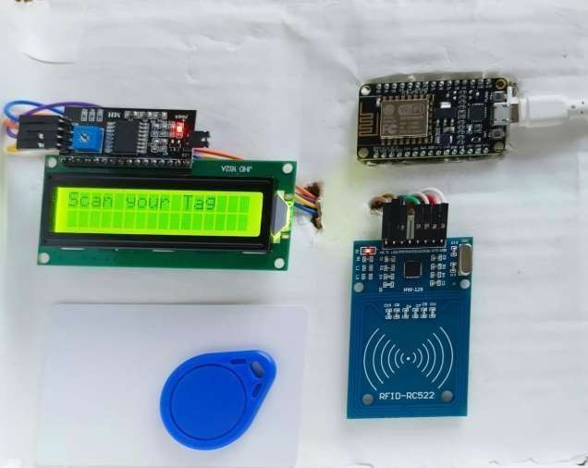

**Fig – 4: Real-Time Working Project**

The RFID system's quick processing speed improves overall operational effectiveness. One important benefit of the system is its capacity to produce intricate data logs of input and output times. These records make it easy to track movement on the property and enable improved monitoring and auditing. In-depth logs have shown to be quite helpful in spotting possible security problems and examining usage trends. It is easier to react swiftly to any security anomalies or breaches with this degree of data.

# References:

1. RFID TECHNOLOGY AND ITS APPLICATIONS IN INTERNET OF THINGS (IOT) DOI: 10.1109/CECNet.2012.6201508
2. SMART ATTENDANCE MONITORING SYSTEM USING IOT AND RFID MGT

Bharathy, MS Bhavani, T Tamilselvi International Journal of Advances in Engineering and Management (IJAEM), 2021•ijaem.net

1. SMART TRANSPORTATION SYSTEM USING RFID

Authors: Sim Liew Fong, Amir Ariff Azham bin Abu Bakar, Falah Y. H. Ahmed, Arshad https://doi.org/10.1145/3316615.3316719

1. SIMPLE RFID SMARTER CIRCUITRY

BLOG https://[www.circuitspecialists.com/blog/esp-](http://www.circuitspecialists.com/blog/esp-) microcontroller-quick-start-guide/

1. RFID, RTLS BRING DATA TO AI IN THE

FACTORY https://[www.rfidjournal.com/news/rfid-](http://www.rfidjournal.com/news/rfid-) rtls-bring-data-to-ai-in-the-factory/221289/