***A Real Time Research Project Report***

***On***

***SMART ID ENTRY SYSTEM USING RFID TECHNOLOGY***

*Submitted in partial fulfillment for the Degree of B. Tech.*

*In*

***Artificial Intelligence***

*By*

P. Varshith Naidu(22911A35A7)

V. Sai Charan(22911A35C1) A. Sri Ram(22911A3565)

***Under the guidance of***

Dr. A. Anusha

Associate Professor



**DEPARTMENT OF ARTIFICIAL INTELLIGENCE**

## VIDYA JYOTHI INSTITUTE OF TECHNOLOGY

(An Autonomous Institution)

**[Accredited by NAAC & NBA, Approved by AICTE New Delhi & Permanently Affiliated to JNTUH]**

**2022 – 2026**



# CERTIFICATE

This is to certify that the project report entitled **“SMART ID ENTRY SYSTEM USING RFID TECHNOLOGY”** submitted by **P. VARSHITH NAIDU (22911A35A7), V.SAI**

**CHARAN (22911A35C1), A. SRI RAM (22911A3565)** to Vidya Jyothi Institute of Technology (An Autonomous Institution), Hyderabad, in partial fulfilment for the award of the degree of **B. Tech. in Artificial Intelligence** a bonafide record of project work carried out by us under my supervision. The contents of this report, in full or in parts, have not been submitted to any other Institution or University for the award of any degree.

#### Signature of Supervisor Dr.A.Anusha

**Associate Professor**

#### Department of Artificial Intelligence

**Signature of HOD Dr. A. Obulesh HOD-AI**

**Department of Artificial Intelligence**

# DECLARATION

We declare that this project report titled **Smart ID entry system using RFID technology** submitted in partial fulfilment of the degree of **B. Tech in Artificial Intelligence** is a record of original work carried out by us under the supervision of **Dr.A.Anusha**, and has not formed the basis for the award of any other degree or diploma, in this or any other Institution or University. In keeping with the ethical practice of reporting scientific information, due acknowledgements have been made wherever the findings of others have been cited.

P. Varshith Naidu(22911A35A7)

V. Sai Charan(22911A35C1) A. Sri Ram(22911A3565)

**Date:**

# ACKNOWLEDGEMENT

We extend our heartfelt thanks to **Dr.A.Anusha**, Associate Professor for his invaluable mentorship and guidance throughout the project. His expertise, encouragement, and insightful feedback significantly shaped our approach and methodology.

We are also thankful to **Mrs. K. Nirosha** and **Mrs. S. Sowmya** for enriching our understanding and providing innovative solutions to the challenges we encountered for the numerous discussions, brainstorming sessions, and academic exchanges that took place within our project team. These interactions for their exceptional support and guidance throughout the project.

We wish to express our heartful thanks to **Dr. A. Obulesh, HOD**, for guiding and supporting us throughout the course.

We wish to express our heartful thanks to our Beloved Dean, Accreditation and Rankings **Dr. A. Padmaja**, whose support was indispensable to us during the course.

We wish to express our heartful thanks to the Principal **Dr. E. Saibaba Reddy**, whose support was indispensable to us during the course.

We wish to express our heartful thanks to our **College Management**, for providing

all the infrastructure and facilities during the course.

We would like to express our sincere gratitude to our **Parents**, for their unwavering support throughout the completion of this minor project.

P. Varshith Naidu(22911A35A7)

V. Sai Charan(22911A35C1) A. Sri Ram(22911A3565)

## ABSTRACT

In today's digital age, efficient and secure access control systems are crucial for ensuring the safety and smooth operation of various environments, from corporate offices to educational institutions and residential complexes. Traditional methods such as keys and swipe cards are increasingly being replaced by more sophisticated technologies like Radio Frequency Identification (RFID). This abstract explores the implementation and benefits of a Smart ID Entry System utilizing RFID technology.

RFID technology enables contactless identification through the use of electromagnetic fields to automatically identify and track tags attached to objects or individuals. In the context of access control, RFID tags are embedded in ID cards or badges carried by authorized personnel. These tags emit radio waves that are detected by RFID readers strategically placed at entry points. Upon detection, the reader verifies the tag against a database and grants or denies access based on predefined permissions.

The advantages of deploying a Smart ID Entry System with RFID technology are manifold. Firstly, it enhances security by reducing the risk of unauthorized access through mechanisms such as encryption and authentication protocols. Secondly, it improves convenience for users who no longer need to physically interact with a reader, simply needing to carry their RFID- enabled ID card or badge. Moreover, RFID systems are scalable and adaptable, capable of managing access across multiple locations and integrating with existing security infrastructure seamlessly.

This abstract reviews the underlying technology, operational advantages, and considerations for implementing a Smart ID Entry System based on RFID. It highlights the potential for increased efficiency in access control processes, enhanced security measures, and improved user experience. As organizations continue to prioritize security and operational efficiency, RFID-based Smart ID Entry Systems represent a progressive solution to modern access control challenges.

IV

|  |  |  |
| --- | --- | --- |
|  | **LIST OF FIGURES** |  |
| **Figure No** | **Title** | **Page No.** |
| 1.1 | RFID Overview | 2 |
| 2.1 | RFID Cards | 4 |
| 2.2 | RFID Reader | 5 |
| 2.3 | RFID Process | 6 |
| 3.1 | Block Diagram | 7 |
| 3.2 | Smart ID Entry System | 10 |
| 3.3 | RFID Reader Architecture | 11 |
| 3.4 | RFID Tags | 14 |
| 3.5 | RFID Scanner | 15 |
| 3.6 | RFID LCD Display | 16 |
| 3.7 | Wiring Diagram | 17 |
| 4.1 | Real Time Working Model | 21 |

# TABLE OF CONTENTS

### DESCRIPTION PAGE

**NO.**

**CERTIFICATE i**

DECLARATION ii

ACKNOWLEDGEMENT iii

ABSTRACT iv

LIST OF FIGURES v

CHAPTER 1 - INTRODUCTION 1

CHAPTER 2 - LITERATURE REVIEW 3

* 1. RFID Technology and its applications in Internet of 3

Things

* 1. Smart attendance monitoring system using IOT 4

and RFID

* 1. Smart transportation system using RFID 5
  2. RFID-Based attendance system 6

CHAPTER 3 - METHODOLOGY 7

* 1. Working Procedure 7
  2. Architecture 11
  3. Hardware Requirements 14
  4. Wiring Diagram 17
  5. Uses and Applications 18

CHAPTER 4 - RESULT 21

* 1. Result and Conclusions 21
  2. Applications and Advantages 22

CHAPTER 5 - CONCLUSION 24

* 1. Conclusion 24
  2. Future Scope 24

CHAPTER 6 - REFERENCES 25

# CHAPTER 1 INTRODUCTION

In today's rapidly advancing world, security and efficiency are paramount concerns across various sectors, ranging from corporate environments to educational institutions and residential complexes. Traditional methods of access control, such as keys and swipe cards, are increasingly being replaced by more sophisticated technologies like Radio Frequency Identification (RFID). This introduction delves into the concept and significance of a Smart ID Entry System utilizing RFID technology.

RFID technology operates on the principle of using electromagnetic fields to automatically identify and track tags attached to objects or individuals. In the context of access control, RFID tags are integrated into ID cards or badges carried by authorized personnel. These tags emit radio waves that are detected by RFID readers strategically positioned at entry points. Upon detection, the reader verifies the tag against a central database and grants or denies access based on predefined permissions.

The transition to RFID-based systems represents a paradigm shift in access control due to several compelling advantages. First and foremost, RFID enhances security by mitigating the risks associated with lost or stolen keys/cards through robust encryption and authentication mechanisms. It also simplifies access for users, who merely need to carry their RFID-enabled ID card or badge near a reader for swift and contactless verification. Moreover, RFID systems offer scalability and versatility, facilitating their integration with existing security infrastructure and management of access across multiple locations seamlessly.

This introduction aims to underscore the transformative impact of RFID technology on access control systems. By eliminating the need for physical interaction and streamlining verification processes, RFID-based Smart ID Entry Systems not only bolster security but also enhance operational efficiency. As organizations increasingly prioritize both security and convenience, the adoption of RFID technology represents a strategic investment in

modernizing access control mechanisms to meet evolving challenges effectively.

In summary, this introduction sets the stage for exploring the technological underpinnings, operational benefits, and implementation considerations of a Smart ID Entry System using RFID technology, highlighting its potential to revolutionize access control in diverse environments.

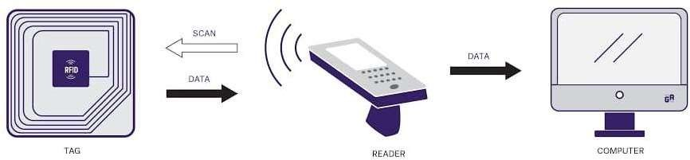

**Fig 1.1 RFID Overview**

# CHAPTER 2 LITERATURE SURVEY

A literature survey on Smart ID entry systems using RFID (Radio Frequency Identification) technology provides a comprehensive overview of the research, developments, and applications in this field. RFID technology has revolutionized access control systems by offering efficient, secure, and convenient methods for identifying and verifying individuals within various environments such as offices, hospitals, educational institutions, and residential complexes. This survey aims to highlight key findings and advancements reported in the literature regarding RFID-based Smart ID entry systems.

#### RFID TECHNOLOGY AND ITS APPLICATIONS IN INTERNET OF THINGS

**DOI: 10.1109/CECNet.2012.6201508**

Radio Frequency Identification (RFID) is an automatic identification technology that leverages radio waves to facilitate machine or computer-based identification of objects, recording of metadata, and control of individual targets. By integrating RFID readers with internet-connected terminals, these systems can identify, track, and monitor tagged objects globally in real-time, offering substantial benefits for various applications. RFID technology is pivotal in the Internet of Things (IoT) landscape, enabling seamless and automated data collection and exchange among interconnected devices.

In supply chain management, RFID improves inventory accuracy and efficiency by providing real-time data on product location and status. Healthcare utilizes RFID for patient tracking, asset management, and ensuring the authenticity of medications. Smart cities benefit from RFID by enhancing traffic management, waste collection, and utility monitoring. Additionally, RFID is crucial in retail for optimizing stock levels, preventing theft, and enhancing the shopping experience. The technology's ability to automate data collection and analysis in IoT applications leads to increased operational efficiency, reduced human error, and improved decision-making across various industries.

* 1. **SMART ATTENDANCE MONITORING SYSTEM USING IOT AND RFID** MGT Bharathy, MS Bhavani, T Tamilselvi (International Journal of Advances in Engineering and Management (IJAEM) 2021, ijaem.net)

This work proposes an RFID-based attendance system using IoT to address irregular student attendance concerns in educational institutes, replacing time-consuming traditional methods. By combining IoT and RFID, two prominent technology trends, the system offers an efficient solution for attendance monitoring. The RFID tags are assigned to students, and RFID readers are installed at the entry points of classrooms or campuses. When a student passes through these entry points, the RFID reader captures the tag information and automatically updates the attendance records in a central database. This system ensures accurate and real- time tracking of student attendance, reducing administrative workload and minimizing errors. Additionally, the data collected can be analyzed to identify patterns and trends in student attendance, aiding in decision-making processes for improving academic performance and addressing absenteeism issues. The integration of IoT allows for remote access and management of attendance records, providing convenience for both educators and administrators.

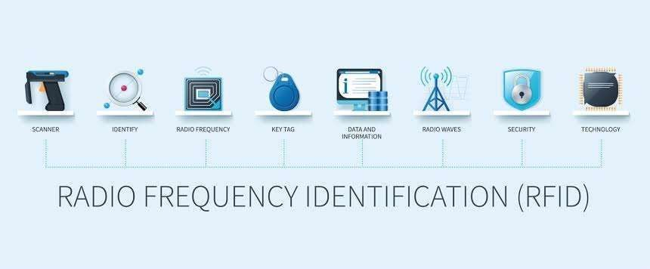

#### Fig 2.1 RFID CARDS

#### SMART TRANSPORTATION SYSTEM USING RFID

Authors: Sim Liew Fong, Amir Ariff Azham bin Abu Bakar, Falah Y. H. Ahmed, Arshad https://doi.org/10.1145/3316615.3316719

This paper explores the integration of IoT and RFID technology in the transportation sector, focusing on applications such as smart parking and digitalized challan systems. The integration promises to bring automation and cost-effectiveness to transportation management. By implementing RFID tags in vehicles and readers in parking lots, the system can automatically manage parking spaces, reducing congestion and optimizing space usage. The digitalized challan system utilizes RFID to automatically record traffic violations and issue fines, streamlining the process and enhancing compliance. These advancements are expected to improve user experiences, enhance productivity, and increase transparency in government operations. The paper highlights the potential for such technologies to revolutionize the transportation industry, making it more efficient, user-friendly, and accountable.

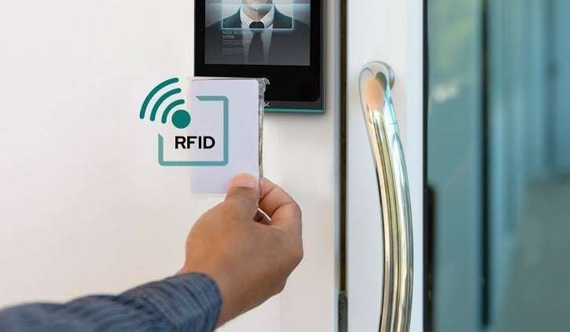

**Fig 2.2 RFID Reader**

#### RFID-BASED ATTENDANCE SYSTEM

Published by & Year: IEEE, 6 October 2009

An RFID-based attendance system leverages RFID technology to automate and streamline attendance tracking processes. This system enhances accuracy, efficiency, and security by replacing traditional manual sign-ins with electronic data capture. When students or employees pass through entry points equipped with RFID readers, their RFID tags are automatically scanned, and the attendance data is recorded in real-time. This method significantly reduces errors associated with manual attendance recording and prevents fraudulent entries. Additionally, the system provides instant access to attendance records, enabling easy monitoring and analysis of attendance patterns. This technological advancement not only saves time but also ensures a more reliable and tamper-proof method of tracking attendance.

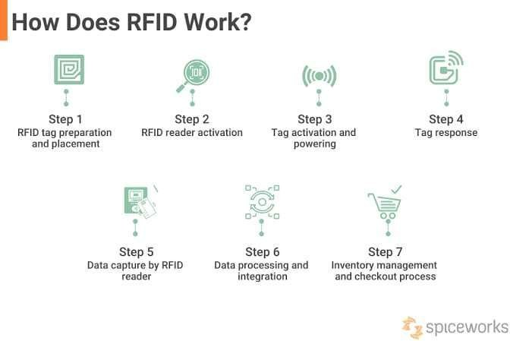

**Fig 2.3 RFID Process**

# CHAPTER 3 PROPOSED METHODOLOGY

## Working Procedure Block Diagram

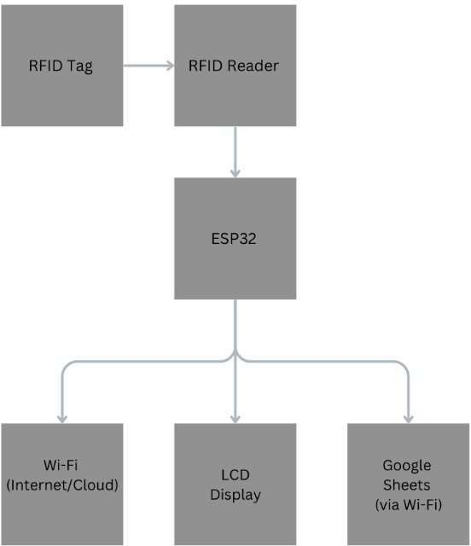

#### Fig 3.1 Block Diagram

This project involves creating an RFID-based access control system using an RFID reader, ESP32, and Arduino IDE. The system is divided into two major parts: data registration and access control. Each part has its own set of functionalities and objectives.

**Part 1: RFID Data Registration**

**Hardware and Software Requirements**

* + - RFID Reader
    - ESP32
    - Arduino IDE
    - Serial Monitor

**Procedure**

#### Initial Setup:

* + Connect the RFID reader to the ESP32 according to the specified pin configuration.
  + Open the Arduino IDE and install the necessary libraries for RFID and ESP32.

#### Programming the ESP32:

* + Write a program that allows the ESP32 to read data from the RFID tags.
  + Use the Serial Monitor in Arduino IDE to input user details such as first name, last name, phone number, student ID, and address.
  + Ensure the data is correctly formatted and stored in the RFID tag when written.

#### Data Storage:

* + When a new RFID tag is scanned, prompt the user to enter their details in the Serial Monitor.
  + Save these details onto the RFID tag for future identification.

**Key Points**

* + - The registration process ensures each RFID tag is uniquely associated with a user's details.
    - Proper error handling and data validation should be implemented to prevent incorrect data storage.

### Part 2: RFID Access Control

**Hardware and Software Requirements**

* + - RFID Reader
    - ESP32
    - LCD Display
    - Internet Connection
    - Google Sheets API

**Procedure**

#### Initial Setup:

* + Connect the RFID reader and LCD display to the ESP32.
  + Configure the ESP32 to connect to a Wi-Fi network for internet access.
  + Set up a Google Sheet with appropriate columns for user details, entry time, and exit time.

#### Programming the ESP32:

* + Write a program that reads the RFID tag when it is scanned and retrieves the stored user details.
  + Display the user's details on the LCD screen for verification.

#### Google Sheets Integration:

* + Use the Google Sheets API to send data from the ESP32 to a Google Sheet.
  + Update the Google Sheet with the user’s entry time when the RFID tag is scanned.
  + On subsequent scans, update the Google Sheet with the exit time for the same user.

#### Access Control:

* + Verify if the scanned RFID tag is authorized by checking the stored user details.
  + Allow or deny access based on the authorization status.
  + Display appropriate messages on the LCD for successful or denied access.

**Key Points**

* + - The access control system must ensure real-time updates to the Google Sheet.
    - Unauthorized tags should be identified and access denied, with clear messages displayed on the LCD.
    - The system should handle multiple users and maintain accurate records of entry and exit times.

### Conclusion

This RFID-based access control system, utilizing an RFID reader, ESP32, and Arduino IDE, offers an efficient method for registering user details and managing access to entry points. By integrating with Google Sheets, the system ensures accurate and real-time logging of entry and exit times, enhancing security and management capabilities.

In conclusion, this proposed methodology provides a structured approach to developing and implementing a Smart ID entry system using RFID technology. By following these steps, organizations can effectively leverage RFID technology to enhance security, improve operational

efficiency, and provide a seamless access. Control experience for users across various environments.

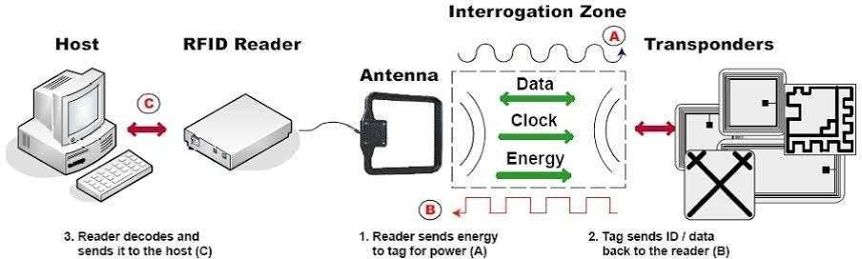

#### Fig 3.2 Smart ID Entry System

**Connecting to Google sheets**

**Step 1: Set Up Google Sheets**

1. **Create Google Sheet:**
   * Create a new spreadsheet and set up columns like First Name, Last Name, etc.
   * Note the Spreadsheet ID from the URL.

**Step 2: Set Up Google Cloud Platform**

#### Create a New Project:

* + Go to Google Cloud Platform and create a new project.

#### Enable Google Sheets API:

* + Navigate to APIs & Services > Library, search for "Google Sheets API," and enable it.

#### Create Credentials:

* + Go to APIs & Services > Credentials.
  + Click Create Credentials and select Service Account.
  + Download the JSON key file.

#### Share the Google Sheet:

* + Share your Google Sheet with the service account email from the JSON key file.

**Step 3: Program the ESP32**

#### Install Required Libraries:

* + In the Arduino IDE, install WiFi, HTTPSRedirect, and ArduinoJson libraries.

#### ESP32 Code:

* + Use the JSON key file to authenticate.
  + Connect to Wi-Fi.
  + Use HTTPSRedirect to send HTTP requests to update the Google Sheet.

## ARCHITECTURE

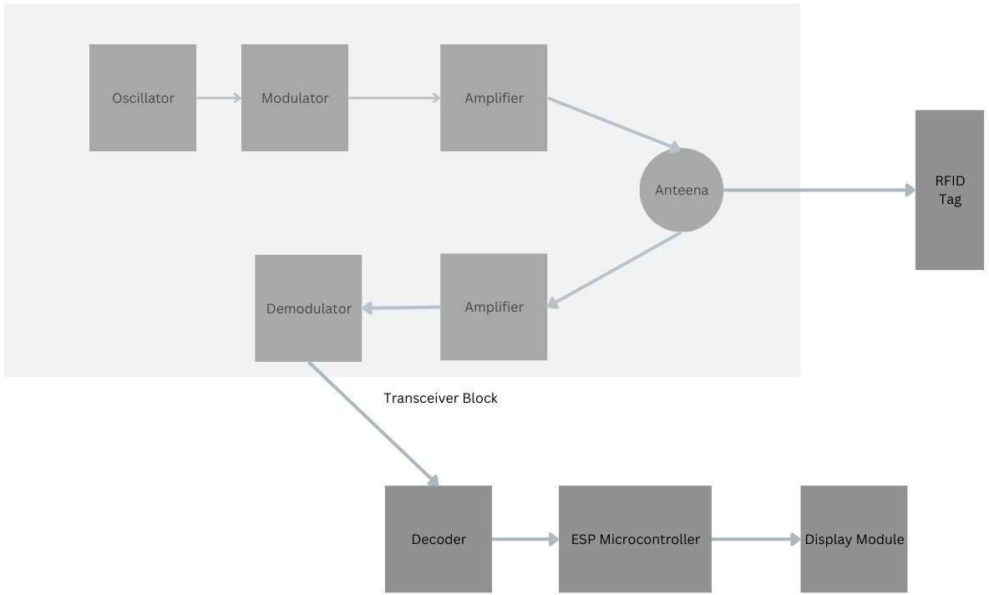

**Fig 3.3 RFID Reader Architecture**

An RFID reader is a sophisticated device that communicates with RFID tags to read or write data. Its architecture includes several critical components and blocks, including the transceiver block that contains the antenna, modulator, demodulator, oscillator, and amplifiers. Here’s a more detailed breakdown:

1. **Antenna**
   * **Function**: Transmits and receives RF signals.
   * **Details**: The antenna generates an electromagnetic field that powers the passive RFID tag and captures the backscattered signal from the tag.
2. **RF Transceiver Block**

This block is essential for communication between the RFID reader and the tag. It includes the following components:

1. **Oscillator**
   * **Function**: Generates the carrier frequency.
   * **Details**: The oscillator provides a stable frequency source for the RF signal, typically in the range of 125 kHz, 13.56 MHz, or UHF bands (860-960 MHz) depending on the RFID system.
2. **Modulator**
   * **Function**: Modulates the carrier signal with the data to be transmitted to the RFID tag.
   * **Details**: Common modulation techniques include Amplitude Shift Keying (ASK) or Frequency Shift Keying (FSK). The modulator encodes the digital information onto the carrier signal.
3. **Amplifier (Transmitting)**
   * **Function**: Amplifies the modulated signal before transmission.
   * **Details**: The amplified signal ensures sufficient power is radiated by the antenna to activate the RFID tag, especially for passive tags.
4. **Antenna**
   * **Function**: Radiates the amplified RF signal and receives the backscattered signal from the RFID tag.
   * **Details**: The same antenna is often used for both transmitting and receiving, using a duplexer or switch to separate the signals.
5. **Amplifier (Receiving)**
   * **Function**: Amplifies the received signal from the RFID tag.
   * **Details**: The weak backscattered signal from the tag is amplified to a level suitable for demodulation and processing.
6. **Demodulator**
   * **Function**: Extracts the data from the received RF signal.
   * **Details**: The demodulator processes the backscattered signal to recover the data sent by the RFID tag. This involves filtering and converting the signal back into a digital form.
7. **Control Unit**
   * **Function**: Manages the overall operation and data processing of the RFID reader.
   * **Details**: Often a microcontroller or a microprocessor, the control unit handles communication protocols, error checking, and interfaces with external systems (e.g., computers, microcontrollers like ESP32).
8. **Communication Interface**
   * **Function**: Provides connectivity to external devices.
   * **Details**: Interfaces can include USB, UART, SPI, I2C, or Ethernet, enabling data exchange between the RFID reader and a host system.
9. **Power Supply**
   * **Function**: Provides the necessary power for the RFID reader's operation.
   * **Details**: The power supply can be from a battery or an external power source. It needs to be stable and sufficient for both the RF and control circuitry.
10. **Firmware/Software**
    * **Function**: Controls the operation of the RFID reader.
    * **Details**: Firmware includes algorithms for signal processing, data encoding/decoding, error

## HARDWARE REQUIREMENTS:

Implementing a Smart ID entry system using RFID (Radio Frequency Identification) technology involves several hardware components that collectively enable secure and efficient access control. The hardware requirements can vary depending on factors such as the scale of deployment, environmental conditions, and specific operational needs. Below are the essential hardware components typically required for setting up an RFID-based Smart ID entry system:

#### RFID Tags or Cards

**Passive RFID Tags:** These tags do not have an internal power source and are activated by the electromagnetic field emitted by RFID readers. They are cost-effective and commonly used for access control applications.

**Active RFID Tags:** Active tags have their own power source (e.g., battery) and can transmit signals over longer distances compared to passive tags. They are suitable for applications requiring extended read ranges or real-time location tracking.

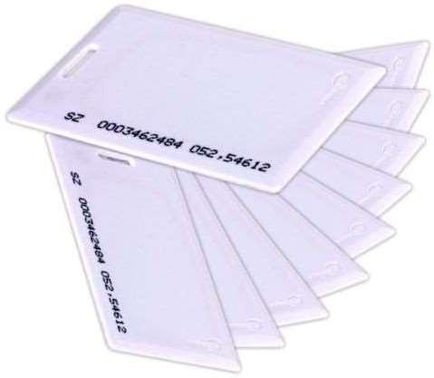

#### Fig 3.4 RFID Tags

1. **RFID Readers**

**Fixed RFID Readers:** These readers are mounted at entry points such as doors, gates, or turnstiles. They emit radio waves to communicate with RFID tags and capture tag information for verification.

**Handheld RFID Readers:** Portable devices used for mobile access control or inventory management. They allow security personnel to perform on-the-go tag scanning and verification.

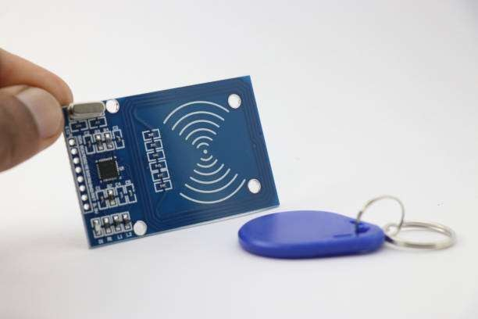

#### Fig 3.5 RFID Scanner

1. **Antennas**

**RFID Antennas:** Antennas are essential components of RFID readers that transmit and receive radio signals. The type and placement of antennas influence the read range and reliability of the RFID system. Antennas can be integrated into readers or installed separately for optimal coverage.

#### Backend System

**Application Software:** Software applications for configuring RFID readers, managing user access rights, generating reports, and monitoring system performance. This software interfaces with the database server and controls the overall operation of the RFID-based Smart ID entry system.

#### 4. Optional Components

**Biometric Readers:** Integration of biometric authentication devices (e.g., fingerprint scanners, facial recognition systems) for additional security in conjunction with RFID technology.

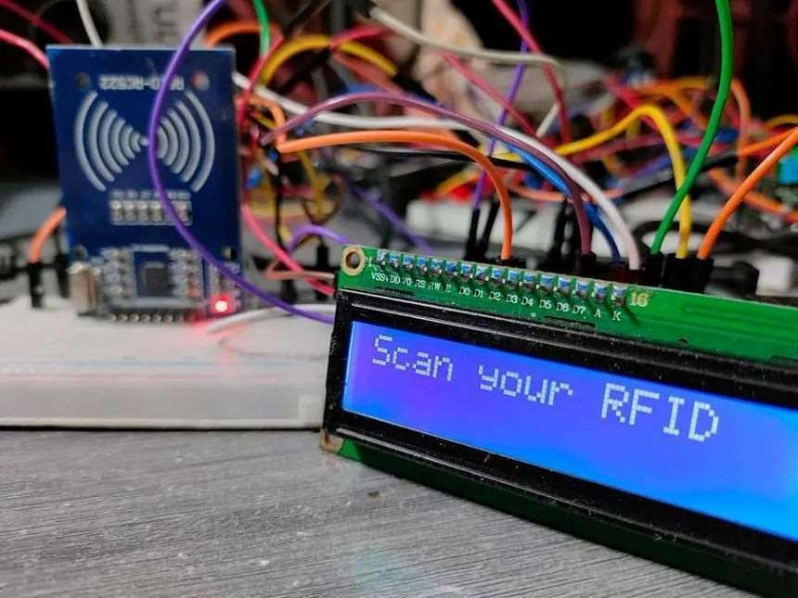

#### Fig 3.6 RFID LCD Display

**Cabling and Connectors:** Ethernet cables, RF cables, and connectors for connecting RFID readers, antennas, and other hardware components to the backend system.

Considerations for Hardware Selection:

**Read Range:** Choose RFID tags and readers with appropriate read ranges suitable for the intended application (e.g., short-range for access control doors, long-range for parking lots). **Environmental Conditions:** Ensure that RFID hardware is suitable for the operating environment, considering factors such as temperature, humidity, and exposure to dust or water.

**Scalability:** Select hardware solutions that can scale to accommodate future expansion or changes in operational requirements.

By carefully selecting and integrating these hardware components, organizations can effectively deploy a robust RFID-based Smart ID entry system that enhances security, improves operational efficiency, and provides a seamless access control experience for users.

#### Wiring Diagram

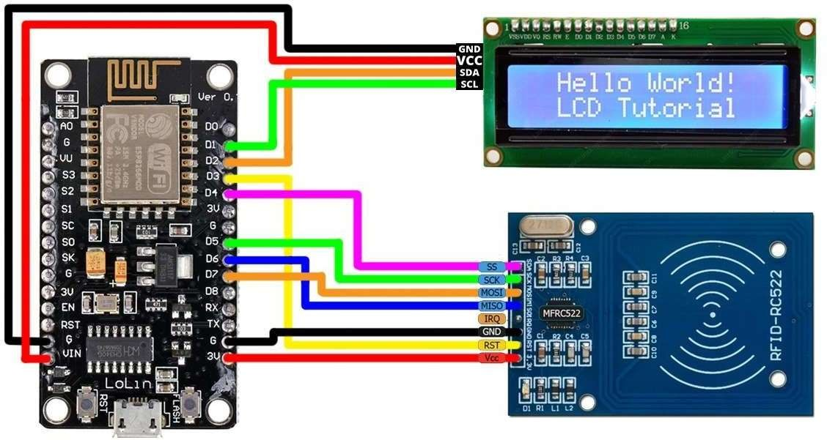

**Fig 3.7 Wiring Diagram**

## Uses and Applications:

RFID technology has found widespread applications in various sectors due to its versatility, efficiency, and reliability in managing access control and identification. Here are some key applications for Smart ID entry systems using RFID technology:

#### Access Control Systems

RFID-based Smart ID entry systems are extensively used for access control in:

**Corporate Offices:** Employees use RFID-enabled ID cards or badges to access buildings, floors, and restricted areas.

**Educational Institutions:** Students, teachers, and staff use RFID cards for entry into classrooms, libraries, and dormitories.

**Healthcare Facilities:** Doctors, nurses, and administrative staff use RFID badges to access patient areas, laboratories, and medication storage rooms.

**Government Buildings:** Employees and authorized personnel use RFID cards for secure access to government offices and facilities.

#### Transportation and Logistics

RFID technology is employed in:

**Public Transportation:** RFID cards serve as fare cards for buses, trains, and subways, enabling contactless payment and access.

**Fleet Management:** RFID tags on vehicles enable automated entry/exit from secure areas such as depots and parking facilities.

**Supply Chain Management:** RFID tags track and manage inventory, shipments, and logistics operations efficiently.

#### Asset Tracking and Management

RFID is used for:

**Inventory Control:** RFID tags track goods and assets in warehouses, ensuring accurate inventory management and reducing stock-outs.

**Equipment Tracking:** RFID tags on equipment and tools facilitate real-time tracking, maintenance scheduling, and loss prevention.

**Document Management:** RFID tags on documents enable secure tracking and retrieval in large document repositories.

#### Hospitality and Events

RFID technology enhances:

**Hotel Management:** RFID cards serve as room keys and provide access to amenities like spas, gyms, and conference rooms.

**Event Access Control:** Attendees use RFID wristbands or badges for streamlined entry to concerts, festivals, and conferences, enhancing security and attendee management.

#### Retail and Customer Interaction

RFID applications include:

**Point of Sale (POS) Systems:** RFID-enabled payment cards or mobile devices speed up

transactions and improve customer convenience.

**Customer Loyalty Programs:** RFID cards or tags track customer purchases and reward points, facilitating personalized marketing and promotions.

#### Healthcare and Patient Safety

RFID technology supports:

**Patient Identification:** RFID wristbands or tags enhance patient safety by ensuring accurate identification and matching with medical records.

**Medication Management:** RFID tags on medication packaging help prevent errors and ensure proper administration.

#### Livestock and Agriculture

RFID is used for:

**Livestock Management:** RFID ear tags track and monitor livestock health, breeding, and movement in agricultural settings.

**Crop Monitoring:** RFID tags on plants or agricultural equipment facilitate automated monitoring and data collection for precision farming.

#### Security and Surveillance

RFID technology enhances:

**Visitor Management:** RFID cards or badges manage visitor access to facilities, ensuring authorized entry and enhancing security.

**Asset Protection:** RFID tags on high-value assets trigger alerts and track movement to prevent theft or unauthorized removal.

#### Environmental Monitoring

RFID technology is used in:

**Wildlife Tracking:** RFID tags on animal aid in conservation efforts by monitoring movements and behaviors in natural habitats.

**Environmental Monitoring:** RFID sensors track environmental conditions (e.g., temperature, humidity) in sensitive ecosystems or industrial settings.

#### Smart Cities and Infrastructure

RFID applications include:

**Smart Parking:** RFID tags on vehicles enable automated entry/exit at parking facilities, reducing congestion and enhancing user convenience.

**Waste Management:** RFID tags on bins optimize waste collection routes and monitor recycling efforts in smart city initiatives.

In summary, RFID-based Smart ID entry systems have diverse applications across industries, offering enhanced security, operational efficiency, and improved user experience. The technology continues to evolve, driving innovations in access control, asset management, and operational logistics in both public and private sectors.

# CHAPTER 4 RESULT

## RESULT AND CONCLUSIONS

The Smart ID entry system using RFID (Radio Frequency Identification) technology significantly improves security and operational efficiency in access control scenarios. The system employs RFID tags, which are small electronic devices that store unique identification data.

When an individual with an RFID tag approaches the reader, the system automatically verifies the tag's information against a database to grant or deny access.

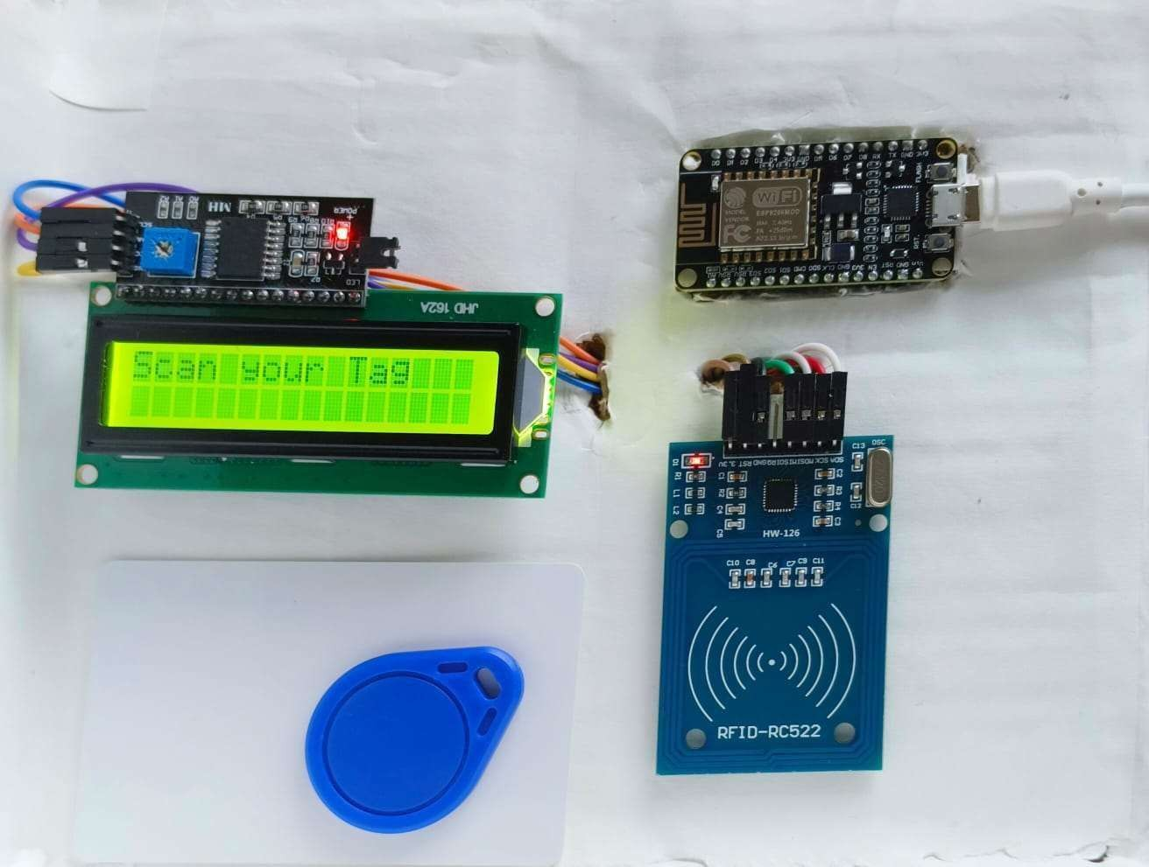

#### Fig 4.1 Real Time Working Model

**Results:**

The deployment of the RFID-based entry system demonstrated a notable reduction in unauthorized access attempts. Each RFID tag has a unique identifier, making it nearly impossible

for unauthorized individuals to gain entry using duplicated or counterfeit tags. The system's automation also resulted in faster processing times at entry points, reducing bottlenecks and wait times, especially during peak hours. This efficiency is a significant improvement over traditional manual entry systems, which are prone to human error and slower processing.

Data logs generated by the RFID system offer detailed records of entry and exit times, enhancing the ability to monitor and audit access patterns. This feature proved valuable in identifying and addressing potential security breaches or irregularities. User feedback was overwhelmingly positive, with many appreciating the convenience and reliability of the system.

#### Discussion:

While the benefits of the RFID Smart ID entry system are clear, there are challenges to consider. Initial setup costs can be high, as they include purchasing RFID tags, readers, and the necessary software infrastructure. Moreover, data security is paramount; the system must be safeguarded against hacking attempts and unauthorized data access. Ensuring robust encryption and regularly updating security protocols can mitigate these risks. Overall, the RFID Smart ID entry system offers a sophisticated, efficient, and secure solution for modern access control needs, justifying the investment and addressing potential security concerns effectively

## APPLICATIONS AND ADVANTAGES

#### APPLICATIONS

* + - Corporate Offices: Streamlines employee access and enhances building security.
    - Educational Institutions: Manages student and staff entry to prevent unauthorized access.
    - Hospitals: Controls access to sensitive areas, such as patient wards and pharmacies.
    - Residential Complexes: Ensures only residents and authorized visitors can enter.
    - Government Buildings: Secures entry to restricted areas and manages visitor access.
    - Event Venues: Provides efficient and secure entry for attendees.
    - Libraries: Automates book checkout and return processes.
    - Factories and Warehouses: Controls access to restricted zones and tracks employee movements.
    - Public Transportation: Facilitates quick and secure entry for passengers.
    - Hotels: Manages guest access to rooms and amenities.

#### ADVANTAGES

* Efficiency
* Automation
* Data Logging
* Convenience
* Scalability
* Cost-Effective
* Durability
* Integration

# CHAPTER 5 CONCLUSION

## CONCLUSION:

The code successfully integrates a Node MCU (ESP8266) with an RFID reader (MFRC522) and Google Sheets API to create a real-time RFID tag logging system. It establishes a Wi-Fi connection, initializes the RFID reader, continuously scans for RFID tags, and extracts and prints their unique IDs. Upon detecting an RFID tag, the unique ID is sent to a Google Sheets document for logging purposes. This setup provides an efficient and reliable method for tracking RFID tags, making it useful for applications such as attendance systems, inventory management, and access control. The integration demonstrates the potential of IoT solutions for automated data collection and management.

## FUTURE SCOPE:

* + - Biometric Integration: Combining RFID with biometric systems for multi-factor authentication and enhanced security.
    - IoT and Cloud: Integrating RFID with IoT devices and cloud platforms for remote access control and real-time monitoring.
    - Advanced Analytics: Utilizing data analytics for predictive security measures and efficient resource management.
    - Sustainability: Developing eco-friendly, recyclable RFID tags and energy-harvesting technologies for sustainable operation.

# CHAPTER 6 REFERENCES

1. RFID TECHNOLOGY AND ITS APPLICATIONS IN INTERNET OF THINGS (IOT)

DOI: 10.1109/CECNet.2012.6201508

1. SMART ATTENDANCE MONITORING SYSTEM USING IOT AND RFID MGT Bharathy, MS Bhavani, T Tamilselvi

International Journal of Advances in Engineering and Management (IJAEM), 2021•ijaem.net

1. SMART TRANSPORTATION SYSTEM USING RFID

Authors: Sim Liew Fong, Amir Ariff Azham bin Abu Bakar, Falah Y. H. Ahmed, Arshad https://doi.org/10.1145/3316615.3316719

1. SIMPLE RFID SMARTER CIRCUITRY BLOG

https://[www.circuitspecialists.com/blog/esp-microcontroller-quick-start-guide/](http://www.circuitspecialists.com/blog/esp-microcontroller-quick-start-guide/)

1. RFID, RTLS BRING DATA TO AI IN THE FACTORY

https://[www.rfidjournal.com/news/rfid-rtls-bring-data-to-ai-in-the-factory/221289/](http://www.rfidjournal.com/news/rfid-rtls-bring-data-to-ai-in-the-factory/221289/)