**VISVESVARAYA TECHNOLOGICAL UNIVERSITY**

**“JnanaSangama”, Belgaum -590014, Karnataka.**



**LAB REPORT on**

# Machine Learning

***Submitted by***

## G.SAI RAMAKRISHNA(1BM19CS056)

***in partial fulfillment for the award of the degree of***

**BACHELOR OF ENGINEERING**

***in***

## COMPUTER SCIENCE AND ENGINEERING



## B.M.S. COLLEGE OF ENGINEERING BENGALURU-560019 May-2022 to July-2022

**(Autonomous Institution under VTU)**

**B. M. S. College of Engineering,**

**Bull Temple Road, Bangalore 560019**

(Affiliated To Visvesvaraya Technological University, Belgaum)

### Department of Computer Science and Engineering



**CERTIFICATE**

This is to certify that the Lab work entitled “Machine Learning” carried out by **G.SAI RAMAKRISHNA(1BM19CS056),** who is bonafide student of **B. M. S. College of Engineering.** It is in partial fulfillment for the award of **Bachelor of Engineering in Computer Science and Engineering** of the Visvesvaraya Technological University, Belgaum during the year 2022. The Lab report has been approved as it satisfies the academic requirements in respect of a **Machine Learning - (20CS6PCMAL)** work prescribed for the said degree.

|  |  |
| --- | --- |
| Dr G R Asha | **Dr. Jyothi S Nayak** |
| Assistant Professor | Professor and HOD |
| Department of CSE | Department of CSE |
| BMSCE, Bengaluru | BMSCE, Bengaluru |

## Index Sheet

|  |  |  |
| --- | --- | --- |
| **Sl.**  **No.** | **Experiment Title** | **Page No.** |
| **1** | **Find-S** |  |
| **2** | **Candidate Elimination** |  |
| **3** | **Decision Tree** |  |
| **4** | **Naive Bayes** |  |
| **5** | **Linear Regression** |  |
|  |  |  |
|  |  |  |
|  |  |  |
|  |  |  |
|  |  |  |
|  |  |  |
|  |  |  |
|  |  |  |
|  |  |  |
|  |  |  |

**Implement and demonstrate the FIND-S algorithm for finding the most specific hypothesis based on a given set of training data samples.**

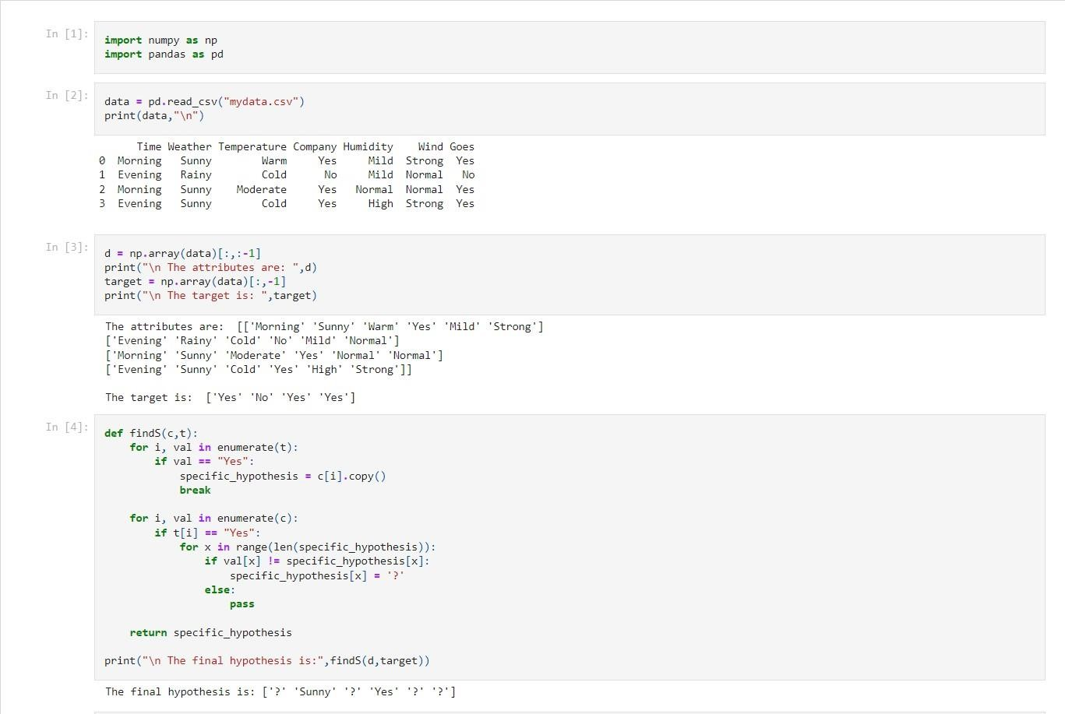

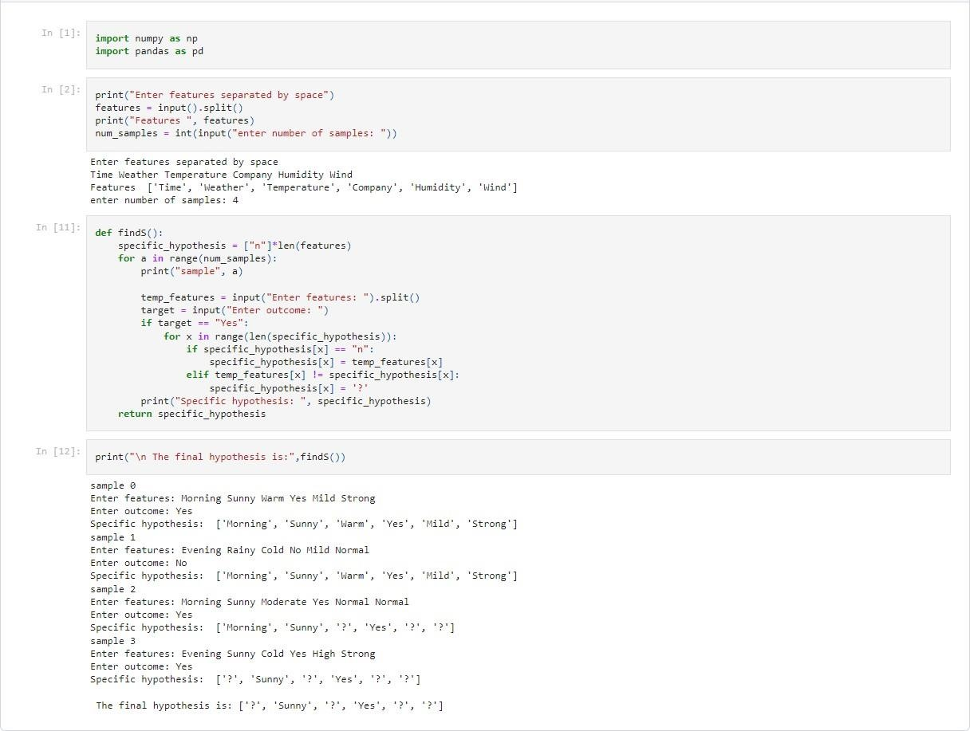

1. **For a given set of training data examples stored in a .CSV file, implement and demonstrate the Candidate-Elimination algorithm to output a description of the set of all hypotheses consistent with the training examples.**

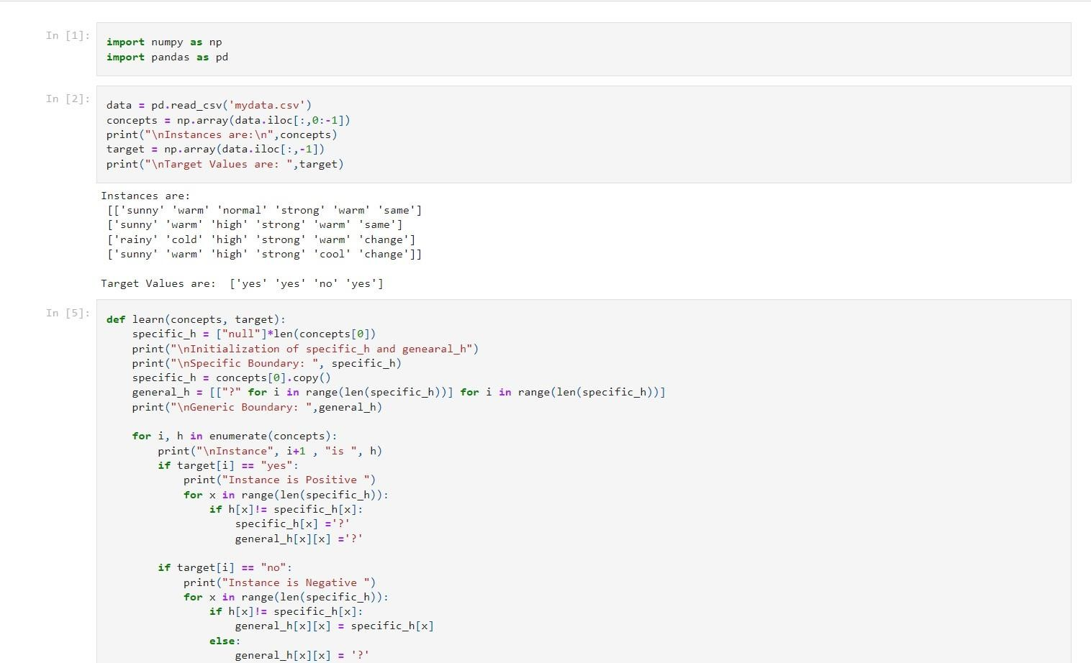

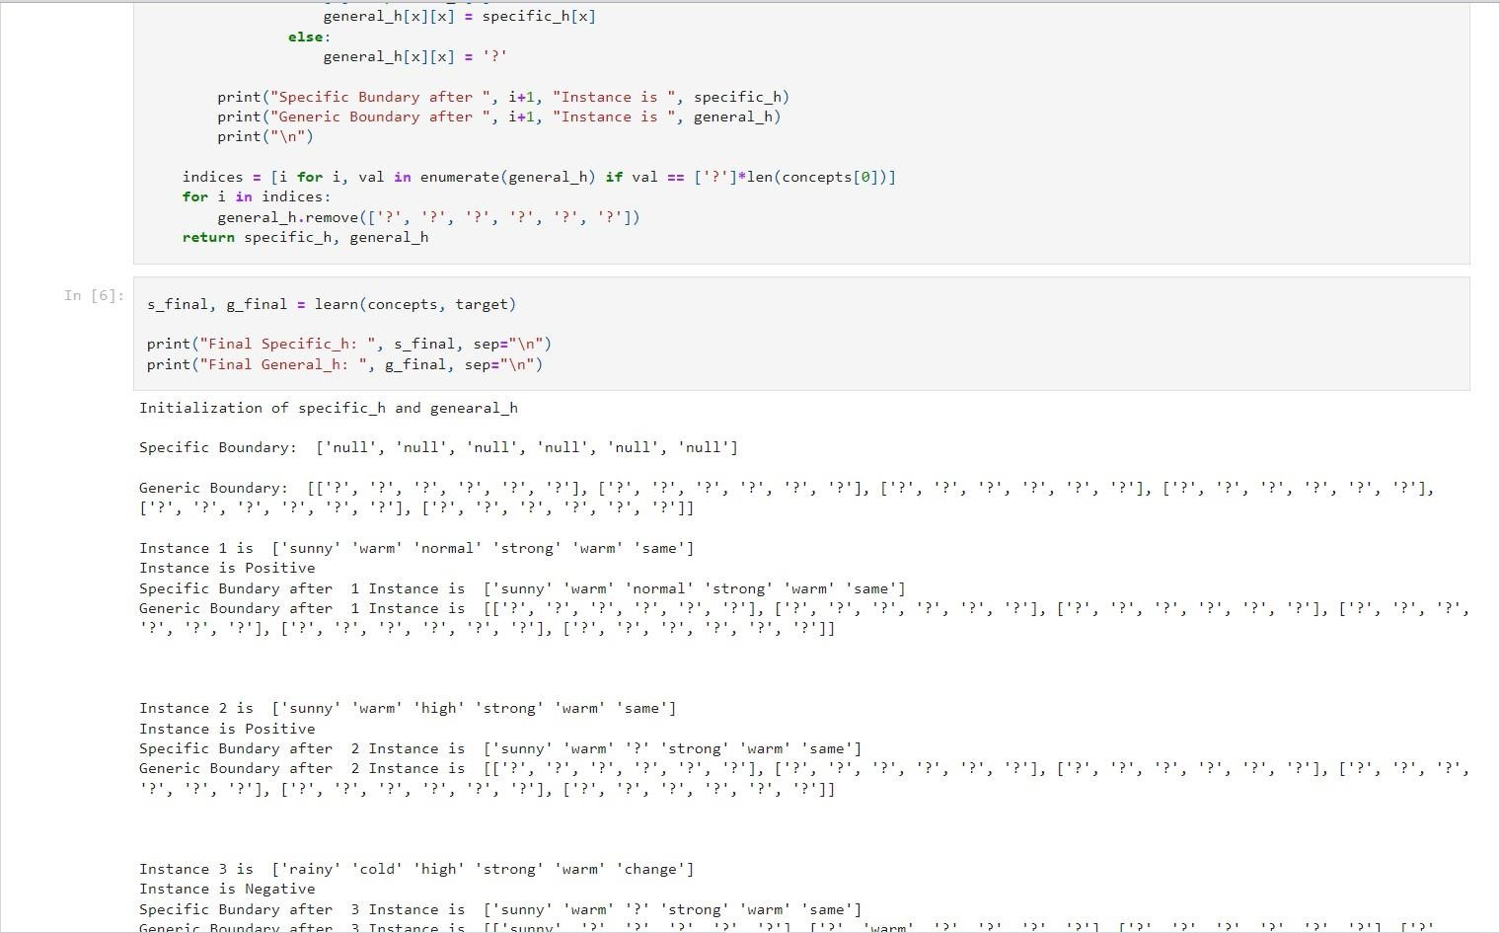

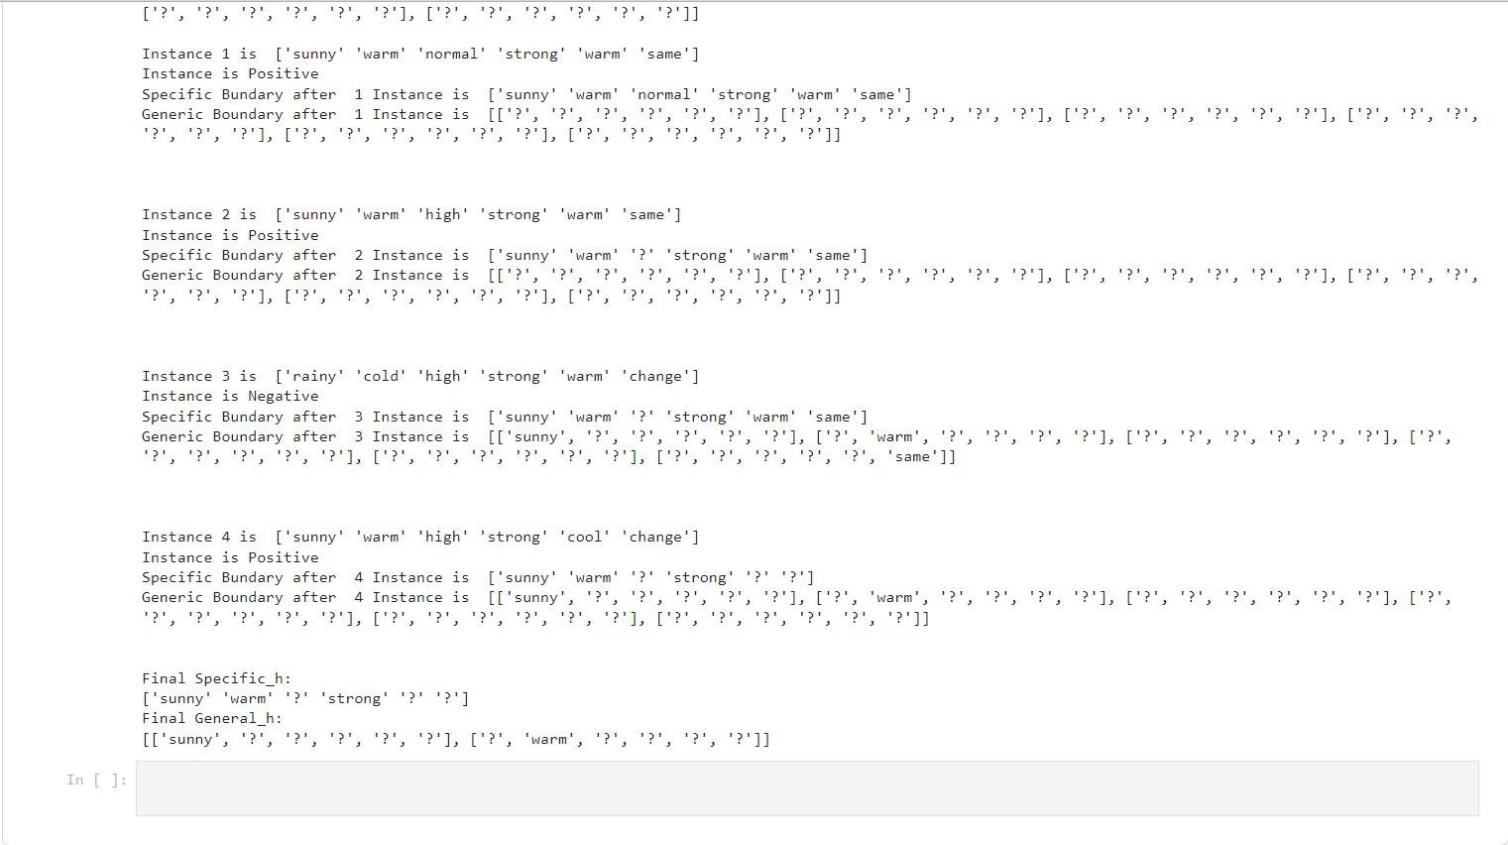

1. **Write a program to demonstrate the working of the decision tree based ID3 algorithm. Use an appropriate data set for building the decision tree and apply this knowledge to classify a new sample.**

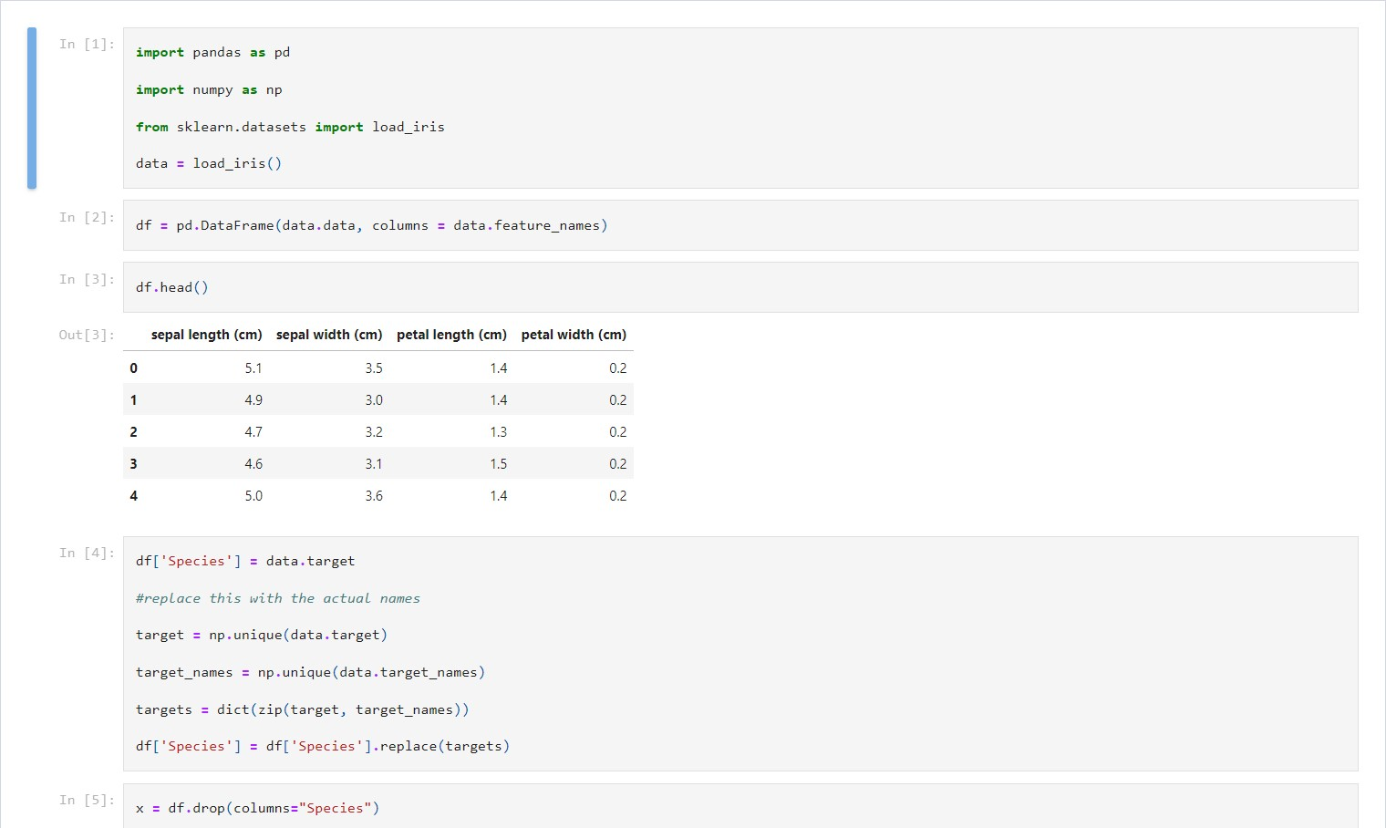

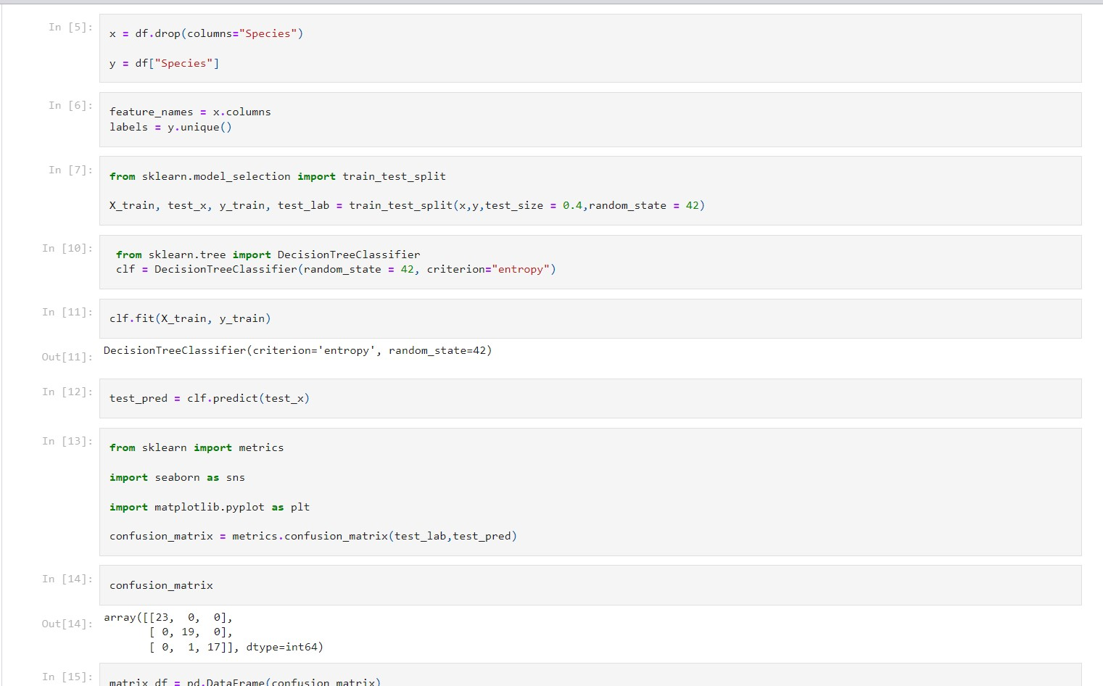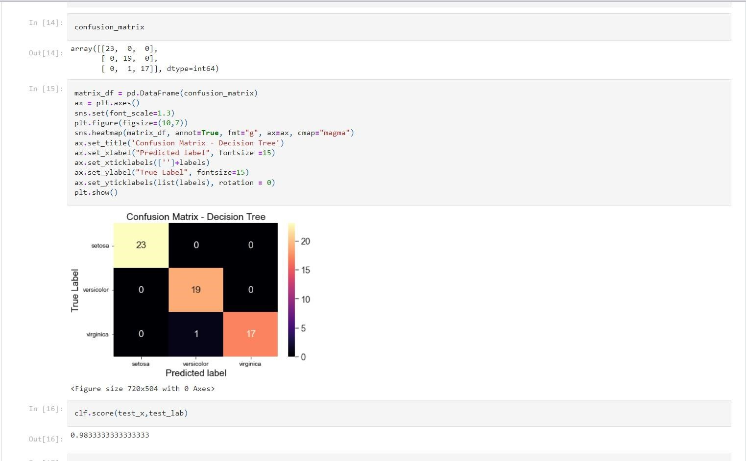

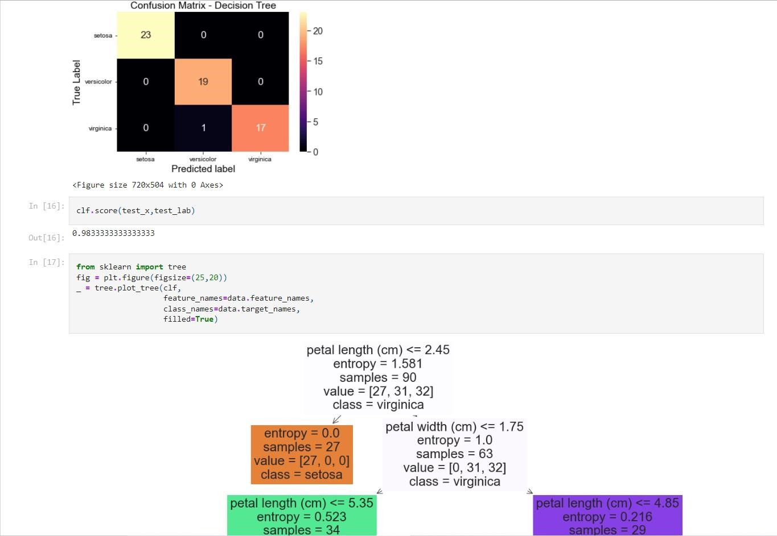

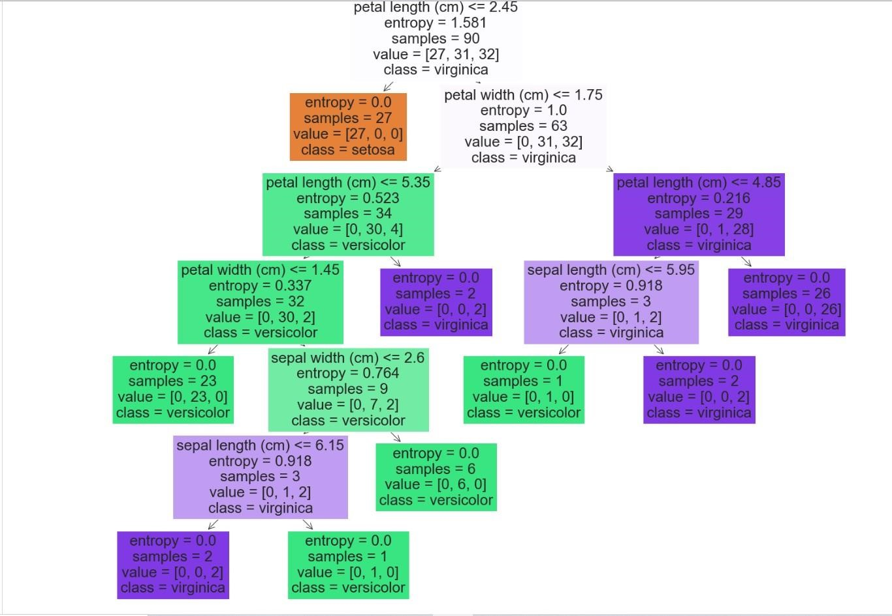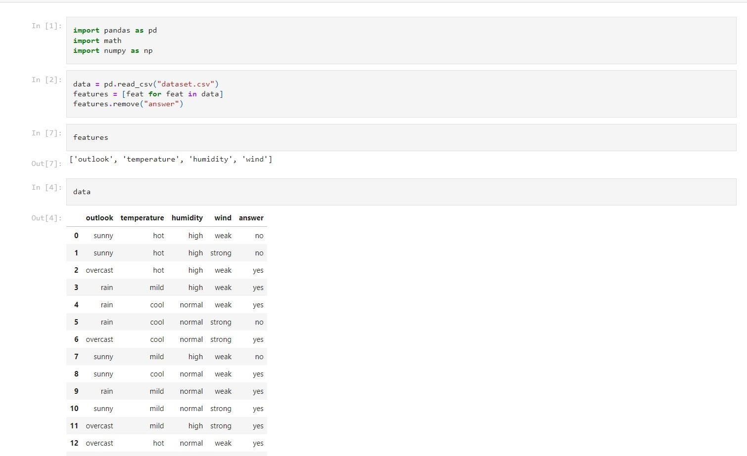

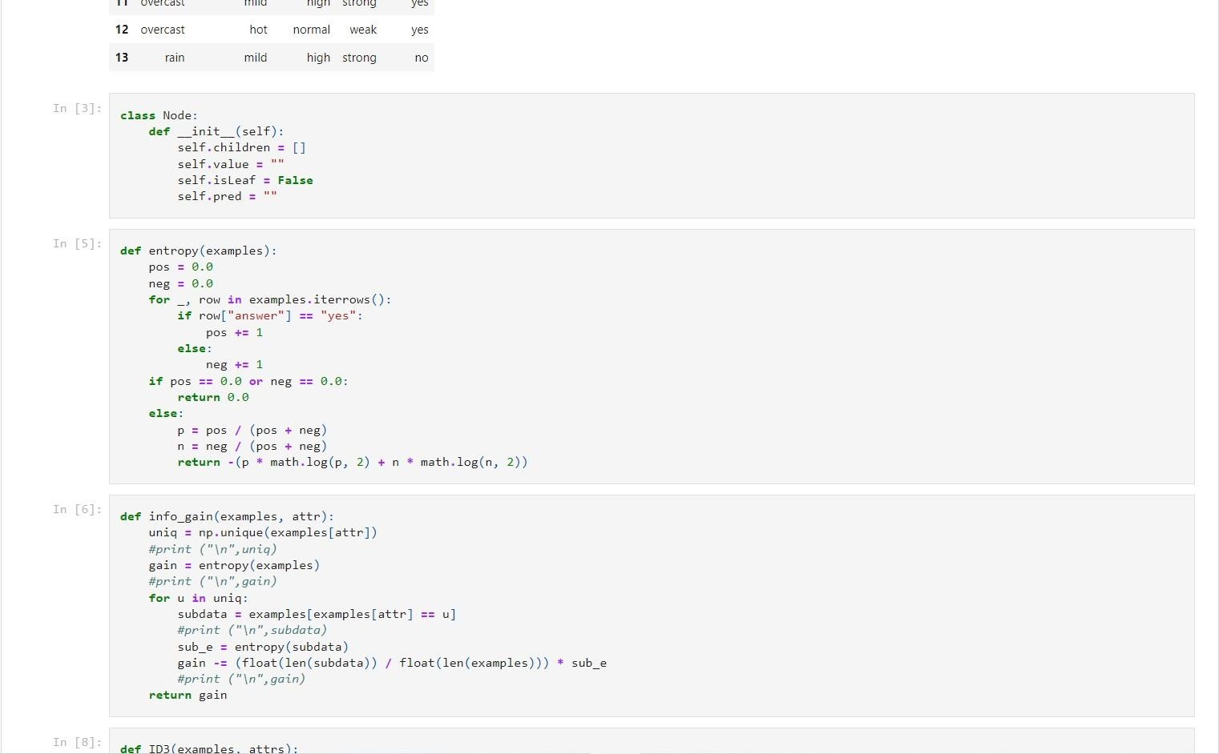

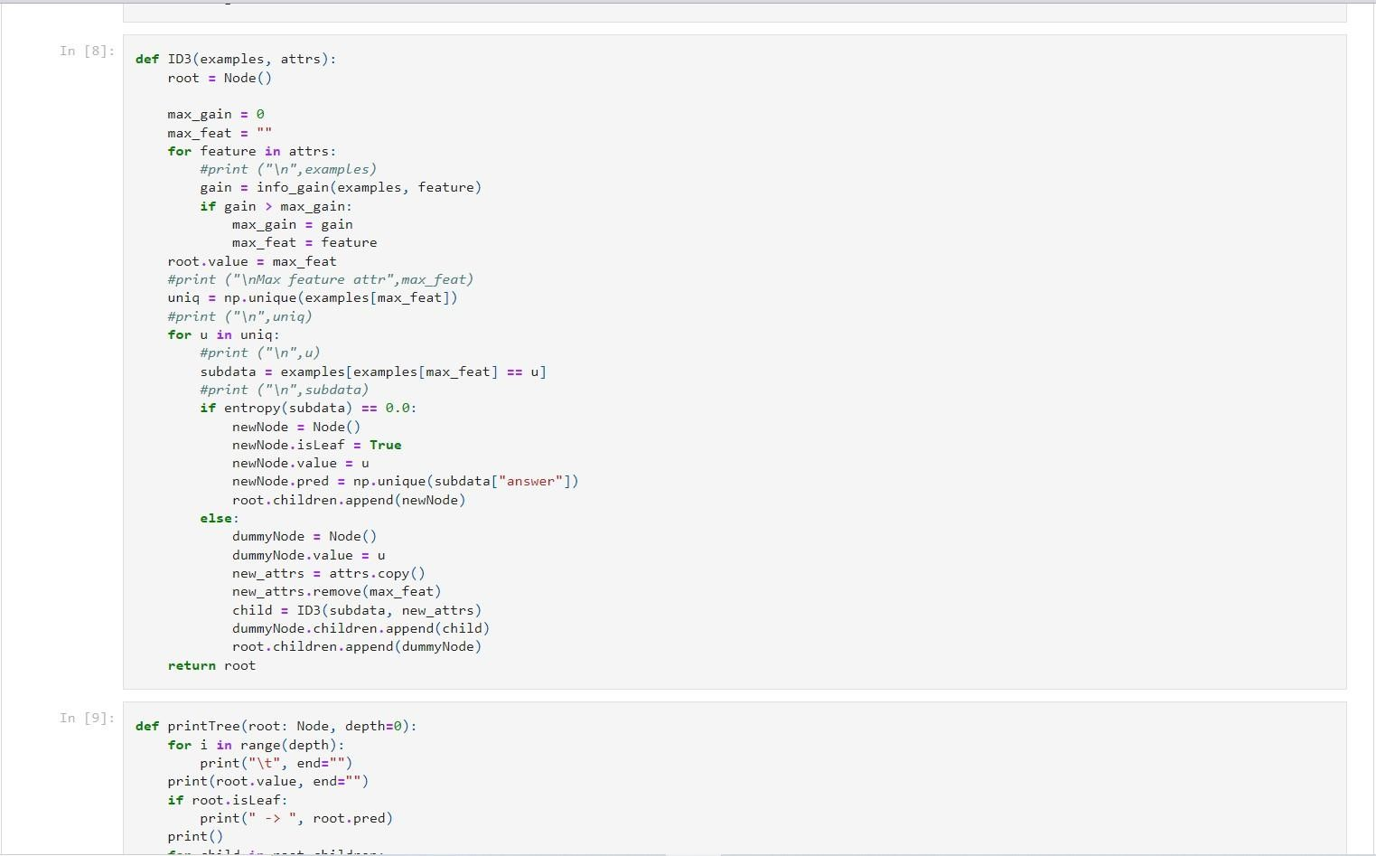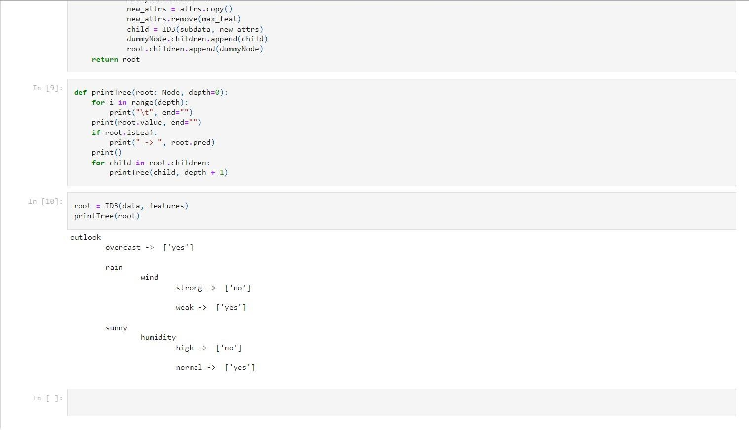

1. **Write a program to implement the naïve Bayesian classifier for a sample training data set stored as a .CSV file. Compute the accuracy of the classifier, considering few test data sets.**

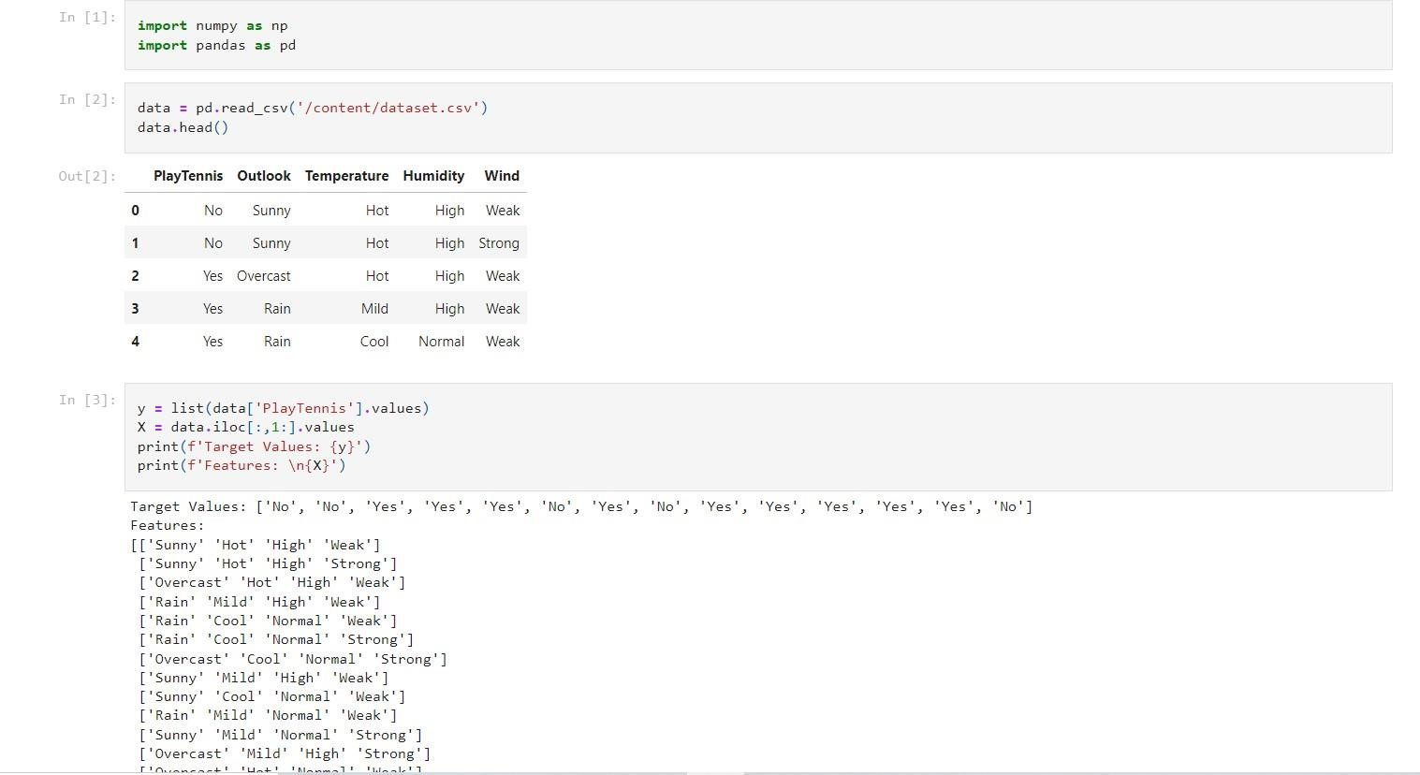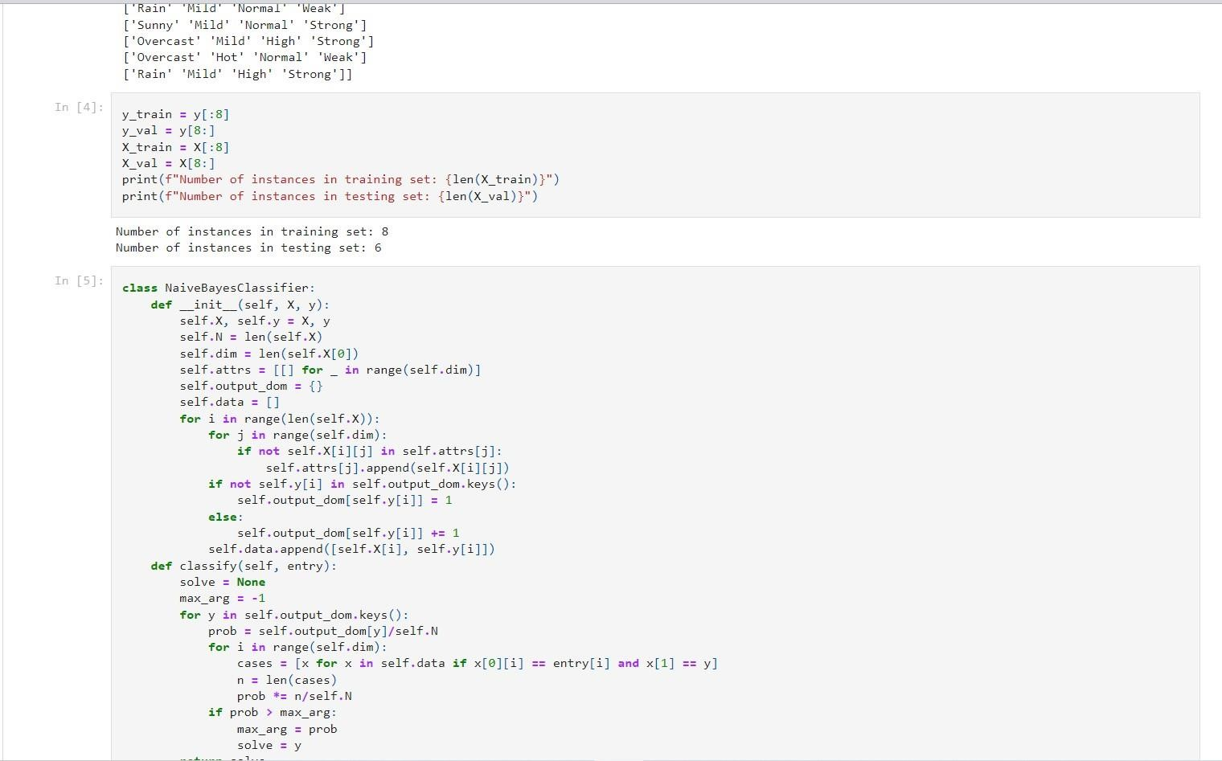

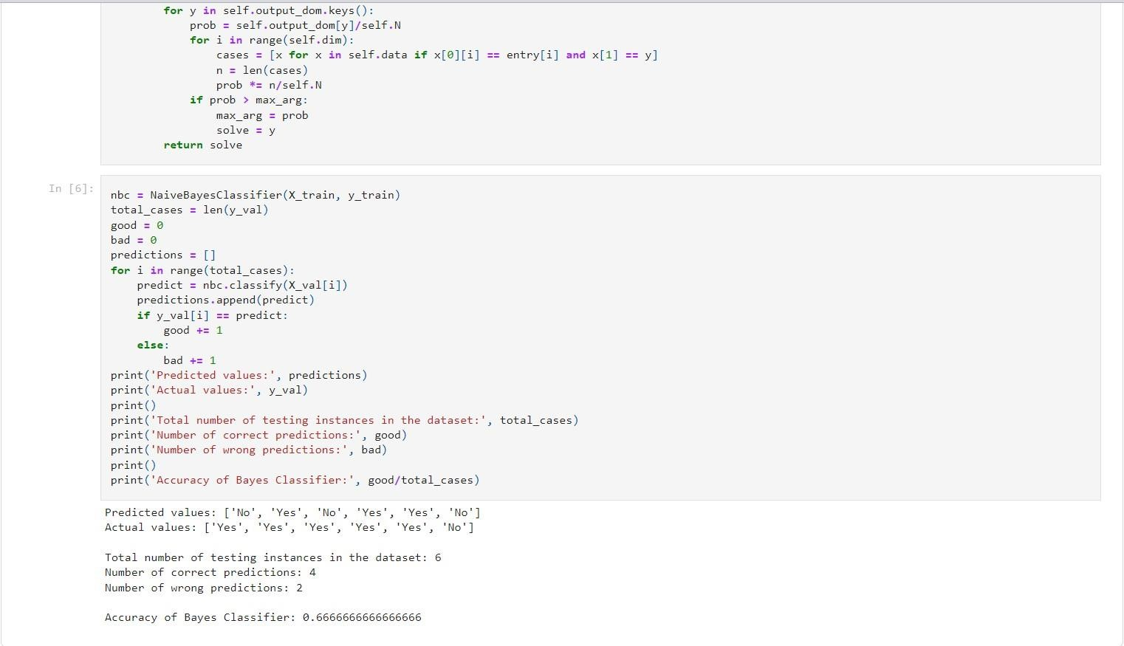

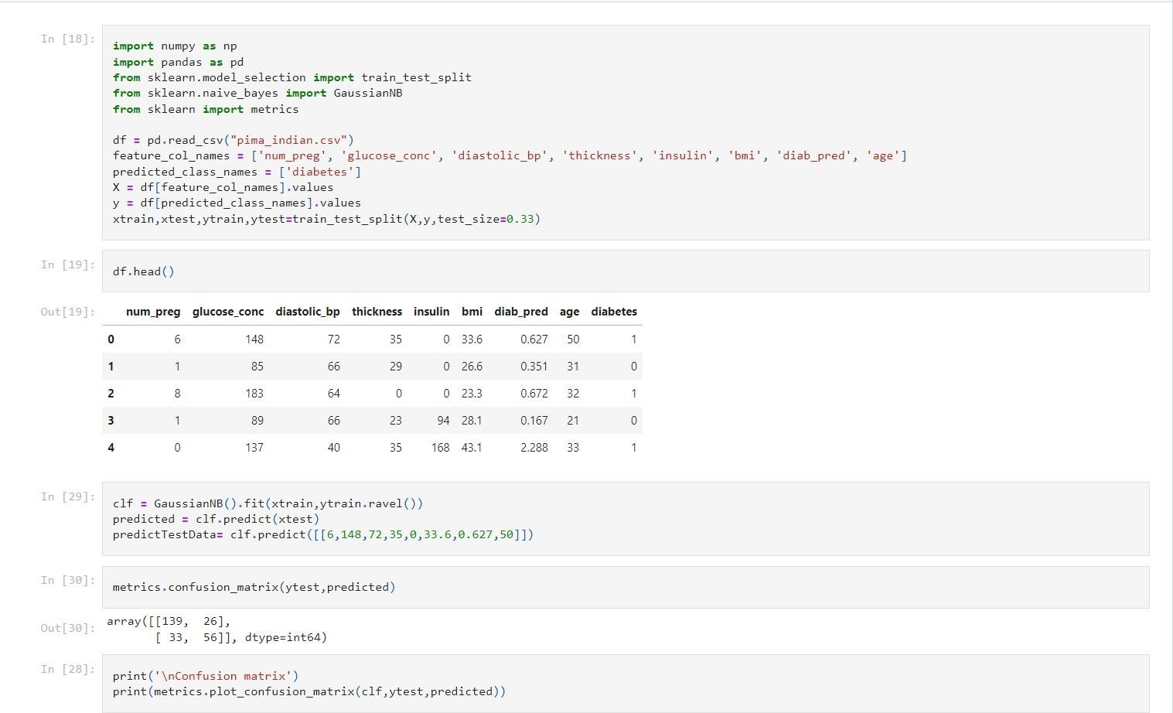

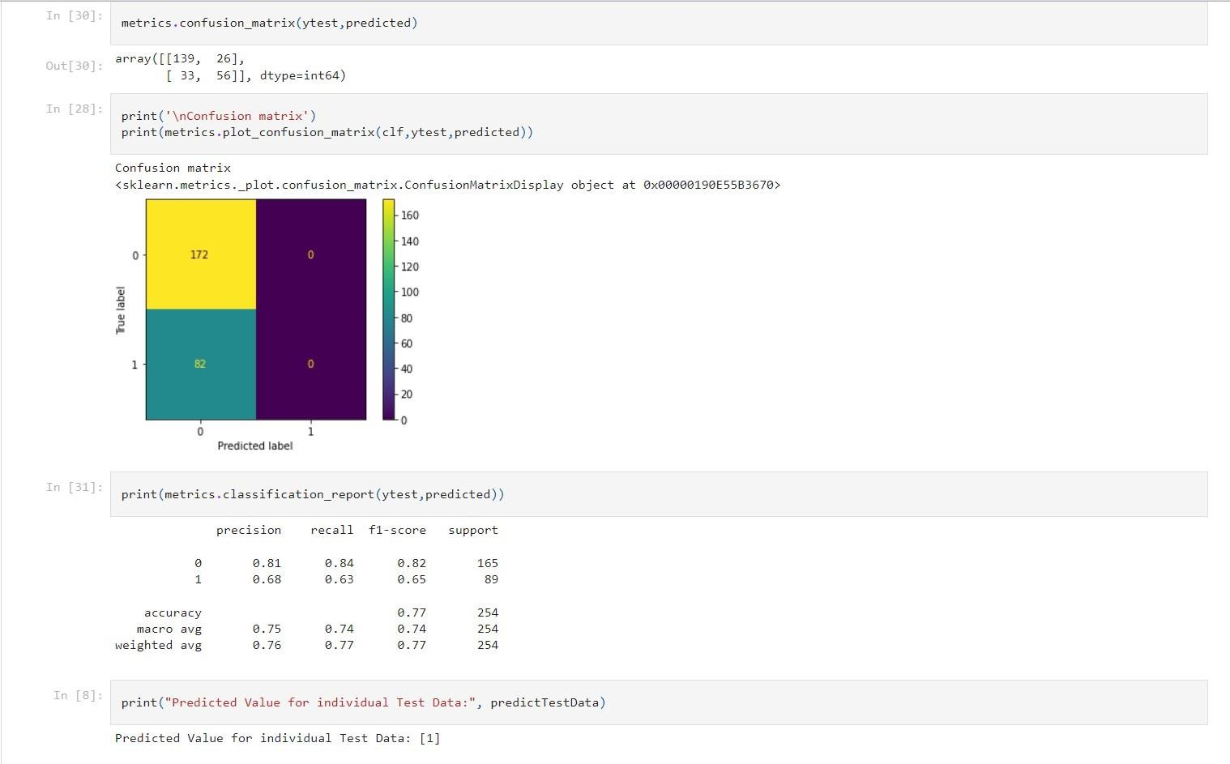

1. **Write a program to construct a Bayesian network considering training data. Use this model to make predictions.**

