Infosys Springboard Virtual Internship 6.0 Completion Report

Team Details <Do not mention any personally identifiable information like email ID, institute details, mobile phone number etc.>
Batch Number
Start date: 13-10-2025
Names: Rachapudi Sai Sree
Internship Duration: 8 Weeks

1. Project Title
Infosys_InsurAI – Corporate Policy Automation & Intelligence System

2. Project Objective
The primary objective of the project was to design and develop a secure, scalable, and intelligent insurance management system that automates policy handling, agent onboarding, and customer interactions.
The system aims to digitalize the insurance workflow, reduce manual verification, and enhance accessibility for customers, agents, and administrators through a role-based web platform.
This project aligns with the evolving digital transformation requirements within the insurance industry by ensuring faster onboarding, secure authentication, and automated processing.

3. Project description in detail
The Infosys_InsurAI system was developed as a full-stack web application leveraging Spring Boot and MySQL for backend services and React.js for the frontend interface.
My Approach
The project was divided into multiple phases covering authentication, authorization, agent verification, dashboard design, and partial implementation of intelligent features.
Key Features Developed
✔ JWT-based secure login & authentication
✔ Role-based access system (Customer / Agent / Admin)
✔ Document upload for agent verification
✔ Admin module to verify pending agent applications
✔ Integrated React frontend with backend APIs
✔ Partially implemented AI logic (rule-based suggestions for policy recommendations)
✔ Attractive dashboards for each role (Customer / Agent / Admin)
Technologies Used
- Backend: Spring Boot, Spring Security, JWT, MySQL
- Frontend: React.js, HTML, CSS
- Tools: Postman, VS Code, Eclipse, Git
- Database: MySQL Workbench

4. Timeline Overview
Week | Activities Planned | Activities Completed
Week 1 | Requirement analysis, backend setup | Completed Spring Boot setup + DB design
Week 2 | Implement authentication | JWT Auth + Login/Registration completed
Week 3 | Implement role-based access | Customer/Agent/Admin roles completed
Week 4 | Agent verification workflow | File upload + Admin verification working
Week 5
Week 6
Week 7
Week 8

5a. Key Milestones
Milestone | Description | Status
Project Kickoff | Understanding the requirements | Completed
Backend Foundation | API structure + JWT + MySQL | Completed
Role-based System | Customer/Agent/Admin roles | Completed
Mid-term Review | Partial system functional | Achieved
Final Submission | Full project | Pending

5b. Project execution details
The project implementation followed a module-wise approach:
Backend Execution
- Designed tables for users and agent documents using MySQL.
- Implemented secure REST APIs using Spring Boot.
- Added JWT authentication with login/registration endpoints.
- Implemented role-based authorization using Spring Security filters.
- Built admin APIs for viewing pending agents and verifying them.
Frontend Execution
- Used React to create Login, Register, Admin, Customer, and Agent dashboards.
- Integrated backend APIs with Axios.
- Added external CSS for a professional and attractive UI design.
- Tested user flows for all three roles: Customer, Agent, and Admin.

6. Snapshots / Screenshots

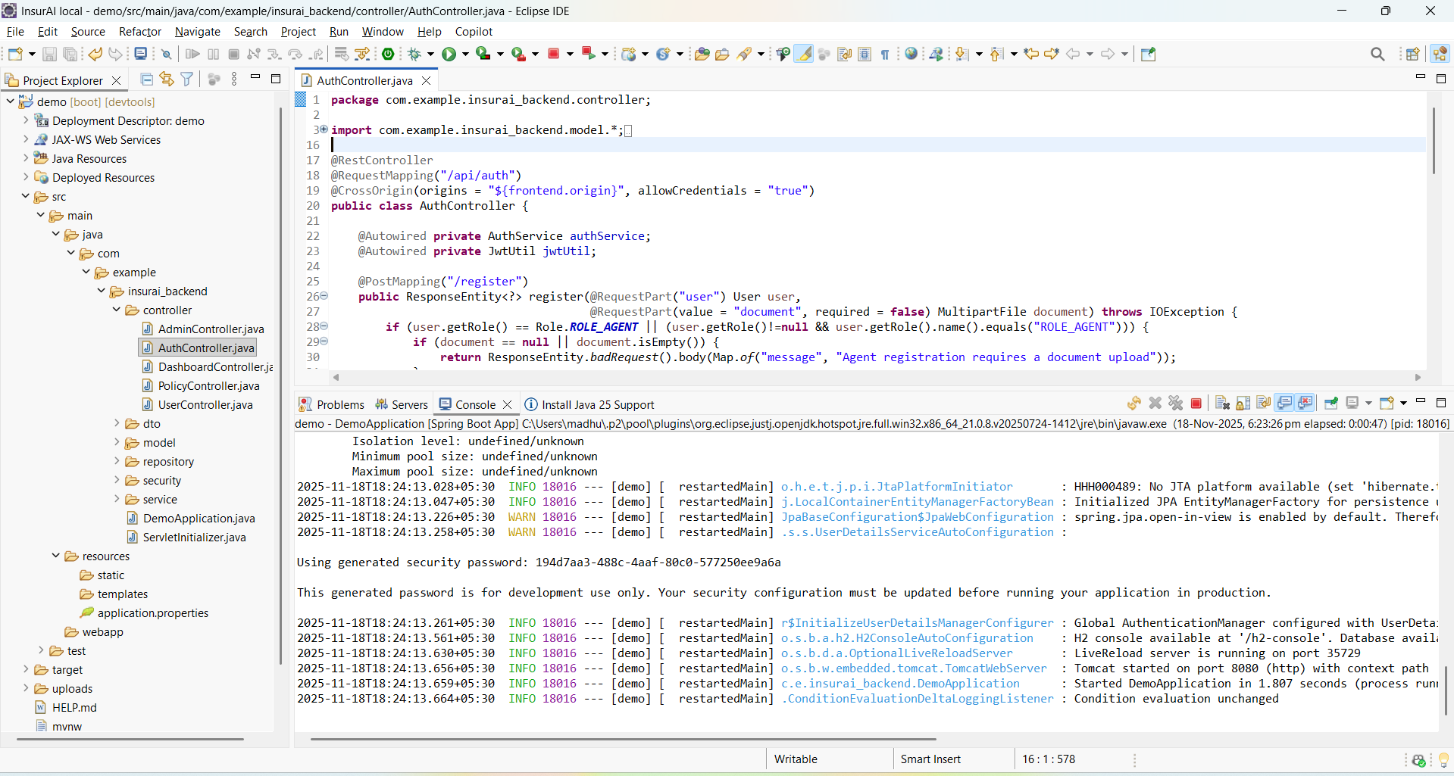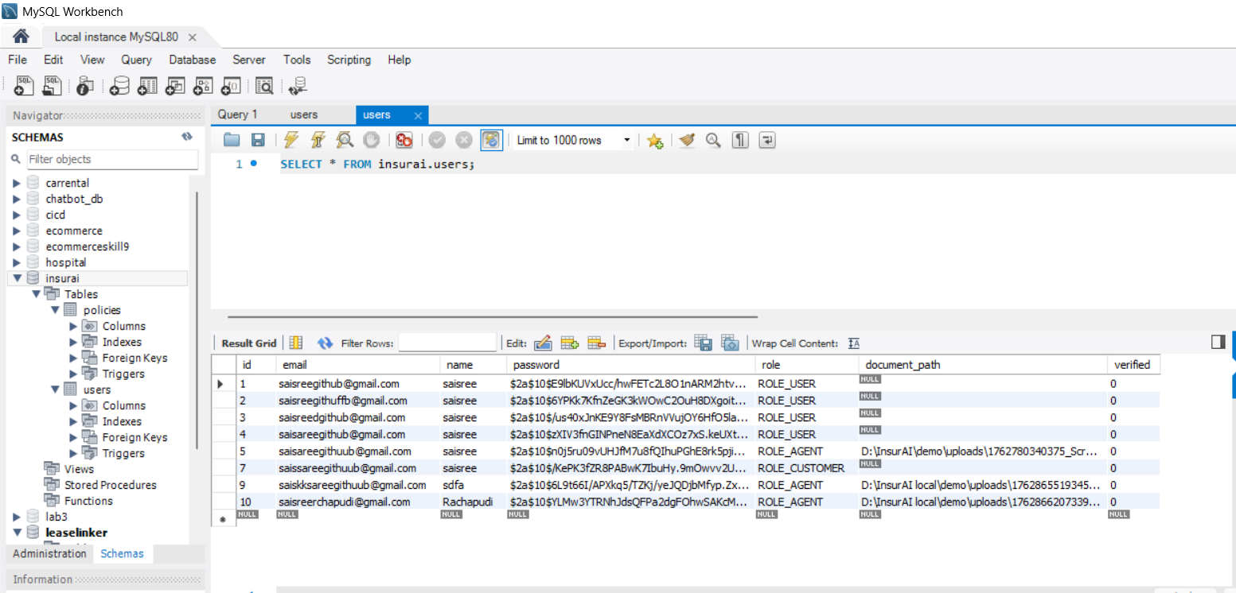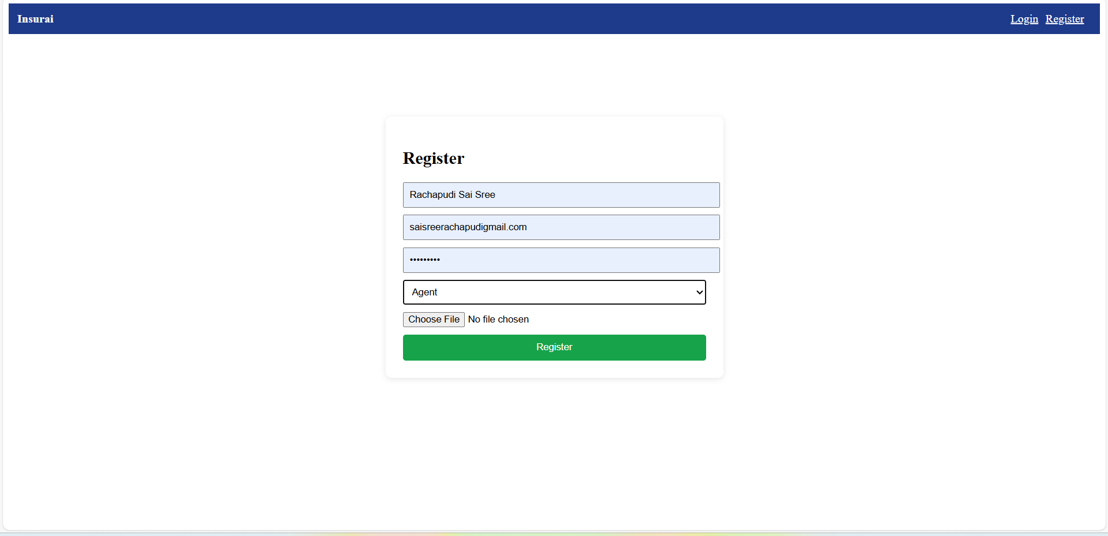

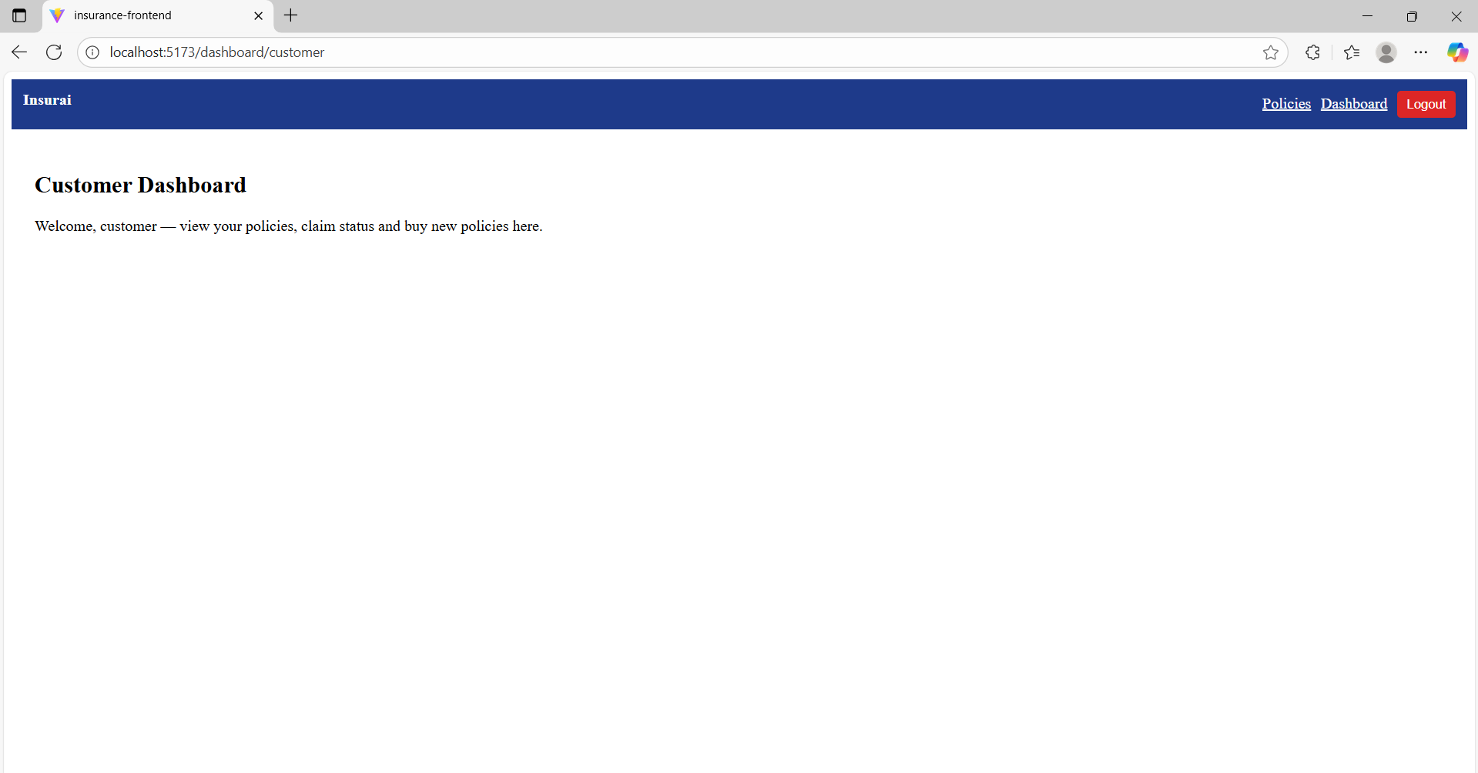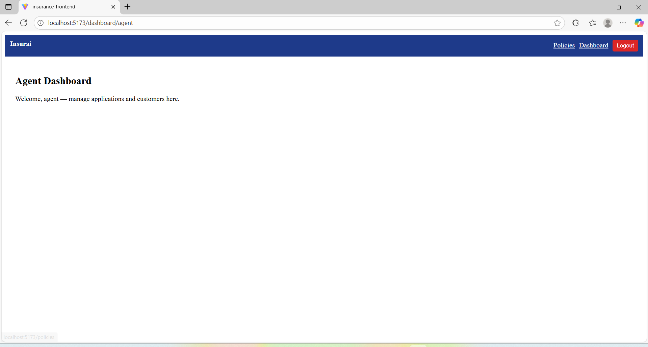7. Challenges Faced
Throughout the internship, I faced several technical and non-technical challenges:
Technical Challenges
- Configuring JWT authentication and Spring Security correctly
- Handling multipart form-data for agent document upload
- Designing database tables aligned with future scalability
- Frontend UI/UX improvements without using frameworks like Tailwind
- Connecting React with Spring Boot and resolving CORS issues
Operational Challenges
- Time management across weekly deliverables
- Debugging authentication and role-based access issues
- Understanding basic insurance workflows and terminology

8. Learnings & Skills Acquired
Technical Skills
- Spring Boot (REST API development)
- JWT Authentication & Spring Security
- MySQL table design and query operations
- React.js component development
- File upload handling
- API integration using Axios
- Version control using Git
Soft Skills
- Problem-solving
- Time management
- Requirement understanding
- Independent development
- Debugging and troubleshooting

9. Testimonials from team
This internship gave me practical exposure to developing a complete full-stack application similar to real-world corporate systems. I gained hands-on experience in secure authentication, role-based access, API design, and frontend integration.
Building the InsurAI platform boosted my confidence in backend development and strengthened my understanding of the insurance domain.

10. Conclusion
The Infosys Springboard Virtual Internship was a valuable learning journey where I built a functional insurance automation system using industry-relevant technologies. The project strengthened my backend development skills, introduced me to real-world business requirements, and aligned closely with my goal of becoming a full-stack engineer. The experience will greatly support my academic growth and future career aspirations.

11. Acknowledgements
I would like to thank:
- Infosys Springboard for providing this opportunity
- All mentors for their structured learning modules
- Online communities and documentation resources that helped solve implementation challenges

